

AE 499 Special Studies Course
Particle Image Velocimetry 3D Pressure Reconstruction

Alex Cameron Bailey
San Diego State University, San Diego CA, 92182

Professor: Xiaofeng Liu
Spring, 2019

Introduction
This report discusses the problem assigned for AE 499 at San Diego State University by Dr. Xiaofeng Liu during the Spring semester of 2019. In this report we develop the equation of a sphere with an inscribed cuboid and then allocate uniformly distributed dots on the sphere. Once the sphere has been generated, we find the coordinates of the uniformly distributed dots. A line equation is then found that connects an arbitrary surface dot to the center of the sphere. A group of uniformly distributed parallel rays are then generated that align with the direction of the line equation and the intersection points of the rays with the cuboid are found.

Equation of Cuboid Inscribed Sphere
The first part of the problem statement asks for the equation about a sphere with an inscribed cuboid. Using the dimensions given for the inscribed cuboid and the coordinate system as shown in the problem statement, an expression about the sphere is found. The equation is expressed in terms of the length, width, and height of the cuboid and a MATLAB generated plot is developed in order visualize the results. The plot shows the eight corners of the cuboid inscribed in the sphere with the dimensions used to calculate the radius. The blue lines represent half of the length, width and height and using Pythagorean theorem twice we can calculate the radius. Here $ξ$ represents the first solution to Pythagorean theorem

$$\begin{aligned}r=\sqrt{ξ^{2}+(0.5{h)}^{2}}\#(1)\end{aligned}$$

$$\begin{aligned}ξ=\sqrt{{\left(0.5l\right)}^{2}+(0.5{w)}^{2}}\#(2)\end{aligned}$$

$$\begin{aligned}r=\sqrt{{\left(0.5l\right)}^{2}+(0.5{w)}^{2}+(0.5{h)}^{2}}\#(3)\end{aligned}$$

Figure 1: MATLAB plot of a cuboid inscribed sphere generated using Equation 3

Uniformly Distributed Dots on a Sphere
One of the major goals of this report is to generate a sphere with uniformly distributed dots allocated on the surface and to obtain a mathematical expression for the coordinates of these dots. The approach taken in this write up is to create what is known as a geodesic dome which includes the following steps.

In order to create a sphere with uniformly distributed dots we must first start with an icosahedron. An icosahedron is a 20 face, 12 vertex polyhedron as shown in the figure below. The algorithm starts with known vertices that are developed by finding the corner points of the three, unit length squares, that form the polyhedron. This can be visualized in figure 3 below.

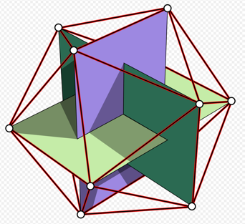

Figure 2: Visualization of the vertices of an icosahedron

The vertex values are either $±$1, 0, or $±$ tau which is a value known as the golden ratio. The vertex values shown in the appendix are divided by their normalized version using Euclidean normalization as seen below in order to give them unit length which facilitates projecting the newly created vertices onto the sphere.

$\begin{aligned}tau=\frac{1+\sqrt{5}}{2}=1.618\#(4)\end{aligned}$

$\begin{aligned}v=\frac{v}{\sum_{i=1}^{N}{\sqrt{v_{i}^{2}}}}=\frac{v}{∥v∥}\#\left(5\right)\end{aligned}$

The radius can then be shown to be 1 using the following formula which uses the values from a random vertex.

$\begin{aligned}r=\sqrt{x_{1}^{2}+y_{1}^{2}+z_{1}^{2}}=1.00\#\left(6\right)\end{aligned}$

Next the relationships between the 20 triangular faces were hard-coded into MATLAB. The table of values as seen in table 2 in the appendix are needed in order to index the appropriate vertices that make up a given face as to allow the subdivisions to bisect the lines that make up each triangle. This will allow us to generate our sphere by subdividing the triangular faces which are known as the principle polyhedral triangle (PPT). Each PPT face can be subdivided into four smaller triangles by bisecting the edges and connecting the bisected edges as seen in the figures below. Each subdivision makes the sphere more resolute.

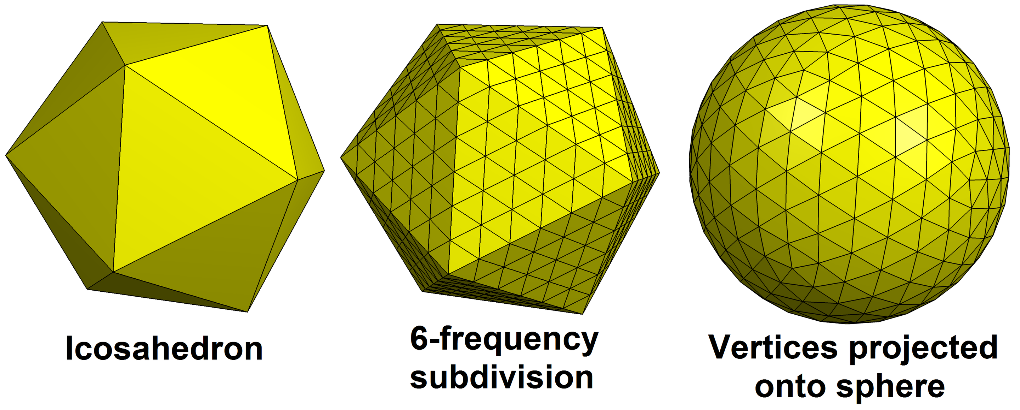
Figure 3: Example process of icosahedron subdivision

Figure 4: Example of one subdivision on one face generated in MATLAB for illustration

The subdivisions of our equilateral triangles are obtained through a recursive function in order to perform as many as we need for our purposes. The function can be looked at in the MATLAB code located in the appendix. For each subdivision the number of faces grows by a factor of 4. The new vertices are obtained by using our matrix of triangular faces in table 2 as an index to the table of vertices in table 1. The vertices in the triangular faces are added together using vector addition and then divided by 2 in order to get our midpoint of the two vectors. The process is shown in the equations below.

$$\begin{aligned}Faces_{number}=Faces_{previous}⋅4\#\left(7\right)\end{aligned}$$

$$\begin{aligned}\vec{v_{1}}+\vec{v_{2}}=\left[\begin{aligned}x_{1}+x_{2} \\ y_{1}+y_{2} \\ z_{1}+z_{2}\end{aligned}\right]=\vec{v_{3}}\#\left(8\right)\end{aligned}$$

$$\begin{aligned}\vec{v_{new}}=\vec{v_{3}}/2=\left[\begin{aligned}x_{new} \\ y_{new} \\ z_{new}\end{aligned}\right]\#\left(9\right)\end{aligned}$$

After the subdivision is performed and the midpoint is obtained, the midpoint is again divided by its normalization in order to make sure the point will lie on the sphere. This is done the same way as shown above for the initial vertices and our new vertices are added to the list of vertices to be plotted at the end of the subdivision process.

After this is complete, we will need to remove duplicate vertices which occur due to adjacent triangles and this is accomplished with built in MATLAB functions as seen in the code.

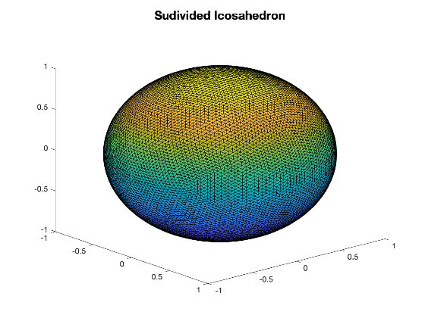
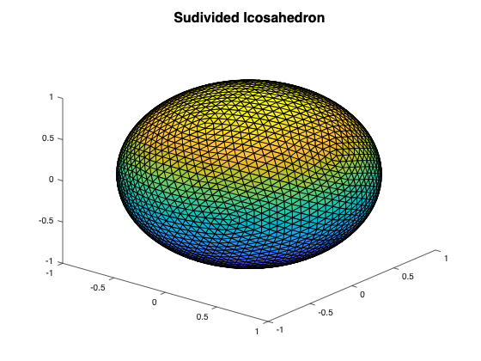
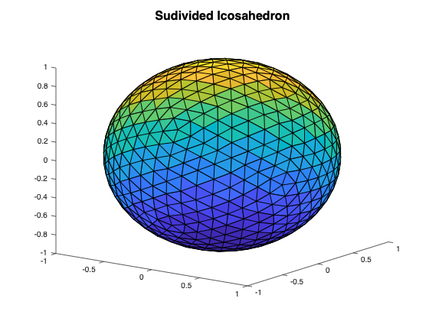
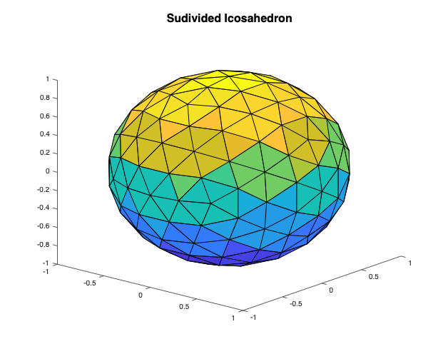
The end result is a program that allows you to choose a value for the number of subdivisions and then generate a sphere based on that. The following plots are examples of spheres generated where n is the number of subdivisions performed. It can be observed that more subdivisions correlates to a more resolute sphere.
Figure 5: The subdivided icosahedron after 1, 2, 3, and 4 subdivisions respectively (left to right)

Computational Efficiency
Upon analyzing the computational efficiency of the code, the following running times were collected for several values of n.

Number of subdivisions | Running Time (seconds)
1 | 0.003538
2 | 0.010564
3 | 0.023509
4 | 0.073572
5 | 0.560178
6 | 11.335681
7 | 373.191938

Table 1: Computational complexity involved with icosahedron subdivisions
It can be seen that after 6 subdivisions the running time drastically increases. At n = 7 there are 327,680 faces and 163,842 vertices. According to the formula for number of faces shown above an 8th subdivision would correspond to over a million faces.

In order to ensure uniformity of the dots generated on the sphere the distance formula as shown in Equation 10 is used on several points. It is found that after two subdivisions the distance between points is found to be 0.3129. This formula was used for several different variations of vertices and subdivisions and uniformity was shown to be consistent.

$\begin{aligned}d=\sqrt{(x_{2}-x_{1})^{2}+(y_{2}-y_{1})^{2}+(z_{2}-z_{1})^{2}}\#\left(10\right)\end{aligned}$

$\begin{aligned}d=\sqrt{(-1-(-0.951))^{2}+(0-(-0.263))^{2}+(0-0.162)^{2}}=0.3129\#\left(11\right)\end{aligned}$

$\begin{aligned}d=\sqrt{(-1-(-0.951))^{2}+(0-0.263))^{2}+(0-(-0.162{))}^{2}}=0.3129\#\left(12\right)\end{aligned}$

The following table represents the variation of face and vertex numbers when the number of subdivisions is incremented. This further proves the exponential growth that occurs showing us that for optimal running times we should keep the number of subdivisions limited to six or less.

Number of subdivisions (n) | Number of faces | Number of vertices
1 | 80 | 42
2 | 320 | 162
3 | 1280 | 642
4 | 5120 | 2562
5 | 20480 | 10242

Table 2: Vertex and face number values for variations in subdivisions

Face Centroid
The subdivided icosahedron results in a sphere with an increasing amount of faces based on how many subdivisions are performed. One goal of this report is to demonstrate how the centroid of each face can be calculated which will allow for more options to create our parallel rays around. In order to calculate the centroid of a chosen face, we recognize that they are equilateral triangles. By taking the average of the x, y, and z coordinates of the three vertices that make up the triangle and then dividing them by the euclidean normalization, the chosen faces centroid is obtained. Normalizing the values projects the centroid onto the sphere. The equations below illustrate this process and the code that performs these calculations can be viewed in the appendix.

$$\begin{aligned}\overline{x}=\frac{v_{1,x}+v_{2,x}+v_{3,x}}{3}\#\left(12\right)\end{aligned}$$
$$\begin{aligned}\overline{y}=\frac{v_{1,y}+v_{2,y}+v_{3,y}}{3}\#\left(13\right)\end{aligned}$$
$$\begin{aligned}\overline{z}=\frac{v_{1,z}+v_{2,z}+v_{3,z}}{3}\#\left(14\right)\end{aligned}$$
$$\begin{aligned}\vec{v}=\left[\overline{x},\overline{y},\overline{z}\right]\#\left(15\right)\end{aligned}$$
$$\begin{aligned}Centroid_{x,y,z}=\frac{\overline{v}}{\left\|\vec{v}\right\|}\#\left(16\right)\end{aligned}$$

Figure 5: Vector from the center of the sphere to an arbitrary face centroid

Equation from Sphere Center to Arbitrary Surface Dot
In order to define an expression of a line that connects an arbitrary surface dot to the center of the sphere we must utilize the coordinates for the vertices on the sphere as well as the center of the sphere which in our case is the origin of our coordinate system. This makes our line equation very simple which is illustrated in the equations below. Here $\vec{v_{o}}$ is the origin, $\vec{v}$ contains the x, y, and z coordinates of the desired point and r is the radius which gives us the length of the vector.

$$\begin{aligned}\vec{r}=\vec{v_{o}}+\vec{v}⋅r\#\left(17\right)\end{aligned}$$
Figure 6: Graphic representation of a line equation from sphere center to dot
Parallel Rays and Normal Plane
The parallel rays developed in this project originate from a plane that is normal to any given vector to a vertex from the origin, therefore the first step is to create an expression for a tangent plane to the spheres vertices that can be defined at any chosen point of interest. In order to this we must first calculate the gradient of the equation for a sphere with respect to a chosen point This process is illustrated through Equations 18 and 19. Here our radius is equal to 1. Using the orthonormal vectors calculated using Matlab and the gradient, we can then calculate the tangent plane using Equation 20. Here $f\left(x_{0},y_{0}\right)$ represents the vertex in which the plane is being defined with respect to. The orthonormal basis of the gradient acts as a scaling factor that keeps the points acting on the tangent plane in both the x, and y directions therefore creating an expression in which any specified x, y, coordinates will fall on the tangent plane. This plane is normal to the vector from the spheres center to the vertex which will now become the starting plane for are parallel rays. Once the hexagonal grid of points is defined, we apply these points to tile them on the newly defined plane.

$$\begin{aligned}f\left(x,y,z\right)=x^{2}+y^{2}+z^{2}=1\#\left(18\right)\end{aligned}$$

$$\begin{aligned}∇\left(f\right)=2\left[v_{x}+v_{y}+v_{z}\right]\#\left(19\right)\end{aligned}$$

$$\begin{aligned}T\left(x,y\right)=f\left(x_{0},y_{0}\right)+f_{x}\left(x_{0},y_{0}\right)x+f_{y}\left(x_{0},y_{0}\right)y\#\left(20\right)\end{aligned}$$

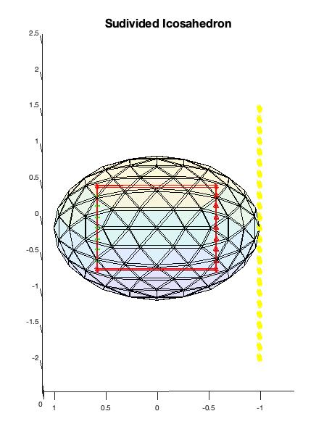
Figure 7: The normal plane to a point on the sphere

Once the normal plane has been defined a grid is created on the plane where the parallel rays will originate from. The grid is developed in order to ensure that the parallel rays are uniformly distributed. The grid constructed is represented by the following figure in which equilateral triangles are tiled in a hexagonal pattern using a method known as triangular tessellation.

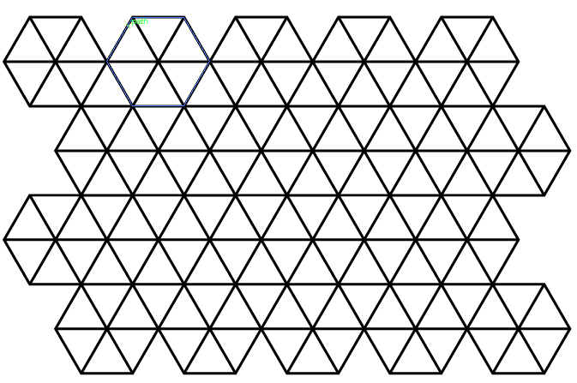
Figure 8: Equilateral triangular tessellation

The points on the grid are defined by iterating through the angles of the hexagon and applying the following equations where d represents the length from the origin to a vertex which in our case is unit length. The angles of the hexagon are as follows 60, 120, 180, 240, 300, 360, 60. Once the new values for the x and y coordinates are calculated for each angle, they are added to the originating point in order to obtain the new hexagonal coordinates. This process is repeated recursively using specified bounds which define the size of the grid. The calculation of the midpoints between hexagons is significantly more involved and can be referred to in the MATLAB code in the appendix. A density feature was added to program to allow for a specified density of the parallel rays. By scaling the density up or down we can change how close together the rays are. This is accomplished by using a scalar multiplier to the points found through the following calculations.

$$\begin{aligned}x=d⋅cos\left(θ\right)\#(21)\end{aligned}$$
$$\begin{aligned}y=d⋅sin\left(θ\right)\#\left(22\right)\end{aligned}$$

$$\begin{aligned}x_{new}=x_{o}+x\#\left(23\right)\end{aligned}$$
$$\begin{aligned}Y_{new}=y_{o}+y\#\left(24\right)\end{aligned}$$

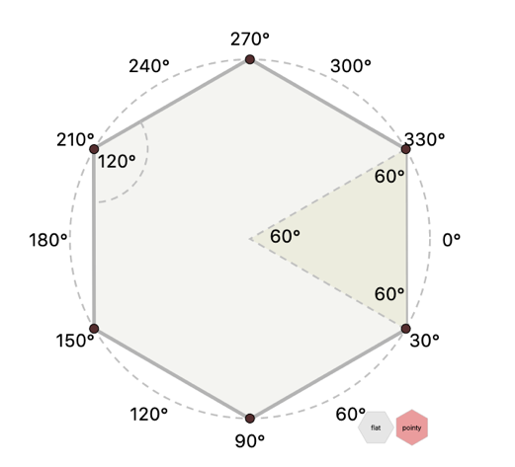
Figure 9: Hexagonal tile with angles visualized

By using the values we calculated for the hexagonal arrangement combined with our expression for the normal plane, a plane of uniformly distributed points are created that are on a plane normal to the specified point of interest. The distance formula was again used to ensure the points, and therefore, rays are in fact uniformly distributed. These points will be the origin of our parallel rays. Using the equation of a line shown below we can define a set of parallel rays that shine through the sphere and cuboid. Here $\vec{v_{0}}$, represents the originating point which in our case is the points on the hexagonal grid. $\vec{v_{P}}$ represents the vector of coordinates from the chosen point about which the normal plane and grid is defined, and t represents the scaling factor that determines how long the rays are.
$$\begin{aligned}r\left(t\right)=\vec{v_{0}}+\vec{v_{P}}⋅t\#\left(25\right)\end{aligned}$$

Figure 10: MATLB plot that illustrates the parallel rays from a hexagonal grid

Intersection Points
The last goal of this report is to obtain the intersection points of the parallel rays with the inscribed cuboid and to differentiate between entrance and exit intersections. Some properties about the cuboids faces and the rays must be obtained first in order to find the points of intersection. We begin by defining a point on each of the 6 faces of the cuboid as well as the normal vectors to each face. In our case the normal vectors to each face are $±$[1,0,0], $±$[0,1,0],$±$[0,0,1] with respect to our coordinate system. The points on each plane are similarly $±$[L,0,0],$±$[0,L,0],$±$[0,0,L], where L represents the length from the spheres center to any cuboid faces center point and is calculated using Equations . The radius is first calculated using the coordinates of a vertex that coincides with one of the cubes corners. Then the length to a cuboid face is obtained by recognizing that the length, width, and height of the cuboid are all equal. L can be visualized in Figure 8. It’s worth noting that L is half of the length, width, and height.
$$\begin{aligned}r=\sqrt{v_{x}+v_{y}+v_{z}}=\sqrt{3L^{2}}\#\left(26\right)\end{aligned}$$

$$\begin{aligned}L=\sqrt{\frac{r}{3}}\#\left(27\right)\end{aligned}$$

Figure 11: Illustration of the value for L which is used to calculate points on the cuboid faces

Next, we need the starting and end points for each of the parallel rays. The starting point is found by using the points on the hexagonal grid and the ending points are found using the equation for a line that represents the parallel rays and by plugging in the ending bound of the line segment to the equation. The following line equation is used to calculate the end point. Here t represents the ending bound of the parallel ray, $x_{o},y_{o},z_{o}$ represent the starting point of the respective ray and $v\left(p,1\right), v\left(p,2\right), v\left(p,3\right) represent the vertex value for the chosen point at x, y, and z respectively.$

$$\begin{aligned}x_{end}=x_{o}+v\left(p,1\right)⋅t\#\left(28\right)\end{aligned}$$
$$\begin{aligned}y_{end}=y_{o}+v\left(p,2\right)⋅t\#\left(29\right)\end{aligned}$$
$$\begin{aligned}z_{end}=z_{o}+v\left(p,3\right)⋅t\#\left(30\right)\end{aligned}$$

Now that we have the starting and ending points of each ray, the normal vectors, and points on each face of the cuboid we can calculate the intersection points of each parallel ray. The parametric representation of a line defined by two points is defined in Equation 30. In this equation s is the fraction of P(s)'s distance along the segment, $P_{0}$ is the origin of the line and $\vec{u}$ is the direction vector of the starting and end points of the line. We must first calculate the direction vector of each ray which is done by subtracting the end point from the beginning in the manner shown in Equation 32.
$$\begin{aligned}P\left(s\right)=P_{0}+s\left(P_{1}-P_{0}\right)=P_{0}+s\vec{u}\#\left(31\right)\end{aligned}$$

At the intersection point, $P\left(s\right)-v_{0}=\vec{w}+s\vec{u}$, is perpendicular to the normal vector where $\vec{w}$ is defined below. This is equivalent to $n⋅\left(\vec{w}+s\vec{u}\right)=0$. By solving this we can define $s_{i}$, the fraction of the line at the intersection point, using the equation below. After calculating $s_{i}$ we can define our intersection points by plugging in our values to the parametric equation for a line shown in Equation 30. An abbreviated form of the. equation is also shown in Equation 34.

$$\begin{aligned}s_{i}=\frac{-\vec{n}⋅\vec{w}}{\vec{n}⋅\vec{u}}=\frac{\vec{n}⋅{(v}_{0}-p_{0})}{\vec{n}⋅\left(P_{1}-P_{o}\right)}\#\left(32\right)\end{aligned}$$

$$\begin{aligned}\vec{u}=P_{1}-P_{o}\#\left(33\right)\end{aligned}$$
$$\begin{aligned}\vec{w}=P_{o}-v_{o}\#\left(34\right)\end{aligned}$$
$$\begin{aligned}I=P_{o}+s_{i}⋅\vec{u}\#\left(35\right)\end{aligned}$$

These equations are used on each parallel ray for each face of the cuboid. By performing these calculations, we are able to determine a list of intersection points with each of the six planes of the cuboid. Further processing must be done in order to eliminate any points that do not lie within the bounds of the cuboid. This is done by realizing the cuboid spans from -L to L on each plane and removing points of intersection that do not fall within this range. L was calculated at the beginning of this section.

After the intersection points have been collected, we determine whether or not the point is an entrance point or an exit point. This can be accomplished by using the distance formula as displayed in Equation 10. While each ray has its intersection points calculated and stored, the distance formula is used and the distance from the intersection points to the originating point on the hexagonal grid is determined. This allows us to choose the shortest distance intersection point as the entrance point and the other one as the exit point. It is shown in Figure 9 that where the parallel rays enter the cuboid it is marked with a red triangle. The exit points are marked with a green ‘+’ symbol. These points are displayed when the program is run.

Figure 12: Plot generated depicting the entrance and exit points of the parallel rays through the cuboid. The red triangles are the entrance points and the green ‘+’ are the exit points
Appendix

MATLAB code

Matlab script For SDSU AE499 Dr. X. Liu
Author: Alex Bailey
1. Generates an icosahedron and performs n sudivisions in order to create equidistant points on a sphere
2. creates parallel rays to a chosen vertex or centroid and determines entrance and exit intersection points with the spheres inscribed cuboid

Create an icosahedron with 20 faces and 12 vertices 1
Subdivide icosahedron in order to uniformly distribute dots on sphere 2
calculations 2
functions written to facilitate project goals 3

Create an icosahedron with 20 faces and 12 vertices
Constants
tau: the golden ratio
n: number of subdivisions
n = 2;
tau = (1+sqrt(5)) / 2;
% create the 12 vertices using known coordinate relationships (x, y, z)
v = [-1, tau, 0;
1, tau, 0;
-1,-tau, 0;
1,-tau, 0;
0,-1, tau;
0, 1, tau;
0,-1,-tau;
0, 1,-tau;
tau, 0,-1;
tau, 0, 1;
-tau, 0,-1;
-tau, 0, 1];
% Euclidean normalize vertices to unit size to project the vertices onto a sphere
v = v./norm(v(1,:));
% create 20 faces of the icosahedron
f = [ 1,12, 6;
1, 6, 2;
1, 2, 8;
1, 8,11;
1,11,12;
2, 6,10;
6,12, 5;
12,11, 3;
11, 8, 7;
8, 2, 9;
4,10, 5;
4, 5, 3;
4, 3, 7;
4, 7, 9;
4, 9,10;
5,10, 6;
3, 5,12;
7, 3,11;
9, 7, 8;
10, 9, 2];

Subdivide icosahedron in order to uniformly distribute dots on sphere
tic; recursively subdivide equilateral triangle faces
for i = 1:n
newF = zeros(size(f,1)*4,3);
for j = 1:size(f,1) % for each triangle
tri = f(j,:);
% calculate mid points (add new points to v)
[a,v] = bisectTriangle(tri(1),tri(2),v);
[b,v] = bisectTriangle(tri(2),tri(3),v);
[c,v] = bisectTriangle(tri(3),tri(1),v);
% generate new subdivision triangles
newFace = [tri(1),a,c;
tri(2),b,a;
tri(3),c,b;
a,b,c];
% replace triangle with subdivision
index = 4*(j-1)+1:4*j;
newF(index,:) = newFace;
end
f = newF;
end
% toc;
% remove duplicate vertices that occurr when sudiving adjacent triangles
[v,b,ix] = unique(v,'rows');
% reassign faces to trimmed vertex list and remove any duplicate faces
f = unique(ix(f),'rows');
% Plot subdived icosahedron
s = patch('Faces',f,'Vertices',v, 'VertexNormals',v,'LineWidth',0.5, ...
'FaceLighting','phong', 'BackFaceLighting','unlit', ...
'AmbientStrength', 0.3,'DiffuseStrength',0.6, 'SpecularExponent', ...
10,'SpecularStrength',0.9, 'FaceColor','flat','CData',v(:,3));
alpha(s, 0.08)
hold on;
title('Sudivided Icosahedron', 'FontSize', 16);

calculations
%Compute radius and length width and height (l)
r = sqrt((v(1,1))^2 + (v(1,2))^2 + (v(1,3)^2));
l = sqrt((r/3));
%calls to functions in order to visualize results
plotCube(l);
%vector2vertex(v(1,1),v(1,2),v(1,3));
%faceCentroid(f, 10, v, 1);
%gridRays(v,1,0.3); hold on;

functions written to facilitate project goals
function [dist] = distance(i, j, v)
% Distance formula to find distance between vertices and ensure uniformity
% input: i = first vertex
% j = second vertex
% v = vertex data
% output: dist = distance between two vertices
dist = sqrt((v(i,1)-v(j,1))^2 + (v(i,2)-v(j,2))^2 + (v(i,3)-v(j,3))^2);
end
function [i,v] = bisectTriangle(t1,t2,v)
% function: bisectTriangle is used in the subdivision of the icosahedron
% faces. This function bisects the triangles sides in order to
% develop more equilateral triangles from a single triangle
% input: t1 = a desired point
% t2 = a second point that connects to the first
% v = the current list of vertices
% output: i = the new size of the list of vertices
% v = the new list of vertices
p1 = v(t1,:);
p2 = v(t2,:);
% calculate mid point and normalize
pm = (p1 + p2) ./ 2;
pm = pm./norm(pm);
% add to vertices list, return index
i = size(v,1) + 1;
v = [v;pm];
end
function [cords] = faceCentroid(face, cf, v, plot)
% faceCentroid is a function to find the centroid of any given face. This
% allows for more flexibilty when developing parallel rays
% input: f = face data
% v = vertex data
% cf = any desired/chosen face number
% plot = boolean meant to let user choose to plot a vector to the
% centroid 1 = plot 0 = dont plot
% output: cords = the cartesian coordinate values of the centroid
v1 = v(face(cf,1),:);
v2 = v(face(cf,2),:);
v3 = v(face(cf,3),:);
% Calculate mean of given vertices of the face
meanx = mean([v1(1) v2(1) v3(1)]);
meany = mean([v1(2) v2(2) v3(2)]);
meanz = mean([v1(3) v2(3) v3(3)]);
% Normalize the centroid in order to project onto the sphere
centroid = [meanx meany meanz] ./ norm([meanx meany meanz]);
% Plot the vector to the centroid
if plot == 1
vector2vertex(centroid(1), centroid(2), centroid(3)); hold on;
end
cords = centroid;
return
end
function [] = vector2vertex(x, y, z)
% vector2vertex plots a vector from origin to a given vertex
% input: x y z coordinates of any desired point
origin = [0 0 0];
vector = [x y z];
plot3([origin(1) vector(1)], [origin(2) vector(2)],[origin(3) vector(3)], 'b*-', 'LineWidth', 1);
end
function [] = plotCube(l)
% function that plots an inscribed cuboid into the sphere in order to view
% intersection points. This function was written for visualization purposes
% Inputs: l - the length from the origin to the faces of the cube. It is
% also 1/2 of the width, height, and length
% Outputs: None
c1 = [l, l, l];
c2 = [-l, -l, -l];
c3 = [-l, l, l];
c4 = [l, -l, l];
c5 = [l, l, -l];
c6 = [l, -l, -l];
c7 = [-l, -l, l];
c8 = [-l, l, -l];
plot3([c1(1) c2(1) c3(1) c4(1) c5(1) c6(1) c7(1) c8(1)], ...
[c1(2) c2(2) c3(2) c4(2) c5(2) c6(2) c7(2) c8(2)], ...
[c1(3) c2(3) c3(3) c4(3) c5(3) c6(3) c7(3) c8(3)], 'r*'); hold on;
plot3([c1(1) c4(1)], [c1(2) c4(2)], [c1(3) c4(3)], 'r*-', 'LineWidth', 1.2);
plot3([c1(1) c3(1)], [c1(2) c3(2)], [c1(3) c3(3)], 'r*-', 'LineWidth', 1.2);
plot3([c1(1) c5(1)], [c1(2) c5(2)], [c1(3) c5(3)], 'r*-', 'LineWidth', 1.2);
plot3([c5(1) c8(1)], [c5(2) c8(2)], [c5(3) c8(3)], 'r*-', 'LineWidth', 1.2);
plot3([c5(1) c6(1)], [c5(2) c6(2)], [c5(3) c6(3)], 'r*-', 'LineWidth', 1.2);
plot3([c6(1) c2(1)], [c6(2) c2(2)], [c6(3) c2(3)], 'r*-', 'LineWidth', 1.2);
plot3([c2(1) c8(1)], [c2(2) c8(2)], [c2(3) c8(3)], 'r*-', 'LineWidth', 1.2);
plot3([c8(1) c3(1)], [c8(2) c3(2)], [c8(3) c3(3)], 'r*-', 'LineWidth', 1.2);
plot3([c2(1) c7(1)], [c2(2) c7(2)], [c2(3) c7(3)], 'r*-', 'LineWidth', 1.2);
plot3([c7(1) c3(1)], [c7(2) c3(2)], [c7(3) c3(3)], 'r*-', 'LineWidth', 1.2);
plot3([c6(1) c4(1)], [c6(2) c4(2)], [c6(3) c4(3)], 'r*-', 'LineWidth', 1.2);
plot3([c7(1) c4(1)], [c7(2) c4(2)], [c7(3) c4(3)], 'r*-', 'LineWidth', 1.2); hold on;
end
function [] = plotNormals()
%plotNormals when called will plot normal vectors to each face of the
%spheres inscribed cuboid. It needs no input and does not return anything
% this function was written for visualization and debugging purposes
n1 = [1,0,0];
n2 = [0,1,0];
n3 = [0,0,1];
n4=[-1,0,0];
n5=[0,-1,0];
n6=[0,0,-1];
vector2vertex(n1(1), n1(2), n1(3));
vector2vertex(n2(1), n2(2), n2(3));
vector2vertex(n3(1), n3(2), n3(3));
vector2vertex(n4(1), n4(2), n4(3));
vector2vertex(n5(1), n5(2), n5(3));
vector2vertex(n6(1), n6(2), n6(3));
end
function [] = gridRays(v, pt, density)
% function: gridRays creates a normal grid of hexagonal points of a
% desired density in which our parallel rays will be created
% from. The intersection points are then calculated and
% displayed in the command window
% input: v = vertex data gathered from subdivisions
% pt = desired point about which to create normal plane
% density = desired density of the hexagonal grid. A higher value
% gives the grid more dense points and thus rays
% The following sectioned code is optional for visualization purposes
% ------------------------------------------------------------------------
% plot vector from origin to chosen vertex to ensure orthonormality.
% uncomment following line for visualization
% vector2vertex(v(pt,1),v(pt,2),v(pt,3));
% Plot surface normal to chosen point for visualization purposes
% uncomment this portion of code to visualize a surface normal to the point
% [x1, y1] = meshgrid(-1:.1:1);
% for i =1:length(x1)
% x2 = v(pt,1) + n(1,1)*y11 + n(1,2)*x11;
% y2 = v(pt,2) + n(2,1)*y11 + n(2,2)*x11;
% z2 = v(pt,3) + n(3,1)*y11 + n(3,2)*x11;
% plot3(v(pt,1),v(pt,2),v(pt,3), 'b*'); hold on;
% plot3(x(i),y(i),z(i), 'b*');
% end
% surf(x2,y2,z2)
% ------------------------------------------------------------------------
%define bounds of the grid
point_X = -5:3:5;
point_Y = -5:sqrt(3):5;
%define variables
d = 1;
hex_X = [];
hex_Y = [];
x_mid_in = [];
y_mid_in = [];
x_mid_out = [];
y_mid_out = [];
k = 0;
%determine the points for the hexagonal grid
for j = 1:1:length(point_X)
for q = 1:1:length(point_Y)
hex_X_temp = [];
hex_Y_temp = [];
kk = 0;
%iterate through the full hexagon by degrees
for i = [60,120,180,240,300,360,60]
k = k+1;
kk = kk + 1;
hex_01_x = d * cosd(i);
hex_01_y = d * sind(i);
hex_X(k,:) = point_X(j) + hex_01_x;
hex_Y(k,:) = point_Y(q) + hex_01_y;
hex_X_temp(kk,:) = point_X(j) + hex_01_x;
hex_Y_temp(kk,:) = point_Y(q) + hex_01_y;
end
x1 = [hex_X_temp(1) hex_X_temp(4)];
y1 = [hex_Y_temp(1) hex_Y_temp(4)];
% Line2 (second and fifth point of hexagon - in counterclockwise)
x2 = [hex_X_temp(2) hex_X_temp(5)];
y2 = [hex_Y_temp(2) hex_Y_temp(5)];
%fit linear polynomial
p1 = polyfit(x1,y1,1);
p2 = polyfit(x2,y2,1);
%calculate intersection
x_intersect = fzero(@(x) polyval(p1-p2,x),3);
y_intersect = polyval(p1,x_intersect);
x_mid_in = [x_mid_in ; x_intersect];
y_mid_in = [y_mid_in ; y_intersect];
% Line 3 (first and second point of hexagon - in counterclockwise)
x3 = [hex_X_temp(1) hex_X_temp(2)];
y3 = [hex_Y_temp(1) hex_Y_temp(2)];
% Line 4 (fifth and sixth point of hexagon - in counterclockwise)
x4 = [hex_X_temp(6) hex_X_temp(5)];
y4 = [hex_Y_temp(6) hex_Y_temp(5)];
%fit linear polynomial
p3 = polyfit(x3,y3,1);
p4 = polyfit(x4,y4,1);
%calculate intersection
x_mid = fzero(@(x) polyval(p3-p4,x),3);
y_mid = polyval(p3,x_mid);
x_mid_out = [x_mid_out ; x_mid];
y_mid_out = [y_mid_out ; y_mid];
end
end
% concatenate calculated points for plotting purposes
x1 = [hex_X; x_mid_in; x_mid_out;];
y1 = [hex_Y; y_mid_in; y_mid_out;];
% multiply points by scaling factor in order to determine density of grid
x1 = x1*density; y1 = y1*density;
% calculate the gradient and null matrix for defining the normal plane
grad = 2*[v(pt,1) v(pt,2) v(pt,3)];
n = null(grad);
%PLot hexagonal grid arrangement on normal plane.
for i =1:length(x1)
x(i) = v(pt,1) + n(1,1)*y1(i) + n(1,2)*x1(i);
y(i) = v(pt,2) + n(2,1)*y1(i) + n(2,2)*x1(i);
z(i) = v(pt,3) + n(3,1)*y1(i) + n(3,2)*x1(i);
plot3(v(pt,1),v(pt,2),v(pt,3), 'y*'); hold on;
plot3(x(i),y(i),z(i), 'y*');
end
%Plot parallel rays
for i = 1:length(x)
t = -2:0;
x22 = x(i)+v(pt,1)*t;
y22 = y(i)+v(pt,2)*t;
z22 = z(i)+v(pt,3)*t;
ray = plot3(x22,y22,z22, 'y-', 'LineWidth', 0.7); hold on; ray.Color(4)=0.3;
end
% Intersection points
l=0.5774;
ip = [];
intPoints = [];
plotCube(l);
for i = 1:length(x)
% Determine end point of the rays for finding intersection points
xEnd = x(i)+v(pt,1)*-2;
yEnd = y(i)+v(pt,2)*-2;
zEnd = z(i)+v(pt,3)*-2;
% Determine intersection points of the rays and the cuboid
I1 = intersectionPoints([1 0 0], [l 0 0], [x(i) y(i) z(i)],[xEnd,yEnd,zEnd]);
I2 = intersectionPoints([0 1 0], [0 l 0], [x(i) y(i) z(i)],[xEnd,yEnd,zEnd]);
I3 = intersectionPoints([0 0 1], [0 0 l], [x(i) y(i) z(i)],[xEnd,yEnd,zEnd]);
I4 = intersectionPoints([-1 0 0], [-l 0 0], [x(i) y(i) z(i)],[xEnd,yEnd,zEnd]);
I5 = intersectionPoints([0 -1 0], [0 -l 0], [x(i) y(i) z(i)],[xEnd,yEnd,zEnd]);
I6 = intersectionPoints([0 0 -1], [0 0 -l], [x(i) y(i) z(i)],[xEnd,yEnd,zEnd]);
% ensure the intersection points lie within the bounds of the cuboid faces
if (I1(3)>-l && I1(3)<l && I1(2)<l && I1(2)>-l)
ip = [ip;I1];
intPoints = [intPoints;I1];
end
if (I2(1)>-l && I2(1)<l && I2(3)<l && I2(3)>-l)
ip = [ip;I2];
intPoints = [intPoints;I2];
end
if (I3(1)>-l && I3(1)<l && I3(2)<l && I3(2)>-l)
ip = [ip;I3];
intPoints = [intPoints;I3];
end
if (I4(3)>-l && I4(3)<l && I4(2)<l && I4(2)>-l)
ip = [ip;I4];
intPoints = [intPoints;I4];
end
if (I5(1)>-l && I5(1)<l && I5(3)<l && I5(3)>-l)
ip = [ip;I5];
intPoints = [intPoints;I5];
end
if (I6(1)>-l && I6(1)<l && I6(2)<l && I6(2)>-l)
ip = [ip;I6];
intPoints = [intPoints;I6];
end
disp("The intersection points of the parallel rays are: ");
disp(intPoints)
%determine the distance from the intersection point to the beginning of the
%ray in order to distinguish between entrance and exit points
if length(ip) >2
d1 = sqrt((ip(1,1)-x(i))^2+(ip(1,2)-y(i))^2+(ip(1,3)-z(i))^2);
d2 = sqrt((ip(2,1)-x(i))^2+(ip(2,2)-y(i))^2+(ip(2,3)-z(i))^2);
if d1>d2
plot3(ip(1,1),ip(1,2),ip(1,3),'g+','MarkerSize', 6); hold on;
plot3(ip(2,1),ip(2,2),ip(2,3),'r^','MarkerSize', 6); hold on;
%disp("d2 is entry point");
else
plot3(ip(1,1),ip(1,2),ip(1,3),'r^','MarkerSize', 6); hold on;
plot3(ip(2,1),ip(2,2),ip(2,3),'g+','MarkerSize', 6); hold on;
%disp("d1 is entry point");
end
end
ip = [];
end
end
function [I] = intersectionPoints(n, V0, P0, P1)
% intersectionPoints computes the intersection of a plane and the parallel rays
% Inputs:
% n: normal vector of the Plane
% V0: any point on the Plane
% P0: end point 1 of the line P0P1
% P1: end point 2 of the line P0P1
% Outputs:
% I: is the point of interection
u = P1-P0;
w = P0-V0;
D = dot(n,u);
N = -dot(n,w);
sI = N / D;
I = P0+ sI.*u;
end
Published with MATLAB® R2019a

Table 3: Empirically accepted vertex coordinates for an Icosahedron

Vertex | X coordinate | Y coordinate | Z coordinate
1 | 1 | 1.6180340 | 0
2 | -1 | 1.6180340 | 0
3 | 1 | -1.6180340 | 0
4 | -1 | -1.6180340 | 0
5 | 0 | 1 | 1.6180340
6 | 0 | -1 | 1.6180340
7 | 0 | 1 | -1.6180340
8 | 0 | -1 | -1.6180340
9 | 1.6180340 | 0 | 1
10 | -1.6180340 | 0 | 1
11 | 1.6180340 | 0 | -1
12 | -1.6180340 | 0 | -1

Table 4: values for the icosahedrons faces. Each one corresponds to a vertex

Face Number | Vertex 1 | Vertex 2 | Vertex 3
1 | 1 | 12 | 6
2 | 1 | 6 | 2
3 | 1 | 2 | 8
4 | 1 | 8 | 11
5 | 1 | 11 | 12
6 | 2 | 6 | 10
7 | 6 | 12 | 5
8 | 12 | 11 | 3
9 | 11 | 8 | 7
10 | 8 | 2 | 9
11 | 4 | 10 | 5
12 | 4 | 5 | 3
13 | 4 | 3 | 7
14 | 4 | 7 | 9
15 | 4 | 9 | 10
16 | 5 | 10 | 6
17 | 3 | 5 | 12
18 | 7 | 3 | 11
19 | 9 | 7 | 8
20 | 10 | 9 | 2

References

[1] A. (n.d.). Retrieved from https://www.mathworks.com/help/matlab/ref/null.html

[2] Hexagonal Grids. (n.d.). Retrieved from https://www.redblobgames.com/grids/hexagons/

[3] Nowell, T. J. (n.d.). How to generate a subdivided icosahedron? Retrieved from https://stackoverflow.com/questions/561093/how-to-generate-a-subdivided-icosahedron

[4] Sunday, D. (n.d.). Retrieved from http://geomalgorithms.com/a05-_intersect-1.html

[5] Tangent planes. (n.d.). Retrieved from https://www.khanacademy.org/math/multivariable-calculus/applications-of-multivariable-derivatives/tangent-planes-and-local-linearization/a/tangent-planes

[6] Untitled Document. (n.d.). Retrieved from http://www.opengl.org.ru/docs/pg/0208.html

