npm install -D tailwindcss

Then npx tailwindcss init

Next

Add the below paths to all of your template files in your tailwind.config.js file.

content: ["./src/\*\*/\*.{html,js}"],

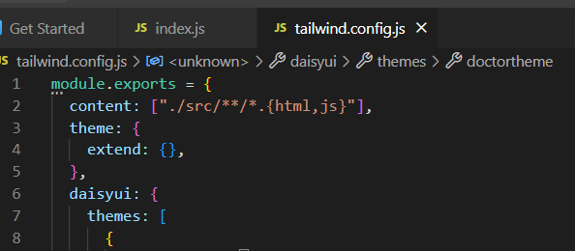

Then go to index.css file and paste the below

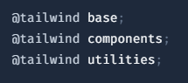 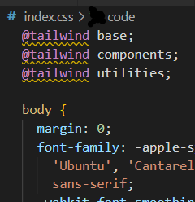

Next

Need to install npm i daisyui

Then

