#### 72-2 Create Appointment Banner using React Day Picker

#### Make google search as react day picker

#### Go to https://react-day-picker.js.org/

#### npm install react-day-picker date-fns

Need to import below

import { DayPicker } from 'react-day-picker';  
import 'react-day-picker/dist/style.css';

72-3 Lift up state to share data and Available Appointment Component

#### 72-5 Display a modal from on booking click with dynamic data

#### Replace Button(from Service component) by Label Button(from modal code)

#### 

                <button className="btn btn-sm btn-secondary text-white uppercase bg-gradient-to-r from-secondary to-primary">Book Appoinment</button>

#### 

#### For close modal set below code

#### 

const express = require('express')

const app = express()

const port = 3000

<https://expressjs.com/>

then Getting started , get below code

app.get('/', (req, res) => {

res.send('Hello World!')

})

app.listen(port, () => {

console.log(`Example app listening on port ${port}`)

})

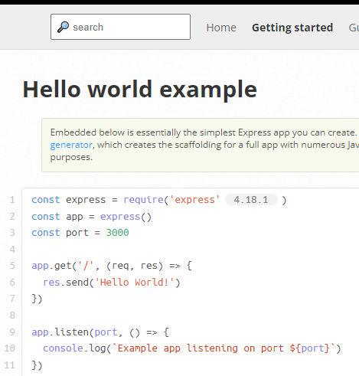

At Mongodb

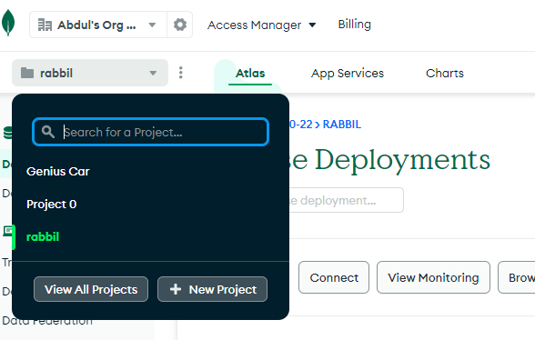

Next

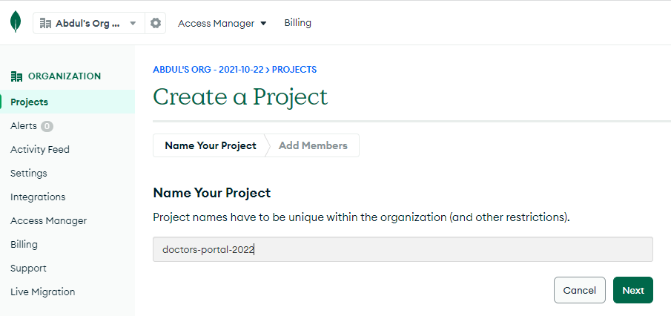

Next

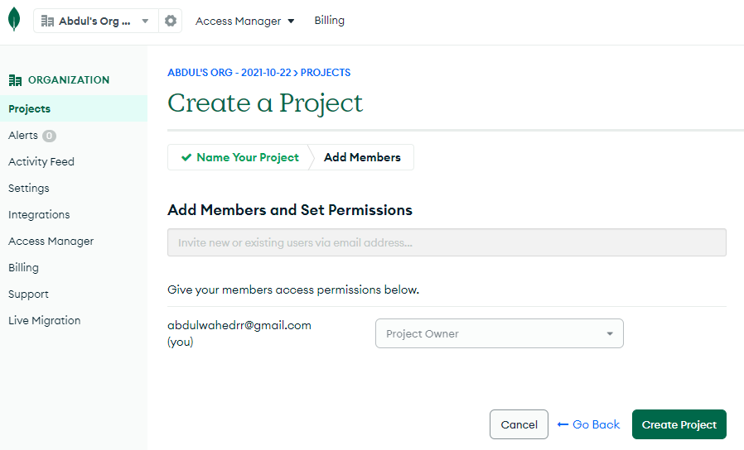

Next

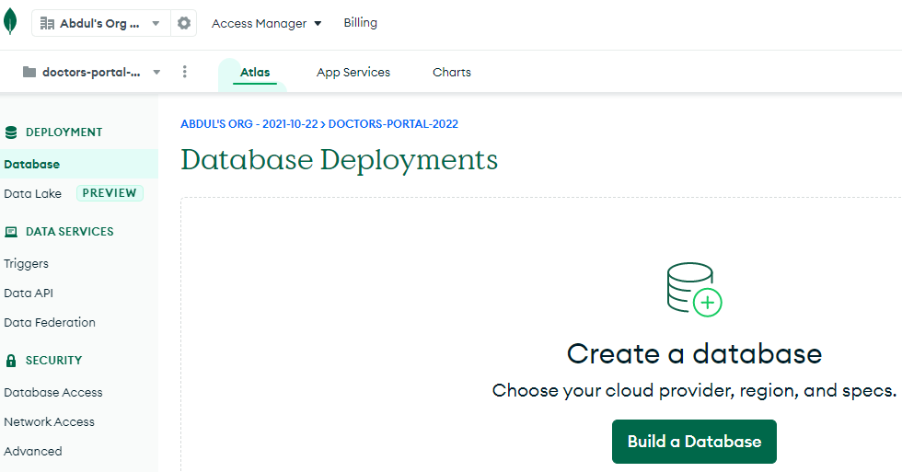

Next

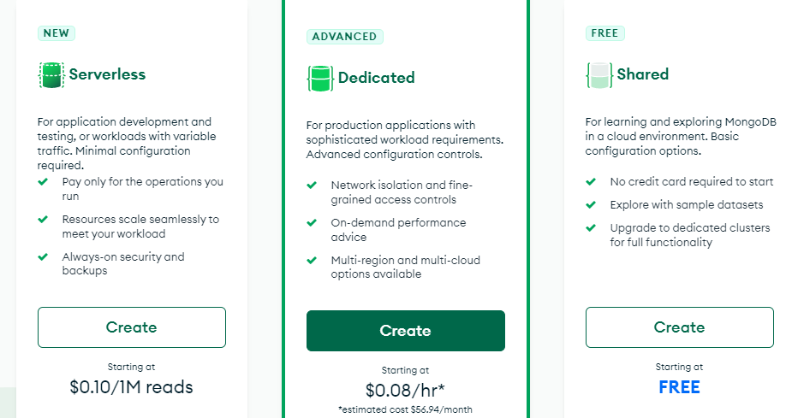

Next

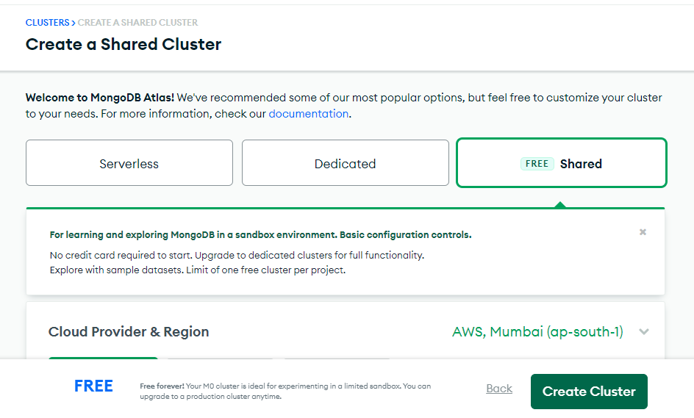

Just click on Create Cluster

Next

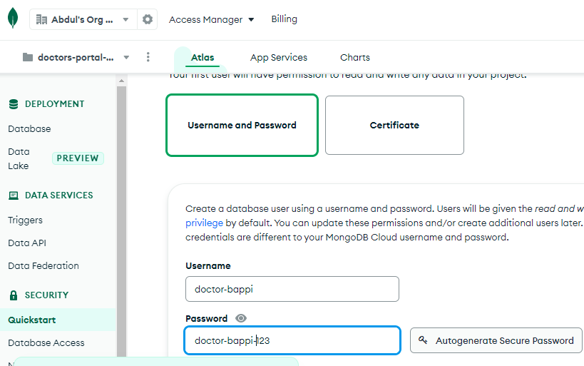

Next

Then go to Network Access

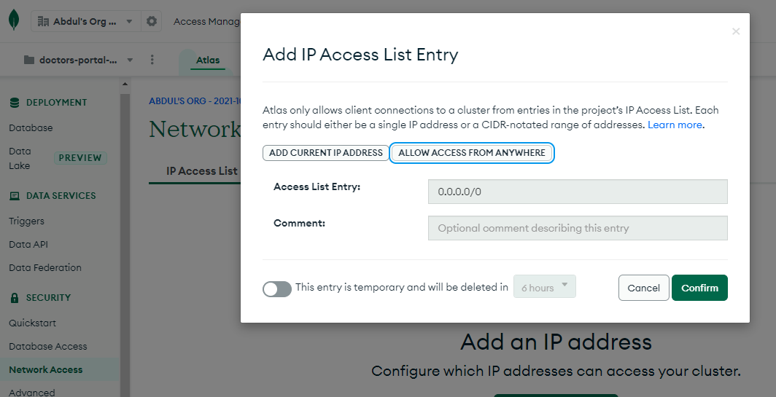

Next

Now active

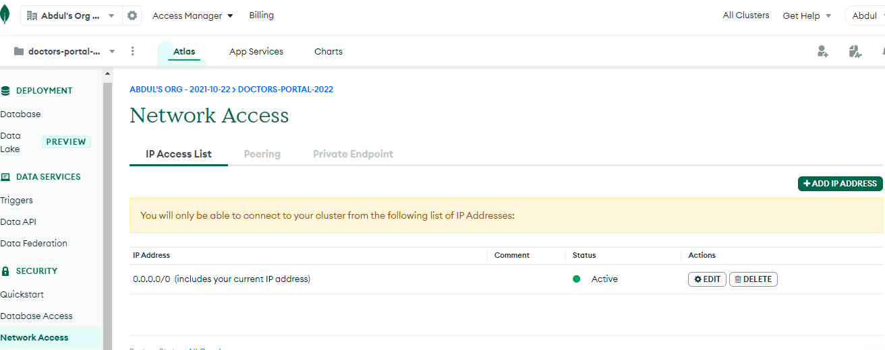

Next

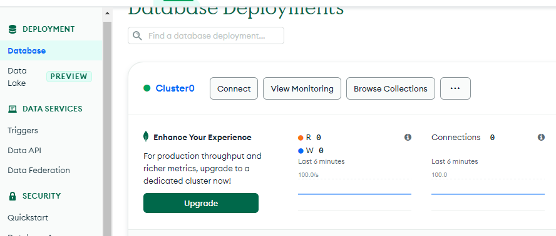

Next

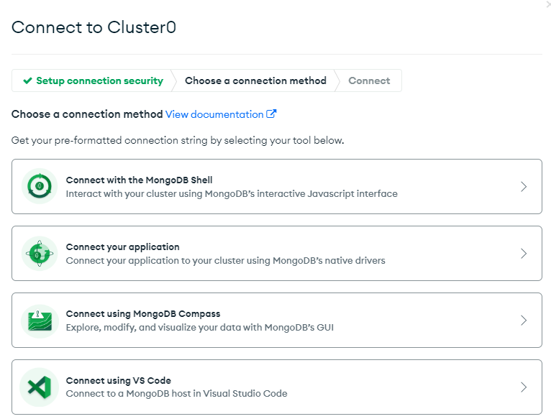

Next

mongodb+srv://doctor-bappi:<password>@cluster0.kyko0wj.mongodb.net/?retryWrites=true&w=majority

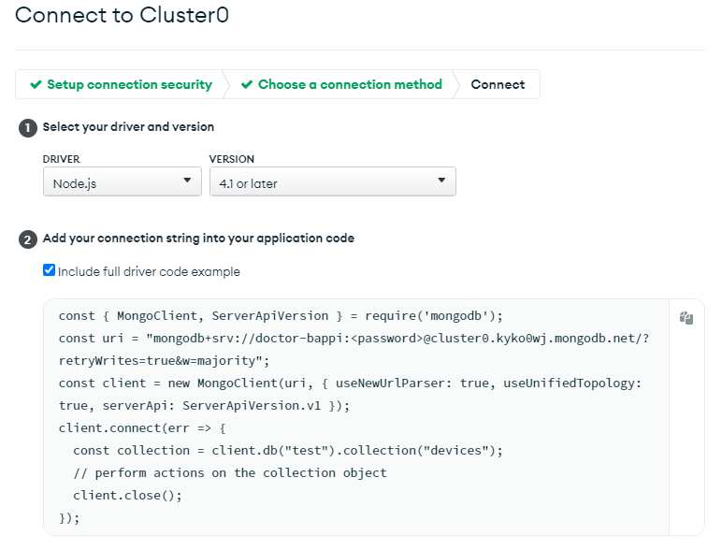

Or below code

const { MongoClient, ServerApiVersion } = require('mongodb');

const uri = "mongodb+srv://doctor-bappi:<password>@cluster0.kyko0wj.mongodb.net/?retryWrites=true&w=majority";

const client = new MongoClient(uri, { useNewUrlParser: true, useUnifiedTopology: true, serverApi: ServerApiVersion.v1 });

client.connect(err => {

const collection = client.db("test").collection("devices");

// perform actions on the collection object

client.close();

});

Need to create database and collection

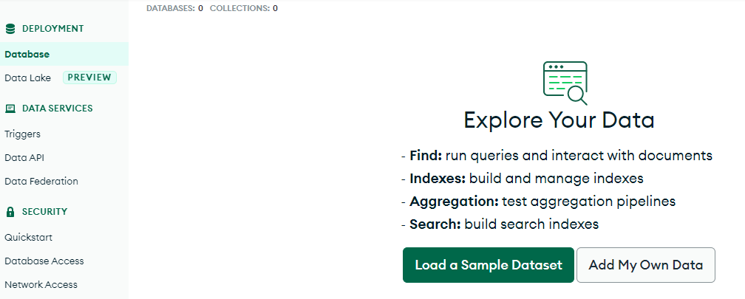

Next

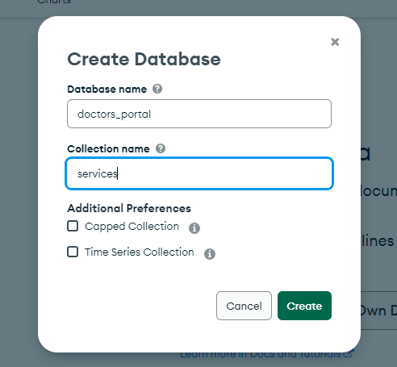

Next

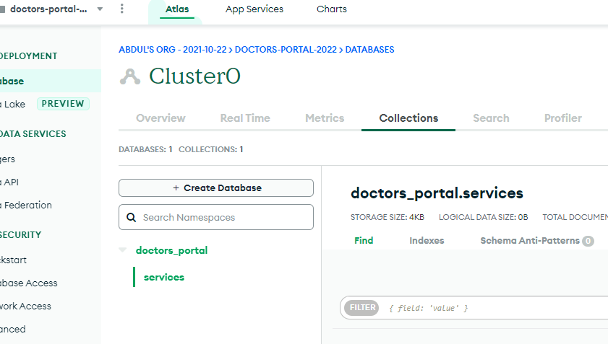

Next