MY URL: <https://cbaniekwena1.azurewebsites.net/>

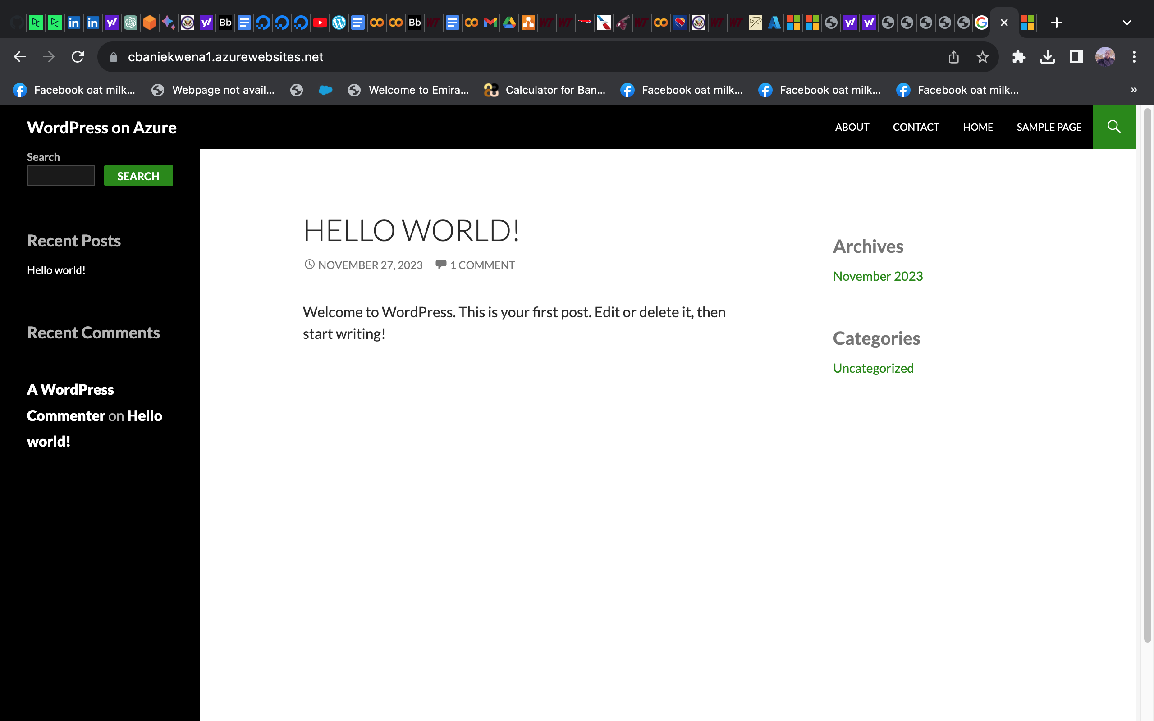

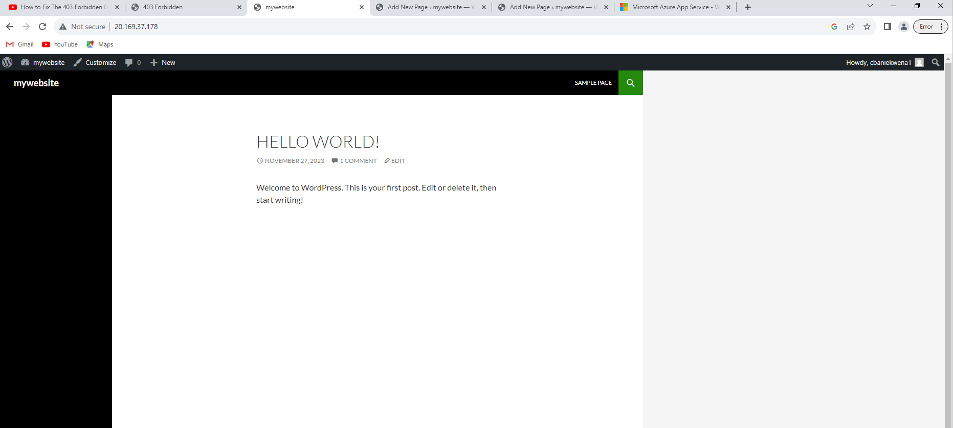

**1. What did you learn from building this website?**

Building the WordPress website at my IP address 20.169.37.178 was a valuable experience that provided insights into various aspects of web development and content management.

I was able to

* Understand the process of installing and configuring WordPress on a virtual machine.
* **Theme and Plugin Management:** Learnt how to choose and customize themes, as well as select and manage plugins..
* Configure and manage the MySQL database that WordPress uses to store content, settings, and user information.
* Explore the WordPress dashboard to create and manage pages and posts.
* Set up and configure server settings, including firewall rules, to ensure proper access to the website.

**2. How I enhanced the security of my website?**

Ensuring the security of the WordPress website at 20.169.37.178 was a top priority. Several measures were implemented to enhance security:

* **Firewall Configuration:** Utilized a firewall (e.g., UFW) to control incoming and outgoing traffic, allowing only necessary connections such as SSH, HTTP, and HTTPS.
* **Regular Updates:** Kept the WordPress core, themes, and plugins up to date to patch vulnerabilities and improve security.
* **Strong Authentication:** Enforced strong and unique passwords for WordPress accounts, including admin accounts, to prevent unauthorized access.
* **Backup Strategy:** Implemented a regular backup strategy to safeguard against data loss, ensuring that critical content and configurations can be restored in case of an incident.
* **Limited Access:** Restricted access to sensitive server configurations, ensuring that only necessary ports were open and that unnecessary services were disabled.
* **Monitoring and Logging:** Set up monitoring tools and reviewed server logs to detect and respond to any unusual activities or security threats.
* **Removed Unnecessary Services:** Eliminated unnecessary services and applications that could potentially introduce security risks.
* **Secure Configuration Files:** Ensured that configuration files, such as **wp-config.php**, were properly configured with secure settings and proper permissions.