Sort analysis of merge, quick, comb, shell, and heap.
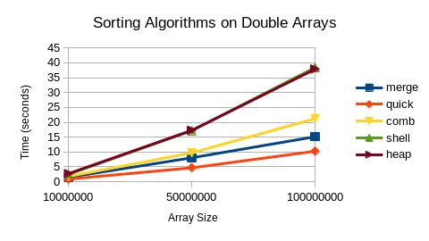
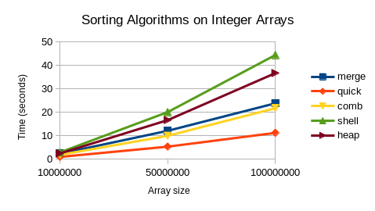
In the above graphs, We see that the integer and doubles have a fairly similar timing scheme. This is believable since these sorts are sorting based on comparisons. This subset of sorting algorithms are the most optimized sorts that contain comparisons. The change in data type should be fairly irrelevant in this case since we are making no assumptions based on the fact that they are decimals or that they are integers. This family of sorting algorithms should be bounded as average case Ω(nlog(n)) since the quickest of these sorts is quick sort which is Average case Ω(nlog(n)).

Radix Sort Analysis
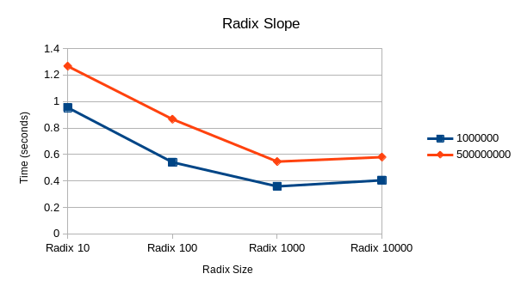
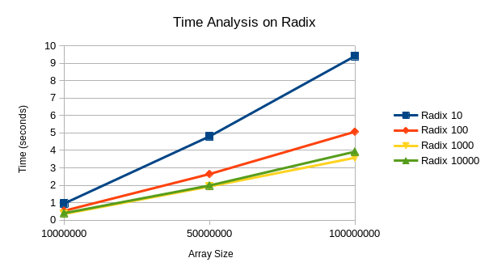
The Radix sort is one of a subset of sorts that sort without comparison. This causes it to be much faster than the sorts we saw in the previous analysis. When comparing to the last analysis, these sorts are much faster, showing just how different the speed is when comparison isn’t involved. The first graph shows us that the radix 10 has a linear timing so its most likely Ω(nk) which would make sense as the chosen radix value. As the radix values get larger the timing seems to go faster and faster. However, The radix of 10000 seems to appear slower than radix 1000 after the array size starts to increase. In the graph on the right, we decided to graph the radix values on their own graph to show how we have found a minimum at 1000. It seems that no matter the array size, we should end up with these radix values being the best range for the radix.

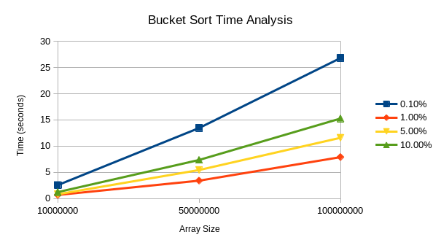
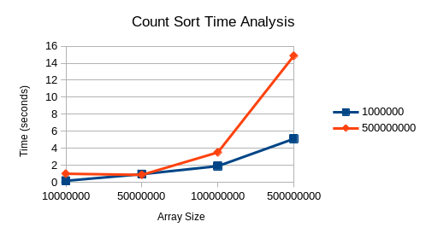
Count Sort:
The count sort is much faster than the sorts that we timed in the first analysis. This shows that they are much faster than Ω(nlogn).
Count sort seemed to perform better with larger frequencies of the same value since it would have to go through less of the second array that is filled with counts. The larger the range of random numbers the lower the frequency and since there is more variance in the values it will be much slower. In conclusion, The count sort is optimized when the array contains higher frequencies of each value.

Bucket Sort:
The bucket sort when the constant fastest bucket size is used will result in a much faster algorithm than the sorts in the first analysis.
The bucket sort was interesting to analyze since the best performance with different bucket sizes was 1 % of the array size. Any other values were getting slower and slower. This conclusion makes sense since either way the algorithm must work harder. For instance, when the bucket sizes are large then this becomes just sorting an array with insertion sort. When the sizes are small, The algorithm must also sort using insertion sort, a great deal of times.

