Cole Barbes
Question 3.
The ciphertext is almost impossible to tell which one is smaller. This makes cracking the RSA extremely tough.
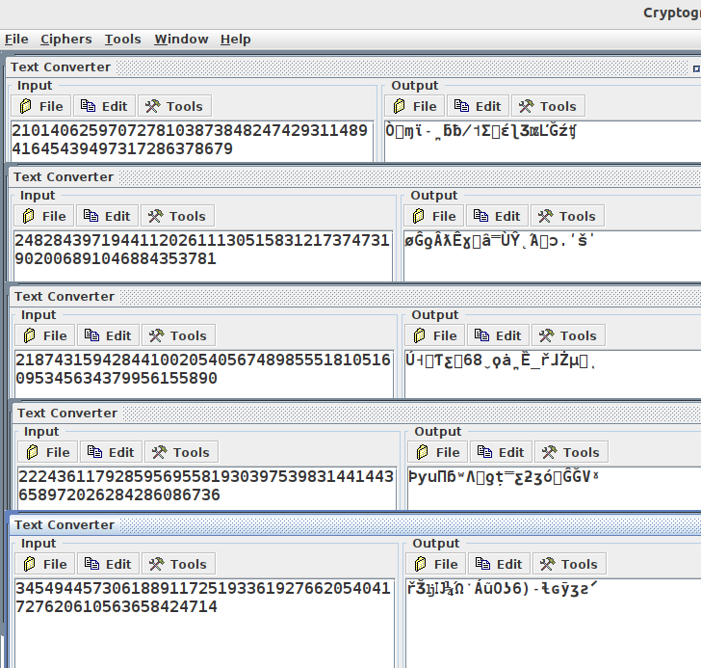

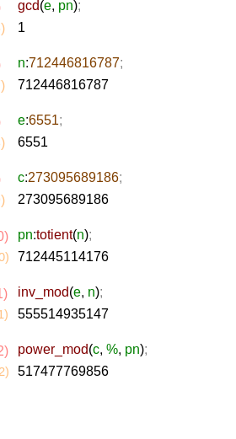
Question 1:

