1. Let E be the elliptic curve y^2 = x^3 + 2x+3(mod 19)
a)
Find the sum (1, 5) + (9, 3)
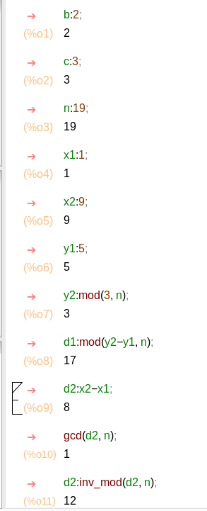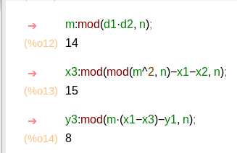

b)
find the sum (9, 3) + (9, -3)

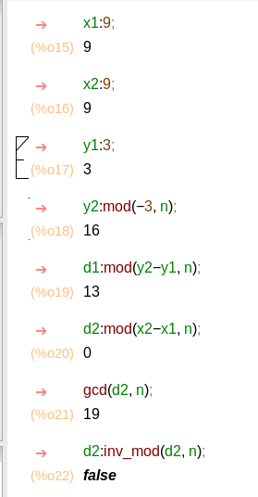
Since the points are directly above each other, The sum is infinity

c)
using the fact that (9, 3) + (9, -3) is infinity
Find (1, 5) – (9, 3)

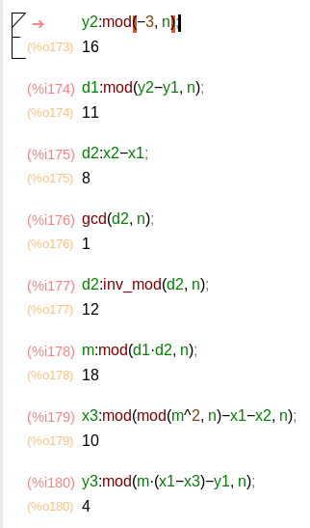

d)
as we can see at 20 we hit infinity and cycle back to (1, 5) so we now have the number of distinct multiples including infinity

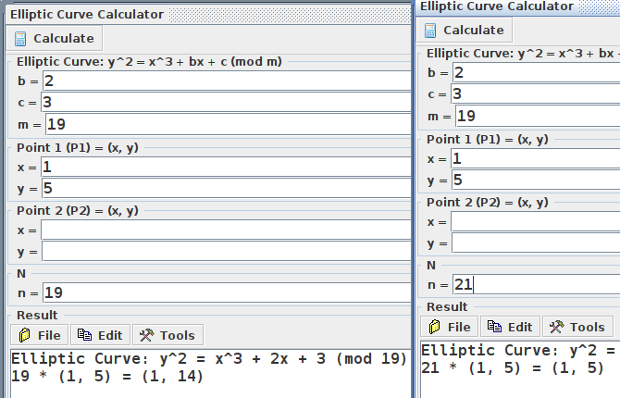

e)

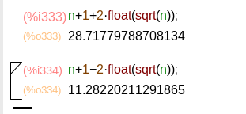

11 <= 20 <= 28
20-19-1 < 28

4)

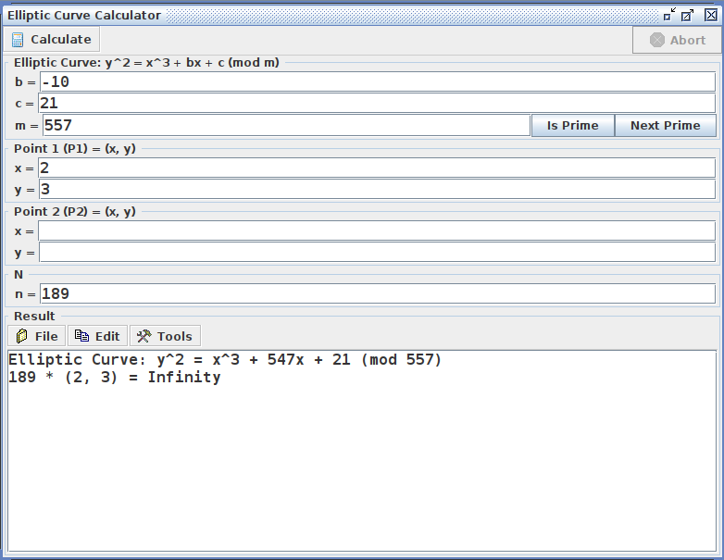

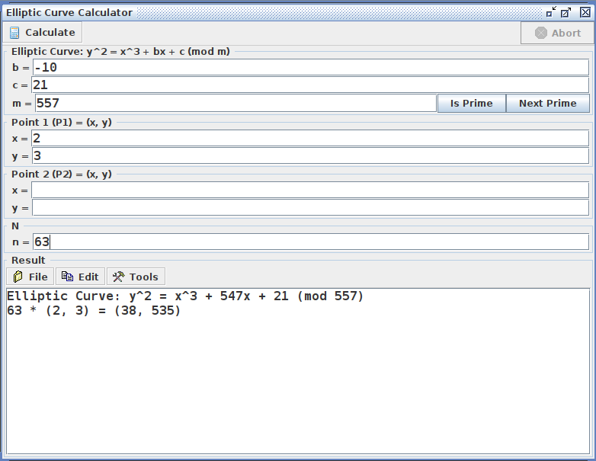

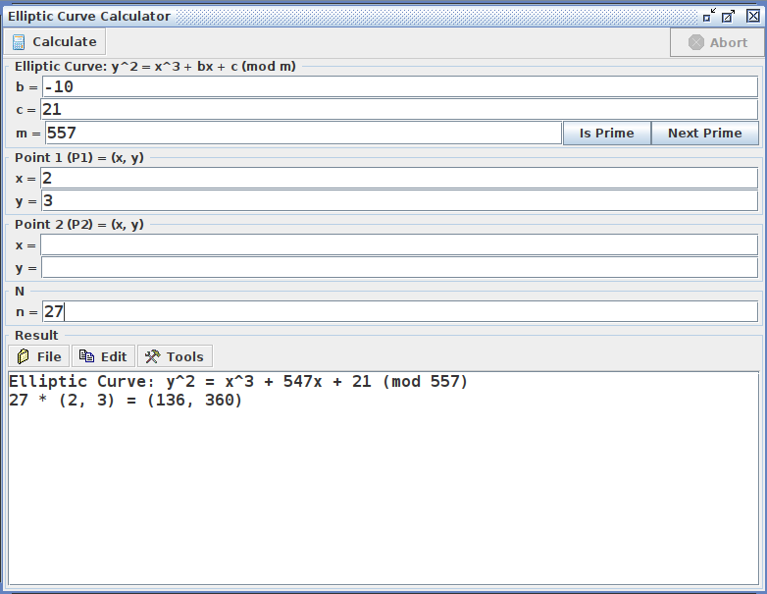

5)
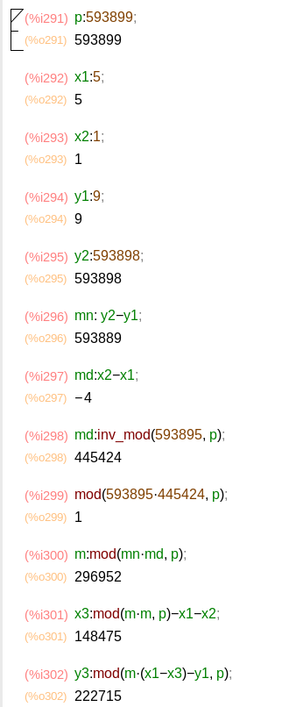

2) represent 12345 as a ciphertext so 12345_ and output was (123453, 65243 )
y^2 = x^3 + 7x + 11 (mod 593899)

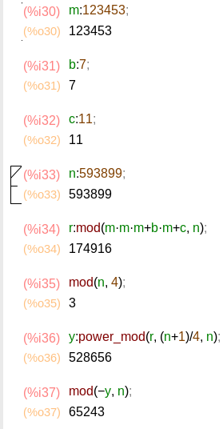

3)

4)

