Incidence Prevalence Report

DARWIN



This is an automated report with incidence and prevalence results for the study “Incidence Prevalence Report”.

# Here is a table with the results for prevalence.

| time | numerator | denominator | prev |
| --- | --- | --- | --- |
| 2008 | 0 | 542 | 0.0000000 |
| 2009 | 5 | 549 | 0.0091075 |
| 2010 | 4 | 632 | 0.0063291 |
| 2011 | 1 | 564 | 0.0017730 |
| 2012 | 0 | 557 | 0.0000000 |

# Here is a table showing the results for prevalence.

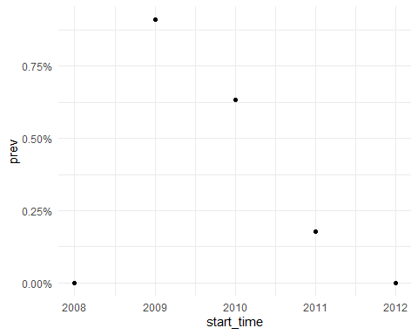

# Here is a table with the results for incidence.

| time | n_persons | person_days | n_events | person_years | ir_100000_pys |
| --- | --- | --- | --- | --- | --- |
| 2008 | 1159 | 181969 | 126 | 498.2040 | 25290.85 |
| 2009 | 1227 | 189304 | 149 | 518.2861 | 28748.60 |
| 2010 | 1174 | 185702 | 146 | 508.4244 | 28716.17 |
| 2011 | 1152 | 181749 | 116 | 497.6016 | 23311.82 |

# Here is a graph showing the results for incidence.

