I tested transferability errors for Vanadium with 2 KB boxes to search for minima in the function Er_stat = f(box1_height,box2_height), where Er_stat is either the eigenvalue errors, the norm errors, or the sum of the two, for a single test_configuration. The +2 ion was used as the reference configuration, and the neutrol atom was used as the test configuration for calculating Er_stat. I set the bounds of the inner box as 0.01 to 0.75 au, and the bounds of the outer box as 0.75 to 1.5 au.
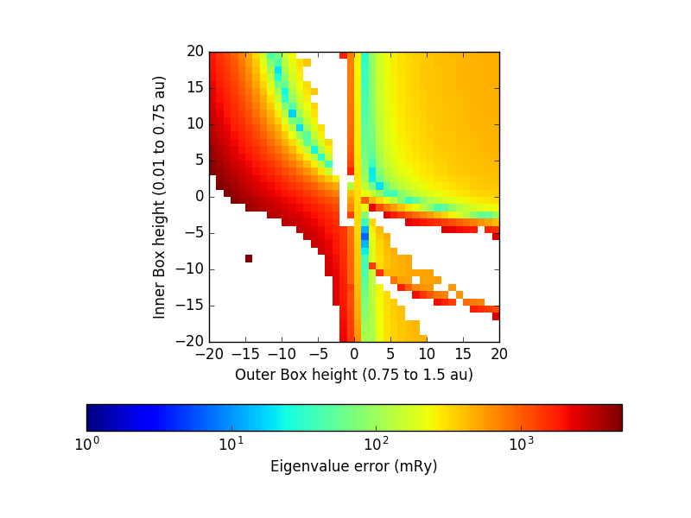
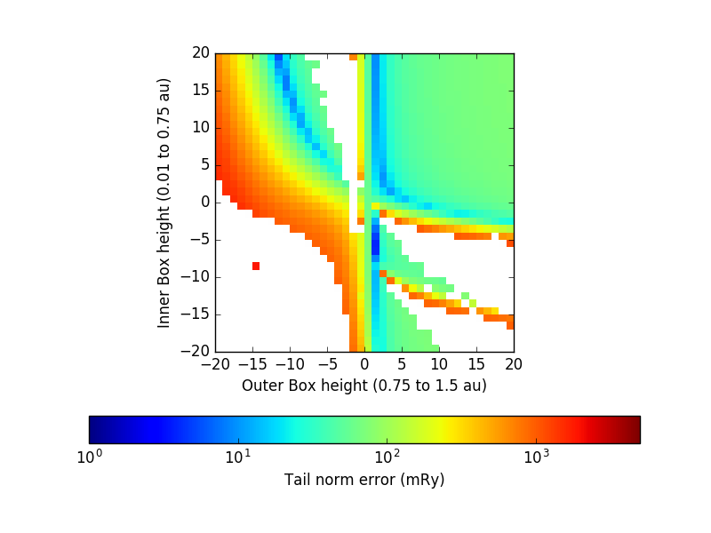
I tested every combination of KB box heights from -20 to 20, in increments of 0.5. I then did higher-resolution tests on the regions surrounding the local minima found in the first test. Here are graphs of the results:
Note: the white areas are KB box settings for which there was an OPIUM error and no .rpt file was produced.

The similarity between these graphs suggests that regions with low eigenvalue errors tend to also have low tail norm errors, so that minimizing the sum of eigenvalue and norm errors should produce similar results as minimizing one or the other individually (i.e. there is not a large trade-off between eigenvalue error and norm error).

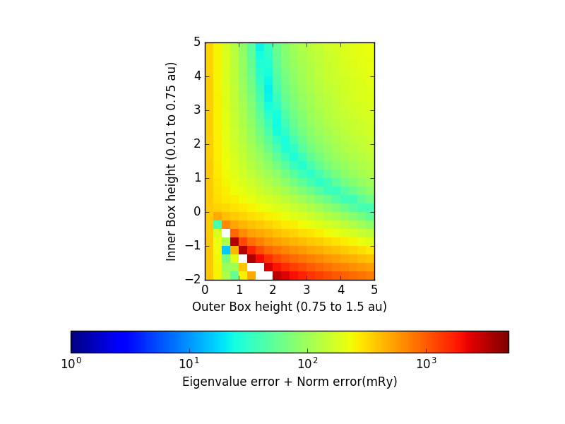
Here are higher resolution graphs of the local minima above:
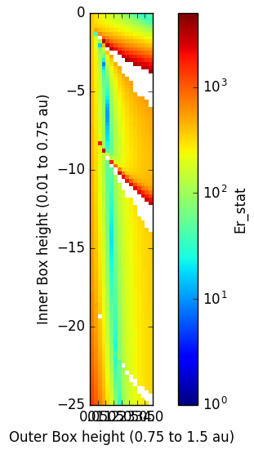
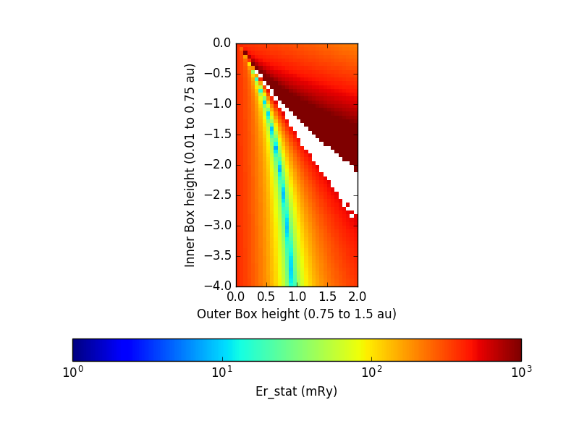

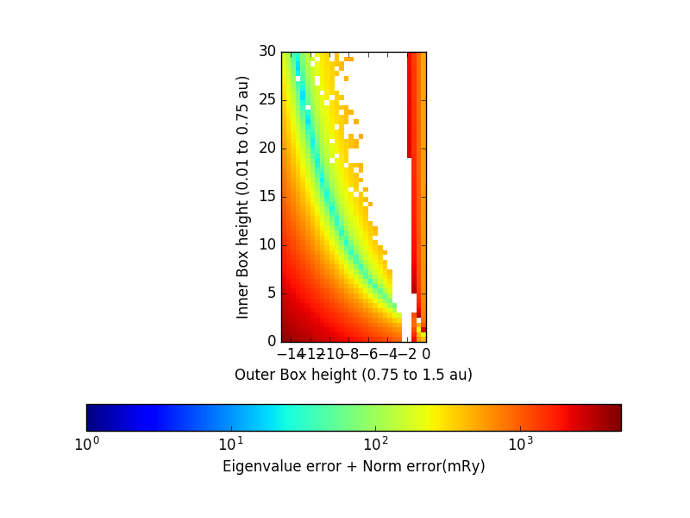
0 1 2 3 4

