The Bioinformatic Detective
Identification & characterisation of unknown protein “sequence B”
Identity: TEM-1 β-lactamase (UniProt P62593, Escherichia coli)
Bioinformatics Minor — 2025–2026

Contents

Executive summary
Unknown sequence B is the TEM-1 β-lactamase of Escherichia coli (UniProt P62593, gene bla/blaTEM-1; EC 3.5.2.6). The 286-residue query matches the reviewed Swiss-Prot entry exactly (100 % identity, full coverage), and carries the three diagnostic sequence signatures of Ambler class A serine β-lactamases: the S-x-x-K nucleophile elbow, the SDN loop, and the K-[S/T]-G triad.
Functionally, the enzyme hydrolyses the β-lactam ring of penicillins and early cephalosporins, conferring antibiotic resistance. It is the most widespread plasmid-mediated β-lactamase in Gram-negative bacteria and the ancestral scaffold from which many extended-spectrum β-lactamases (ESBLs) and inhibitor-resistant variants have evolved by point mutation — making it a textbook case in the biology of antimicrobial resistance (AMR).

1. Sequence similarity search (BLAST)
Method. BLASTp of sequence B against the NCBI non-redundant protein database (nr), BLOSUM62, default gap penalties. Note: the table below states the expected top hits and the identity that diagnoses the protein. Record the exact E-value and query coverage produced by your own run in the empty column — these are run-/database-version specific.
Top hit (protein / gene) | Organism | % identity | E-value / coverage (your run)
TEM-1 β-lactamase / blaTEM-1 | Escherichia coli | 100 % | _____ / _____
TEM-type β-lactamase (variants) | Klebsiella, Salmonella, Shigella, Enterobacter… | ≈100 % | _____ / _____
TEM-2 / ESBL TEM variants | Enterobacterales | 99–100 % | _____ / _____
SHV-1 β-lactamase | Klebsiella pneumoniae | ≈65 % | _____ / _____
Do the top hits come from the same organism? No. Near-identical hits appear across many different Gram-negative genera (E. coli, Klebsiella, Salmonella, Shigella…). Interpretation: blaTEM is a mobile gene — carried on plasmids and the Tn3 transposon and disseminated by horizontal gene transfer rather than vertical inheritance. The fact that the protein stays almost invariant across hosts reflects strong selection by β-lactam antibiotics: the sequence is highly conserved because its catalytic machinery cannot drift without losing the resistance phenotype.

2. Gene & protein characterisation

2.1 Gene
Field | Value
Gene name | bla (blaTEM-1); synonyms blaT-3..blaT-6
Organism / taxid | Escherichia coli — NCBI taxid 562
Genomic location | Plasmid-borne; embedded in transposon Tn3; classic marker on cloning vector pBR322
Gene type | Protein-coding; antibiotic-resistance (AMR) gene
Promoters | Weak P3 (Tn3); strong overlapping Pa/Pb after a C32T change → ~10× higher expression
Biological relevance | Confers resistance to penicillins & early cephalosporins; parent of TEM-type ESBLs and inhibitor-resistant (IRT) variants

2.2 Protein (reviewed entry: UniProt P62593, Swiss-Prot)
Property | Value
Protein name | Beta-lactamase TEM (TEM-1); penicillinase
EC number | 3.5.2.6
Length | 286 aa (precursor) — mature enzyme ≈263 aa after signal-peptide cleavage
Molecular weight | 31 514.9 Da (≈31.5 kDa)
Theoretical pI | ≈5.7 (computed) / 5.9 (DrugBank)
Signal peptide | Residues 1–23 (MSIQHFR…PVFA) — cleaved during Sec export
Subcellular localisation | Periplasm (Gram-negative)
Fold / domain | Single class A β-lactamase / transpeptidase domain (mixed α + α/β)
Function | Hydrolyses the β-lactam amide bond → inactivates the antibiotic

2.3 Catalytic / functional residues (Ambler numbering)
- Ser70 — nucleophilic serine of the S-x-x-K motif; attacks the β-lactam carbonyl to form the acyl-enzyme.
- Lys73 — general base partner of Ser70 in the same S-x-x-K motif.
- Ser130–Asp131–Asn132 (SDN loop) — positions the substrate and shuttles protons.
- Glu166 — Ω-loop residue that activates the deacylating water (hydrolysis step).
- Lys234–[Ser/Thr]–Gly236 (K-[S/T]-G triad) — anchors the substrate carboxylate in the oxyanion pocket.

3. Literature search
Searching blaTEM / “TEM-1 β-lactamase” in PubMed returns thousands of studies — the gene is one of the most heavily studied resistance determinants, spanning enzymology, structural biology, clinical epidemiology and AMR surveillance.
Selected key paper. Sutcliffe (1978), PNAS — “Nucleotide sequence of the ampicillin resistance gene of E. coli plasmid pBR322.”
Why it matters: this paper established the reference blaTEM-1 sequence still used today and characterised it within pBR322 — a founding cloning vector whose ampicillin-resistance selection marker is the blaTEM-1 gene. The work therefore sits at the intersection of clinical AMR and the birth of recombinant-DNA technology.

4. Homolog collection
Five class A β-lactamases from different taxa were assembled into a single multi-FASTA file (homologs.fasta), including the query. The set spans the three dominant Gram-negative families (TEM, SHV, CTX-M) plus a Gram-positive outgroup to root the tree.
Label | Enzyme | Organism | Accession
TEM-1 (QUERY) | TEM-1 β-lactamase | E. coli | P62593
SHV-1 | SHV-1 β-lactamase | K. pneumoniae | P0AD64
SHV-2 | SHV-2 (ESBL) | K. pneumoniae | P0A9Z7
CTX-M-15 | CTX-M-15 (ESBL) | E. coli | H6UQH2
BlaZ/PC1 (outgroup) | BlaZ penicillinase | S. aureus (Gram+) | blaZ

5. Multiple sequence alignment (MSA)
Method. MSA built with FAMSA; 293 alignment columns, 5 sequences. 48 columns are fully conserved (identical residue, no gaps) across all five enzymes — concentrated in the catalytic core, exactly as expected for a functionally constrained enzyme family.
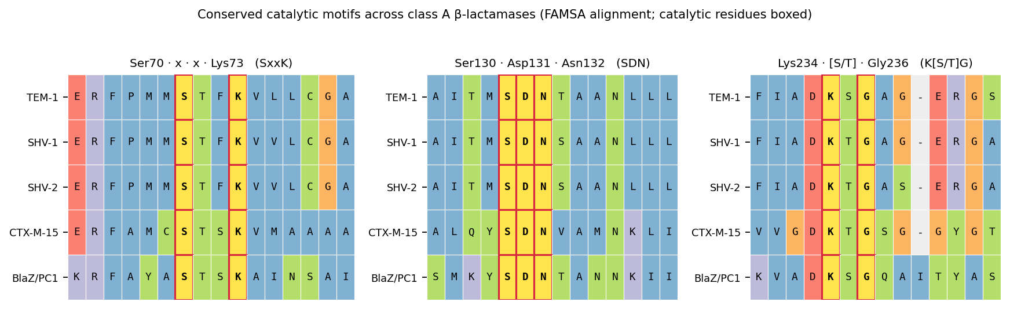
Figure 1. The three catalytic motifs in the FAMSA alignment. Catalytic residues (boxed) are invariant across all five enzymes; only neutral neighbours vary.
Conserved regions / catalytic residues. The nucleophile Ser70 and Lys73 (S-x-x-K), the SDN loop (Ser130-Asp131-Asn132) and the Lys234 … Gly236 triad are conserved in every sequence. The middle triad residue toggles between Ser (TEM-1, BlaZ) and Thr (SHV, CTX-M) — a neutral substitution that does not affect catalysis.
Variable regions. Sequence divergence is confined to surface loops and the N-terminal signal peptide — regions under no catalytic constraint. This conserved-core / variable-surface pattern is the structural signature of an ancient, functionally essential enzyme scaffold.

6. Phylogenetic tree
Method. Neighbour-joining tree from BLOSUM62 pairwise distances on the FAMSA alignment, rooted on the Gram-positive BlaZ outgroup.
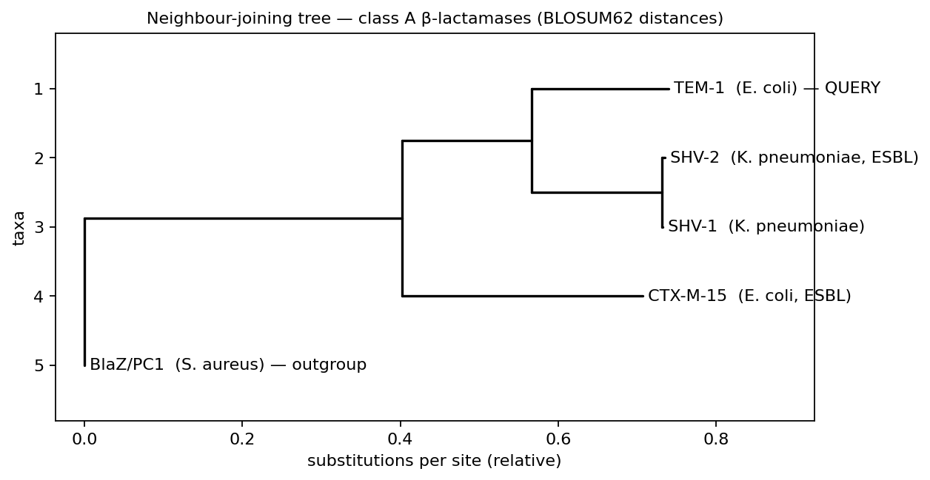
Figure 2. Neighbour-joining tree of the five class A β-lactamases.

6.1 Interpretation
- SHV-1 and SHV-2 cluster almost on top of each other (distance ≈ 0.004). They differ by a single residue — the G→S substitution at the K-[S/T]-G+2 position that converts the narrow-spectrum SHV-1 into the extended-spectrum ESBL SHV-2. A one-amino-acid change with a major clinical phenotype.
- TEM-1 groups with the SHV clade (both Enterobacteriaceae, distance ≈ 0.34), while CTX-M-15 sits on its own branch (≈ 0.63–0.65) — consistent with CTX-M enzymes having a distinct evolutionary origin (mobilised from Kluyvera chromosomal genes).
- BlaZ/PC1 (S. aureus) is the most distant (≈ 0.71–0.74) and roots the tree — the Gram-positive enzyme separates cleanly from the Gram-negative clade.
Consistent with taxonomy and function? Both. Clustering follows taxonomy (Gram-positive outgroup vs Enterobacterales clade) and function (all five share the invariant class A catalytic core). The within-family micro-distances (SHV-1 vs SHV-2) also map neatly onto resistance phenotype.

7. Galaxy workflow
A reproducible Galaxy workflow chaining the three analyses is described in the companion file galaxy_workflow.md. Pipeline outline:
- Input: multi-FASTA of homologs (Get Data → Upload File).
- Step 1 — BLAST: NCBI BLAST+ blastp of the query vs nr / a protein DB → tabular hits.
- Step 2 — MSA: MUSCLE or MAFFT on the homolog set → FASTA alignment.
- Step 3 — Tree: FastTree (or IQ-TREE) on the alignment → Newick tree, then visualise.

8. Biological, medical & clinical significance
TEM-1 is the single most prevalent plasmid-mediated β-lactamase in Gram-negative bacteria. Clinically it drives resistance to aminopenicillins (ampicillin, amoxicillin) and early cephalosporins. Its real danger is evolvability: a handful of point mutations turn TEM-1 into extended-spectrum β-lactamases (TEM-3, TEM-10…) that defeat third-generation cephalosporins, or into inhibitor-resistant variants (IRT) that survive clavulanate. The SHV-1→SHV-2 pair in this very dataset — separated by one residue — illustrates exactly how a small genetic step yields a large resistance gain.
Because blaTEM is plasmid- and transposon-borne, it spreads readily across species (as the BLAST result showed), making it a central player in the global AMR crisis and a standard model system for studying β-lactamase mechanism, inhibitor design, and resistance evolution.

Appendix — reproducibility
- homologs.fasta — query + 4 homologs (multi-FASTA).
- alignment.fasta / alignment.clustal — FAMSA MSA (293 columns).
- tree.nwk — Newick tree; tree.png, msa_motifs.png — figures.
- galaxy_workflow.md — step-by-step Galaxy build notes.

Sutcliffe JG. Nucleotide sequence of the ampicillin resistance gene of Escherichia coli plasmid pBR322. PNAS 1978;75(8):3737-41.

