CJ Barreiro

# CJ Barreiro

Hi, I'm CJ! I'm a sophomore Computer Science student at Virginia tech with a Music minor. I love Country Music and play the guitar. I also like to play video games, and I'm a huge Star Wars fan.

Go



## CHOCOLATE MOUSSE

20 mins

This delicious chocolate mousse will delight dinner guests of all ages!

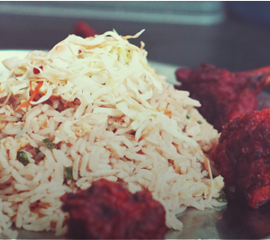

## SMOKED LAMB WITH RICE

120 mins

Want to feel like your favorite relative came over and made you dinner? This comfort meal of smoked lamb and rice will quickly become a weekend favorite!

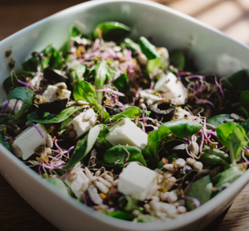

## GOAT CHEESE SALAD

25 mins

In addition to the full flavor of goat cheese, this salad includes kale, avocado, and farro to balance it out.

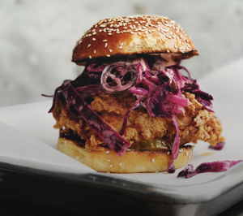

## CHICKEN SANDWICH

45 mins

We've packed a lot into this one - shredded cabbage, carmalized onions, deep-fried chicken, chipotle mayo, half-sour pickles, and a toasted sesame bun will leave you thoroughly satisfied!



## SWEET CHURROS

90 mins

Making this classic summer treat at home will remind you of a childhood spent in the park.

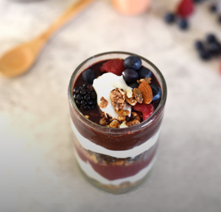

## BERRY PARFAIT

10 mins

This low-calorie, vitamin-packed parfait is great for breakfast, dessert, or post-workout!



## SWEET CHURROS

90 mins

Making this classic summer treat at home will remind you of a childhood spent in the park.



## BERRY PARFAIT

10 mins

This low-calorie, vitamin-packed parfait is great for breakfast, dessert, or post-workout!