Steroid OpenFlow Service (SOS): A Transparent Network Performance Enhancement Service
Aaron Rosen and Kuang-Ching Wang
Clemson University
{arosen, kwang}@clemson.edu

Proposed Experiment
State-of-the-art high performance computing (HPC) relies on a capable network infrastructure to transport large amounts of consumed and produced data among computing and storage servers. Today, this is achieved with very high bandwidth networks inside carefully engineered data centers. Moving data across geographically separated sites remains a challenging task due to a myriad of protocol and policy issues; as a result, HPC is by far a mostly “stationary” service.
However, this has to change soon to cope with a number of emerging trends: 1) data center operators demand increasingly higher “mobility” of computing resources for resiliency and cost efficiency, 2) mobile devices increasingly rely on cloud services, offloading computation to the cloud and retrieving large data from the cloud, 3) fast growing bandwidth on wired and wireless networks alike and hence higher performance loss for end-to-end protocols (such as TCP) that are not optimized for high and dynamic bandwidth networks, 4) increasing multi-homing capabilities and multi-path routing potential. Configuring cross-site HPC today requires significant coordination among IT staffs of all involved sites; it is only to get more complicated tomorrow.
The proposed experiment is an attempt to decouple such network configuration tasks from the end users (perhaps even the IT staff). The considered approach leverages OpenFlow’s ability to reconfigure networks on the fly in software to handle different traffic types with different forwarding rules transparent to the communicating end hosts. The experiment demonstrates a service dubbed Steroid OpenFlow Service (SOS), which allows a network provider to transparently invoke advanced transport solutions inside the network to help enhance end users’ perceived performance without any changes needed on the end hosts (users and servers). For example, a user may invoke a TCP connection with a remote server to download a large data set across the country over a fast (10Gbps) but long (300ms) network. A regular TCP connection will take a long time to (or never) deliver data at near 10 Gbps throughput due to TCP’s conservative congestion control algorithm; however, a SOS-capable network operator can transparently terminate the end user and server’s TCP connections at their nearby switches (with the help of a SOS agent to be described later) and initiate a specialized high speed TCP variant (such as SCTP [1], pTCP [2], HSTCP [3], and so on.) between the two switches instead to carry the user’s data at close to capacity rate. The service not only can be used for performance enhancement (hence the “steroid” in name), it can also provide other services for purposes like anonymity (like The Onion Router service), security, and mobility, all transparent to the end users. Figure 1 shows the SOS architecture. The architecture supports not only point-to-point but also multi-point connections.

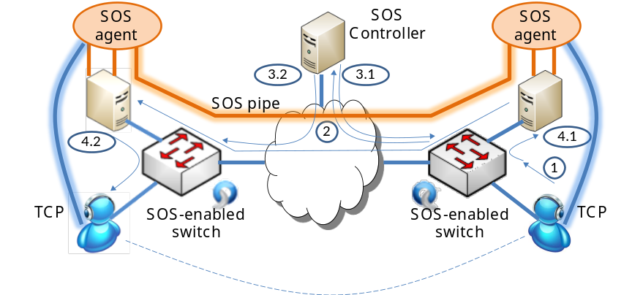
Figure 1. SOS service architecture based on an example with end users initiating a TCP connection that gets transparently replaced with a SOS pipe optimized for high rate transport.

HPC Relevance
SOS is relevant to HPC in various respects:
- Moving large data across sites.
- Cloud computing for mobile devices: As mobile devices move across IP subnets, a mobile IP like service is required (e.g., an OpenFlow implementation was shown in [4]). Simply updating the forwarding path, however, can still incur unacceptable fluctuation in end-to-end data throughput. Initiating a SOS service at an anchored SOS agent can effectively mask such effects.
- Security and anonymity: With SOS, the network operator decides the data pipe protocols among SOS agents. For example, the agents can selectively apply encryption to the forwarded data, or they can connect to an anonymous routing network such as The Onion Router (TOR).
- Enterprise IT operation: SOS eases the end users’ burden of using specialized transport protocols for HPC. Instead, the task becomes a part of infrastructure management. The SOS agents must be deployed as a middleware across the Internet next to OpenFlow-enabled switches. The intelligence of SOS lies in the SOS controllers and SOS agents, which are expected to stimulate new businesses providing software driven network optimization services.

Desired Outcome
The experiment aims at highlighting a number of key features of SOS and, at the same time, helping us understand the limiting factors for its use. Our tentative list of objectives includes the following:
- Demonstrate point-to-point and multi-point SOS operation for large data.
- Demonstrate point-to-point and multi-point SOS operation for multimedia.
- Demonstrate multi-homing/multi-path SOS operation (based on SCTP).
- Measurement of long and short running session performance across sites (e.g., Clemson-Stanford-Wisconsin-Seattle).
- Optional – Conference attendee engagement. Performance allowing, we would invite conference attendees to use either a few wired laptops and/or Wi-Fi clients to connect to the SCinet OpenFlow network to experience the SOS performance.

Experiment Setup
Figure 2 shows the high level connectivity expected for the experiment. Other than Clemson and SCinet, we tentatively expect help from the Stanford and UW-Madison OpenFlow teams for their OpenFlow resources. Each site will have at least one OpenFlow switch with two directly connected Linux hosts, and all sites are connected to the GENI core network. At each site, one host runs the SOS agent, while the other acts as the client. Additional clients can be connected at each site as desired and if available.
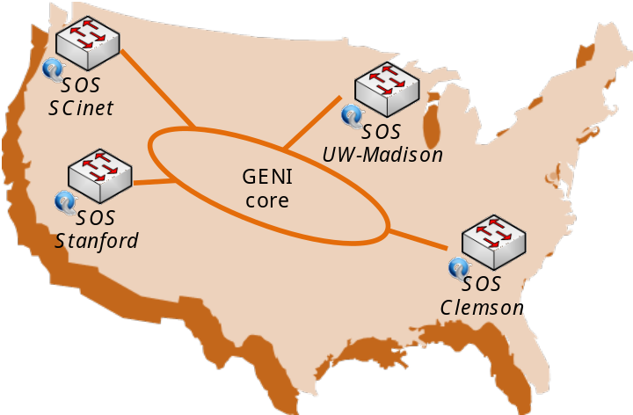
Figure 2. SOS Experiment Topology.
For the experiment, we tentatively selected and implemented Stream Transmission Control Protocol (SCTP) [1] for the SOS data pipes. Other alternatives are feasible and may be implemented for performance comparison if time permits (e.g., pTCP can be one candidate). Next to TCP and UDP, SCTP is the third transport protocol standardized by IETF. SCTP addresses TCP’s head-of-line blocking problem by initiating multiple independent logical streams inside one connection, while each stream separately observes the TCP flow control and congestion control algorithms. SCTP also supports multi-homing, allowing a connection to fall back to a secondary network interface when the first one fails. Our SOS agents will experiment with single and multi-path connections. An OpenFlow controller, dubbed SOS controller, will be implemented to transparently redirect a client connection to a local SOS agent and set up flow rules in the local OpenFlow switch to direct the SOS pipe to a remote SOS agent connected to the switch where the intended end host resides.
The SOS controller maintains information of all available SOS agents, such that when an incoming connection is detected, the controller decides the SOS agents closest to the connection’s intended end hosts. The numbers in Figure 1 illustrates the SOS service activation process:
Step 1: OpenFlow switch detects incoming TCP SYN
Step 2: OpenFlow switch forwards TCP SYN to the controller.
Step 3.1, 3.2: Controller identifies SOS agents closest to the end hosts and sets up flow rules at the switches they are connected to.
Step 4.1: Sending side SOS agent receives TCP SYN, responds with TCP ACK/SYN (spoofing intended end host’s IP address and port) to effectively terminate the TCP connection, and initiates a SCTP connection towards the remote SOS agent.
Step 4.2: The remote SOS agent accepts the SCTP connection, buffers and reorders data from multiple SCTP streams, and initiate a TCP connection (spoofing sending host’s IP address and port) towards the intended end host.

Implementation Issues
SCTP is not the fastest option for sending large data over long fat pipes. Other high speed TCP variants can easily outperform SCTP. It is only chosen to demonstrate how any transport protocol can be adopted by SOS agents to carry any incoming transport protocol in a completely transparent process.

References
[1] IETF, “Stream Transmission Control Protocol”, RFC 2960, http://www.ietf.org/rfc/rfc2960.txt, Oct. 2000.
[2] H.-Y. Hsieh and R. Sivakumar, “A Transport Layer Approach for Achieving Aggregate Bandwidths on Multi-homed Mobile Hosts,” in Proceedings of ACM MobiCom, September 2002.
[3] Sally Floyd, “High-Speed TCP (HSTCP),” http://www.icir.org/floyd/hstcp.html.
[4] Aaron Rosen, K.-C. Wang, Jim Pepin, and Dan Schmiedt, “OpenFlow in Mesh Networks”, http://groups.geni.net/geni/attachment/wiki/GEC10DemoSummary/GEC10-OFCLEM-mesh-mobility-demo.pdf, Mar. 2011.

