**Tadpoles Bulk Image Download Script**

Author: Christopher Bartholomew ([cbartholomew@gmail.com](mailto:cbartholomew@gmail.com))

Description: This script allows the parent to download multiple images and videos based on the chosen month from the Tadpoles website. I have three children with over 5 years’ worth of images and videos for each one, and so downloading 1-by-1 was not an option.

1. Open Google Chrome, and go to the “Settings” page by going to the top-left-hand-corner and selecting the “3 dots”. Then, Click on Settings.

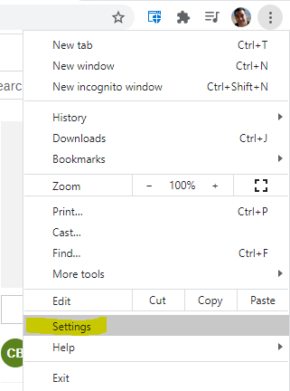

1. In the “Search” field at the top, type “Downloads”. Then, select “Location”. Here you’ll want to create a new folder (right click in the folders area, then go to “New”-> “Folder”). Your images will be stored to this folder after selecting it. ***Note: you do not have to create a new folder, but I recommend selecting a folder that’s empty because a bunch of stuff downloads. If you have another folder for photos, you can select that here instead.***

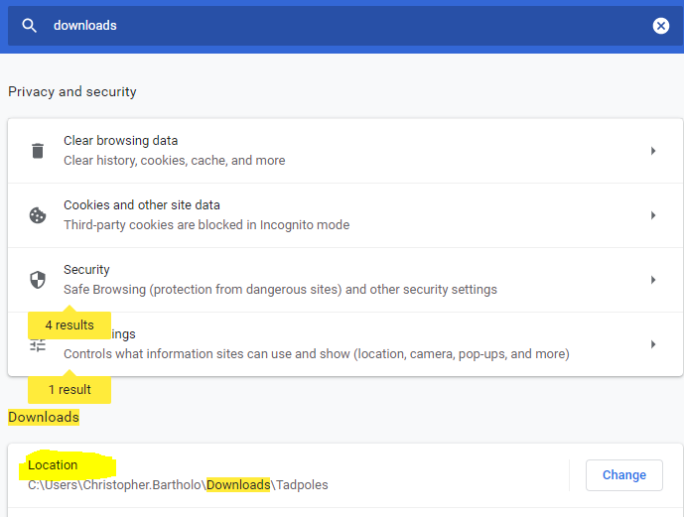

*Selecting the location in chrome.*

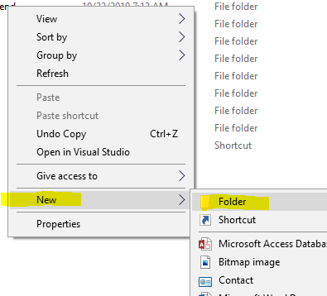

*When the dialog comes up, right click, and create new folder. Name it “tadpoles” for simplicity. For Mac users, you’ll need to click the new folder icon or save it in another location.*

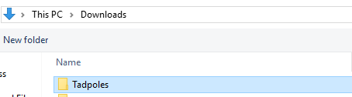

*Selecting the newly created folder.*

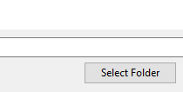

*Finish by selecting the folder and pressing the “Select Folder” button.*

1. Once a location has been set, login to <https://www.tadpoles.com/>. At the top, select your child (or “all kids”), then, select “observations” from the timeline, then finally, the month you wish to pull down. ***Remember, this script only works by running it month by month***.

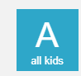 -> 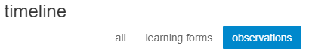-> 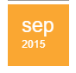

1. You’ll need to enter the “Chrome Console” to run the script. You can accomplish this by either the following ways:

* Pressing F12
* Right-Clicking anywhere on the web page, and Selecting “Inspect”
* Ctrl+shift+I (for windows users)

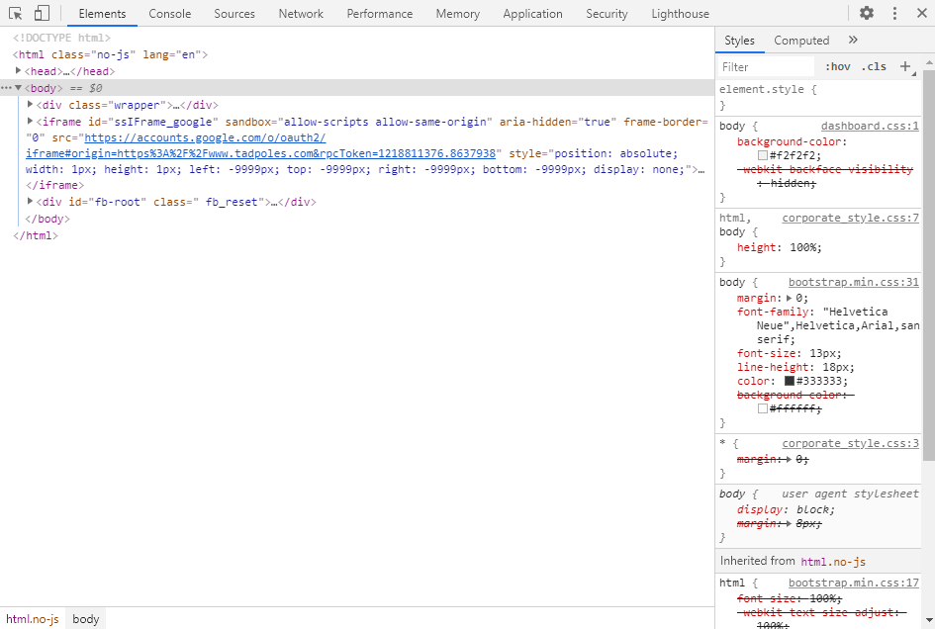

1. A window inside of the webpage should appear that looks like the above. This is the Chrome Console. Where this window is placed on the page doesn’t matter. What you’ll do is select the “Console” tab along the top bar.

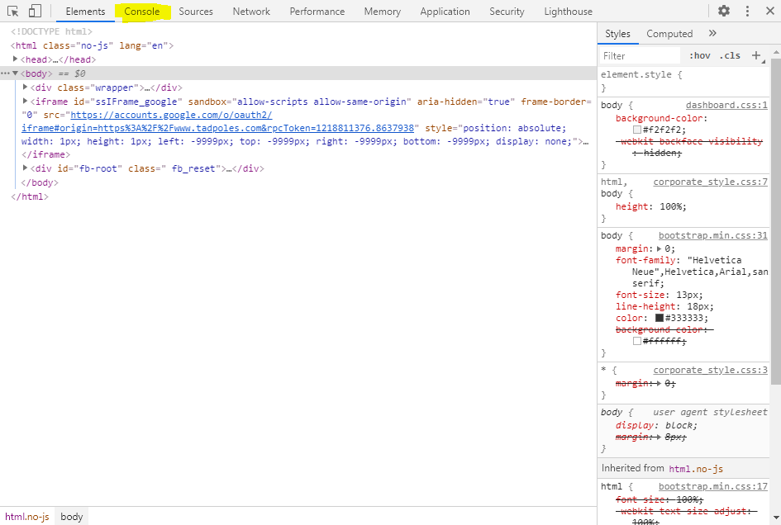

1. Inside the console, there might be some messages there, but you can ignore those. All that matters is that it there’s a “>” image there. It should look something like the following:

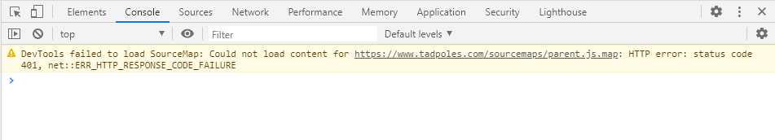

1. Next, copy all the contents of just the script from the following URL: <https://github.com/cbartholomew/tadpoles_parent_bulk_image_download/blob/master/download-all-images-script-tadpoles.js>

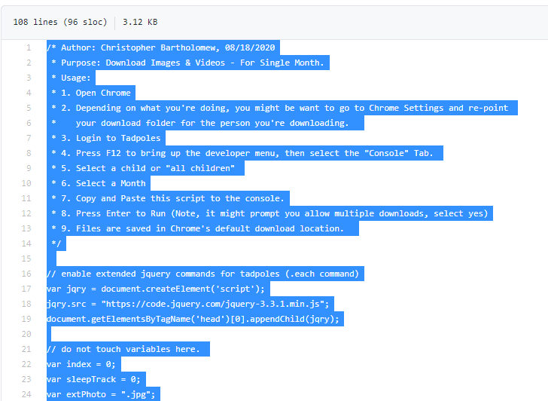

1. Then, paste the contents in the chrome console. It should look something like this when you’re completed the paste.

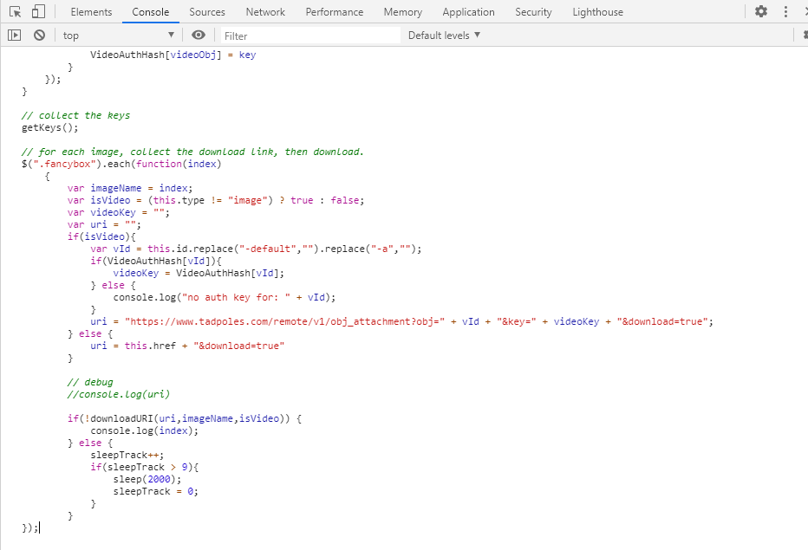

1. Finally, in the console, press “Enter” on your keyboard. This will initiate the download of the images and videos to your folder. You should start seeing them download – ***Note 1: google chrome may interject about multiple downloads through a prompt in the right-hand-corner, if it does, you should “allow” multiple downloads for this page – otherwise, the script will stop downloading.***

**Note 2: if you intend to download multiple months, all you need to do is click on the new month in the Tadpoles page, then, in the console window, press the “up arrow” on your keyboard, this will bring up the script that you’ve just ran, and then, you’d hit enter on the keyboard to re-execute it.**