LPR CPE Service Assurance Mockup
Design Specification — Audit-Hardened Streamlit, FastAPI, LangGraph, MCP and Controlled LLM Decision Assistance
DEMONSTRATION DESIGN — AUDIT-HARDENED — NOT FOR PRODUCTION USE

Document date | 16 August 2026
Revision | 1.1 — audit-hardened
Audience | LPR service assurance, field operations, solution architecture, and development teams
Technology | Docker Desktop, Streamlit, FastAPI, LangGraph, PostgreSQL, MCP, and optional LLM API
Operating scope | HFC and PON CPE incidents, Clean Boots / Dirty Boots handover, tap / ODP delimiter, jTrack MR
Source baseline | Verified repository handover at commit 0296d09, LPR workflow materials, and the 12 August 2026 specification audit
Design rule: deterministic services calculate facts and constraints; LLMs assist with evidence synthesis and recommendations; policy and named humans control consequential actions.
Prepared for LPR CPE Service Assurance
Revision 1.1 incorporates the 12 August 2026 specification audit and verified repository handover.

Contents
1 | Purpose, baseline and scope
2 | Design principles and operating roles
3 | Target architecture and component responsibilities
4 | End-to-end workflow and decision points
5 | Deterministic, LLM-assisted and human decisioning
6 | MCP and simulated LPR system contracts
7 | Streamlit user experience
8 | API, state, persistence and read model
9 | Docker Desktop deployment
10 | Security, observability and KPI design
11 | Test scenarios, acceptance criteria and future hardening
A | Appendix — schemas and interfaces
B | References

1. Purpose, baseline and scope

1.1 Purpose
This specification defines a small but structurally sound demonstration of the LPR CPE service-assurance workflow. The mockup runs on Docker Desktop, presents the workflow through a Streamlit console, exposes query and command APIs through FastAPI, persists one LangGraph thread per incident in PostgreSQL, uses deterministic services for measurable facts and constraints, and uses optional LLM calls for evidence synthesis, root-cause analysis, and best/next-best-action recommendations. Revision 1.1 adds an explicit deterministic-versus-LLM domain-agreement gate, replay-safe approval execution, bounded return loops, a parent/child SLA rule, reverse handover, live UI refresh, and a verified MCP compatibility profile. [U4]
The intended outcome is a working vertical slice that can be shown to operations and engineering stakeholders without connecting to production NXT, CPE-management, WFM, inventory, or jTrack systems. The design remains proportionate: it adds no new container beyond the original four-service footprint and does not alter the deliberately partial production parent graph.

1.2 Verified repository baseline
Verified current state The source repository is a library-only Python package. It has no HTTP server and no user interface; only D01-D06 are attached to the executable parent graph; Stage 3 and later are declared but not wired; the remote-resolution and self-help subgraphs are implemented but not attached; no LLM is called at runtime; and only simulated adapters work. [U1]

Area | Verified baseline
Repository revision | Commit 0296d09, 16 August 2026
Implemented graph | P01-P11 intake, evidence and diagnosis; D01-D06 wired
Declared frontier | Preventive maintenance, low-confidence RCA interrupt, and Stage 3 onward
Existing controls | Typed state, reducers, budget ceilings, fail-closed policy, WriteGate, RBAC models, audit and KPI events
Existing subgraphs | Remote resolution and guided self-help, both tested but unreachable from parent graph
External systems | Ten adapter families with simulation implementations only
Model involvement | No runtime LLM; deterministic detectors, decision services, policies, and named human approval gates
Quality gate | 98 source files, 24 routers, and 762 passing tests at the documented revision [U1]

1.3 Proposed mockup scope
- A separate demo graph that reuses current domain models, policies, detectors, persistence patterns, and simulated adapters without changing the deliberately partial production parent graph.
- Four Docker services: Streamlit UI, FastAPI plus LangGraph runtime, PostgreSQL, and one MCP simulation server.
- A fake deterministic model mode that runs without any API key, plus an optional configured LLM provider for RCA and action recommendations.
- Seven to nine fixture-backed scenarios showing remote repair, failed remote action followed by Clean Boots, PON ODP handover to Dirty Boots, reverse handover, common-cause correlation, deterministic/LLM domain disagreement, replay safety, and bounded escalation after repeated failure.
- Human decision points for low-confidence RCA, deterministic/LLM responsibility-domain disagreement, remote action, dispatch, tap/ODP handover, high-blast-radius action, and exceptional closure.
- A permanent DEMONSTRATION MODE banner and zero production writes.

1.4 Non-goals
- Real CommScope ServAssure NXT, ACS/USP, WFM, inventory, or jTrack integration.
- Production-grade identity federation, high availability, multi-region deployment, or enterprise disaster recovery.
- A complete implementation of all 24 existing decisions and every Stage 3-5 node.
- Autonomous scheduling, plant changes, or unrestricted model tool use.
- Replacement of the current graph builder or removal of its declared PENDING_STAGES controls.

1.5 Demonstration scenarios
ID | Scenario | Expected demonstration
S1 | HFC remote success | RCA identifies a recoverable provisioning issue; human approves; simulated reprovision succeeds; post-action verification passes; incident closes without a truck roll.
S2 | Remote failure then Clean Boots | Remote attempt is recorded, the graph returns to RCA, a Clean Boots dispatch is approved, the first visit resolves the customer-domain fault, and the same SLA clock continues.
S3 | PON ODP handover | Clean Boots proves the fault beyond the ODP, the evidence contract is reviewed, one jTrack MR is created, Dirty Boots repairs the plant, and NXT-style validation permits coordinated closure.
S4 | HFC common cause | Several CPE signals correlate to one shared resource; child cases attach to a parent incident, use the parent SLA for current breach display, and avoid duplicate customer-premises dispatches.
S5 | Failed plant action | A simulated MR action fails; attempt counters and evidence update; no duplicate MR is created; the incident returns to cross-domain RCA while budget remains.
S6 | Restart during approval | The graph pauses, containers restart, the incident resumes from PostgreSQL with the same thread ID, and no pre-approval side effect is duplicated.
S7 | PON reverse handover | Dirty Boots restores the ODP/plant path, service remains degraded in-home, and the same evidence contract returns the case to Clean Boots without a new incident or SLA reset.
S8 | RCA domain disagreement | Confidence is above threshold but deterministic and LLM responsibility domains differ; the graph still stops for a named human with gate_reason=domain_disagreement.
S9 | Replay and bounded loop | An approved action is resumed twice but produces one effect; a consumed approval is rejected; repeated failure escalates instead of looping indefinitely.

1.6 Audit disposition and applied hardening
The 12 August 2026 audit approved the architecture to build subject to the RCA disagreement and interrupt/replay controls. Revision 1.1 applies all eleven findings. Where the audit lacked repository access, the implementation is aligned to the verified handover: existing state reducers protect checkpoint replay, existing budget guards own loop ceilings, and the external-effect idempotency store remains a separate control. [U1][U4]
Audit focus | Applied update | How it is proven
RCA disagreement | A dedicated domain-agreement gate forces human review even when confidence is high. | Scenario S8 and pure-router unit tests.
Interrupt discipline | Prepare approval, request approval, and execute are separate nodes; the interrupt node contains one interrupt and no side effects. | Restart and node-replay tests.
Approval and idempotency | Every execution validates the approval, consumes it once, and returns the stored result on replay. | S9, duplicate resume, and rejection-code tests.
Bounded loops | The demo reuses existing check_budgets and policy attempt limits; a retry requires new evidence. | Failure-budget and no-new-evidence tests.
MCP compatibility | The build selects one explicit protocol profile; no silent SDK/protocol downgrade is accepted. | Startup compatibility probe and CI contract test.
Operating completeness | Parent/child SLA semantics, reverse handover, Streamlit polling, MCP healthcheck, and corrected model/tool-call architecture are specified. | S4, S7, health and UI refresh tests.

2. Design principles and operating roles

2.1 Non-negotiable design principles
Principle | Specification
One incident and one clock | The incident ID is the LangGraph thread ID. Remote actions, self-help, work orders, MR records, Clean/Dirty handovers, repeat visits, and closure all remain on the same case.
Evidence before action | Every proposed action identifies evidence references, observation times, data freshness, missing evidence, confidence, and the rule or approval that permits the next step.
Deterministic facts | Validation, topology resolution, clustering, thresholds, SLA calculations, attempt limits, dispatch optimization, and restoration checks are deterministic.
Bounded LLM assistance | The LLM summarizes and proposes. It does not calculate thresholds, authorize writes, schedule crews, or declare restoration.
Policy and human control | Every consequential action passes the fail-closed policy engine and, when required, a named human approval.
Typed actions only | No model or user sends free-text production commands. Every side effect uses a typed request, a validated approval when required, a deterministic idempotency key, and a stored effect result.
Proof before closure | A successful command or completed visit is not proof of restoration. Closure requires service tests, post-fix telemetry, an observation window, and linked-record reconciliation.
Re-diagnose before repetition | A failed remote action, self-help attempt, visit, or MR adds evidence and returns to RCA before another attempt is issued.

2.2 LPR operating boundary
The mockup uses the LPR field boundary described in the attached architecture: Clean Boots owns the premises/customer side; Dirty Boots owns the outside-plant side; and a joint assignment is possible at the boundary when neither side can be proved independently. The default HFC delimiter is the tap and the default PON delimiter is the ODP. [U1][U2][U3]
Domain | Default responsibility | Evidence expected
Clean Boots | CPE, power, Wi-Fi, inside wiring, premises-side drop and customer access | CPE diagnostics, meter readings, photos, actions, parts, last clean point and first failed point
Dirty Boots | Distribution, feeder, node/OLT, plant power, outside plant and network elements upstream of the accepted delimiter | MR acceptance, plant measurements, repair action, components changed, resolution code and post-repair evidence
Joint | HFC tap or PON ODP when both sides must be tested together | Coordinated slot, both crew skills, shared test plan and one incident evidence record

2.3 User roles
Role | Primary pages | Permitted decisions
Viewer | Cockpit, incident queue, workbench | Read-only
NOC analyst | Queue, workbench, system monitor | Request evidence and tests; initiate low-risk simulation
L2 / SME | Workbench, decision center | Approve or edit RCA; request more evidence; escalate
Dispatcher | Decision center, field/handover | Approve Clean, Dirty, or joint work; select feasible simulated slot
Clean Boots lead | Field/handover, workbench | Validate premise-side evidence and delimiter findings
Plant supervisor | Decision center, field/handover | Accept or reject tap/ODP handover; approve MR creation
Operations supervisor | Cockpit, decision center | Approve high-risk action or exceptional closure
Administrator | System monitor | Manage feature flags, model mode and demonstration roles

3. Target architecture and component responsibilities

3.1 Logical architecture
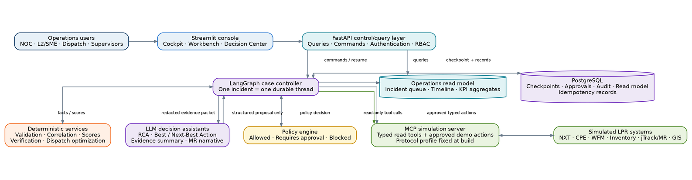
Figure 1. Mockup architecture. Streamlit is supervisory; FastAPI owns commands; LangGraph owns case progression; deterministic and LLM services remain separate; MCP exposes tools and simulated systems.
Key architectural boundary Streamlit never reads or writes LangGraph checkpoints directly. It queries an operations read model and submits typed commands to FastAPI. FastAPI authenticates, authorizes, validates, and resumes the correct thread.

3.2 Component responsibilities
Component | Responsibility | Explicitly not responsible for
Streamlit UI | Monitoring, case selection, evidence display, approvals, overrides, simulation controls and KPI charts | Owning incident state, executing production actions, holding SLA state
FastAPI | Query and command API, user/role context, input validation, approval persistence, idempotent graph start/resume, webhook simulation and projection triggers | Rendering the UI or making free-form operational decisions
LangGraph demo workflow | One durable incident thread, routing, interrupt/resume, attempt loops, action history and closure sequence | Portfolio queries, enterprise identity, direct database reporting
PostgreSQL | Checkpoints, read model, approval state, human decisions, audit events, consumed approvals, action idempotency and scenario state | Business logic
Deterministic services | Signal quality, correlation, impact, confidence thresholds, policy, dispatch constraints, verification and KPI math | Writing narratives or deciding through natural language
LLM decision assistants | Evidence summary, ranked RCA proposal, missing-test suggestions, best/next-best-action rationale and MR narrative | Authorizing actions, calculating thresholds, scheduling crews, or declaring service restored
MCP simulation server | Typed tools and resources for NXT, CPE, WFM, inventory, jTrack/MR and GIS fixtures | Model invocation or policy authorization
External LLM API | Structured text generation for approved assistant functions | Direct access to write tools or unredacted customer data

3.3 Architectural decisions
ADR | Decision | Reason
ADR-01 | Create a separate demo graph namespace | The verified production parent graph is intentionally partial and build-enforced; the mockup must not disguise its frontier or weaken PENDING_STAGES. [U1]
ADR-02 | Use PostgreSQL for checkpoints and read model | Human approvals must survive restart, and Streamlit requires cross-incident queries the thread-keyed checkpointer cannot provide. [U1][O2]
ADR-03 | Use FastAPI between Streamlit and LangGraph | Authorization, idempotency, input validation and thread resume should not live in a rerunning UI script.
ADR-04 | Use MCP for tools and context, not for the model call | MCP standardizes tools/resources for LLM applications; model invocation remains a provider adapter inside the API service. [O3][O6]
ADR-05 | Expose only read-only MCP tools to the LLM | Side-effecting actions are selected by graph logic and executed only after policy and human gates.
ADR-06 | Default to fake model and simulation mode | The demo must run without credentials and must never imply that a simulated write succeeded in production.
ADR-07 | Use prepare → interrupt → execute nodes | The source subgraphs already use a two-node approval pattern; the demo adds a downstream execution node so replay cannot duplicate a side effect. [U1][O1]
ADR-08 | Select an explicit MCP compatibility profile | As of 16 August 2026, langchain-mcp-adapters 0.3.2 pins mcp<2, while MCP Python SDK 2.0 supports the 2026-07-28 protocol. The simple default uses the legacy profile unless a modern client integration is proven. [O8][O9][O10]

4. End-to-end workflow and decision points

4.1 Simplified demonstration workflow
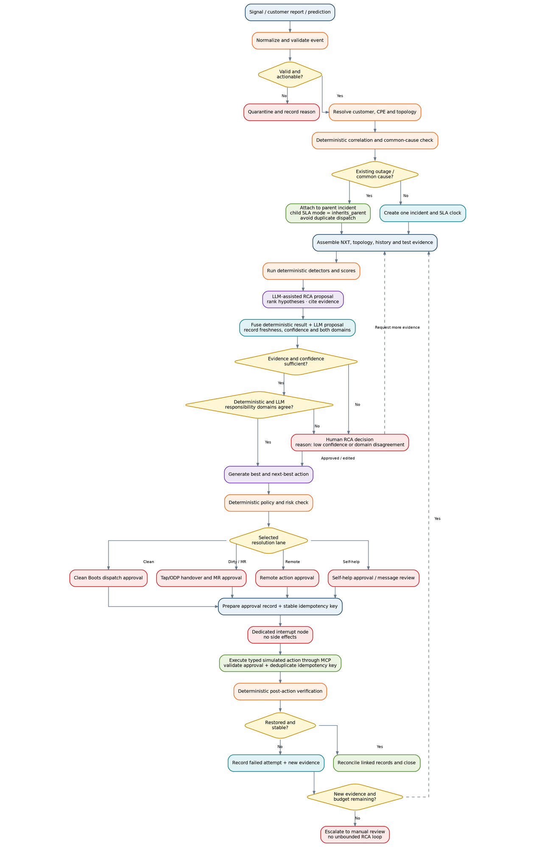
Figure 2. Simplified vertical-slice workflow. Failed actions return to evidence and RCA; the incident and SLA clock remain unchanged.

4.2 Process and decision specification
ID | Step / decision | Behavior | Primary owner
P01 | Receive signal | Accept NXT-style anomaly, customer report or predictive-risk fixture. | Graph
P02 | Normalize and validate | Create canonical event, calculate data quality and reject malformed or stale signals. | Deterministic
D01 | Valid and actionable? | No: quarantine and show reason. Yes: continue. | Deterministic
P03 | Resolve identity and topology | Resolve customer → service → CPE → premise/drop → tap/ODP → node/OLT/plant. | Deterministic + MCP read
P04 | Correlate and deduplicate | Check existing incidents, outages, work orders, MRs, planned work and neighboring CPEs. | Deterministic + MCP read
D02 | Common cause or existing case? | Yes: attach to parent and set child SLA mode to inherits_parent. No: create one incident. | Deterministic
P05 | Assemble evidence | Collect NXT trends, topology, service tests, history and field/MR context. | Workflow coordinator
P06 | Run detectors | Calculate anomaly, fault-domain, repeat-risk and handover-quality scores. | Deterministic
P07 | Generate RCA proposal | Return ranked hypotheses, evidence, contradictions, missing evidence and concise rationale. | LLM-assisted
P08 | Fuse analysis | Record deterministic domain, LLM domain, agreement, confidence, freshness and gate reason. | Deterministic
D03 | Evidence/confidence sufficient? | No: route to human RCA. Yes: evaluate responsibility-domain agreement. | Policy + router
D03A | Responsibility domains agree? | No: human RCA regardless of confidence. Yes: proceed. | Deterministic router
P09 | Generate best/next-best action | Create a structured action sequence with success tests and failure triggers. | LLM-assisted + deterministic scoring
P10 | Policy and risk check | Return allowed, requires approval, or blocked with reason codes. | Deterministic policy
D04 | Select lane | Remote, self-help, Clean Boots, Dirty Boots/MR, shared network or manual review. | Deterministic routing
P11A | Prepare approval | Persist ApprovalRequest and a stable idempotency key before pausing. | Graph
P11B | Request approval | Dedicated node with exactly one interrupt and no side effects. | Human interrupt
P12 | Execute simulated action | Validate approval and idempotency key, then invoke a typed MCP tool; replay returns the stored result. | Graph + MCP
P13 | Verify outcome | Run post-action telemetry and service tests; enforce observation window. | Deterministic
D05 | Restored and stable? | Yes: reconcile and close. No: record attempt and evaluate retry budget. | Deterministic
D05A | New evidence and budget remaining? | Yes: return to RCA. No: escalate to manual review. | Budget guard + policy
P14 | Reconcile and close | Align alarm, incident, work order, MR and customer status before closure. | Workflow controller

4.3 Interrupt behavior
A human decision uses the verified source pattern: a prepare node commits the ApprovalRequest and stable idempotency key; a separate request node contains exactly one interrupt and no side effects; a router validates the response; and a downstream execution node performs the typed action. Never conditionally skip interrupts within a node, never wrap interrupt() in a bare try/except, and never place an external effect before the interrupt. Because resume restarts the node from its beginning, graph-state reducers and the external-effect idempotency store provide separate, complementary replay protections. [U1][O1]
Approval kind | Default reviewer | Mockup trigger
Low-confidence RCA | L2 / SME | Confidence below threshold or deterministic/LLM responsibility-domain disagreement, even when confidence is otherwise high
Remote action | NOC analyst or supervisor | Any side-effecting CPE action in the demo
Dispatch | Dispatcher | Before work-order creation and simulated slot commitment
Clean-to-Dirty handover | Plant supervisor | Before creating or updating a jTrack MR at tap or ODP
High-blast-radius action | Operations supervisor | Shared network action affecting multiple services
Exceptional closure | Operations supervisor | Telemetry cannot prove restoration but approved exception exists

5. Deterministic, LLM-assisted and human decisioning

5.1 Decision allocation
Function | Deterministic service | LLM assistant | Human decision
Signal validation | Required | None | Exception only
Common-cause correlation | Required | Explain cluster only | Exception only
RCA | Baseline scores and constraints | Rank, synthesize, identify missing evidence | Approve or override when required
RCA domain agreement | Compare controlled domains and record gate reason | None | Mandatory review on disagreement
Best and next-best action | Risk/cost/success scores and policy filter | Explain sequence and failure trigger | Approve, edit or reject
Remote eligibility | Required | Explain proposed action | Approve side effect
Customer self-help | Safety and eligibility rules | Draft bilingual instructions | Optional review
Dispatch | Constraint solver / fixture schedule | Prepare requirements and rationale | Commit slot
Tap/ODP handover | Evidence completeness and deduplication | Draft structured narrative | Accept responsibility change
Restoration | Thresholds, tests and stability window | Summarize evidence | Exceptional closure only
KPI calculation | Required | None | None

5.2 Decision fusion
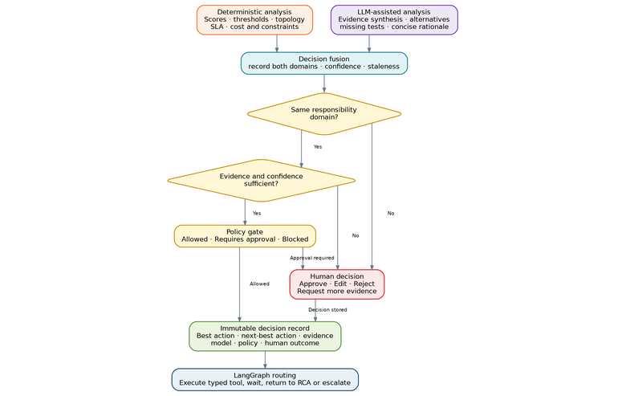
Figure 3. Deterministic facts and LLM-assisted analysis are fused, policy-gated, and stored as an immutable decision record before routing.

5.3 LLM RCA contract
The RCA assistant receives a compact redacted evidence packet and returns a validated structured object. It does not receive write tools. The assistant must cite evidence IDs rather than restating raw customer data.
Field | Requirement
llm_recommended_domain | One controlled value: cpe, wifi_or_home, premise_wiring, drop, hfc_tap, pon_odp, shared_network, plant, provisioning or unknown
deterministic_domain | Copied from the deterministic RCA result; never authored by the model
domain_agreement | agree or disagree; disagreement forces the human RCA gate
gate_reason | low_confidence, domain_disagreement, stale_evidence, policy or none
hypotheses | Ranked list with probability, supporting evidence IDs and contradicting evidence IDs
confidence | 0.0-1.0; used as a proposal, not an authorization
missing_evidence | Tests or data required to reduce uncertainty
ruled_out | Causes excluded and the evidence supporting exclusion
recommended_tests | Read-only tests only
concise_rationale | Short operator-facing explanation; no hidden reasoning trace
model_metadata | Provider, model, prompt version, latency and token/cost metadata

5.4 Best and next-best action contract
Field | Requirement
best_action | Preferred action under current evidence and constraints
next_best_action | Fallback when the preferred action is unavailable, blocked or unsuccessful
fallback_trigger | Observable condition that causes transition to the next action
do_not_repeat | Action and attempt condition that forces re-diagnosis
expected_success | Deterministically supplied probability or band
expected_duration | Deterministically supplied estimate or fixture value
cost_class / risk_class | Controlled categories used by policy
success_test | Telemetry or service-test condition that must pass
required_evidence | Evidence needed before action can execute

5.5 Staleness and revision rules
- Every recommendation has a decision ID, created time, expiry time, evidence references, model version, prompt version and policy version.
- A recommendation becomes stale when new evidence arrives, the fault domain changes, telemetry exceeds its freshness threshold, an action completes, a work order or MR changes status, or SLA context materially changes.
- The UI never silently overwrites an earlier proposal. Human edits and later model calls create new decision revisions linked to the same incident.
- The UI shows agreement, disagreement, missing evidence and human override reason; it does not expose private chain-of-thought.

6. MCP and simulated LPR system contracts

6.1 Recommended MCP pattern
MCP is the tool and context interface. The LLM provider call remains in the API service through a model adapter. The build selects one explicit protocol profile. The simple default is langchain_legacy: langchain-mcp-adapters 0.3.2 with mcp<2 and the handshake-era protocol. A modern profile may use MCP Python SDK 2.0 and protocol 2026-07-28 only after a contract test proves the chosen LangChain integration. Silent negotiation or dependency downgrade is a build failure. [O3][O6][O8][O9][O10]
Security and execution boundary Only read-only tools are exposed to the LLM. The graph executes every MCP call. A side-effecting tool first returns a prior result for a consumed idempotency key, then validates approval ownership, action type and status, performs the simulated effect, stores the result, and consumes the approval atomically.

6.2 Read-only tool set
Tool | Returns
get_nxt_snapshot | Alarm, health band, measurements, observation time and evidence IDs
get_nxt_trend | Time-series trend summary and affected-subscriber pattern
get_topology | Customer/service/CPE to tap or ODP and upstream plant
get_prior_incidents | Recent related incidents and confirmed outcomes
get_prior_work_orders | Clean/Dirty visits, parts, findings and repeat count
find_existing_mr | Related jTrack MR or null
run_read_only_cpe_test | Typed test result with units, threshold and timestamp
search_procedure | Approved procedure excerpts and source metadata

6.3 Side-effecting demo tools
Tool | Required controls | Mock result
simulate_remote_action | Approval exists, incident/action match, allowlist, attempt, idempotency lookup | ActionResult with simulated=True; replay returns stored result with replayed=True
create_clean_boots_work_order | Dispatch approval, crew requirement, access, parts, slot, unconsumed approval | One linked WorkOrder; duplicate resume returns prior WorkOrder
create_or_update_mr | Handover approval, exact tap/ODP, evidence completeness, outage/MR dedupe | One linked MR record; never a duplicate on replay
assign_dirty_boots | Accepted MR, matching approval and crew requirements | Simulated assignment and status timeline
close_linked_records | Passed validation or exceptional-closure approval | Reconciled simulated record statuses

6.4 Approval and execution rejection codes
The MCP execution boundary returns typed rejection codes so the Streamlit workbench can prove that the approval gate is operational rather than decorative.
Code | Meaning
APPROVAL_NOT_FOUND | No approval record exists.
APPROVAL_NOT_GRANTED | The approval is pending, rejected or expired.
APPROVAL_INCIDENT_MISMATCH | The approval belongs to another incident.
APPROVAL_ACTION_MISMATCH | The approval authorizes another action type.
APPROVAL_ALREADY_CONSUMED | The approval was already used; replay is accepted only through the matching idempotency key.

6.5 LPR evidence contract for MR creation
- Unchanged incident ID and SLA clock.
- HFC or PON technology and exact tap or ODP identifier.
- Customer, service, CPE, address/GIS and upstream topology references.
- Fault-domain classification and confidence.
- NXT-style alarms, trend and pre-fix snapshot.
- Remote/self-help actions and outcomes.
- Clean Boots tests, measurements, photos, parts, last clean point and first failed point.
- Existing outage and MR deduplication result.
- Required plant skill, tools, access, owner, priority and recommended action.
- MR acceptance, status, resolution code and post-fix evidence.
The user-supplied LPR material treats jTrack as the MR system. Its vendor attribution and real API are not established in the source; the mockup therefore uses a generic adapter and simulation schema. [U3]

7. Streamlit user experience

7.1 Page structure
Use a multipage Streamlit app defined with st.Page and st.navigation. Cockpit, incident-stage and decision-queue regions poll the FastAPI read model with st.fragment(run_every="2s"); the UI never reads the checkpointer. Streamlit remains suitable for the demonstration because it supports multipage navigation, forms, dialogs, independently rerunning fragments, interactive dataframes and Docker deployment. [O4][O5][O11]
Page | Purpose | Key controls
Scenario Launcher | Create fixture incidents and choose fake or external model mode | Technology, scenario, auto-run-until-decision, start/reset
Operations Cockpit | Monitor open cases, workflow stages, pending decisions and demo KPI | 2-second read-model fragment, filters, click-through
Incident Queue | Find and select cases | Interactive table, priority/stage/technology filters, 2-second refresh
Incident Workbench | Inspect evidence, both RCA domains, gate reason, best/next action, action history and current state | Request test, run next, open decision dialog, stale-proposal warning
Decision Center | Review all pending interrupts | Approve, edit, reject, request more evidence, escalate; 2-second refresh
Field and Handover | Review Clean/Dirty boundary, tap/ODP evidence, MR package and reverse handover | Accept, return for evidence, associate existing MR, reverse responsibility
System and Agent Monitor | Show service health, protocol profile, model calls, MCP tools, errors and current interrupts | Health refresh, protocol check, model switch in demo mode

7.2 Incident workbench wireframe
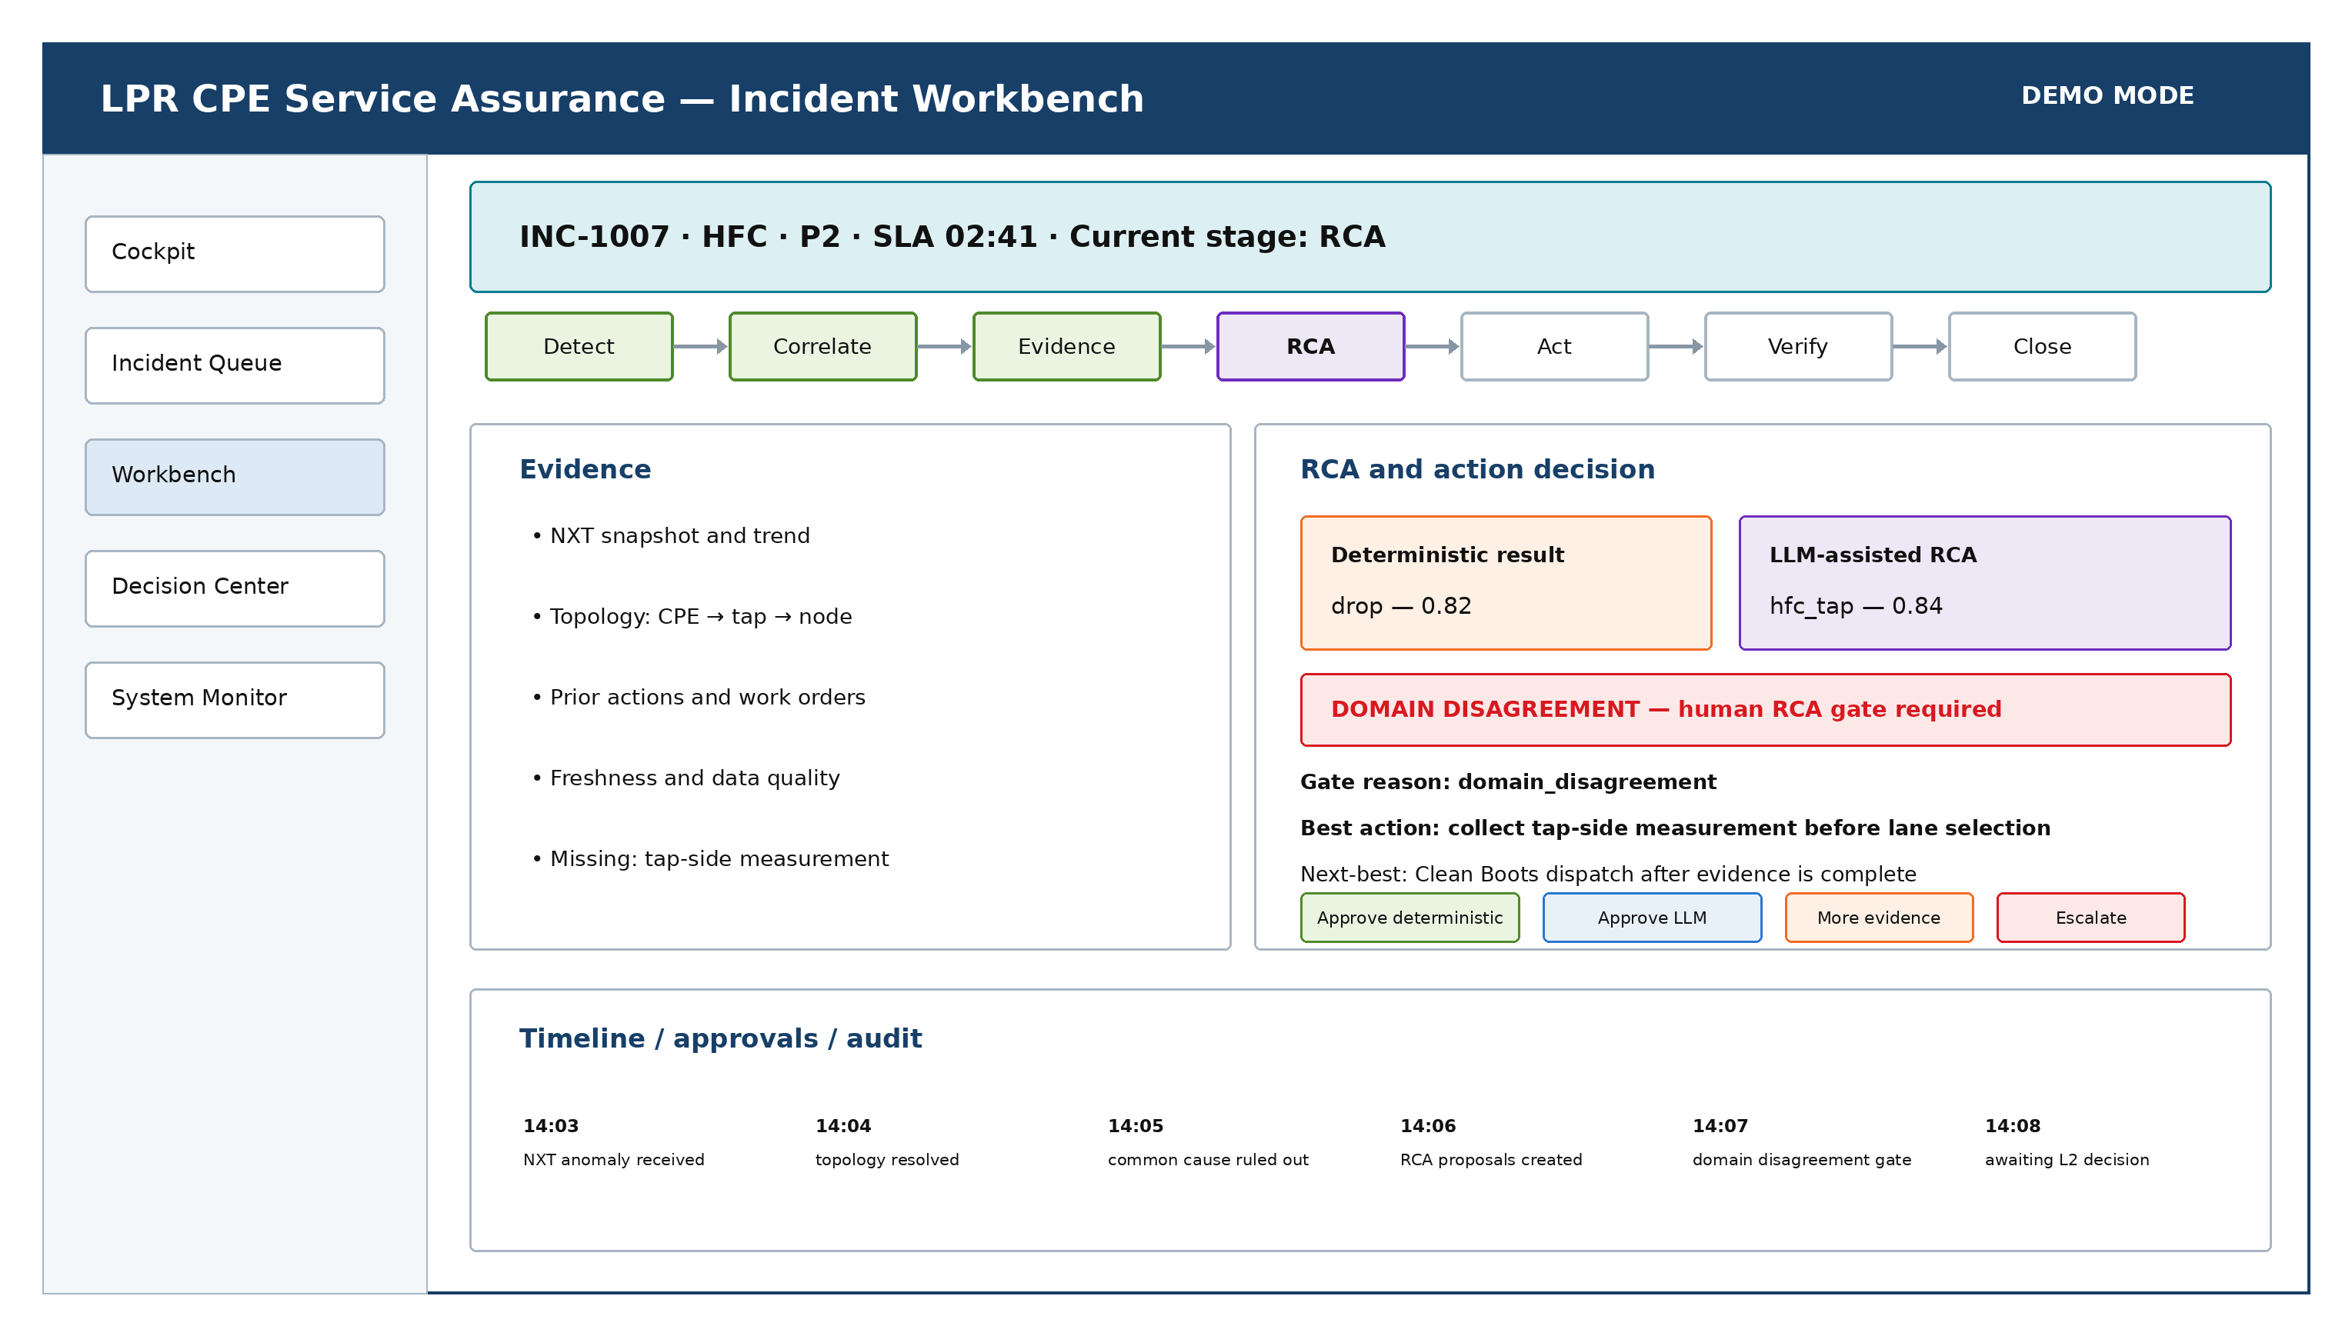
Figure 4. Incident workbench wireframe. Evidence and deterministic results are displayed beside the LLM proposal and the policy-controlled human decision.

7.3 Human decision form
Displayed information | Required behavior
Recommendation | Best action, next-best action and fallback trigger
Evidence | Evidence IDs, source, timestamp and freshness
Alternatives | Ranked RCA hypotheses or action candidates
Policy | Verdict, reason codes, required role and expiry
Operational impact | SLA, estimated time, cost class, customer effort and risk
Responses | Approve as proposed; approve alternative; edit permitted fields; request more evidence; reject; return to RCA; escalate
Audit | Operator identity, timestamp, reason code, free-text reason and decision revision
Gate state | Deterministic domain, LLM domain, agreement result, gate reason and proposal freshness

7.4 Session-state boundary
Streamlit session state may store the selected incident, filters, active tab and unsaved form values. It must not hold authoritative incident state, approval state, SLA timestamps, work orders or MR records. Authoritative data is fetched from FastAPI on each fragment refresh; a fragment must not create a side effect because it can rerun automatically.

8. API, state, persistence and read model

8.1 Minimum API
Method | Endpoint | Purpose
POST | /demo/scenarios/{name}/start | Create a fixture case and run until completion or interrupt
GET | /demo/incidents | List queryable incident summaries
GET | /demo/incidents/{id} | Get current workbench projection
GET | /demo/incidents/{id}/timeline | Get ordered domain and decision events
GET | /demo/incidents/{id}/decisions | Get decision revisions and human outcomes
GET | /demo/approvals | List pending approvals
POST | /demo/approvals/{approval_id}/decision | Validate decision, store it and resume the same thread
POST | /demo/incidents/{id}/run-next | Run one graph step
POST | /demo/incidents/{id}/run-until-decision | Run until interrupt or terminal state
GET | /demo/system/status | Return UI, API, database, MCP and model health

8.2 Graph state
Reuse the source state conventions: one IncidentState, append-only evidence and action history, write-once incident/thread/SLA identifiers, replay-safe counters, validated lifecycle transitions, and node-entry budget checks. [U1] The demo may use a smaller state type but must preserve these invariants. State reducers make checkpoint replay safe; they do not replace the external-effect idempotency record.
State group | Minimum fields
Identity | incident_id, thread_id, parent_incident_id, source, technology, customer_ref, service_ref, cpe_ref
Topology | premise, drop, delimiter_type, delimiter_id, node_or_olt, upstream_resource
Control | status, stage, SLA, sla_mode, attempt counts, budget/escalation state, approval state
Evidence | events, evidence items, test plan, test results, data-quality result, new_evidence_since_last_rca
Decision | deterministic_domain, llm_domain, domain_agreement, gate_reason, fused RCA, best/next-best action, policy decision
Execution | action history, idempotency key, work orders, MR records, crew type, handover contract
Closure | validation result, reconciliation result, closure record, KPI timestamps
Audit | decision revisions, approvals, errors, model metadata, tool-call records and replay flags

8.3 Persistence
- Use PostgreSQL-backed LangGraph checkpoints for any approval or restart demonstration. In-memory persistence is acceptable only for unit tests. [O2]
- Use the incident ID as the stable thread ID and keep it under the checkpointer limit; a UUID-compatible identifier is preferred. [O2]
- Store large telemetry and photos outside graph state; graph state contains secure object references and metadata.
- Use a separate read model for cross-incident queries. A checkpointer is not a reporting database, which is an explicit current-state limitation in the source. [U1]

8.4 Minimum read model
Table | Purpose | Key fields
incident_summary | Queue and cockpit | incident_id, parent_incident_id, sla_mode, technology, priority, stage, displayed SLA, both RCA domains, domain agreement, gate reason, proposed action, attempts, updated_at
incident_timeline | Workbench event history | incident_id, sequence, event_type, actor, timestamp, summary, evidence refs
decision_proposal | RCA and action revisions | decision ID, type, candidates, confidence, both domains, agreement, gate reason, evidence, model/prompt versions, policy result, expiry
approval | Decision Center and execution control | approval ID, incident, action type, required role, status, expiry, idempotency key, consumed_at
human_decision | Audit | approval ID, operator, response, edits, reason and time
idempotency_record | Effect replay protection | idempotency key, incident, tool, approval, result JSON, created time
agent_run | System monitor | provider/model, latency, tokens/cost, validation result, error and tool calls
kpi_snapshot | Cockpit | period, technology, stage, count, rate numerator/denominator and duration metrics

8.5 Parent/child SLA rule
sla_mode is own, inherits_parent or paused. A common-cause child retains its original SLA start but uses the parent deadline for current breach calculation while attached. Detaching restores its own clock without resetting it. The display and API must identify which clock is authoritative.

9. Docker Desktop deployment

9.1 Deployment topology
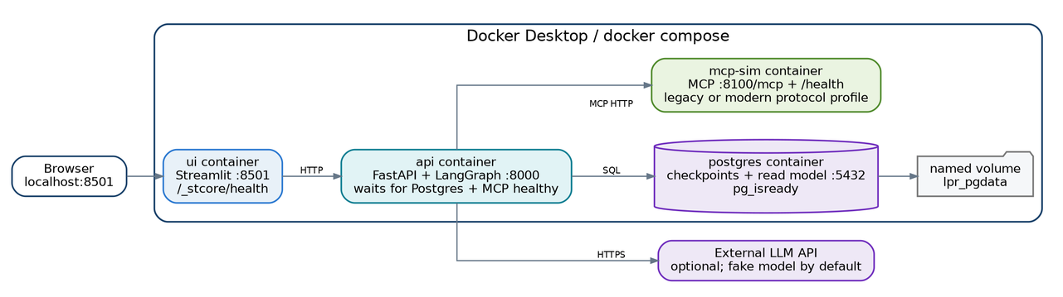
Figure 5. Four-container Docker Desktop footprint with an optional external LLM API. PostgreSQL data persists in a named volume.
Docker Compose is used because the demonstration has multiple cooperating services. PostgreSQL and mcp-sim both expose health checks, and the API waits on service_healthy for both before accepting traffic. The API also runs an MCP protocol/profile compatibility probe at startup. [O7] Streamlit uses its standard container port and health endpoint. [O5]

9.2 Service specification
Service | Port | Dependencies | Health
ui | 8501 | api | GET /_stcore/health
api | 8000 | postgres healthy; mcp-sim healthy | GET /health and /ready
mcp-sim | 8100 | none | GET /health plus MCP endpoint test
postgres | 5432 | named volume | pg_isready

9.3 Configuration
Setting | Default | Purpose
APPLICATION_MODE | simulation | Prevents production semantics
PRODUCTION_WRITES_ENABLED | false | Second independent write guard
MODEL_PROVIDER | fake | Runs without API credentials
MODEL_NAME | demo | Model adapter label
MODEL_API_KEY | unset | Optional external model key, API container only
MCP_PROFILE | langchain_legacy | Explicit client/server compatibility profile
MCP_PROTOCOL_VERSION | 2025-11-25 | Default with langchain-mcp-adapters 0.3.2 and mcp<2; modern profile uses 2026-07-28
MCP_STRICT_VERSION | true | Fail startup if the observed version differs from the selected profile
MCP_URL | http://mcp-sim:8100/mcp | Container-to-container tool endpoint
DATABASE_URL | postgresql://...@postgres:5432/... | Checkpoint, approval, idempotency and read-model database
DEMO_SCENARIO_DIR | /app/fixtures | Fixture location
UI_REFRESH_SECONDS | 2 | Read-model polling interval for live regions
LOG_LEVEL | INFO | Structured logging verbosity

10. Security, observability and KPI design

10.1 Security controls
Control | Mockup requirement
Demonstration banner | Persistent visual warning that all operational actions are simulated
RBAC | FastAPI validates role for every approval and action; Streamlit controls are not the security boundary
Secrets | Model keys live only in API-container environment or Docker secrets; never in browser state, checkpoints or fixtures
PII minimization | Use synthetic customer data; redact identifiers before model calls and traces
Prompt injection | Treat technician notes, procedures and retrieved text as data; do not execute embedded instructions
Tool allowlist | LLM sees read-only tools only; graph nodes own write calls
Idempotency | Every write request has a deterministic key. The execution boundary returns the stored result on matching replay and rejects an approval that is missing, mismatched, not granted or already consumed by another key.
Stale decision protection | Recheck evidence freshness and policy after an approval resumes
Origin control | The MCP HTTP server validates allowed origins and is exposed only on the local Compose network by default [O6]
Protocol compatibility | Client and server profile is pinned and verified at startup; no silent modern-to-legacy downgrade

10.2 Observability
- Structured logs with incident ID, correlation ID, stage, node, decision ID, approval ID and tool call ID.
- OpenTelemetry-compatible spans for graph nodes, model calls, MCP calls, database operations and human wait time.
- Optional LangSmith tracing for model and tool evaluation, disabled by default and redacted.
- System monitor showing service status, current interrupts, model latency, structured-output failures and MCP errors.
- Immutable audit timeline showing deterministic outputs, LLM proposals, policy reason codes, human decisions and action outcomes.

10.3 Demonstration KPIs
KPI | Definition in mockup
Workflow throughput | Cases completed per scenario run
Time to detect | Signal occurrence to incident creation
Time to diagnose | Incident creation to approved RCA
Human wait time | Approval request to decision
Recommendation acceptance | Approved best-action recommendations / decisions reviewed
Human override rate | Approved alternative or edited decisions / decisions reviewed
Remote resolution | Cases closed after remote action / eligible cases
Truck-roll avoidance | Cases resolved without Clean/Dirty work order / active service incidents
Repeat attempt rate | Cases returning to RCA after an unsuccessful action / acted cases
Handover acceptance | Accepted MR handovers / handovers proposed
Premature closure blocks | Closure attempts blocked by validation or reconciliation
Model quality | RCA agreement and final confirmed-domain accuracy across fixtures

11. Test scenarios, acceptance criteria and future hardening

11.1 Test strategy
Layer | Tests
Unit | Detectors, policy, fusion, schemas, routing, staleness, role checks, idempotency and KPI calculations
Contract | Every MCP tool, model adapter, FastAPI endpoint and persistence adapter
Graph | Each branch, interrupt, resume, retry loop, failure budget and closure gate
Integration | FastAPI + LangGraph + Postgres + MCP simulation
UI | Streamlit page rendering, filters, selection, approval dialogs and error states
Scenario | S1-S9 from a clean Compose environment, including reverse handover, domain disagreement, duplicate resume and bounded escalation
Resilience | Container restart during approval, duplicate webhook, stale telemetry, MCP timeout and model unavailable

11.2 Acceptance criteria
1. A clean workstation with Docker Desktop can run the stack using docker compose up --build.
2. The Streamlit console is available at localhost:8501 and FastAPI documentation at localhost:8000/docs.
3. The demo runs with MODEL_PROVIDER=fake and no external credentials.
4. Each scenario creates one incident and one durable thread; the SLA start never resets.
5. Common-cause children expose parent_incident_id and the authoritative SLA mode without losing their original clock.
6. At least one graph path pauses for human approval and resumes correctly after an API-container restart.
7. The incident queue is populated from the read model rather than checkpoint scanning.
8. The workbench shows deterministic analysis, LLM proposal, evidence, confidence, both responsibility domains, gate reason, policy result, best action and next-best action.
9. Confidence above threshold does not bypass a human when deterministic and LLM responsibility domains disagree.
10. Resuming an approved action twice creates exactly one effect; the second request returns replayed=true.
11. Using an already-consumed approval with a different key returns APPROVAL_ALREADY_CONSUMED and records the rejection.
12. A failed action records the attempt and returns to RCA only when new evidence exists and the existing budget guard permits another cycle.
13. Exceeding the diagnostic or attempt budget escalates instead of starting another loop.
14. Clean-to-Dirty handover requires exact tap/ODP and complete evidence; incomplete evidence blocks MR creation.
15. Reverse handover returns the same incident from Dirty Boots to Clean Boots without a new SLA clock.
16. Closure is blocked until post-action validation and linked-record reconciliation pass.
17. All external actions are marked simulated; production writes remain disabled; both PostgreSQL and mcp-sim report healthy before the API becomes ready.
18. The observed MCP protocol version matches the selected compatibility profile, or startup fails with a clear diagnostic.

11.3 Production hardening path
Mockup capability | Production upgrade
Synthetic roles | Enterprise OIDC and backend RBAC binding
One API process | Separate API and workflow workers with queueing and concurrency control
Fixture MCP server | Verified adapters for NXT, CPE, WFM, inventory and jTrack; per-system authentication
Single Postgres | Managed database, backup, retention, encryption and HA
Simple read model | Event/outbox projector, durable event stream and historical KPI warehouse
Optional external LLM | Approved model gateway, prompt/model registry, evaluation, rate limits and cost controls
Demo dispatch fixture | Deterministic optimizer integrated with real availability, travel, parts and access constraints
Basic audit | Enterprise SIEM, immutable retention and operational runbooks

Appendix A. Schemas and interfaces

A.1 RCA proposal
Illustrative Pydantic contract
class RCAProposal(BaseModel):
decision_id: str
llm_recommended_domain: FaultDomain
hypotheses: list[RCAHypothesis]
confidence: float = Field(ge=0.0, le=1.0)
evidence_refs: list[str]
ruled_out: list[str]
missing_evidence: list[str]
recommended_tests: list[str]
concise_rationale: str
model_name: str
prompt_version: str
created_at: datetime
expires_at: datetime
class FusedRCA(BaseModel):
deterministic_domain: FaultDomain
llm_domain: FaultDomain
domain_agreement: Literal["agree", "disagree"]
gate_reason: Literal["low_confidence", "domain_disagreement", "stale_evidence", "policy", "none"]
confidence: float

A.2 Action proposal
Illustrative Pydantic contract
class ActionPlan(BaseModel):
best_action: ActionCandidate
next_best_action: ActionCandidate | None
fallback_trigger: str | None
do_not_repeat: str | None
evidence_refs: list[str]
policy_decision_id: str | None = None
approval_kind: ApprovalKind | None = None

A.3 Approval response
Illustrative Pydantic contract
class ApprovalDecision(BaseModel):
approval_id: str
incident_id: str
response: Literal[
"approve", "approve_alternative", "edit",
"request_more", "reject", "return_to_rca", "escalate"
]
selected_option_id: str | None = None
permitted_edits: dict[str, JsonValue] = Field(default_factory=dict)
reason_code: str
reason_text: str
actor_id: str
actor_role: Role
idempotency_key: str
decided_at: datetime

A.4 Write-tool envelope
Illustrative Pydantic contract
class ToolActionRequest(BaseModel):
incident_id: str
correlation_id: str
action_type: ActionType
target_ref: str
attempt: int
approval_id: str | None
actor_id: str
reason_code: str
idempotency_key: str
dry_run: bool = True
payload: dict[str, JsonValue]
class ToolActionResult(BaseModel):
outcome: ActionOutcome
simulated: bool = True
replayed: bool = False
approval_consumed: bool
result_ref: str

Appendix B. References
Ref. | Source
[U1] | CPE Service Assurance Workflow — Architecture and Engineering Handover, e2e_CPE_service_assurance, revision at commit 0296d09, 16 August 2026. User-supplied source.
[U2] | LangChain CPE orchestration architecture. User-supplied source describing deterministic prediction/scheduling, one durable thread, typed state, dispatch constraints and Clean/Dirty handover.
[U3] | LPR CPE Flow — Puerto Rico HFC/PON KPIs, TM Forum alignment and LPR-specific NXT, Clean Boots, tap/ODP and jTrack/MR process. User-supplied source.
[O1] | LangChain, LangGraph Interrupts, official documentation, accessed 16 August 2026: https://docs.langchain.com/oss/python/langgraph/interrupts
[O2] | LangChain, LangGraph Persistence, official documentation, accessed 16 August 2026: https://docs.langchain.com/oss/python/langgraph/persistence
[O3] | LangChain, Model Context Protocol, official documentation, accessed 16 August 2026: https://docs.langchain.com/oss/python/langchain/mcp
[O4] | Streamlit, Multipage Apps and st.navigation, official documentation, accessed 16 August 2026: https://docs.streamlit.io/develop/concepts/multipage-apps/page-and-navigation
[O5] | Streamlit, Deploy Streamlit using Docker, official documentation, accessed 16 August 2026: https://docs.streamlit.io/deploy/tutorials/docker
[O6] | Model Context Protocol, Streamable HTTP transport, specification revision 2026-07-28: https://modelcontextprotocol.io/specification/2026-07-28/basic/transports/streamable-http
[O7] | Docker, Compose startup order and health checks, official documentation, accessed 16 August 2026: https://docs.docker.com/compose/how-tos/startup-order/
[U4] | CPE demo mockup — specification audit and proposed changes, 12 August 2026. User-supplied source.
[O8] | Model Context Protocol, The 2026-07-28 Specification release notes: https://blog.modelcontextprotocol.io/posts/2026-07-28/
[O9] | Model Context Protocol Python SDK v2 protocol versions and release notes: https://github.com/modelcontextprotocol/python-sdk/blob/main/docs/protocol-versions.md
[O10] | LangChain MCP Adapters 0.3.2 release, including mcp<2 compatibility cap: https://github.com/langchain-ai/langchain-mcp-adapters/releases
[O11] | Streamlit st.fragment official documentation: https://docs.streamlit.io/develop/api-reference/execution-flow/st.fragment

