**Executive Summary**

When on the golf course, golfers have no accurate way of recording their swing and technique. While golfing innovation has improved over the years, the most common systems are bulky and unappealing to consumers. In order to help the golfer accurately record their swing for personal analysis, the Golf Glove was created. The Golf Glove is a system that consists of multiple inertial, pressure and flex measurement units that can accurately track and record a golfer’s swing in real time. The system is broken down into three subsystems which are the glove garment, the wrist mounted controller, and the coaching application as described in figure 1.

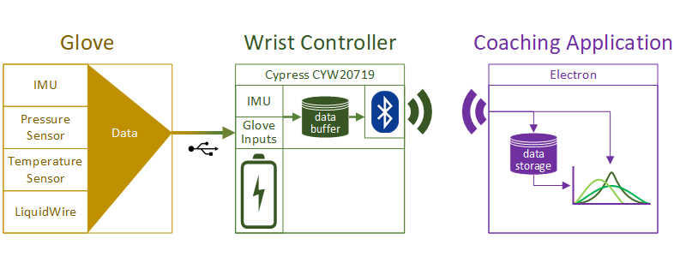

**Figure 1:** Golf Glove System Architecture

Some main constraints of the overall Golf Glove design will be the wireless transmission speed and the resolution of the various measurement sensors. The entire system must be able to fit onto a standard golf glove as well as a wrist mounted unit that is no wider than a standard sweatband (3”). The Golf Glove must also be able to be recharged to allow for multiple golfing sessions. Seeing as the Golf Glove will be used outside, the system must be able to handle harsh environments with features such as splash resistance, and resistance to freezing and hot temperatures. Finally, the system talks wirelessly to the application and therefore must be able to transmit across the length of an average golf tee box.

Each Golf Glove system is comprised of a Microcontroller, two IMU’s, two pressure sensors, 4 LiquidWire stretch sensors, and a battery all located in both a back hand and wrist mounted unit. Two IMU’s were chosen to increase the tracking accuracy of the system. A large battery will be installed to continuously power the unit for 5 hours. The system uses LiquidWire stretch sensors to track the inflection and deviation of the wrist and were chosen due to their ability to be sewn into the glove itself with minimal obstruction to the user. The Golf Glove communicates to the mobile application through use of Bluetooth LE and will send packets containing the user’s golf swing data. Lastly, palm mounted pressure sensors will allow the system to detect the users grip force and were chosen due to their flexible and overall unobtrusive nature.

The Golf Glove improves on existing systems by shrinking the size of the control units, while adding the additional capability of tracking wrist movement through the use of flexible sensors. Possible improvements on the system include a 3D rendering of your golf swing, data tracking and intelligent feedback based on gathered data. Adoption of the Golf Glove system would increase the overall performance of participating customers, while also reducing the number of injuries associated with poor golf swing form.