**EXECUTIVE SUMMARY**

Golf Glove offers golfers a revolutionary way of tracking one’s golf swing. In contrast to other systems, the Golf Glove is low-profile and convenient. When on the course, golfers have no accurate way of recording swing technique on their own. The Golf Glove is a system that consists of multiple inertial, pressure, and flex sensors that can accurately track and record a golfer’s swing in real time. This gathered data is used to provide real time coaching feedback to the golfer. The system, depicted in Figure 1, is comprised of three subsystems: the glove garment, the wrist-mounted controller, and the coaching application.

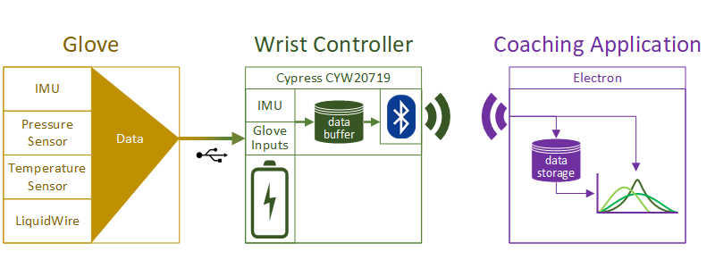

Figure 1**.** Golf Glove System Architecture

The main constraints of the Golf Glove design include the wireless transmission speed and the resolution of the various measurement sensors. Additionally, the entire system must be able to fit onto a standard golf glove and connect to a wrist-mounted controller that is no wider than a standard sweatband (3”). The Golf Glove will typically be used in outdoor environments; therefore, the system must be able to handle realistic environments with protections against water and dust ingression as well as moderate temperature conditions. Finally, the wrist-mounted controller must be battery powered and communicate wirelessly to the coaching application across 10 meters, the length of an average golf tee box.

The Golf Glove system contains a controller to record sensor data. Its array of sensors includes two accelerometers to track swing movement, two pressure sensors to read grip pressure, and four LiquidWire stretch sensors to measure wrist angle. Finally, a battery will be integrated to continuously power the device for at least 5 hours. The system uses a novel stretch sensor technology developed by LiquidWireto track the flexion and deviation of the wrist. LiquidWire sensors were chosen due to their ability to be sewn into the glove itself while being able to stretch without inhibiting function. The Golf Glove communicates via Bluetooth Low Energy to send packets containing the user’s swing data to the coaching application.

Golf Glove improves on existing systems by shrinking the system size and by adding the capability to track wrist movement via flexible sensors. Future improvements to the system may include 3D rendering of the user’s swing and generating intelligent feedback based on gathered data. Golf Glove provides an affordable and comprehensive solution by combining stretch sensors with the motion and pressure sensing capabilities of products currently on the market.