1) Menu items (we will maybe need to decrease the font size)
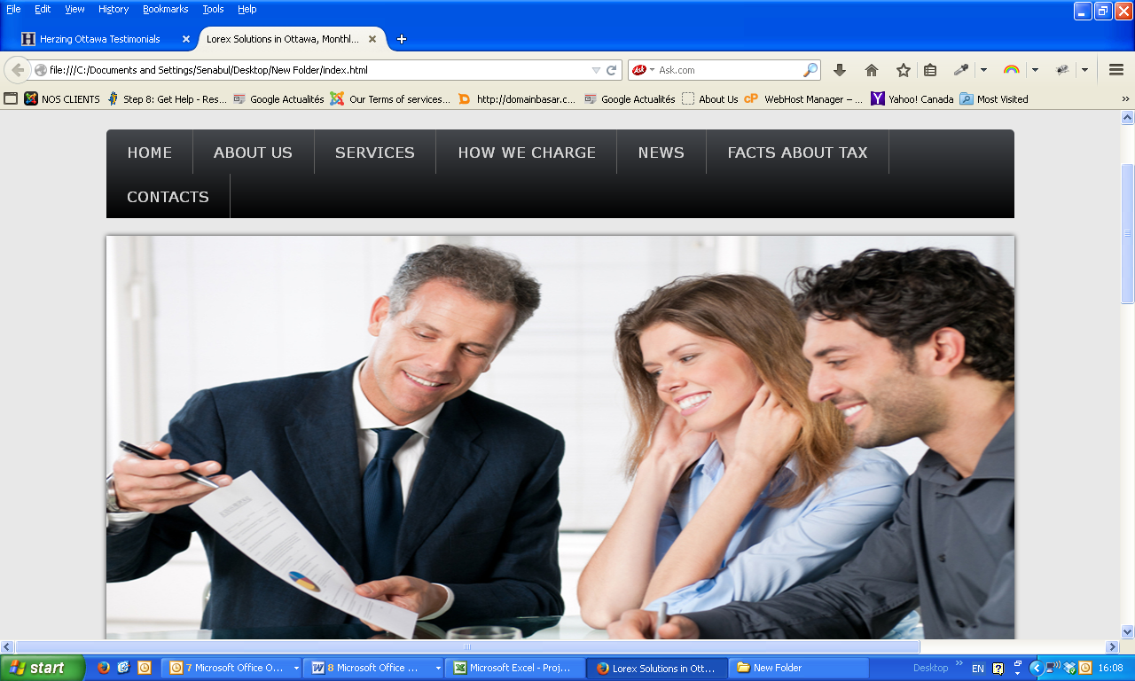

2) Here is how the page appears in my browser
We can put this section lower where we have What we offer (see below)
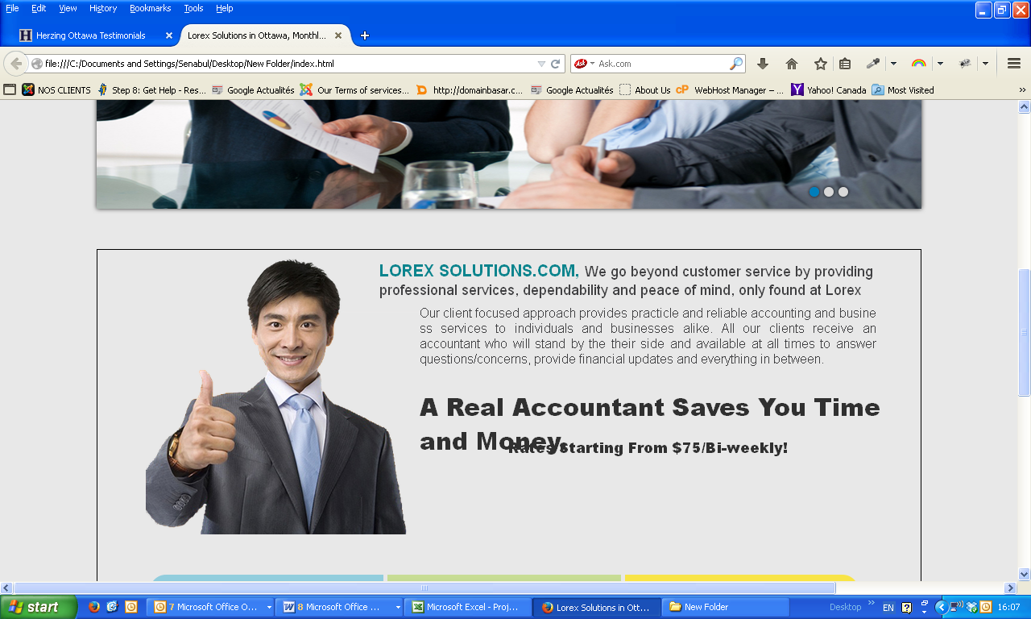

3) We can remove the What we offer section and make the footer a little bit nicer

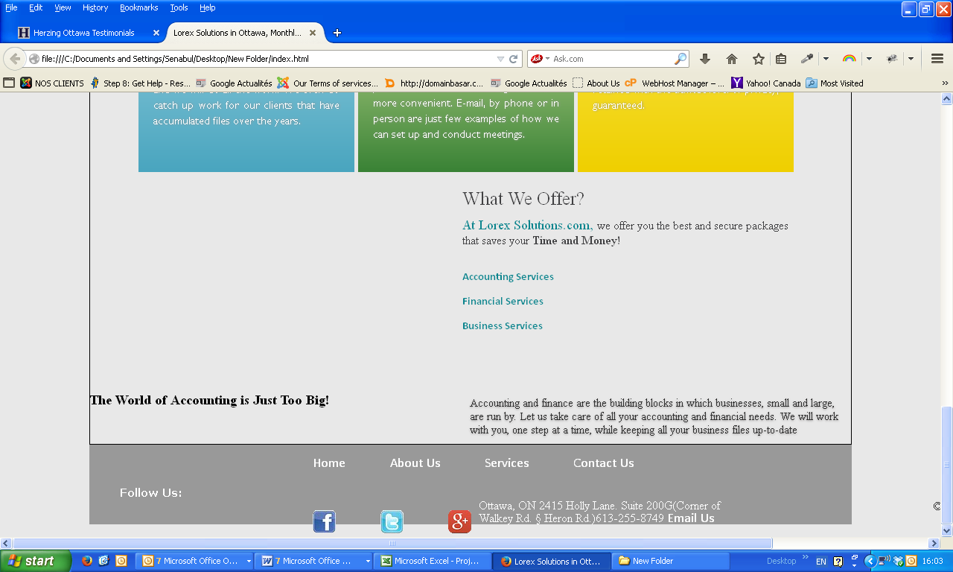

4) Colors
We can replace #F8E342 by #EC9222

