- Slideshow
Can we add two more sliders to the animation? There is the word caption in the slideshow. We can add some text there.

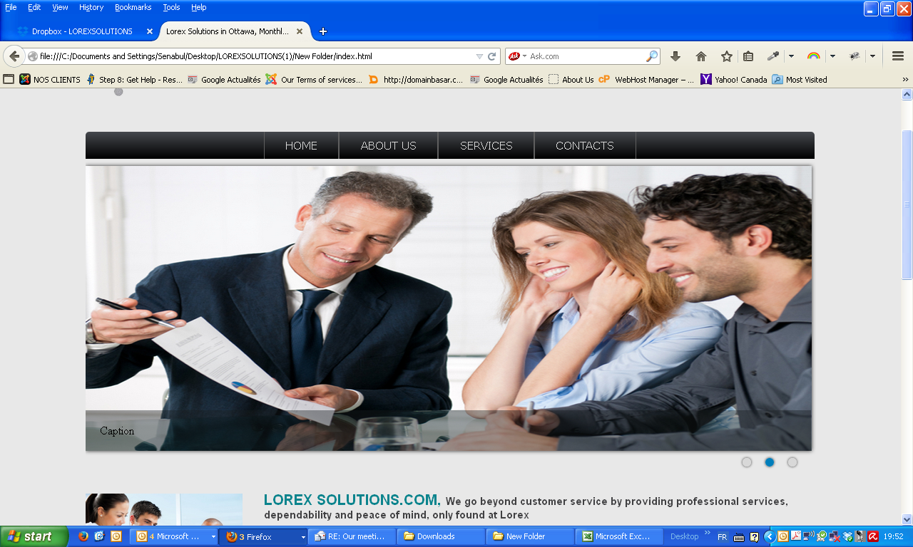

- Three color boxes
We will try to find a nicer font
we can use #EC9525, #468A3D and #4EA7C1 as colors

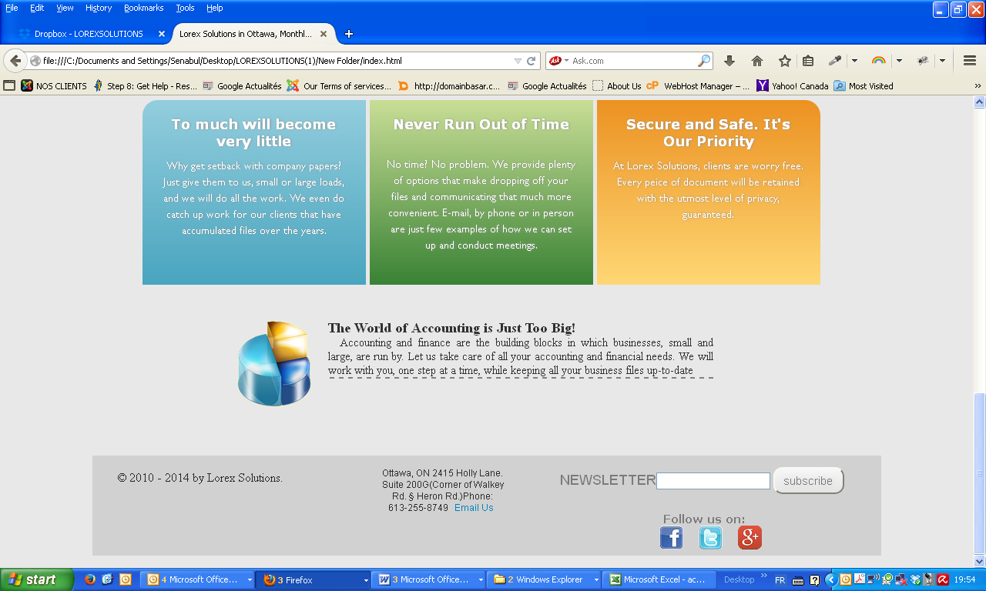
- The dotted line - we will remove it
- About us
We can move the image to the right and remove Lorex Solutions.com
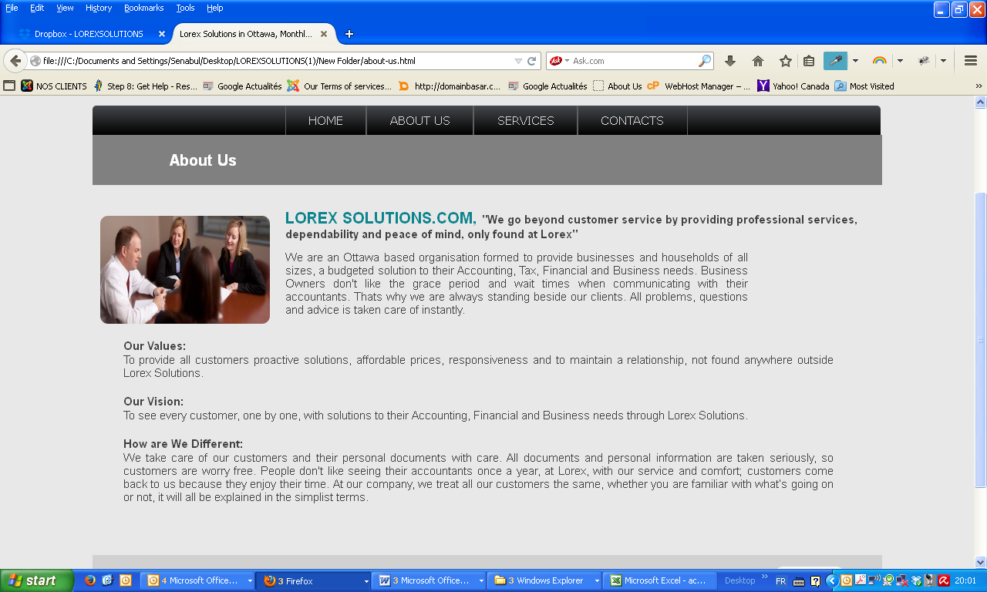

5) We will put the three boxes higher and maybe use a price table here to provide a better overview to the visitor
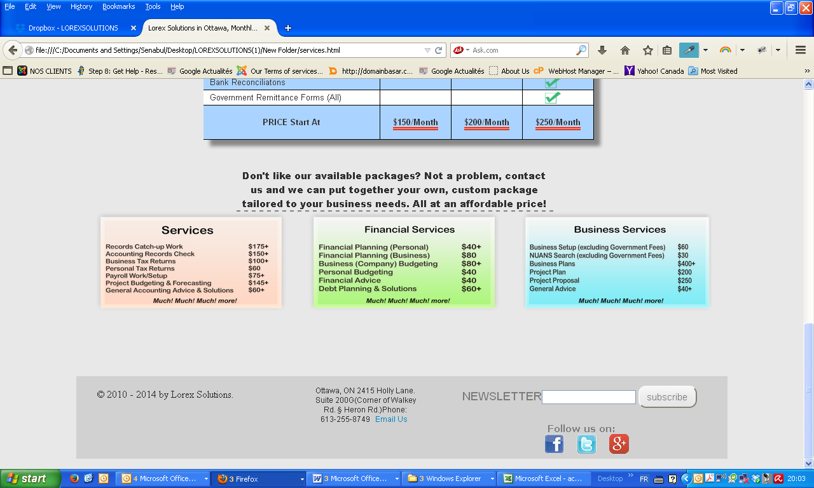
- Contact us
Will put the form on the left in the middle
We can move the text "we offer a little bit to the left
We will add catchpa to prevent spam.
- 