1) Color boxes color
We will take these colors #69B932, #ED982D
2) This page is really not nice for a Home page. We must find a way to make it nicer
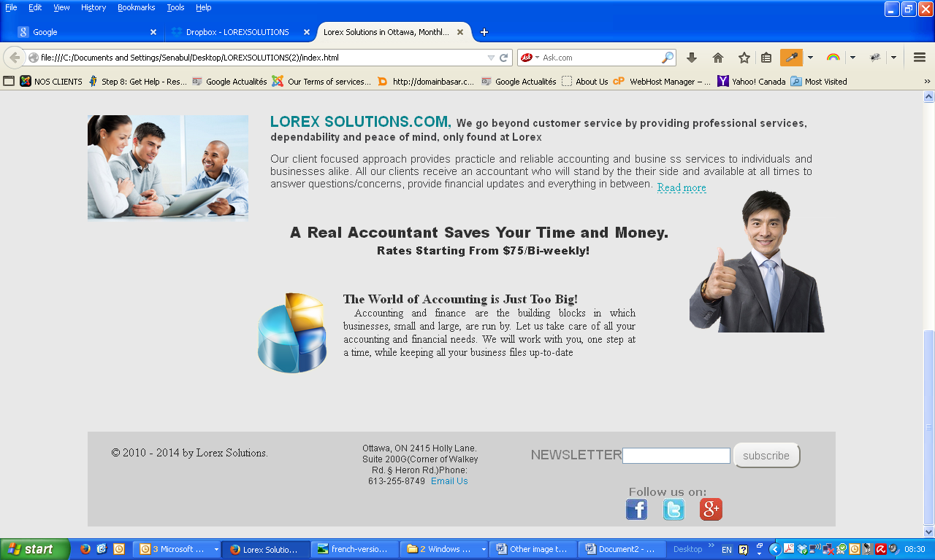

Please present it like this
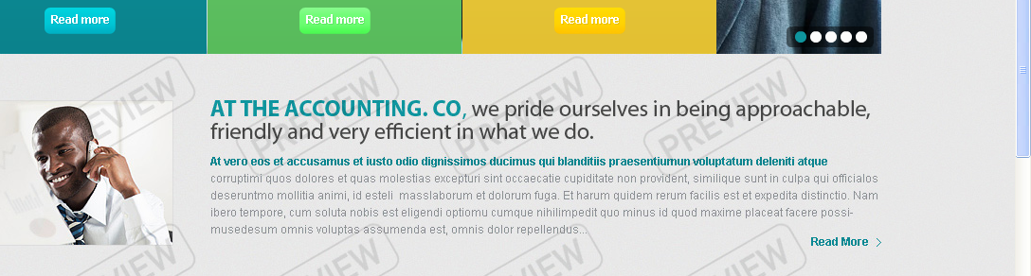

3) We will use here the same front as the one in the content. If we can find a bigger image to fill in the space, it's fine. Otherwise, we can take a second image from his website
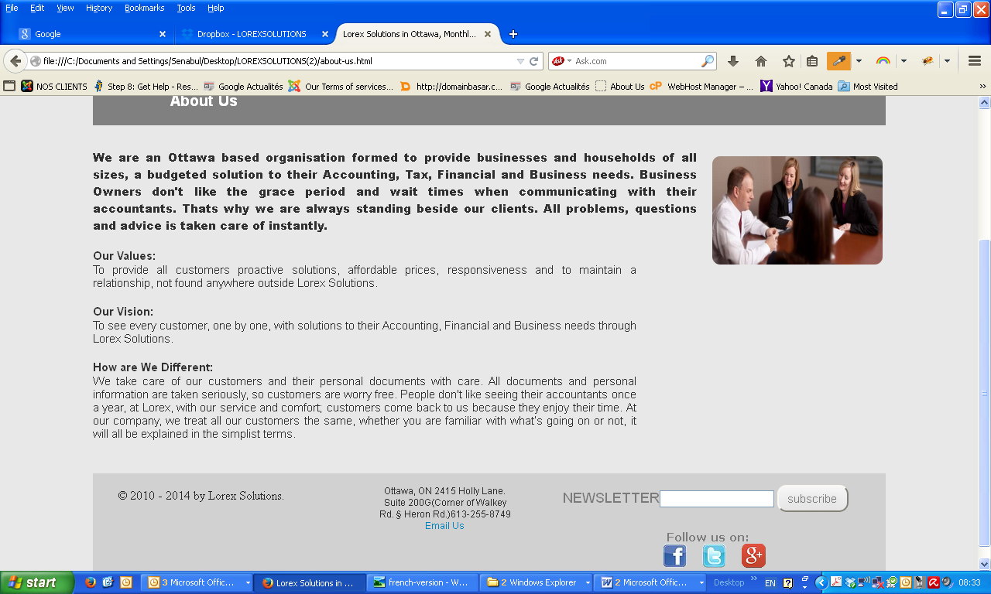
3) Here is how the page is appearing in my browser. I found what you did before much better. You did something very nice yesterday. Unfortunately, I was very busy and could not get to you quickly.
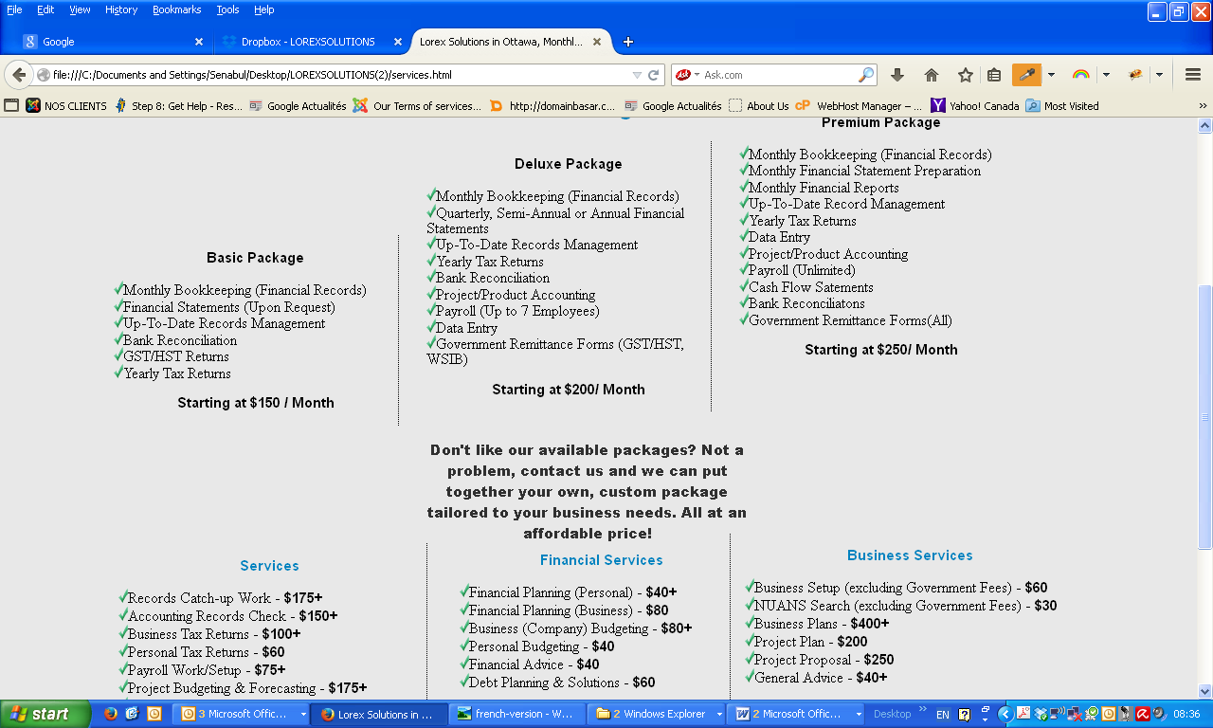

4) We can try to make the page nicer and add a Google map here

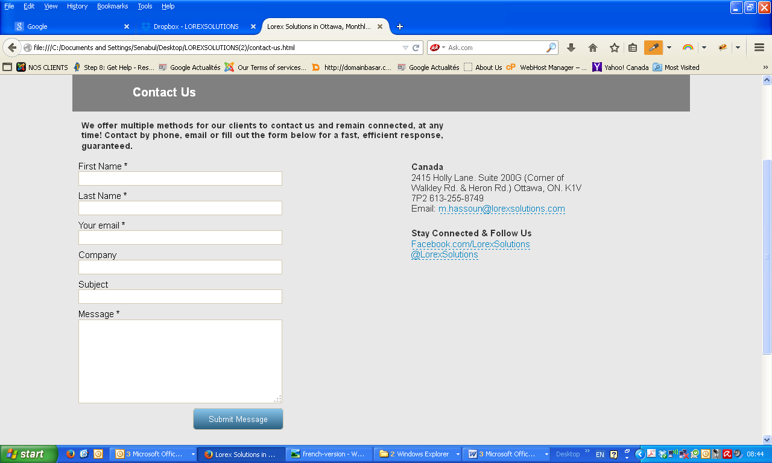

The way he displayed his content is nice

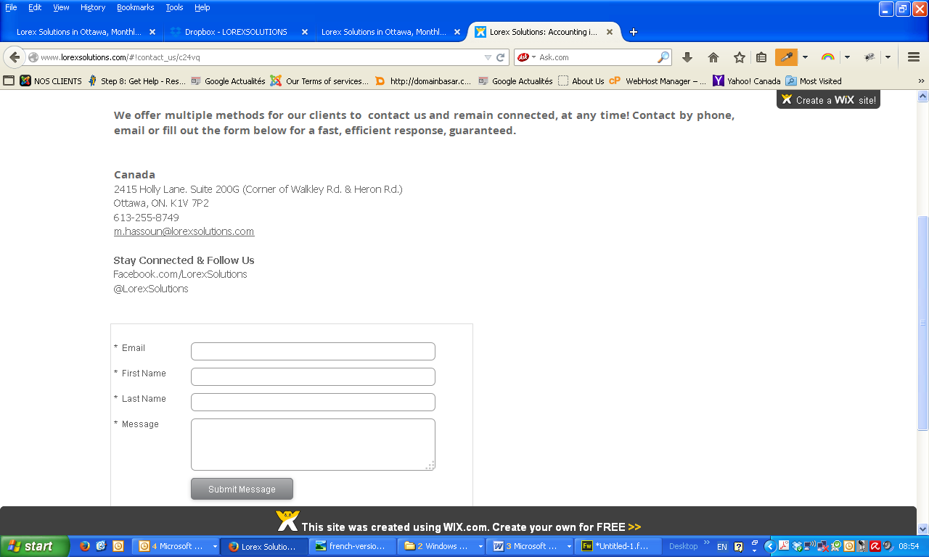

5) Can we make quickly a new logo that better matches the content? I think the problem is the logo. Let’s impress him with a nicer logo :).

6) The button effect he has in his menu is very nice, if we can have it, it would be nice

