Data  
Open the CoNet app in Cytoscape.

1. Open the "Data" menu and load your "otu_table.biom" file that contains the lineages.
2. Enable "Biom file in HDF5 format".
3. Open the "Metadata and Features sub-menu and enable

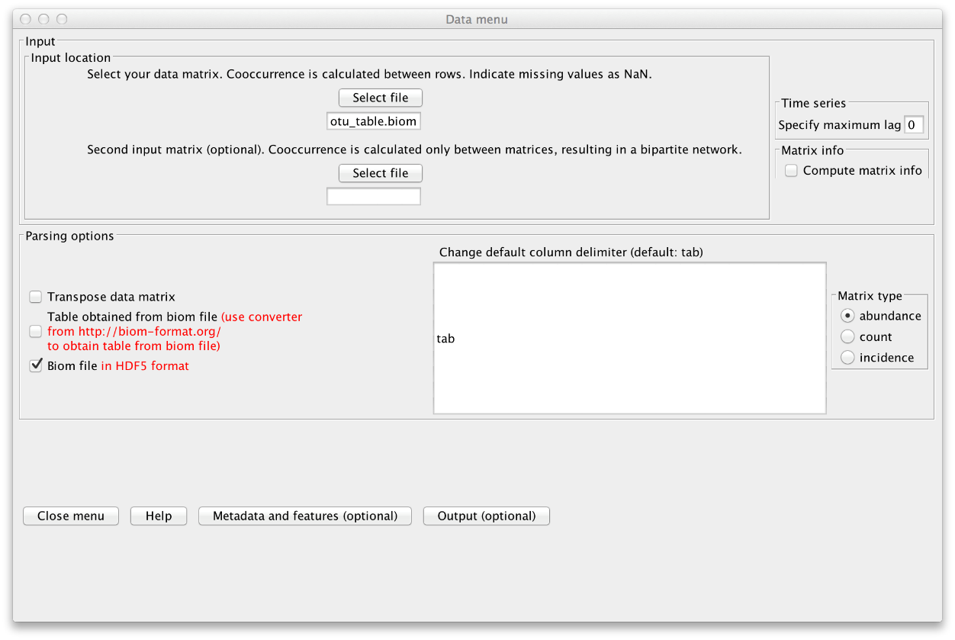

1. "explore links between higher-level taxa". This will cause CoNet to assign higher-level taxa from the lineages, e.g. "Solibacterales".
2. enable "Parent-child exclusion" to prevent links between higher- and lower-level taxa of the same lineage, e.g. between Acidobacterales and Acidobacteriaceae.
3. Finally, load the "features.txt" file via the "Select file" button in the Features part of the "Metadata and Features" sub-menu and enable "Transpose" and "Match samples". CoNet will transpose the environmental parameter file such that rows become columns and vice versa and will in addition match the sample names (discarding samples that are not present in both files), such that samples in the OTU file and in the environmental parameter file have the same order.   
     
      
     
   Preprocessing  
   Rare taxa need to be discarded, since their presence and absence is depending more on the sequencing depth than on biological reasons. In addition, sequencing depth differences can introduce spurious correlations. We lump all taxa below a minimum occurrence of 20 across the samples into a garbage taxon and convert counts into relative abundances by opening the "Preprocessing and filtering menu" from the main menu and enabling "row_minocc" with value 20, "Keep sum of filtered rows" and "col_norm".  
     
   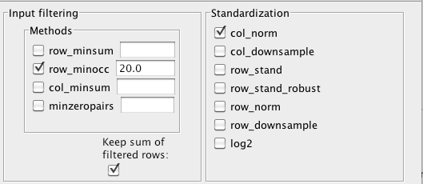   
     
   Methods and thresholds  
   In the "Methods menu", we select 5 methods for the ensemble inference: Pearson, Spearman, Mutual Information, Bray Curtis and Kullback-Leibler dissimilarity. Instead of specifying their thresholds manually, we request the 1000 top edges for each method in the "Threshold setting menu", where we also enable "Top and bottom" (to retrieve the 1000 top negative correlations as well).   
   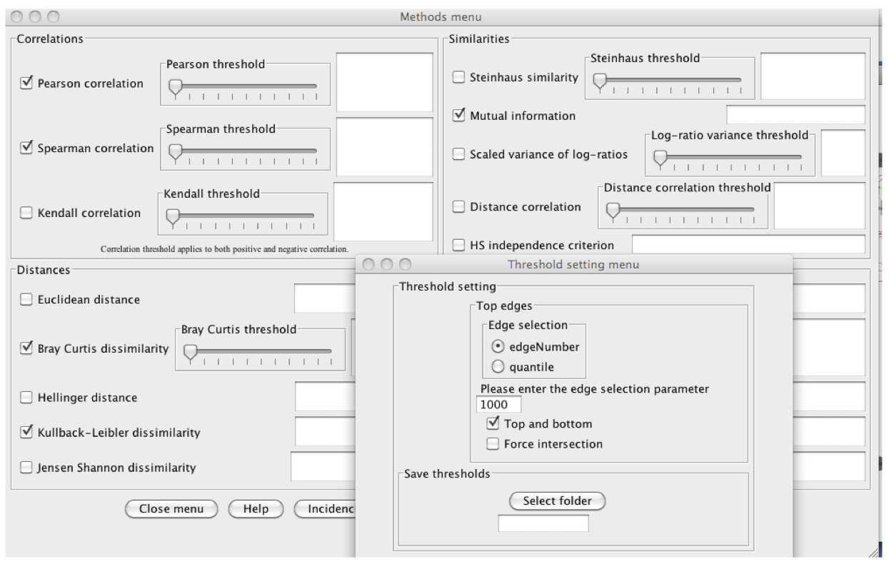   
     
   Run  
   If you now click "GO" in the main menu, a multigraph with at least 5*2*1000 edges will be constructed (5 methods, top and bottom, 1000 top edges). There can be more edges in case of ties (scores of equal value). This is the initial network, which will be refined by randomization. Positive edges are automatically colored in green, whereas negative edges are colored in red. Do you have an idea why mutual information edges are black and not green or red? You can look up the answer [here](http://psbweb05.psb.ugent.be/conet/microbialnetworks/solutions.php#mi).   
     
   **Step 3 - Permutation**  
   Continuing with the configuration from above, we can now carry out the permutations that are needed to compute p-values. To make them re-usable, we will store them in a file.  
     
   You can skip the permutation step (which takes around 5 minutes to run) and proceed with the next if you download and unzip the precomputed [conetNewPermutations.txt.zip](http://psbweb05.psb.ugent.be/conet/microbialnetworks/documents/conetNewPermutations.txt.zip) file.   
     
   If you want to use the permutation settings file, open "Settings loading/saving" in the main menu and load the [conet-permut-settings.txt](http://psbweb05.psb.ugent.be/conet/microbialnetworks/documents/conet-permut-settings.txt) file in the "Load CoNet settings" section. Clicking button "Apply settings in selected file" will configure CoNet with the settings in the file. You still need to adjust the paths to all your input files (that is "232_otu_table.biom.txt" in the Data menu and "arctic_soils_features.txt" in the "Metadata and Features" sub-menu). Please also enable "Biom file in HDF5 format" in the Data menu.   
     
   Else, open the "Randomization menu" and select "edgeScores" as routine and "shuffle_rows" as resampling strategy. Enable "Renormalize" (this will shift the permutation distribution such that compositionality biases are mitigated, as described in [PLoS Computational Biology 8 (7), e1002606](http://www.ploscompbiol.org/article/info%3Adoi%2F10.1371%2Fjournal.pcbi.1002606). Select a folder in which the permutation file will be stored. You can then enter a name for the permutation file (we will call it "conetNewPermutations.txt") and enable "Save randomizations to file".   
   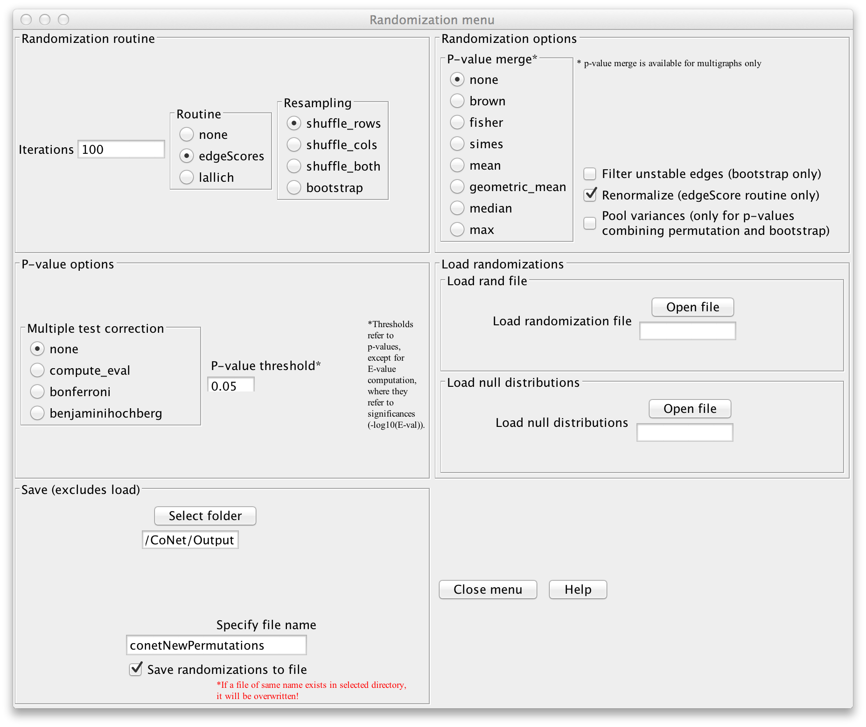   
     
   Click "GO" in the main menu to launch the computation. You can delete the intermediate network that appears when computation is finished.   
     
   **Step 4 - Bootstrapping**  
   Final p-values are computed from method- and edge-specific permutation and bootstrap score distributions. Thus, we will now compute the bootstrap distribution.   
     
   You can skip the bootstrap step (which takes 5 minutes to run) by downloading and unzipping the[conetNewBootstraps.txt.zip](http://psbweb05.psb.ugent.be/conet/microbialnetworks/documents/conetNewBootstraps.txt.zip) file. The next step explains how to obtain networks from precomputed permutations and bootstraps.   
     
   If you want to use a configuration file for the bootstrap step, please download the [conet-boot-settings.txt](http://psbweb05.psb.ugent.be/conet/microbialnetworks/documents/conet-boot-settings.txt) file and load it the same way as the permutation settings file. After adjustment of paths to input files and enabling "Biom file in HDF5 format" in the Data menu, you also need to adjust the path to the permutation file given in the randomization menu.   
     
   If you want to configure CoNet manually, open the randomization menu, select "bootstrap" as resampling method and choose "brown" as p-value merge strategy. In the permutation step, we computed method- and edge-specific p-values, but for the final network, we will merge all method-specific p-values of an edge into one p-value using Brown's method [(Biometrics 31 (4) 987-992, 1975)](http://www.jstor.org/discover/10.2307/2529826?uid=3737592&uid=2&uid=4&sid=21103560945017). Disable "Renormalize" and enable "Filter unstable edges", which discards edges with original scores outside the 0.95 range of their bootstrap distribution. You can then enable the "benjaminihochberg" multiple testing correction. The permutation file can be loaded via "Load null distributions". The bootstraps can be saved into a file by selecting a folder in the "Save" section, then specifying a file name (we use "conetNewBootstraps.txt") and enabling "Save randomizations to a file".   
   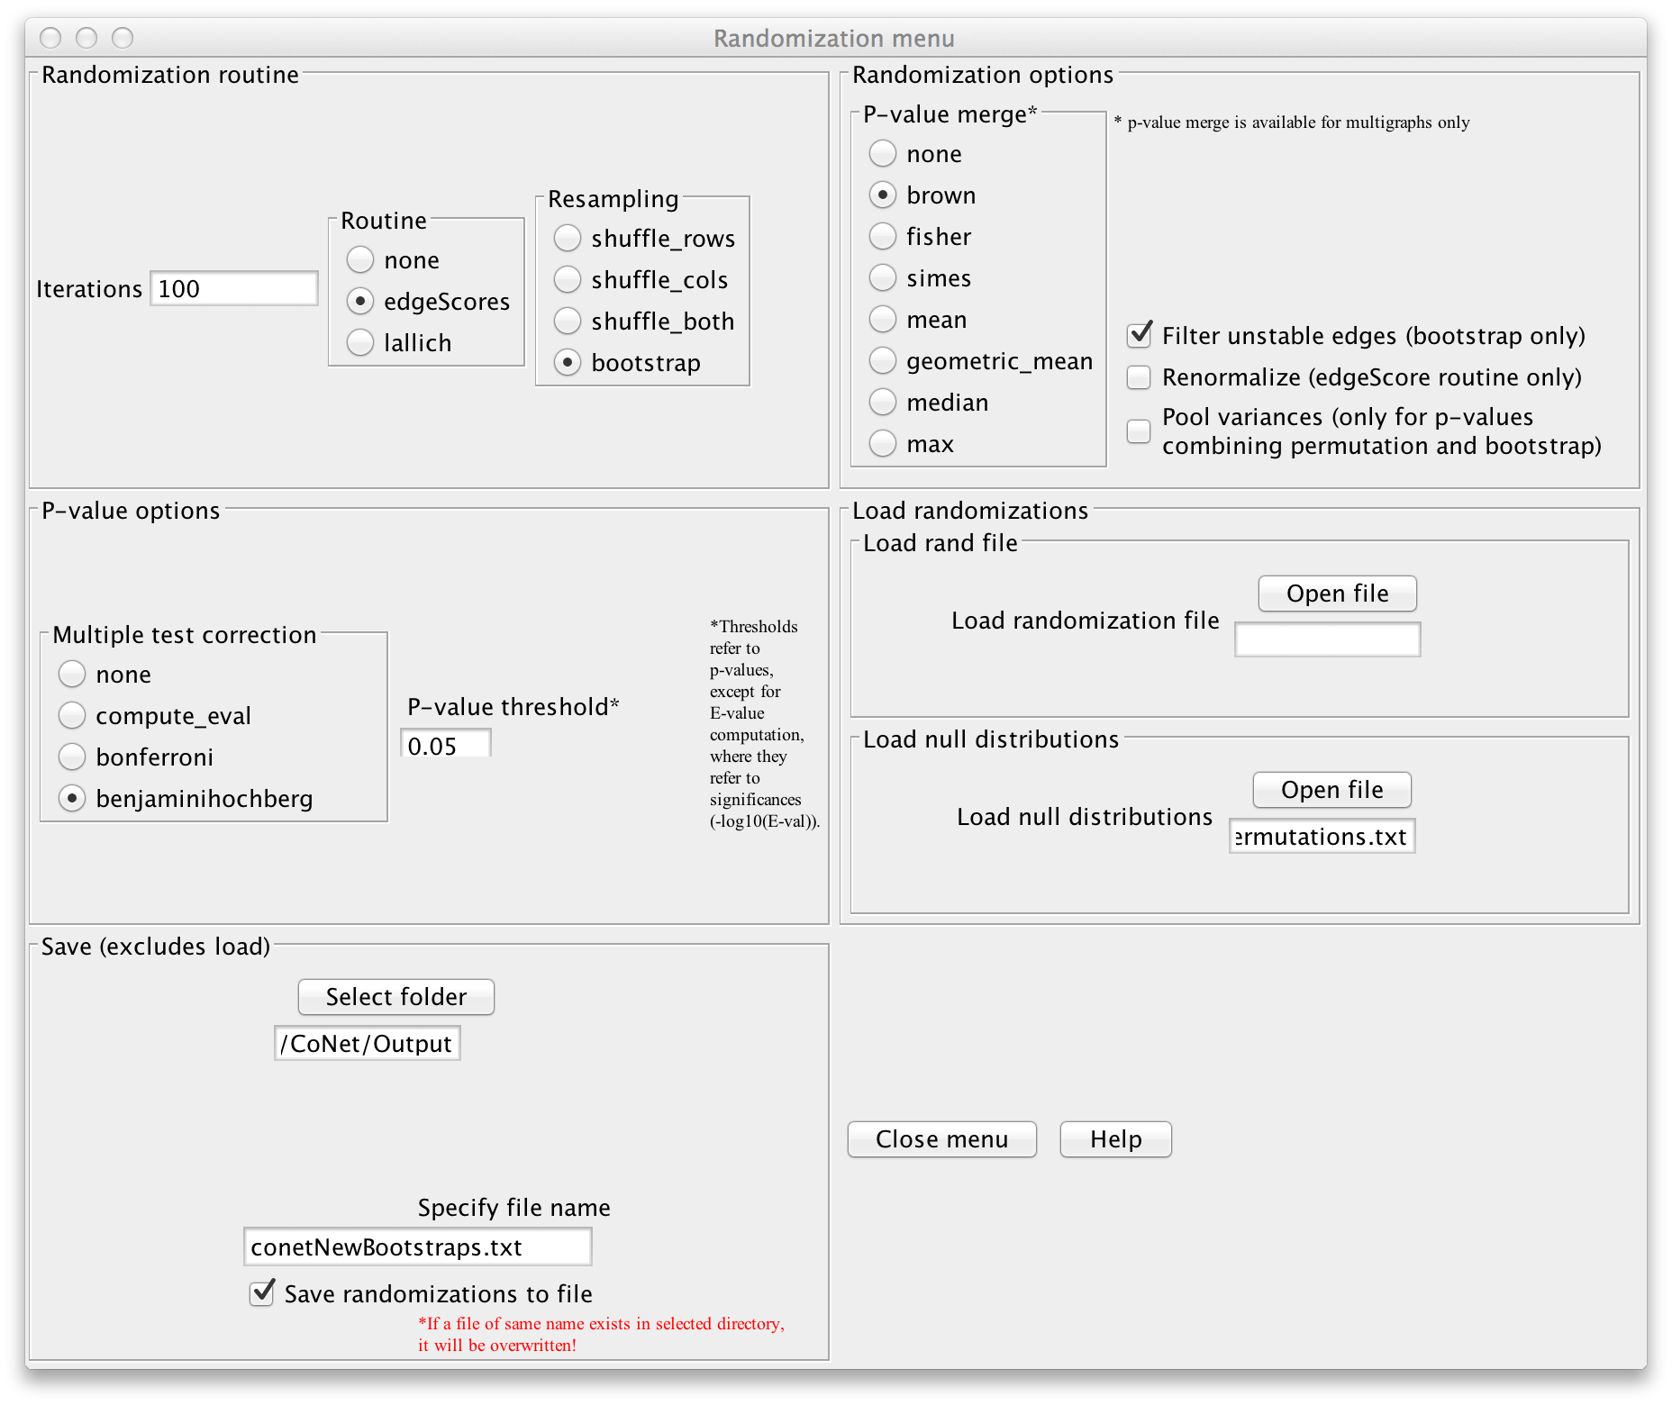   
     
   Click "GO" in the main menu to launch the computation. You have now computed the final network.   
     
   **Optional Step 5 - Restore network from random files**  
   Here we show how to restore a network from precomputed permutation and bootstrap files. For this, either load the settings in the [conet-restore-settings.txt](http://psbweb05.psb.ugent.be/conet/microbialnetworks/documents/conet-restore-settings.txt) file as described previously (taking care to adjust the paths to all input and random files and to enable "Biom file in HDF5 format" in the Data menu) or open the Randomization menu, select "edgeScores" as routine, "bootstrap" as resampling strategy, disable "Renormalize" and "Save randomizations", enable "Filter unstable edges" and empty the "Select folder" and "file name" fields in the "Save" section. You can then choose a p-value merge technique (we propose "brown") and a multiple-test correction method (e.g. "bejaminihochberg"). We then load the previously computed permutations as null distribution and the bootstraps as random distribution.   
   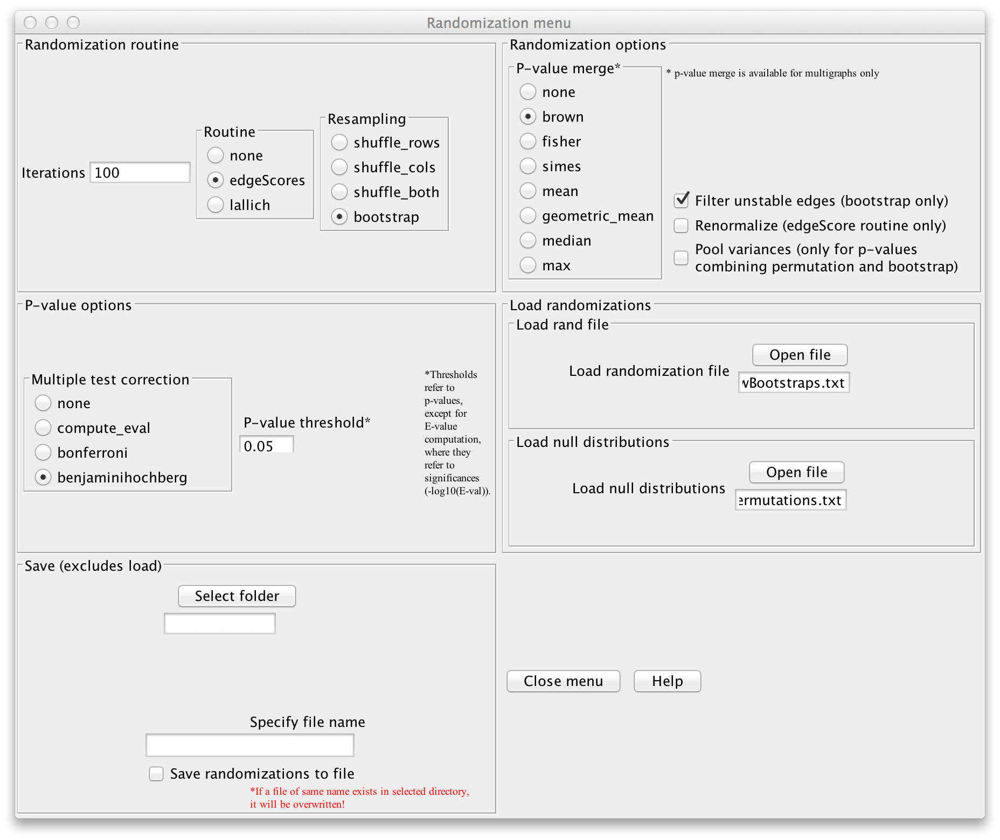   
   Click "GO" in the main menu to launch the computation. You have now (re-)computed the final network.   
     
   **Step 6 - Visualization**  
   First, you can select a network layout, e.g. Layout->yFiles Layouts->Organic. CoNet returns a network with its own style, where positive and negative edges are colored green and red, respectively. We can enhance the default style for instance by assigning colors to different classes. For this, open the Style panel for Node, select "Fill Color" with "class" as Column and choose "Discrete Mapping" as Mapping Type. You can right-click on "Mapping Type", select "Mapping Value Generators", then "Rainbow" to fill the different nodes with randomly selected class-specific colors.   
   