CBDB User MDB — Issues Report
A respectful summary of issues uncovered during regression testing.
Dear maintainer,
Below is a summary of the issues we uncovered while building an automated regression-test suite for the CBDB User MDB. We hope this report is useful as you continue your wonderful stewardship of this dataset, and we sincerely thank you for the immense work that has gone into building it.
The issues are ordered by severity (P0 highest). Each entry includes a concise description, step-by-step user reproduction, screenshots where the issue is visible in the Access UI, and a suggested fix. None of these are urgent; they are documented so they can be addressed at the maintainer's convenience.

Table of Contents
Right-click here and choose 'Update Field' to populate.

Severity legend
- P0 — Silent data corruption: data is wrong or missing without an error popup.
- P1 — Visible runtime crash: a popup appears, the operation aborts.
- P2 — Silent display: form fields render blank when they should show data.
- P3 — Missing UI: a feature exists in code but no button invokes it.
- P4 — Setup: one-time hurdle on each new install.
- P5 — Dormant / latent / not currently reproducible: kept as historical record; we re-checked on the current dump and could not trigger the symptom.

P0 — Silent data corruption

Issue #7 — LookAtPlace.CmdNeo4j people-CSV silently fails on the first record

Affected sub
Form_LookAtPlace.CmdNeo4j_Click

Severity
P0 — Silent data corruption (export silently produces nothing)

Description
The People-CSV section of `LookAtPlace.CmdNeo4j_Click` (line ~322 onward) builds a recordset from a SELECT that projects only four `ZZ_SCRATCH_P_TEXT` columns, but the row-write loop reads `!c_dynasty`, `!c_dynasty_chn`, and `!c_female` from that recordset. As soon as the loop hits the first row, JET raises 'Item not found in this collection'. The error handler silences it with `MsgBox`, so the user sees a single popup, then NO files are produced for any of the downstream Neo4j export steps.

Steps to reproduce
- Open **LookAtPlace**. Pick the address picker, choose a well-attested address — for example **c_addr_id = 100658** (Kaifeng 開封; this is also the addr_id used by `tests/test_vba_inline.py`'s kaifeng-yin fixture) — so the resulting query has plenty of people to feed the People-CSV loop. Click **Run Query**.
- Once the query finishes, click the **Neo4j** export button.
- Pick a save location at the first SaveAs prompt (the 'People file' prompt).
- A `Run-time error 3265 — Item not found in this collection` popup appears almost immediately.
- After clicking OK, the chosen folder is empty — no Neo4j export file was written.

Screenshots
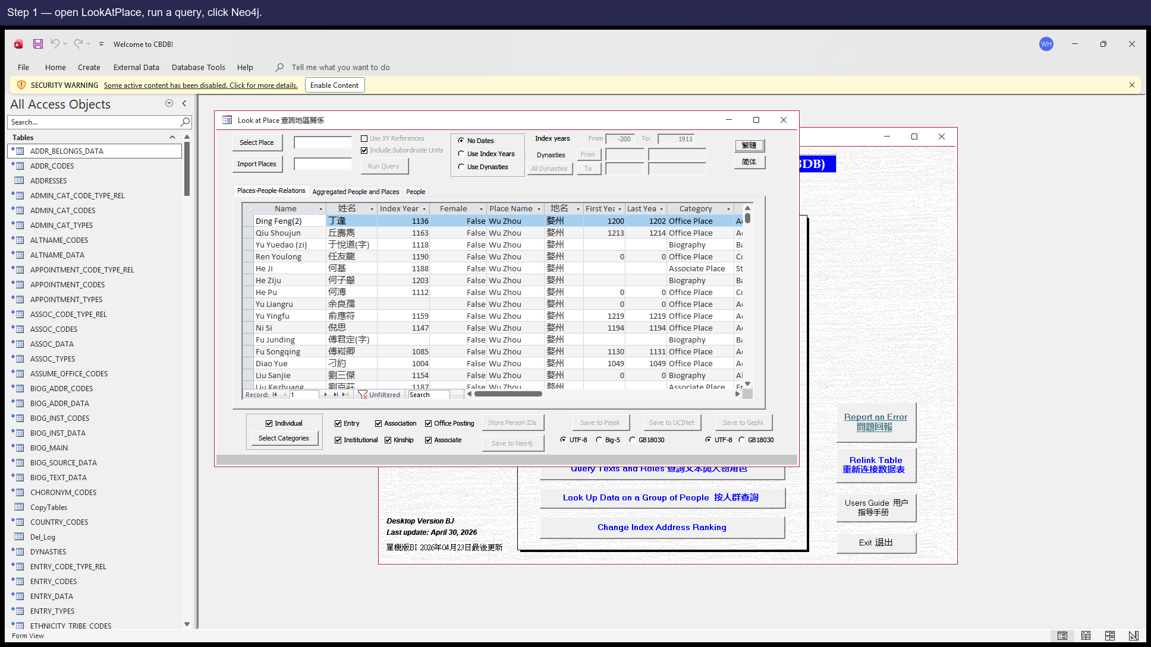
Step 1 — open LookAtPlace, run any query, click **Neo4j**. The CmdNeo4j button is in the bottom export-button row; reachability verified against `analysis/dump/control_inventory.json` (LookAtPlace has a `CmdNeo4j` control with the `CmdNeo4j_Click` event bound — re-checked 2026-05-03).
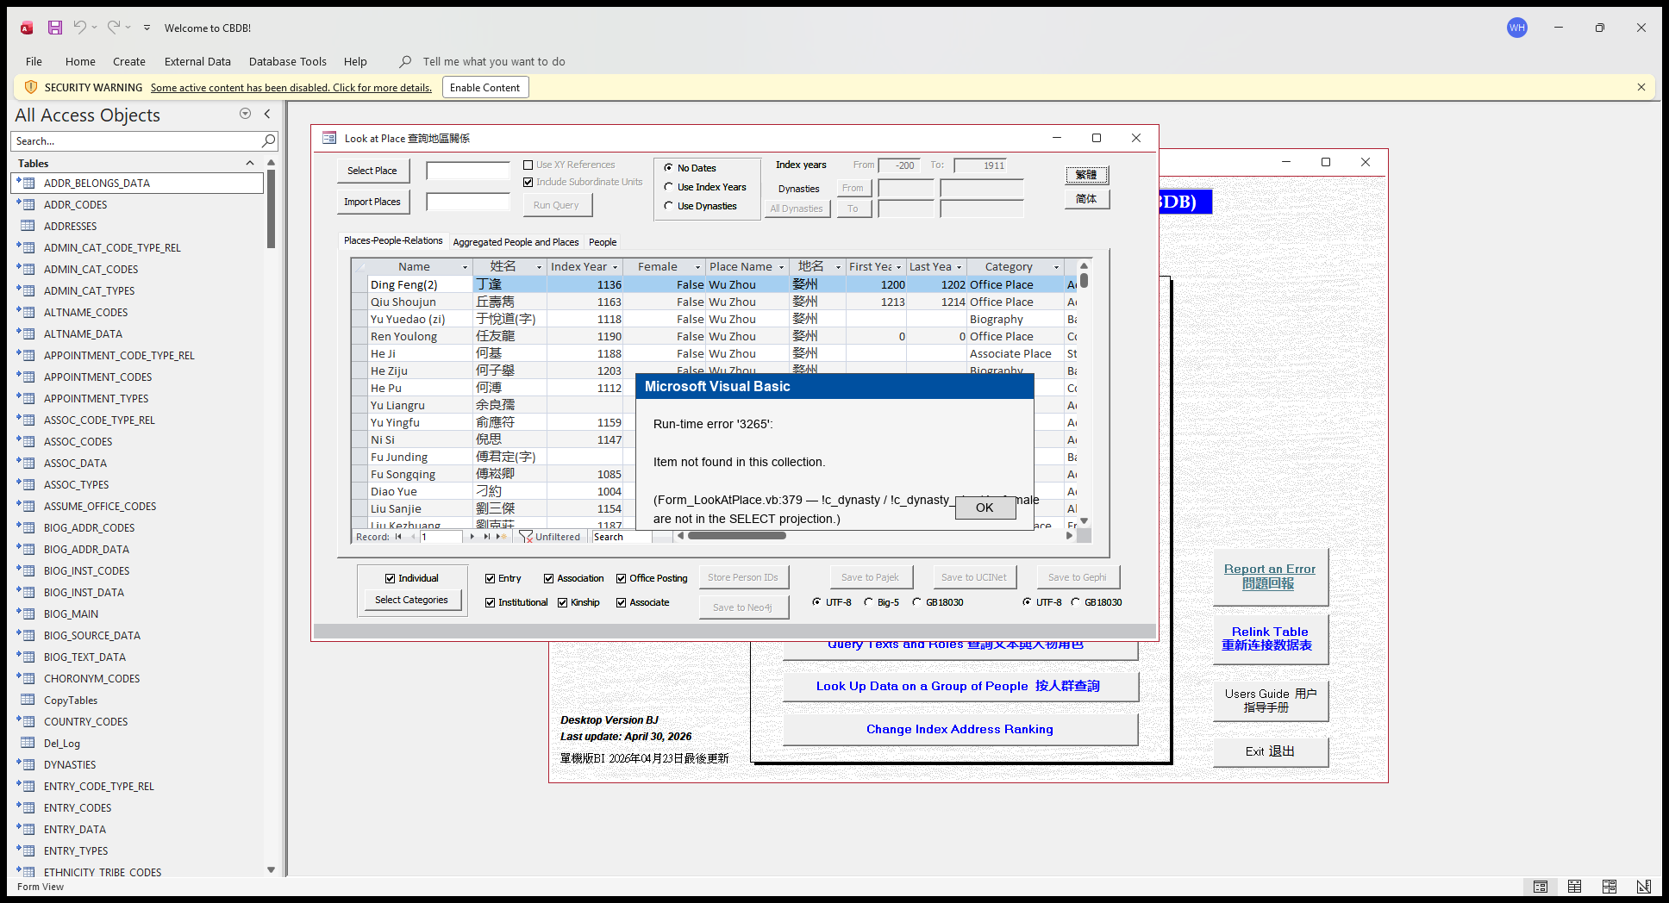
Step 2 — the popup users see. Reconstructed in PIL because the real popup would block the COM test driver; the error code (DAO 3265 'Item not found in this collection') and message text come from JET's documented behaviour for a recordset field that isn't in the underlying SELECT.

Suggested fix
Extend the SELECT in the People-CSV branch to project the fields the loop reads, e.g. `DYNASTIES.c_dynasty`, `DYNASTIES.c_dynasty_chn`, `BIOG_MAIN.c_female` (the JOINs already expose them).

Issue #8 — LookAtNetworks.CmdNeo4j people/place CSVs silently fail on the first record

Affected sub
Form_LookAtNetworks.CmdNeo4j_Click

Severity
P0 — Silent data corruption

Description
Same shape as Issue #7 but on a different form. Two SELECTs in `LookAtNetworks.CmdNeo4j_Click` are missing fields that the row-write loop reads:
• `tRstPlace` SELECT (line 2458) projects 3 columns; the loop reads `!x_coord` / `!y_coord` (not projected).
• `tRstPeoplePlace` SELECT similarly omits `c_person_id` / `c_index_addr_id` that the loop reads.
Same silent-fail symptom as Issue #7.

Steps to reproduce
- Open **LookAtNetworks** (note: this form has a known opening-delay issue; please allow several seconds).
- Run a query, then click **Neo4j**.
- When the export reaches the People-with-Place file, the same `Item not found` popup appears, and no further files are written.

Screenshots
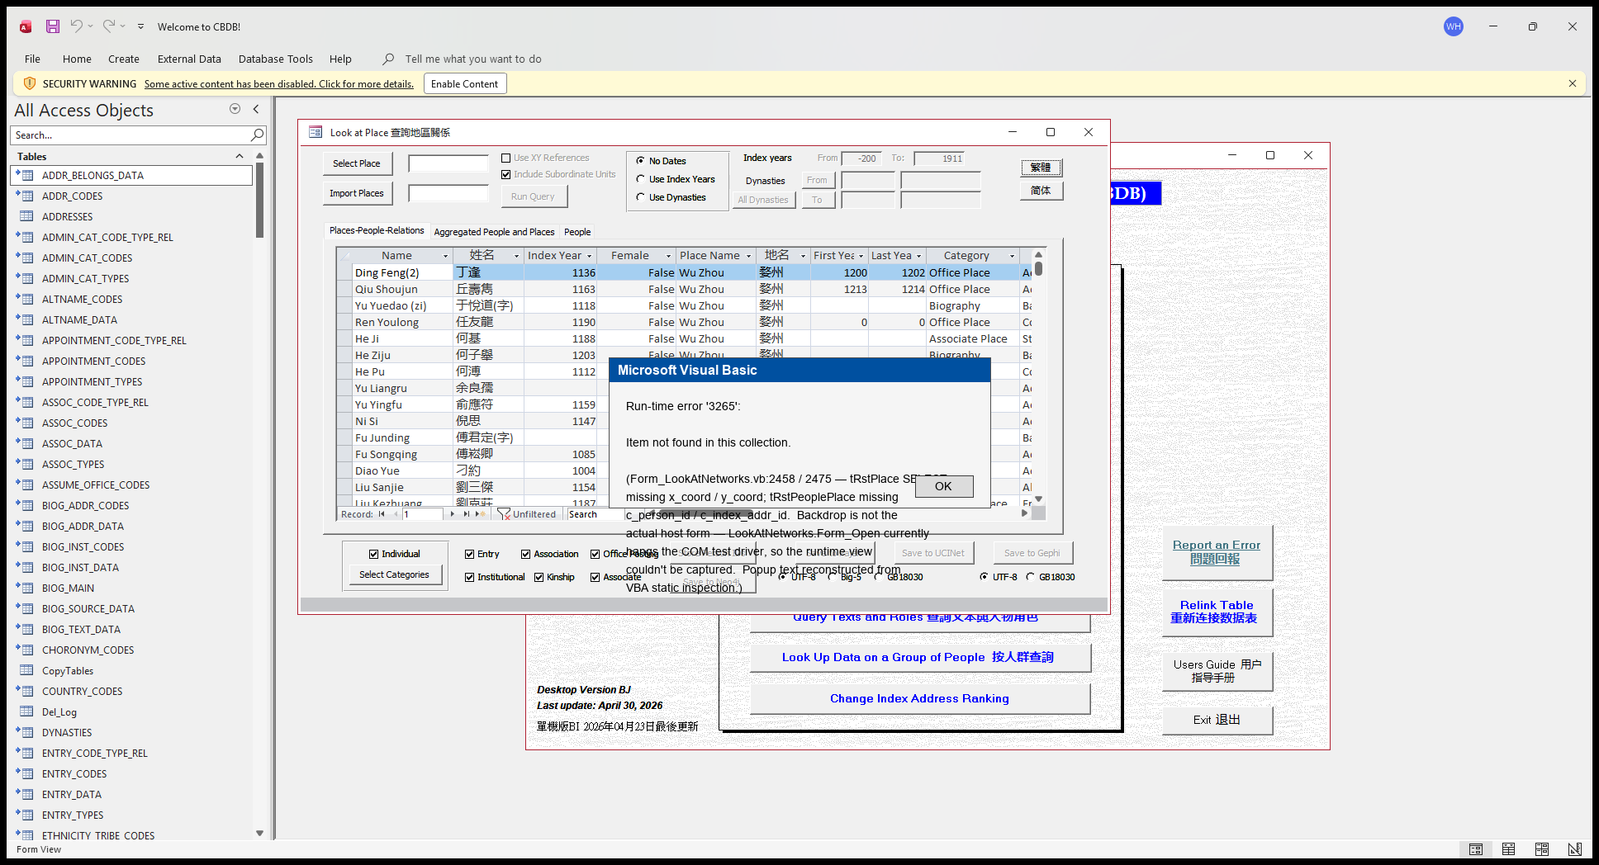
Reconstructed-in-PIL popup showing the JET 'Item not found in this collection' error users would see. **Important caveat:** the backdrop in this image is LookAtPlace, NOT LookAtNetworks — LookAtNetworks's `Form_Open` currently hangs the COM test driver, so a real runtime view of the host form couldn't be captured. The popup text is reconstructed from VBA static inspection of `Form_LookAtNetworks.vb:2458` / `:2475`.

Suggested fix
Extend each SELECT to project every field the loop reads. For tRstPlace: add `ADDR_CODES.x_coord`, `ADDR_CODES.y_coord`. For tRstPeoplePlace: add the missing `c_person_id` / `c_index_addr_id` columns from the joined tables.

Issue #20 — BOM-prefixed address names can become embedded tabs and misalign GIS exports

Affected sub
ADDR_CODES + Form_LookAt*.CmdGIS_Click

Severity
P0 — Silent export column misalignment (numeric fields land in text columns; values shifted by one and one extra trailing column appears)

Description
315 rows of `ADDR_CODES` carry a stray `U+FEFF` (BOM) prefix in **both** `c_name` and `c_name_chn`, almost certainly the residue of a UTF-8-with-BOM paste at data-import time. When `LookAtStatus.CmdQuery` (and the equivalent CmdQuery / CmdRun on the other LookAt forms) copies one of these rows into its scratch staging table via SQL UPDATE/INSERT, JET strips the BOM and re-interprets the remaining UTF-16 LE bytes as single-byte chars — promoting them back to Unicode but with mangled values. For `c_addr_id = 702559` (Wei Shi / 尉氏) the source string `﻿尉氏` (UTF-16 bytes `ff fe 09 5c 0f 6c`) becomes the staged string `\t\\\x0fl` (UTF-16 bytes `09 00 5c 00 0f 00 6c 00`) — with a literal **TAB character at position 0**.
`Form_LookAtStatus.CmdGIS_Click` (lines 1554–1636) then writes each cell as `tStr + value + tC` with `tC = Chr(9)` (line 1552) — no escaping is performed. The embedded TAB becomes a delimiter, splits AddrChn into two cells, and silently shifts every column to its right. A user opening the resulting `.tab` file in Excel sees coordinates land in the wrong column and an extra trailing column. The same `tStr + value + tC` pattern is present in the CmdGIS body of LookAtTexts / LookAtPlace / LookAtAssociations / LookAtOffice / LookAtKinship, so any LookAt form whose query happens to include one of the 315 dirty addresses reproduces the same misalignment.
Evidence — full byte-level trace in `analysis/gis_status_embedded_delim_root_cause.md`; source-side scan in `reports/gis_embedded_delimiter_findings.json`; exported-file dump in `reports/gis_status_export_bytes_dump.json`. The regression test `tests/test_addr_codes_embedded_delim.py` will fail (intentionally) if the upstream data is cleaned, prompting a re-evaluation.
**Known reach (PR W).** Of the 315 dirty `ADDR_CODES` rows, **only 1** (`c_addr_id = 702559` / Wei Shi 尉氏) is referenced by any person record in `BIOG_MAIN` or `BIOG_ADDR_DATA`; the other 314 are orphan rows with no person attached. So today's user-facing surface is small: byte-confirmed in **LookAtStatus** (`c_status_code=40` fixture, the row this report was filed on); **likely reachable** in **LookAtKinship** (any of the 3 persons whose kin includes Ruan Fu) and in **LookAtPlace** (if a user picks `c_addr_id = 702559`); **not currently reachable** in **LookAtTexts / LookAtAssociations / LookAtOffice** under existing source data. Full per-form reach analysis in `analysis/gis_embedded_delimiter_reach.md` and `reports/gis_embedded_delimiter_reach.json`. The 314 orphan rows are a latent data-quality issue — they would reproduce the same misalignment the moment any of them gains its first person link. Both candidate fixes above remain warranted.

Steps to reproduce
- Open **LookAtStatus**. Pick the status picker and choose status code **40** (civil office / [為官者：文]) without setting any year filter — `FrameFilterYears = 1` in the test fixture.
- Click **Run Query**. ~17 000 rows populate the result grid.
- Click **GIS** with the encoding selector set to UTF-8 (`GISFrame = 1`). Save the resulting `.tab` file.
- Open the file in any tab-aware tool (Excel / a text editor with column rulers). Around row **11476** (corresponding to person Ruan Fu / 阮孚, `c_addr_id = 702559` / Wei Shi 尉氏) one row has 10 tab cells against the 9-column header. AddrChn is blank, X column contains text, the real X / Y values have all shifted one column to the right.

Suggested fix
Two complementary fixes, both worth doing:
1. **One-shot data cleanup.** Strip the leading `U+FEFF` from the 315 affected `ADDR_CODES.c_name` / `c_name_chn` rows (e.g. `UPDATE ADDR_CODES SET c_name = Mid(c_name, 2) WHERE Left(c_name, 1) = ChrW(65279)` and the parallel statement for `c_name_chn`). This removes the immediate user-visible misalignment.
2. **Defensive sanitisation in the export writers.** Before each `tStr = tStr + value + tC` append in the CmdGIS bodies of LookAtStatus / Texts / Place / Associations / Office / Kinship, replace any embedded Chr(9), Chr(10), Chr(13), Chr(11), Chr(12), or `U+FEFF` in `value` with a space. This protects the same export writers against any future similar dirty data — without it, the next tab character that creeps into `ADDR_CODES.c_name` (or `BIOG_MAIN.c_name`, or any other text field these exports touch) will reproduce the same silent misalignment.
3. **Optional pre-release audit.** A short script scanning every export-bound text column for delimiter or control characters before each release would catch this class of dirty-data issue before it ships. `analysis/probe_status_gis_embedded_delim.py` is a concrete starting point.

P1 — Visible runtime crash

Issue #6 — LookAtGroupData ChkEntry path references a non-existent column ENTRY_DATA.c_parental_status

Affected sub
Form_LookAtGroupData.queryEntry

Severity
P1 — Visible crash on a common path (Entry sub-query)

Description
`Form_LookAtGroupData.vb` line 2621 has an INSERT INTO whose target column list ends with `c_parental_status_code` but whose SELECT projection ends with `ENTRY_DATA.c_parental_status` (no `_code` suffix). The actual column on `ENTRY_DATA` is `c_parental_status_code`; the typo means the SQL crashes with 'No such field' the moment the user checks **Entry** and clicks **Run**.
`Form_LookAtEntry.vb:1650` does the same logical query and uses the correct name, so this is a single-line drift.

Steps to reproduce
Recommended demo person: c_personid=1 (安惇, An Dun)
Use person 1 (安惇, An Dun) as the import list (small: only 2 entry row, fast to reproduce). In LookAtGroupData, leave only the **Entry** checkbox ticked, click **Run**. — picked by `reports/probe_demo_persons.py`; a SQL probe selected this person because their row counts genuinely satisfy the precondition the bug needs.
- In **LookAtGroupData**, populate the import list with one entry — c_personid = 1 (An Dun 安惇) is enough; he has exactly 2 ENTRY_DATA rows so the broken queryEntry SQL will run on a tiny well-known sample.
- Tick **only** the **Entry** checkbox (leave Status / Office / Text / Addr unchecked so the unrelated query branches don't fire).
- Click **Run**.
- A popup appears reporting that a field doesn't exist (JET reports this as 'No value given for one or more required parameters' / 'No such field' depending on the Office build — both mean the SQL referenced `ENTRY_DATA.c_parental_status` which doesn't exist).

Screenshots
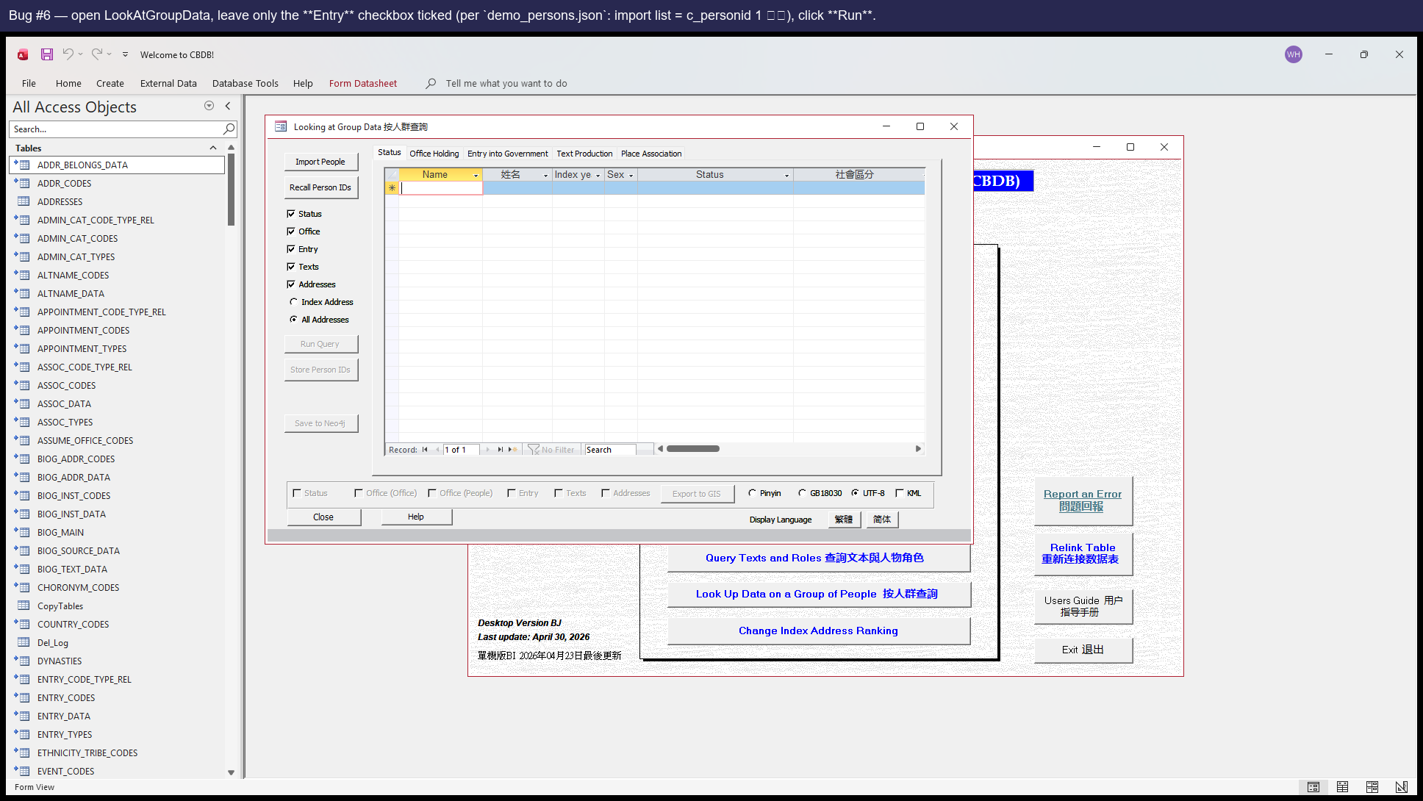
Step 1 — open LookAtGroupData, leave only the Entry checkbox ticked, click Run. (Demo input from `reports/demo_persons.json`: import list = c_personid 1, 安惇.)
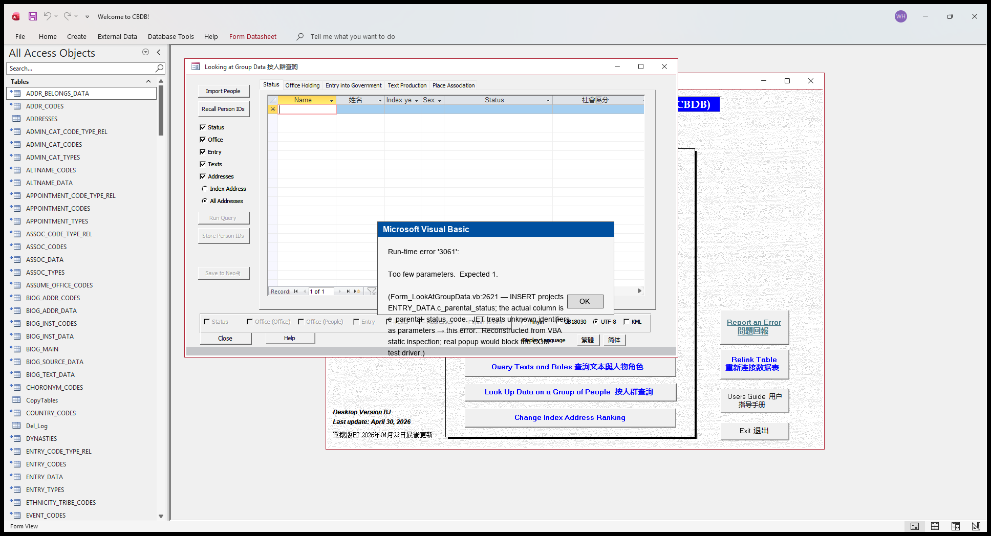
Step 2 — the JET error popup users see. The popup graphic is reconstructed in PIL because the real popup would block the COM test driver; the error code (3061) and message text come from JET's documented behaviour for unknown-identifier-as-parameter on the line cited in the summary.

Suggested fix
Change `ENTRY_DATA.c_parental_status` to `ENTRY_DATA.c_parental_status_code` on line 2621. One-line fix.

Issue #13 — BIOG_MAIN_2 Subform tries to open a picker form (frmPickNIAN_HAO) that doesn't exist

Affected sub
Form_BIOG_MAIN_2_Subform.c_fl_ey_notes_Click

Severity
P1 — Visible crash on a user click

Description
When the user clicks the `c_fl_ey_notes` field on a person's biographical detail subform, `Sub c_fl_ey_notes_Click` runs `DoCmd.OpenForm "frmPickNIAN_HAO"`. There is no form named `frmPickNIAN_HAO` in the .mdb's CurrentProject.AllForms collection. Access raises 'Item not found …' and the field click does nothing useful for the user.
Likely cause: a picker form was renamed or consolidated in an earlier refactor, and this caller wasn't updated.

Steps to reproduce
Recommended demo person: c_personid=5 (查籥, Zha Yue)
Open person 5 (查籥, Zha Yue). Their `c_fl_ey_notes` field has actual text in it (sample: '紹興二十一年進士。…'), so clicking it actually triggers the broken Sub. — picked by `reports/probe_demo_persons.py`; a SQL probe selected this person because their row counts genuinely satisfy the precondition the bug needs.
- Open the biographical detail form for **c_personid = 5 (Zha Yue 查籥)** — picked because his BIOG_MAIN row has a non-empty `c_fl_ey_notes` value, so the field is interactable (clicking an empty field doesn't fire the Sub).
- On the BIOG_MAIN_2 subform, click the `c_fl_ey_notes` field — that fires the `c_fl_ey_notes_Click` Sub.
- An `Item not found in this collection.` popup appears (because the Sub tries `DoCmd.OpenForm "frmPickNIAN_HAO"` and that form doesn't exist).

Screenshots
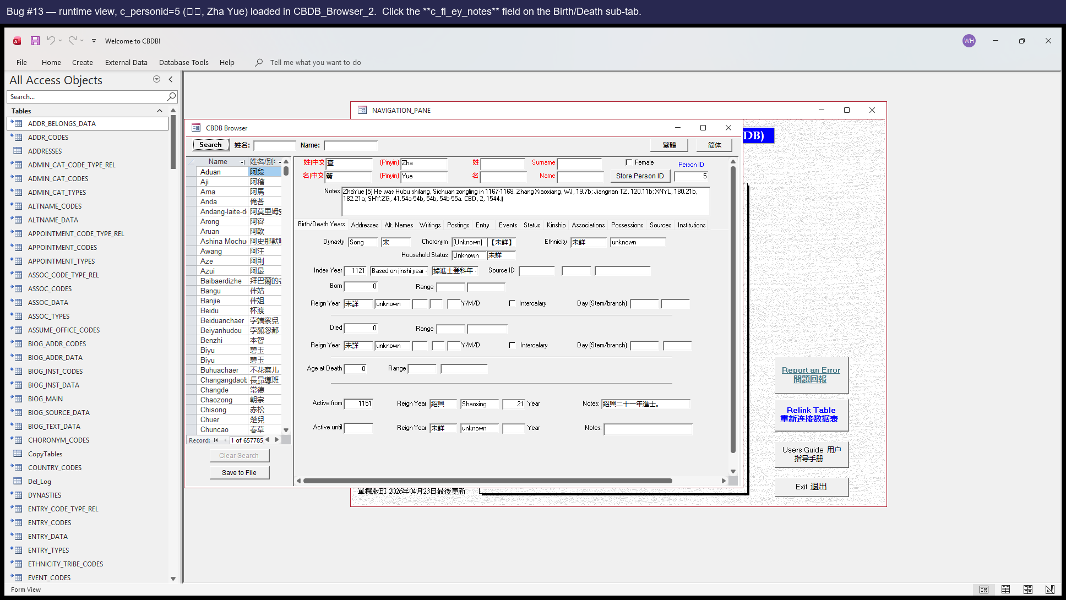
Step 1 — open CBDB_Browser_2, navigate to c_personid=5 (查籥 Zha Yue), click the `c_fl_ey_notes` field on the Birth/Death sub-tab (this fires `c_fl_ey_notes_Click`).
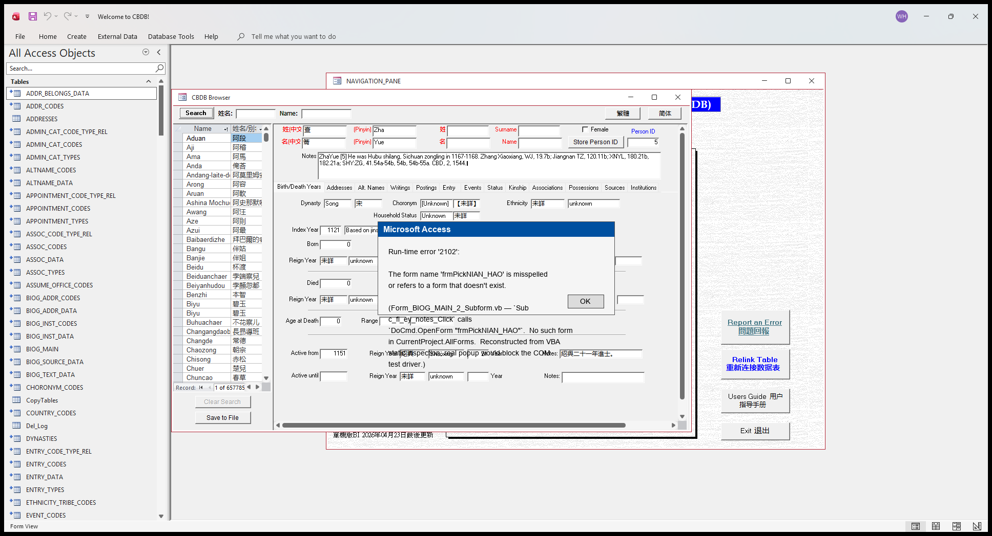
Step 2 — the popup users see. Reconstructed in PIL because the real popup would block the COM test driver; error 2102 + 'misspelled or refers to a form that doesn't exist' is Access's standard message when DoCmd.OpenForm targets a form not in CurrentProject.AllForms.

Suggested fix
Either restore the picker form `frmPickNIAN_HAO`, or update the caller in `Form_BIOG_MAIN_2_Subform.c_fl_ey_notes_Click` to use whichever picker form replaced it.

Issue #21 — LookAtGroupData.CmdNeo4j crashes with 'No current record' on empty sections

Affected sub
Form_LookAtGroupData.CmdNeo4j_Click

Severity
P1 — Visible crash on a normal user click (any GroupData CmdNeo4j export where Entry data is absent for the queried person, which is the common case for figures with sparse entry records)

Description
All 11 CSV export blocks in `Form_LookAtGroupData.CmdNeo4j_Click` open a scratch recordset and immediately call `.MoveFirst` without first checking if the recordset is empty (no `.EOF` or `.RecordCount > 0` guard). When a user queries a group whose data has no rows in a given category — for example, no Entry data so `ZZ_SCRATCH_ENTRY` is empty — the `.MoveFirst` call instantly raises DAO 3021 'No current record', a popup blocks the user, and the entire Neo4j export chain aborts.
On the current dump and a typical small fixture the **first user-reachable failure is block #9 PeopleEntry** (line 1243-1245) — `Set tRstPeopleEntry = CurrentDb.OpenRecordset("ZZ_SCRATCH_ENTRY", dbOpenDynaset)` followed unguarded by `.MoveFirst`. The same missing-guard pattern also exists in the immediately-following **block #10 EntryCode** (line 1383-1385) and in other ungated tail blocks; block #10 doesn't currently surface as a separate symptom only because the chain bails at block #9 first.
Note on broader code scope: blocks #1-#8 share the same `Set ... = OpenRecordset(...)` followed by `.MoveFirst` shape, but their feeder scratch tables (ZZ_SCRATCH_STATUS, ZZ_SCRATCH_OFFICE, ZZ_PLACE, ZZ_SCRATCH_P_TEXT, ZZ_ADDRESSES) are non-empty under any normal user enable scope, so the empty-feeder failure mode is NOT user-reachable on those blocks today. Block #11 InstitutionCodes (line 1485-1487) is correctly gated by `If tRecDeleted > 0 Then` upstream and is NOT part of the bug. Only blocks #9 and #10 need a guard added to fix the user-reachable symptom.
This is **distinct from Issue #6**: Issue #6 is a column-typo (`ENTRY_DATA.c_parental_status` vs `c_parental_status_code`) in `queryEntry` that prevents `ZZ_SCRATCH_ENTRY` from being populated at all when ChkEntry is on. Issue #21 is a separate downstream missing-guard bug in `CmdNeo4j_Click` that fires whenever `ZZ_SCRATCH_ENTRY` happens to be empty — including via the upstream Issue #6 path, but also independently when the user simply doesn't tick ChkEntry. Two different code-level defects; should be filed and fixed separately.

Steps to reproduce
- In **LookAtGroupData**, populate the import list with c_personid = 1 (An Dun 安惇) — he has 2 STATUS_DATA / 2 ENTRY_DATA / ~12 POSTED_TO_OFFICE rows so the chain has substantive feeder data for Status / Office but Entry data won't appear in ZZ_SCRATCH_ENTRY unless ChkEntry is ticked (which would also trigger Issue #6 separately).
- Tick **Status**, **Office**, **Addr** and the matching **GIS** sister checkboxes — but leave **Entry** unticked (ZZ_SCRATCH_ENTRY stays empty). Click **Run**.
- After CmdRun finishes (ZZ_SCRATCH_STATUS gets 2 rows, ZZ_SCRATCH_OFFICE gets 12), click the **Neo4j** export button.
- The chain produces 8 CSVs cleanly (People, Places, PeoplePlaces, PersonPlaceCodes, PeopleStatus, StatusCode, PeopleOffice, OfficeCodes), then a `Run-time error 3021 — No current record` popup appears when the chain reaches block #9 (PeopleEntry). The remaining 2-3 expected files (PeopleEntry, EntryCode, optional InstitutionCodes) are never written.
- Verified end-to-end via probe at `analysis/probe_groupdata_cmdneo4j.py` and `analysis/probe_groupdata_cmdneo4j_tail.py` — the tail probe's iter 3 split-then-seed iteration manually inserts one row into ZZ_SCRATCH_ENTRY, at which point the chain produces 10 files with no ERR (proves the trigger is the empty source recordset, not anything else).

Suggested fix
Add an `.EOF` (or `.RecordCount > 0`) guard before the `.MoveFirst` call in **block #9 PeopleEntry (line ~1245) and block #10 EntryCode (line ~1385)** of `Form_LookAtGroupData.CmdNeo4j_Click`. These are the two user-reachable blocks; the other tail blocks either have an upstream gate (block #11 InstitutionCodes — `If tRecDeleted > 0 Then`) or their feeder scratch tables are non-empty under any normal user enable scope (blocks #1-#8). Suggested shape:
```vb
Set tRstPeopleEntry = CurrentDb.OpenRecordset("ZZ_SCRATCH_ENTRY", dbOpenDynaset)
With tRstPeopleEntry
If Not .EOF Then
.MoveFirst
Do While Not .EOF
' ... existing per-row write ...
.MoveNext
Loop
End If
End With
```
Defensive scope option (not required to close this issue): adding the same guard to blocks #1-#8 is harmless and would future-proof against a new enable path leaving any of those feeder tables empty. Not required because no such path exists today.

Issue #22 — LookAtAssociations.CmdUCINet crashes with 'Invalid procedure call or argument' on networks containing CJK Han characters in c_name

Affected sub
Form_LookAtAssociations.CmdUCINet_Click

Severity
P1 — Visible crash on a normal user click. Any user attempting `LookAtAssociations × CmdUCINet` whose 1st-order association network happens to include a person with a CJK Han ideograph in their `c_name` will hit a Run-time error 5 popup and lose the export. On the current dump that's at least the 8087-row scratch table for person 437 (the verified fixture); the broader prevalence across CBDB persons depends on how many BIOG_MAIN rows have Han ideographs in their ostensibly-Latin `c_name` field — at minimum 2 such rows reach person 437's network, and any person with even one such 1st-order neighbour is affected.

Description
`Form_LookAtAssociations.CmdUCINet_Click` writes the `.vna` export via `Scripting.FileSystemObject.CreateTextFile(tFileName, True)` (line ~2575). The 3rd argument (`Unicode`) is omitted, so it defaults to FALSE — the file is opened in the system default ANSI code page (cp1252 on en-US Windows).
Inside the `*node properties` section, the body writes `tQuote + !c_name + tQuote` for each row. When `c_name` contains a character that has no cp1252 representation AND no FSO substitution mapping (CJK Han ideographs in particular — e.g. U+7A1C 稜), `tVNA.WriteLine` raises VBA error 5 ('Invalid procedure call or argument') and the whole CmdUCINet export aborts. The partial `.vna` file is left on disk — `*node data` complete, `*node properties` truncated, `*tie data` never written.
User-visible symptom: a Run-time error 5 popup blocks the user; the exported `.vna` file is incomplete and unusable in UCINET / Visone.
**Affected forms (per current evidence on this dump):**
- **LookAtAssociations** — directly canonicalized. Static + runtime pinned via `tests/test_known_bugs.py::test_bug22_associations_cmducinet_createtextfile_no_unicode_arg` and `tests/test_vba_bug_behaviors.py::test_bug22_associations_cmducinet_fires_invalid_procedure_call`. Original investigation evidence in `analysis/probe_associations_cmducinet_error5.md`.
- **LookAtKinship** — **runtime-confirmed sibling form sharing the same root cause.** `Form_LookAtKinship.CmdUCINet_Click` uses the same `CreateTextFile(tFileName, True)` 2-arg pattern at line ~2510. Reproduced via probe `investigate/kinship-cmducinet-sibling-risk` (commit 154bb4b) using picker = pid 152930 (He Jing 何淨) whose sole 1-hop kin is pid 140733 (He Mou 取, U+53D6 = same CJK Han ideograph trigger class as Associations' 稜 = U+7A1C). Probe outcome: same `:ERR Invalid procedure call or argument`, same partial-file shape (full `*node data` + truncated `*node properties` + missing `*tie data`). Static marker `tests/test_known_bugs.py::test_bug22_associations_cmducinet_createtextfile_no_unicode_arg` extended in this PR to also assert the same 2-arg pattern in `Form_LookAtKinship.vb`; runtime pin for Kinship is deferred (see Coverage caveat below).
- **LookAtPlace** — possible separate risk; **NOT covered by this issue's confirmation.** `Form_LookAtPlace.CmdUCINet_Click` uses ADO Stream (`tStream.WriteText`) rather than FSO (`tVNA.WriteLine`), so its encoding behaviour is potentially different and would need its own per-form probe before any same-bug-family claim. Place CmdUCINet stays `gap` in the inventory.
**Coverage caveat:** the existing Kinship × CmdUCINet coverage test (`tests/test_vba_cmducinet_kinship.py`) remains `covered` in the inventory but is now **known fixture-fragile** — it passes only because the matrix-supplied person 3211's network happens to contain no Han-character c_name values. Switching that fixture to one whose network reaches a Han-name person (the sibling probe demonstrates this directly) reproduces the same crash there. Documented in the test's docstring + the inventory manifest's notes field.

Steps to reproduce
- Open CBDB_BJ_User.mdb in Microsoft Access.
- Open the **LookAtAssociations** form (F11 → navigation pane → forms → double-click `LookAtAssociations`).
- Use the person picker to select **c_personid = 437 (Jia Zhaoming 賈昭明)** — one of the people whose 1st-order association network contains a person with a Han ideograph in their `c_name` field on the current dump (specifically pid 445395, c_name = `Hu Fa稜`).
- Click **Run** (CmdQuery) and wait for it to finish populating ZZ_SCRATCH_ASSOC + ZZ_SCRATCH_P_ASSOC.
- Click the **UCINet** export button (CmdUCINet) and choose any save location for the `.vna` file.
- A popup appears: `Run-time error '5': Invalid procedure call or argument`. The export aborts. The partial `.vna` file on disk has the complete `*node data` section but a truncated `*node properties` section and no `*tie data` section at all — unusable as a UCINET / Visone import.
- Verified end-to-end via probe at `analysis/probe_associations_cmducinet_error5.py` — reproduces deterministically in ~15 s (see `analysis/probe_associations_cmducinet_error5.md` for the full evidence chain including the row-position localisation).

Suggested fix
Add `True` as the 3rd argument of `CreateTextFile` to open the file in Unicode (UTF-16LE) mode:
```vb
' before (Form_LookAtAssociations.vb:2575)
Set tVNA = tFileSystem.CreateTextFile(tFileName, True)
' after — 3rd arg = Unicode = True
Set tVNA = tFileSystem.CreateTextFile(tFileName, True, True)
```
This should make `tVNA.WriteLine` write all characters as UTF-16LE and prevent the cp1252 write crash on non-cp1252 c_name values. Downstream UCINET / Visone compatibility with UTF-16 `.vna` is NOT verified by this PR's evidence and should be verified on the fixed build before declaring the bug closed.
Alternative (less recommended): strip / transliterate non-cp1252 chars from `c_name` before the `WriteLine` call. Loses real data from the export and is more code; the Unicode flag is the right fix.
Same one-line fix (with the same 3rd-arg addition) is also required for `Form_LookAtKinship.CmdUCINet_Click` (line ~2510) — see the Affected-forms section above. Kinship is a runtime-confirmed sibling form of THIS issue (same root cause, same failure class, different host form / fixture trigger), so a single upstream patch should add the Unicode flag to BOTH CreateTextFile call sites in the same change. Place (LookAtPlace.CmdUCINet) is NOT in scope for this issue — it uses ADO Stream rather than FSO and would need its own per-form probe before any same-bug-family claim or fix coordination.

Issue #23 — LookAtAssociations.CmdNeo4j INSERT references non-existent target column ZZ_SCRATCH_PEOPLE.c_index_addr_type_code (likely intended c_addr_type)

Affected sub
Form_LookAtAssociations.CmdNeo4j_Click

Severity
P1 — Visible crash on a normal user click (any LookAtAssociations CmdNeo4j export with a non-empty associations result; the JET 3061 fires deterministically on the matrix Associations fixture per PR #112's runtime probe and the static schema evidence per PR #114)

Description
`Form_LookAtAssociations.CmdNeo4j_Click` builds the `ZZ_SCRATCH_PEOPLE` working table via an `INSERT INTO ZZ_SCRATCH_PEOPLE ( c_person_id, c_name, c_name_chn, c_index_year, c_index_year_type_code, c_dy, c_addr_id, c_index_addr_type_code, c_female ) SELECT DISTINCT … BIOG_MAIN.c_index_addr_type_code, BIOG_MAIN.c_female …`. The INSERT target list references **c_index_addr_type_code** as a target column on `ZZ_SCRATCH_PEOPLE`, but `ZZ_SCRATCH_PEOPLE` has no such column on the current dump (22 columns total; canonical column names in `analysis/dump/tables.json`). JET reports this as **3061 'The INSERT INTO statement contains the following unknown field name: c_index_addr_type_code'** and the entire Neo4j export aborts mid-body, BEFORE any disk file is written — even though `dlgSaveAs.Show` did fire and the chain entered the People-block True branch.
Static schema cross-check: the source side `BIOG_MAIN` DOES have `c_index_addr_type_code` (55 columns total; this column is one of `tests/test_schema.py`'s REQUIRED_COLUMNS so a passing schema test confirms it independently). So the unknown field is on the **target** table, not the source.
Strong static inference about author intent: the follow-up `UPDATE` (next statement after the failing INSERT) LEFT JOINs on `ZZ_SCRATCH_PEOPLE.c_addr_type = BIOG_ADDR_CODES.c_addr_type` and SETs descriptive address columns from `[BIOG_ADDR_CODES]`. Target table DOES have `c_addr_type`, but the failing INSERT never populates `c_addr_type` — and `c_addr_type` is the natural rename target for the source's `BIOG_MAIN.c_index_addr_type_code` (the same INSERT already does the analogous rename in the previous column position: `BIOG_MAIN.c_index_addr_id ↦ ZZ_SCRATCH_PEOPLE.c_addr_id`). The author appears to have copied the source column name verbatim into the INSERT target list when they meant to rename it to `c_addr_type`. Same per-form column-name typo class as Bugs #4 / #5 / #6.
**Distinct from Issue #22 (LookAtAssociations × CmdUCINet).** That issue is the FSO `CreateTextFile` missing-Unicode-arg crash on CJK Han characters via ANSI cp1252 encoder; this issue is a SQL JET 3061 column-not-found in `CmdNeo4j_Click` that fires before any export-encoder runs. Different sub, different VBA error family, different fix path.
**Distinct from AssociationPairs × CmdNeo4j blocking-MsgBox layer** (canonical evidence: PR #109 driver patch + PR #110 coverage on main). AssocPairs's CmdNeo4j writes ≥1 files first and is then blocked by a UI debug-MsgBox layer (now driver-suppressed). Associations writes 0 files and is blocked by the SQL schema mismatch above. Different chain depths, different VBA error families, no shared fix path — they should NOT be filed as the same issue.

Steps to reproduce
- Open **LookAtAssociations**.
- Pick a substantive **association code** (any single code with ≥ a few hundred associated persons works; the matrix `_make_assoc_fixtures` first fixture, `assoc_<top_code>_unfiltered`, gives ZZ_SCRATCH_ASSOC ≈ 11,867 rows + ZZ_SCRATCH_P_ASSOC ≈ 8,087 rows on the current dump — same fixture used by the existing Associations × CmdGIS / CmdPajek / CmdGephi tests).
- Leave **FrameFilterYears** at its default (no year filter). Do NOT tick any checkbox that gates an unrelated query branch.
- Click **Run Query** — CmdQuery completes cleanly; the underlying scratch tables are populated.
- Click **Neo4j** (the export button).
- A **Run-time error 3061 — The INSERT INTO statement contains the following unknown field name: c_index_addr_type_code** popup appears (or in the headless / driver-instrumented run, the equivalent ZZ_TEST_DEBUG marker `LookAtAssociations:ERR ...` is written). The Neo4j export produces **0 CSV files** — no `People_*.csv`, no `Places_*.csv`, nothing.
Verified end-to-end via the probe at `analysis/probe_associations_cmdneo4j.py` (PR #112, merged commit `1145219`); root cause confirmed via the static investigation at `analysis/investigate_associations_cmdneo4j_c_index_addr_type_code.{py,md}` (PR #114, merged commit `68cfa9b`).

Suggested fix
**Recommended upstream CBDB fix:** rename the INSERT target column from `c_index_addr_type_code` to `c_addr_type`. The follow-up UPDATE later joins on `ZZ_SCRATCH_PEOPLE.c_addr_type = BIOG_ADDR_CODES.c_addr_type`, so this rename has the side benefit of populating the join key the UPDATE already requires (today the join key is never populated, so even a hypothetical 'just remove the extra column' patch would leave the UPDATE silently joining on NULL).
Suggested shape (rename one identifier; SELECT side unchanged because the source column name is correct):
```vb
tQueryStr = "INSERT INTO ZZ_SCRATCH_PEOPLE ( " & _
"c_person_id, c_name, c_name_chn, c_index_year, " & _
"c_index_year_type_code, c_dy, c_addr_id, " & _
"c_addr_type, c_female ) " & _
"SELECT DISTINCT ZZ_SCRATCH_P_TEXT.c_person_id, BIOG_MAIN.c_name, ... " & _
"BIOG_MAIN.c_dy, BIOG_MAIN.c_index_addr_id, " & _
"BIOG_MAIN.c_index_addr_type_code, BIOG_MAIN.c_female " & _
"FROM ZZ_SCRATCH_P_TEXT INNER JOIN BIOG_MAIN ON ..."
```
**Driver-side workaround option** (separate brief; NOT part of this issue): mirror the `_PER_FORM_CMDGIS_PATCHES` Issue #4 (`GISFrame → CodeFrame`) and Issue #5 (`ChkIDs → False`) workarounds with a per-form rewrite mapping the literal `c_index_addr_type_code` → `c_addr_type` inside `Form_LookAtAssociations`'s CmdNeo4j_Click only. This would unblock the test suite without requiring a CBDB-side fix.

Issue #24 — LookAtPlace.CmdNeo4j tRstPeople SELECT projection lacks c_dynasty / c_dynasty_chn / c_female; downstream loop reads them and crashes JET 3265 'Item not found in this collection'

Affected sub
Form_LookAtPlace.CmdNeo4j_Click

Severity
P1 — Visible crash on a normal user click (any LookAtPlace CmdNeo4j export with a non-empty place-people result; the JET 3265 fires deterministically at line 757's `!c_dynasty` read on the matrix Place fixture per PR #120's runtime probe and the static investigation per PR #121)

Description
`Form_LookAtPlace.CmdNeo4j_Click` opens a recordset into `tRstPeople` via `Set tRstPeople = CurrentDb.OpenRecordset(tQueryStr, dbOpenDynaset)` (line 651). The bound SQL (lines 643-647) projects only **four** columns from `ZZ_SCRATCH_P_TEXT`:
```
SELECT DISTINCT
ZZ_SCRATCH_P_TEXT.c_person_id,
ZZ_SCRATCH_P_TEXT.c_name,
ZZ_SCRATCH_P_TEXT.c_name_chn,
ZZ_SCRATCH_P_TEXT.c_index_year
FROM ZZ_SCRATCH_P_TEXT INNER JOIN
( DYNASTIES RIGHT JOIN BIOG_MAIN ON
DYNASTIES.c_dy = BIOG_MAIN.c_dy )
ON ZZ_SCRATCH_P_TEXT.c_person_id = BIOG_MAIN.c_personid
```
The `INNER JOIN` brings `DYNASTIES` and `BIOG_MAIN` into scope, but the SELECT clause does not project any of their columns. DAO's `Recordset.Fields` collection contains only the SELECT-projected columns; the JOIN is for filtering / row-shaping, NOT for field access.
Despite this, the loop body (lines 689-783) reads **three columns from the JOINed tables that are NOT in the SELECT projection**:
- `tRstPeople!c_dynasty` (line 757; expected from `DYNASTIES`)
- `tRstPeople!c_dynasty_chn` (line 769; expected from `DYNASTIES`)
- `tRstPeople!c_female` (line 777, also 783; expected from `BIOG_MAIN`)
JET reports this as **3265 'Item not found in this collection.'** on the FIRST such read (`!c_dynasty` at line 757). The error trap routes to `Exit_CmdNeo4j_Click` BEFORE the chain's `gStream.WriteText` flushes any disk file, so the user sees a popup AND the export produces **0 CSV files** — even though the line-545 `dlgSaveAs.Show` already fired and captured a filename.
Static schema cross-check (verified against `analysis/dump/tables.json`): `DYNASTIES` DOES have `c_dynasty` and `c_dynasty_chn`; `BIOG_MAIN` DOES have `c_female` (also in `tests/test_schema.py::REQUIRED_COLUMNS`). So this is NOT source-side column rename / removal — the columns exist on the source tables, the SELECT just doesn't project them. Pure recordset projection mismatch.
**Distinct from Issue #23** (LookAtAssociations × CmdNeo4j target-column mismatch). Issue #23 is JET 3061 (SQL parser): an INSERT statement's target column list references a non-existent target table column. This is JET 3265 (DAO field-collection lookup): a `Recordset!field` reference at the VBA layer can't find the field in the runtime field collection. Same SURFACE root cause class (a missing column reference) but **different trigger surface** (DAO field lookup vs SQL parser) and **different fix surface** (the SELECT projection vs the INSERT target list). Should not be merged into Issue #23.
**Distinct from Issue #21** (LookAtGroupData × CmdNeo4j unguarded `.MoveFirst` on empty recordset). Issue #21 is DAO 3021 'No current record' — a state-machine error on an empty but valid recordset. This is a field-existence error on a non-empty recordset that simply doesn't expose the field. Different DAO error code, different fix path.

Steps to reproduce
- Open **LookAtPlace**.
- Pick a substantive **address** in the address picker (any single c_addr_id with substantial associated biography data; the matrix `_make_place_fixtures` first fixture, `place_addr_<top_addr_by_indexed_persons>`, gives ZZ_SCRATCH_PLACE_PEOPLE ≈ 5,764 rows on the current dump and is the same fixture the existing Place × CmdGIS / CmdPajek tests use).
- On the form, set the tab to **Places** (TabPlaces=0; the current cross-form CmdNeo4j test handles this in `_seed_query_inputs`). Tick **ChkIndividual** and leave **ChkOffice / ChkAssoc / ChkPosting / ChkEntry** unchecked.
- Click **Run Query** — CmdQuery completes cleanly; scratch tables are populated (ZZ_SCRATCH_PEOPLE, ZZ_SCRATCH_PLACE_PEOPLE, ZZ_SCRATCH_PLACE_AGG all non-empty).
- Click **Neo4j** (the export button).
- A **Run-time error 3265 — Item not found in this collection.** popup appears (or in the headless / driver-instrumented run, the equivalent ZZ_TEST_DEBUG marker `LookAtPlace:ERR Item not found in this collection.` is written). The Neo4j export produces **0 CSV files** — no `People_*.csv`, no `Places_*.csv`, nothing.
Verified end-to-end via the probe at `analysis/probe_place_cmdneo4j.py` (PR #120, merged commit `8f94276`); chain-order-first failing reference identified by the static investigation at `analysis/investigate_place_cmdneo4j_item_not_found.{py,md}` (PR #121, merged commit `97e1162`).

Suggested fix
**Recommended upstream CBDB fix:** extend the SELECT projection in `Form_LookAtPlace.vb:643-647` to include the three columns the loop reads:
```vb
tQueryStr = "SELECT DISTINCT " & _
"ZZ_SCRATCH_P_TEXT.c_person_id, " & _
"ZZ_SCRATCH_P_TEXT.c_name, " & _
"ZZ_SCRATCH_P_TEXT.c_name_chn, " & _
"ZZ_SCRATCH_P_TEXT.c_index_year, " & _
"DYNASTIES.c_dynasty, " & _
"DYNASTIES.c_dynasty_chn, " & _
"BIOG_MAIN.c_female " & _
"FROM ZZ_SCRATCH_P_TEXT INNER JOIN " & _
"( DYNASTIES RIGHT JOIN BIOG_MAIN ON " & _
"DYNASTIES.c_dy = BIOG_MAIN.c_dy ) " & _
"ON ZZ_SCRATCH_P_TEXT.c_person_id = BIOG_MAIN.c_personid"
```
The FROM / JOIN structure already brings the source tables into scope; this is purely a missing-from-SELECT issue. Three columns added; nothing else changes.
**Driver-side workaround option** (separate brief; NOT part of this issue): mirror the `_PER_FORM_CMDGIS_PATCHES` Issue #4 (`GISFrame -> CodeFrame`), Issue #5 (`ChkIDs -> False`), and Issue #23 (`c_index_addr_type_code -> c_addr_type` INSERT target rewrite) workaround patterns with a per-form rewrite that extends the SELECT projection literal inside `Form_LookAtPlace`'s CmdNeo4j_Click only. This would unblock the test suite without requiring a CBDB-side fix.

P2 — Silent display

Issue #10 — EVENT_ADDR_2 Subform address columns silently render blank (wrong ControlSource)

Affected sub
EVENT_ADDR_2 Subform

Severity
P2 — Silent display (EVENT_ADDR_2's TxtAddrCHN / TxtAddrPY render blank for every row)

Description
On the EVENT_ADDR_2 sub-form (events with addresses), the two address controls are bound as follows:
• `TxtAddrCHN`.ControlSource = `c_name_chn`
• `TxtAddrPY`.ControlSource = `c_name`
But the form's RecordSource is the saved query `View_EventAddrData`, which aliases ADDR_CODES.c_name_chn as `c_event_addr_chn` and ADDR_CODES.c_name as `c_event_addr_name`. Neither `c_name` nor `c_name_chn` is in the projection, so both controls silently render blank for every row.

Steps to reproduce
Recommended demo person: c_personid=44872 (孫才, Sun Cai)
Open person 44872 (孫才, Sun Cai). The EVENTS sub-datasheet shows 1 event row(s); 1 of them have an associated address. That's where the bound controls render blank on every row. — picked by `reports/probe_demo_persons.py`; a SQL probe selected this person because their row counts genuinely satisfy the precondition the bug needs.
- Open CBDB_Browser_2 and navigate to **c_personid = 44872 (Sun Cai 孫才)** — picked because he has 1 EVENTS_DATA row with an associated EVENT_ADDR row pointing at `c_addr_id = 12603` (Anfeng / 安豐 in ADDR_CODES). Switch to the **Events** sub-tab.
- Look at the small EVENT_ADDR_2 sub-form embedded inside the event row (it's nested below the main event line). The two address textboxes there — `TxtAddrCHN` and `TxtAddrPY` — render blank.
- **Note:** the parent EVENTS_DATA_2 sub-form has its own address controls (also called TxtAddrCHN / TxtAddrPY but bound to `c_addr_chn` / `c_addr_name`, which `View_EventsData` DOES project) — those work and show '安豐' / 'Anfeng'. Bug #10 is specifically about the inner EVENT_ADDR_2 sub-form's controls being blank, not about the visible address values on the parent row.
- SQL verification (no Access needed): `SELECT c_name_chn FROM View_EventAddrData` raises `Too few parameters. Expected 2.` — JET treats the unknown identifier as a parameter, confirming the column is not in the projection.

Screenshots
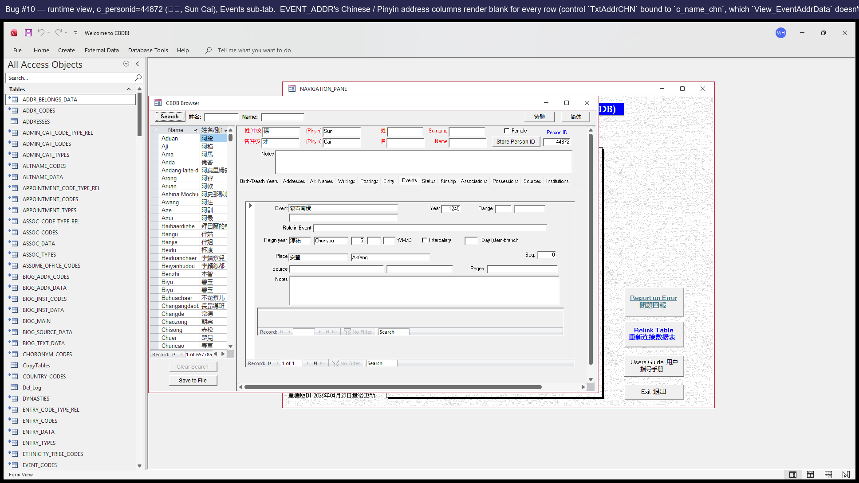
Runtime view of CBDB_Browser_2 → BIOG_MAIN_2 → Events tab with c_personid=44872 (孫才) loaded. **The visible '安豐' / address values come from the parent EVENTS_DATA_2 sub-form's TxtAddrCHN (correctly bound to `c_addr_chn`).** Bug #10's blank controls live in the smaller EVENT_ADDR_2 sub-form nested inside the event row — those two controls (TxtAddrCHN / TxtAddrPY bound to `c_name_chn` / `c_name`, neither in `View_EventAddrData`'s projection) render empty. COM probe confirms both are Visible=True with widths 2340 / 2100 twips (≈4cm / 3.5cm) — i.e. real user-visible blank columns, just smaller than the parent row's address display. Verification scripts: `analysis/probe_bug_10_11_12_visibility.py` (control visibility) + the SQL probe in the steps above.

Suggested fix
In the form designer for `EVENT_ADDR_2 Subform`, change `TxtAddrCHN`.ControlSource from `c_name_chn` to `c_event_addr_chn`, and `TxtAddrPY`.ControlSource from `c_name` to `c_event_addr_name` (the actual aliases in View_EventAddrData).

P3 — Missing UI

Issue #15 — LookAtPlace is missing its CmdGIS button (handler exists but no UI control)

Affected sub
LookAtPlace

Severity
P3 — Missing UI (feature unavailable to users)

Description
`Form_LookAtPlace.vb` defines a fully functional `CmdGIS_Click` handler — it builds and writes a GIS .tab export, identical in shape to the GIS button on Status / Texts / Associations / Office / Kinship. But LookAtPlace's form design has NO `CmdGIS` button on it. Users on Place can use Pajek / Gephi / Neo4j export but cannot use GIS export — the handler is there, just unreachable from the UI.

Steps to reproduce
- Open **LookAtPlace**.
- Look at the export-buttons row at the bottom right.
- There's no GIS button. Compare with LookAtStatus / LookAtAssociations / LookAtOffice etc., all of which have one.

Screenshots
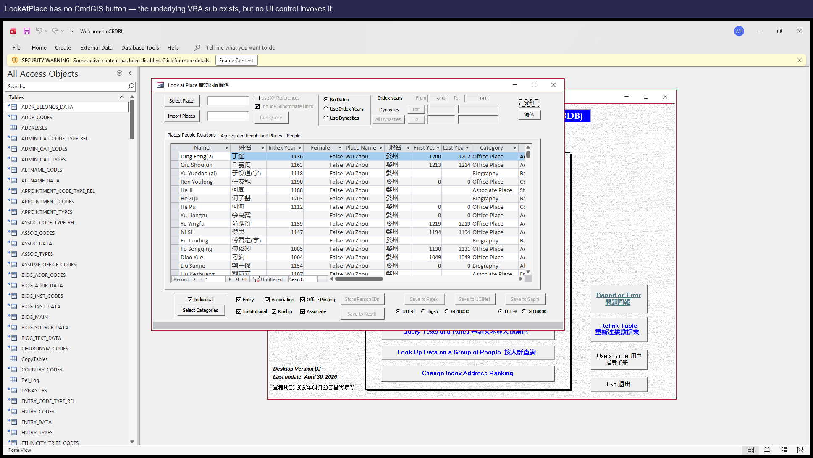
LookAtPlace as it ships — no GIS button is rendered, even though `Sub CmdGIS_Click()` exists in the module.

Suggested fix
In LookAtPlace's form design, add a CmdGIS button next to the existing CmdPajek / CmdGephi buttons, with `OnClick = [Event Procedure]` so it invokes the existing CmdGIS_Click Sub. (Also fix Issue #4 first, otherwise the button will throw 'Object required' on the first click.)

Issue #16 — LookAtStatus is missing its CmdPajek button

Affected sub
LookAtStatus

Severity
P3 — Missing UI

Description
Same shape as Issue #15. `Sub CmdPajek_Click()` exists in `Form_LookAtStatus.vb` (would write a Pajek .net export of the status data) but no CmdPajek button is rendered on Status's form design.
Note: even if the button is added, Issue #5 (the SQL/control defects in CmdPajek_Click itself) needs to be fixed first.

Steps to reproduce
- Open **LookAtStatus**. The export-buttons row has only GIS and Neo4j; there's no Pajek button.

Screenshots
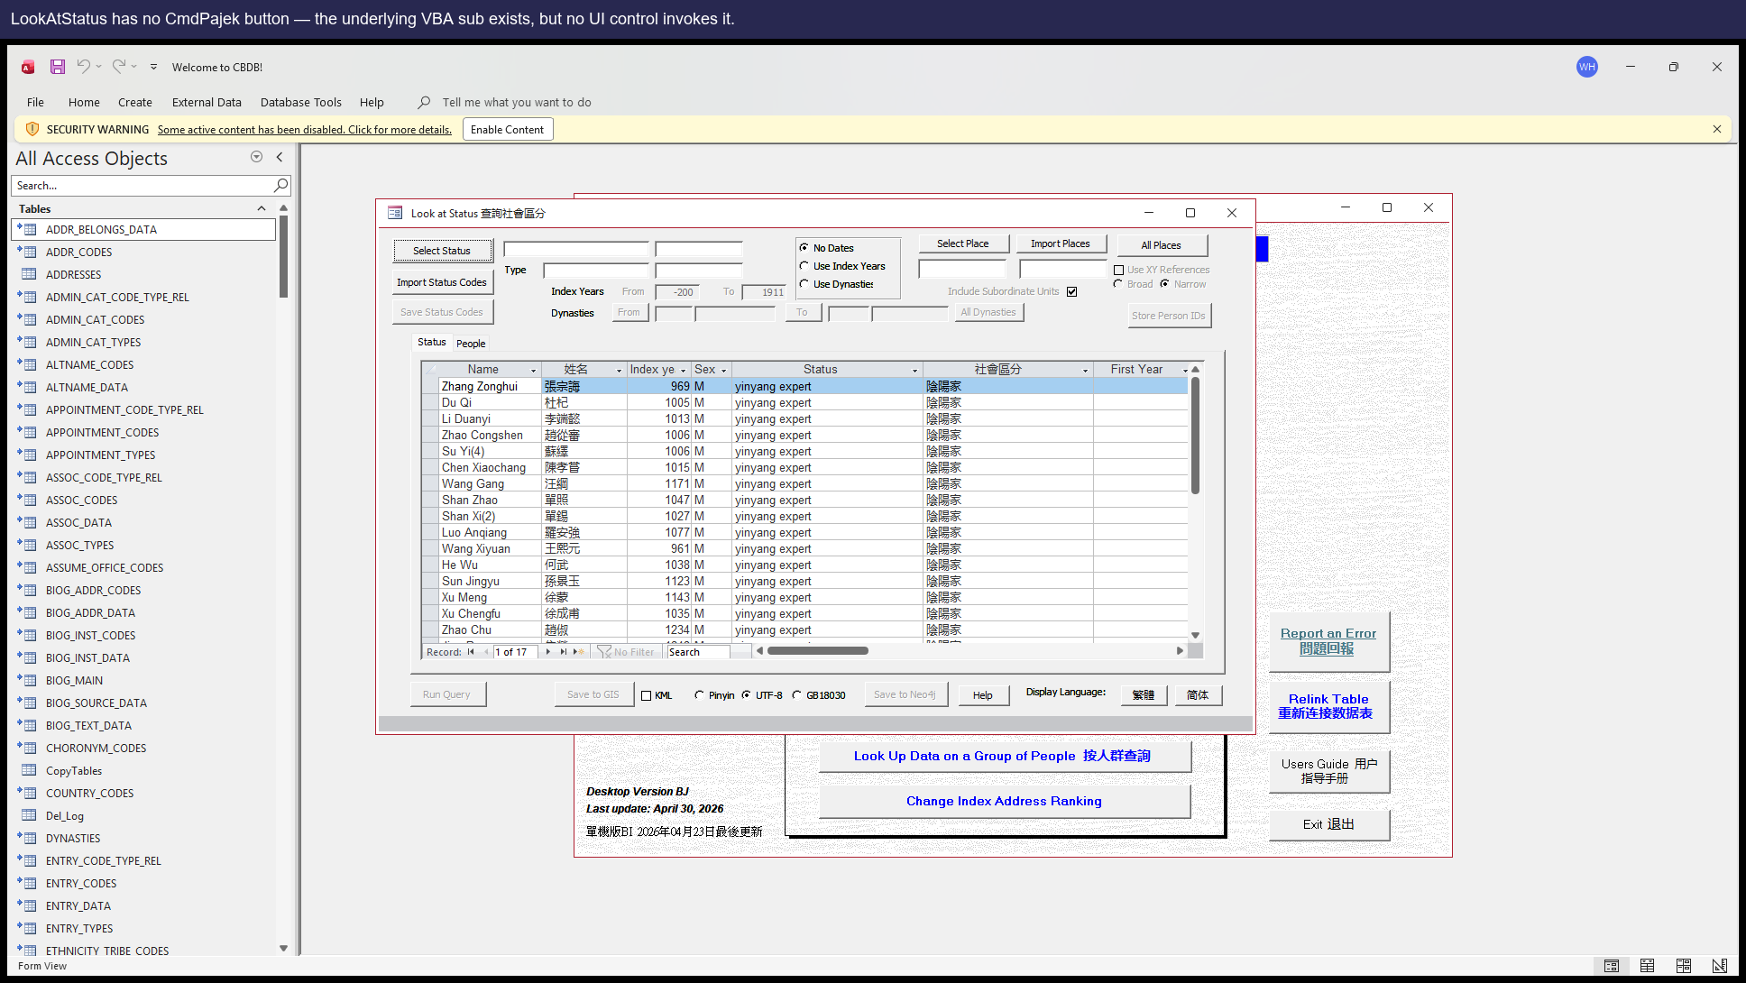

Suggested fix
Add a CmdPajek button to LookAtStatus's design (after fixing Issue #5).

Issue #17 — LookAtStatus is missing its CmdGephi button

Affected sub
LookAtStatus

Severity
P3 — Missing UI

Description
`Sub CmdGephi_Click()` exists in `Form_LookAtStatus.vb` but no matching button is on the form design.

Steps to reproduce
- Open **LookAtStatus**. There is no Gephi export button.

Screenshots
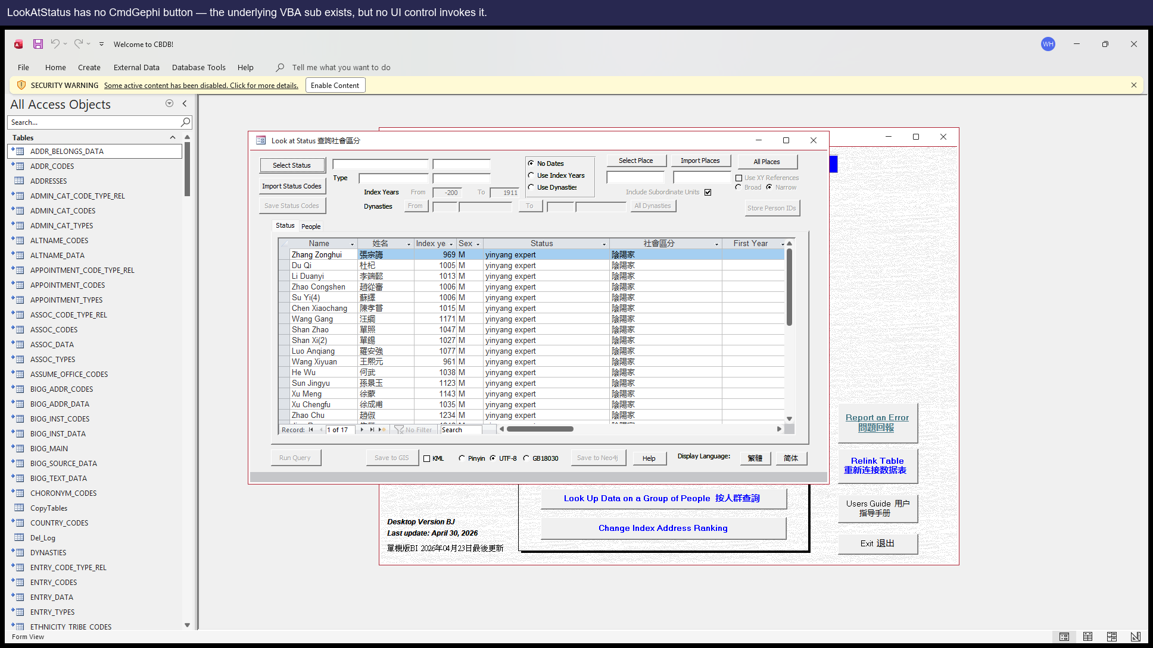

Suggested fix
Add a CmdGephi button to LookAtStatus's design.

Issue #18 — LookAtStatus is missing its CmdUCINet button

Affected sub
LookAtStatus

Severity
P3 — Missing UI

Description
`Sub CmdUCINet_Click()` exists in `Form_LookAtStatus.vb` but no matching button is on the form design.

Steps to reproduce
- Open **LookAtStatus**. There is no UCINet export button.

Screenshots
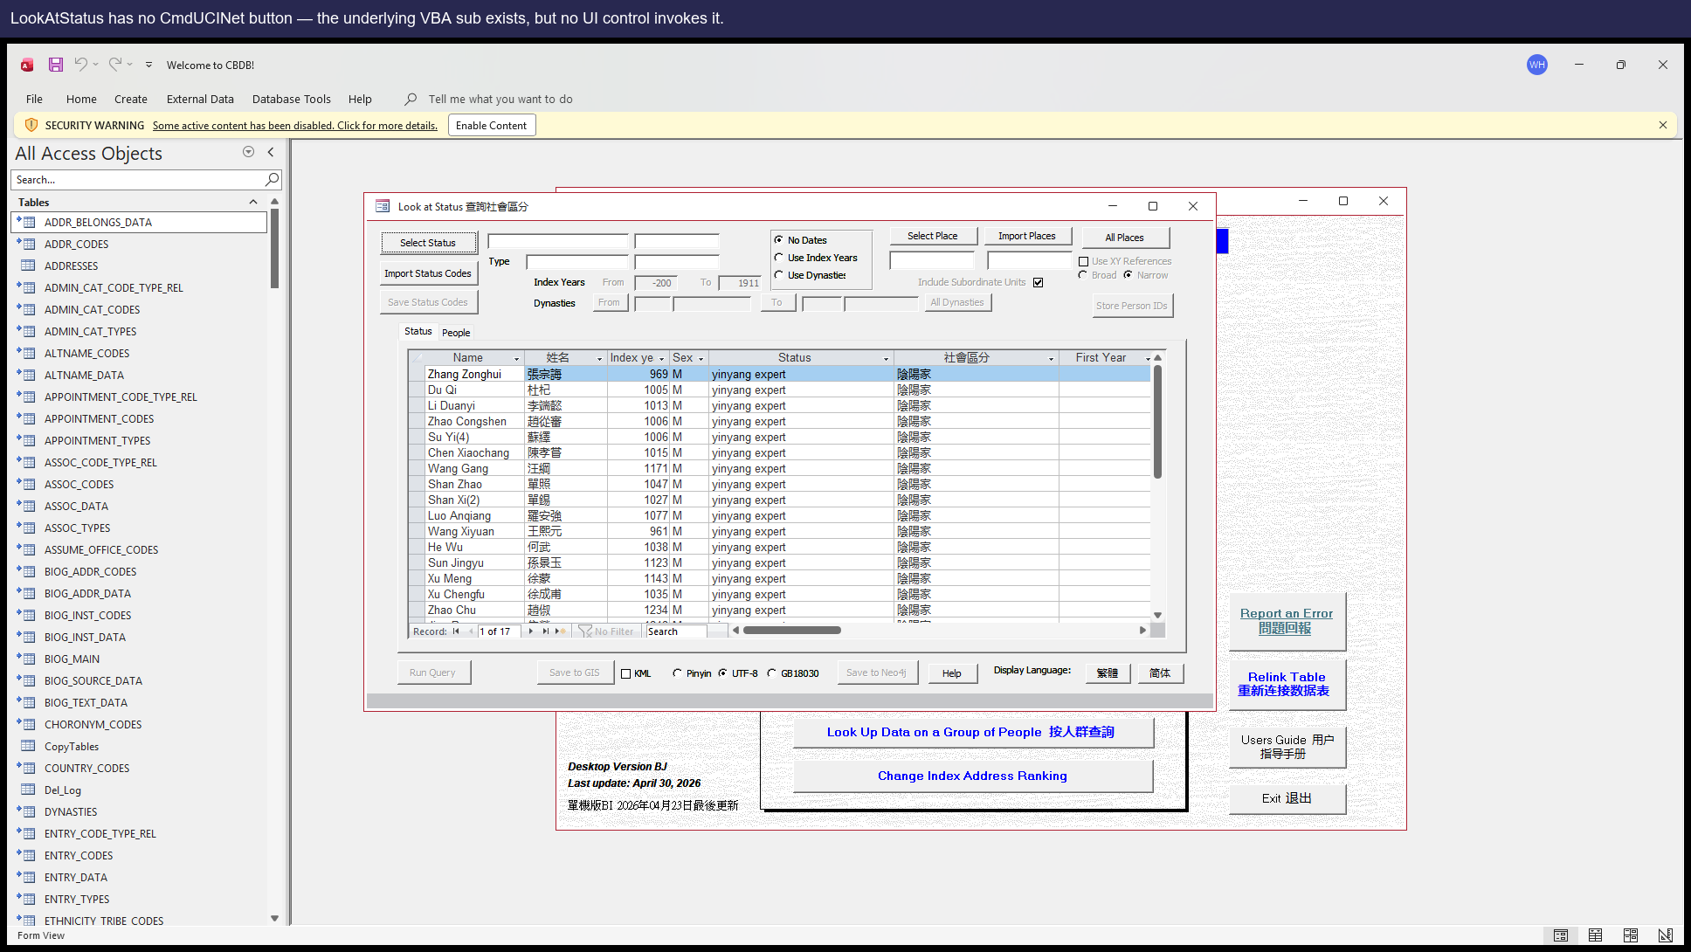

Suggested fix
Add a CmdUCINet button to LookAtStatus's design.

Issue #19 — LookAtOffice is missing its CmdGUESS button

Affected sub
LookAtOffice

Severity
P3 — Missing UI

Description
`Sub CmdGUESS_Click()` exists in `Form_LookAtOffice.vb` but no CmdGUESS button is on the form design. Users on Office can use GIS / GISPeople / Neo4j export but not GUESS.

Steps to reproduce
- Open **LookAtOffice**. There is no GUESS export button.

Screenshots
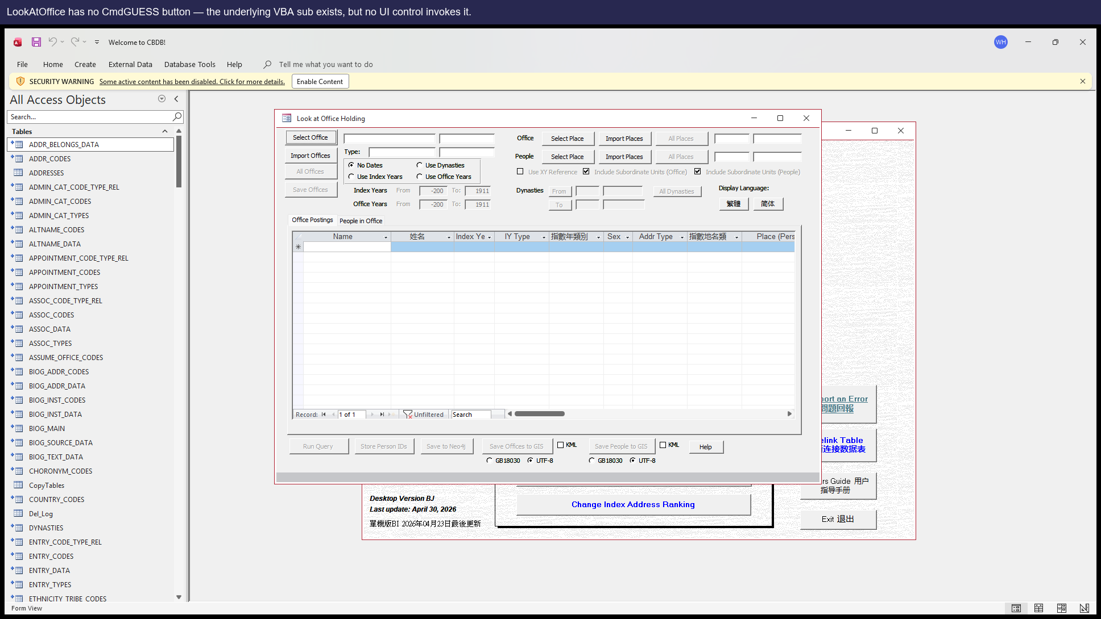

Suggested fix
Add a CmdGUESS button to LookAtOffice's design.

P4 — Setup

Issue #2 — VBA project references the legacy dao360.dll which isn't on Office 2016+ machines

Affected sub
VBE Project References

Severity
P4 — One-time setup hurdle on each new machine

Description
The shipped .mdb's VBA project carries a hard reference to `C:\Program Files\Common Files\Microsoft Shared\DAO\dao360.dll`, which was the DAO 3.6 location used by Access 2003. Modern Office (2016 onward) ships `ACEDAO.DLL` instead and does NOT install the legacy DLL. On any clean modern machine, the first attempt to open any LookAt form raises 'Can't find project or library', which is opaque and scary to end users.
Severity is low because it's a one-time fix per machine, but every new install hits it.

Steps to reproduce
- Install `CBDB_BJ_User.mdb` on a fresh modern Office machine.
- Open the file. Press Alt+F11 to enter the VBE.
- Tools → References. Notice an entry marked `MISSING: dao360.dll`.
- Open any LookAt form. A 'Can't find project or library' error appears.

Suggested fix
Once, on the maintainer's machine, do:
1. Open the .mdb in Access. Press Alt+F11.
2. Tools → References. Untick the MISSING dao360.dll entry.
3. Tick `Microsoft Office 16.0 Access Database Engine Object Library` (i.e. ACEDAO.DLL).
4. Save the .mdb.
Then re-distribute the fixed file. Future end users won't need to do anything.

P5 — Dormant / latent / not currently reproducible
Items in this tier are kept as historical / latent record. They fall into three categories: (a) DORMANT — current source data doesn't trigger the symptom; (b) NOT CURRENTLY REPRODUCIBLE — the symptom no longer surfaces even though the suspect code is still present (we have NOT confirmed an upstream source-level fix; the cause could be a JET / Office behaviour change, a fixture / driver change on our side, or the original diagnosis was a false positive); (c) LATENT — the source-code defect is real, but the user can't reach it because another issue (e.g. a missing UI button) blocks the path. None of these are user-facing today; **none have been verified as fixed upstream** — please consult before treating any of them as either urgent or closed.

Issue #1 — View_StatusData would display last-year range in the first-year column — DORMANT (no source rows trigger it on this dump)

Affected sub
View_StatusData

Severity
P5 — Dormant on this dump (would be P0 if any STATUS_DATA row had both fy/ly range codes set differently)

Description
The saved query `View_StatusData` joins `YEAR_RANGE_CODES` twice (once aliased as `YEAR_RANGE_CODES_1` for the last-year range), but the SELECT list pulls every range field from the _1 alias. As a result, every status row displayed in the Status sub-datasheet shows the last-year range value in the first-year range column.

Steps to reproduce
⚠ Currently UI-dormant on this data snapshot — see note below
On this data snapshot the bug is **DORMANT** — STATUS_DATA has 70,761 rows, but only 13 have c_fy_range > 0 and 0 have c_ly_range > 0; 0 have both populated AND different. So no person currently surfaces the alias swap through the UI. The SQL bug still exists; the moment a future data refresh adds a STATUS_DATA row with both fy/ly range codes set differently, the corresponding sub-datasheet line will display the wrong text. To verify the bug today, run the SQL directly:
SELECT c_personid, c_fy_range, c_fy_range_desc, c_ly_range, c_ly_range_desc FROM View_StatusData WHERE c_fy_range > 0 OR c_ly_range > 0;
- Because no STATUS_DATA row in the current dump has both c_fy_range AND c_ly_range populated, this bug cannot be demonstrated through the UI today. Verify it directly in SQL instead:
- Open the .mdb in Access. Press F11 to show the navigation pane, then double-click query **View_StatusData**.
- Inspect the SELECT clause: every `c_fy_range_*` alias is pulled from `YEAR_RANGE_CODES_1`, but the FROM clause joins that alias on the LAST-year range. That's the swap.
- (Optional) Run `SELECT TOP 100 c_personid, c_fy_range, c_fy_range_desc, c_ly_range, c_ly_range_desc FROM View_StatusData WHERE c_fy_range > 0 OR c_ly_range > 0` in the Access query window — once a future data refresh populates both fields differently, every such row will display the wrong first-year text.

Suggested fix
In `View_StatusData` change `YEAR_RANGE_CODES_1.c_range AS c_fy_range_desc` and `YEAR_RANGE_CODES_1.c_range_chn AS c_fy_range_chn` to use the un-aliased `YEAR_RANGE_CODES.*` fields (which the FROM clause already joins on `c_fy_range`).

Issue #9 — LookAtEntry.CmdNeo4j Institutions block uses the wrong recordset variable — LATENT (gated unreachable on this dump; no ENTRY_DATA row has c_inst_code > 0)

Affected sub
Form_LookAtEntry.CmdNeo4j_Click

Severity
P5 — Latent source-level typo (gated unreachable on this dump; would re-promote to P1 if any future ENTRY_DATA row has c_inst_code > 0)

Description
**Source-level typo, currently unreachable on this dump.**
Line 1415 of `Form_LookAtEntry.vb` opens the institutions recordset as `Set tRstInstitutions = CurrentDb.OpenRecordset(tQueryStr)`. Ten lines later, line 1425 says `With tRstAssocCodes` and the loop reads `!c_inst_code`, `!c_inst_name_code`, etc. against THAT recordset — which was bound much earlier to the AssocCodes SELECT and was already `Close`d at line 1373 of the AssocCodes block. If executed, this would raise DAO 3021 (`No current record`) on the `.MoveFirst` line; the misnamed reference is a genuine source-level bug.
However, on the current dump the entire SaveAs prompt and buggy `With` block sit inside the gate `If tRecDeleted > 0 Then` at line 1389, where `tRecDeleted` is the row count of an `INSERT INTO ZZ_SCRATCH_P_TEXT … WHERE ZZ_SCRATCH_ENTRY.c_inst_code > 0`. `ZZ_SCRATCH_ENTRY.c_inst_code` is copied verbatim from `ENTRY_DATA.c_inst_code` by CmdQuery (lines 1645-1652), and on this MDB **0 of 263,454 ENTRY_DATA rows have `c_inst_code > 0`** (also 0 with `c_inst_name_code > 0`). So `tRecDeleted = 0` for every possible LookAtEntry fixture, the gate evaluates false, the SaveAs prompt is never shown, the `With tRstAssocCodes` line is never executed, and CmdNeo4j proceeds cleanly to "Finished saving to Neo4j" — silently omitting `InstitutionCodes_*.csv` because there are no institution rows to write.
**The missing `InstitutionCodes_*.csv` is not itself a user-visible bug** on the current dump. Skipping an optional per-block file when its source-table count is 0 is the same gating pattern the surrounding blocks use (when `c_assoc_code = 0` for a fixture, the AssocCodes block is also silently skipped — see the matching behaviour in the re-verification artifacts). The latent typo only becomes user-visible if a future MDB drop introduces any `ENTRY_DATA` row with `c_inst_code > 0`.
**Re-verification evidence:** SQL pre-image plus real Access COM probes for `c_entry_code = 36` (jinshi) and `c_entry_code = 101` (recommendation / 薦舉) confirmed no popup, chain finishes cleanly, no `InstitutionCode`-shape file in the produced set. Details in `analysis/issue9_neo4j_institutioncodes_reverification.md` and `reports/issue9_neo4j_institutioncodes_reverification.json`.

Steps to reproduce
- **On the current dump this bug cannot be triggered through the UI** — the `If tRecDeleted > 0 Then` gate at Form_LookAtEntry.vb:1389 is false for every possible LookAtEntry fixture (0 of 263,454 ENTRY_DATA rows have `c_inst_code > 0`). Verify the source-level typo statically instead:
- Open `analysis/dump/vba/Form_LookAtEntry.vb` and read lines 1415-1425. Line 1415: `Set tRstInstitutions = CurrentDb.OpenRecordset(tQueryStr)`. Line 1425: `With tRstAssocCodes` (intended: `With tRstInstitutions`). `tRstAssocCodes` was already `Close`d at line 1373 of the AssocCodes block, so `.MoveFirst` would raise DAO 3021.
- (Optional, SQL) Confirm the gate condition on the current dump: `SELECT COUNT(*) FROM ENTRY_DATA WHERE c_inst_code > 0` returns 0 (same with `c_inst_name_code > 0`). This is what makes the buggy block unreachable.
- (Optional, runtime evidence) Pick `c_entry_code = 36` (jinshi) or `c_entry_code = 101` (recommendation / 薦舉) on LookAtEntry → Run Query → Neo4j. The chain finishes cleanly with `Finished saving to Neo4j`; no popup, no `InstitutionCodes_*.csv` in the output folder. These are not user-visible errors today — they are evidence that the gate works.
- The source-level typo will become user-visible the first time a future MDB drop introduces any `ENTRY_DATA` row with `c_inst_code > 0`. At that point the gate opens, the `With tRstAssocCodes` line executes against a `Close`d recordset, and DAO 3021 (`No current record`) fires on `.MoveFirst`.

Concrete reproduction
These two `c_entry_code` values are used as investigation evidence in the re-verification — they exercise CmdQuery + CmdNeo4j end-to-end and demonstrate that the InstitutionCodes branch is gated out today. **They are NOT a popup reproduction** — both produce `Finished saving to Neo4j` with no error and no `InstitutionCodes_*.csv`:
- `c_entry_code = 36` (jinshi / 科舉: 進士) — 92,514 ENTRY_DATA rows, 0 with `c_inst_code > 0`
- `c_entry_code = 101` (recommendation / 薦舉) — 878 ENTRY_DATA rows, 0 with `c_inst_code > 0`
Re-run the evidence with `python analysis/investigate_issue9_neo4j_institutioncodes.py` (SQL only) or `… --com` (also runs real Access COM).

Suggested fix
Change `With tRstAssocCodes` on line 1425 to `With tRstInstitutions`. Single-character class of fix; the underlying recordset variable was simply mis-named. Although currently unreachable on this dump, fixing it costs nothing and prevents a future-data regression.

Issue #4 — LookAtPlace.CmdGIS would abort with 'Object required' — LATENT, masked by Issue #15 (no CmdGIS button on the form)

Affected sub
Form_LookAtPlace.CmdGIS_Click

Severity
P5 — Latent (would be P1 if Issue #15 fixed without first fixing this)

Description
Note: this issue is moot in the current dump because there is no CmdGIS button on LookAtPlace's design (Issue #15) — users physically cannot click it. But the underlying VBA problem remains: line 1539 of `Form_LookAtPlace.vb` reads `If GISFrame.Value = 1 Then`, and there is no control named `GISFrame` on this form (the actual encoding control is `CodeFrame`). If the missing button is ever re-added (Issue #15) without first fixing this line, every click will throw.

Steps to reproduce
- (Hypothetical, after Issue #15 is fixed.) Open **LookAtPlace**.
- Run any query.
- Click the GIS button.
- A `Run-time error 424 — Object required` popup appears, the export does nothing.

Screenshots
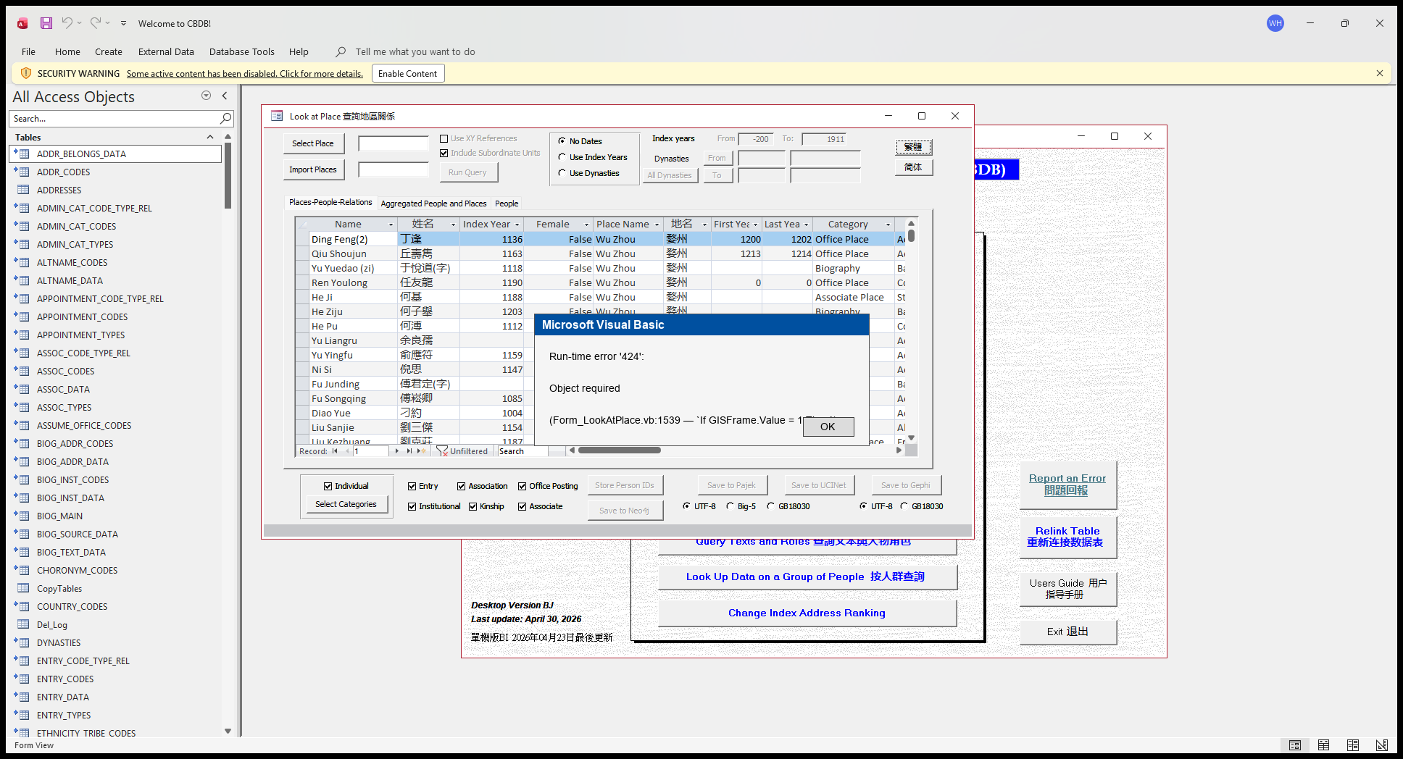
**Hypothetical** popup, reconstructed in PIL. Users currently CAN'T trigger this — Bug #15 means the CmdGIS button does not exist on LookAtPlace, so the click that would fire `CmdGIS_Click` (and produce this 'Object required' error) has nowhere to come from. This image shows what the user would see if a future change restored the CmdGIS button without first fixing the GISFrame → CodeFrame typo on line 1539. The earlier bug4 step1 / step2 runtime screenshots were misleading (their annotations implied a clickable GIS button) and were removed in PR C — only this faux popup is kept as latent-state evidence.

Suggested fix
Change `GISFrame.Value` to `CodeFrame.Value` on line 1539 of `Form_LookAtPlace.vb`. Same change `CmdNeo4j_Click`, `CmdGephi_Click`, and `CmdPajek_Click` on the same form already use correctly.

Issue #5 — LookAtStatus.CmdPajek references a missing control AND uses three columns that don't exist

Affected sub
Form_LookAtStatus.CmdPajek_Click

Severity
P5 — Latent (would be P1 if Issue #16 fixed without first fixing this)

Description
Two related defects in the same handler:
(a) Line 2308 reads `If ChkIDs.Value Then`, but Status has no control named `ChkIDs` — only `ChkXYRef`, `ChkKML`, and `ChkSubUnits`.
(b) Lines 2335–2338 build a SELECT that references `ZZ_SCRATCH_STATUS.c_person_id`, `c_status_id`, and `c_status_count` — none of which exist in the schema (the real columns are `c_personid`, `c_status_code`, no count column at all).
The whole sub looks copy-pasted from `LookAtAssociations.CmdPajek_Click` where these names ARE valid; the rename pass missed both spots. Like Issue #4 this is also somewhat moot because LookAtStatus has no Pajek button (Issue #16); the SQL still fails the moment the sub is invoked though, so adding the button without fixing the SQL would just expose the failure to users.

Steps to reproduce
- (Hypothetical, after Issue #16 is fixed.) Open **LookAtStatus**.
- Run a query, then click the Pajek button.
- First: an `Object required` popup appears (the ChkIDs reference).
- If that's worked around, the next click hits the SQL: a `No such field` error from the SELECT that references three non-existent columns.

Suggested fix
Two fixes:
(a) Replace `ChkIDs.Value` with either a constant `False` (if the optional behaviour isn't needed) or add a real ChkIDs control to LookAtStatus's design.
(b) Rewrite the SELECT to use `ZZ_SCRATCH_STATUS.c_personid` and `ZZ_SCRATCH_STATUS.c_status_code`, and either drop the count aggregate or compute it some other way (the source table doesn't have `c_status_count`).
Realistically the whole sub probably needs a thoughtful rewrite rather than spot fixes — it was clearly inherited from another form without verification.

Issue #14 — KIN_DATA Subform's CmdPickKinRel calls a missing picker (frmPickKINSHIP_CODES) — but the host sub-form is currently an orphan (LATENT)

Affected sub
Form_KIN_DATA_Subform

Severity
P5 — Latent (would be P1 if `KIN_DATA Subform` were re-embedded somewhere users can reach)

Description
**Static defect is real, runtime trigger is not currently reachable.** The Sub `CmdPickKinRel_Click` in `Form_KIN_DATA_Subform` (line 52) calls `DoCmd.OpenForm "frmPickKINSHIP_CODES"` and references `Forms!frmPickKINSHIP_CODES!frmKINSHIP_CODES.Form!c_kincode`. Neither form exists in the current .mdb — same shape as Issue #13.
**Why LATENT.** The host sub-form `KIN_DATA Subform` (which owns the `CmdPickKinRel` button) is not contained by any active form in the current `control_inventory.json`. `BIOG_MAIN_2_Subform` (the kinship surface users actually navigate to via CBDB_Browser_2) embeds `KIN_DATA_2 Subform` instead — and that variant has no `CmdPickKinRel` button (its 15 controls are all read-only fields). The only place the embedding still appears is `Form__TMPCLP487951` (a design-time backup snapshot, not a navigable form).
Because no user-facing navigation reaches the picker button, users cannot trigger the popup from normal use. The latent code path will resurface the moment a developer re-embeds `KIN_DATA Subform` somewhere reachable, so the underlying fix is still worth applying.

Steps to reproduce
Recommended demo person: c_personid=1 (安惇, An Dun)
Open person 1 (安惇, An Dun). The KIN_DATA sub-datasheet shows 5 kinship row(s) — click any one's kinship-code picker to trigger the broken Sub. — picked by `reports/probe_demo_persons.py`; a SQL probe selected this person because their row counts genuinely satisfy the precondition the bug needs.
- Verification path is **static-only** — the runtime click cannot be reproduced in the current .mdb because no parent form embeds the affected sub-form.
- Static evidence (1): open `analysis/dump/vba/Form_KIN_DATA_Subform.vb` line 52 — confirms the Sub calls `DoCmd.OpenForm "frmPickKINSHIP_CODES"`.
- Static evidence (2): open `analysis/dump/control_inventory.json` and search for `"frmPickKINSHIP_CODES"` as a key — absent. The picker form does not exist.
- Reachability evidence: in the same JSON, search for `"KIN_DATA Subform"` as a `source_object` or sub-form control name — only `Form__TMPCLP487951` (a design backup) references it. `BIOG_MAIN_2_Subform` embeds `KIN_DATA_2 Subform` instead, which has no `CmdPickKinRel` button.

Suggested fix
Same as Issue #13: restore the picker form (or update the caller to its replacement). Even though the runtime path is not currently reachable, the static defect should be cleaned up so it doesn't resurface when `KIN_DATA Subform` is re-embedded.

Issue #11 — EVENTS_DATA_2's c_event_record_id control bound to a non-existent column — but the control is hidden (LATENT)

Affected sub
EVENTS_DATA_2 Subform

Severity
P5 — Latent (would be P2 if the control were ever made Visible=True or widened past its current 240-twip width)

Description
**Static defect is real, runtime symptom is not user-visible.** The EVENTS_DATA_2 sub-form has a control named `c_event_record_id` whose ControlSource is also `c_event_record_id`. Neither EVENTS_DATA nor `View_EventsData` projects a column of that name (SQL probe confirms — `SELECT c_event_record_id FROM View_EventsData` raises `Too few parameters. Expected 1.`), so the control would render blank if shown.
**Why LATENT.** A live COM probe of the rendered form (`analysis/probe_bug_10_11_12_visibility.py`) reports the control as `Visible = False`, with width = 240 twips (~4mm) and height = 270 twips — i.e. a hidden internal control, almost certainly a leftover join-key field that was never meant to be shown. Real users won't see a blank column because they don't see the control at all. Reclassed from P2 to P5 on 2026-05-03.

Steps to reproduce
Recommended demo person: c_personid=44872 (孫才, Sun Cai)
Open person 44872 (孫才, Sun Cai). The EVENTS sub-datasheet shows 1 event row(s); 1 of them have an associated address. That's where the bound controls render blank on every row. — picked by `reports/probe_demo_persons.py`; a SQL probe selected this person because their row counts genuinely satisfy the precondition the bug needs.
- Verification path is **static + COM probe only** — there's no UI symptom to demonstrate.
- Static evidence: `SELECT c_event_record_id FROM View_EventsData` against the user mdb raises `Too few parameters. Expected 1.`, confirming the column is not in the projection.
- Visibility evidence: run `python analysis/probe_bug_10_11_12_visibility.py` and look at the entry for bug #11 in `analysis/dump/bug_10_11_12_visibility.json` — `control_summary.visible` is `False` and `width` is 240 twips.

Suggested fix
If the hidden control isn't needed, delete it. If it's intentionally a hidden join-key holder, change its ControlSource to a real column (e.g. `c_event_code`) so it doesn't carry a stale binding. Either way, the change is invisible to users; this is code-hygiene only.

Issue #12 — POSTED_TO_OFFICE_DATA_2's c_appt_type_code control bound to a non-projected column — but the control is hidden AND the user-facing appointment-type controls work (LATENT)

Affected sub
POSTED_TO_OFFICE_DATA_2 Subform

Severity
P5 — Latent (would be P2 if the control were ever made Visible=True or widened past its current 180-twip width)

Description
**Static defect is real, runtime symptom is not user-visible.** The hidden internal control `c_appt_type_code` on POSTED_TO_OFFICE_DATA_2 has ControlSource `c_appt_type_code`, which `View_PostingOfficeData` doesn't project (SQL probe: raises `Too few parameters. Expected 1.`).
**Why LATENT.** Two reasons:
1. The COM probe (`analysis/probe_bug_10_11_12_visibility.py`) reports the control as `Visible = False`, with width = 180 twips (~3mm) and height = 330 twips — a hidden internal control, almost certainly a join-key holder.
2. The **user-facing** appointment-type controls on the same sub-form are `TxtApptType` (bound to `c_appt_desc`) and `TxtApptTypeChn` (bound to `c_appt_desc_chn`). Both of those columns ARE in `View_PostingOfficeData`'s projection — SQL probe shows they return real values (e.g. `'Regular Appointment'` / `'正授'`). So the appointment type IS displayed correctly on the Postings sub-tab; only the hidden `c_appt_type_code` control is broken.
Reclassed from P2 to P5 on 2026-05-03 — the original P2 claim that 'the appointment-type column is blank on every row' was wrong; the user-facing appointment-type column works fine.

Steps to reproduce
Recommended demo person: c_personid=2 (安邡, An Fang)
Open person 2 (安邡, An Fang). The POSTED-TO-OFFICE sub-datasheet shows 1 posting row(s) with non-null c_appt_code — yet the appointment-type column on every row is blank. — picked by `reports/probe_demo_persons.py`; a SQL probe selected this person because their row counts genuinely satisfy the precondition the bug needs.
- Verification path is **static + COM probe only** — there's no UI symptom to demonstrate.
- Static evidence: `SELECT c_appt_type_code FROM View_PostingOfficeData` raises `Too few parameters. Expected 1.`, confirming the column is not projected.
- Visibility evidence: run `python analysis/probe_bug_10_11_12_visibility.py` and look at the entry for bug #12 in `analysis/dump/bug_10_11_12_visibility.json` — `control_summary.visible` is `False` and width = 180 twips.
- Counter-evidence (what users actually see works fine): `SELECT TOP 1 c_appt_desc, c_appt_desc_chn FROM View_PostingOfficeData` returns real values (e.g. `'Regular Appointment'` / `'正授'`), and those are what `TxtApptType` / `TxtApptTypeChn` (the visible controls) render.

Suggested fix
If the hidden control isn't needed, delete it. If it's an intentional hidden join-key holder, change its ControlSource to a real column (e.g. `c_appt_code`). Either way the change is invisible to users; this is code-hygiene only.

Appendix — `c_index_year` / `c_index_addr_id` drift vs the cbdb-online-main-server snapshot (differences need per-row classification before being filed as bugs)
When we compare BIOG_MAIN's `c_index_year` and `c_index_addr_id` between this User MDB and the weekly cbdb-online-main-server SQLite snapshot, a small fraction of persons disagree.
**The two sides are independent implementations.** The SQLite snapshot's `c_index_year` is produced by cbdb-online-main-server's PHP `IndexYearRebuildService.php` and its `c_index_addr_id` by `IndexAddressRebuildService.php` (both at <https://github.com/cbdb-project/cbdb-online-main-server>); the User MDB-side: `c_index_addr_id` is rebuilt by VBA in `Form_frmIndexAddr` in the front-end mdb; `c_index_year` is rebuilt by **37 saved QueryDefs named `BM IY Rule …`** in the linked-tables backend `data/CBDB_<YYYYMMDD>_DATA.mdb`, driven by `frmBaseMaintenance`. Both algorithms are now extracted and committed to the repo (`analysis/dump_data/querydefs_index/*.sql`); the form / module driver VBA still needs an interactive Access `SaveAsText` pass. PHP is intended to mirror the VBA but they are separate code paths. Per-row differences can come from at least four sources, and a diff alone doesn't tell us which: (1) source-data snapshot drift (the online system updates source rows continuously; the User MDB ships a point-in-time snapshot); (2) algorithm / porting divergence between PHP and VBA; (3) priority / tie-break differences when multiple candidate years apply; (4) null / default handling differences (e.g. how a missing birthyear collapses).
**We have not classified the steady ~575 / 657 246 diffs we currently observe.** The examples below are a small sample (currently 13 rows across 3 buckets, from `reports/index_drift_examples.json`) — illustrative of the *shapes* of disagreement, not statistically representative. Please don't treat them as a verdict either way; they're a starting point for whoever does the per-row triage.
Why we still keep this appendix: if the *shape* of disagreement changes between releases (e.g. addresses start diverging where only years used to, or per-rule type-code distributions shift sharply), that hints the algorithm, schema, or one of the implementations moved — a stronger signal than per-row counts alone.

Classification summary
Compared 657,245 personids common to both databases (User MDB total 657,784; SQLite total 657,478; User-only 539; SQLite-only 233).
• 656,682 (99.914%) — exact match on all four compared fields
• 2 (0.000%) — source drift but indices agreed (algorithms tolerated the drift)
• 14 (0.002%) — source drift AND at least one index field differs (consistent with simple data-drift hypothesis)
• 59 (0.009%) — c_birthyear+c_deathyear identical, only c_index_year differs — needs follow-up
• 478 (0.073%) — c_birthyear+c_deathyear identical, only c_index_addr_id differs — needs follow-up
• 10 (0.002%) — c_birthyear+c_deathyear identical, BOTH index fields differ — strongest signal of compound divergence, needs follow-up
Net diffs: 563 of 657,245 (0.086%). Of those, 16 are clearly attributable to source drift in birthyear/deathyear; 547 need per-row follow-up (could be PHP↔VBA divergence, or drift in evidence tables — BIOG_ADDR_DATA / ENTRY_DATA / NIAN_HAO etc. — that this classifier does not compare). Full output: `reports/index_drift_classification.json`; algorithm pointers: `analysis/index_drift_algorithm_notes.md`.

Year-only diffs — per-row rule classification
Of the 69 year-only diffs, each row was bucketed against PR N's rule-level runtime-vs-PHP comparison (`analysis/index_year_rule_comparison.md`). Conservative buckets (rows count once each):
• 1 php_returned_sentinel
• 19 php_did_not_compute
• 7 access_did_not_compute
• 5 iteration_order_diff
• 14 consistent_within_rule
• 5 candidate_algorithm_divergence
• 18 unclassified
None of these are confirmed bugs. Full per-row output (with the source-data evidence we used to bucket each one) is in `reports/index_year_drift_rule_classification.json`.
Deeper triage (PR K2, `analysis/triage_index_year_drift_groups.py`) named the leftover buckets:
• 14 `consistent_within_rule` rows → 5 signature groups. PR AI + AJ probes reversed the prior tie-break hypothesis: all 14 rows are `source_data_drift_biog_main_or_kin_data_between_sides` (8 BIOG_MAIN birthyear drift + 6 KIN_DATA evidence-pid drift). Upstream PHP-side / SQLite-snapshot data issue, not a CBDB algorithm divergence.
• 18 `unclassified` rows → 18 named, 17 flagged `blocked_by_runtime_priority_triage_pending` (PR M dumped frmBaseMaintenance, so the source is in repo; resolving each row still needs a per-row walk of the runtime priority/iteration order).
• 19 `php_did_not_compute` rows → 6 groups by Access tcode; biggest is `access_tcode='05'` × 7 (`candidate_php_entry_code_mapping_gap` for jinshi).
Full per-group output: `reports/index_year_drift_rule_groups.json`.

c_index_addr_id diffs — per-row classification
Of the 488 c_index_addr diffs (478 `index_addr_only_diff` + 10 `index_both_diff` from PR G's bucketing), each row was classified by re-simulating the rank-priority + MAX(c_sequence) algorithm against each side's BIOG_ADDR_DATA + the shared BIOG_ADDR_CODES rank table:
• 412 mdb_stale_index_addr — User MDB stored value doesn't match its own recompute; SQLite does — User MDB c_index_addr_id is stale (re-run frmBaseMaintenance)
• 47 mdb_value_php_null — User MDB has a value, PHP wrote 0/null
• 10 same_candidates_diff_winner — identical BIOG_ADDR_DATA, different winner — candidate algorithm divergence (all in addr_type=1)
• 10 both_stale_recompute_mismatch — neither side matches recompute
• 6 both_sides_match_recomputed — both stored values match recompute over their own BIOG_ADDR_DATA — diff is source-data drift
• 2 sqlite_stale_index_addr — PHP stored value doesn't match its own recompute
• 1 mdb_null_php_value
None of these are confirmed bugs. The 412 `mdb_stale_index_addr` rows are a maintenance-cadence diff (the User MDB needs its frmBaseMaintenance rebuild re-run before the next release). The 10 `same_candidates_diff_winner` rows are the only candidate algorithm-divergence rows. Full per-row output: `reports/index_addr_drift_classification.json`.
PR M (`analysis/dump_data_mdb_vba.py`) extracted `frmBaseMaintenance.CmdIndexAddress_Click` from the DATA mdb. It does NOT explicitly `MAX(c_sequence)`-aggregate the way PHP does — a candidate algorithmic divergence on top of the maintenance-cadence issue. Suggested release-checklist mitigation: run `CmdIndexYear` then `CmdIndexAddress` on the DATA mdb before shipping a new User MDB. See `analysis/index_drift_algorithm_notes.md` § "Maintenance trigger path" for the full write-up.

What currently explains the drift
Per-bucket cause / supporting evidence / confidence / next action lives in `analysis/index_drift_cause_analysis.md`. This section just summarises the headline counts and confidence per bucket; no bucket is labelled a confirmed CBDB bug.

c_index_year cause buckets
Bucket | Count | Confidence
php_returned_sentinel | 1 | high
php_did_not_compute | 19 | tcode='05' × 7: supported_by_focused_probe (PR Z). tcode='11' × 5: medium. Phase-C tcodes (14/20/2304): medium. tcode='07' × 1: medium (vestigial-vs-intentional unresolved).
access_did_not_compute | 7 | medium
iteration_order_diff | 5 | medium
consistent_within_rule | 14 | supported_by_focused_probe (PR AI + AJ)
candidate_algorithm_divergence | 5 | low-medium
blocked_by_runtime_priority_triage_pending | 17 | low (per-row causes); high (category label)

c_index_addr_id cause buckets
Bucket | Count | Confidence
mdb_stale_index_addr | 412 | high
mdb_value_php_null | 47 | medium
same_candidates_diff_winner | 10 | high
both_stale_recompute_mismatch | 10 | medium-high
both_sides_match_recomputed | 6 | low-medium
sqlite_stale_index_addr | 2 | medium
mdb_null_php_value | 1 | medium-high

Top suggested next investigations (full list in the cause-analysis md):
1. B1 release-process step (CmdIndexYear → CmdIndexAddress before shipping User MDB) — would close 412 rows; engineering cost: zero (process change).
2. B3 secondary tie-break (MIN(c_addr_id)) added to both implementations — would close 10 rows; engineering cost: small algorithm tweak per side.
3. A2 tcode 05 entry-code-mapping check — DONE by PR Z (6 mapping gaps + 1 c_year=0 gap; all PHP-side upstream data) — would close 7 rows; engineering cost: single SQL probe (already run).

Examples where only c_index_year disagrees
Same person, same source data, but the two pipelines picked different priority rules. The User MDB's `c_index_year_type_code` and `c_index_year_source_id` differ from the snapshot's, which means each pipeline selected a different upstream evidence row when deciding 'which year is most representative for this person'.

c_personid = 3501 — 李孝稱 (Li Xiaocheng)
Field | User MDB | cbdb-online-main-server snapshot
c_index_year | 1018 | 1028
c_index_addr_id | 100658 | 100658
c_birthyear | 0 | 0
c_deathyear | 0 | 0
c_index_year_type_code | 19 | 1912
c_index_year_source_id | 19149 | 3479

c_personid = 16266 — 錢孟回 (Qian Menghui)
Field | User MDB | cbdb-online-main-server snapshot
c_index_year | 1004 | 992
c_index_addr_id | 12723 | 12723
c_birthyear | 0 | 0
c_deathyear | 0 | 0
c_index_year_type_code | 13 | 0512
c_index_year_source_id | 700103 | 3035

c_personid = 16267 — 錢知雄 (Qian Zhixiong)
Field | User MDB | cbdb-online-main-server snapshot
c_index_year | 1034 | 1071
c_index_addr_id | 12723 | 12723
c_birthyear | 0 | 0
c_deathyear | 0 | 0
c_index_year_type_code | 1312 | 14
c_index_year_source_id | 16266 | 16269

Examples where only c_index_addr_id disagrees
Year agrees, address doesn't. Most commonly the User MDB still has an older `c_index_addr_id` choice while the snapshot has been re-classified to a finer-grained or higher-quality address (or to NULL when the evidence was downgraded). The two pipelines apply the same address-priority rules but to different snapshots of `BIOG_ADDR_DATA`.

c_personid = 1 — 安惇 (An Dun)
Field | User MDB | cbdb-online-main-server snapshot
c_index_year | 1042 | 1042
c_index_addr_id | 101117
c_birthyear | 1042 | 1042
c_deathyear | 1104 | 1104
c_index_year_type_code | 01 | 01
c_index_year_source_id

c_personid = 470 — 金君卿 (Jin Junqing)
Field | User MDB | cbdb-online-main-server snapshot
c_index_year | 1012 | 1012
c_index_addr_id | 12879 | 12785
c_birthyear | 0 | 0
c_deathyear | 0 | 0
c_index_year_type_code | 05 | 05
c_index_year_source_id

c_personid = 481 — 周秩 (Zhou Zhi)
Field | User MDB | cbdb-online-main-server snapshot
c_index_year | 1043 | 1043
c_index_addr_id | 100416 | 12785
c_birthyear | 0 | 0
c_deathyear | 0 | 0
c_index_year_type_code | 05 | 05
c_index_year_source_id

c_personid = 485 — 周穜 (Zhou Tong)
Field | User MDB | cbdb-online-main-server snapshot
c_index_year | 1046 | 1046
c_index_addr_id | 100416 | 12785
c_birthyear | 0 | 0
c_deathyear | 0 | 0
c_index_year_type_code | 05 | 05
c_index_year_source_id

c_personid = 562 — 范沖 (Fan Chong)
Field | User MDB | cbdb-online-main-server snapshot
c_index_year | 1067 | 1067
c_index_addr_id | 100658 | 13292
c_birthyear | 1067 | 1067
c_deathyear | 1141 | 1141
c_index_year_type_code | 01 | 01
c_index_year_source_id

Examples where the SOURCE data itself differs (birthyear / deathyear)
Here the SQLite snapshot has different `c_birthyear` / `c_deathyear` from the User MDB. This is the clearest case of pure data drift: someone updated the source row in the cbdb-online-main-server pipeline after the User MDB was last exported. There's no algorithmic disagreement here — just two different snapshots in time.

c_personid = 1455 — 沈邈 (Shen Miao)
Field | User MDB | cbdb-online-main-server snapshot
c_index_year | 1001 | 1008
c_index_addr_id | 12887 | 12887
c_birthyear | 1001 | 0
c_deathyear | 1047 | 0
c_index_year_type_code | 01 | 05
c_index_year_source_id

c_personid = 19149 — 李孝基 (Li Xiaoji)
Field | User MDB | cbdb-online-main-server snapshot
c_index_year | 1016 | 1026
c_index_addr_id | 100658 | 100658
c_birthyear | 1016 | 0
c_deathyear | 1076 | 0
c_index_year_type_code | 01 | 11
c_index_year_source_id |  | 41030

These examples were collected by `reports/collect_index_year_diffs.py` from the first 20 000 person ids common to both databases. The full automated cross-check (`tests/test_index_year_xcheck.py`, ~657 246 persons) reports roughly the same shape: very small fractions disagree, with addresses being the most common drift type.

Closing note
Thank you for taking the time to read this report. None of the items above is urgent; we hope having them all in one place makes it easy to address them at your own pace.
If any of the descriptions or suggested fixes are unclear, we would be glad to discuss further. The corresponding regression tests in this repository will automatically flip from PASS to FAIL the moment any regression marker stops reproducing in the source dump — that is a signal to investigate, not an automatic confirmation that the bug is fixed (the marker could fail because of an upstream fix, a fixture / driver change on our side, or a misclassification we made earlier).

