CBDB User MDB — Issues Report
A respectful summary of issues uncovered during regression testing.
Dear maintainer,
Below is a summary of the issues we uncovered while building an automated regression-test suite for the CBDB User MDB. We hope this report is useful as you continue your wonderful stewardship of this dataset, and we sincerely thank you for the immense work that has gone into building it.
The issues are ordered by severity (P0 highest). Each entry includes a concise description, step-by-step user reproduction, screenshots where the issue is visible in the Access UI, and a suggested fix. None of these are urgent; they are documented so they can be addressed at the maintainer's convenience.

Table of Contents
Right-click here and choose 'Update Field' to populate.

Severity legend
- P0 — Silent data corruption: data is wrong or missing without an error popup.
- P1 — Visible runtime crash: a popup appears, the operation aborts.
- P2 — Silent display: form fields render blank when they should show data.
- P3 — Missing UI: a feature exists in code but no button invokes it.
- P4 — Setup: one-time hurdle on each new install.

P0 — Silent data corruption

Issue #1 — View_StatusData displays last-year range in the first-year column

Affected sub
View_StatusData

Severity
P0 — Silent data corruption

Description
The saved query `View_StatusData` joins `YEAR_RANGE_CODES` twice (once aliased as `YEAR_RANGE_CODES_1` for the last-year range), but the SELECT list pulls every range field from the _1 alias. As a result, every status row displayed in the Status sub-datasheet shows the last-year range value in the first-year range column.

Steps to reproduce
- Open any person's biographical detail form.
- Switch to the **Status** sub-datasheet.
- Compare the column **First-year range** (`c_fy_range_desc`) with the column **Last-year range** (`c_ly_range_desc`).
- Whenever the underlying `c_fy_range` and `c_ly_range` codes differ, the displayed first-year text actually shows the last-year value.

Suggested fix
In `View_StatusData` change `YEAR_RANGE_CODES_1.c_range AS c_fy_range_desc` and `YEAR_RANGE_CODES_1.c_range_chn AS c_fy_range_chn` to use the un-aliased `YEAR_RANGE_CODES.*` fields (which the FROM clause already joins on `c_fy_range`).

Issue #3 — LookAtEntry.CmdQuery backfill UPDATE silently fails on large result sets

Affected sub
Form_LookAtEntry.CmdQuery_Click

Severity
P0 — Silent data corruption

Description
`Form_LookAtEntry.vb:1778-1789` runs a single UPDATE that joins seven+ lookup tables to backfill descriptive columns (`c_entry_desc`, `c_addr_name`, `c_kin_name`, …) into `ZZ_SCRATCH_ENTRY`. When the result set is large enough (roughly 30,000+ rows), JET silently leaves those columns NULL — the user sees a query result with empty description fields and no error message. Confirmed only on LookAtEntry; Status / Texts / Associations all backfill correctly at similar row counts because their UPDATE chains are simpler.

Steps to reproduce
- Open **LookAtEntry**.
- Pick a high-frequency entry code such as **36 (jinshi general)** without any year or place filters.
- Click **Run Query**. Wait for the query to complete.
- Open the result table `ZZ_SCRATCH_ENTRY` and inspect the `c_entry_desc`, `c_addr_name`, `c_kin_name` columns.
- Many rows have NULL values where descriptive text should be, even though the matching lookup rows exist in the source tables.

Suggested fix
Split the giant multi-table UPDATE into several smaller ones — one per lookup join (UPDATE … LEFT JOIN INDEXYEAR_TYPE_CODES, UPDATE … LEFT JOIN BIOG_MAIN, etc.). Same pattern Status / Texts / Associations already use successfully.

Issue #7 — LookAtPlace.CmdNeo4j people-CSV silently fails on the first record

Affected sub
Form_LookAtPlace.CmdNeo4j_Click

Severity
P0 — Silent data corruption (export silently produces nothing)

Description
The People-CSV section of `LookAtPlace.CmdNeo4j_Click` (line ~322 onward) builds a recordset from a SELECT that projects only four `ZZ_SCRATCH_P_TEXT` columns, but the row-write loop reads `!c_dynasty`, `!c_dynasty_chn`, and `!c_female` from that recordset. As soon as the loop hits the first row, JET raises 'Item not found in this collection'. The error handler silences it with `MsgBox`, so the user sees a single popup, then NO files are produced for any of the downstream Neo4j export steps.

Steps to reproduce
- Open **LookAtPlace** and run any successful query.
- Click **Neo4j** to start the multi-file export.
- Pick a save location for the first prompt (People file).
- A `Run-time error 3265 — Item not found in this collection` popup appears.
- After clicking OK, no files have been written to the chosen folder.

Screenshots
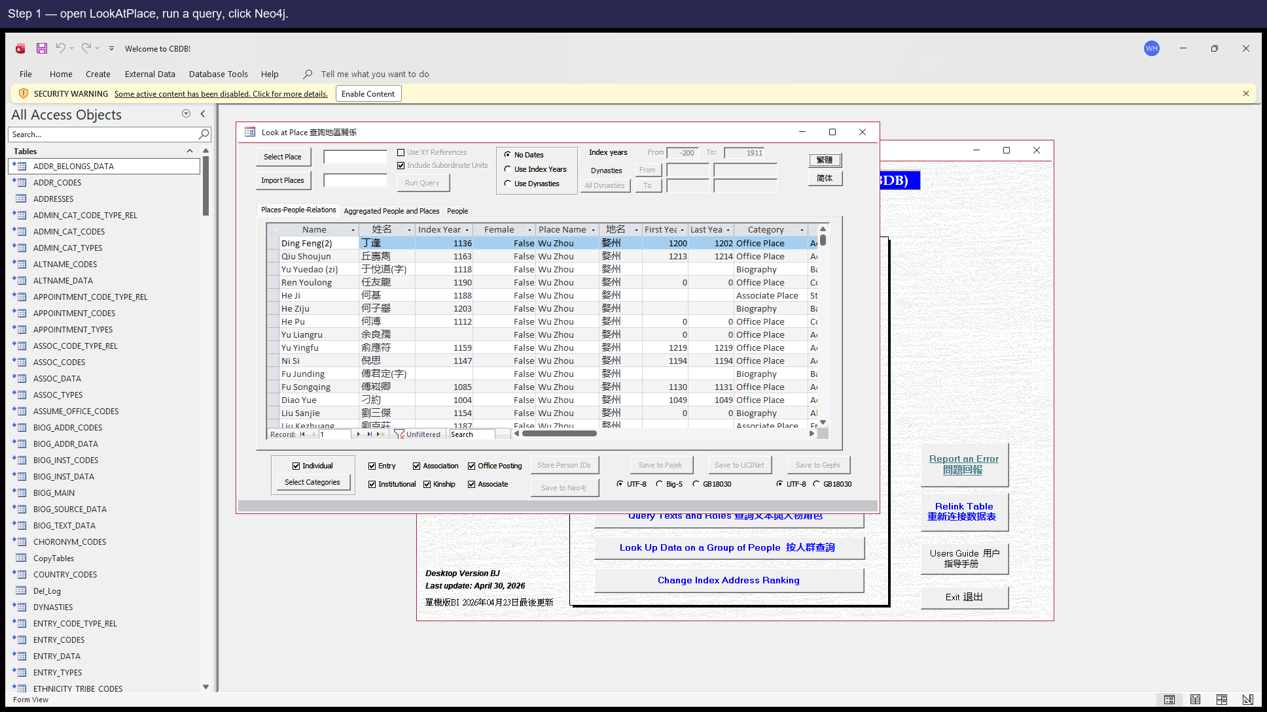
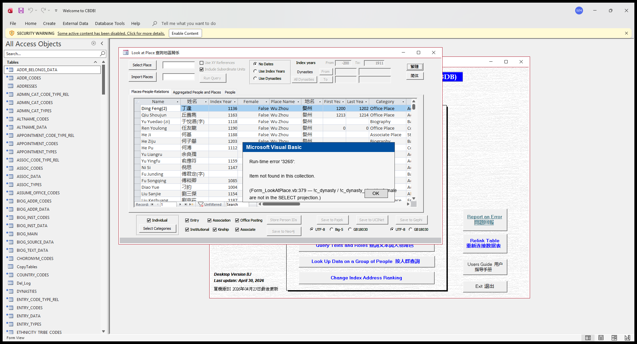
The popup users see (re-rendered for the report; the real popup blocks the COM thread our test driver runs in).

Suggested fix
Extend the SELECT in the People-CSV branch to project the fields the loop reads, e.g. `DYNASTIES.c_dynasty`, `DYNASTIES.c_dynasty_chn`, `BIOG_MAIN.c_female` (the JOINs already expose them).

Issue #8 — LookAtNetworks.CmdNeo4j people/place CSVs silently fail on the first record

Affected sub
Form_LookAtNetworks.CmdNeo4j_Click

Severity
P0 — Silent data corruption

Description
Same shape as Issue #7 but on a different form. Two SELECTs in `LookAtNetworks.CmdNeo4j_Click` are missing fields that the row-write loop reads:
• `tRstPlace` SELECT (line 2458) projects 3 columns; the loop reads `!x_coord` / `!y_coord` (not projected).
• `tRstPeoplePlace` SELECT similarly omits `c_person_id` / `c_index_addr_id` that the loop reads.
Same silent-fail symptom as Issue #7.

Steps to reproduce
- Open **LookAtNetworks** (note: this form has a known opening-delay issue; please allow several seconds).
- Run a query, then click **Neo4j**.
- When the export reaches the People-with-Place file, the same `Item not found` popup appears, and no further files are written.

Suggested fix
Extend each SELECT to project every field the loop reads. For tRstPlace: add `ADDR_CODES.x_coord`, `ADDR_CODES.y_coord`. For tRstPeoplePlace: add the missing `c_person_id` / `c_index_addr_id` columns from the joined tables.

Issue #9 — LookAtEntry.CmdNeo4j Institutions block uses the wrong recordset variable

Affected sub
Form_LookAtEntry.CmdNeo4j_Click

Severity
P0 — Silent data corruption (export silently produces nothing)

Description
Line 1415 of `Form_LookAtEntry.vb` opens the institutions recordset as `tRstInstitutions = CurrentDb.OpenRecordset(tQueryStr)`. Ten lines later, line 1425 says `With tRstAssocCodes` and the loop reads `!c_inst_code`, `!c_inst_name_code`, etc. against THAT recordset — which was bound much earlier to the AssocCodes SELECT and doesn't have `c_inst_*` columns. Same `Item not found` symptom; InstitutionCodes file is never written.
Note: triggering this path requires entries with `c_inst_code > 0` (i.e. social-institution-bearing entries). Not every fixture reaches this With block.

Steps to reproduce
- Open **LookAtEntry** with a query that produces entries with social institution codes (those are uncommon — most entries don't trigger this).
- Click **Neo4j**, accept all the SaveAs dialogs.
- When the export reaches the InstitutionCodes file, the same `Item not found` popup appears.

Suggested fix
Change `With tRstAssocCodes` on line 1425 to `With tRstInstitutions`. Single-character class of fix; the underlying recordset variable was simply mis-named.

P1 — Visible runtime crash

Issue #4 — LookAtPlace.CmdGIS aborts with 'Object required' (references a control that doesn't exist)

Affected sub
Form_LookAtPlace.CmdGIS_Click

Severity
P1 — Visible crash, blocks the export

Description
Note: this issue is moot in the current dump because there is no CmdGIS button on LookAtPlace's design (Issue #15) — users physically cannot click it. But the underlying VBA problem remains: line 1539 of `Form_LookAtPlace.vb` reads `If GISFrame.Value = 1 Then`, and there is no control named `GISFrame` on this form (the actual encoding control is `CodeFrame`). If the missing button is ever re-added (Issue #15) without first fixing this line, every click will throw.

Steps to reproduce
- (Hypothetical, after Issue #15 is fixed.) Open **LookAtPlace**.
- Run any query.
- Click the GIS button.
- A `Run-time error 424 — Object required` popup appears, the export does nothing.

Screenshots
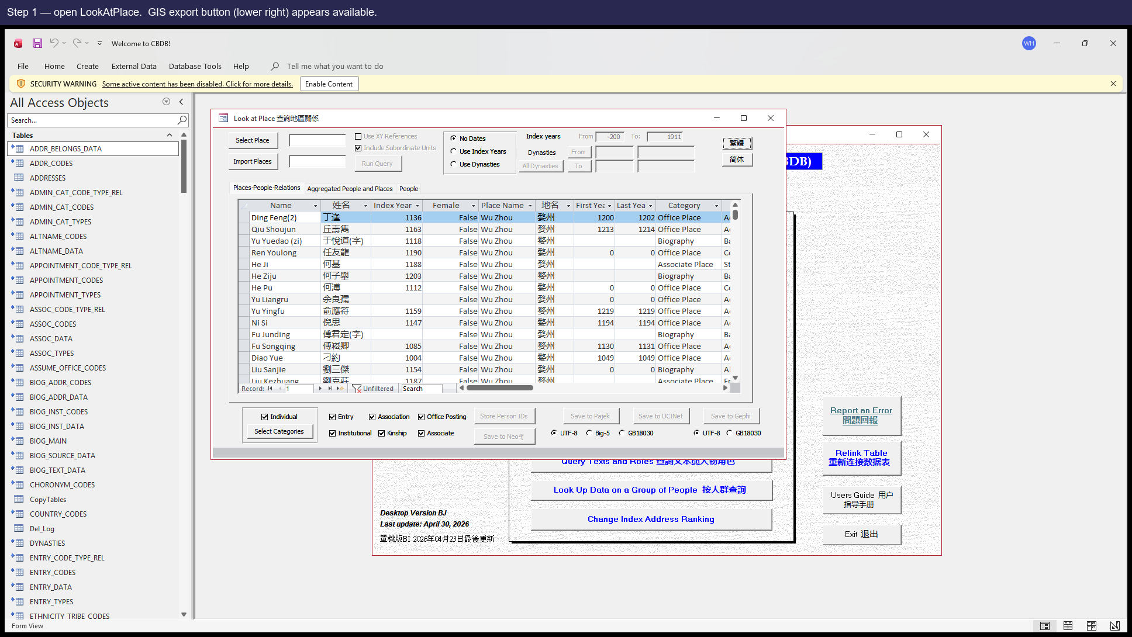
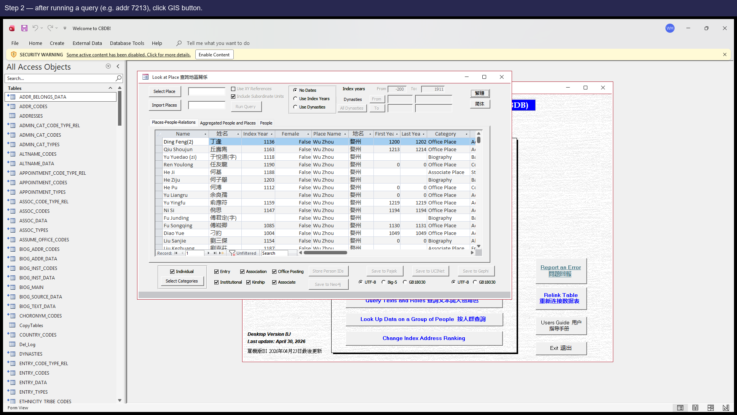
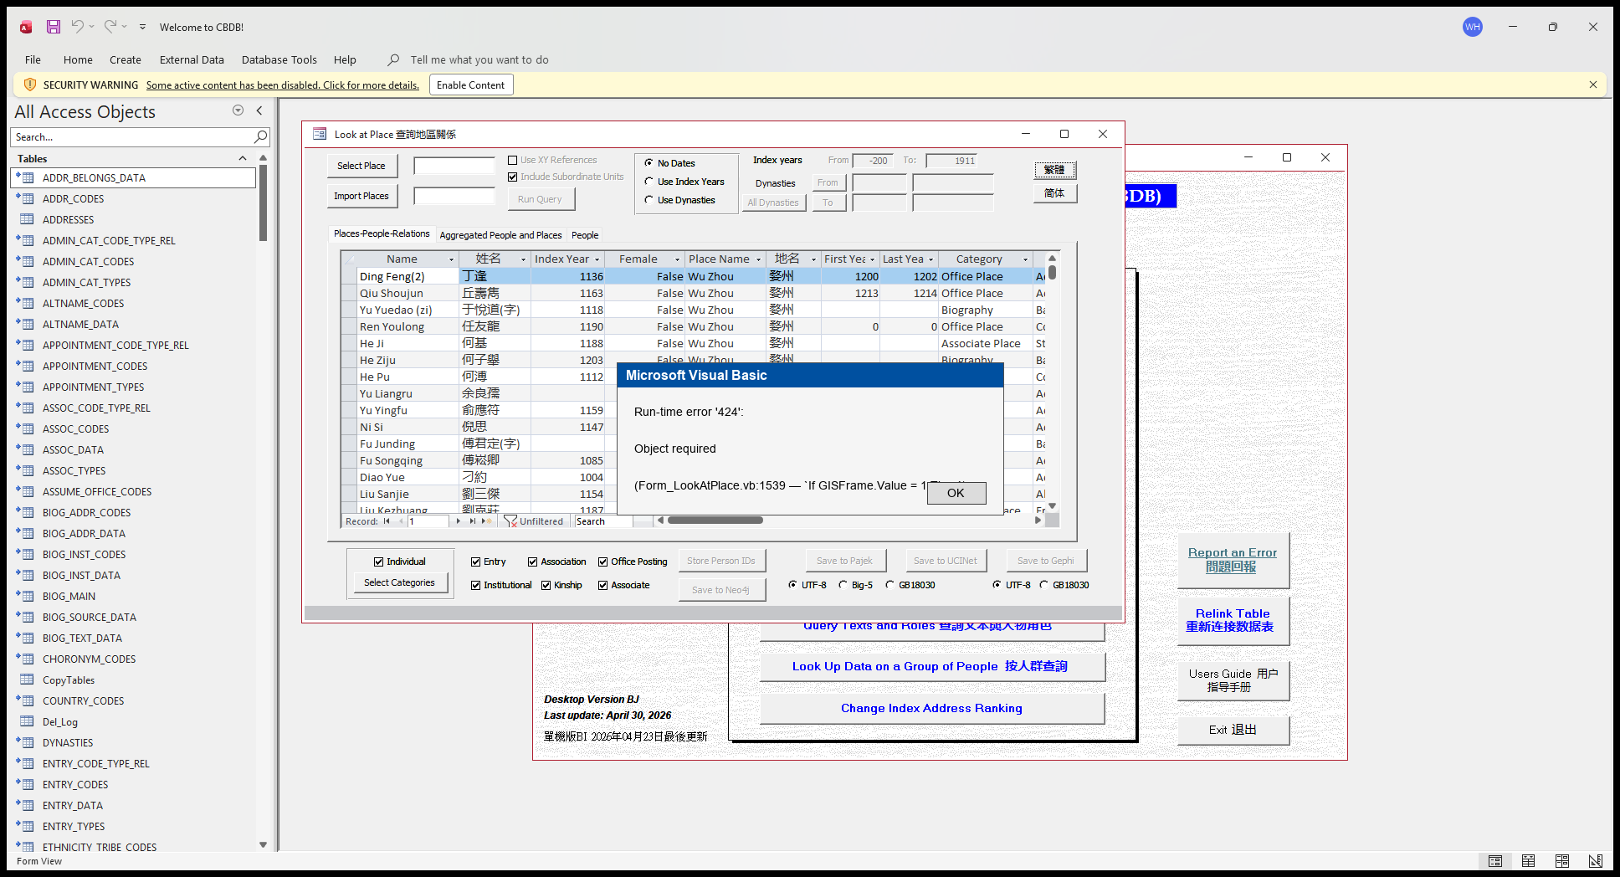
Re-rendered popup — exact runtime error users would see if the button were present.

Suggested fix
Change `GISFrame.Value` to `CodeFrame.Value` on line 1539 of `Form_LookAtPlace.vb`. Same change `CmdNeo4j_Click`, `CmdGephi_Click`, and `CmdPajek_Click` on the same form already use correctly.

Issue #5 — LookAtStatus.CmdPajek references a missing control AND uses three columns that don't exist

Affected sub
Form_LookAtStatus.CmdPajek_Click

Severity
P1 — Visible crash (cluster of two)

Description
Two related defects in the same handler:
(a) Line 2308 reads `If ChkIDs.Value Then`, but Status has no control named `ChkIDs` — only `ChkXYRef`, `ChkKML`, and `ChkSubUnits`.
(b) Lines 2335–2338 build a SELECT that references `ZZ_SCRATCH_STATUS.c_person_id`, `c_status_id`, and `c_status_count` — none of which exist in the schema (the real columns are `c_personid`, `c_status_code`, no count column at all).
The whole sub looks copy-pasted from `LookAtAssociations.CmdPajek_Click` where these names ARE valid; the rename pass missed both spots. Like Issue #4 this is also somewhat moot because LookAtStatus has no Pajek button (Issue #16); the SQL still fails the moment the sub is invoked though, so adding the button without fixing the SQL would just expose the failure to users.

Steps to reproduce
- (Hypothetical, after Issue #16 is fixed.) Open **LookAtStatus**.
- Run a query, then click the Pajek button.
- First: an `Object required` popup appears (the ChkIDs reference).
- If that's worked around, the next click hits the SQL: a `No such field` error from the SELECT that references three non-existent columns.

Suggested fix
Two fixes:
(a) Replace `ChkIDs.Value` with either a constant `False` (if the optional behaviour isn't needed) or add a real ChkIDs control to LookAtStatus's design.
(b) Rewrite the SELECT to use `ZZ_SCRATCH_STATUS.c_personid` and `ZZ_SCRATCH_STATUS.c_status_code`, and either drop the count aggregate or compute it some other way (the source table doesn't have `c_status_count`).
Realistically the whole sub probably needs a thoughtful rewrite rather than spot fixes — it was clearly inherited from another form without verification.

Issue #6 — LookAtGroupData ChkEntry path references a non-existent column ENTRY_DATA.c_parental_status

Affected sub
Form_LookAtGroupData.queryEntry

Severity
P1 — Visible crash on a common path (Entry sub-query)

Description
`Form_LookAtGroupData.vb` line 2621 has an INSERT INTO whose target column list ends with `c_parental_status_code` but whose SELECT projection ends with `ENTRY_DATA.c_parental_status` (no `_code` suffix). The actual column on `ENTRY_DATA` is `c_parental_status_code`; the typo means the SQL crashes with 'No such field' the moment the user checks **Entry** and clicks **Run**.
`Form_LookAtEntry.vb:1650` does the same logical query and uses the correct name, so this is a single-line drift.

Steps to reproduce
- Open **LookAtGroupData** with any non-empty person list.
- Tick the **Entry** checkbox.
- Click **Run**.
- A popup appears reporting that a field doesn't exist (the exact wording varies between Office versions).

Suggested fix
Change `ENTRY_DATA.c_parental_status` to `ENTRY_DATA.c_parental_status_code` on line 2621. One-line fix.

Issue #13 — BIOG_MAIN_2 Subform tries to open a picker form (frmPickNIAN_HAO) that doesn't exist

Affected sub
Form_BIOG_MAIN_2_Subform.c_fl_ey_notes_Click

Severity
P1 — Visible crash on a user click

Description
When the user clicks the `c_fl_ey_notes` field on a person's biographical detail subform, `Sub c_fl_ey_notes_Click` runs `DoCmd.OpenForm "frmPickNIAN_HAO"`. There is no form named `frmPickNIAN_HAO` in the .mdb's CurrentProject.AllForms collection. Access raises 'Item not found …' and the field click does nothing useful for the user.
Likely cause: a picker form was renamed or consolidated in an earlier refactor, and this caller wasn't updated.

Steps to reproduce
- Open any person's biographical detail form.
- On the BIOG_MAIN_2 subform, click the `c_fl_ey_notes` field.
- An `Item not found in this collection.` popup appears.

Suggested fix
Either restore the picker form `frmPickNIAN_HAO`, or update the caller in `Form_BIOG_MAIN_2_Subform.c_fl_ey_notes_Click` to use whichever picker form replaced it.

Issue #14 — KIN_DATA Subform tries to open a picker form (frmPickKINSHIP_CODES) that doesn't exist

Affected sub
Form_KIN_DATA_Subform

Severity
P1 — Visible crash on a user click

Description
Same shape as Issue #13, on a different sub-form. The kinship-code picker logic in KIN_DATA_Subform calls `DoCmd.OpenForm "frmPickKINSHIP_CODES"` and references `Forms!frmPickKINSHIP_CODES!frmKINSHIP_CODES.Form!c_kincode`. Neither form exists in the current .mdb.

Steps to reproduce
- Open any person's kinship subform.
- Click the field that's bound to the kinship-code picker.
- An `Item not found in this collection.` popup appears.

Suggested fix
Same as Issue #13: restore the picker form or update the caller to point at its replacement.

P2 — Silent display

Issue #10 — EVENT_ADDR_2 Subform address columns silently render blank (wrong ControlSource)

Affected sub
EVENT_ADDR_2 Subform

Severity
P2 — Silent display (address columns blank)

Description
On the EVENT_ADDR_2 sub-form (events with addresses), the two address controls are bound as follows:
• `TxtAddrCHN`.ControlSource = `c_name_chn`
• `TxtAddrPY`.ControlSource = `c_name`
But the form's RecordSource is the saved query `View_EventAddrData`, which aliases ADDR_CODES.c_name_chn as `c_event_addr_chn` and ADDR_CODES.c_name as `c_event_addr_name`. Neither `c_name` nor `c_name_chn` is in the projection, so both controls silently render blank for every row.

Steps to reproduce
- Open any person's biographical detail form for someone with events that have associated addresses.
- Switch to the EVENT_ADDR sub-datasheet.
- The Chinese address column and the Pinyin address column are blank, even though the underlying data is populated.

Screenshots
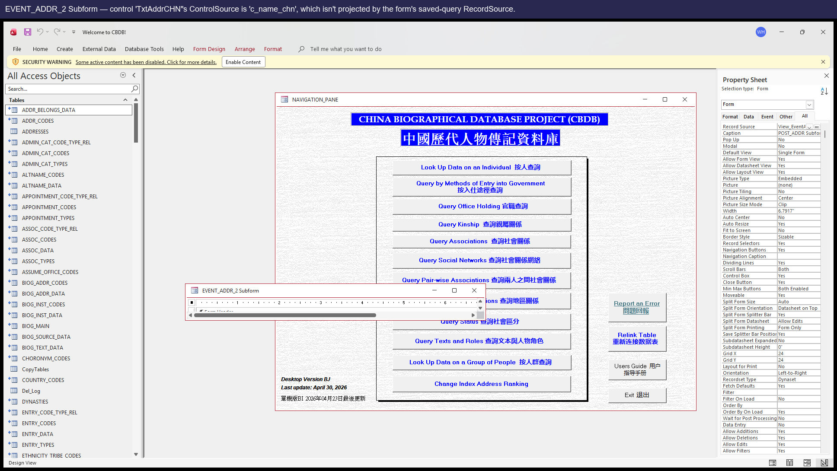
EVENT_ADDR_2 in design view, annotated — TxtAddrCHN's ControlSource (`c_name_chn`) is not in the form's RecordSource projection.

Suggested fix
In the form designer, change `TxtAddrCHN`.ControlSource from `c_name_chn` to `c_event_addr_chn`, and `TxtAddrPY`.ControlSource from `c_name` to `c_event_addr_name` (the actual aliases in View_EventAddrData).

Issue #11 — EVENTS_DATA_2 Subform has a control bound to a non-existent column c_event_record_id

Affected sub
EVENTS_DATA_2 Subform

Severity
P2 — Silent display (column blank)

Description
The EVENTS_DATA_2 sub-form has a control whose ControlSource is `c_event_record_id`. Neither the source table EVENTS_DATA nor the form's RecordSource (`View_EventsData`) has a column of that name — likely a stale design-time leftover from when the schema had an event-record id, or an intended `c_event_code` that was typo'd. The control silently shows blank for every row.

Steps to reproduce
- Open any person's biographical detail form.
- Switch to the EVENTS sub-datasheet.
- The column is blank for every row.

Screenshots
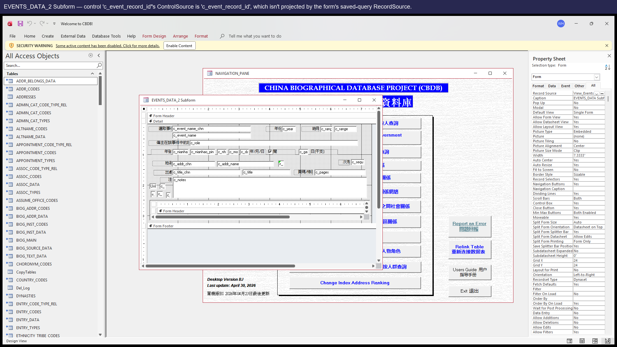
EVENTS_DATA_2 in design view, annotated.

Suggested fix
Decide what was intended. If the column is no longer needed, remove the control. If it should map to `c_event_code`, fix the ControlSource to that name. If the schema needs a real event-record-id column, add it to EVENTS_DATA AND project it in View_EventsData.

Issue #12 — POSTED_TO_OFFICE_DATA_2 Subform appointment-type control bound to wrong column name

Affected sub
POSTED_TO_OFFICE_DATA_2 Subform

Severity
P2 — Silent display (column blank)

Description
The control `c_appt_type_code` on POSTED_TO_OFFICE_DATA_2 subform has ControlSource `c_appt_type_code`. The form's RecordSource (`View_PostingOfficeData`) projects `POSTED_TO_OFFICE_DATA.c_appt_code` (no `_type` infix). The control silently shows blank.
Looks like a renamed column the form designer didn't follow.

Steps to reproduce
- Open any person's biographical detail form for someone with office postings.
- Switch to the POSTED_TO_OFFICE sub-datasheet.
- The appointment-type column is blank for every row.

Screenshots
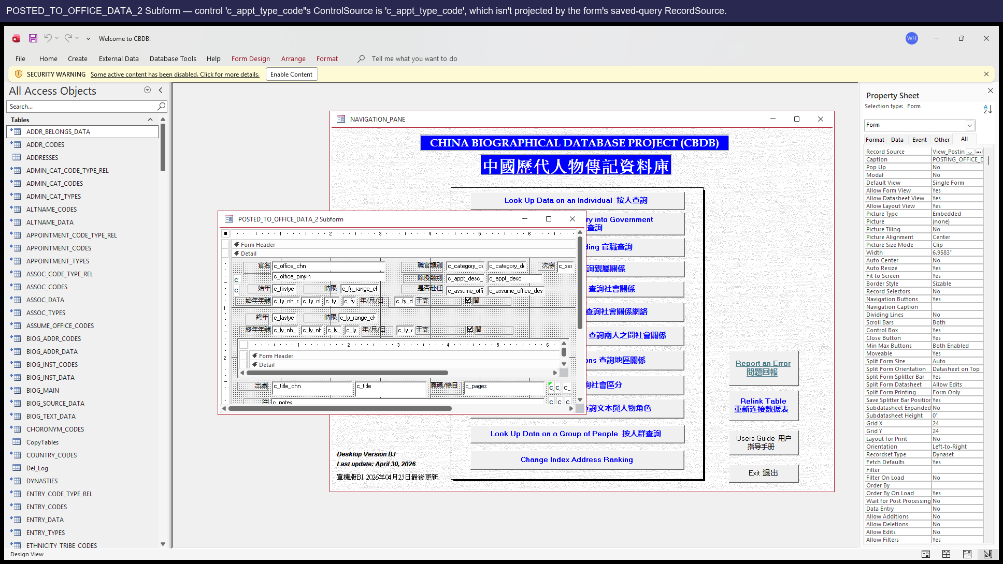
POSTED_TO_OFFICE_DATA_2 in design view, annotated.

Suggested fix
Change the control's ControlSource from `c_appt_type_code` to `c_appt_code` (the actual column projected by View_PostingOfficeData).

P3 — Missing UI

Issue #15 — LookAtPlace is missing its CmdGIS button (handler exists but no UI control)

Affected sub
LookAtPlace

Severity
P3 — Missing UI (feature unavailable to users)

Description
`Form_LookAtPlace.vb` defines a fully functional `CmdGIS_Click` handler — it builds and writes a GIS .tab export, identical in shape to the GIS button on Status / Texts / Associations / Office / Kinship. But LookAtPlace's form design has NO `CmdGIS` button on it. Users on Place can use Pajek / Gephi / Neo4j export but cannot use GIS export — the handler is there, just unreachable from the UI.

Steps to reproduce
- Open **LookAtPlace**.
- Look at the export-buttons row at the bottom right.
- There's no GIS button. Compare with LookAtStatus / LookAtAssociations / LookAtOffice etc., all of which have one.

Screenshots
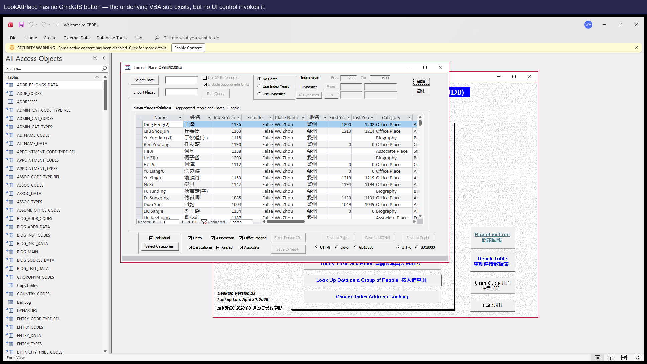
LookAtPlace as it ships — no GIS button is rendered, even though `Sub CmdGIS_Click()` exists in the module.

Suggested fix
In LookAtPlace's form design, add a CmdGIS button next to the existing CmdPajek / CmdGephi buttons, with `OnClick = [Event Procedure]` so it invokes the existing CmdGIS_Click Sub. (Also fix Issue #4 first, otherwise the button will throw 'Object required' on the first click.)

Issue #16 — LookAtStatus is missing its CmdPajek button

Affected sub
LookAtStatus

Severity
P3 — Missing UI

Description
Same shape as Issue #15. `Sub CmdPajek_Click()` exists in `Form_LookAtStatus.vb` (would write a Pajek .net export of the status data) but no CmdPajek button is rendered on Status's form design.
Note: even if the button is added, Issue #5 (the SQL/control defects in CmdPajek_Click itself) needs to be fixed first.

Steps to reproduce
- Open **LookAtStatus**. The export-buttons row has only GIS and Neo4j; there's no Pajek button.

Screenshots
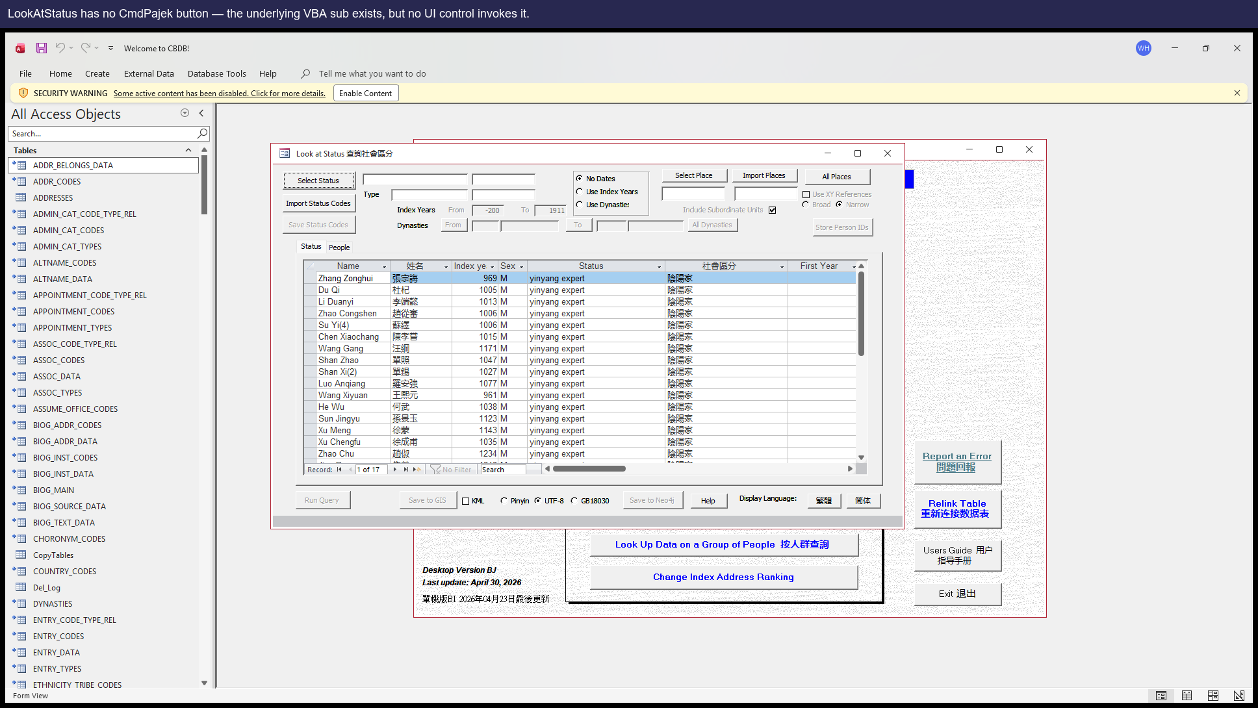

Suggested fix
Add a CmdPajek button to LookAtStatus's design (after fixing Issue #5).

Issue #17 — LookAtStatus is missing its CmdGephi button

Affected sub
LookAtStatus

Severity
P3 — Missing UI

Description
`Sub CmdGephi_Click()` exists in `Form_LookAtStatus.vb` but no matching button is on the form design.

Steps to reproduce
- Open **LookAtStatus**. There is no Gephi export button.

Screenshots
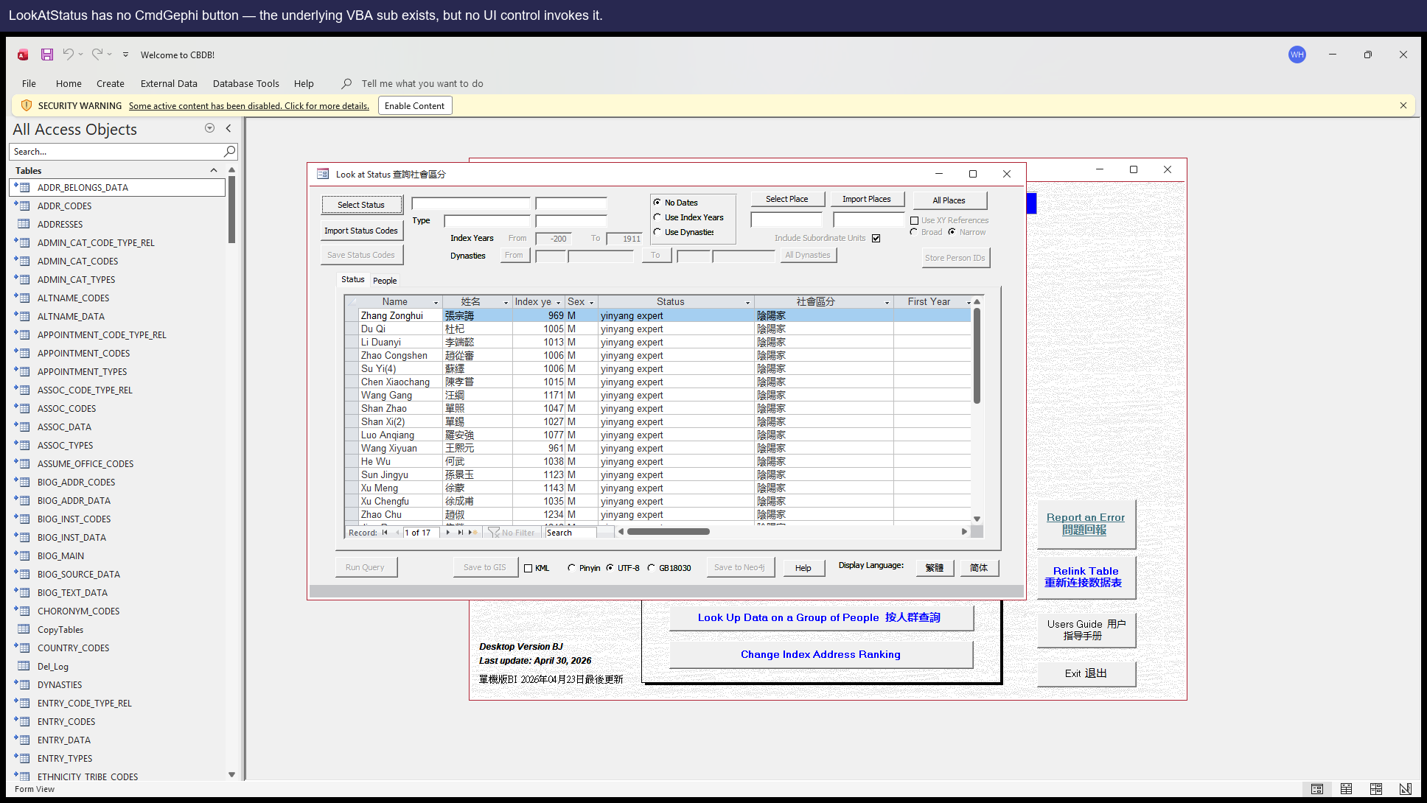

Suggested fix
Add a CmdGephi button to LookAtStatus's design.

Issue #18 — LookAtStatus is missing its CmdUCINet button

Affected sub
LookAtStatus

Severity
P3 — Missing UI

Description
`Sub CmdUCINet_Click()` exists in `Form_LookAtStatus.vb` but no matching button is on the form design.

Steps to reproduce
- Open **LookAtStatus**. There is no UCINet export button.

Screenshots
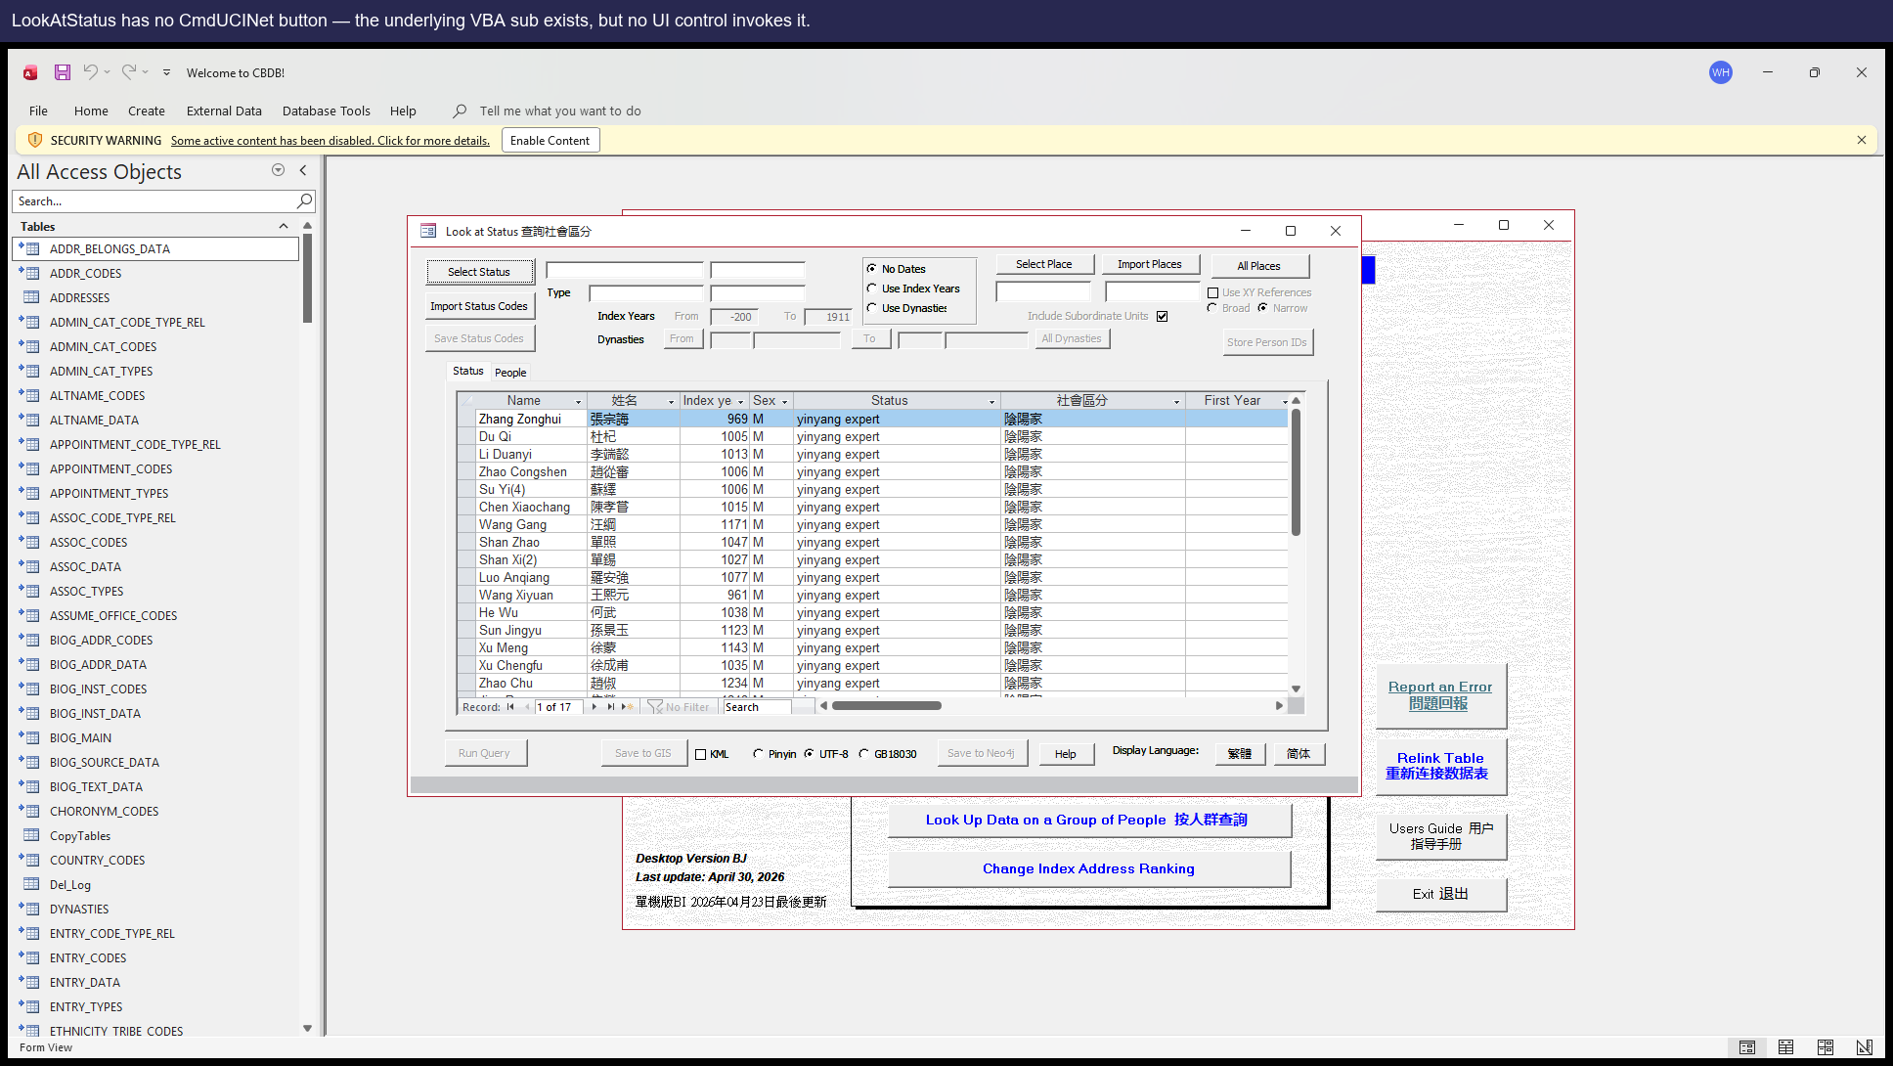

Suggested fix
Add a CmdUCINet button to LookAtStatus's design.

Issue #19 — LookAtOffice is missing its CmdGUESS button

Affected sub
LookAtOffice

Severity
P3 — Missing UI

Description
`Sub CmdGUESS_Click()` exists in `Form_LookAtOffice.vb` but no CmdGUESS button is on the form design. Users on Office can use GIS / GISPeople / Neo4j export but not GUESS.

Steps to reproduce
- Open **LookAtOffice**. There is no GUESS export button.

Screenshots
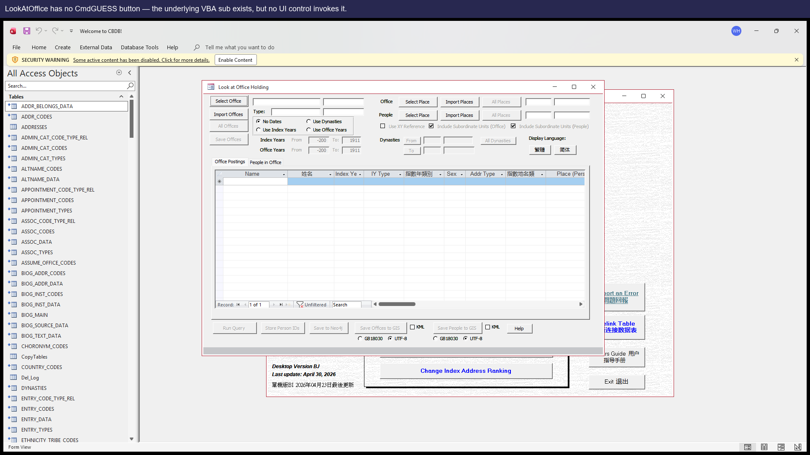

Suggested fix
Add a CmdGUESS button to LookAtOffice's design.

P4 — Setup

Issue #2 — VBA project references the legacy dao360.dll which isn't on Office 2016+ machines

Affected sub
VBE Project References

Severity
P4 — One-time setup hurdle on each new machine

Description
The shipped .mdb's VBA project carries a hard reference to `C:\Program Files\Common Files\Microsoft Shared\DAO\dao360.dll`, which was the DAO 3.6 location used by Access 2003. Modern Office (2016 onward) ships `ACEDAO.DLL` instead and does NOT install the legacy DLL. On any clean modern machine, the first attempt to open any LookAt form raises 'Can't find project or library', which is opaque and scary to end users.
Severity is low because it's a one-time fix per machine, but every new install hits it.

Steps to reproduce
- Install `CBDB_BJ_User.mdb` on a fresh modern Office machine.
- Open the file. Press Alt+F11 to enter the VBE.
- Tools → References. Notice an entry marked `MISSING: dao360.dll`.
- Open any LookAt form. A 'Can't find project or library' error appears.

Suggested fix
Once, on the maintainer's machine, do:
1. Open the .mdb in Access. Press Alt+F11.
2. Tools → References. Untick the MISSING dao360.dll entry.
3. Tick `Microsoft Office 16.0 Access Database Engine Object Library` (i.e. ACEDAO.DLL).
4. Save the .mdb.
Then re-distribute the fixed file. Future end users won't need to do anything.

Closing note
Thank you for taking the time to read this report. None of the items above is urgent; we hope having them all in one place makes it easy to address them at your own pace.
If any of the descriptions or suggested fixes are unclear, we would be glad to discuss further. The corresponding regression tests in this repository will automatically flip from PASS to FAIL the moment any issue is fixed in the source dump — so you can use them as a confirmation signal.

