MS12-U Track Edition Environmental Reliability (ENV) Test Plan
Project Name：Modena-U 27A
Test Plan No.：Unified ENV Department Number
Product Name: MECHANISM ASM - GOOSENECK-STYLE SPOILER
Product No.：P000042958001 LH/ P000042959001 RH

Test Phase | Test Location | Test Time
B Sample
C Sample (DV)
D Sample (PV)

Suppliers |  |  |  | Xiaomi EV  Xiaomi Automobile
Prepared by |  | Approved by |  | Engineer ENV |  | Approved by
Date |  | Date |  | Date |  | Date

ENV Information
Component Supplier Basic Information
Supplier Name
Address
Basic Laboratory Information
Laboratory Name
Laboratory Address
Laboratory Contact Information | Name | Telephone | Email
Test Plan Preparation and Approval
Prepared by |  | Tel
Prepared by |  | Email
Approved by |  | Tel
Approved by |  | Date
Test Plan Review and Approval
Xiaomi Components Engineer |  | Tel
Xiaomi Components Engineer |  | Email
Xiaomi Components Engineer |  | Date
Xiaomi Environmental Engineer |  | Tel
Xiaomi Environmental Engineer |  | Email
Xiaomi Environmental Engineer |  | Date
Test Plan Number |  | Validity Period | Year Month Day

Test Plan Change History
Version | Description | Responsible Person | Date
1.0 | Initial Version
- The test plan review is conducted according to the following revisions and/or newly added clauses:

Test Plan Template Change History
Version | Description | Responsible Person | Date
1.0 | Initial Version | Liu Chongjun, Wang Junjie, Gao Yuan | 2022/02/08
1.1 | - Added description for data acquisition directly from third-party laboratories  - Added description of the notification sequence in the event of failure | Liu Chongjun, Wang Junjie, Gao Yuan | 2022/03/22
1.2 | Added requirements for the Second-Party Laboratory in the description, equivalent to those for third-party laboratories | Liu Chongjun, Huang Kehua, Wang Junjie | 2022/09/22
1.3 | 1. Added Section 3.1 General Requirements  2. Added examples | Liu Chongjun, Huang Kehua, Wang Junjie, Yang Kaichen | 2022/10/22
1.4 | 1. Update to the description in Chapter 1  2. Addition of clause c in Section 3.1 | Liu Chongjun, Huang Kehua, Wang Junjie, Yang Kaichen | 2023/02/07
2.0 | Updated in accordance with QMAT 5502-2023 | Yang Kaichen, Jiang Congxi, Deng Shaokun | 2023/10/07
3.0 | Updated in accordance with QMAT 5502-2025 | Xu Dingyu, Luxu, Shi Yue, Zhao Wei | 2025/04/16
4.0 | Updated in accordance with QMAT 5502-2026 | Xu Dingyu, Deng Shaokun, Luxu, Ma Haitong, Tu Wendi, Zhang Danying, Meng Chao | 2025/05/09

Table of Contents
1 Description 10
2 DUT Introduction 12
2.1 DUT Information 12
2.2 Product Structure 13
2.2.1 Product Installation Position and Orientation 13
2.2.2 Wiring Harness Side Connector (Complete Vehicle End) 14
2.2.3 Product Photograph 14
2.3 Product Hardware Information 15
2.3.1 Pin Definition 15
2.3.2 Theory of Operation 16
2.4 Product Categories 16
2.4.1 Classification of Functional Level Importance 16
2.4.2 Function Performance Class 17
3 Test Requirements 18
3.1 General Requirements 18
3.2 Test Setup Description 19
3.3 DUT Operating Mode Description 19
3.4 Test Item Requirements 20
3.5 Reference Documents 20
3.6 Test Sequence 21
3.7 Load Box Description 21
4 X-ray and Sectioning Inspection 23
4.1 Test Conditions 23
4.2 Test Points and Requirements 23
4.3 Test Class and Acceptance Criteria 23
5 Hermeticity Test 24
5.1 Test Conditions 24
5.2 Test Setup 24
5.3 Test Procedure 24
5.4 Test Class and Acceptance Criteria 24
6 Five-Point Function/Performance Test 25
6.1 Test Conditions 25
6.2 Test Setup 25
6.3 Test Pulse 26
6.4 Test Procedure 26
6.5 Test Class and Acceptance Criteria 26
7 Temperature Gradient Test 27
7.1 Test Conditions 27
7.2 Test Setup 27
7.3 Test Pulse 28
7.4 Test Procedure 28
7.5 Test Class and Acceptance Criteria 28
8 Temperature Cycling Test 29
8.1 Test Conditions 29
8.2 Test Setup 29
8.3 Test Pulse 30
8.4 Test Procedure 30
8.5 Test Class and Acceptance Criteria 30
9 Rapid Temperature Change Test 31
9.1 Test Conditions 31
9.2 Test Setup 31
9.3 Test Pulse 32
9.4 Test Procedure 32
9.5 Test Class and Acceptance Criteria 32
10 Ice Water Impact Splash Test 33
10.1 Test Conditions 33
10.2 Test Setup 34
10.3 Test Pulse 34
10.4 Test Procedure 35
10.5 Test Class and Acceptance Criteria 35
11 Salt Spray Corrosion Test 36
11.1 Test Conditions 36
11.2 Test Setup 37
11.3 Test Pulse 37
11.4 Test Procedure 37
11.5 Test Class and Acceptance Criteria 37
12 Salt Water Spray Test 38
12.1 Test Conditions 38
12.2 Test Setup 39
12.3 Test Pulse 39
12.4 Test Procedure 39
12.5 Test Class and Acceptance Criteria 40
13 Damp Heat Cycle 2 – Frost Test 41
13.1 Test Conditions 41
13.2 Test Setup 42
13.3 Test Pulse 42
13.4 Test Procedure 43
13.5 Test Class and Acceptance Criteria 44
14 Damp Heat Cycle 3 – Condensation Test 45
14.1 Test Conditions 45
14.2 Test Setup 46
14.3 Test Pulse 46
14.4 Test Procedure 47
14.5 Test Class and Acceptance Criteria 47
15 Steady-state Damp Heat Test 48
15.1 Test Conditions 48
15.2 Test Setup 49
15.3 Test Pulse 49
15.4 Test Procedure 49
15.5 Test Class and Acceptance Criteria 50
16 Waterproof and Dustproof Sealing 51
16.1 Test Conditions 51
16.2 Test Setup 52
16.3 Test Pulse 52
16.4 Test Procedure 52
16.5 Test Class and Acceptance Criteria 53
17 Combined Vibration Test 54
17.1 Test Conditions 54
17.2 Test Setup 55
17.3 Test Pulse 55
17.4 Vibration Table Fixture Approval 56
17.5 Test Procedure 57
17.6 Test Class and Acceptance Criteria 58
18 Mechanical Shock Test on Vehicle and Rigid Frame Attachment Points 59
18.1 Test Conditions 59
18.2 Test Setup 59
18.3 Test Pulse 60
18.4 Test Procedure 60
18.5 Test Class and Acceptance Criteria 60
19 Drop Test 61
19.1 Test Conditions 61
19.2 Test Setup 61
19.3 Test Pulse 62
19.4 Test Procedure 62
19.5 Test Class and Acceptance Criteria 62
20 High Temperature Durability Test 63
20.1 Test Conditions 63
20.2 Test Setup 63
20.3 Test Pulse 64
20.4 Test Procedure 64
20.5 Test Class and Acceptance Criteria 64
21 Temperature Cycle Durability Test 65
21.1 Test Conditions 65
21.2 Test Setup 66
21.3 Test Pulse 66
21.4 Test Procedure 66
21.5 Test Class and Acceptance Criteria 67
22 Transport Vibration Test 68
22.1 Test Conditions 68
22.2 Test Pulse 68
22.3 Test Procedure 69
22.4 Test Class and Acceptance Criteria 69
23 Visual Inspection Before and After Testing 70
23.1 Test Conditions 70
23.2 Test Setup 70
23.3 Test Pulse 70
23.4 Test Procedure 71
23.5 Test Class and Acceptance Criteria 71

- Description
Suppliers executing this test plan shall select second-party or third-party laboratories approved by Xiaomi Automobile.
Should any inconsistencies or uncertainties arise between the test plan and applicable standards, confirmation must be obtained via email from the relevant ENV engineer within the Xiaomi Complete Vehicle Basic Software Department.
Components and systems that satisfy the requirements of this standard qualify only for installation and vehicle-level ENV testing. If any issues occur during vehicle-level ENV testing, the supplier remains responsible and obligated to perform design modifications on the component products until the vehicle ENV requirements are fully met.
Test reports issued by the Second Party or third-party laboratories must include photographs of the test site, with the images clearly indicating the actual time of capture (accurate to the minute).
The sequence of ENV and environmental reliability testing for Xiaomi Automobile follows the relevant ADVP documentation.
The Second-Party or Third-Party Laboratory may commence formal testing only after receiving the signed test plan.
Xiaomi Automobile reserves the right to directly obtain all testing-related information, including test data, from the Second-Party or Third-Party Laboratory for relevant projects.
In the event of any failure or abnormality during formal product testing, the Second-Party or Third-Party Laboratory shall notify Xiaomi Automobile and the component supplier simultaneously within one working day. The Second-Party or Third-Party Laboratory shall not report test nonconformities solely to the component supplier without the knowledge of Xiaomi Automobile.
Xiaomi Automobile reserves the right to select specific test items conducted by the Second-Party Laboratory for re-evaluation at other Third-Party Laboratories. If any inaccurate testing-related information is identified, the laboratory’s accreditation shall be immediately revoked, and its application eligibility suspended for a period of 2 to 3 years.
Tested samples must be stored in a temperature- and humidity-controlled environment for a minimum of two years following the complete vehicle SOP. Destruction of specimens requires prior written approval from Xiaomi via email. During the storage period, Xiaomi reserves the right to request the supplier to retrieve tested samples for verification.

- DUT Introduction
  - DUT Information
Product Basic Information
Product Name |  |  |  |  |  |  |  |  |  |  |  |  |  |  |  |  |  |  | Product Number
Hardware Version |  |  |  |  |  |  |  |  |  |  |  |  |  |  |  |  |  |  | Software Version
Test Phase |  |  |  |  |  |  |  |  |  |  |  |  |  |  |  |  |  |  | Vehicle Type
Product Category(s)
Total Number of DUT |  |  |  |  |  |  |  |  |  |  |  |  |  |  |  |  |  |  | DVB：xxxPCS  DVC：xxxPCS  PV：xxxPCS
Product Size and Weight Information
Product External Dimensions (L×W×H) (cm)
Product Weight (kg)
Product Operating Mode
☐ |  |  |  | Long-Duration |  |  |  |  |  | ☐ |  |  |  |  | Short-Duration |  |  |  |  |  |  |  |  | ☐ |  | Continuous Duration
Product Case Material Information
☐ |  |  | Metal |  |  |  | ☐ |  |  |  | Non-Metal |  |  |  |  |  | ☐ |  |  |  | Conductive |  |  |  |  | ☐ |  |  |  |  | Non-Conductive
Product Installation Location
☐ | Under Hood |  |  |  |  | ☐ |  | Under Body |  |  |  |  |  | ☐ |  | Passenger Compartment |  |  |  |  |  | ☐ | Trunk |  |  |  |  | ☐ |  |  | External Body
Customer Accessibility to Product
☐ | Accessible inside the cabin |  |  |  |  |  |  |  |  |  |  |  |  |  | Accessible outside the vehicle |  |  |  |  |  |  |  |  |  |  |  |  |  |  | ☐ |  |  |  | Not accessible
Customer accessibility to the product
☐ | Direct access (Physical touching) |  |  |  |  |  |  |  |  |  |  |  |  |  |  |  |  | ☐ |  | Indirect access (Remote switch)
How is the Product connected to Power Return (Ground)? (impacts test setups)
☐ | Direct connection to chassis (near-end grounding) |  |  |  |  |  |  |  |  |  |  |  |  |  |  |  |  | ☐ |  | Wiring harness connection (far-end grounding)
How is the product enclosure grounded? (Applicable only to metal enclosures)
1. Method of connecting the product enclosure to the chassis
☐ |  |  |  |  | Connected |  |  |  |  | ☐ |  |  |  |  |  |  |  | Isolated |  |  |  |  |  |  | ☐ |  |  |  |  |  |  |  | Unknown
2. Is there a power return circuit connected to the product enclosure inside the product?
☐ |  | Direct connection |  |  |  |  |  |  |  | ☐ |  | Resistive-capacitive connection |  |  |  |  |  |  |  |  |  |  |  |  |  |  |  |  | ☐ |  |  |  | No connection
Does the product include an internal switch?
☐ |  |  |  |  |  |  | Yes |  |  |  |  |  |  |  |  |  |  | ☐ |  |  |  |  |  |  |  |  | No

Component Operating Environments
Minimum Storage Temperature  T_{min} [°C] | -40 | Minimum Operating Voltage  U_{min} [V] | 9 V  /  36 V  (for 48V components) | Rated Operating  Current (A)
Minimum Operating Temperature  T_{minop} [°C] | -40 | Parking Operating Voltage  U_{B} [V] | 12 V  /  48 V  (for 48V components) | Dust  Ingress Protection (IP) Rating | 6
Maximum Operating Temperature  T_{maxop} [°C] | 80 | Driving Operating Voltage  U_{A} [V] | 13.5 V  /  48 V  (for 48V components) | Water  Ingress Protection (IP) Rating | 7
Maximum Storage Temperature  T_{max} [°C] | 80 | Maximum Operating Voltage  U_{max} [V] | 16 V  /  52 V  (for 48V components) | Salt Spray Corrosion Rating
Remarks

  - Product Structure
    - Product Installation Position and Orientation
Note: Provide a textual description of the product’s installation position and specific orientation within the actual vehicle, accompanied by corresponding CAD model screenshots. If multiple specimens are present, each specimen must have an image illustrating its installation position and orientation.
Note: The actual installation position of the product and the specific angle need to be explained, and corresponding digital model screenshots should be added.

    - Wiring Harness Side Connector (Complete Vehicle End)
LDI Number:
Connector Model:
Manufacturer:

Note: The connector model and manufacturer used for testing must be identical to those used in the actual vehicle.
    - Product Photograph
Note: Provide six-face views of the product in the blank space below. If multiple specimens exist, include six-face views for each.

Figure 1 A-side (X Orientation)

Figure 2 B-side (Y Orientation)

Figure 3 C-side (Z Orientation)

Figure 4 D-side

Figure 5 E-side

Figure 6 F-side
Note: Please provide front and back photographs of the product PCB in the space below.

Figure 7 PCB Top View

Figure 8 PCB Bottom View
  - Product Hardware Information
    - Pin Definition
Note: Please provide the system block diagram and product interface photographs in the space below.

Figure 9 System Block Diagram

Figure 10 Product Interface Photographs

Pin and Interface Definition Information
Connector Number. | Pin | Signal Type | Signal Description | Wiring Harness Type | Input/Output (I/O) | Remark
    - Theory of Operation
Note: Functional schematics and corresponding descriptions are provided in the following blanks.

Figure 11 Function Diagram/Schematic Description:
  - Product Categories
    - Classification of Functional Level Importance
The functional grade priority classification guides the required test intensity levels for the DUT and the performance status levels to be achieved. It categorizes the importance of electronic components and systems in vehicle safety operations as follows:
Class I: Functions that provide convenience and may enhance vehicle handling or control performance but are not essential for vehicle operation or control. Failure does not affect vehicle driving safety and does not produce noticeable user perception.
Class II: Functions that control or affect primary vehicle operations or may cause confusion among other road users.
    - Function Performance Class
Class A: All functions of the tested specimen or System operate normally during and after interference, with deviations caused by disturbances remaining within the design tolerance range of the tested specimen.
Class B: During interference, all functions of the tested specimen or System operate normally; however, one or more functions may deviate beyond the specified tolerance. Following removal of interference, all functions automatically recover to normal status, with the Memory Function remaining unaffected.
Class C: One or more functions of the tested specimen or System do not operate normally during interference but automatically recover to normal status once the interference has ceased, with the Memory Function remaining unaffected.
Class D: During and after interference, the function of the equipment and system cannot operate normally; however, following the removal of interference and activation of a reset by the operator or user, normal operation can resume, with the memory function remaining unaffected.
Class E: During and after interference, the function of the equipment and system cannot operate normally, and normal function cannot be restored without repair or replacement of the equipment or system.

- Test Requirements
All test descriptions and parameters refer to Master_Test_Specifications_DRS_Electro.
  - General Requirements
- Appearance and functional performance inspections shall be performed on the sample before and after testing.
- Each test sample shall have a unique identifiable identifier that remains unchanged before, during, and after testing.
- Samples shall be photographed before and after testing, as well as after the test environment setup is complete; all photos must include a timestamp.
- For tests involving voltage waveform output, waveform verification using an oscilloscope shall be performed after configuring the waveform parameters.
- For tests requiring placement inside the test chamber, samples shall be positioned centrally. For large or multiple samples, maintain a minimum distance of 100 mm between samples and the inner wall of the test chamber, and a minimum spacing of 100 mm between samples, to ensure proper air circulation.
- For temperature-controlled tests, unless otherwise specified, timing shall begin only after the test chamber reaches the initial required temperature of the test.
- A single test shall not be terminated prematurely unless explicitly specified. If an early termination occurs, the cause and time must be recorded and reflected in the test report.
- Humidity-related tests must not be interrupted. In case of an unexpected interruption, Xiaomi must be notified immediately. Testing may only proceed after Xiaomi’s evaluation. Depending on the assessment, measures such as restarting the test or extending its duration may be required.
- Humidity-related tests shall be conducted with the sample positioned at the same orientation as in the actual vehicle, with special attention to the wiring harness arrangement. The routing of the wiring harness must be consistent with that of the actual vehicle.
- For tests in progress, inspections must be conducted at least twice daily. For tests without real-time data saving capabilities, inspections must be carried out at least every two hours. Each inspection shall include photographic documentation, and any issues must be reported to Xiaomi promptly.
  - Test Setup Description

Figure 12 Test Setup Introduction Diagram
  - DUT Operating Mode Description
Operating Mode Group | Number | Description
1.) No voltage is applied to the Device Under Test (DUT) | 1.1 | Components are not connected to the wiring harness
1.) No voltage is applied to the Device Under Test (DUT) | 1.2 | Components simulate vehicle installation position connected to the wiring harness
2.) The DUT is electrically operated using the test voltage U_{B} (battery voltage), simulating a vehicle with the engine shut off, with all electrical connections established | 2.1 | System/Component inactive (e.g., Sleep mode)
 | 2.2 | System/Component operating in normal state with typical load
 | 2.3 | System/Component operating in normal state with minimum load
 | 2.4 | System/Component operating in normal state with maximum load
3.) The DUT is electrically operated using the test voltage U_{A} (alternator voltage), with all electrical connections established. | 3.1 | System/Component inactive (e.g., Stand-by mode)
 | 3.2 | System/Component operating in normal state with typical load
 | 3.3 | System/Component operating in normal state with minimum load
 | 3.4 | System/Component operating in normal state with maximum load

  - Test Item Requirements
Test mode consistent with Section 3.3.
Test Item | DVC Test applies | Test Mode | Remarks
X-ray and Slice Inspection | Y | 1.1 | ENV_018
Hermeticity Test | Y | 1.2 | ENV_006
Five-point Function / Performance Testing | Y | 2.1 / 3.2 | ENV_004
Temperature Gradient Test | Y | 3.1 / 3.2 | ENV_015
Temperature Cycling Test | Y | 3.1 / 3.2 | ENV_014
Rapid Temperature Change Test | Y | 1.1 | ENV_009
Ice Water Shock - Splash Test | Y | 1.2 / 3.2 | ENV_007
Salt Spray Corrosion Test | Y | 1.2 | ENV_011
Salt Solution Spray Test | Y | 1.2 / 3.2 | ENV_010
Damp Heat Cycle - Frost Test | Y | 2.1 / 3.2 | ENV_002
Damp Heat Cycle - Condensation Test | Y | 2.1 / 3.2 | ENV_003
Steady-State Damp Heat Test | Y | 2.1 / 3.2 | ENV_012
Waterproof and Dustproof Sealing | Y | 1.2 | ENV_017
Composite Vibration Test | Y | 3.1 / 3.2 | ENV_001
Mechanical Shock Test (Mounted on Vehicle and Rigid Frame Attachment Points) | Y | 3.2 | ENV_008
Free Drop Test | Y | 1.1 | ENV_005
High Temperature Durability Test | Y | 3.1 / 3.2 | ENV_026
Temperature Cycle Durability Test | Y | 3.1 / 3.2 | ENV_013
Visual Inspection Before and After Testing | Y | 1.1 | ENV_016
Transport Vibration Test | Y | 1.1 | ENV_040
  - Reference Documents
Document | Content | Filename
Master_Test_Specifications_DRS_Electro | General Description of all tests for the DRS system | Master_Test_-Specifications_-DRS_Electro_V011.docx
Test_Leg_Definition | Definition of all applicable test legs and tests | Xiaomi DRS Test matrix.xlsx

  - Test Sequence

Figure 13 DVB Test Sequence Diagram

Figure 14 DVC Test Sequence Diagram

Figure 15 PV Test Sequence Diagram
  - Load Box Description
Test Mode:
Interface Pin Number | Function Description | Simulated/Real Load | Description | Load Parameters
Remarks/Backup:
Note: Provide load schematic diagram, load circuit diagram, and load box photos in the blank area below.
Note: Load schematic diagram Load circuit diagram and Load box photo are given in the blank below.

Figure 16 Load Schematic Diagram

Figure 17 Load Circuit Diagram

Figure 18 Load Box Photo

- X-ray and Sectioning Inspection
Test ID: ENV_018
  - Test Conditions
Test Details | Comments
Standard Test Method | Master_Test_Specifications_DRS_Electro
Environmental Conditions | Ambient Temperature: 23℃
Test Parameters | TBD
Operating Mode | Mode 1.1
Test Object | TBD
DUT Orientation | No Orientation Requirement
Number of DUT | According to test leg
Special Requirements | --
Remarks | --

  - Test Points and Requirements
TBD
  - Test Class and Acceptance Criteria
Refer to IPC610; X-ray inspection of samples before and after testing must show voids no larger than 25%.
Slice inspection of samples before testing must show no cracks; post-test slice inspection must not exceed a crack length of 50%.

- Hermeticity Test
Test ID: ENV_006
  - Test Conditions
Test Details | Comments
Standard Test Method | Master_Test_Specifications_DRS_Electro
Environmental Conditions | Ambient Temperature: 23℃
Test Parameters | TBD
Operating Mode | Mode 1.2
Test Object | Actuator
DUT Orientation | No Orientation Requirement
Number of DUT | TBD
Special Requirements | --
Remarks | --

  - Test Setup
TBD
  - Test Procedure
TBD
  - Test Class and Acceptance Criteria
Product leakage meets the specified requirements.

- Five-Point Function/Performance Test
Test ID: ENV_004
  - Test Conditions
Test Details | Comments
Standard Test Method | Master_Test_Specifications_DRS_Electro
Environmental Conditions | See Test Parameters
Test Parameters | - T_{room}, U_{N}  - T_{min}, U_{min}  - T_{min}, U_{max}  - T_{max}, U_{min}  - T_{max}, U_{max}
Operating Mode | Mode 3.1 / Mode 3.2
Test Object | Actuator
DUT Orientation | No Orientation Requirement
Number of DUT | Number of DUT = DUT number in test sequence
Special Requirements | --
Remarks | --

  - Test Setup
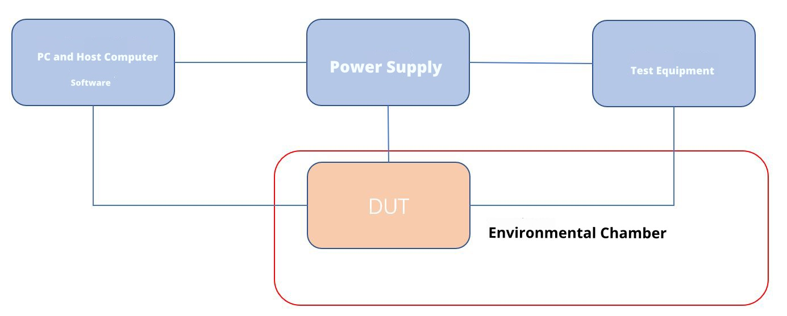
Figure 19 Test Setup Diagram

  - Test Pulse
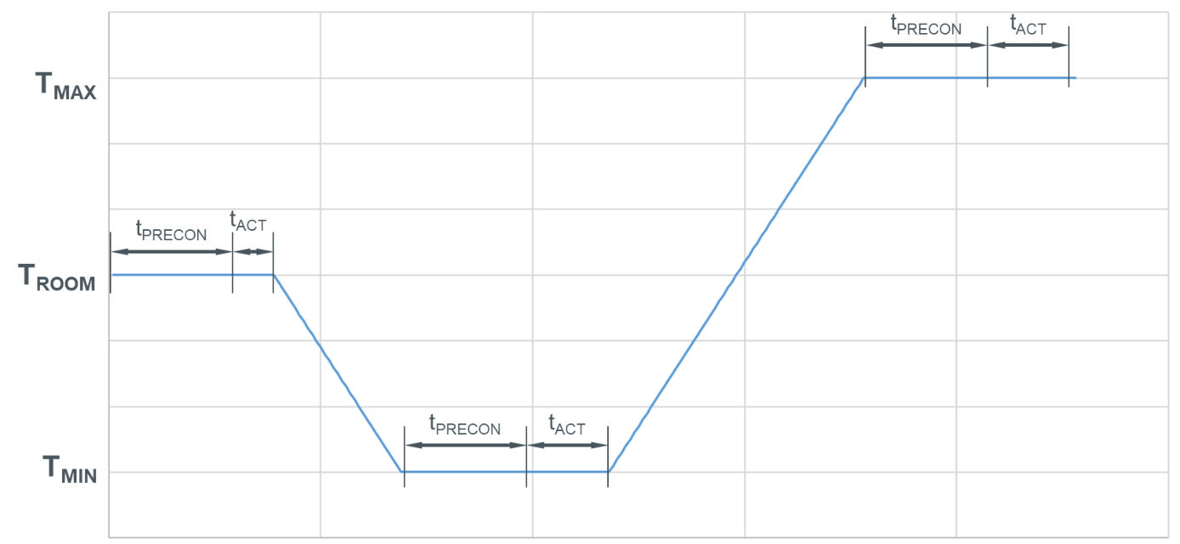
t_{PRECON} Pre-Conditioning at set temperature Operation mode 3.1
t_{ACT} Time where the component is active Operation mode 3.2
Figure 20 Test Setup Diagram
  - Test Procedure
- Place the device under test (DUT) inside the test chamber, ensuring specimen spacing ≥10 cm, and distance from the temperature chamber ≥10 cm; assemble the test plan according to the test setup.
- Set the temperature chamber to T_{room}; once stabilized, maintain this condition for 30 minutes.
- Apply a power supply voltage of U_{N} to the specimen for function inspection.
- Apply the activation profile to the specimen for 10 min
- Set the temperature chamber to T_{min}
- Once stabilized, maintain this condition for 30 minutes.
- Apply a power supply voltage of U_{max} to the specimen for function inspection.
- Apply the activation profile to the specimen for 10 min
- Apply a power supply voltage of U_{min} to the specimen for function inspection.
- Apply the activation profile to the specimen for 10 min
- Repeat steps 6-10, setting temperature to T_{max}
  - Test Class and Acceptance Criteria
All function check results meet the functional status Class A, with no issues identified during visual inspection.
- Temperature Gradient Test
Test ID: ENV_015
  - Test Conditions
Test Details | Comments
Standard Test Method | Master_Test_Specifications_DRS_Electro
Environmental Conditions | Test Temperature: T_{minop}, T_{maxop};  Relative Humidity: 45% ~ 75% RH;
Test Parameters | Powered testing with test voltages: U_{max}, U_{min};  Temperature changes in 5℃ increments, with a temperature change rate of 1℃/min, completing one cycle;  (Specific temperatures shall be subject to the SOR)
Operating Mode | Mode 3.1 / Mode 3.2
Test Object | Actuator
DUT Orientation | No Orientation Requirement
Number of DUT | 6
Special Requirements | --
Remarks | Test Objective: To verify the functional status of components at various temperature points within the operating temperature range;

  - Test Setup
Figure 21 Test Setup Diagram

  - Test Pulse
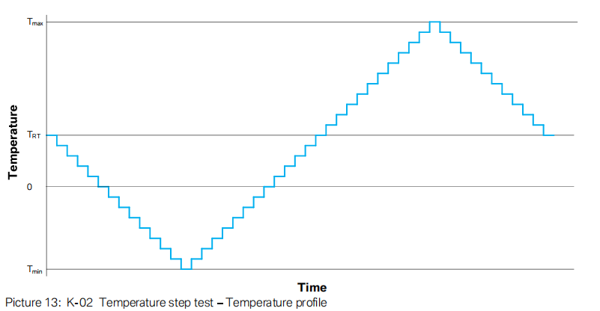
Figure 22 Test Pulse Diagram
  - Test Procedure
- Place the device under test (DUT) inside the test chamber, ensuring specimen spacing ≥10 cm, and distance from the temperature chamber ≥10 cm; assemble the test plan according to the test arrangement.
- Turn on the test chamber and set parameters: T_{minop}; T_{maxop}; Starting from 25℃, temperature changes in 5℃ increments (temperature change rate 1℃/min, each increment held for 30 minutes), gradually cooling to T_{minop}, then gradually heating to T_{maxop}, followed by gradual cooling back to 25℃, completing one cycle;
- Each temperature gradient point shall be executed according to the following operating modes and durations
a) Mode 3.1 held for 25 Minutes duration
b) Mode 3.2 operating at Umax for 1 Minute duration
c) Mode 3.1 held for 3 Minutes duration
d) Mode 3.2 operating at Umin for 1 Minute duration
- Upon test completion, allow the specimen to naturally recover to room temperature, and then conduct a function inspection.
  - Test Class and Acceptance Criteria
All function inspection results comply with Class A standards.
After testing, the specimen must satisfy visual inspection criteria; the appearance shall exhibit no significant damage, and no abnormal noise shall be heard from components after shaking.
- Temperature Cycling Test
Test ID: ENV_014
  - Test Conditions
Test Details | Comments
Standard Test Method | Master_Test_Specifications_DRS_Electro
Environmental Conditions | Test Temperature: 23±5℃;  Relative Humidity: 45% ~ 75% RH;
Test Parameters | Temperature cycling within the range T_{minop} and T_{maxop}, powered testing;  A total of 30 cycles.
Operating Mode | Mode 3.1 / Mode 3.2
Test Object | Actuator
DUT Orientation | Positioned according to the Actual Vehicle Angle; the Cable Outlet Angle direction must be consistent with the vehicle layout.
Number of DUT | 6
Special Requirements | No additional drying measures are permitted inside the test chamber.  The component installation angle must be consistent with that of the complete vehicle.
Remarks | Test Objective: To verify whether temperature variations in the complete vehicle environment cause mechanical or electrolytic corrosion effects on components.
  - Test Setup
Figure 23 Test Setup Diagram
  - Test Pulse
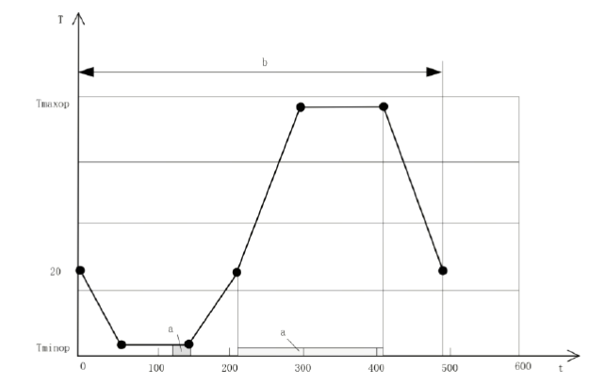
T: Temperature in °C
t: Time in min
a: Operating Mode 3.2
b: one cycle
Figure 24 Test Pulse Diagram
  - Test Procedure
- Place the device under test (DUT) inside the test chamber, ensuring specimen spacing ≥10 cm, and distance from the temperature chamber ≥10 cm; assemble the test plan according to the test arrangement.
- The chamber temperature shall be set according to the following parameters for a total of 30 cycles.
Time (min) | 0 | 60 | 150 | 210 | 300 | 410 | 480
Temperature (℃) | 20 | T_{minp} | T_{minop} | 20 | T_{maxop} | T_{maxop} | 20
- Once the DUT temperature stabilizes at T_{minop}, the DUT is powered on for a brief period to operate in Mode 3.2 to verify normal functionality. Immediately after verification, it enters sleep mode (Mode 3.1), and is powered on again between the 210th and 410th minute.
- Upon test completion, allow the specimen to naturally recover to room temperature, and then conduct a function inspection.
  - Test Class and Acceptance Criteria
During testing, the functional status of components complies with Function Grade Class A.
After testing, the specimen must satisfy visual inspection criteria; the appearance shall exhibit no significant damage, and no abnormal noise shall be heard from components after shaking.
- Rapid Temperature Change Test
Test ID: ENV_009
  - Test Conditions
Test Details | Comments
Standard Test Method | Master_Test_Specifications_DRS_Electro
Environmental Conditions | Test Temperature: T_{min} to T_{max;}  Relative Humidity: 45% ~ 75% RH;
Test Parameters | Temperature cycles within the T_{min} to T_{max} range without power applied.  Maintain stable internal product temperature for 30 minutes.  A total of 100 cycles.
Operating Mode | Mode 1.1
Test Object | Actuator
DUT Orientation | No Orientation Requirement
Number of DUT | 6
Special Requirements | --
Remarks | Test Objective: To simulate multiple rapid temperature cycles experienced in vehicles and verify whether the components suffer material cracking or seal failure due to rapid thermal changes.

  - Test Setup
Figure 25 Test Setup Diagram

  - Test Pulse
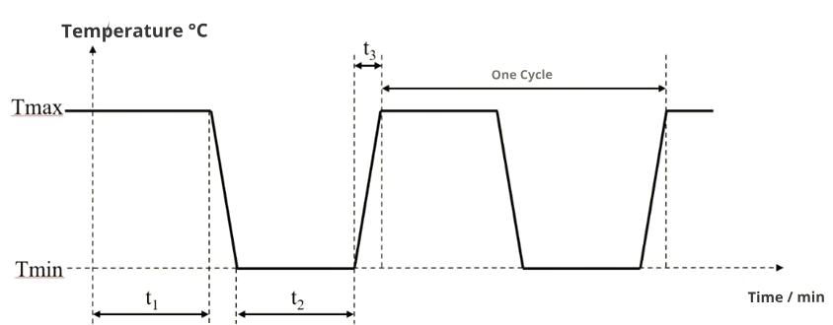
t₁: High-Temperature Duration
t₂: Low-Temperature Duration
t₃: High-Low Temperature Transition Duration
Figure 26 Test Pulse Diagram
  - Test Procedure
- Place the DUT into the test chamber with the parameter settings as follows:
T_{min}；T_{max}；
t₁ = t₂ = maintain for 30 minutes after the product’s internal temperature stabilizes; temperature rise or fall time t₃ ≤ 15 seconds;
A total of 100 cycles.
- Arrange the DUTs neatly on the test tray, then place the tray into the test chamber;
- Upon test completion, allow the specimen to naturally recover to room temperature, and then conduct a function inspection.
  - Test Class and Acceptance Criteria
Operate normally before and after testing; no abnormalities found in appearance inspection; no abnormal noise detected when shaken.
At the midpoint of testing (after completing half of the test cycles), verify all electrical and mechanical functions; no abnormal noise detected when shaken;

- Ice Water Impact Splash Test
Test ID: ENV_007
  - Test Conditions
Test Details | Comments
Standard Test Method | Master_Test_Specifications_DRS_Electro
Environmental Conditions | Test Temperature: T_{maxop};  Relative Humidity: 45% ~ 75% RH;
Test Parameters | Place the DUT into the temperature chamber, heat to T_{maxop} ± 2℃, and conduct powered testing;  A total of 100 cycles.
Operating Mode | Mode 1.2 / Mode 3.2
Test Object | Actuator
DUT Orientation | Positioned according to the Actual Vehicle Angle; the Cable Outlet Angle direction must be consistent with the vehicle layout.
Number of DUT | 6
Special Requirements | The component installation angle must be consistent with that of the complete vehicle.  The fixture used must not enclose the tested component.  The First Fixed Point of the component wiring harness must align with that of the complete vehicle to ensure correct cable outlet angles and routing.
Remarks | Test Objective: To simulate whether cold water splashing onto hot systems/components causes any adverse effects on the function of the components.

  - Test Setup
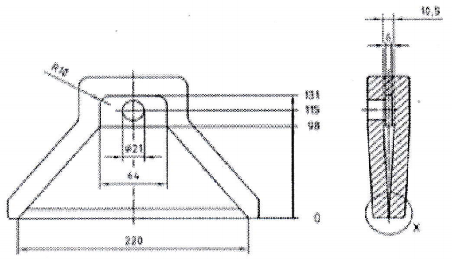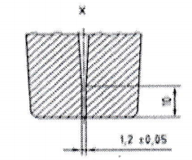
Figure 27 Dimensional Requirements for Nozzle Status
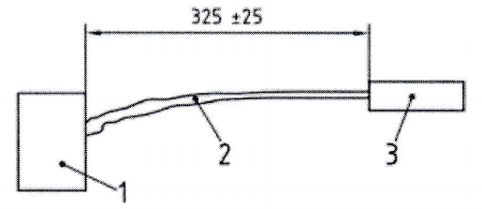
1. Specimen; 2. Liquid; 3. Nozzle
Figure 28 Splash Testing Environment

Figure 29 Specimen Placement Diagram
Note: It must clearly indicate which surface of the specimen is subjected to water spray.
  - Test Pulse
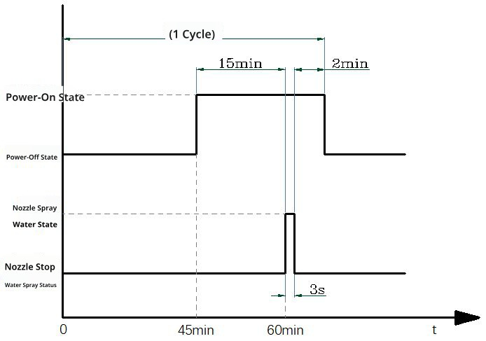
Figure 30 Test Pulse
  - Test Procedure
- Prepare the water spraying device in advance. The test parameters are as follows:
  - Test liquid: deionized water with 3% Arizona dust, with an optional addition of 5% NaCl.
  - Refer to ISO 12103-1; Liquid temperature: 0–4℃, liquid flow rate: (3L to 4L) per 3 seconds (during injection);
- Construct the test plan according to the test setup;
- Activate the high-temperature test chamber and set the temperature to T_{maxop}; Place the DUT in the test chamber for 44 minutes (until the temperature of the DUT stabilizes); 0 to 44 minutes correspond to Mode 1.2; from the 45th minute until the end of the cycle corresponds to Mode 3.2;
- Operate the DUT under powered conditions until the 60th minute, then rapidly transfer it to the spray chamber; the transition time between the temperature chamber and spray must be less than 20 seconds; After spraying for 3 seconds, return the DUT to the test chamber and continue powered operation for 2 minutes, monitoring whether the DUT voltage remains within the normal range; this completes one cycle;
- Distance from the nozzle to the DUT: (325±25) mm; the width of the liquid should exceed the width of the DUT.
- Perform functional testing on the DUT after the test is concluded.
  - Test Class and Acceptance Criteria
Conforms to Class A requirements with no abnormalities detected in appearance inspection.
After testing, the specimen must satisfy visual inspection criteria; the appearance shall exhibit no significant damage, and no abnormal noise shall be heard from components after shaking.
Conduct a lid-opening inspection after the test; no water ingress is permitted inside the specimen or connectors.

- Salt Spray Corrosion Test
Test ID: ENV_011
  - Test Conditions
Test Details | Comments
Standard Test Method | Master_Test_Specifications_DRS_Electro
Environmental Conditions | Test Temperature: see below;  Relative Humidity: see below;
Test Parameters | Place the DUT inside the salt spray test chamber.  Test Method: 6  Duration: 56 days;
Operating Mode | Mode 1.2
Test Object | Actuator
DUT Orientation | Positioned according to the Actual Vehicle Angle; the Cable Outlet Angle direction must be consistent with the vehicle layout.
Number of DUT | 6
Special Requirements | The component installation angle must be consistent with that of the complete vehicle.  The fixture used must not enclose the tested component.  The First Fixed Point of the component wiring harness must align with that of the complete vehicle to ensure correct cable outlet angles and routing.  Upon completion of the test, the sample may be rinsed in distilled water (water temperature below 35℃) for 5 minutes, then dried either by manual shaking or air blowing, followed by drying in a 55℃ test chamber for 1 hour; After removal, the sample should be allowed to cool, with a cooling period between 1 and 2 hours;
Remarks | Test Objective: To simulate whether the materials and surfaces of components can withstand salt spray and salt solution exposure on streets during winter without compromising functionality;

  - Test Setup
Figure 31 Test Setup Diagram
  - Test Pulse
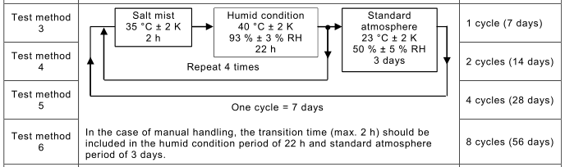
Figure 32 Test Pulse Diagram
  - Test Procedure
- In accordance with IEC 60068-2-52, perform the test following Test Method 6;
- Connect the DUT wiring harness to simulate the actual vehicle, operate in Mode 1.2; activate the Salt Spray Test Chamber;
- Store the DUT in a salt spray environment at 35 ± 2 °C for 2 hours, then in humid conditions at 40 ± 2 °C and 93% ± 3% RH for 22 hours;
- Repeat step 3 four times, then store the DUT in a salt spray environment at 23 ± 2 °C and 50% ± 5% RH for 3 days. This completes one cycle (7 days);
- Continue the test for 8 cycles in total, repeating steps 2 and 3;
- Perform functional testing on the DUT after the test is concluded.
  - Test Class and Acceptance Criteria
Meets Class C requirements with no abnormalities detected during appearance inspection.
The DUT sealing function must remain unaffected; Disassembly inspection shall be conducted upon completion of the test sequence; no salt ingress or corrosion is permitted within the product. All markings and labels must remain clearly visible.
- Salt Water Spray Test
Test ID: ENV_010
  - Test Conditions
Test Details | Comments
Standard Test Method | Master_Test_Specifications_DRS_Electro
Environmental Conditions | Test Temperature: 23±5℃;  Relative Humidity: 45% ~ 75% RH;
Test Parameters | Place the DUT inside the salt spray test chamber.  Duration: 6 cycles (6 days);
Operating Mode | Mode 1.2 / Mode 3.2
Test Object | Actuator
DUT Orientation | Positioned according to the Actual Vehicle Angle; the Cable Outlet Angle direction must be consistent with the vehicle layout.
Number of DUT | 6
Special Requirements | The component installation angle must be consistent with that of the complete vehicle.  The fixture used must not enclose the tested component.  The First Fixed Point of the component wiring harness must align with that of the complete vehicle to ensure correct cable outlet angles and routing.  Upon completion of the test, the sample may be rinsed in distilled water (water temperature below 35℃) for 5 minutes, then dried either by manual shaking or air blowing, followed by drying in a 55℃ test chamber for 1 hour; After removal, the sample should be allowed to cool, with a cooling period between 1 and 2 hours;
Remarks | Test Objective: To simulate whether the materials and surfaces of components can withstand salt spray and salt solution exposure on streets during winter without compromising functionality;

  - Test Setup
Figure 33 Test Setup Diagram
  - Test Pulse
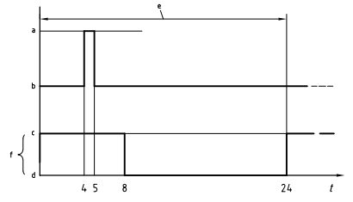
- Operating Mode 3.2
- Operating Mode 1.2
- Normal Salt Solution Spray
- Salt Solution Spray Stop
Figure 34 Test Pulse Diagram
  - Test Procedure
- Reference IEC 60068-2-11 Standard;
- Connect the DUT wiring harness to simulate the actual vehicle, operate in Mode 1.2; activate the Salt Spray Test Chamber;
- One cycle has a duration of 24 hours, with the DUT sprayed for 8 hours followed by a 16-hour pause. Between the 4th and 5th hour of each cycle, the specimen operates in Operating Mode 3.2.
- Testing duration: 6 cycles (6 days);
- Perform functional testing on the DUT after the test is concluded.
  - Test Class and Acceptance Criteria
Meets Class C requirements with no abnormalities detected during appearance inspection.
The DUT sealing function must remain unaffected; Disassembly inspection shall be conducted upon completion of the test sequence; no salt ingress or corrosion is permitted within the product. All markings and labels must remain clearly visible.

- Damp Heat Cycle 2 – Frost Test
Test ID: ENV_002
  - Test Conditions
Test Details | Comments
Standard Test Method | Master_Test_Specifications_DRS_Electro
Environmental Conditions | Room Temperature: see below;  Relative Humidity: see below;
Test Parameters | Testing shall be performed in accordance with IEC 60068-2-38, with a low temperature of -10°C;  A total of 10 cycles;  (The first 5 cycles include low temperature; the subsequent 5 cycles exclude low temperature.)
Operating Mode | Mode 3.1 / Mode 3.2
Test Objects | Actuator
DUT Orientation | Positioned according to the Actual Vehicle Angle; the Cable Outlet Angle direction must be consistent with the vehicle layout.
Number of DUT | 6
Special Requirements | The component installation angle must be consistent with that of the complete vehicle.  The fixture used must not enclose the tested component.  The First Fixed Point of the component wiring harness must align with that of the complete vehicle to ensure correct cable outlet angles and routing.
Remarks | Test Objective: To simulate the performance of components under high humidity conditions;

  - Test Setup
Figure 35 Test Setup Diagram
  - Test Pulse
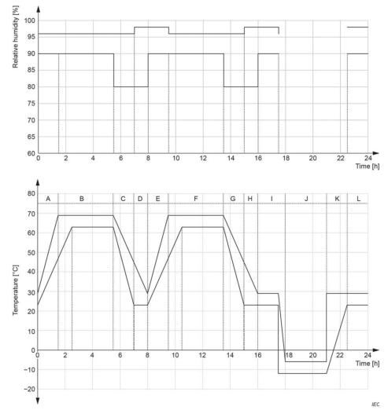
Figure 36 Includes temperature and humidity cycle profile with low temperature
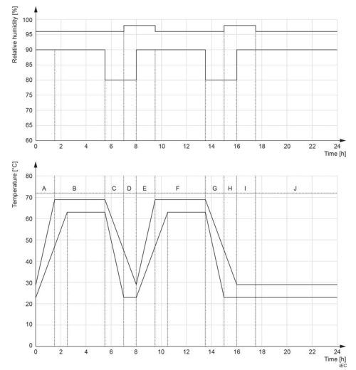
Figure 37 The low-temperature and humidity cycle profile is not included.
  - Test Procedure
- Place the device under test (DUT) inside the test chamber, ensuring specimen spacing ≥10 cm, and distance from the temperature chamber ≥10 cm; assemble the test plan according to the test arrangement.
- Activate the Constant Temperature and Humidity Test Chamber and set the parameters for the first five cycles as follows: starting temperature at 25℃, maximum temperature at 65℃, minimum temperature at -10℃; humidity maintained at (93±3)%RH during the 25℃ to 65℃ Temperature Rise Interval, and at 80%RH during the 65℃ to 25℃ Cooling Phase. Humidity is not controlled within the -10℃ to 25℃ temperature interval.
- When the cycle temperature reaches the maximum of 65℃, switch the DUT to Operating Mode 3.2 for functional testing, conducting one functional test each during Interval B and Interval F as shown in the figure above. Each cycle lasts 24 hours, with a total of five cycles performed.
- Parameters for the last 5 cycles: high temperature 65℃, low temperature 25℃, humidity (93±3)% RH during the 25℃ to 65℃ temperature rise interval; Humidity 80% RH during the 65℃ to 25℃ cooling phase;
- When the cycle temperature reaches the maximum (65℃), the DUT shall be switched to Operating Mode 3.2 for functional testing, performing functional tests once each in Interval B and Interval F as illustrated above; each cycle lasts 24 hours, performed over 5 cycles;
- Upon test completion, allow the specimen to naturally recover to room temperature, and then conduct a function inspection.
  - Test Class and Acceptance Criteria
After the testing sequence, a visual inspection of the product connector and internal components shall be performed. Metal components, PCB, connectors, and plastics shall be free of corrosion.
At the same temperature without humidity load, the current consumption deviation from the DUT typical value shall not exceed ±5%.
The functional status shall comply with Function Grade Class A.

- Damp Heat Cycle 3 – Condensation Test
Test ID: ENV_003
  - Test Conditions
Test Details | Comments
Standard Test Method | Master_Test_Specifications_DRS_Electro
Environmental Conditions | Room Temperature: see below;  Relative Humidity: see below;
Test Parameters | Testing is carried out according to IEC 60068-2-38, with high temperature at 80℃ and low temperature at 23±5℃; a total of 5 cycles (25 hours);
DUT Mode | Mode 3.1 / Mode 3.2
Test Object | Actuator
DUT Orientation | Positioned according to the Actual Vehicle Angle; the Cable Outlet Angle direction must be consistent with the vehicle layout.
Number of DUT | 6
Special Requirements | The component installation angle must be consistent with that of the complete vehicle.  The fixture used must not enclose the tested component.  The First Fixed Point of the component wiring harness must align with that of the complete vehicle to ensure correct cable outlet angles and routing.
Remarks | Test Objective: To simulate the performance of components under high humidity conditions;

  - Test Setup
Figure 38 Test Setup Diagram
  - Test Pulse
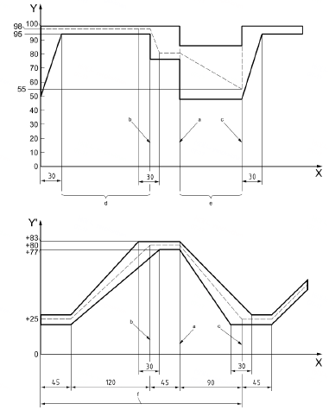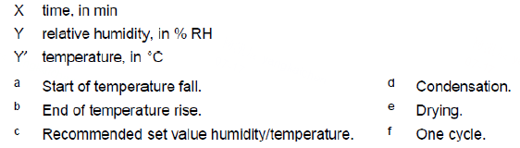
Figure 39 Test Pulse Diagram
  - Test Procedure
- Place the device under test (DUT) inside the test chamber, ensuring specimen spacing ≥10 cm, and distance from the temperature chamber ≥10 cm; assemble the test plan according to the test arrangement.
- Activate the Constant Temperature and Humidity Test Chamber and set the following parameters: high temperature at 80℃, low temperature at 23±5℃; humidity ranging from 95% to 100% RH during the temperature rise interval from 23℃ to 80℃; humidity maintained at 80% RH during the cooling phase from 80℃ to 23℃.
- At the maximum cycle temperature (80℃), switch the DUT from 3.1 mode to 3.2 operating mode and perform functional testing. Functional testing will be conducted once per cycle. Each cycle lasts 5 hours, with a total of five cycles performed.
- Upon test completion, allow the specimen to naturally recover to room temperature, and then conduct a function inspection.
  - Test Class and Acceptance Criteria
The DUT must comply with Class A functional status requirements both prior to and following testing.
After testing, the specimen must satisfy visual inspection criteria; the appearance shall exhibit no significant damage, and no abnormal noise shall be heard from components after shaking.

- Steady-state Damp Heat Test
Test ID: ENV_012
  - Test Conditions
Test Details | Comments
Standard Test Method | Master_Test_Specifications_DRS_Electro
Environmental Conditions | Temperature: 65±2℃;  Relative Humidity: 93±3% RH;
Test Parameters | The entire test cycle shall last 504 hours in accordance with DIN EN 60068-2-78.
Operating Mode | Mode 2.1 / Mode 3.2
Test Object | Actuator
DUT Orientation | Positioned according to the Actual Vehicle Angle; the Cable Outlet Angle direction must be consistent with the vehicle layout.
Number of DUT | 6
Special Requirements | The component installation angle must be consistent with that of the complete vehicle.  The fixture used must not enclose the tested component.  The First Fixed Point of the component wiring harness must align with that of the complete vehicle to ensure correct cable outlet angles and routing.
Remarks | Test Objective: To verify the functional status of components under constant temperature and high humidity conditions.

  - Test Setup
Figure 40 Test Setup Diagram
  - Test Pulse
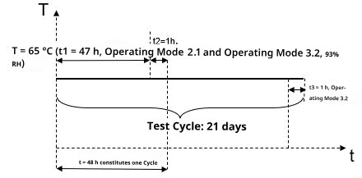
Figure 41 Test Pulse Diagram
  - Test Procedure
- Place the device under test (DUT) inside the test chamber, ensuring specimen spacing ≥10 cm, and distance from the temperature chamber ≥10 cm; assemble the test plan according to the test arrangement.
- Activate the constant temperature and humidity test chamber and set parameters as follows: temperature at 65±2℃, relative humidity at (93±3) %RH. Alternate between the 47-hour 2.1 operating mode and the 1-hour 3.2 operating mode, switching to the 3.2 operating mode during the final hour; the total test duration is 504 hours.
- Upon test completion, allow the specimen to naturally recover to room temperature, and then conduct a function inspection.

  - Test Class and Acceptance Criteria
The DUT is required to meet Class A functional status before, during, and after the test.
At standard atmospheric pressure, after recovery, samples should not exhibit visible damage such as cracking, distortion, swelling, or softening.
Upon completion of the test sequence, two samples shall be selected for lid opening and visual inspection; no corrosion or other abnormalities shall be present inside the samples.

- Waterproof and Dustproof Sealing
Test ID: ENV_017
  - Test Conditions
Test Details | Comments
Standard Test Method | Master_Test_Specifications_DRS_Electro
Environmental Conditions | Room Temperature: 23±5℃;  Relative Humidity: 45% ~ 75% RH;
Test Parameters | Inspect the test specimen in accordance with ISO 20653.  Dust and water sealing rating: IP67
Operating Mode | Mode 1.2
Test Object | Actuator
DUT Orientation | Positioned according to the Actual Vehicle Angle; the Cable Outlet Angle direction must be consistent with the vehicle layout.
Number of DUT | 6
Special Requirements | The component installation angle must be consistent with that of the complete vehicle.  The fixture used must not enclose the tested component.  The First Fixed Point of the component wiring harness must align with that of the complete vehicle to ensure correct cable outlet angles and routing.  Incorporate fluorescent agent in the waterproof testing.
Remarks | Test Objective: To verify the waterproof and dustproof performance of components.

  - Test Setup

(Installation angle, position distance diagram, and actual equipment schematic)
Figure 42 Test Setup Diagram
Note: The waterproof test shall demonstrate the component placement orientation and relative position to spray devices such as nozzles.
  - Test Pulse
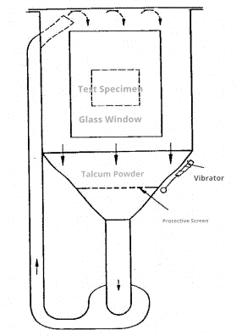
Figure 43 Testing equipment for air-mixed dust vertical flow solid protection at levels 5K and 6K
  - Test Procedure
Waterproof Testing Procedure:
- The DUT shall be set to the 1.2 operating mode (wiring harness connected, without power);
- Testing Equipment and Conditions: immersion tank filled with water; the DUT shall be positioned and immersed in accordance with ISO 20653, and the applicable test setup. The immersion depth and duration shall be defined in accordance with the standard and agreed test requirements. Where applicable, the conventional IPX7 test conditions of immersion for 30 minutes at a depth of 1 m shall be applied;
- Upon completion of the immersion test, the DUT shall be removed from the water, and functional verification shall be performed.

Dustproof Testing Procedure:
- The DUT shall be set to the 1.2 operating mode (wiring harness connected, without power);
- The DUT shall be an unused, clean, and intact specimen;
- Perform the dust ingress test in a dust test chamber in accordance with ISO 20653, using the test conditions applicable to degree of protection 6. The test duration and other applicable parameters shall be defined in accordance with the standard and the agreed test requirements;
- Upon completion of the dust test, functional verification shall be performed on the DUT.
  - Test Class and Acceptance Criteria
Test results shall comply with the waterproof and dustproof sealing requirements specified in ISO 20653. Class A requirements shall be satisfied upon test completion. The DUT shall meet the following acceptance criteria:
• Dustproof 6: Dust-tight; dust shall not penetrate the enclosure;
• Waterproof 7: Temporary immersion in water; water shall not penetrate in a quantity causing harmful effects or impairing performance when the enclosure is immersed in water under the specified pressure and time conditions.
Within one hour after completion of the waterproof test, an airtightness inspection, where applicable, and a visual inspection shall be performed by opening the sample. No water or dust ingress shall be present inside the sample or within the connectors.
After testing, the component shall meet the visual inspection requirements. No damage to the external appearance is permitted, and no abnormal noise shall occur when the component is shaken.
After completion of the test sequence, all samples shall be inspected by opening the cover, and the results shall be recorded.
- Combined Vibration Test
Test ID: ENV_001
  - Test Conditions
Test Details | Comments
Standard Test Method | Master_Test_Specifications_DRS_Electro
Environmental Conditions | Test Temperature: T_{minop} to T_{maxop} Range;  Relative Humidity: 45% ~ 75% RH;
Test Parameters | Refer to IEC 60068-2-64 standard;  Three directions: X, Y, and Z, 8 hours each;
Operating Mode | Mode 3.1 / Mode 3.2
Test Object | Actuator
DUT Orientation | Positioned according to the Actual Vehicle Angle; the Cable Outlet Angle direction must be consistent with the vehicle layout.
Number of DUT | 6
Special Requirements | The component installation angle must be consistent with that of the complete vehicle.  The First Fixed Point of the component wiring harness must correspond with that of the complete vehicle to ensure correct exit angle and routing.  The wiring harness must be unused and the female end must match that of the actual vehicle.
Remarks | Test Objective: To simulate the vibration loads experienced by automotive components during vehicle operation and verify the components’ resistance to failure caused by vibration-induced displacement or material fatigue.

  - Test Setup

(Installation schematic, actual vehicle 3D model, tooling fixture)
Figure 44 Test Setup Diagram
  - Test Pulse

Figure 45 Temperature and operating voltage profiles for combined vibration

Time (min) | Temperature (℃) | Operating status
0 | 20 | 3.1
60 | T_{minop} | 3.1
145 | T_{minop} | 3.2
150 | T_{minop} | 3.1
210 | 20 | 3.2
300 | T_{maxop} | 3.2
410 | T_{maxop} | 3.1
480 | 20 | 3.1
Figure 46 Combined vibration temperature curve parameters

Vibration excitation | Broadband random vibration
Test duration | 8 h per axis for X, Y, Z
Acceleration RMS value | 30.8 m/s²
Vibration envelope as shown in the figure below | Frequency (Hz) | Power spectral density (m/s ²⁾ 2^{/Hz}
Vibration envelope as shown in the figure below | 5 | 0.884
Vibration envelope as shown in the figure below | 10 | 20
Vibration envelope as shown in the figure below | 55 | 6.5
Vibration envelope as shown in the figure below | 180 | 0.25
Vibration envelope as shown in the figure below | 300 | 0.25
Vibration envelope as shown in the figure below | 360 | 0.14
Vibration envelope as shown in the figure below | 1000 | 0.14
Vibration envelope as shown in the figure below | 2000 | 0.14
Figure 47 Combined vibration parameters

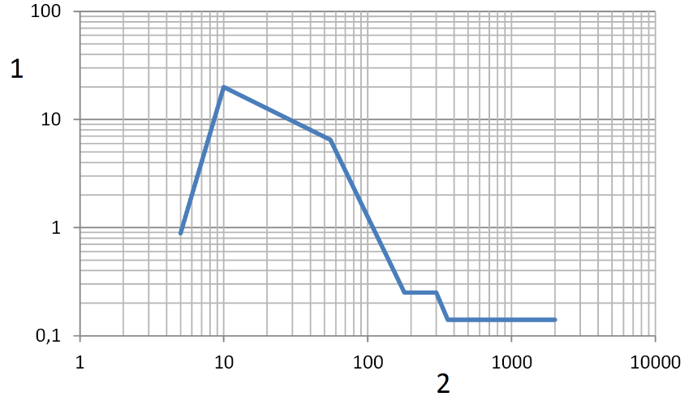
Figure 48 Combined vibration envelope
  - Vibration Table Fixture Approval
Fixture Natural Frequency:
- The testing fixture shall be installed on the vibration table used for formal testing, following an arrangement identical to that of the formal test;
- 1.2 Monitoring sensors shall be positioned at the fixture’s center to measure the fixture’s response during vibration along the X, Y, and Z axes respectively;
- Sweep frequency conditions: frequency range 5 to 2000 Hz, sweep rate 1 octave per minute, vibration amplitude 1g.

Fixture Transfer Function Verification:
- The testing fixture and sample shall be mounted on the vibration table used for formal testing in an arrangement identical to that of the formal test and excited by the same random vibration spectrum as the formal test.
- Install monitoring sensors near the sample’s mounting location to individually monitor the response curves adjacent to the sample during vibration along the X, Y, and Z axes.
Acceptance Criteria:
The fixture’s natural frequency must exceed 500 Hz; the RMS value of the response curve shall remain within ±10% as specified by the standard; response curves below 500 Hz must be within ±3 dB, and those above 500 Hz within ±6 dB. Test results shall be submitted to Xiaomi ENV for verification prior to testing. Any discrepancies require Xiaomi ENV team approval before proceeding with subsequent vibration and mechanical shock testing.
  - Test Procedure
- Secure the DUT onto the fixture, then affix the assembly to the vibration table, ensuring a rigid connection among the DUT, mounting plate, and vibration table. The connector cable routing must remain consistent with that of the actual vehicle.
- Fix the device according to vehicle conditions.
- The control sensor is installed on the fixture near the DUT mounting foot position, while the monitoring sensor is also mounted on the fixture near the opposing mounting foot; both sensors are positioned diagonally.
- Start the triple environmental test chamber used for vibration testing and configure the temperature profile parameters (see the temperature profile parameters in the figure above).
- Configure the vibration test parameters (see the vibration test parameters and vibration envelope shown above).
- Begin testing along the X, Y, and Z axes, 8 hours per axis; the specimen’s operating mode is 3.1.
- Upon test completion, perform functional testing on the DUT and measure the residual torque of the bolts connecting the fixture to the specimen.

  - Test Class and Acceptance Criteria
Complies with Class A requirements; appearance inspection reveals no abnormalities, and no abnormal noise is detected during shaking.
At the end of the sequence, randomly select two specimens for visual inspection upon opening the cover, ensuring no anomalies in the internal structure.
The residual torque of the fastening bolts between the specimen and the fixture after testing must satisfy Xiaomi’s specifications.
Post-testing, extract two samples for intermediate RCL testing, with specific test points confirmed by Xiaomi engineers.

- Mechanical Shock Test on Vehicle and Rigid Frame Attachment Points
Test ID: ENV_008
  - Test Conditions
Test Details | Comments
Standard Test Method | Master_Test_Specifications_DRS_Electro
Environmental Conditions | Test Temperature: 23±5℃;  Relative Humidity: 45% ~ 75% RH;
Test Parameters | Refer to IEC 60068-2-29 standard.  Six directions: ±X, ±Y, ±Z; 10 repetitions per direction.
Operating Mode | Mode 3.2
Test Object | Actuator
DUT Orientation | Positioned according to the Actual Vehicle Angle; the Cable Outlet Angle direction must be consistent with the vehicle layout.
Number of DUT | 6
Special Requirements | The component installation angle must be consistent with that of the complete vehicle.  The First Fixed Point of the component wiring harness must align with that of the complete vehicle to ensure correct cable outlet angles and routing.
Remarks | Test Objective: To simulate whether traversing potholes or impacts with roadside stones adversely affect the functional integrity of components.

  - Test Setup

(Installation schematic, actual vehicle 3D model, tooling fixture)
Figure 49 Test Setup Diagram
  - Test Pulse
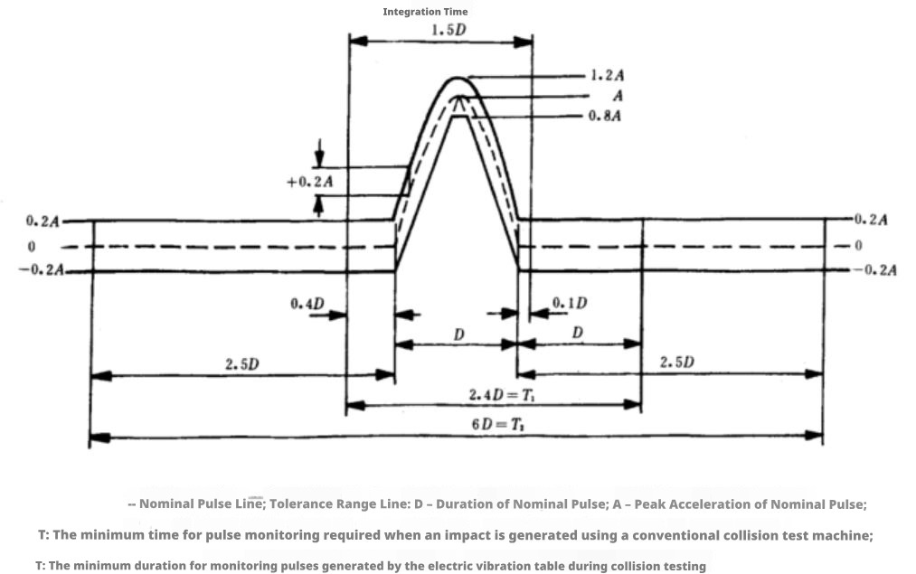
Figure 50 Test Pulse Diagram
  - Test Procedure
- Fix the DUT on the fixture (mounting plate), then secure it together on the test bench, ensuring that the connector wiring method matches that of the actual vehicle;
- Attach the sensors used for signal monitoring to the fixture, close to the DUT mounting pin location;
- Operate the mechanical shock test bench and set the test parameters as follows: acceleration of 500 m/s²; vibration duration of 6 ms; pulse waveform is half-sine; Test quantity: ±X, ±Y, ±Z in six directions, ten times per direction, with the specimen in operating mode 3.2;
- Upon test completion, perform functional testing on the DUT and measure the residual torque of the bolts connecting the fixture to the specimen.
  - Test Class and Acceptance Criteria
Complies with Class A requirements; appearance inspection reveals no abnormalities, and no abnormal noise is detected during shaking.
Randomly select two samples from the sequence for lid opening visual inspection, requiring no abnormalities in the internal structure.
The residual torque of the fastening bolts between the specimen and the fixture after testing must satisfy Xiaomi’s specifications.
- Drop Test
Test ID: ENV_005
  - Test Conditions
Test Details | Comments
Standard Test Method | Master_Test_Specifications_DRS_Electro
Environmental Conditions | Test Temperature: 23±5℃;  Relative Humidity: 45% ~ 75% RH;
Test Parameters | Refer to IEC 60068-2-32 standard;  Six directions: ±X, ±Y, ±Z; one drop in each direction;
Operating Mode | Mode 1.1
Test Object | Actuator
DUT Orientation | None
Number of DUT | 3
Special Requirements | --
Remarks | Test Objective: To simulate and assess the degree of appearance and functional damage to components after a single free fall;
  - Test Setup

X-axis

Y-axis

Z-axis
Figure 51 Test Setup Diagram
  - Test Pulse
NA
Figure 52 Test Pulse Diagram
  - Test Procedure
- Test method references IEC 60068-2-32 standard; test parameters are as follows:
Operating Mode | Power-off non-operating mode (mode 1.1)
Number of drops per sample | 2 drops
Number of tests | Six directions: ±X, ±Y, ±Z;  Each sample shall be dropped twice on the same axis, once in the positive direction and once in the negative direction;
Drop height | 1±0.05 m
Drop surface | Concrete floor or steel plate
Test Specimen | Three units
- Conduct functional testing on the DUT upon test completion.
  - Test Class and Acceptance Criteria
Appearance inspection: In the absence of visible damage, functional requirements must comply with Class C standards; no abnormal noise is permitted during shaking, and hidden damage is not allowed. Any appearance damage must be confirmed with Xiaomi.

- High Temperature Durability Test
Test ID: ENV_026
  - Test Conditions
Test Details | Comments
Standard Test Method | Master_Test_Specifications_DRS_Electro
Environmental Conditions | Test Temperature: T_{maxop};  Relative Humidity: 45% ~ 75% RH;
Test Parameters | Refer to the DIN EN 60068-2-2 standard;  Power on the DUT and maintain it in the T_{max} environment for a continuous period of 48 hours;
Operating Mode | Mode 3.1 / Mode 3.2
Test Voltage | U_{A}
Test Object | Actuator
DUT Orientation | None
Number of DUT | 3
Special Requirements | --
Remarks | --

  - Test Setup
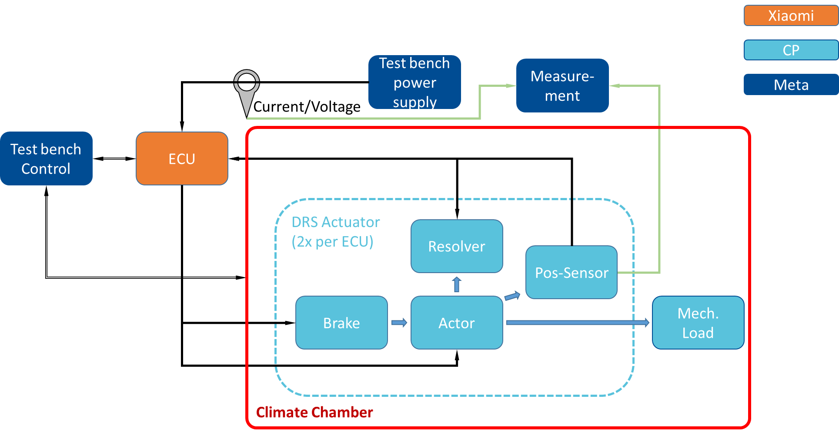
Figure 53 Test Setup Diagram

  - Test Pulse
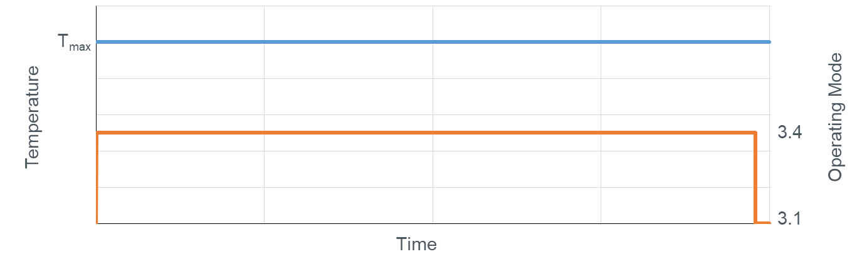Figure 54 Test Pulse Diagram
  - Test Procedure
- Place the device under test (DUT) inside the test chamber, ensuring specimen spacing ≥10 cm, and distance from the temperature chamber ≥10 cm; assemble the test plan according to the test arrangement.
- Set the temperature chamber to T_{max}. Once the test chamber temperature stabilizes, operate the specimen in the 3.2 operating mode for 47 hours;
- After the second step, set the operating mode to 3.1 for 1 hour;
- Upon test completion, allow the specimen to naturally recover to room temperature, and then conduct a function inspection.
  - Test Class and Acceptance Criteria
The test specimen must comply with all functions defined by the specification before, during, and after testing. Verification shall be conducted through continuous monitoring of all parameters throughout the test. Intermediate measurements during the endurance test are only permitted at 25%, 50%, and 75% completion if continuous measurement cannot be ensured throughout the part testing process.
Data acquired from continuous monitoring of component parameters must be analyzed for critical points, trends, and irregularities.
After testing, two samples shall be randomly selected for cover-opening inspection; refer to the requirements specified in section 4.
After testing, the specimen must satisfy visual inspection criteria; the appearance shall exhibit no significant damage, and no abnormal noise shall be heard from components after shaking.
Following testing, two samples shall be extracted for IRCL testing, with specific test locations to be confirmed by Xiaomi engineers.
- Temperature Cycle Durability Test
Test ID: ENV_013
  - Test Conditions
Test Details | Comments
Standard Test Method | Master_Test_Specifications_DRS_Electro
Environmental Conditions | Test Temperature: T_{minop} to T_{maxop} Range;  Relative Humidity: 45% ~ 75% RH;
Test Parameters | In accordance with DIN EN 60068-2-14 standard.  The Device Under Test (DUT) shall be powered and operated according to the temperature profile, cycling 870 times.  4℃/min
Operating Mode | Mode 3.1 / Mode 3.2
Test Object | Actuator
DUT Orientation | Positioned according to the Actual Vehicle Angle; the Cable Outlet Angle direction must be consistent with the vehicle layout.
Number of DUT | 3
Special Requirements | The installation angle of the component must match that of the actual vehicle.
Remarks | Test Objective: To simulate the effects of temperature loads over the complete vehicle life cycle via accelerated testing, thereby verifying the quality and reliability of the components.

  - Test Setup
Figure 55 Test Setup Diagram
  - Test Pulse
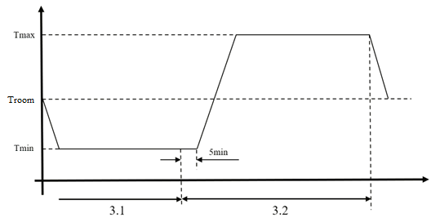
Figure 56 Test Pulse
  - Test Procedure
- Place the device under test (DUT) inside the test chamber, ensuring specimen spacing ≥10 cm, and distance from the temperature chamber ≥10 cm; assemble the test plan according to the test arrangement.
- Configure the test chamber according to the following parameter requirements
Operating Mode | Mode 3.1 / Mode 3.2
Temperature Profile | See Figure above
Initial Test Temperature | T_{room}
Minimum Test Temperature | T_{minop}
Maximum Test Temperature | T_{maxop}
Temperature Change Rate | 4 °C / min. If the temperature change rate cannot be achieved, it may be reduced to a minimum of 3 °C / min
Dwell Time | Maintain for 15 minutes after the specimen’s ambient temperature reaches the target value
Number of Cycles | 870 cycles
Number of Specimens | 3
- Upon reaching the initial temperature, the Device Under Test (DUT) operates in 3.1 mode, cooling from T_{room} down to T_{minop}, holding for 15 minutes, switching to 3.2 operating mode during the final 5 minutes; Next, the temperature ramps up from T_{minop} to T_{maxop}, holds for 15 minutes, then switches operating mode to 3.1; finally, the temperature decreases from T_{maxop} to T_{room}; this completes one cycle, with a total of 870 cycles performed;
- Upon test completion, allow the specimen to naturally recover to room temperature, and then conduct a function inspection.
  - Test Class and Acceptance Criteria
The test specimen must comply with all functions defined by the specification before, during, and after testing. Verification shall be conducted through continuous monitoring of all parameters throughout the test. Intermediate measurements during the endurance test are only permitted at 25%, 50%, and 75% completion if continuous measurement cannot be ensured throughout the part testing process.
Data obtained from continuous monitoring of part parameters shall be evaluated at critical points, trends, and irregularities.
Post-testing, two samples shall be randomly selected for decapsulation and slice inspection, with inspection criteria referencing to Section 4.
After testing, the specimen must satisfy visual inspection criteria; the appearance shall exhibit no significant damage, and no abnormal noise shall be heard from components after shaking.
Following testing, two samples shall be extracted for IRCL testing, with specific test locations to be confirmed by Xiaomi engineers.

- Transport Vibration Test
Test ID: ENV_040
  - Test Conditions
Test Details | Comments
Standard Test Method | Master_Test_Specifications_DRS_Electro
Environmental Conditions | Test Temperature: 23±5℃;  Relative Humidity: 45% ~ 75% RH;
Test Parameters | Vibration directions: X, Y, and Z axes  Vibration Duration: 24 hours per axis  Acceleration RMS Value: 9.8 m/s ²
Operating Mode | Mode 1.1
Test Object | Actuator
DUT Orientation | Placement orientation as defined by the packaging box
Number of DUT | One box of specimens according to actual packaging
Special Requirements | --
Remarks | Test Objective: To evaluate the impact of vibration on electronic and electrical components during transportation from the supplier’s factory to the Xiaomi factory.

  - Test Pulse
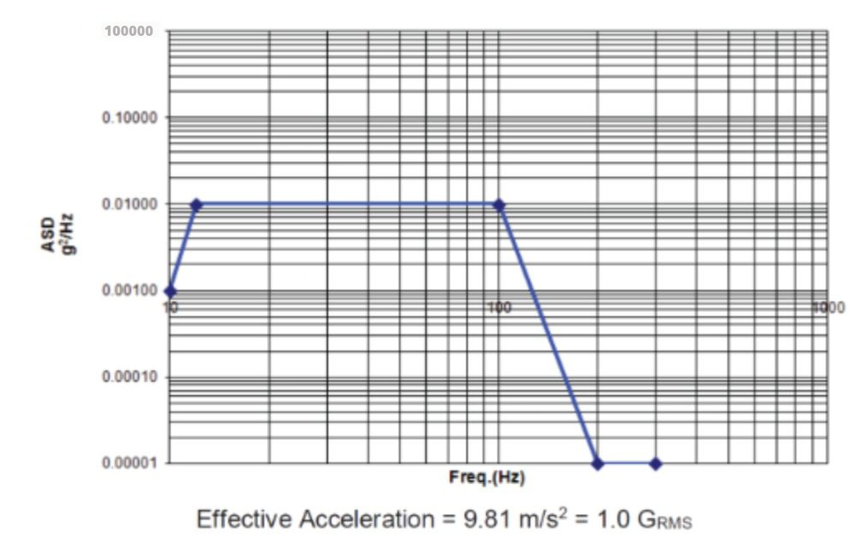
Figure 57 Transport Vibration Profile

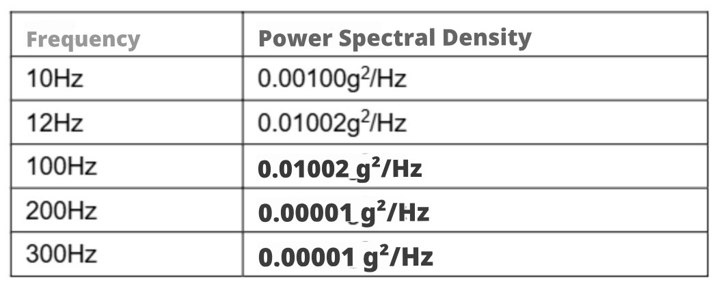
Figure 58 Transport Vibration Conditions

Figure 59 Packaging Diagram
Note: The placement position of the functional specimen shall be clearly indicated
  - Test Procedure
- Position the transport box on the vibration table, restricting movement in the X and Y axes while allowing freedom in the Z axis.
- Mount the control sensor on the vibration table and configure the transport vibration parameters. (Refer to the transport vibration conditions and vibration curve above)
- Initiate testing in the X, Y, and Z directions, with each direction tested for 24 hours.
- Conduct functional testing on six DUTs following test completion.
  - Test Class and Acceptance Criteria
For functional samples, perform function inspection and appearance inspection after testing, ensuring normal operation, absence of mechanical damage, and no appearance defects on external components.
For all other samples, carry out appearance inspection post-testing, with no mechanical damage or appearance defects on external components allowed.

- Visual Inspection Before and After Testing
Test ID: ENV_016
  - Test Conditions
Test Details | Comments
Standard Test Method | Master_Test_Specifications_DRS_Electro
Environmental Conditions | Test Temperature: 23±5℃;  Relative Humidity: 45% ~ 75% RH;
Test Parameters | --
Operating Mode | Mode 1.1
Test Object | Actuator
DUT Orientation | None
Number of DUT | 6
Special Requirements | --
Remarks | --

  - Test Setup

Figure 60 Disassembly Diagram / Exploded View
Note: An exploded view or disassembly diagram is required to clearly indicate the disassembly hierarchy
  - Test Pulse
NA
Figure 61 Test Pulse Diagram
  - Test Procedure
The following inspection reference items apply:
- Enclosure Mechanical Structure: Verify the presence of enclosure deformation, cracks in the enclosure or mounting feet, melting, wear, loose fasteners, corrosion, white rust/red rust, discoloration, tackiness, degradation, and related issues;
- Connector: Verify bent pins, corrosion, ablation, coating wear, and related defects;
- Label / Traceability Code: Verify label detachment or bubbling, blurred printing, unrecognizable traceability codes, and related defects;
- Paint Coating: inspect for scratches, peeling, bubbling, and other defects;
- Internal Mechanical Structure: inspect for detached components, cracked pins, electrolyte capacitor leakage, melting, wear, loose fasteners, adhesive detachment, and related issues;
- Internal Connectors: inspect for bent pins, corrosion, fretting corrosion, burn marks, plating wear, and other irregularities;
- PCBA: inspect for whiskers, dendrites, delamination, discoloration of the solder mask, bubbles or cracks in the conformal coating, burn marks, corrosion, carbon deposits, foreign material traces, and similar defects;
- Solder joints: Inspect for cracking, corrosion, pad detachment, etc. If visible cracks are detected externally on the solder joints, further slice inspection shall be conducted;
- Sample sealing: Verify whether water, dust, or salt spray has infiltrated the interior of the connectors or the sample itself;
- Other abnormal phenomena: Changes in appearance or odor, abnormal noise, and similar issues.
  - Test Class and Acceptance Criteria
No abnormalities were observed in the sample appearance; no internal abnormalities, water ingress, or salt deposits were found inside the sample after disassembly.

