Creel survey sampling evaluation
Evan Booher
2025-07-09
Table of contents

Table _. Links to creel survey data available through the state of Washington’s open data portal, https://data.wa.gov.
Nisqually salmon 2021 | Nisqually salmon 2022 | Nisqually salmon 2023
effort | effort | effort
interview | interview | interview
catch | catch | catch
water_bodies | water_bodies | water_bodies
closures | closures | closures
fishery_manager | fishery_manager | fishery_manager

Results

Creel survey sampling evaluation

Survey days and closures
During the monitoring period from 2021 to 2023, a roving creel survey was conducted on the Nisqually River on 210 out of the 414 (64%) days that the fishery was open.
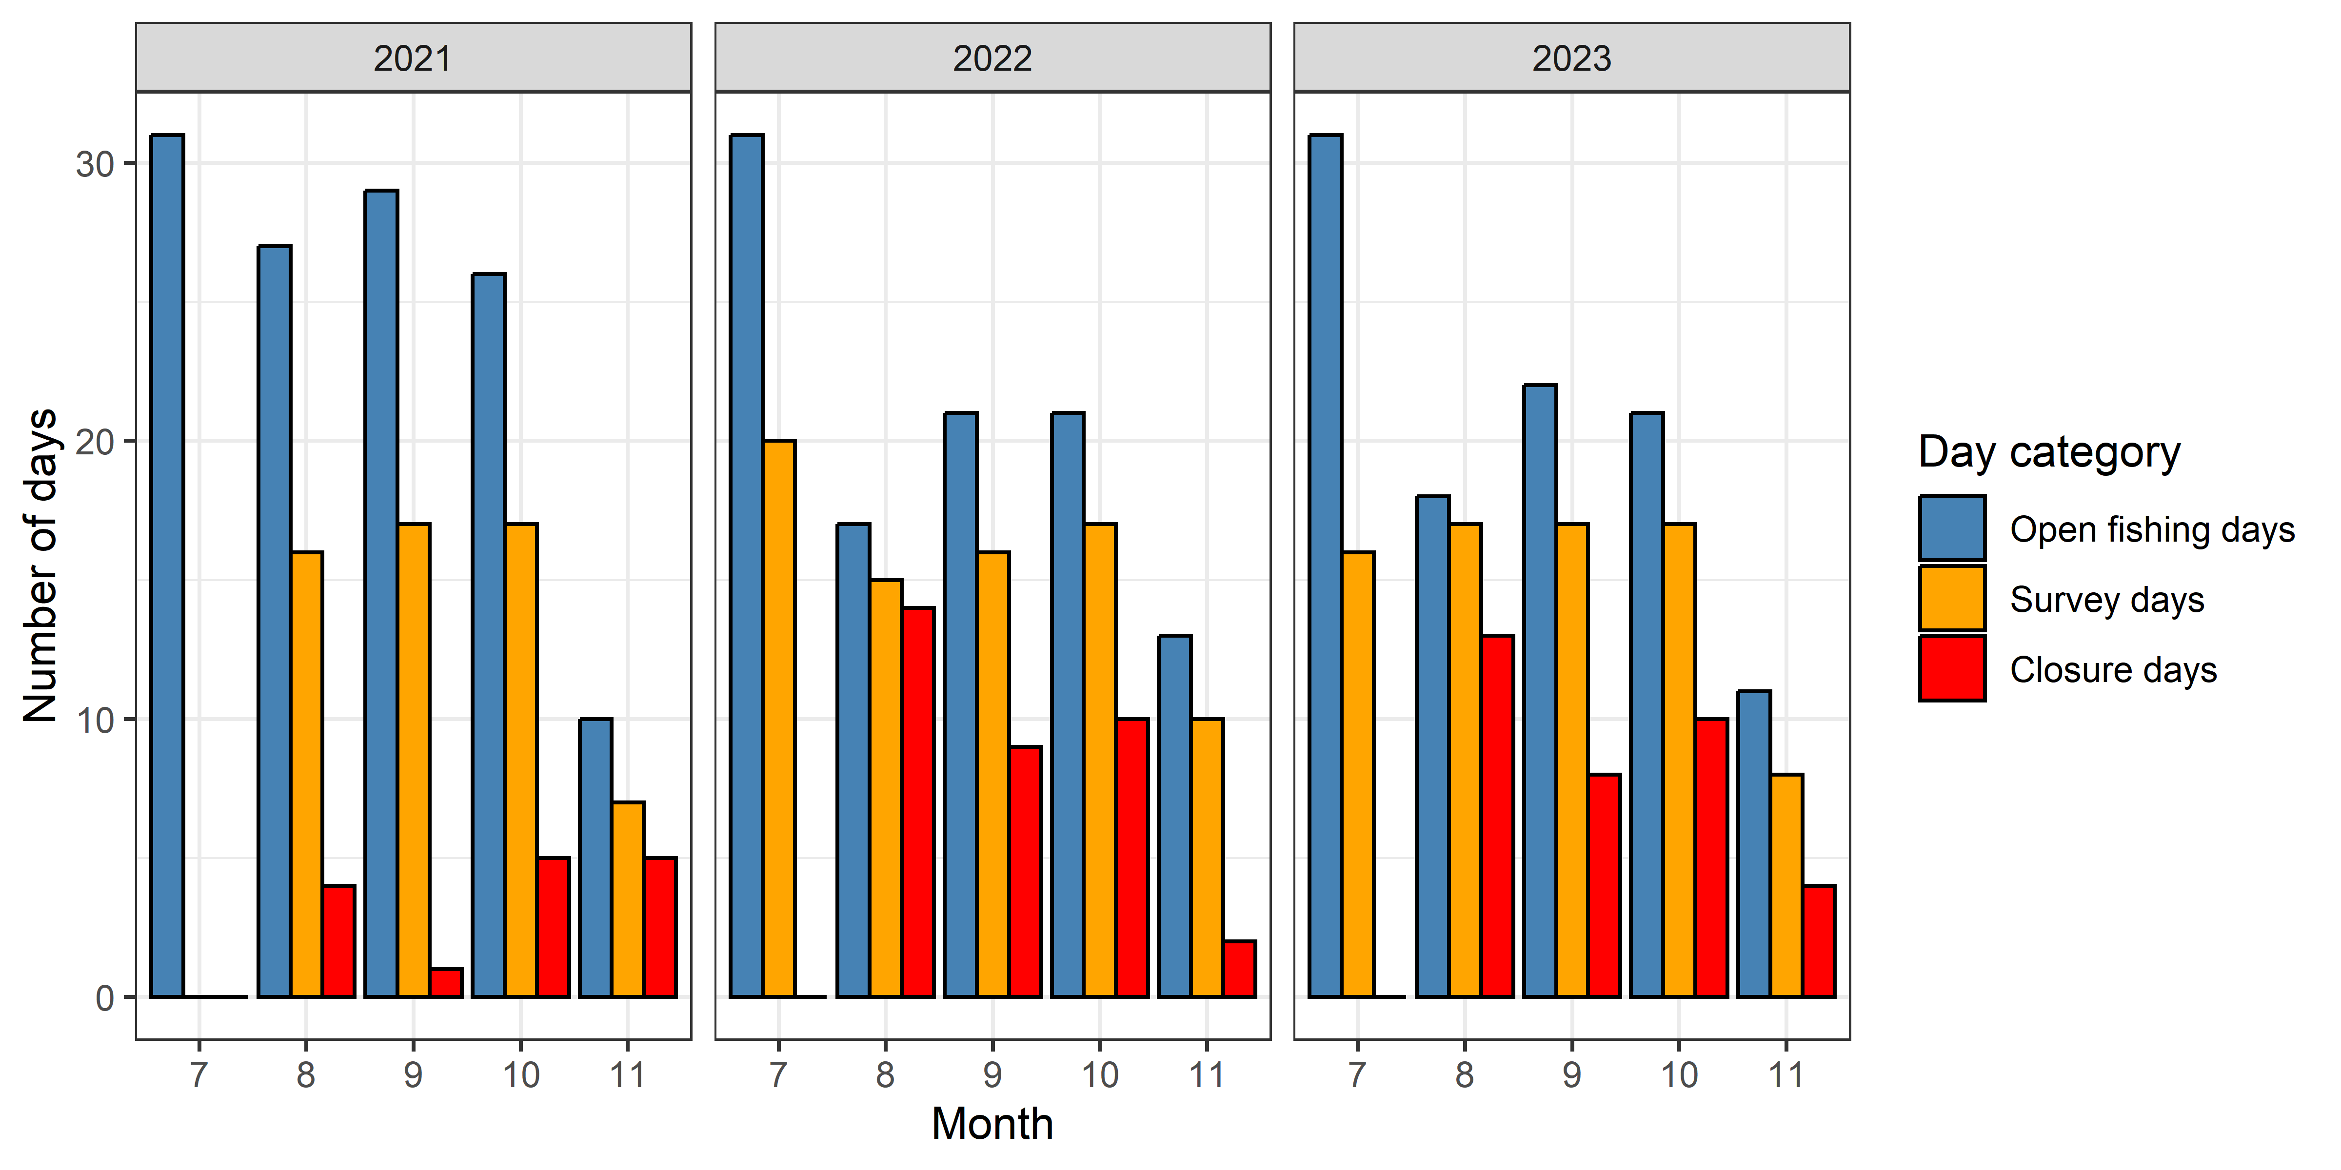
Figure _. The number of open fishing days, survey days, and closure days per month during the Nisqually River salmon fishery from 2021 to 2023.
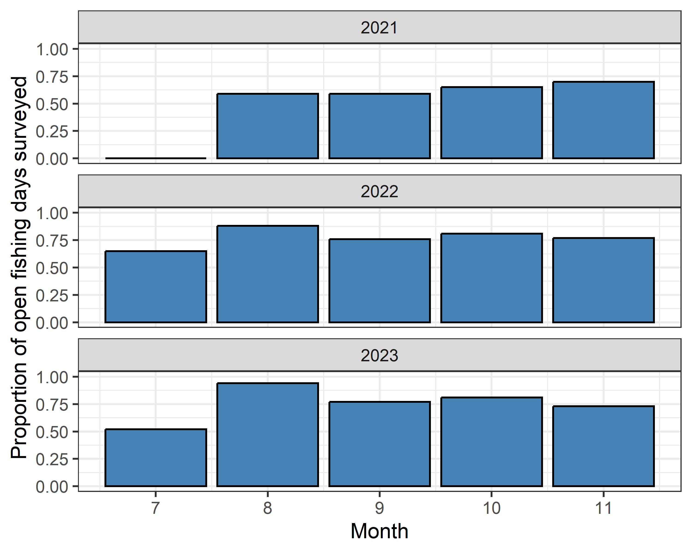
Figure _. The proportion of days open to fishing per month that a roving creel survey was conducted during the Nisqually River salmon fishery from 2021 to 2023.

Angler interviews
In 2021, sampling for interviews only occurred in section 2, where we obtained a total of 3258 interviews, representing 3210 bank angler groups and 48 boat angler groups. In 2022, a total of 2342 interviews were obtained, representing 2282 bank angler group interviews and 60 boat angler group interviews. In 2023, a total of 2123 interviews were obtained, representing 2067 bank angler group interviews and 56 boat angler group interviews. Across all years the vast majority of interviews were obtained in section 2. Relatively few interviews were obtained in the lower river represented by section 1 (n = 4) and the upper river, represented by section 3 (n = 23), and section 4 (n = 6). Sample sizes in these areas were likely limited by accessibility and logistical constraints for sampling staff. See Table _ for a breakout of the number of interviews obtained by year, section, and angler type.
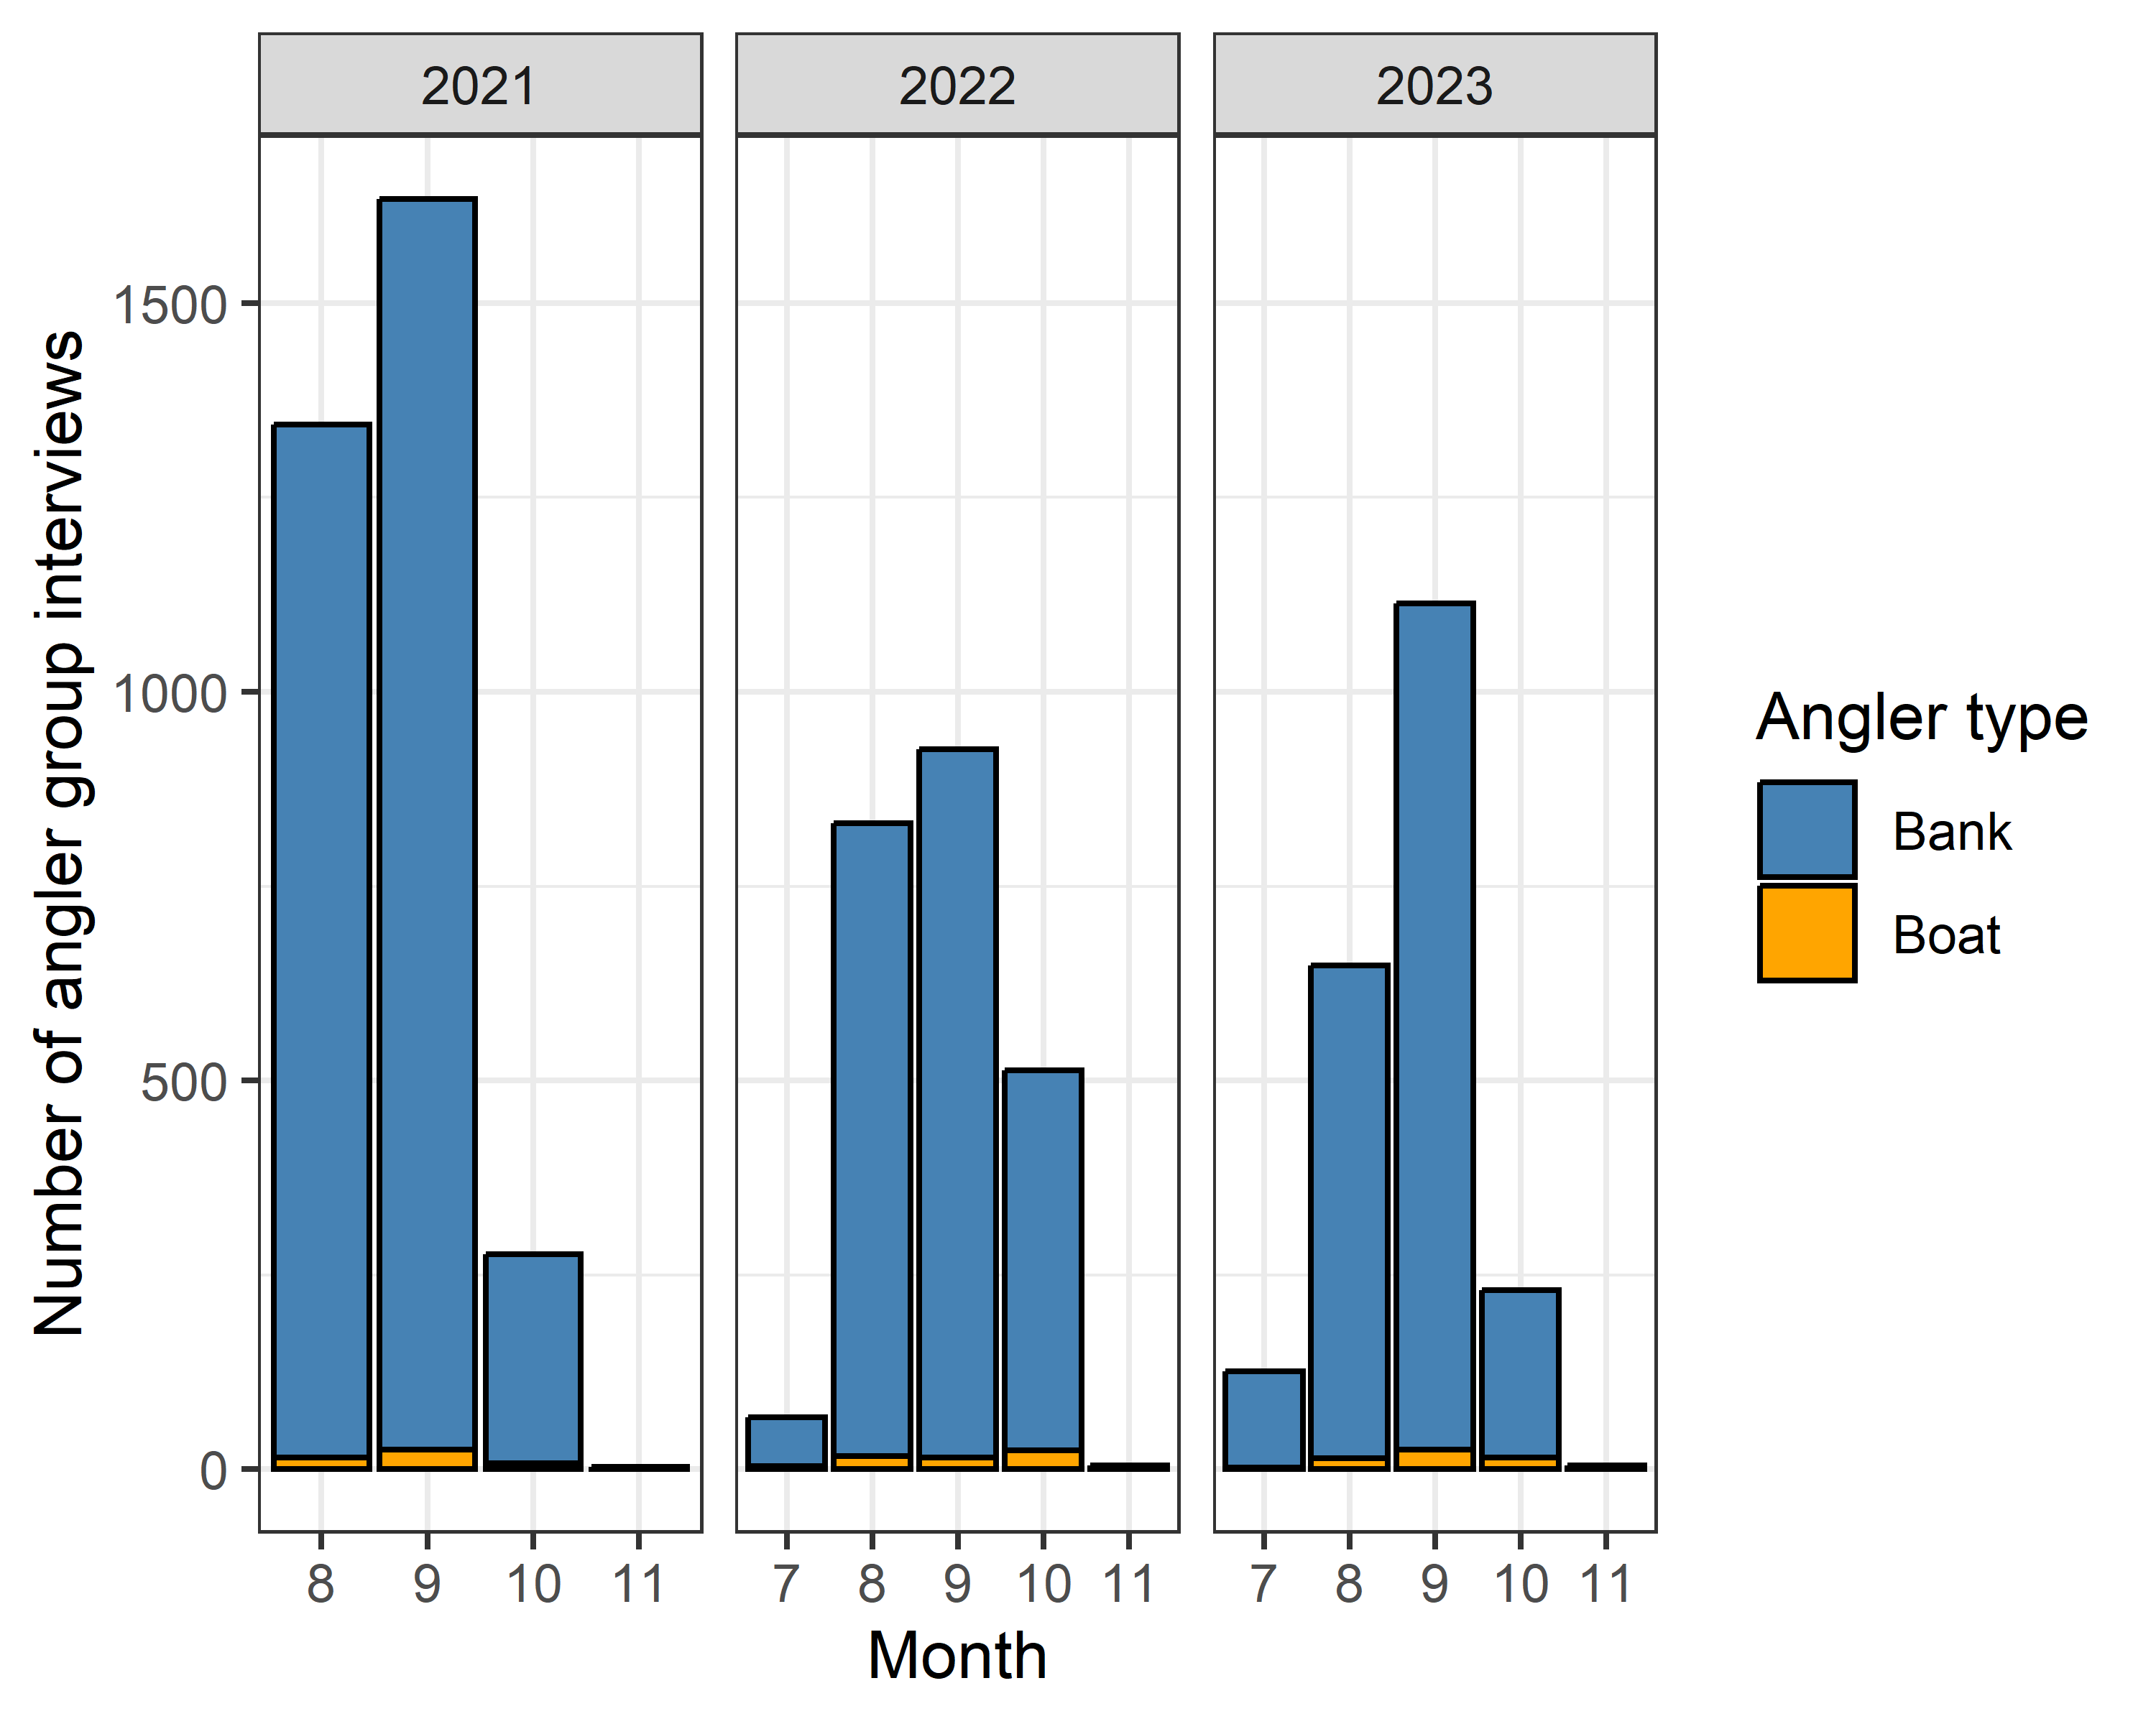
Figure _. The number of interviews obtained, categorized by bank (blue) and boat (orange) angling groups, per month during the Nisqually River salmon fishery from 2021 to 2023.
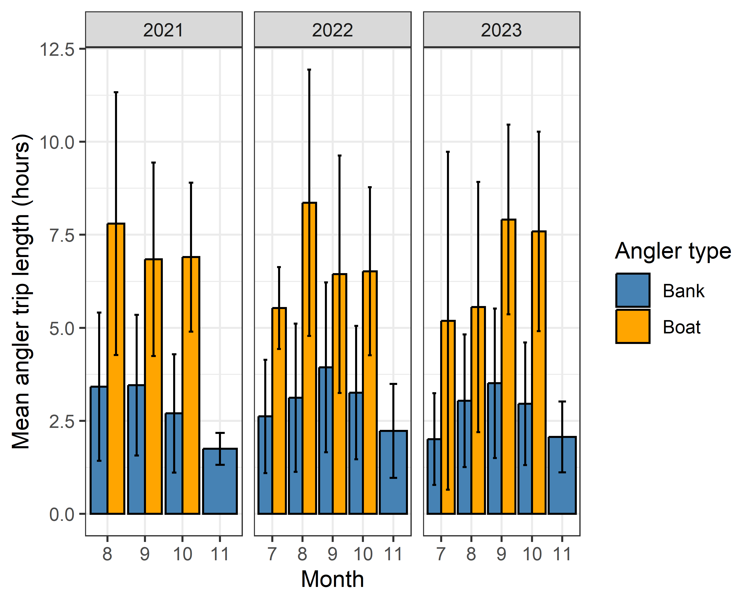
Figure _. Mean monthly trip time (± SD) of bank (blue) and boat (orange) angling groups surveyed on during the Nisqually River salmon fishery from 2021 to 2023.

Effort surveys

Index effort counts
Annual patterns in counts of vehicles and trailers exhibited some variability among years during the monitoring period. In 2021, across all months the mean daily index effort count of boat trailers was 1.11 (SD = 1.26, n = 57) and the mean daily index effort count of vehicles was 61.37 (SD = 52.75, n = 57). In 2022, across all months the mean daily index effort count of boat trailers was 0.9 (SD = 1.25, n = 156) and the mean daily index effort count of vehicles was 22.26 (SD = 37.38, n = 156). In 2023, across all months the mean daily index effort count of boat trailers was 0.71 (SD = 0.98, n = 150) and the mean daily index effort count of vehicles was 20.39 (SD = 34.53, n = 150).
Monthly vehicle and trailer count data exhibited similar seasonal patterns in across the three years, with some differences in variability related to time period and count type. Mean daily index effort counts in August and September of 2021 were higher than in corresponding months in 2022 and 2023. Importantly, we did not conduct census effort counts in 2021, which limits inferences that could be made regarding true difference in angling effort across years. In each month, the standard deviation of mean daily vehicle counts was larger than that observed for trailer counts, indicating more variability in index effort counts of vehicles than boat trailers.
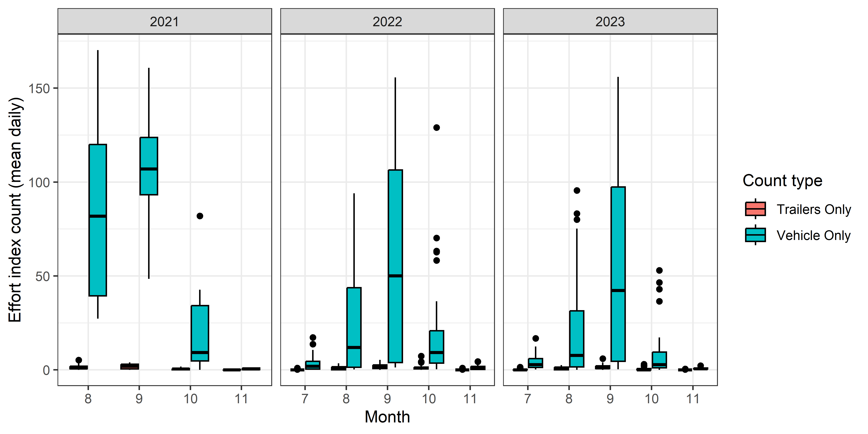
Figure _. Box and whisker plot of mean daily index effort counts, categorized by vehicle (green) and boat trailer (red) count types, per month on the Nisqually River from 2021 to 2023. The lower and upper hinges correspond to the first and third quartiles (the 25th and 75th percentiles). The upper whisker extends from the hinge to the largest value no further than 1.5 * IQR from the hinge (where IQR is the inter-quartile range, or distance between the first and third quartiles). The lower whisker extends from the hinge to the smallest value at most 1.5 * IQR of the hinge. Data beyond the end of the whiskers are plotted individually.
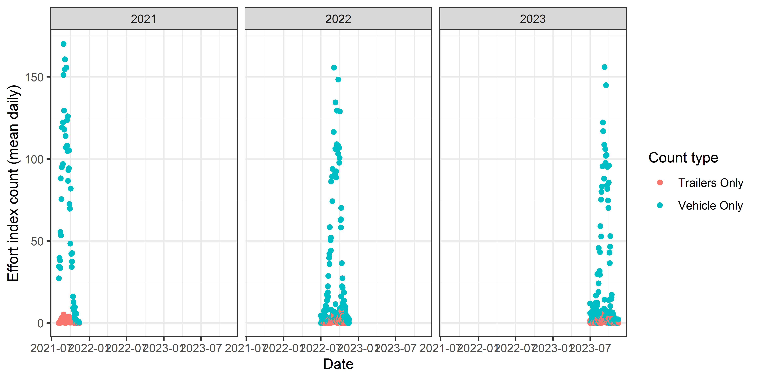
Figure _. Mean daily index effort counts of vehicles and trailers from 2021 through 2023 in the Nisqually River. July counts are not shown for 2022 and 2023 for consist

Census effort counts
In 2022 we conducted 15 census effort counts of anglers. In 2023 we conducted 9 census effort counts of anglers. Proportions of observed angler types were similar across years. Cumulative census counts of two angler types, 1) bank anglers without a vessel, and 2) boat anglers using a motorized boat, drift boat, or raft made up 89% and 7% of observed anglers in 2022, respectively, and 89% and 8% of observed anglers in 2023 (Figure ).
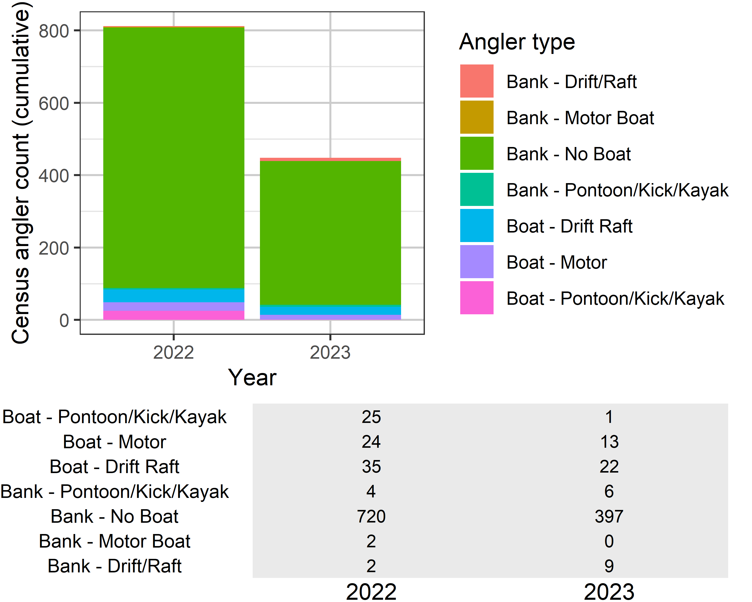
Figure _. Stacked barplots with cumulative counts of anglers observed during census effort count surveys in the Nisqually River in 2022 and 2023. The table contains cumulative counts, with each row grouped by angler type and columns grouping data by year.

Angler trips and sampling rate

Estimated number of angler trips
Across all months and years, the mean trip length of banks anglers was 3.36 hours (SD = 1.97, CV = 0.59), and the mean trip length of boat anglers was 7.08 hours (SD = 2.91, CV = 0.41). Bank anglers on average fished for less time than boat anglers and exhibited more variability in trip length time. Within each angler type, estimates of mean trip length exhibited little variability across months and lacked discernible temporal trends (Figure 9).

Angler Sampling rate
Using the monthly mean trip time and estimated seasonal total angling effort (angler-hours), we estimated the number of bank and boat angler trips. In 2022, an estimated 17311 angling trips occurred (n_{bank} = 16202, n_{boat} = 1109. In 2023, an estimated 18376 angling trips occurred (n_{bank} = 17149, n_{boat} = 1227. Given relative consistency in monthly mean trip length estimates (Figure 9), the estimated number of angler-trips per month (Figure 10) followed a similar pattern to the estimated seasonal total angler effort.

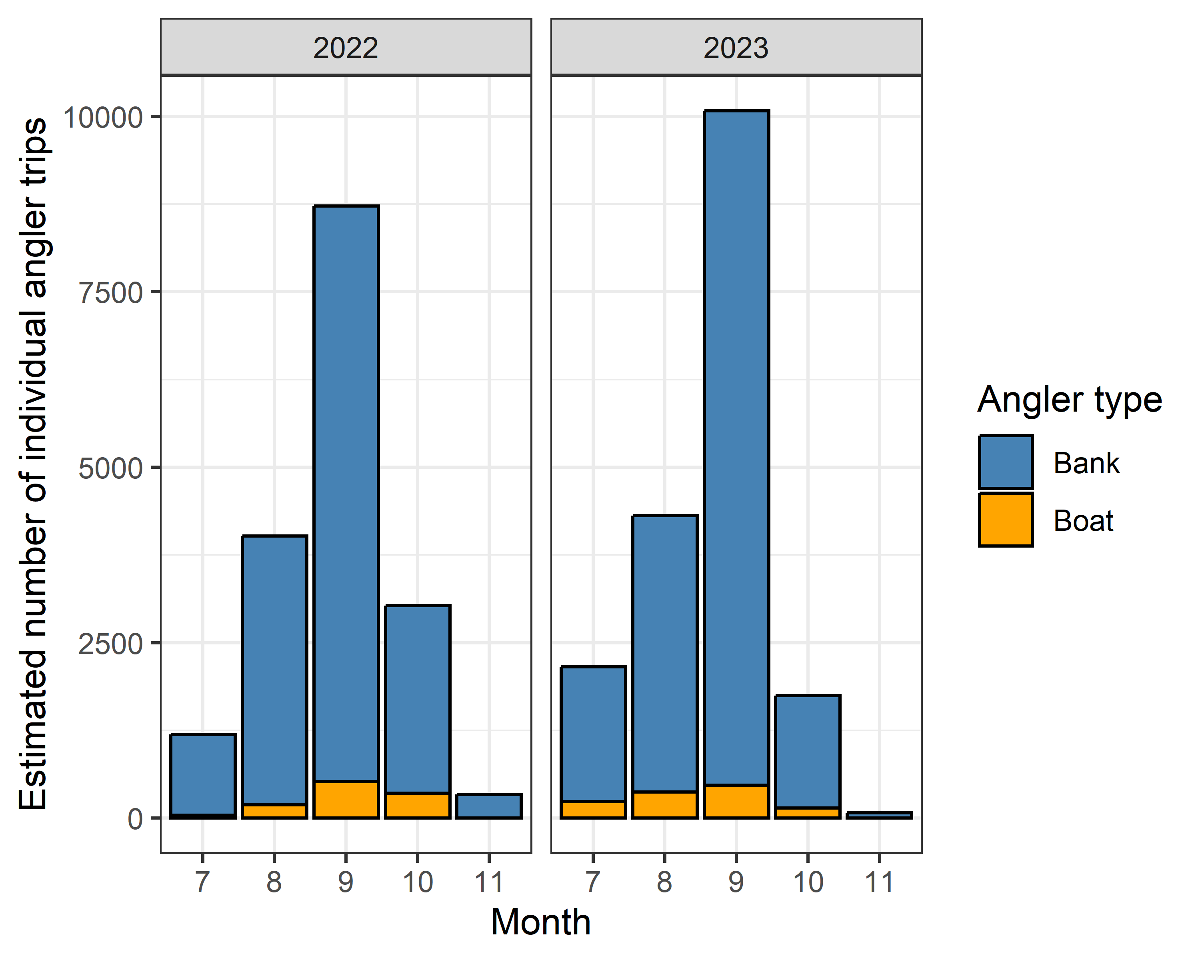
Figure _. The estimated number of individual angler trips, categorized by bank (blue) and boat (orange) angler types, per month on the Humptulips River from September 1, 2022 to November 29, 2023. The fishery was closed through emergency regulations from October 8, 2022 to October 28, 2022 due to drought conditions. The fishery was not open in December 2023.
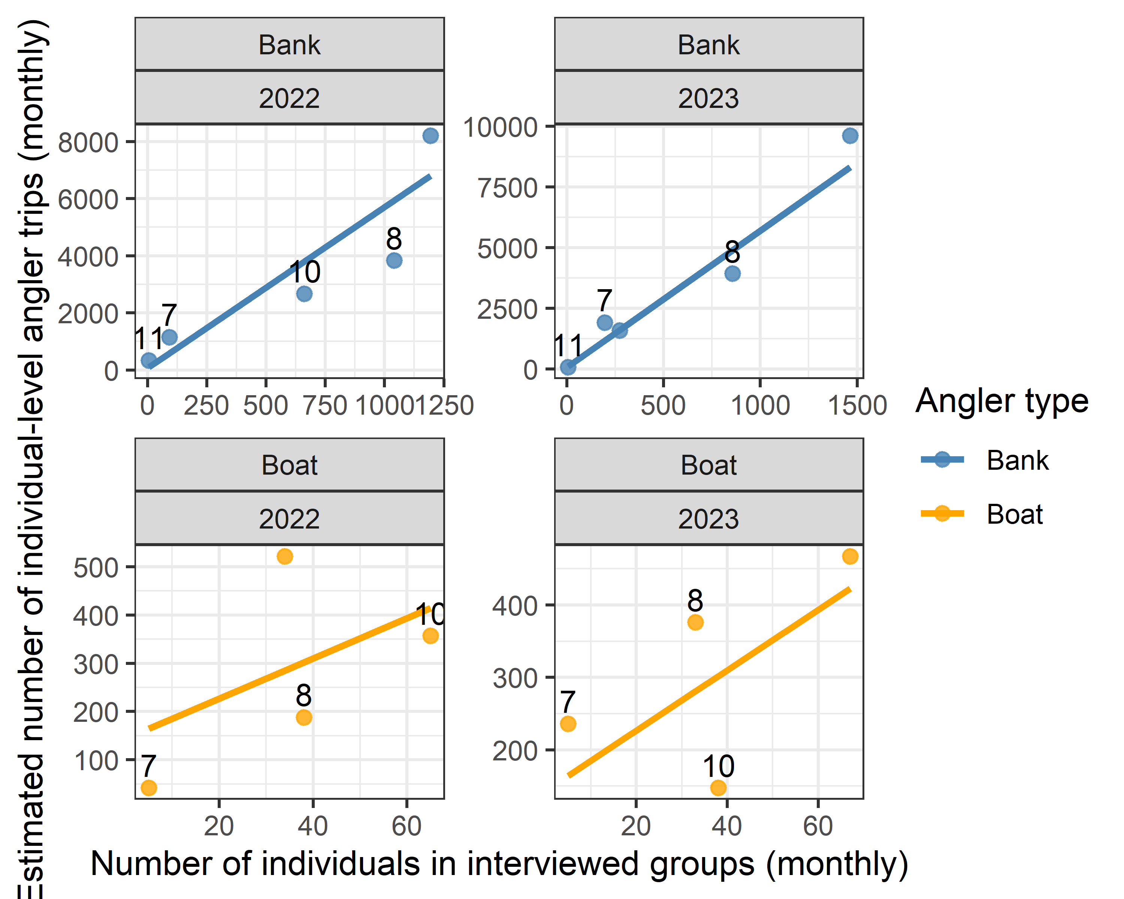
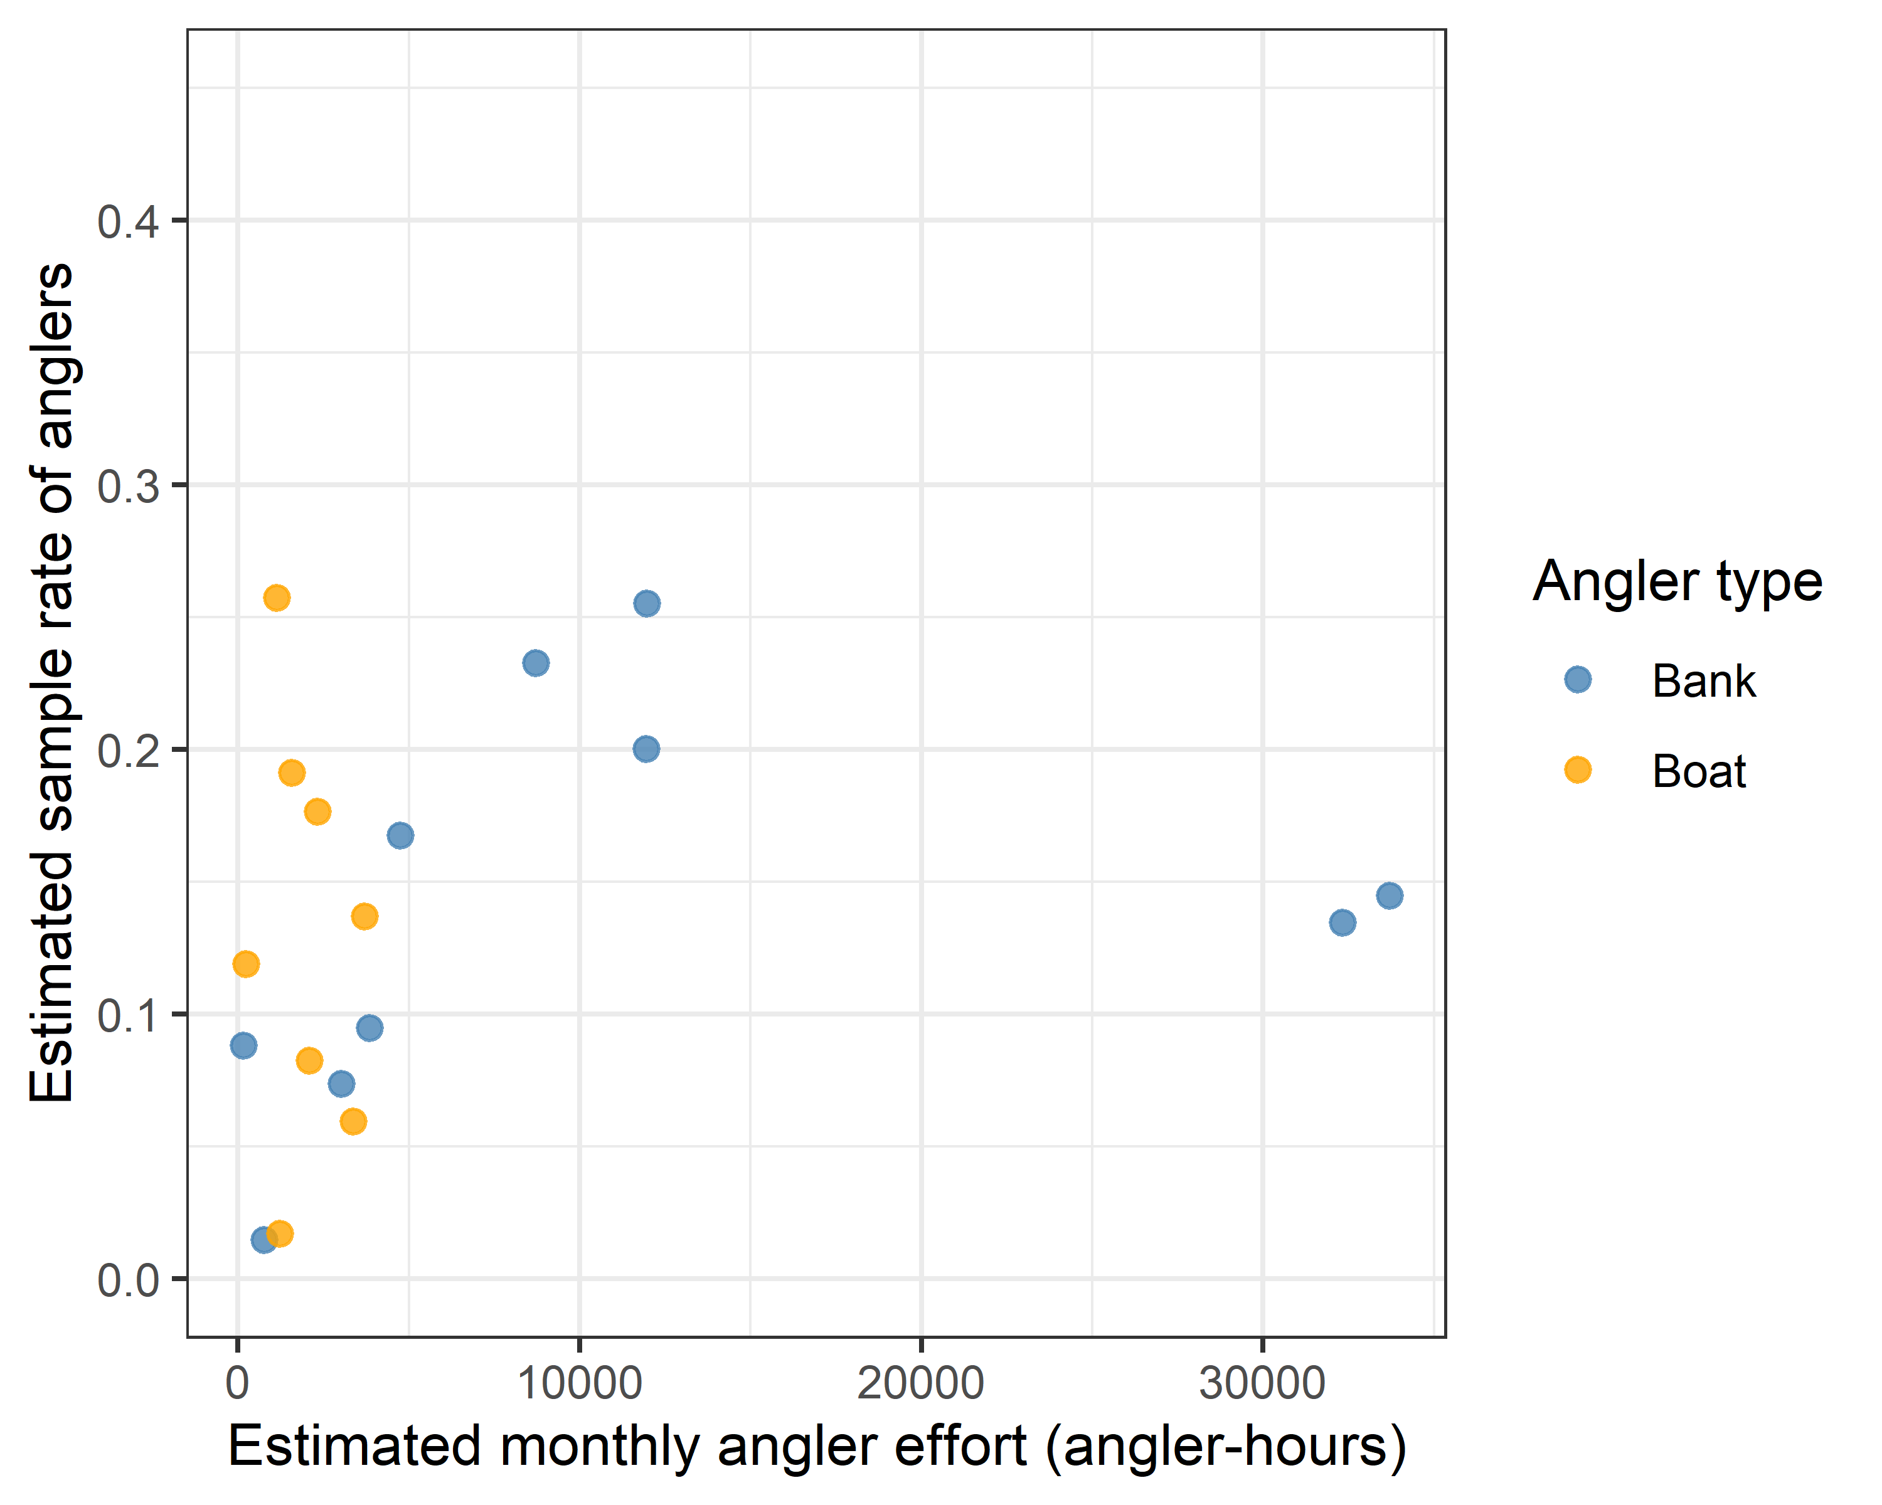
Figure _. The estimated sampling rate of anglers, calculated as a ratio of angler hours directly sampled in interviews to estimated total angling effort, as a function of the total number of individuals within anglers groups interviewed per month, categorized by bank (blue) and boat (orange) angling groups.

