Creel survey sampling evaluation
Evan Booher
2025-05-23
Table of contents

Results

Creel survey sampling evaluation

Survey days and closures
During the monitoring period from 2021 to 2023, a roving creel survey was conducted on the Nisqually River on 210 out of the 414 (64%) days that the fishery was open.
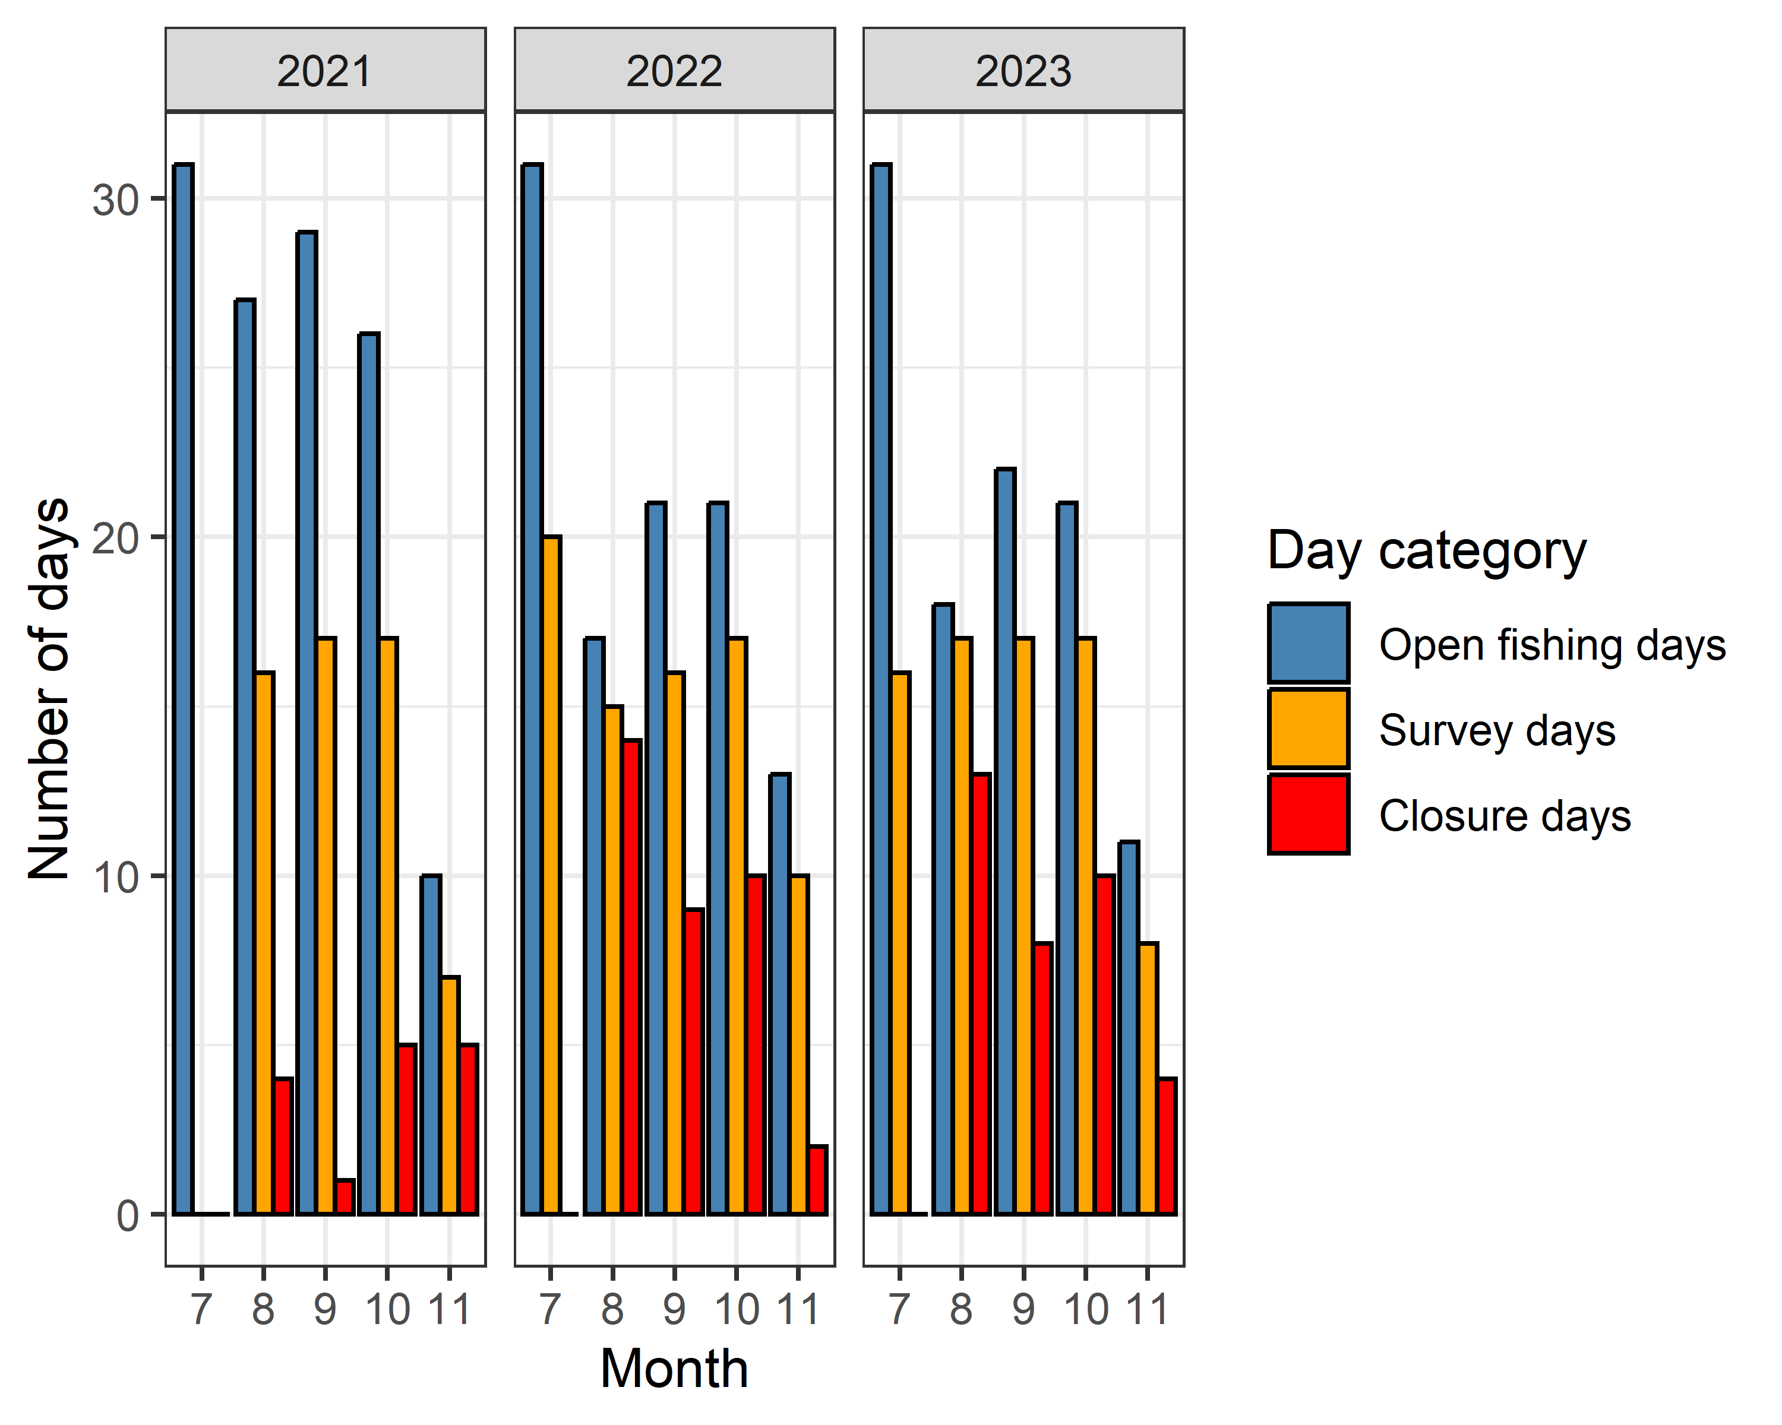
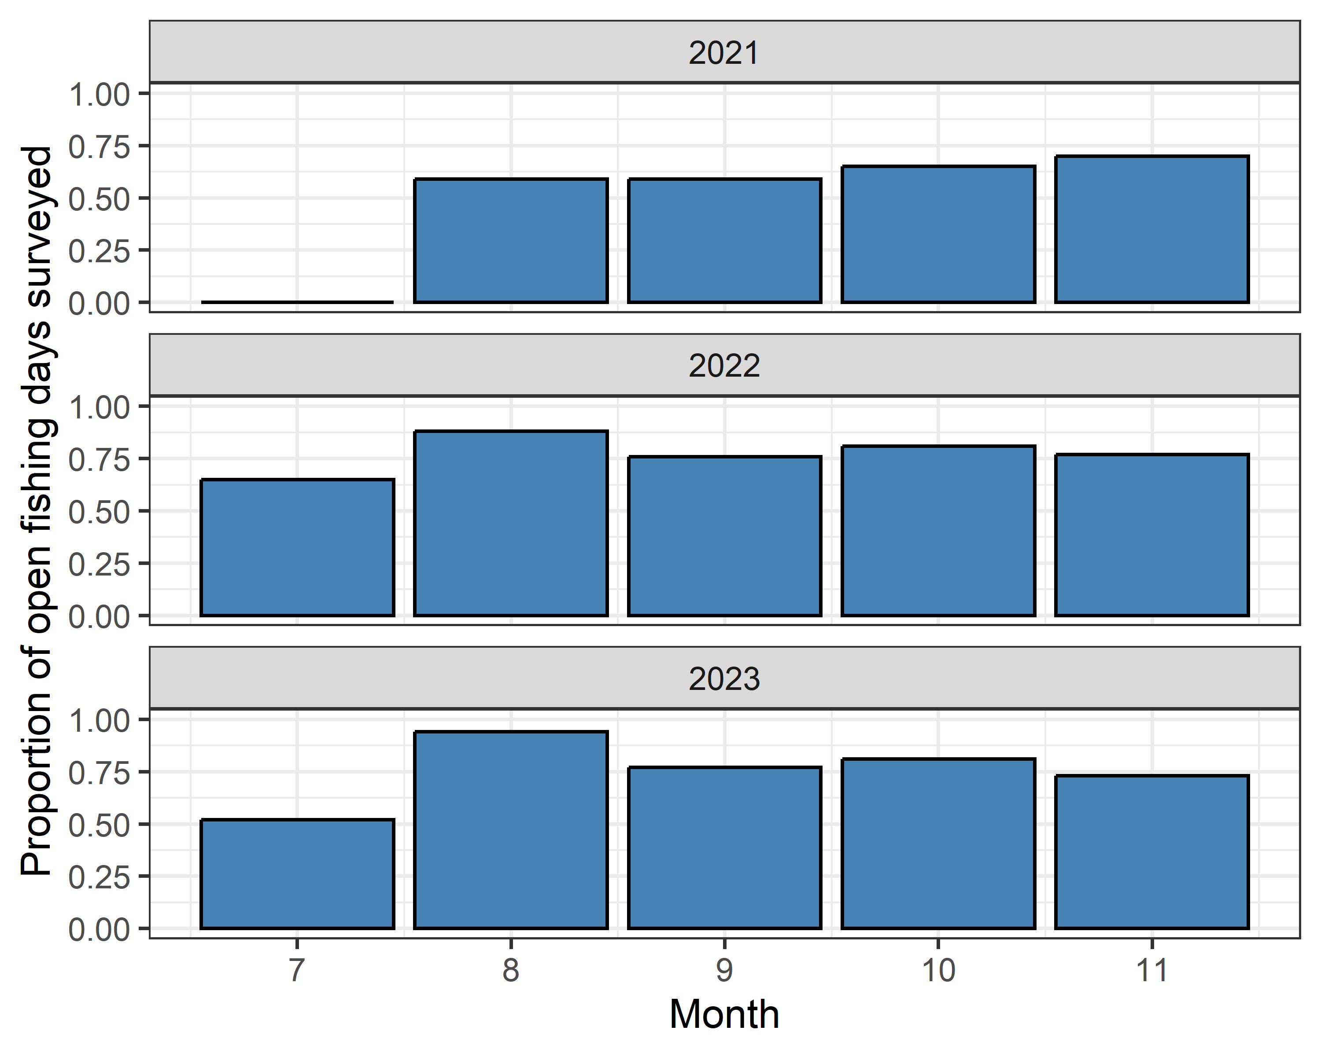
Figure _. The proportion of days open to fishing per month that a roving creel survey was conducted during the Nisqually River salmon fishery from 2021 to 2023.

Angler interviews
In 2021, sampling for interviews only occurred in section 2, where we obtained a total of 3258 interviews, representing 3210 bank angler groups and 48 boat angler groups. In 2022, a total of 2342 interviews were obtained, representing 2282 bank angler group interviews and 60 boat angler group interviews. In 2023, a total of 2123 interviews were obtained, representing 2067 bank angler group interviews and 56 boat angler group interviews. Across all years the vast majority of interviews were obtained in section 2. Relatively few interviews were obtained in the lower river represented by section 1 (n = 4) and the upper river, represented by section 3 (n = 23), and section 4 (n = 6). Sample sizes in these areas were likely limited by accessibility and logistical constraints on sampling. See Table _ for a breakout of the number of interviews obtained by year, section, and angler type.
Year | Section number | Angler type | Count
2021 | 2 | bank | 3210
2021 | 2 | boat | 48
2022 | 1 | bank | 3
2022 | 1 | boat | 1
2022 | 2 | bank | 2276
2022 | 2 | boat | 51
2022 | 3 | bank | 3
2022 | 3 | boat | 6
2022 | 4 | boat | 2
2023 | 2 | bank | 2066
2023 | 2 | boat | 39
2023 | 3 | bank | 1
2023 | 3 | boat | 13
2023 | 4 | boat | 4
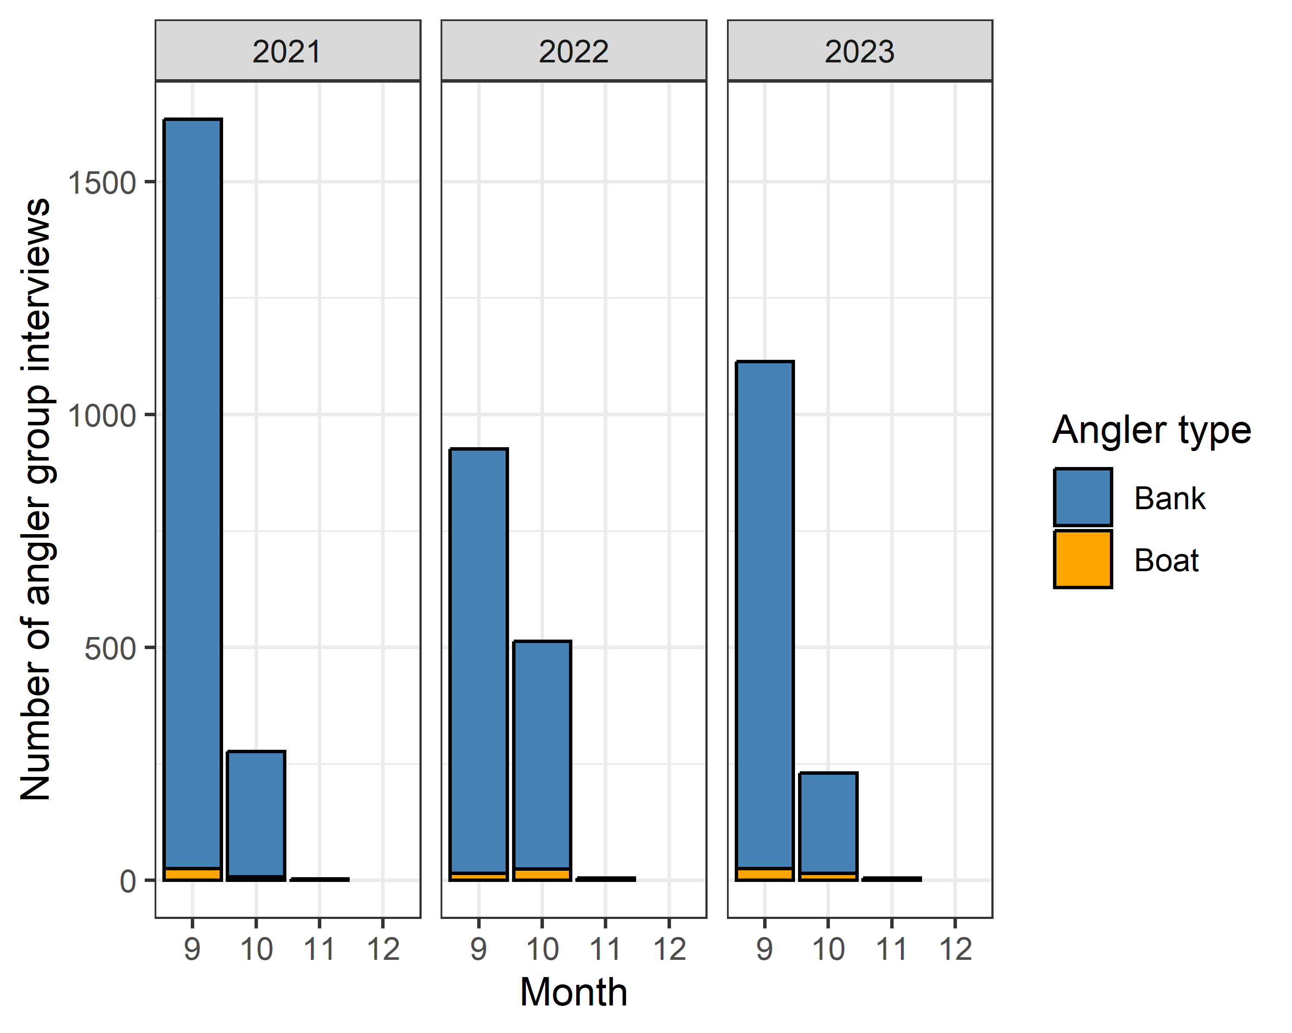
Figure _. The number of interviews obtained, categorized by bank (blue) and boat (orange) angling groups, per month during the Nisqually River salmon fishery from 2021 to 2023.
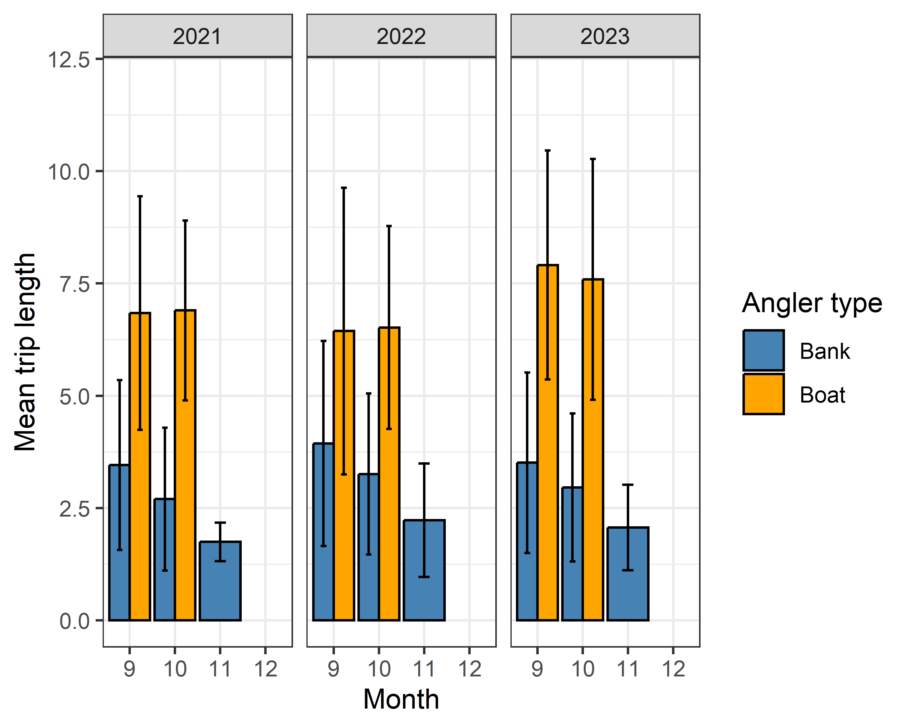
Figure _. Mean monthly trip time (± SD) of bank (blue) and boat (orange) angling groups surveyed on during the Nisqually River salmon fishery from 2021 to 2023.

Effort surveys

Index effort counts
Annual patterns in counts of vehicles and trailers were similar between years 2022 and 2023. In 2022, across all months the mean daily index effort count of boat trailers was 0.9 (SD = 1.25, n = 156) and the mean daily index effort count of vehicles was 21.37 (SD = 36.81, n = 156). In 2023, across all months the mean daily index effort count of boat trailers was 0.71 (SD = 0.98, n = 150) and the mean daily index effort count of vehicles was 19.68 (SD = 34.26, n = 150). **Add 2021 data to this paragraph
Monthly vehicle and trailer count data exhibited some differences in variability related to time period and count type. The peak of index effort count data in 2023 occurred in October and index effort counts in November 2023 were lower than that observed in 2022 (Figure ). In each month, standard deviation of mean daily vehicle counts was larger than that observed for trailer counts, indicating more variability in index effort counts of vehicles than boat trailers. ** update for Nisqually
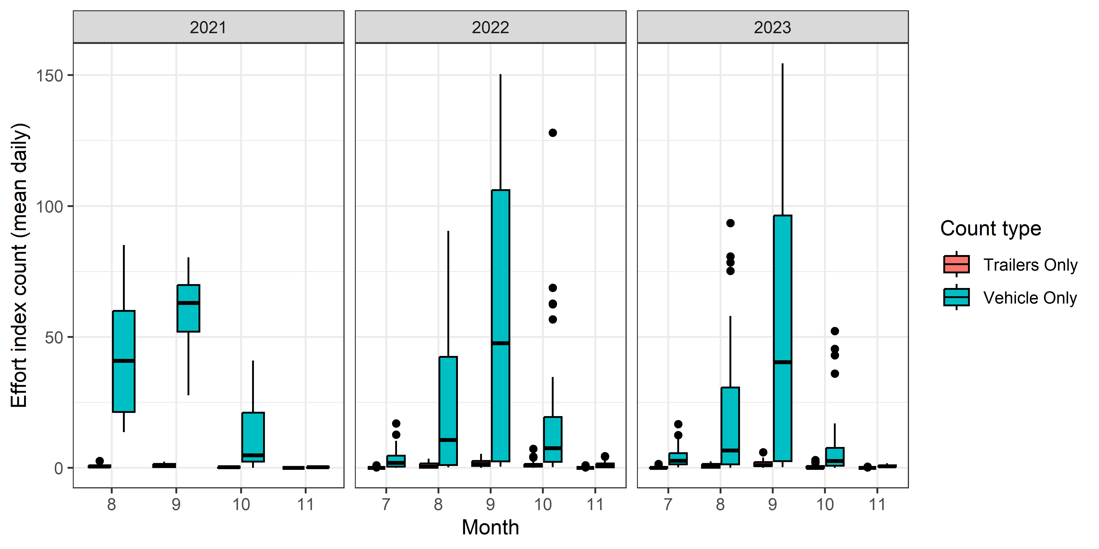
Figure . Box and whisker plot of mean daily index effort counts, categorized by vehicle (green) and boat trailer (red) count types, per month on the River from to . The lower and upper hinges correspond to the first and third quartiles (the 25th and 75th percentiles). The upper whisker extends from the hinge to the largest value no further than 1.5 * IQR from the hinge (where IQR is the inter-quartile range, or distance between the first and third quartiles). The lower whisker extends from the hinge to the smallest value at most 1.5 * IQR of the hinge. Data beyond the end of the whiskers are plotted individually. ________________.

Census effort counts
In both 2022 and 2022 we conducted 15 census effort counts of anglers (appendix ). Proportions of observed angler types were similar across years. Cumulative counts of two angler types, 1) boat anglers using a drift boat or raft and 2) bank anglers without a vessel, made up 91% of observed anglers in 2022 and 88% of anglers in 2023 (Figure ).
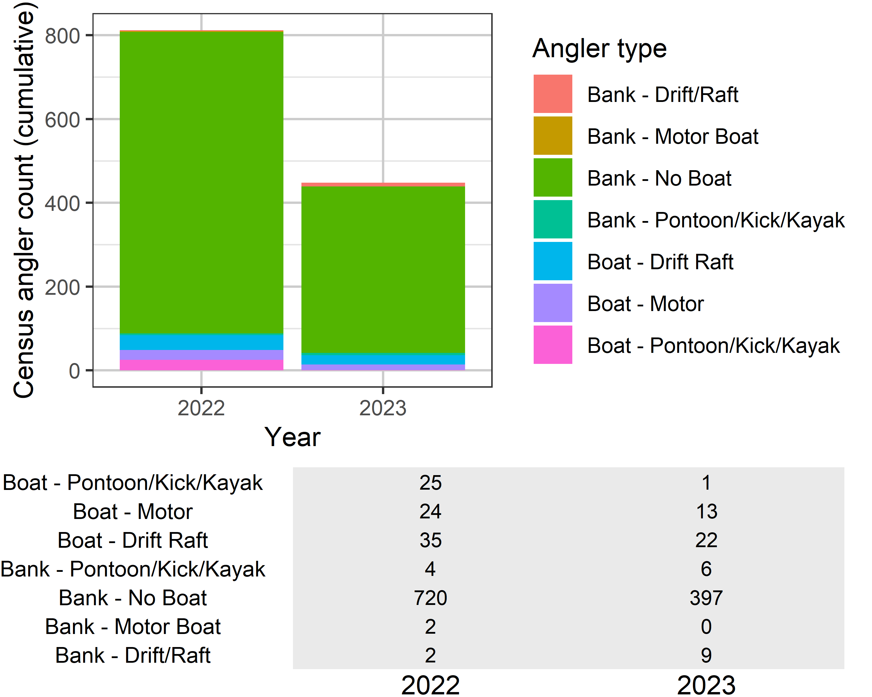
Figure . Stacked barplots with cumulative counts of anglers observed during census effort count surveys in _____. The table contains cumulative counts, with each row grouped by angler type and columns grouping data by year.

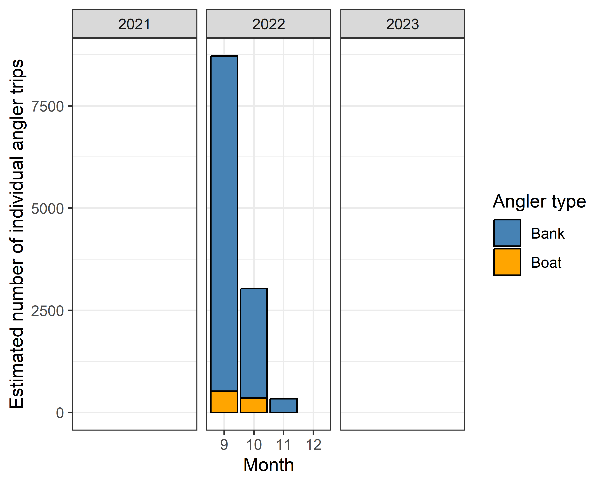
Figure _. The estimated number of individual angler trips, categorized by bank (blue) and boat (orange) angler types, per month on the Humptulips River from September 1, 2022 to November 29, 2023. The fishery was closed through emergency regulations from October 8, 2022 to October 28, 2022 due to drought conditions. The fishery was not open in December 2023.

Angler trips and sampling rate
The estimated number of monthly individual angler trips was related to the observed number of individual anglers that were interviewed during creel surveys (Figure ; Bank: p < 0.04, R² = 0.8; Boat: p < 0.4162, R² = 0.8). The linear model fit for bank anglers was parameterized as: y(Estimated Angler Trips) = 5.12 (Angler Interviews) 172.18. The linear model fit for boat anglers was parameterized as: y(Estimated Angler Trips) = 4.94 (Angler Interviews) 101.9. Therefore, approximately 20% of bank anglers were interviewed, and approximately 20% of boat anglers were interviewed, across all months and years.
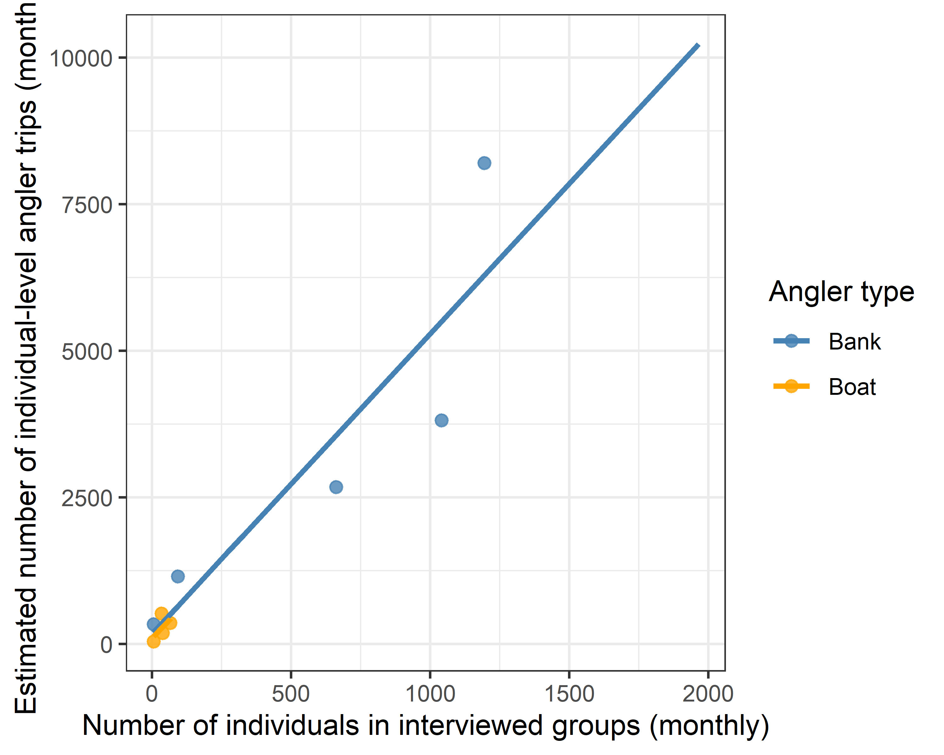
Figure _. The estimated number of individual-level angler trips as a function of the total number of individuals within anglers groups interviewed per month, categorized by bank (blue) and boat (orange) angling groups, on the Humptulips River from September 1, 2022 to November 29, 2023. The fishery was closed through emergency regulations from October 8, 2022 to October 28, 2022 due to drought conditions. The fishery was not open in December 2023.
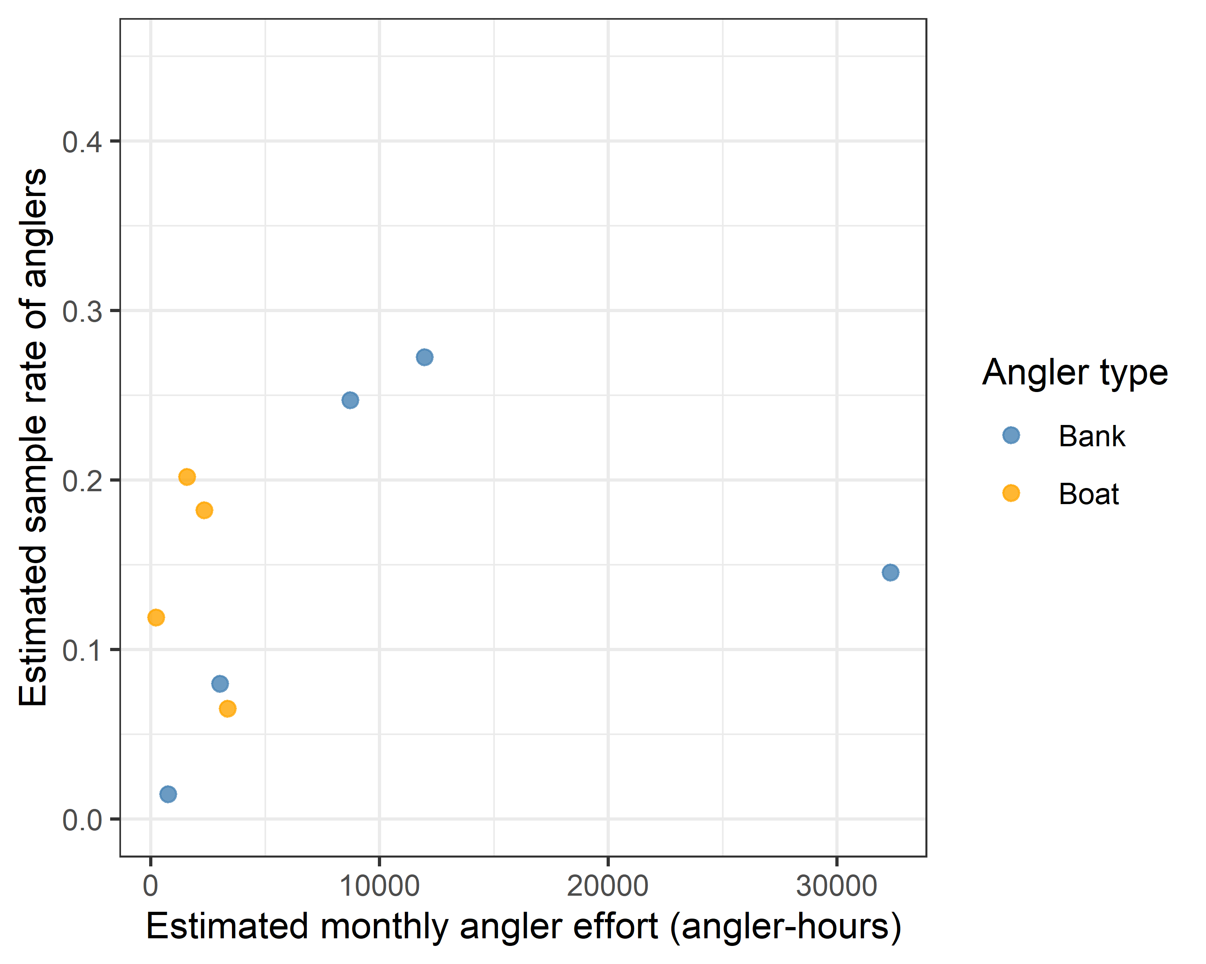
Figure _. The estimated sampling rate of anglers, calculated as a ratio of angler hours directly sampled in interviews to estimated total angling effort, as a function of the total number of individuals within anglers groups interviewed per month, categorized by bank (blue) and boat (orange) angling groups.

