AWS CPU Utilization Alert Project

**Table of Contents**

1. Overview  
2. Prerequisites  
3. Architecture  
4. Steps to Create the Project

- Step 1: Set up EC2 Instance  
 - Step 2: Set Up AWS CloudWatch Alarms  
 - Step 3: Send Email Notification Using SNS  
5. AWS Services Used  
6. Future Enhancements  
7. Conclusion

**1. Overview**

This project demonstrates how to set up an alert mechanism on AWS to monitor CPU utilization and send email notifications using AWS CloudWatch and SNS when CPU usage crosses a certain threshold. This setup ensures timely notifications to the team in case of any resource strain, allowing for immediate action.

**2. Prerequisites**

Before starting, ensure you have the following prerequisites:  
- AWS Account  
- IAM Role with permissions for EC2, CloudWatch, and SNS  
- AWS CLI installed (optional for local configuration)  
- Email ID to receive notifications

**3. Architecture**

The architecture is straightforward, involving an EC2 instance, CloudWatch for monitoring, and SNS for sending email notifications when a threshold is breached. The flow is as follows:  
1. CPU Utilization crosses the threshold.  
2. CloudWatch Alarm triggers an SNS Topic.  
3. SNS sends an email notification to the subscribed email addresses.

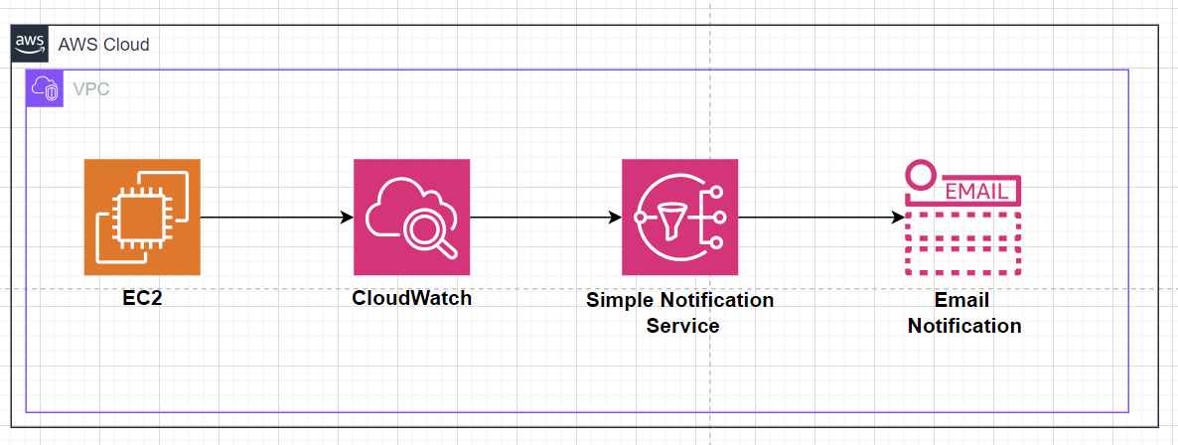

**1. Steps to Create the Project**

**Step1: Set up EC2 Instance**

EC2 instance creation parameters:

1. Enter name of the instance: Web Server Node 1, Web Server Node 2
2. Instance Type: t2 Micros
3. Key Pair: existing
4. VPC: existing
5. Create or Select existing Security Group: Existing Security Group with HTTP
6. Click on Launch Instance

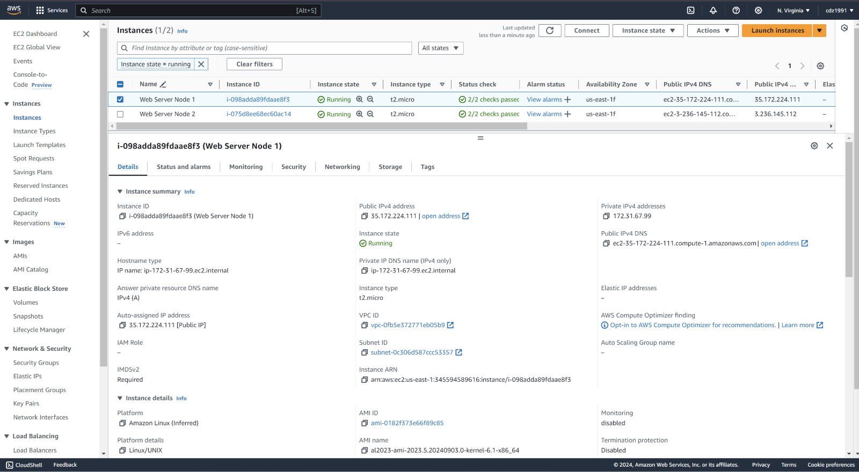

**Step 2 : Send Email Notification Using SNS:**

1. Go to SNS (Simple Notification Service) in the AWS Management Console.  
2. Create a new SNS topic (**SendEmailTopic**).

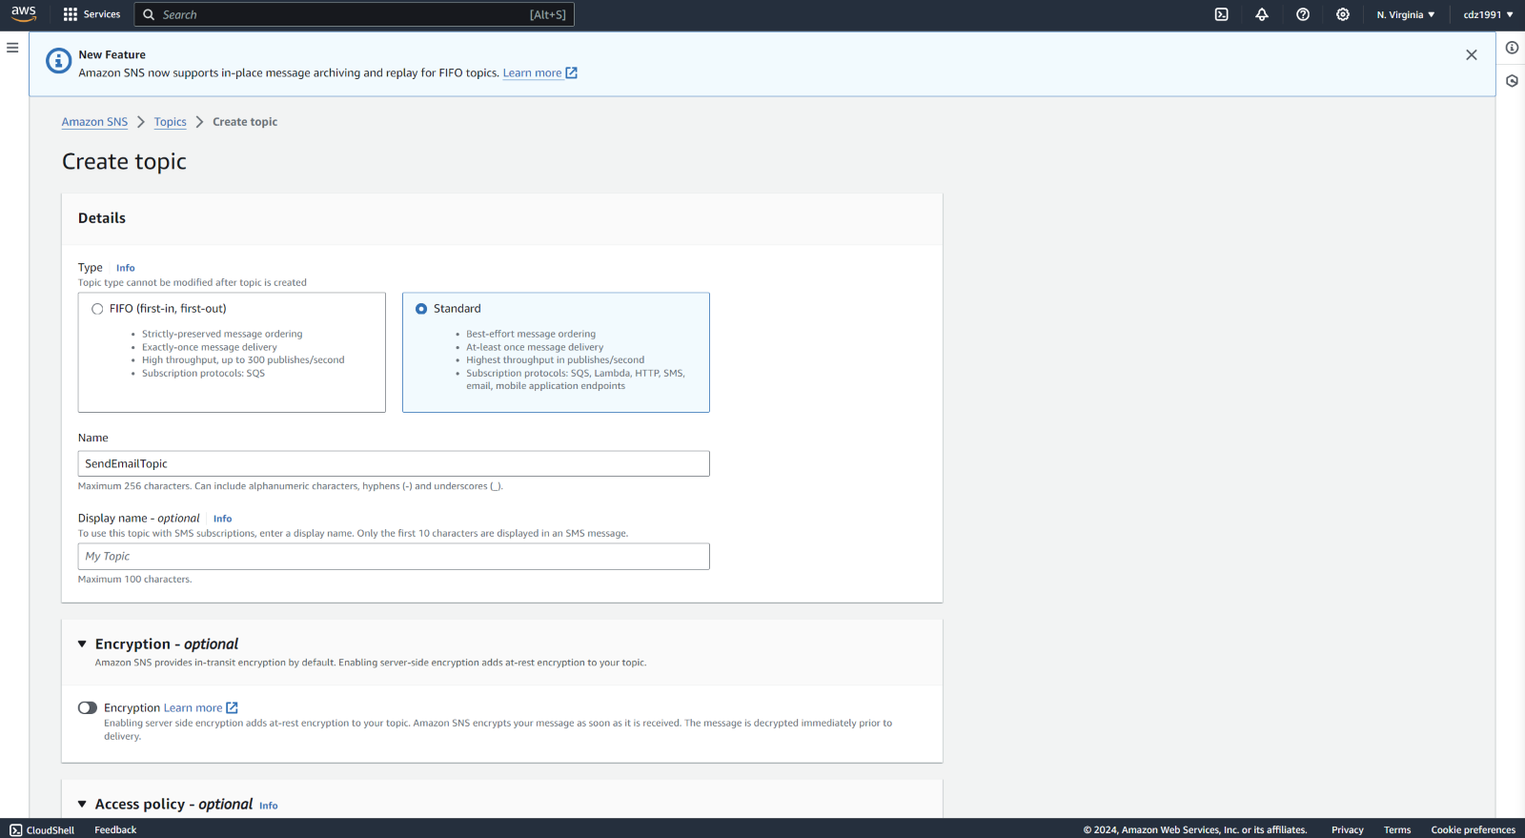

Under Access Policy > Publishers > Select: **Everyone** and Click on create Topic

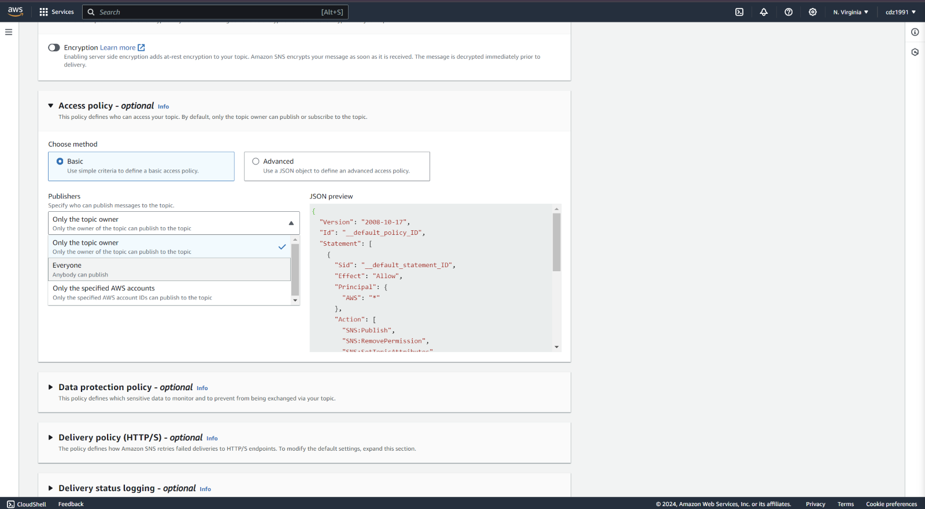  
  
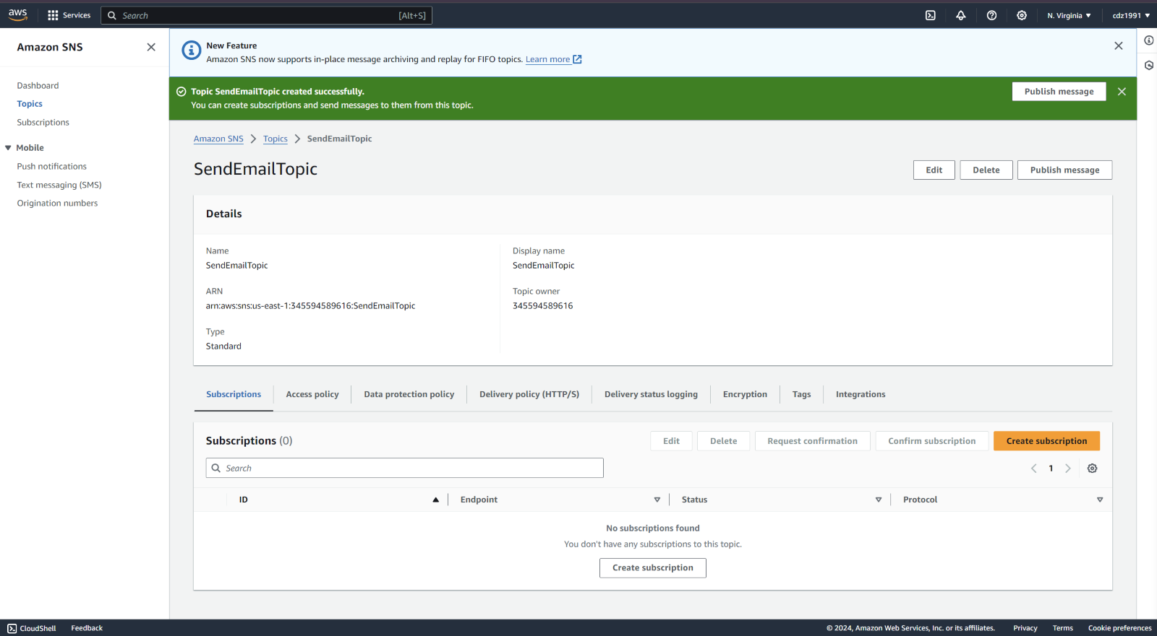

3. Subscribe your email address to the topic

Select Email Protocol to send Email Notifications  
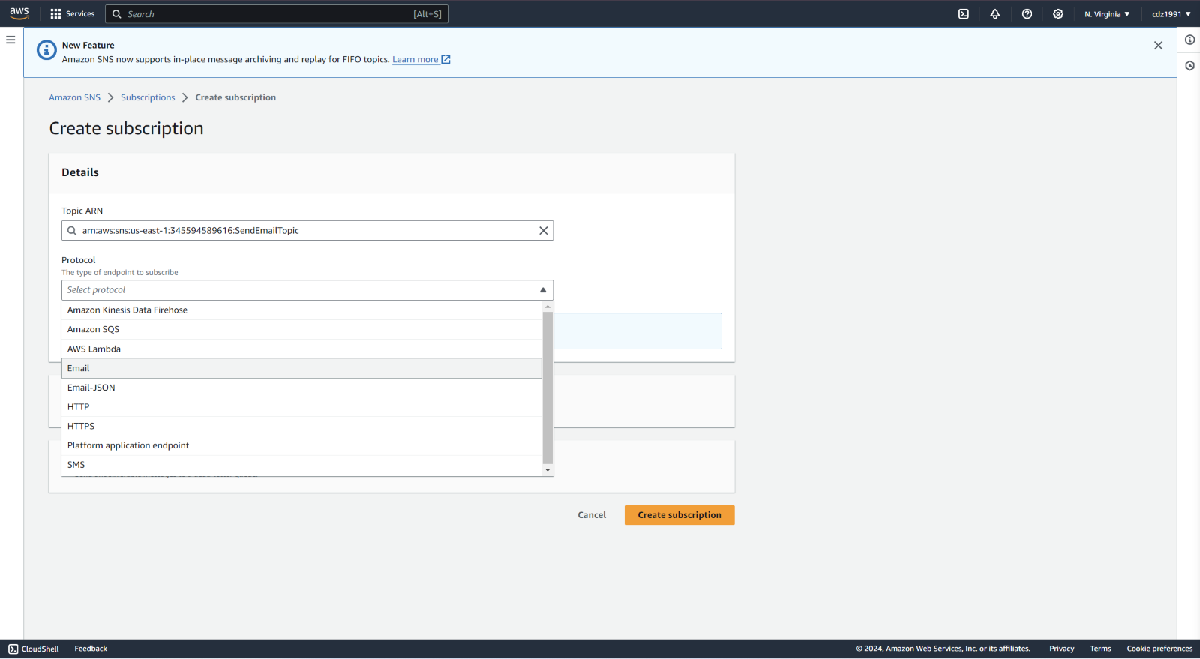

Entered your Email ID to receive Email Alert Notifications.  
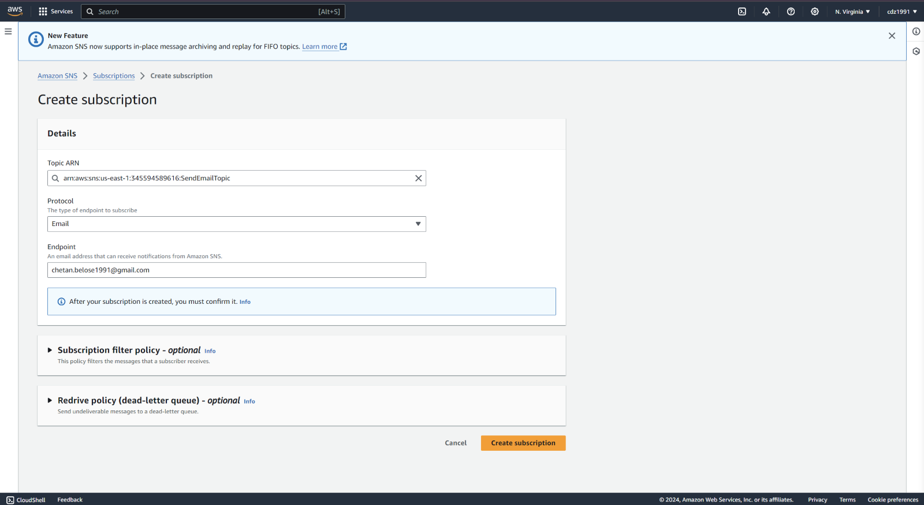  
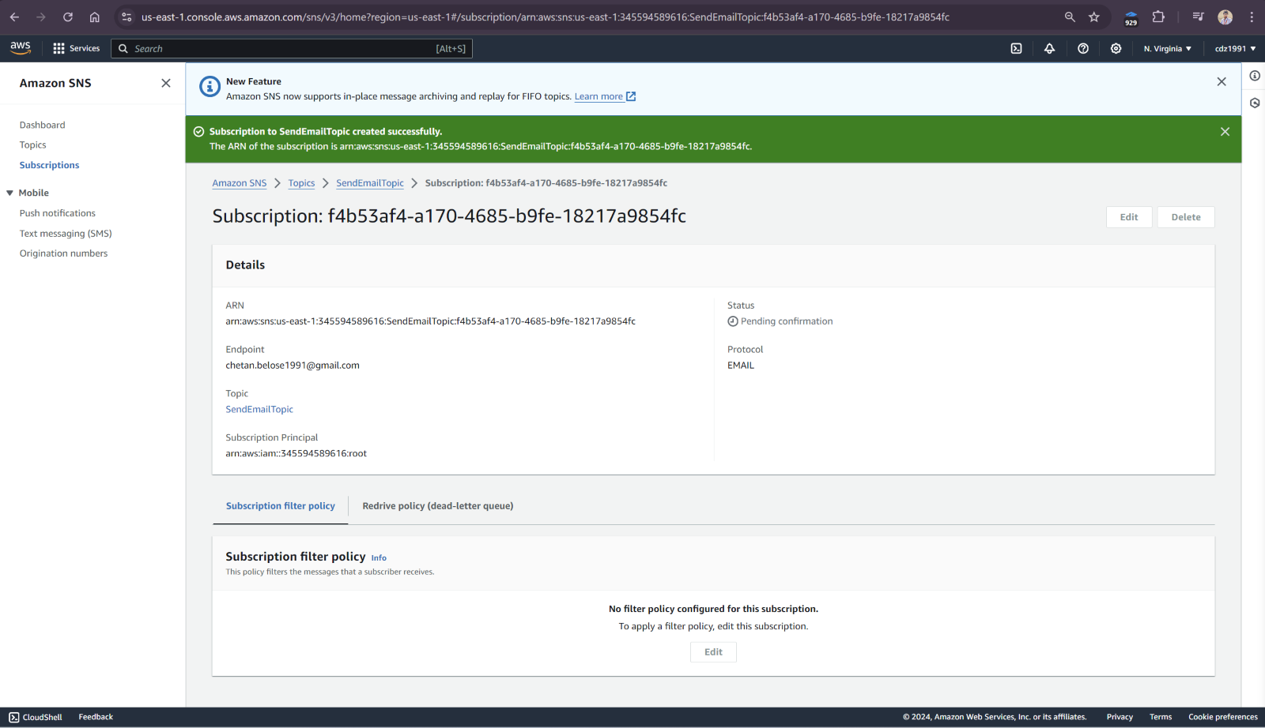

You will receive Email Notification to Confirm the Subscription. Once you click on confirm subscription then your email ID will get added into Subscription list.  
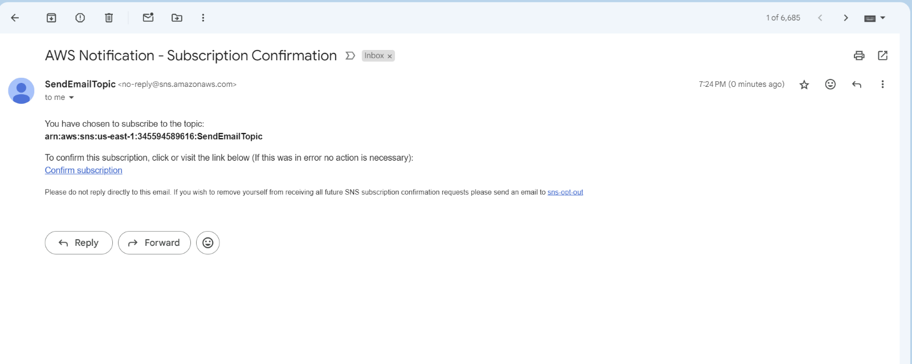

4. Link the CloudWatch Alarm to the SNS topic for alert generation.

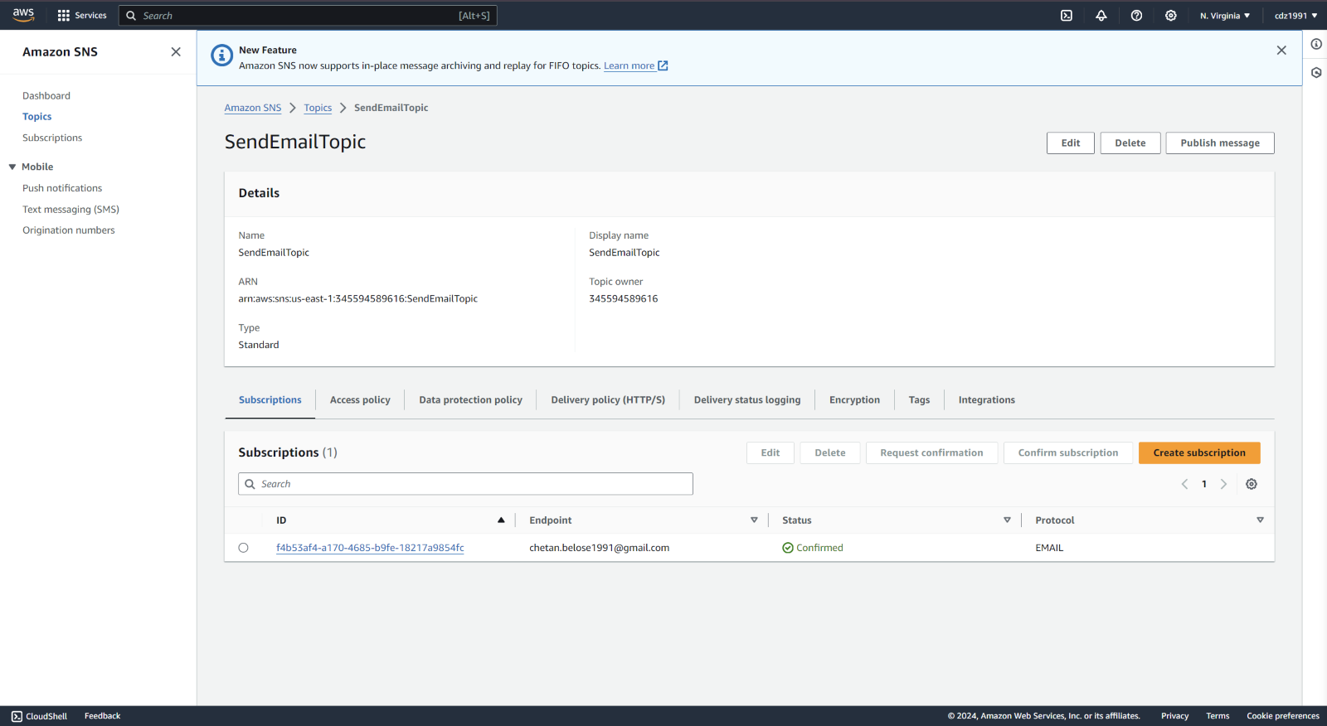

**Step 3: Set Up AWS CloudWatch Alarms:**

1. Open AWS CloudWatch in the AWS Management Console.

2. Navigate to 'Alarms' and click 'Create Alarm'.

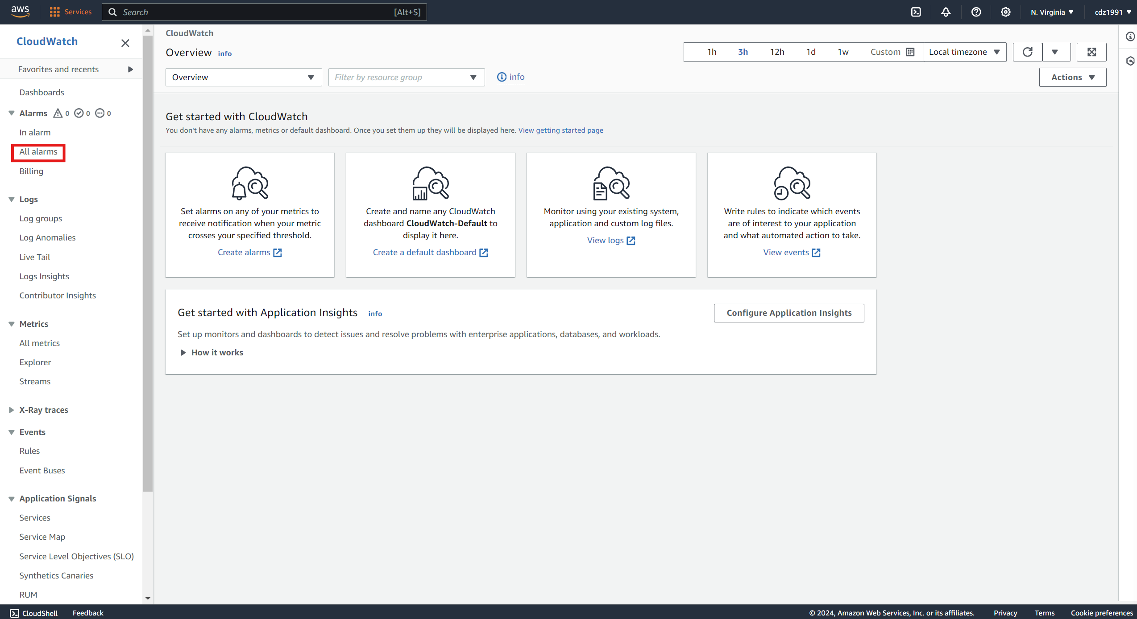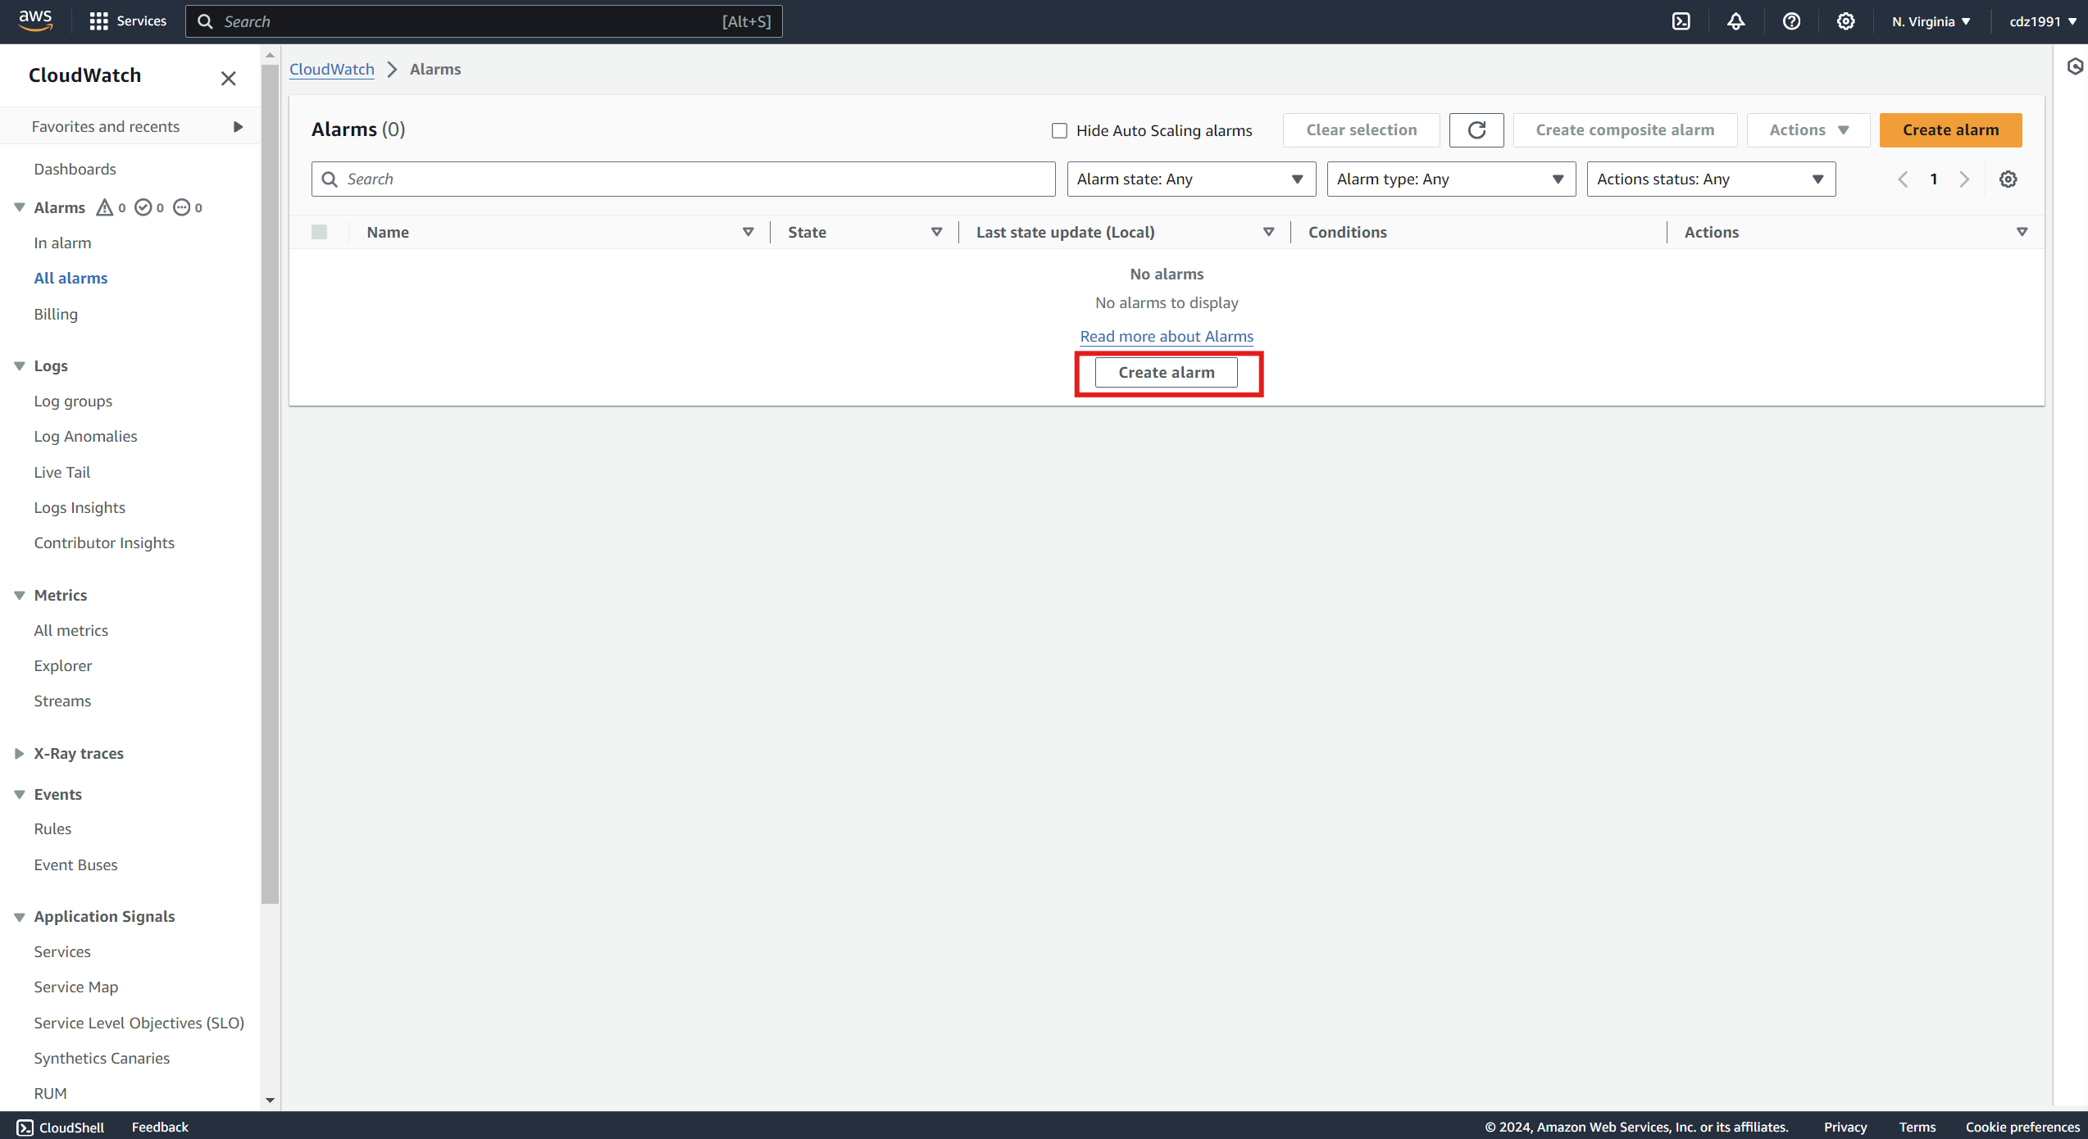

3. Select the EC2 instance you want to monitor for CPU Utilization.

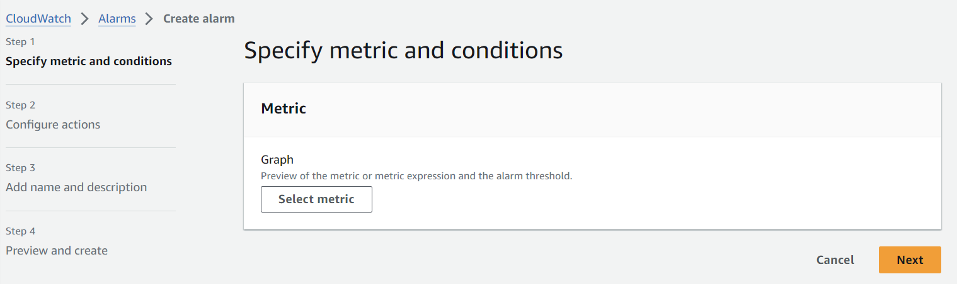

4. Click on **Select metric > Select EC2 > Pre-Instance Metrics > CPU Utilization**

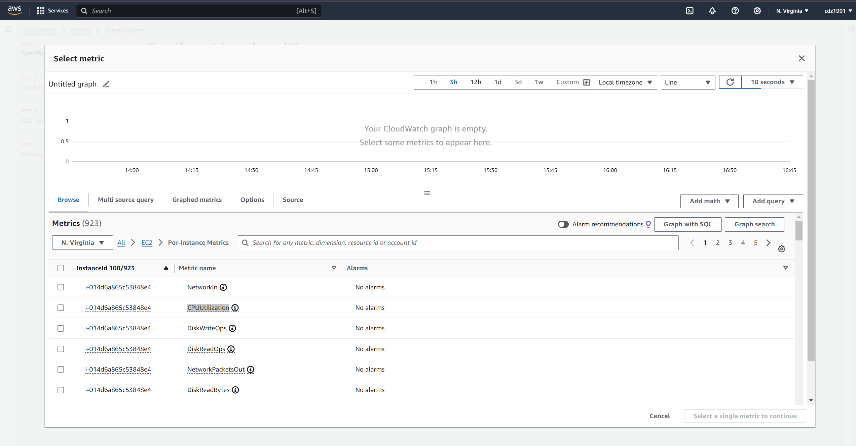  
4. Set the CPU Utilization threshold 50% to trigger the alarm.

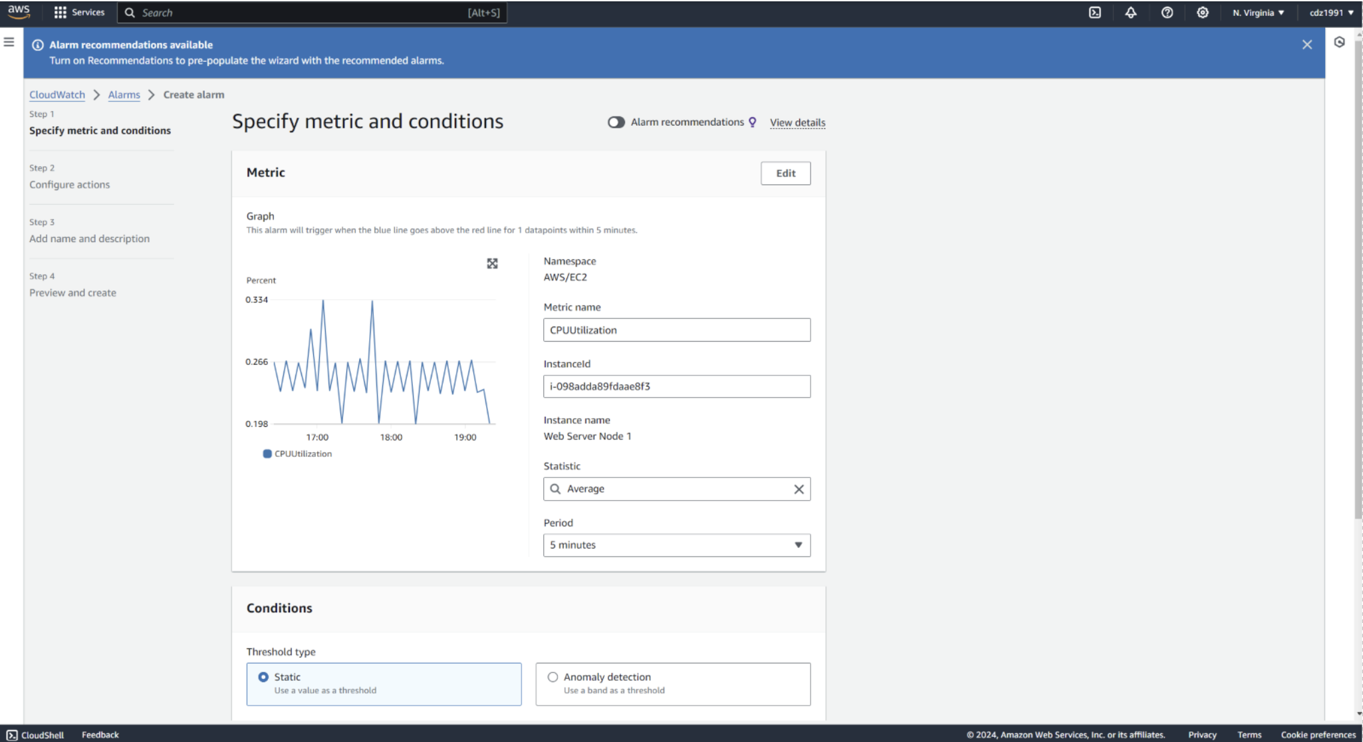

5. Select Existing SNS Topic (**SendEmailTopic**) and send notification to 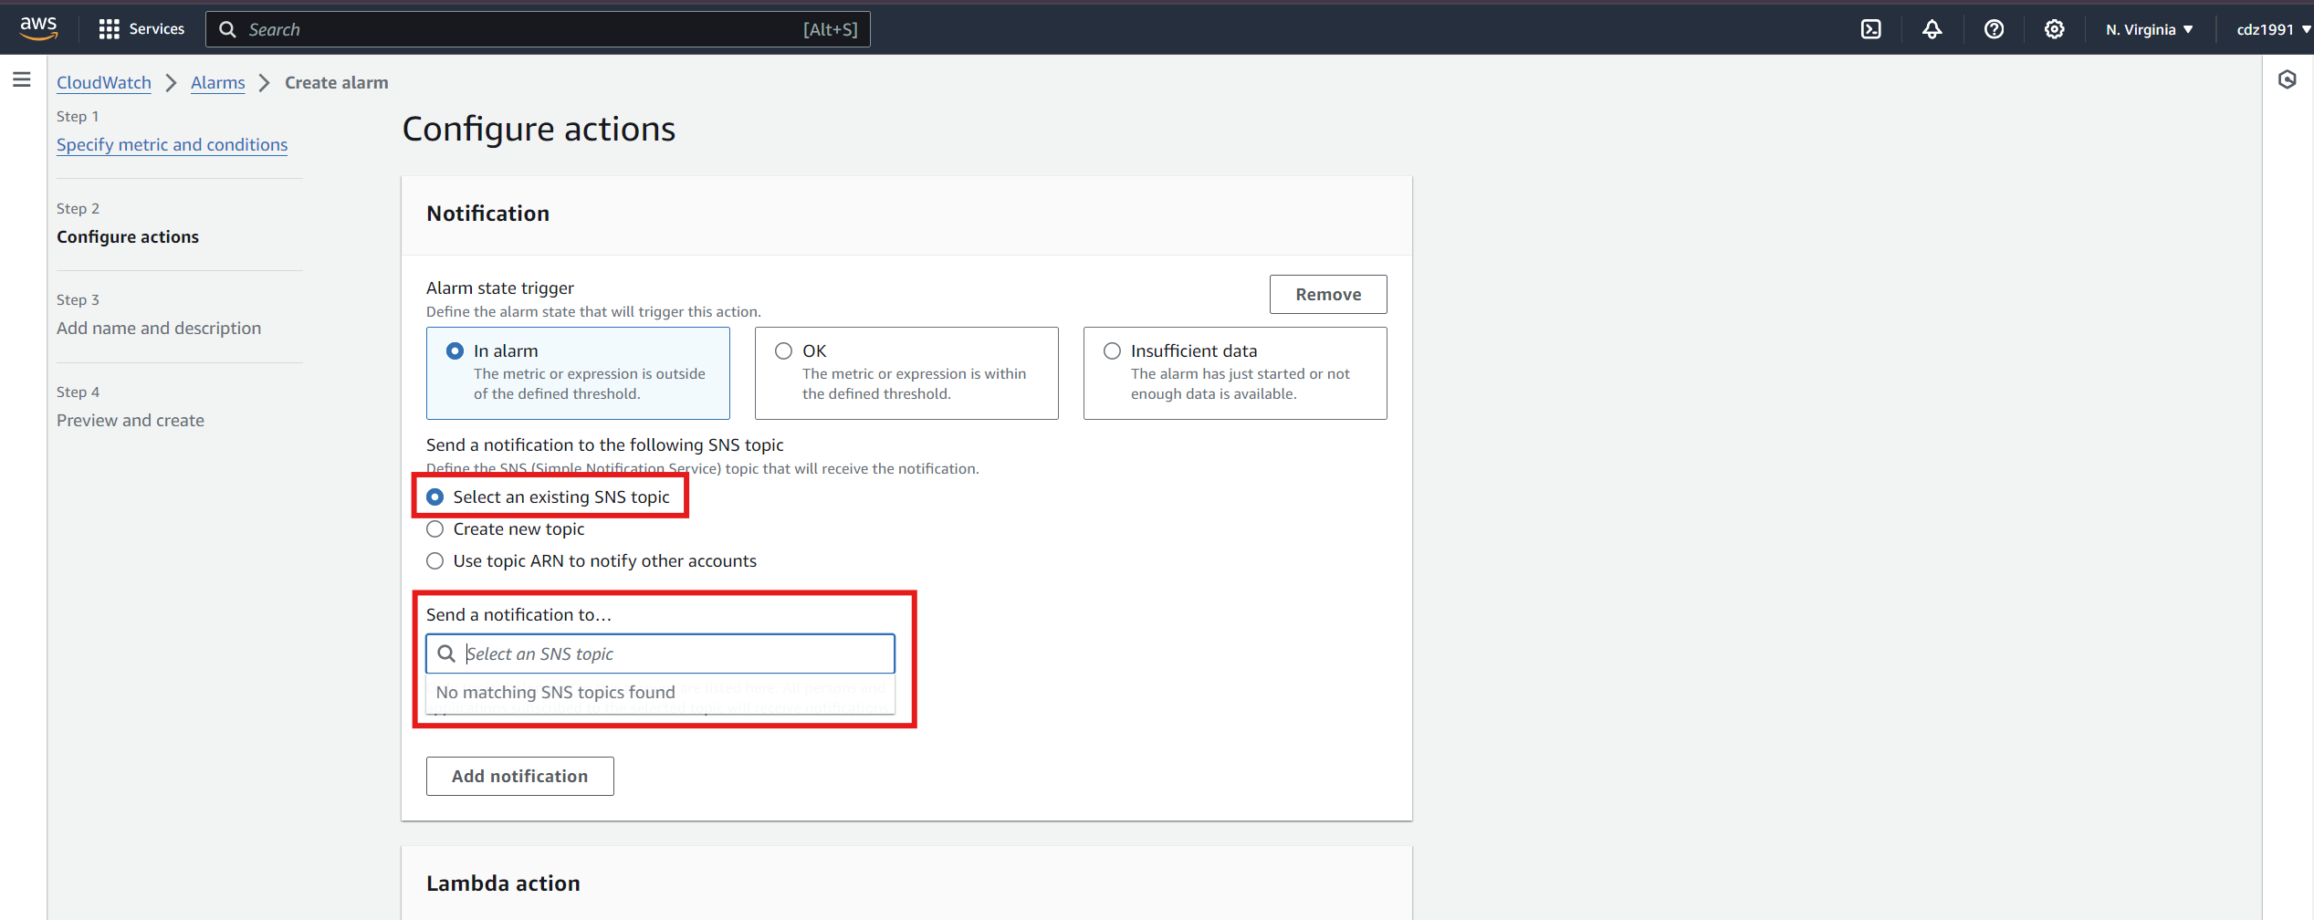

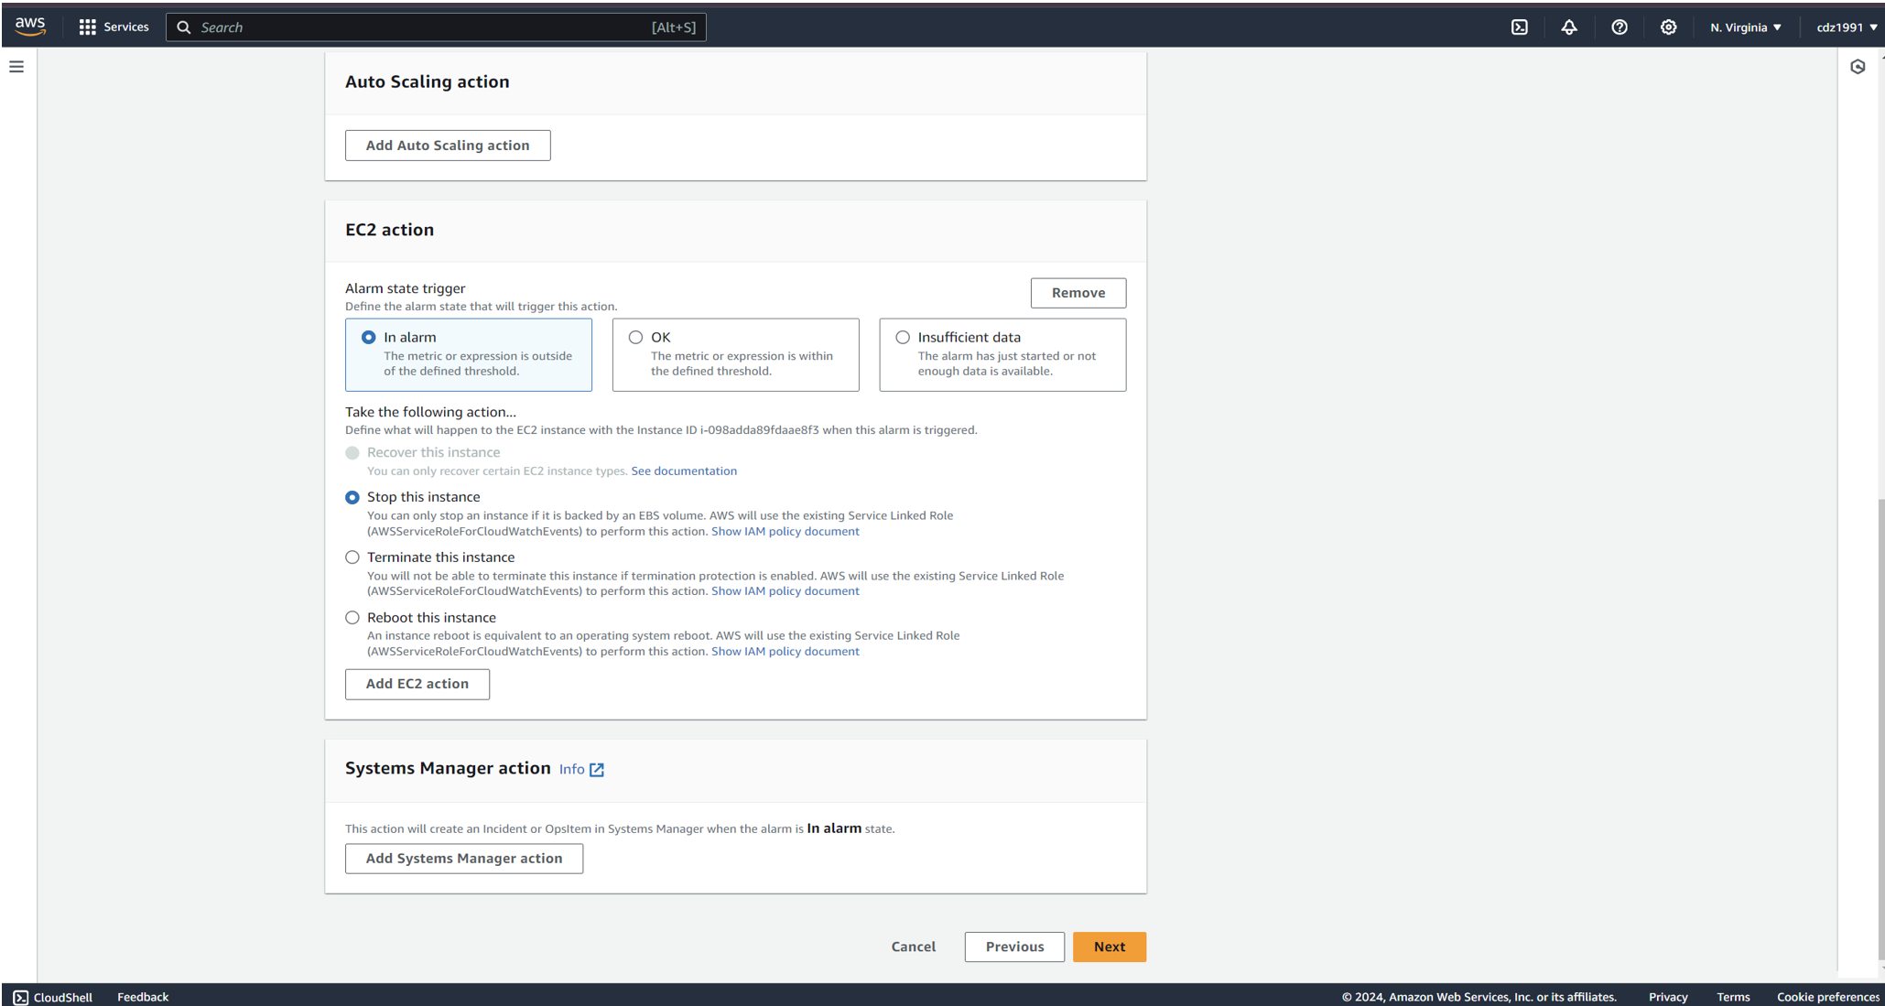

6. Create Alarm > Enter Instance ID > Set CPU Utilization Condition > Greater Than 50% for Both Instances

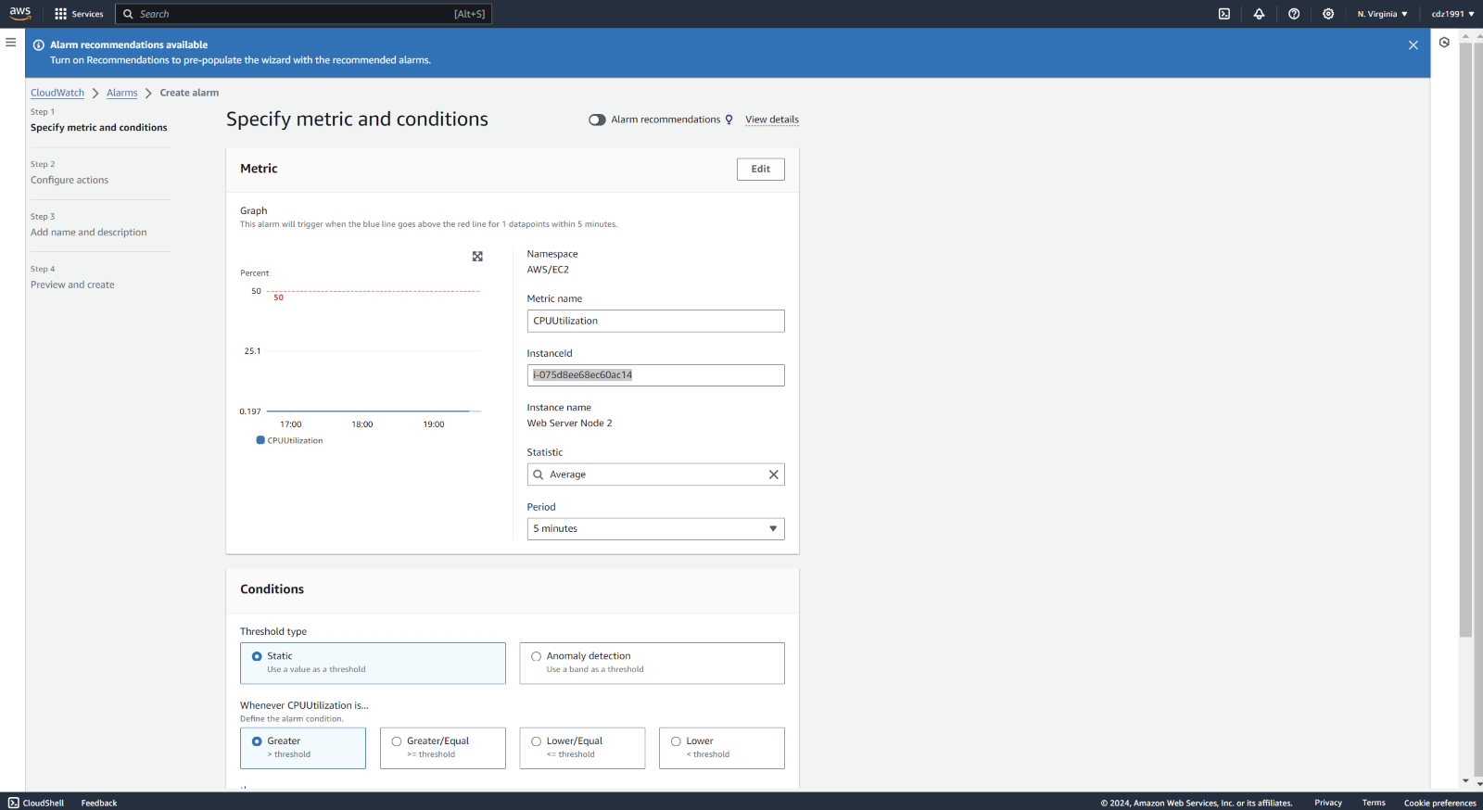

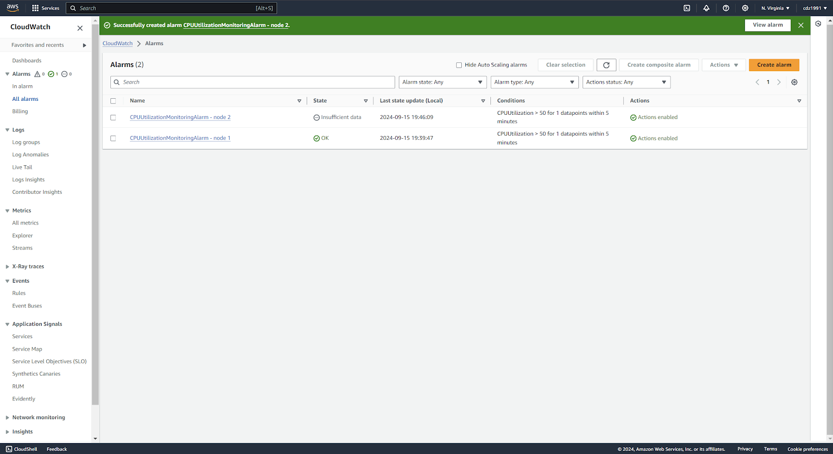

1. Below Commands are used to apply load on Web Server Node 1 and Web Server Node 2 instances.

sudo yum update –y -> Update all packages and dependencies on Linux Server.

sudo –i -> switch to root user

yes > /dev/null -> Used to apply Load on Server

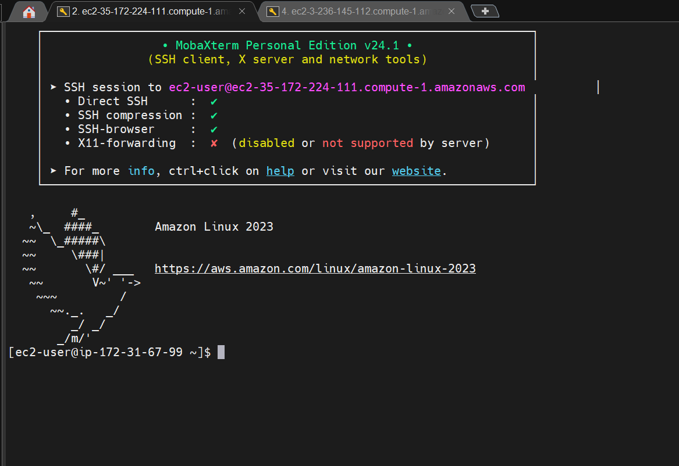

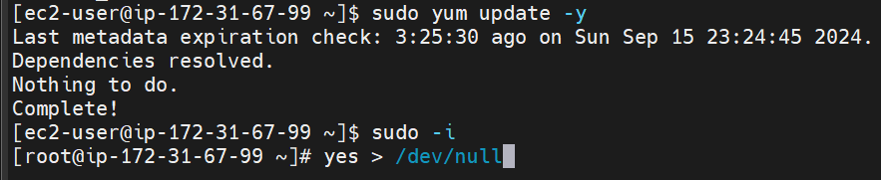  
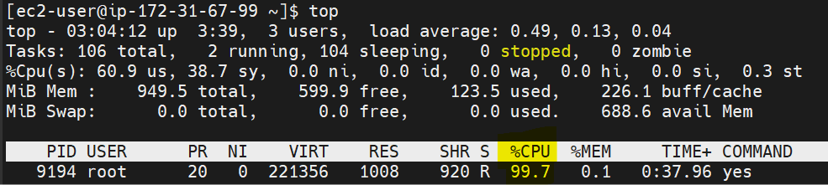

1. After Executing Linux Command monitor CPU Utilization in CloudWatch Alarm section.

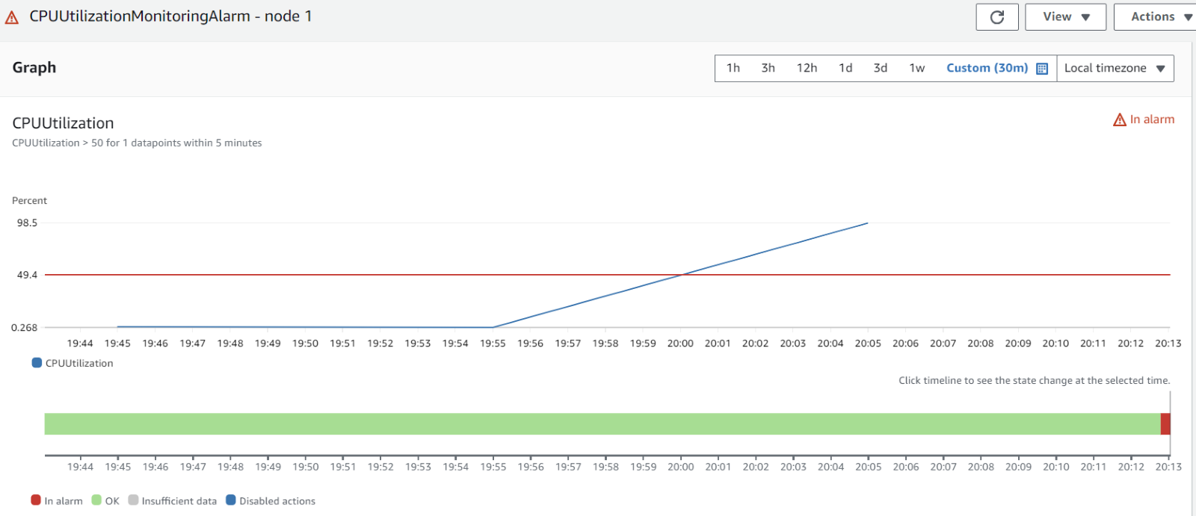

1. Once CPU Utilization Crosses the define limit it will trigger email and will receive below email notification from SNS.  
   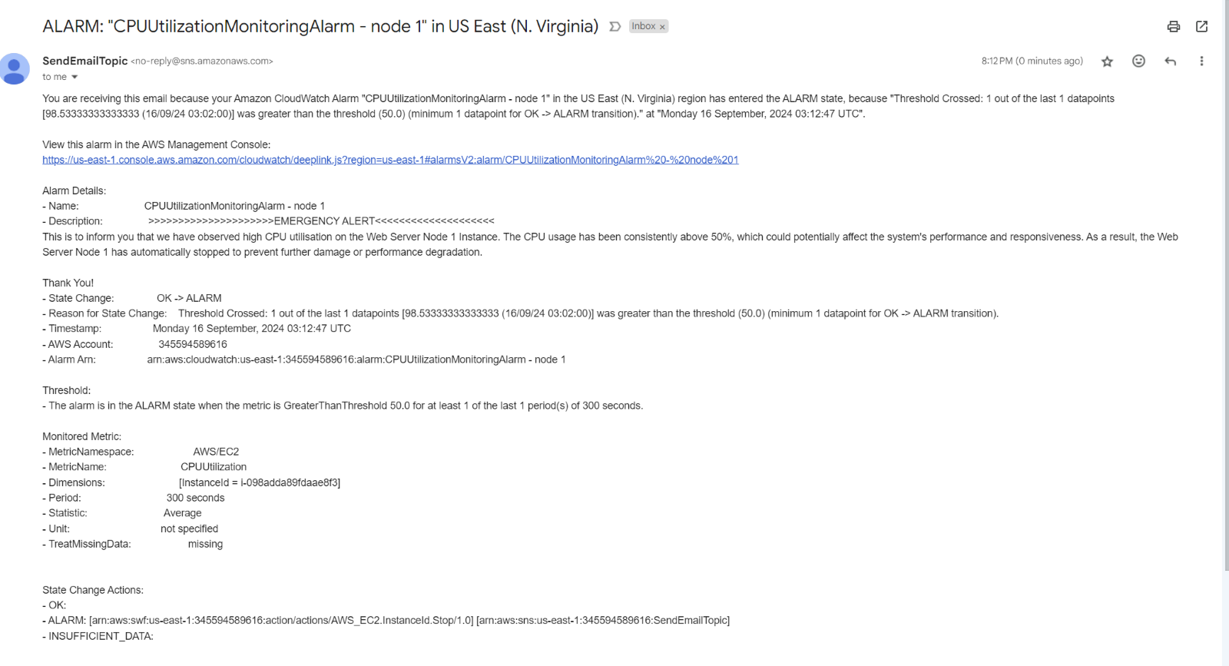

10. Once CPU Utilization crosses the define threshold limit then it will change the Alarm state to “In Alarm” and Both the Instances will stop.  
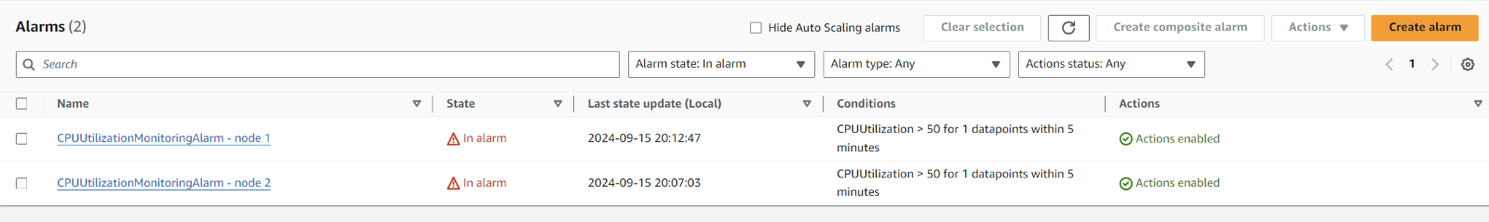  
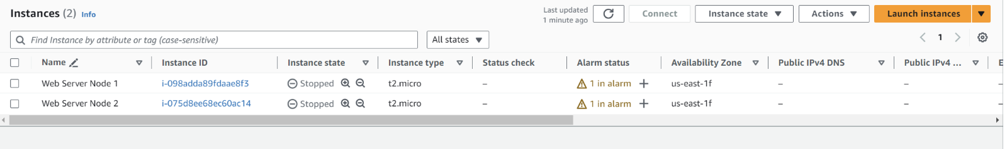

**5. AWS Services Used**

- Amazon EC2: For hosting the instance to monitor.  
- AWS CloudWatch: For monitoring CPU utilization and triggering alarms.  
- AWS SNS: For sending email notifications when the alarm is triggered.

**6. Future Enhancements**

In the future, this project can be enhanced by implementing:

- Auto-scaling based on CPU utilization to dynamically adjust resources.  
- Monitor CPU Utilization of EC 2 instances using auto scaling and trigger Alarm using CloudWatch and SNS notification.

**7. Conclusion**

This project demonstrates how to set up a CPU Utilization Alert System using AWS services like CloudWatch and SNS. It helps maintain resource efficiency and timely notifications to prevent system overloads or failures. With future enhancements, this setup can be extended to scale automatically and provide deeper insights into system performance.