Project Report

On

Water Supply management System

Acknowledgement

I would like to mention our sincere gratitude towards University/College, for giving us the opportunity to carry out our project.

I would like to express our heart full gratitude towards our guide, his/her invaluable advice for the successful completion of this dissertation.

I also like to extend our sincere thanks to the staff of University/College for their invaluable help and support.

Finally, I take this opportunity to mention our sincere thanks to one and all those who helped us directly or indirectly for the completion of our project.

Introduction

The Water Supply Management System (WSMS) is a web based application that can be accessed over the web. This system can be used to automate the workflow of water supply and their invoices.
The project has been planned to be having the view of distributed architecture, with centralized storage of the database. The application for the storage of the data has been planned. Using the constructs of MySQL Server and all the user interfaces has been designed using the PHP technologies. The database connectivity is planned using the “MySQL Connection” methodology. The standards of security and data protective mechanism have been given a big choice for proper usage. The application takes care of different modules and their associated reports, which are produced as per the applicable strategies and standards that are put forwarded by the administrative staff.

PURPOSE OF THE PROJECT

This project is aimed at developing a web based Water Supply management System Tool, which is of importance to either an small water supplier. This is an web based application that can be accessed over the web . This system can be used to automate the workflow of water supply and their invoices. There are features like water bottle booking, tracking,invoice, report generators etc. in this Tool.

SOLUTION OF THESE PROBLEMS

The development of the new system contains the following activities, which try to automate the entire process keeping in view of the database integration approach.

- User friendliness is provided in the application with various controls.
- The system makes the overall project management much easier and flexible.
- There is no risk of data mismanagement at any level while the project development is under process.
- It provides high level of security with different level of authentication.

- User friendliness is provided in the application with various controls.
- The system makes the overall project management much easier and flexible.
- There is no risk of data mismanagement at any level while the project development is under process.
- It provides high level of security with different level of authentication.

SYSTEM ANALYSIS

After analyzing the requirements of the task to be performed, the next step is to analyze the problem and understand its context. The first activity in the phase is studying the existing system and other is to understand the requirements and domain of the new system. Both the activities are equally important, but the first activity serves as a basis of giving the functional specifications and then successful design of the proposed system. Understanding the properties and requirements of a new system is more difficult and requires creative thinking and understanding of existing running system is also difficult, improper understanding of present system can lead diversion from solution.
ANALYSIS MODEL
The model that is basically being followed is the WATER FALL MODEL, which states that the phases are organized in a linear order. First of all the feasibility study is done. Once that part is over the requirement analysis and project planning begins. If system exists one and modification and addition of new module is needed, analysis of present system can be used as basic model.
The design starts after the requirement analysis is complete and the coding begins after the design is complete. Once the programming is completed, the testing is done. In this model the sequence of activities performed in a software development project are: -
- Requirement Analysis
- Project Planning
- System design
- Detail design
- Coding
- Unit testing
- System integration & testing

Here the linear ordering of these activities is critical. End of the phase and the output of one phase is the input of other phase. The output of each phase is to be consistent with the overall requirement of the system. Some of the qualities of spiral model are also incorporated like after the people concerned with the project review completion of each of the phase the work done.
WATER FALL MODEL was being chosen because all requirements were known beforehand and the objective of our software development is the computerization/automation of an already existing manual working system.
Communicated Requirements

Requirements Specification

Design Specification

Executable Software Modules

Integrated Software Product

Delivered Software Product

Changed Requirements

Requirements Engineering
Design
Programming
Integration
Delivery
Maintenance

STUDY OF THE SYSTEM

GUI’S
In the flexibility of the uses the interface has been developed a graphics concept in mind, associated through a browses interface. The GUI’S at the top level have been categorized as
- Administrative user interface
- The operational or generic user interface

The administrative user interface concentrates on the consistent information that is practically, part of the organizational activities and which needs proper authentication for the data collection. The interfaces help the administrations with all the transactional states like Data insertion, Data deletion and Date updation along with the extensive data search capabilities.
The operational or generic user interface helps the users upon the system in transactions through the existing data and required services. The operational user interface also helps the ordinary users in managing their own information helps the ordinary users in managing their own information in a customized manner as per the assisted flexibilities.

NUMBER OF MODULES

The system after careful analysis has been identified to be presented with the following modules:
It has two modules admin and user.

Admin

- Dashboard: In this section admin can see all detail in brief like total order, total new order, total accept order, total order deliver, total cancel order, total company and total register user.

- Water Bottle info: In this section admin can manage water bottle (Add/Update/Delete).

- Company Info: In this section admin can manage company (Add/Update/Delete).

- Pages: In this section admin can update about us and contact us information.

- Orders Management: In this section admin can view the order details and they have also right to change order status according to current status.
- Latest News/Updates: In this section admin can manage news (Add/Update/Delete).

- Reg Users: In this section admin can view register users and their orders.

- Search: In this section admin can search particular order with the help of order number / name/ mobile no.

- Reports: In this section admin can view order details, order counts and sales report according to dates.

Admin can also update his profile, change password and recover password.

User

1. Water Bottle: In this section user can view which drinking bottle available.

2. My Accounts: In this section user can change his/her own password, view and update his/her profile and logout from accounts.

3. My orders: In this section user can view order history after login.

4.Cart: In this section user can add their drinking bottle which he/her want to order.

5. User have also a facility to download his/her invoice and cancel order if he/her want to cancel.

Brief Information about homepage

On this page guest user can only view about us page, contact us page and which drinking bottle is available if anybody want to order the bottle they must registered.

HARDWARE SPEDIFICATIONS
HARDWARE REQUIREMENTS:

- PIV 2.8 GHz Processor and Above
- RAM 512MB and Above
- HDD 20 GB Hard Disk Space and Above

SOFTWARE REQUIREMENTS:

XAMPP

XAMPP is an easy to install Apache distribution containing MySQL, PHP and Perl.
XAMPP is really very easy to install and to use - just download, extract and start.

- WINDOWS OS (XP / 2000 / 200 Server / 2003 Server)
- Apache Server
- PHP 5.6 or Above Version
- phpMyAdmin 4.7.9
- MySQL

Programming Language

- HTML
- CSS
- JQuery
- PHP
- MYSQL

Feasibility Report
Preliminary investigation examine project feasibility, the likelihood the system will be useful to the organization. The main objective of the feasibility study is to test the Technical, Operational and Economical feasibility for adding new modules and debugging old running system. All system is feasible if they are unlimited resources and infinite time. There are aspects in the feasibility study portion of the preliminary investigation:
- Technical Feasibility
- Operation Feasibility
- Economical Feasibility

Technical Feasibility
The technical issue usually raised during the feasibility stage of the investigation includes the following:
- Does the necessary technology exist to do what is suggested?
- Do the proposed equipments have the technical capacity to hold the data required to use the new system?
- Will the proposed system provide adequate response to inquiries, regardless of the number or location of users?
- Can the system be upgraded if developed?
- Are there technical guarantees of accuracy, reliability, ease of access and data security?
Earlier no system existed to cater to the needs of ‘Secure Infrastructure Implementation System’. The current system developed is technically feasible. It is a web based user interface. Thus it provides an easy access to the users. The database’s purpose is to create, establish and maintain a workflow among various entities in order to facilitate all concerned users in their various capacities or roles. Permission to the users would be granted based on the roles specified. Therefore, it provides the technical guarantee of accuracy, reliability and security. The software and hard requirements for the development of this project are not many and are available as free as open source. The work for the project is done with the current equipment and existing software technology. Necessary bandwidth exists for providing a fast feedback to the users irrespective of the number of users using the system.

Operational Feasibility
Proposed projects are beneficial only if they can be turned out into information system. That will meet the organization’s operating requirements. Operational feasibility aspects of the project are to be taken as an important part of the project implementation. Some of the important issues raised are to test the operational feasibility of a project includes the following: -
- Is there sufficient support for the management from the users?
- Will the system be used and work properly if it is being developed and implemented?
- Will there be any resistance from the user that will undermine the possible application benefits?

This system is targeted to be in accordance with the above-mentioned issues. Beforehand, the management issues and user requirements have been taken into consideration. So there is no question of resistance from the users that can undermine the possible application benefits.
The well-planned design would ensure the optimal utilization of the computer resources and would help in the improvement of performance status.
Economic Feasibility
A system can be developed technically and that will be used if installed must still be a good investment for the organization. In the economical feasibility, the development cost in creating the system is evaluated against the ultimate benefit derived from the new systems. Financial benefits must equal or exceed the costs.
The system is economically feasible. It does not require any addition hardware or software. Since the interface for this system is developed using the existing resources and technologies. There is nominal expenditure and economical feasibility for certain.

SYSTEM DESIGN

INTRODUCTION

Software design sits at the technical kernel of the software engineering process and is applied regardless of the development paradigm and area of application. Design is the first step in the development phase for any engineered product or system. The designer’s goal is to produce a model or representation of an entity that will later be built. Beginning, once system requirement have been specified and analyzed, system design is the first of the three technical activities -design, code and test that is required to build and verify software.
The importance can be stated with a single word “Quality”. Design is the place where quality is fostered in software development. Design provides us with representations of software that can assess for quality. Design is the only way that we can accurately translate a customer’s view into a finished software product or system. Software design serves as a foundation for all the software engineering steps that follow. Without a strong design we risk building an unstable system – one that will be difficult to test, one whose quality cannot be assessed until the last stage.
During design, progressive refinement of data structure, program structure, and procedural details are developed reviewed and documented. System design can be viewed from either technical or project management perspective. From the technical point of view, design is comprised of four activities – architectural design, data structure design, interface design and procedural design.

Use Case Diagram Admin

Dashboard
Manage Company (Add / Update/Delete)

()
()
Manage Water Bottles (add / update/Delete)
()
Manage Pages
View Reg. users
Search
Order management
Manage Own Profile
Change Password
Sign in

Use Case Diagram User

View Website
Make Order
()
Signup
Sign in
Manage own Profile

()
()
My Cart
My Order
View order Invoice
Manage Own Profile
Change Password

E – R DIAGRAMS
  - The relation upon the system is structure through a conceptual ER-Diagram, which not only specifics the existential entities but also the standard relations through which the system exists and the cardinalities that are necessary for the system state to continue.
  - The entity Relationship Diagram (ERD) depicts the relationship between the data objects. The ERD is the notation that is used to conduct the date modeling activity the attributes of each data object noted is the ERD can be described resign a data object descriptions.
  - The set of primary components that are identified by the ERD are
Data object Relationships
Attributes Various types of indicators.
The primary purpose of the ERD is to represent data objects and their relationships.

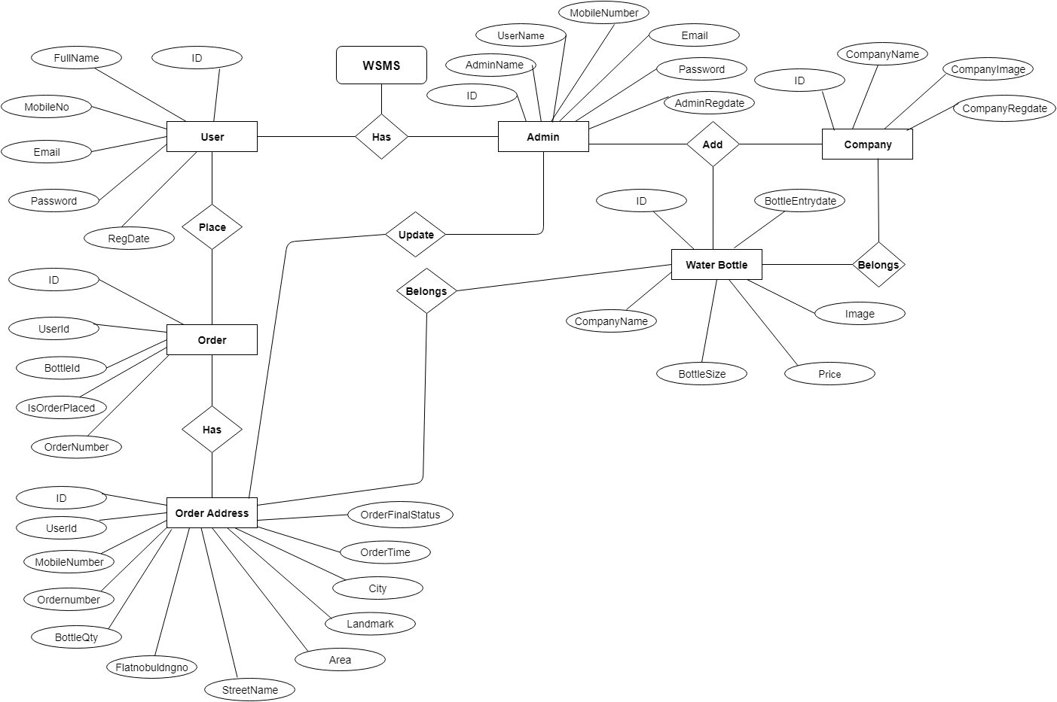

Class Diagram:
A description of set of objects that share the same attributes operations, relationships, and semantics

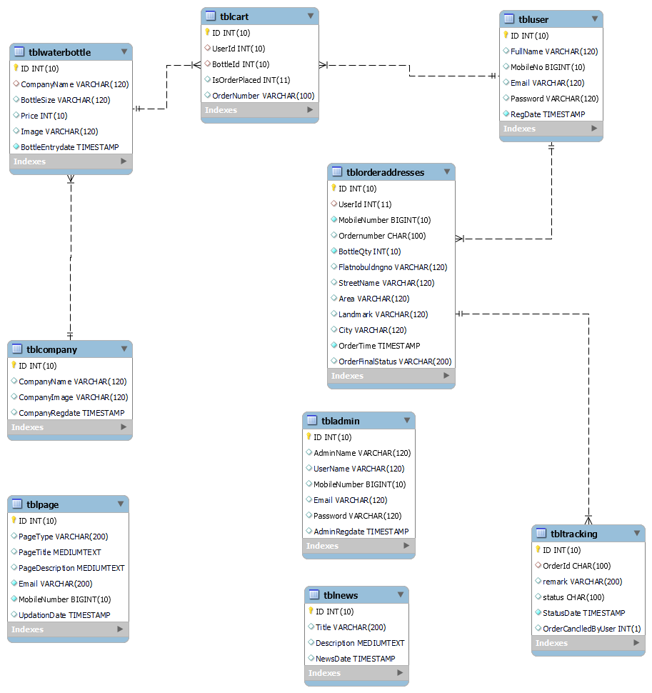

Data Flow Diagram
DFD graphically representing the functions, or processes, which capture, manipulate, store, and distribute data between a system and its environment and between components of a system. The visual representation makes it a good communication tool between User and System designer. Structure of DFD allows starting from a broad overview and expand it to a hierarchy of detailed diagrams. DFD has often been used due to the following reasons:
- Logical information flow of the system
- Determination of physical system construction requirements
- Simplicity of notation
- Establishment of manual and automated systems requirements

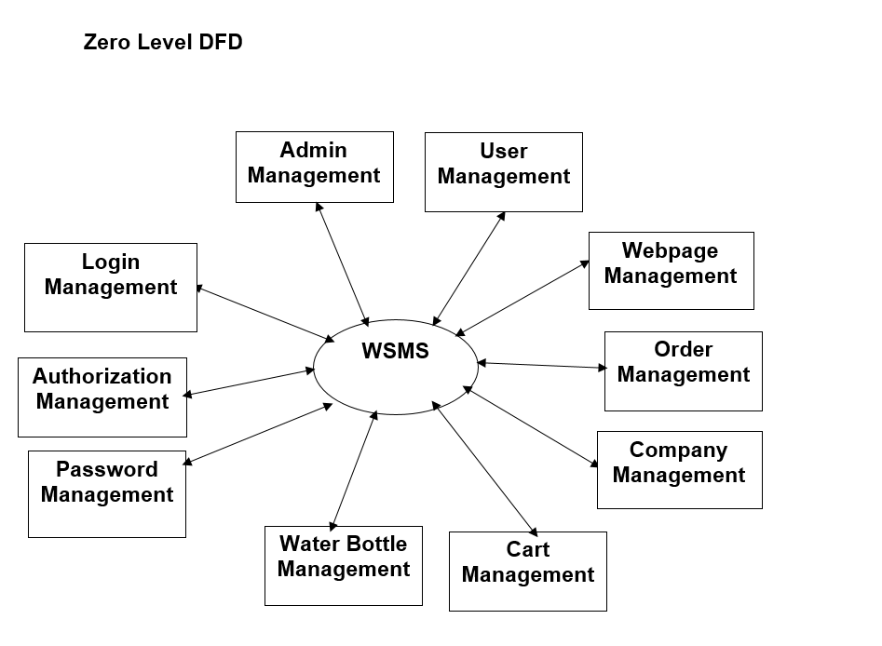

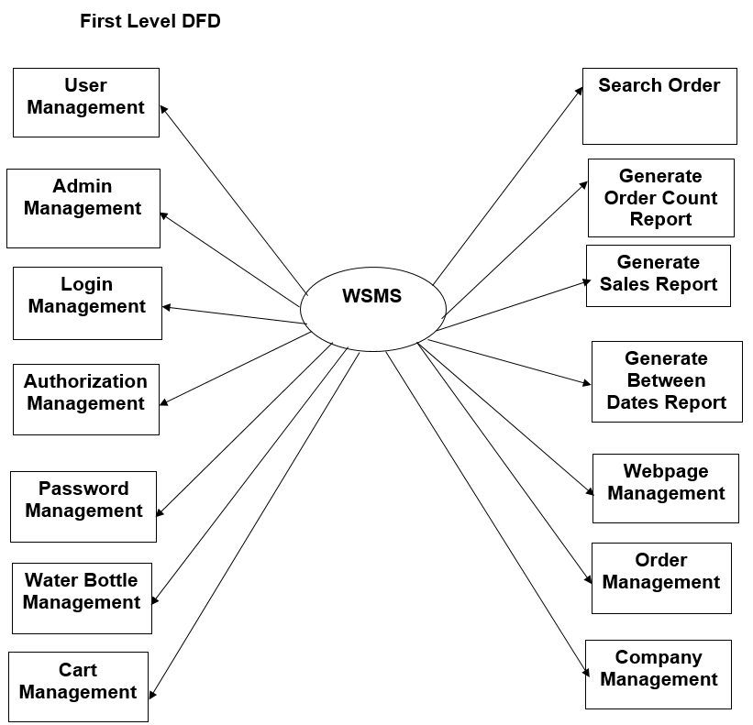

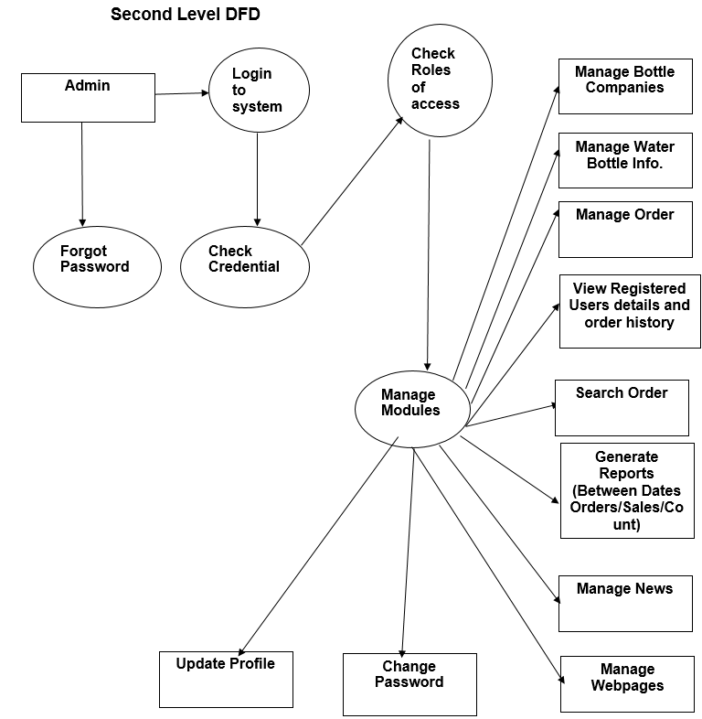

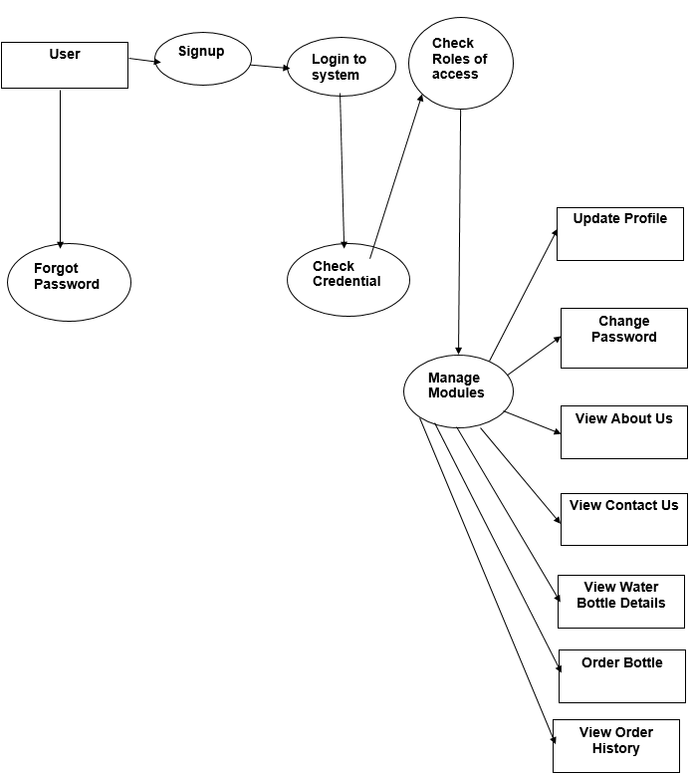

Database Design

The data in the system has to be stored and retrieved from database. Designing the database is part of system design. Data elements and data structures to be stored have been identified at analysis stage. They are structured and put together to design the data storage and retrieval system.

A database is a collection of interrelated data stored with minimum redundancy to serve many users quickly and efficiently. The general objective is to make database access easy, quick, inexpensive and flexible for the user. Relationships are established between the data items and unnecessary data items are removed. Normalization is done to get an internal consistency of data and to have minimum redundancy and maximum stability. This ensures minimizing data storage required, minimizing chances of data inconsistencies and optimizing for updates. The MySQL database has been chosen for developing the relevant databases.
Water Supply Management System (elms) contains 9 MySQL tables :
- tbladmin
- tblcompany
- tblwaterbottle
- tbluser
- tblcart
- tblorderaddresses
- tbltracking
- tblpage
- tblnews
tbladmin : This table stores admin login details
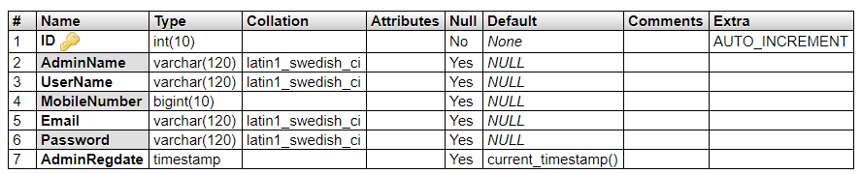
tbladmin : This table stores company details
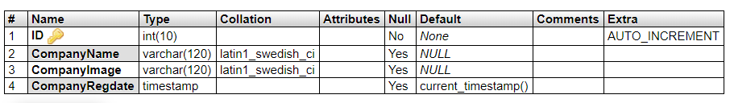
tblwaterbottle: This table stores water bootle details
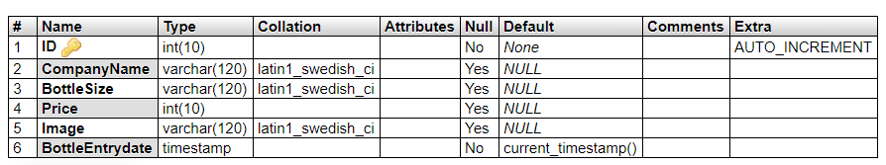
tbluser : This table stores user details.
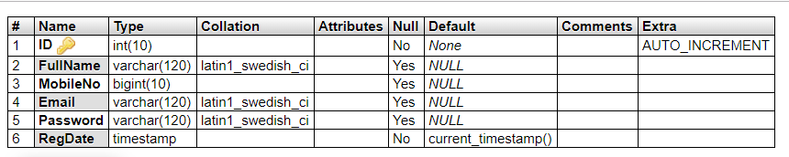
tblcart: This table store order details like (Userid, Product id, Billing number, order date).
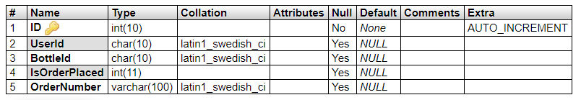

tblorderaddresses : This table stores the delivery address.
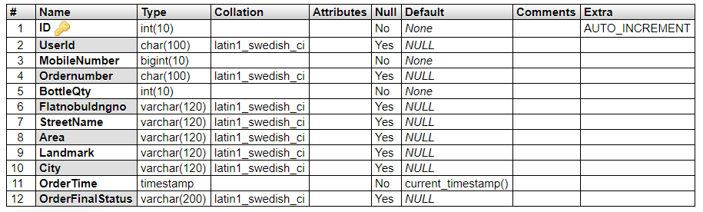
tbltracking : This table store order tracking details.
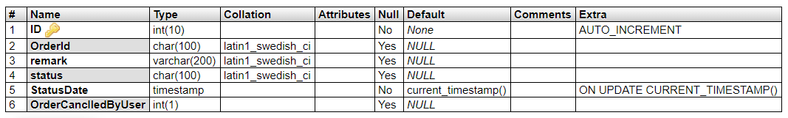
tblpage: This table stores the pages info.
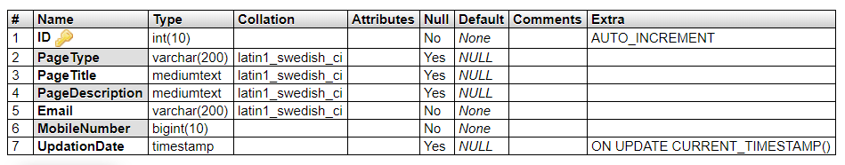
tblnews : This table stores latest news.
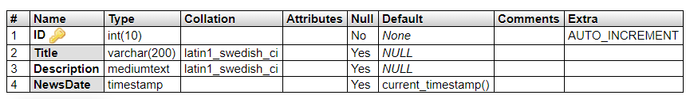

MySQL Tables Relationship

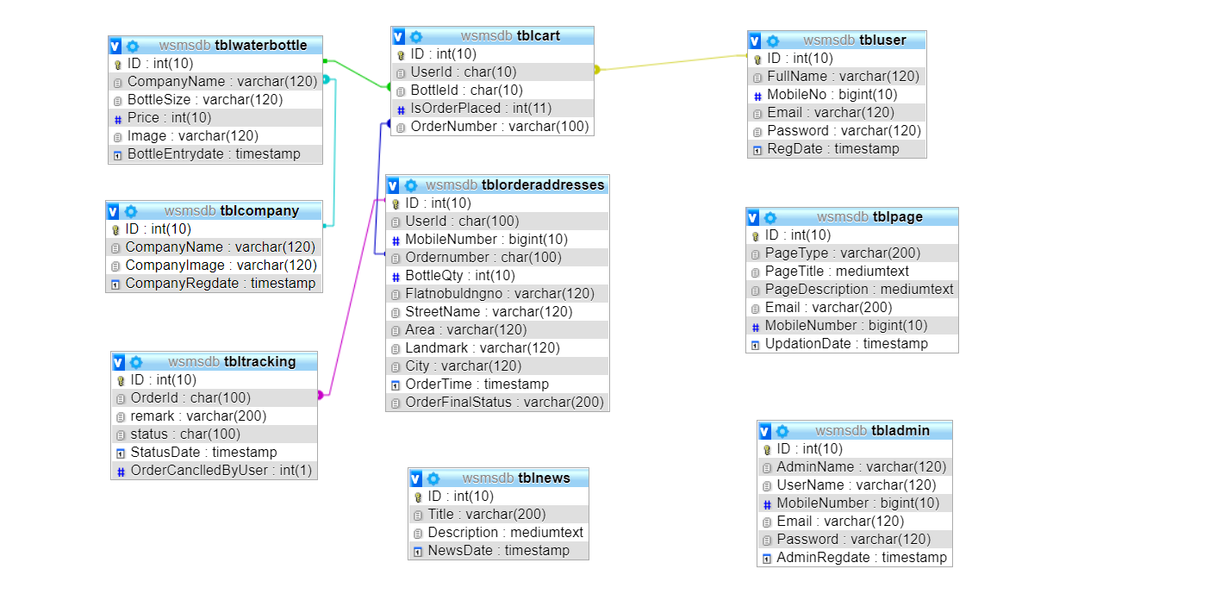

Output Screens

Home Page

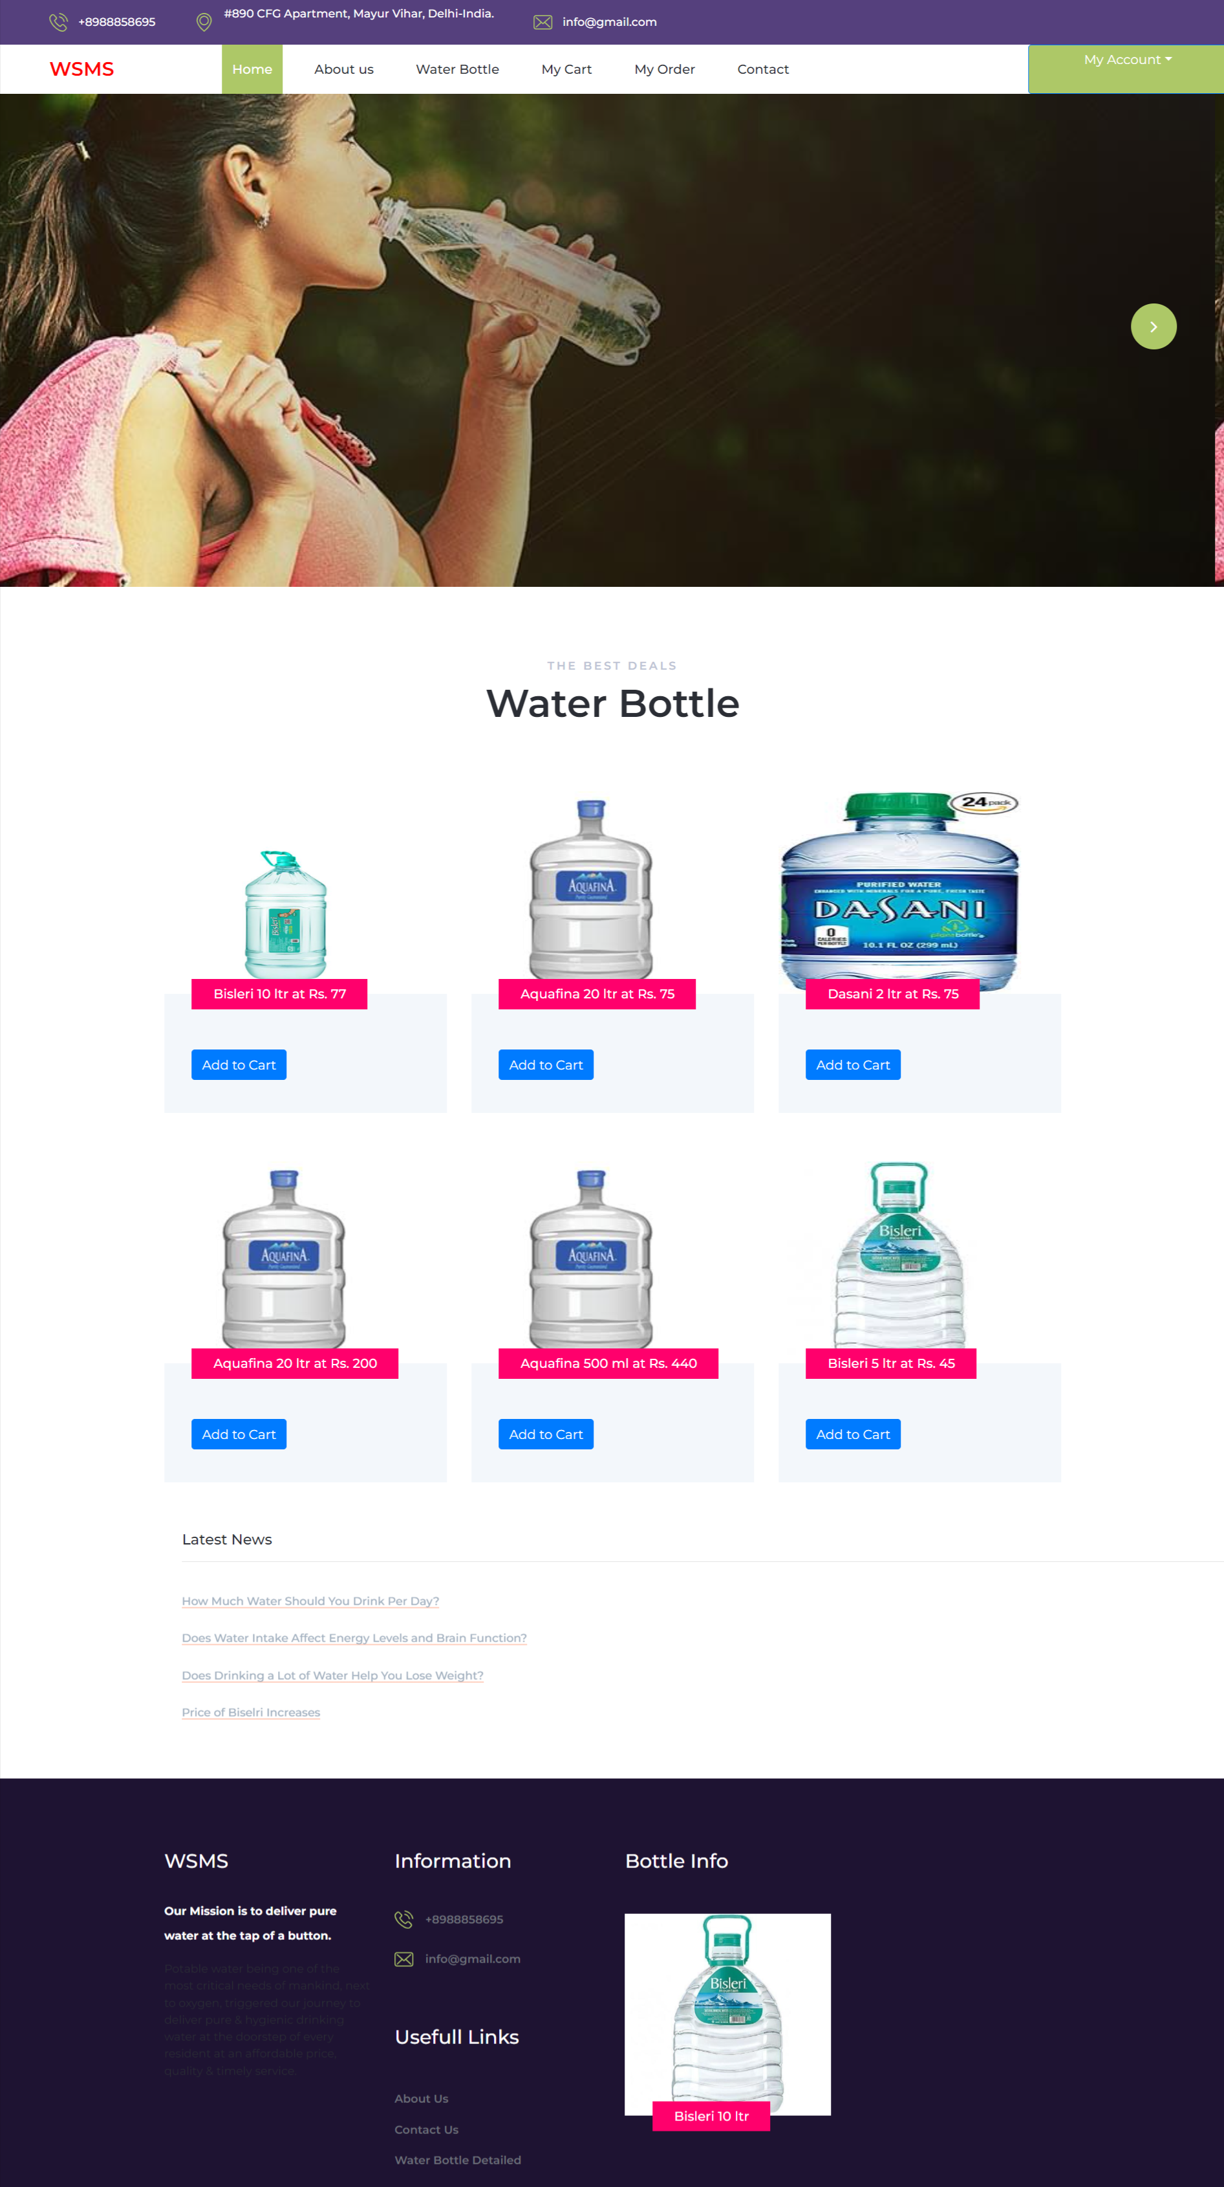

User Panel

Signup Page

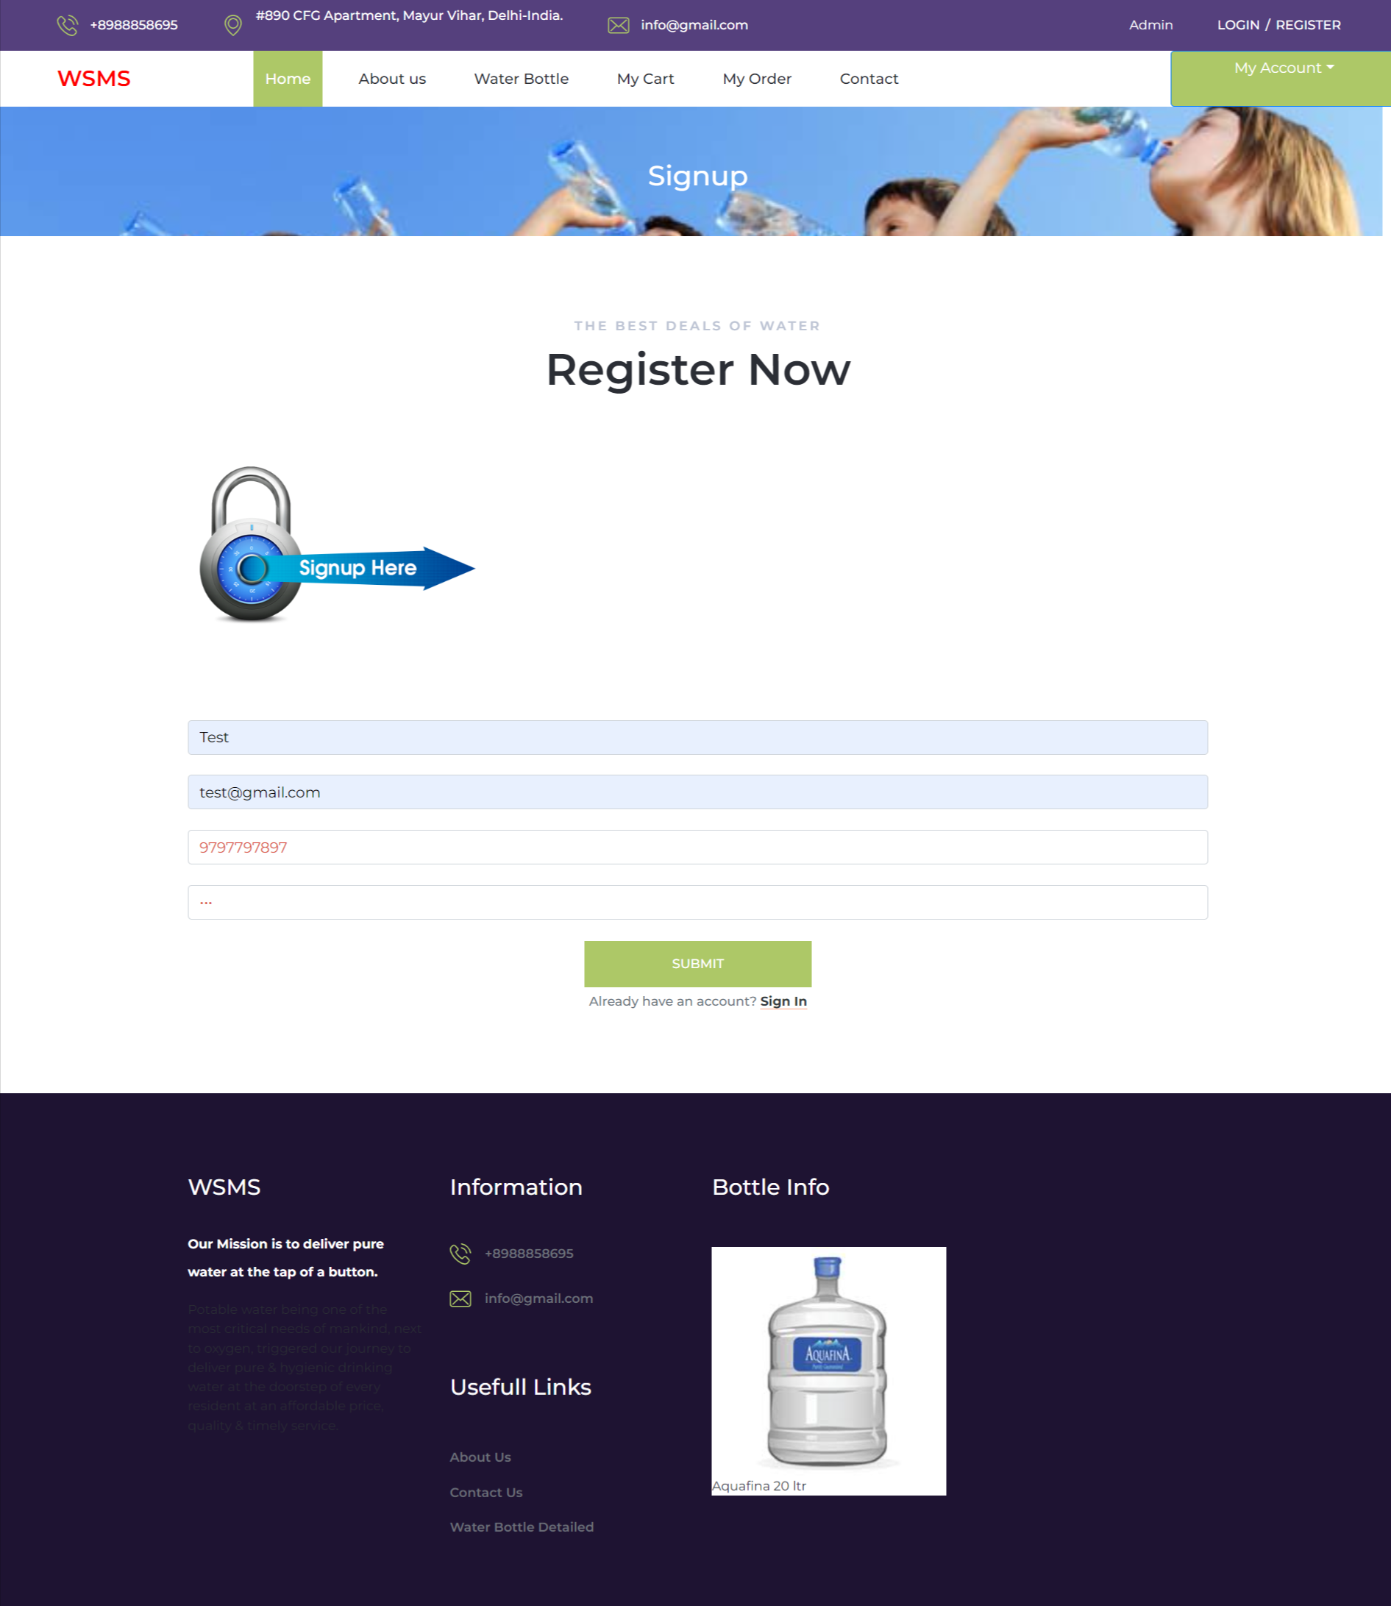

Login Page

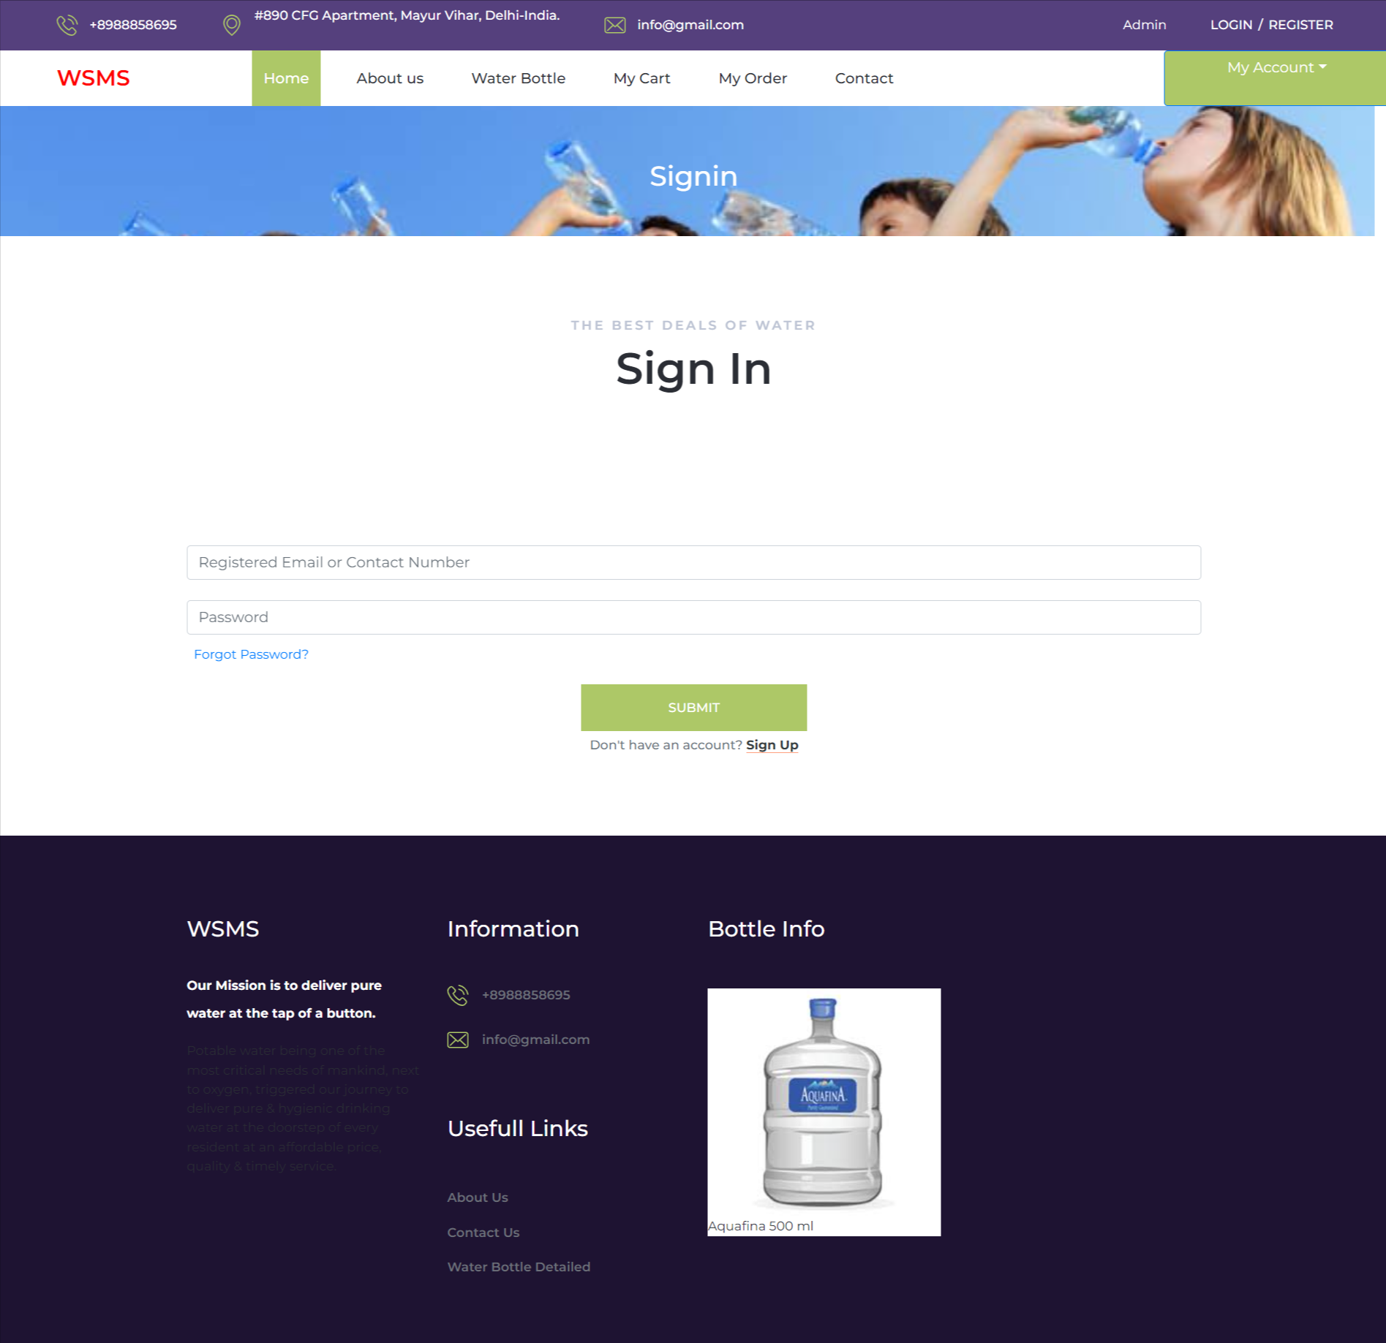

Forgot Password

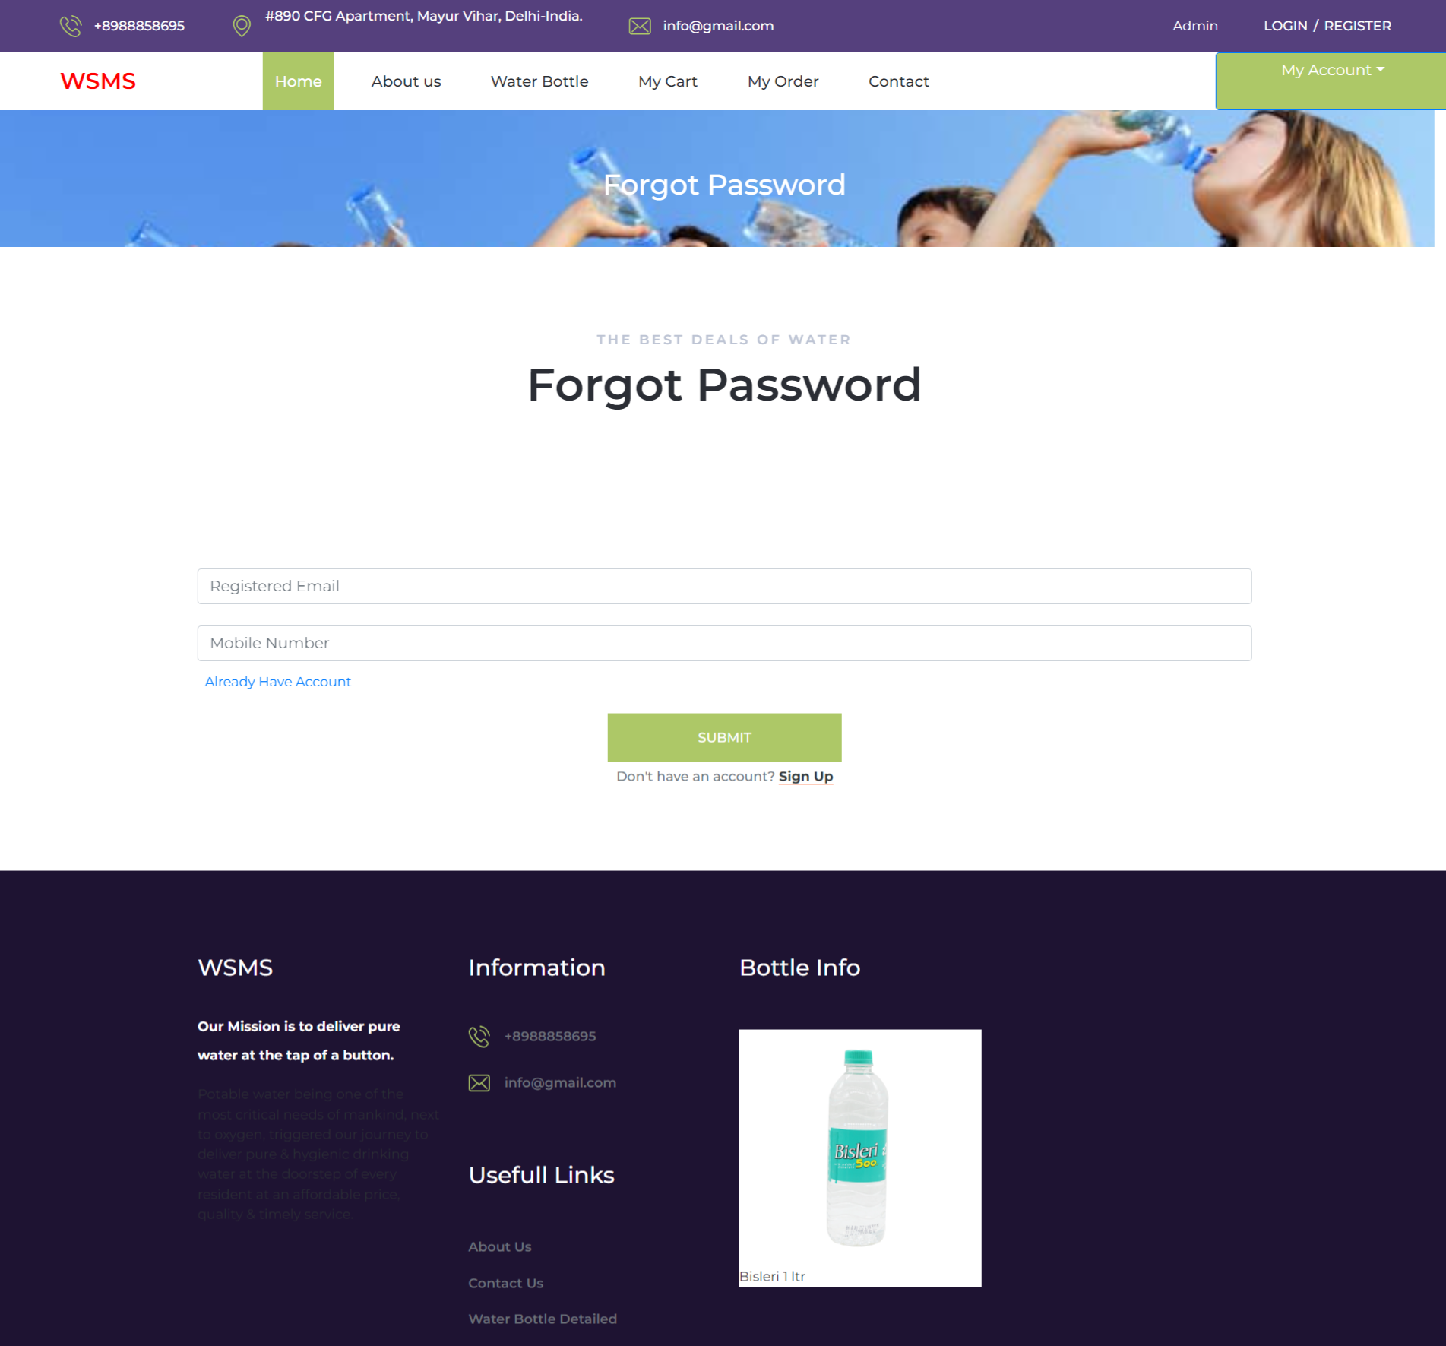

Reset Password

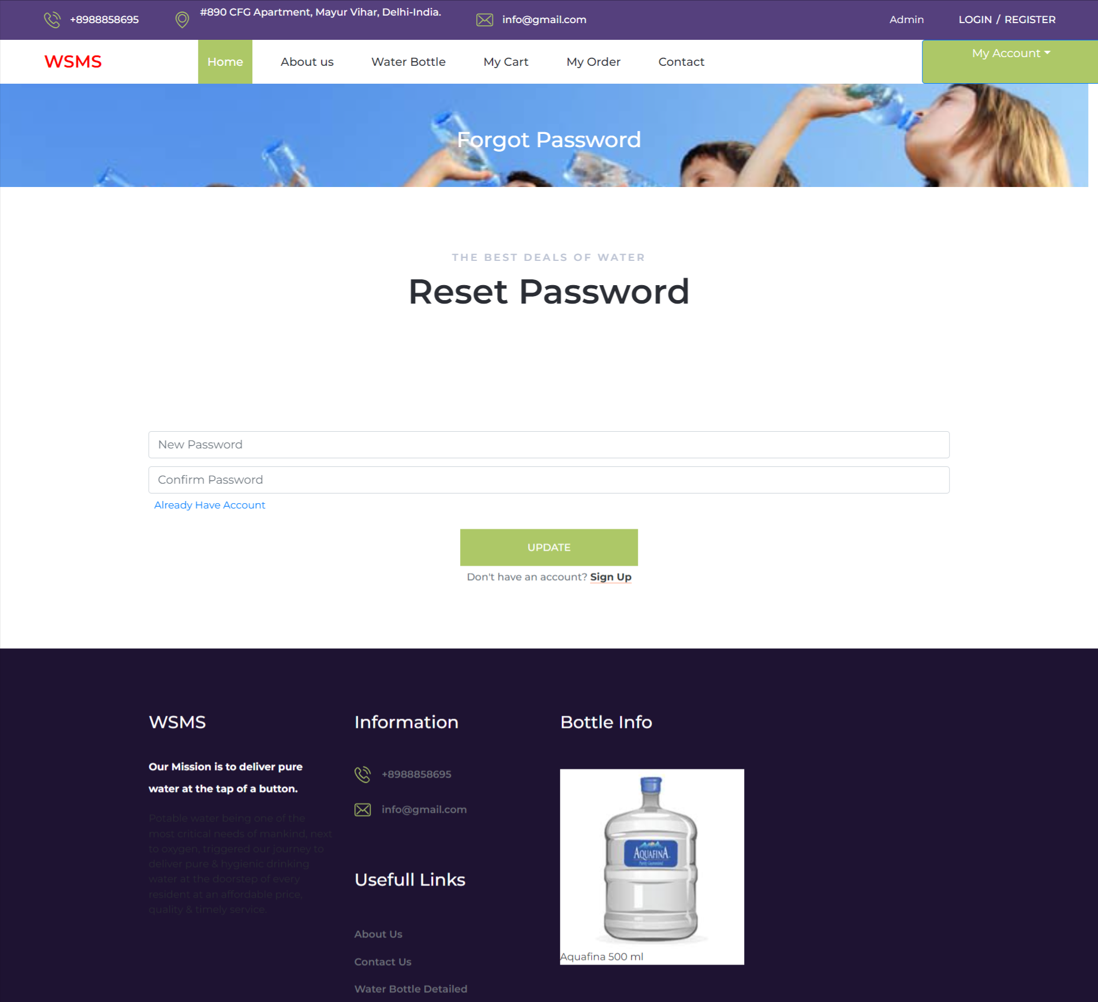

News Details

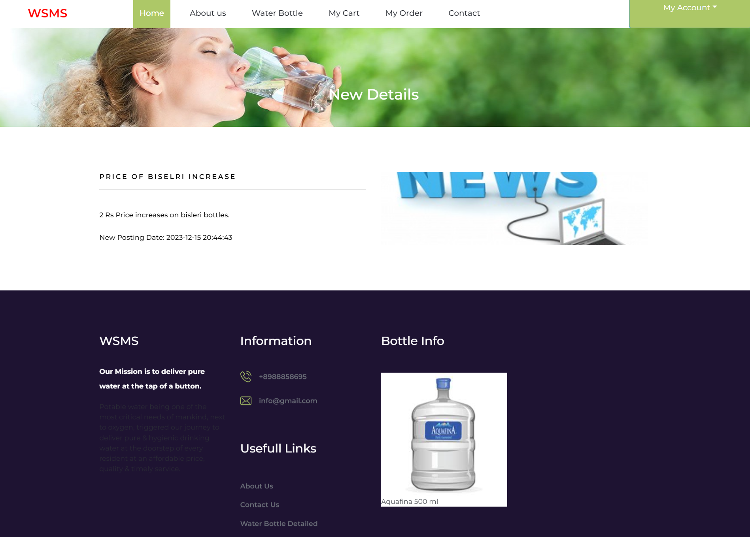

Profile

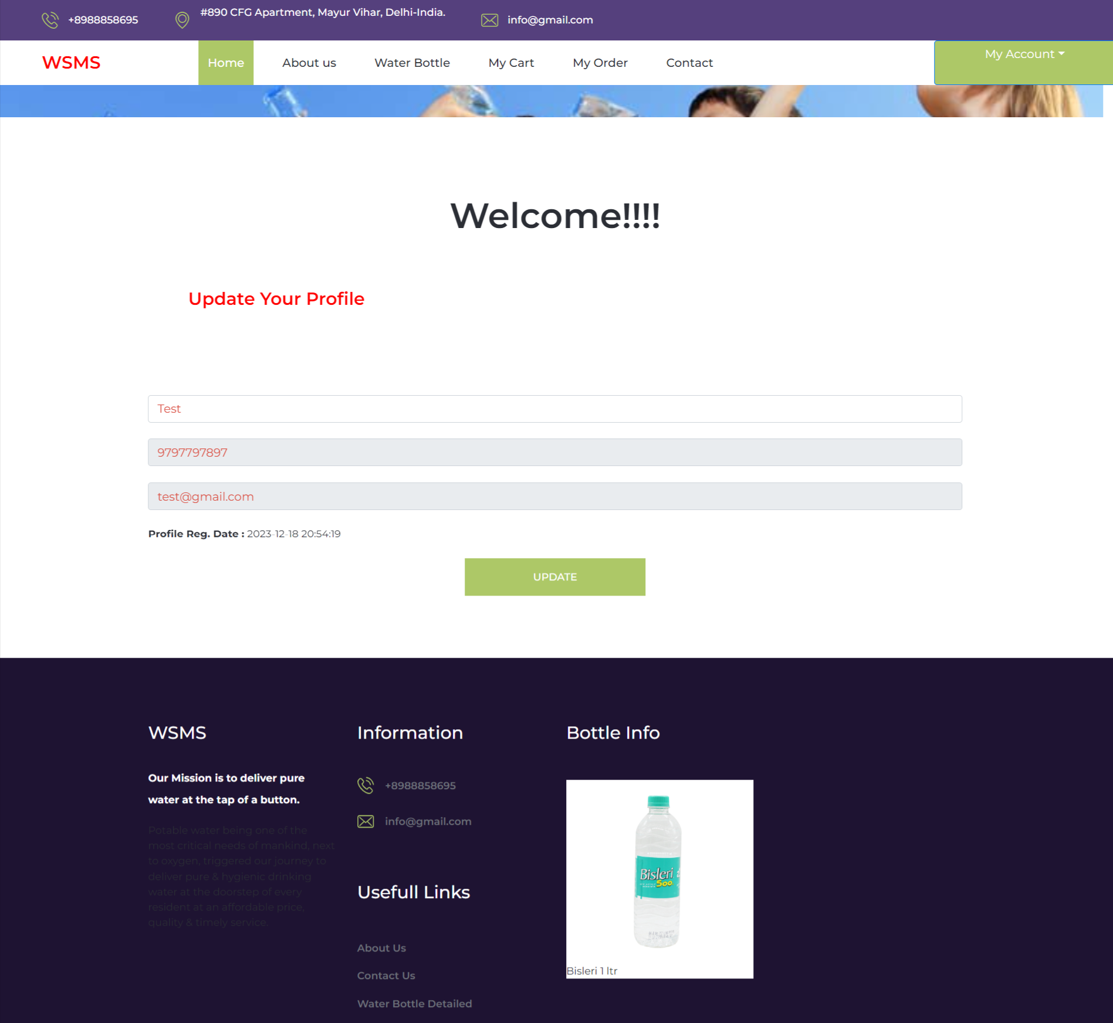

Change Password

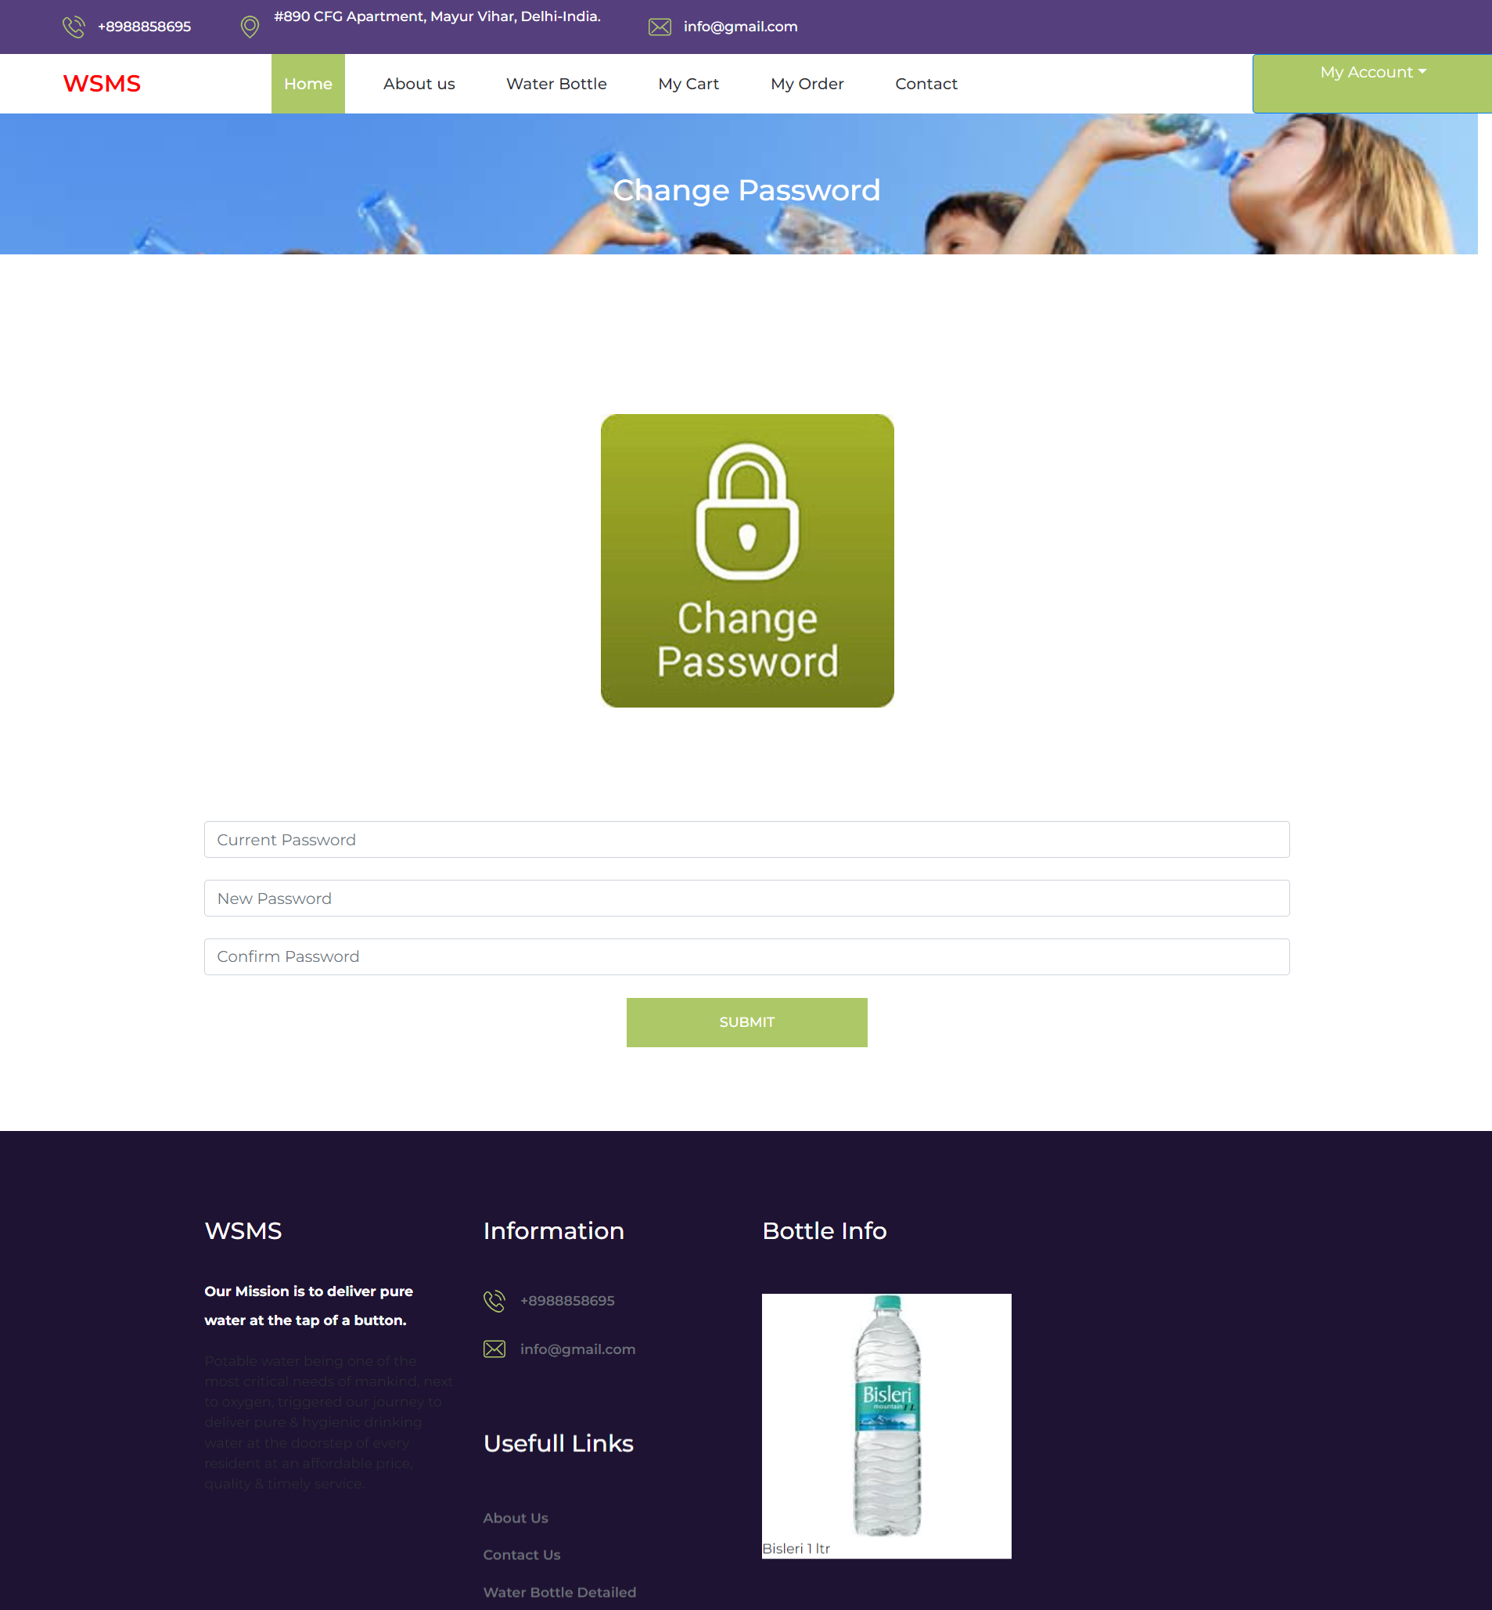

Cart Page

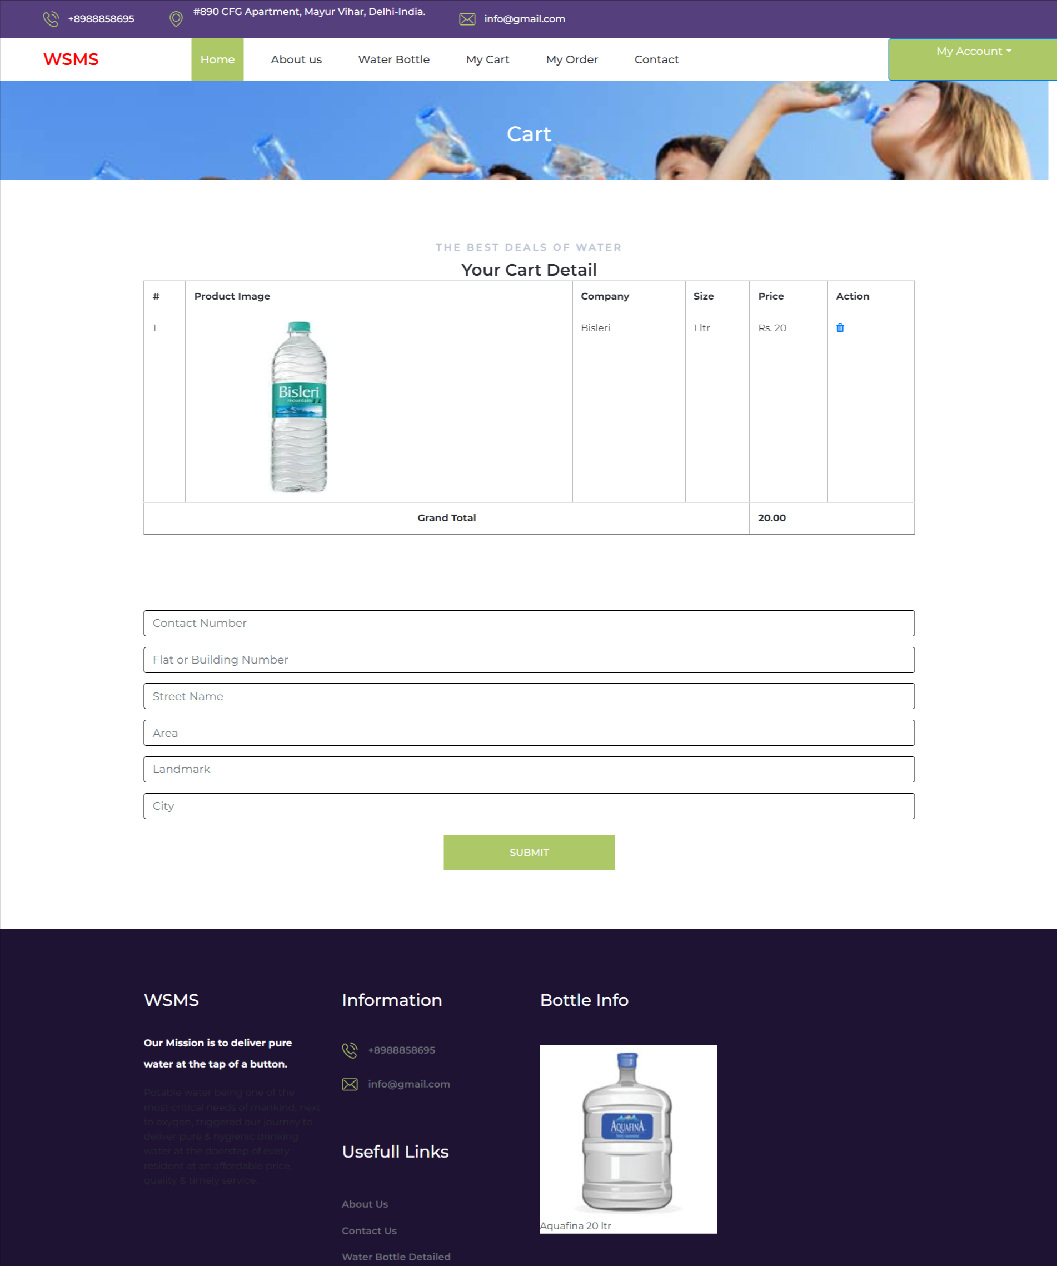

Order Page

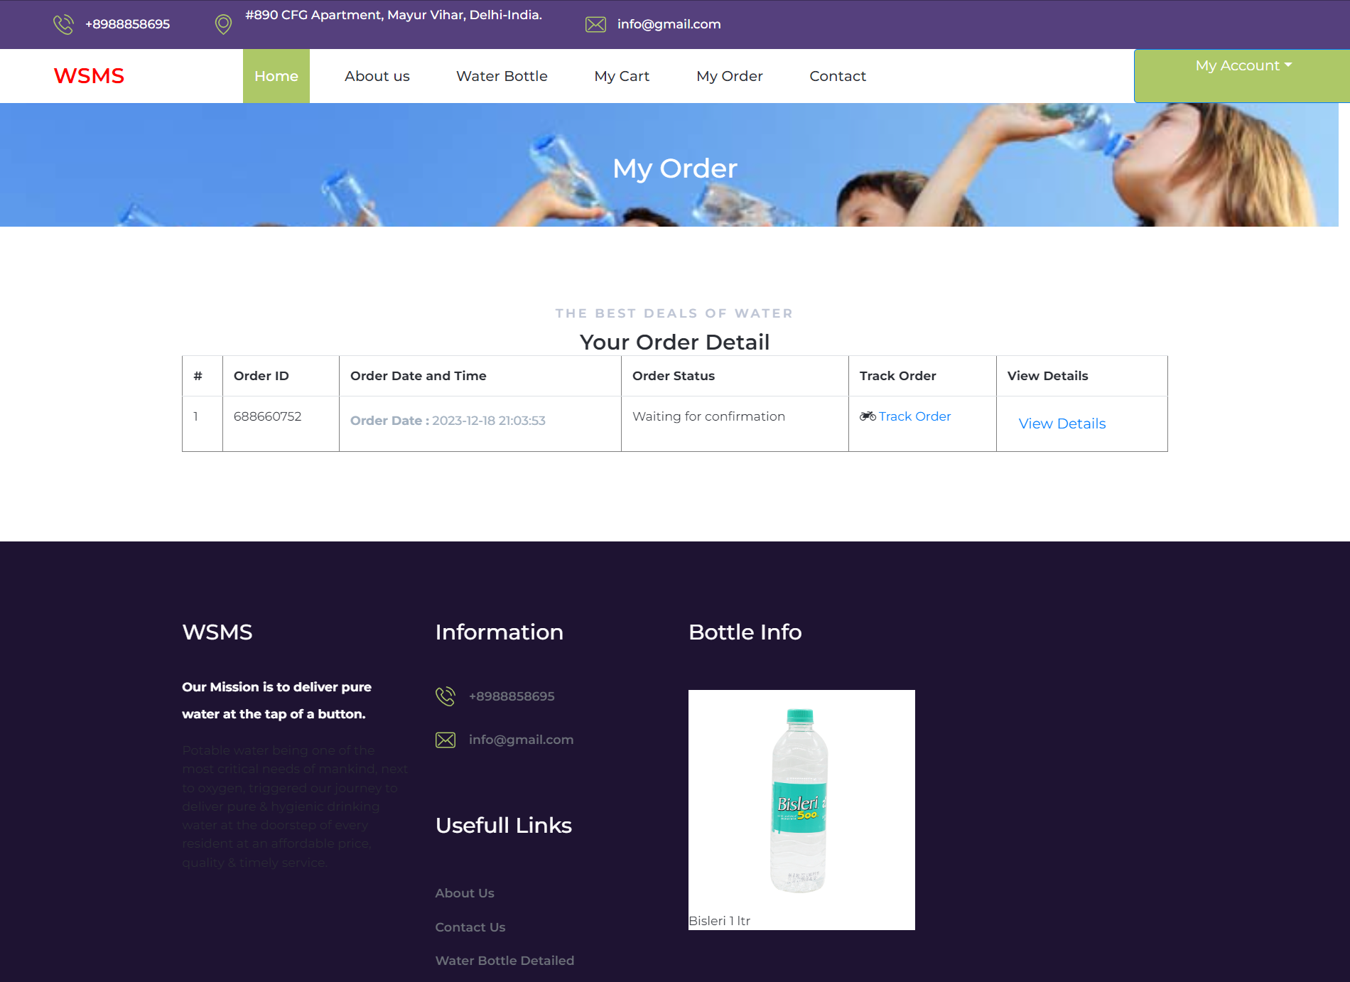

View Order Details
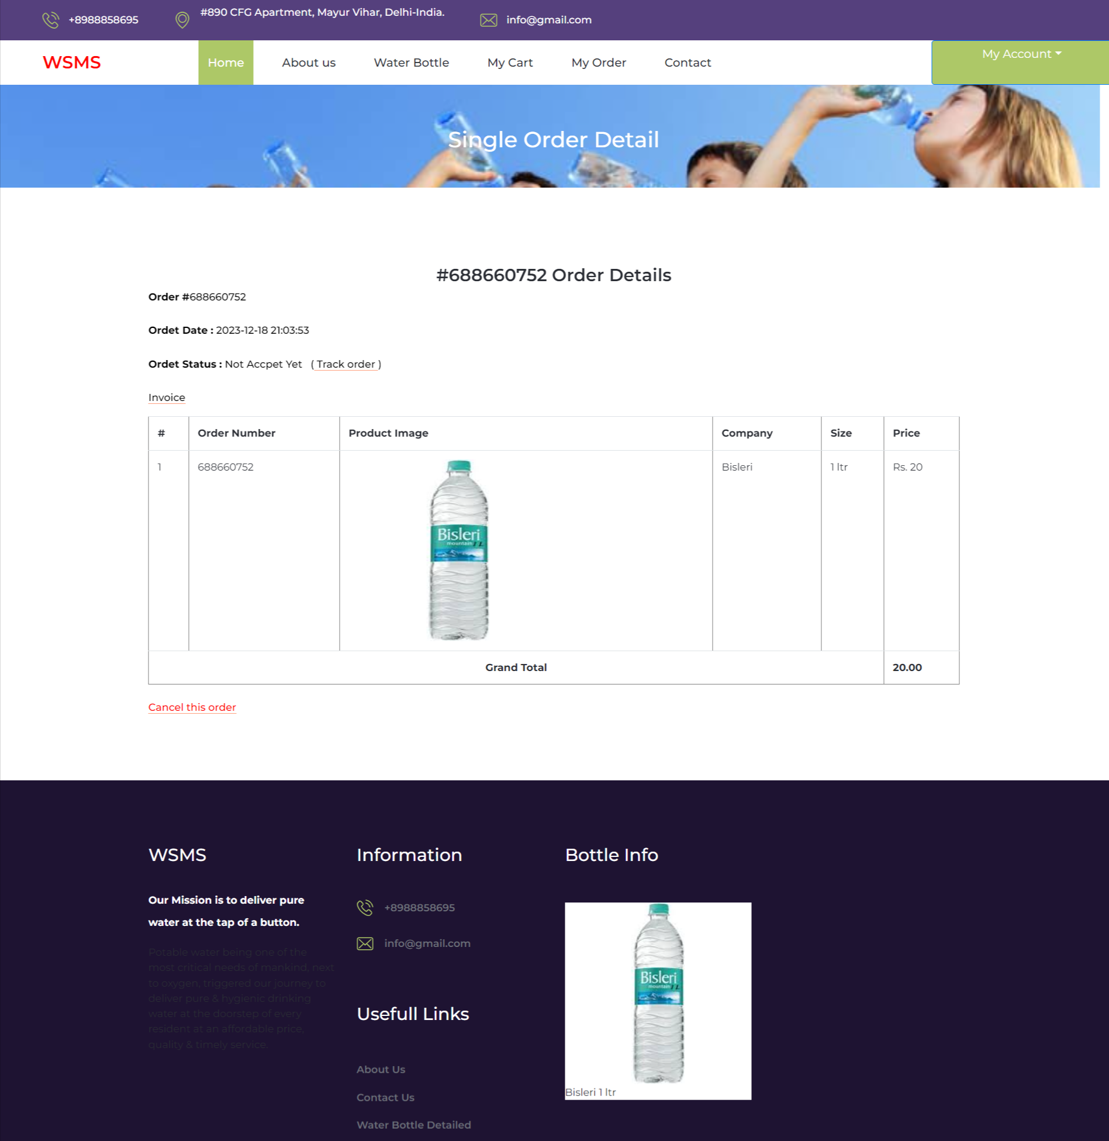

Water Bottle

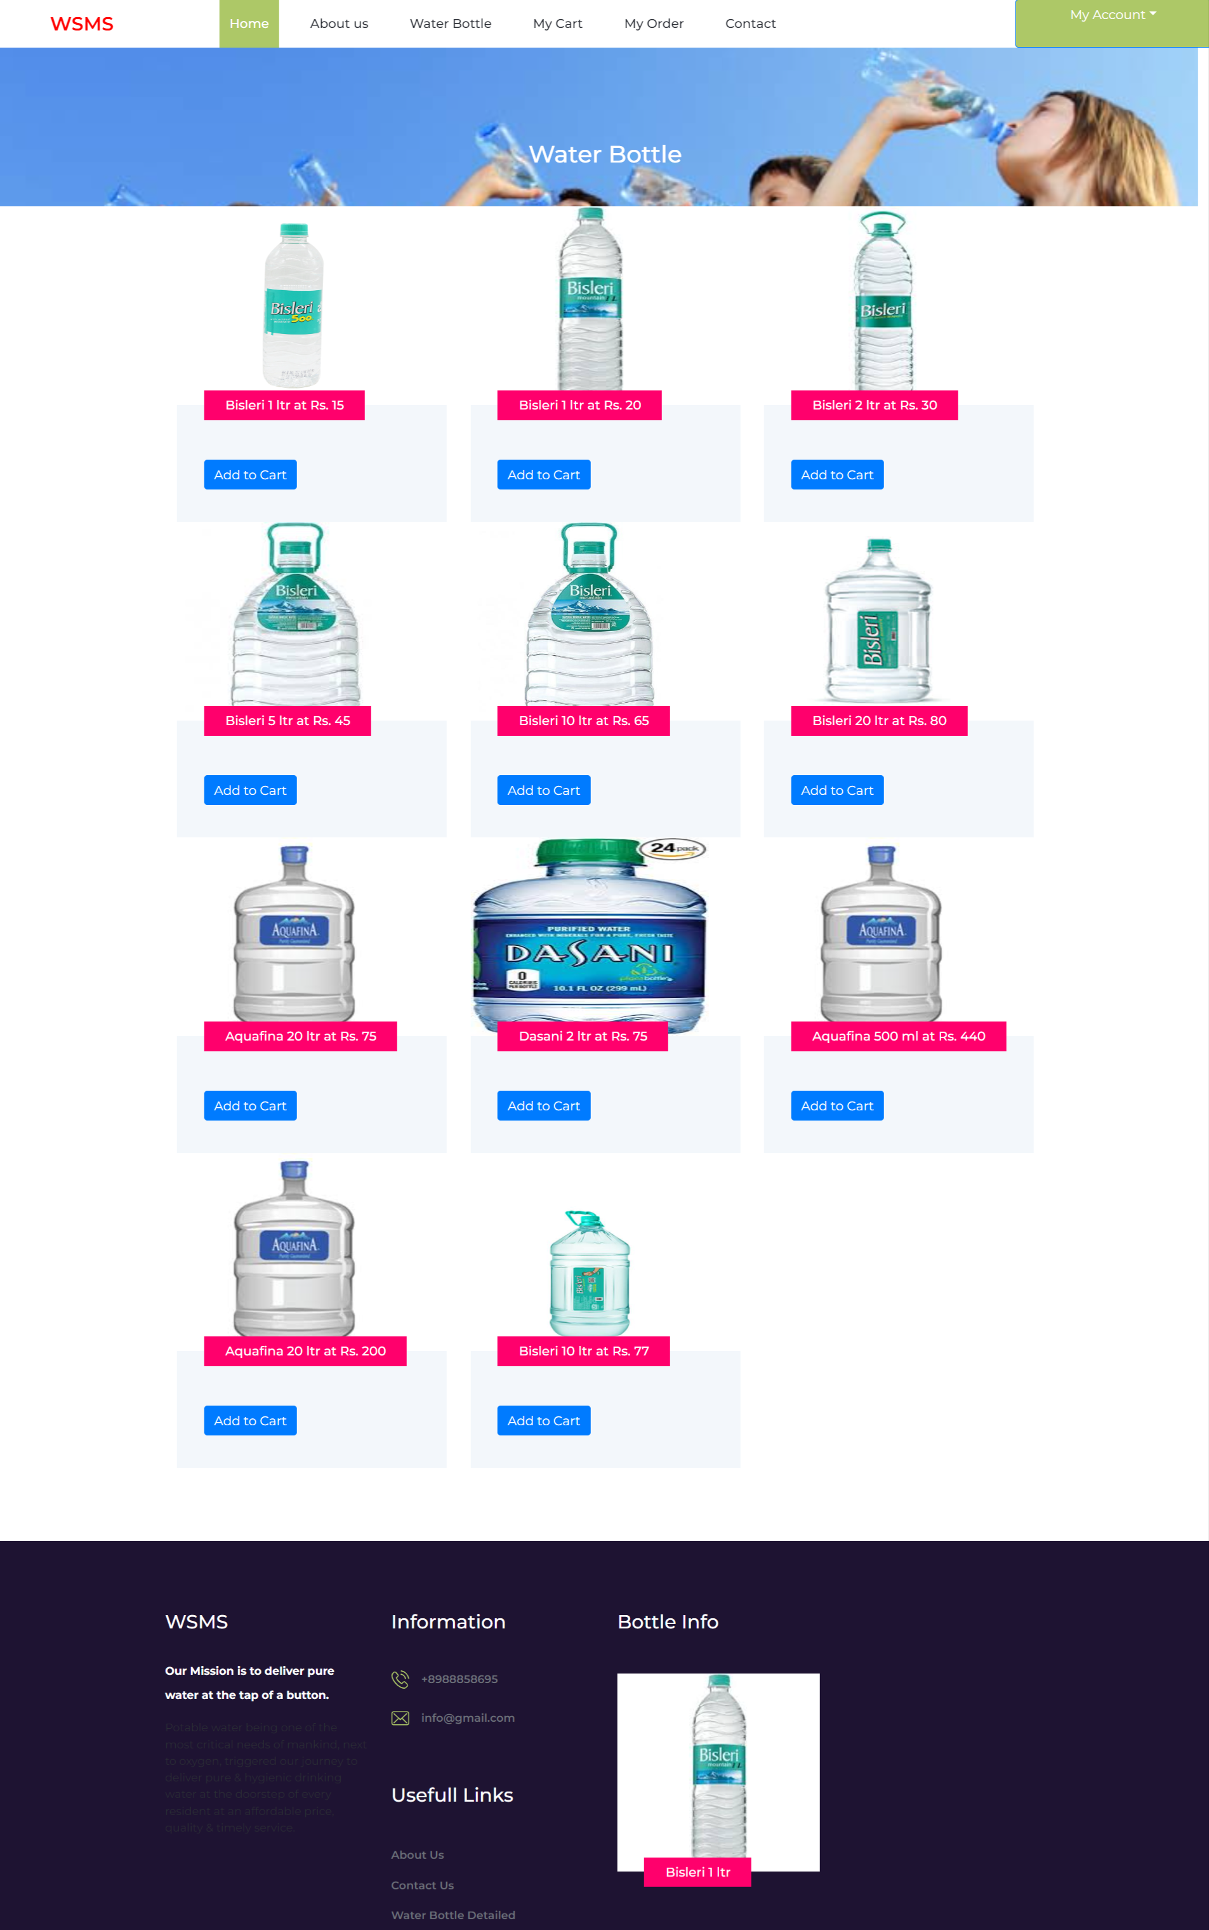

About Us

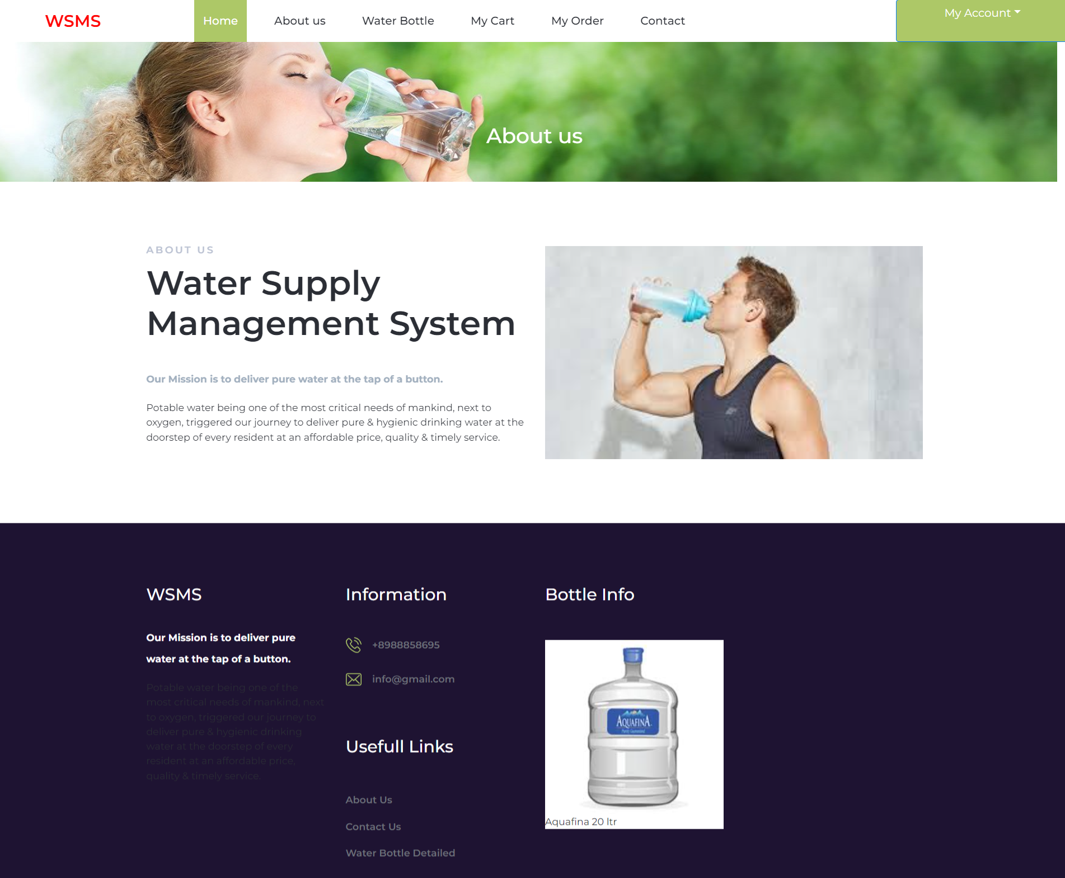

Contact Us

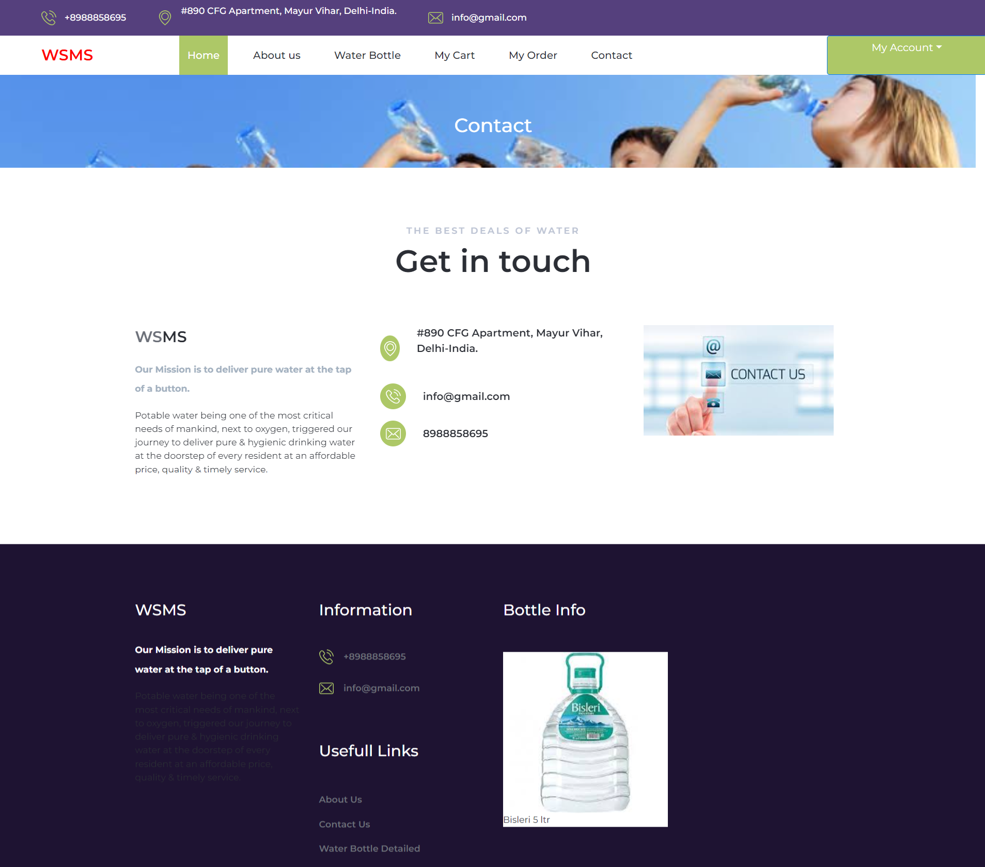

Admin Panel
Login Page

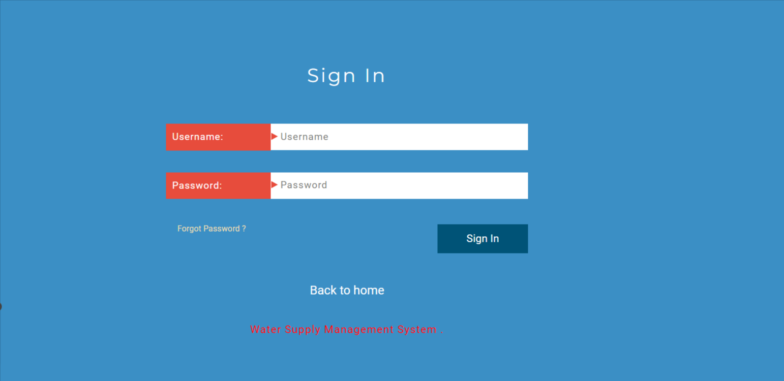

Forgot Password

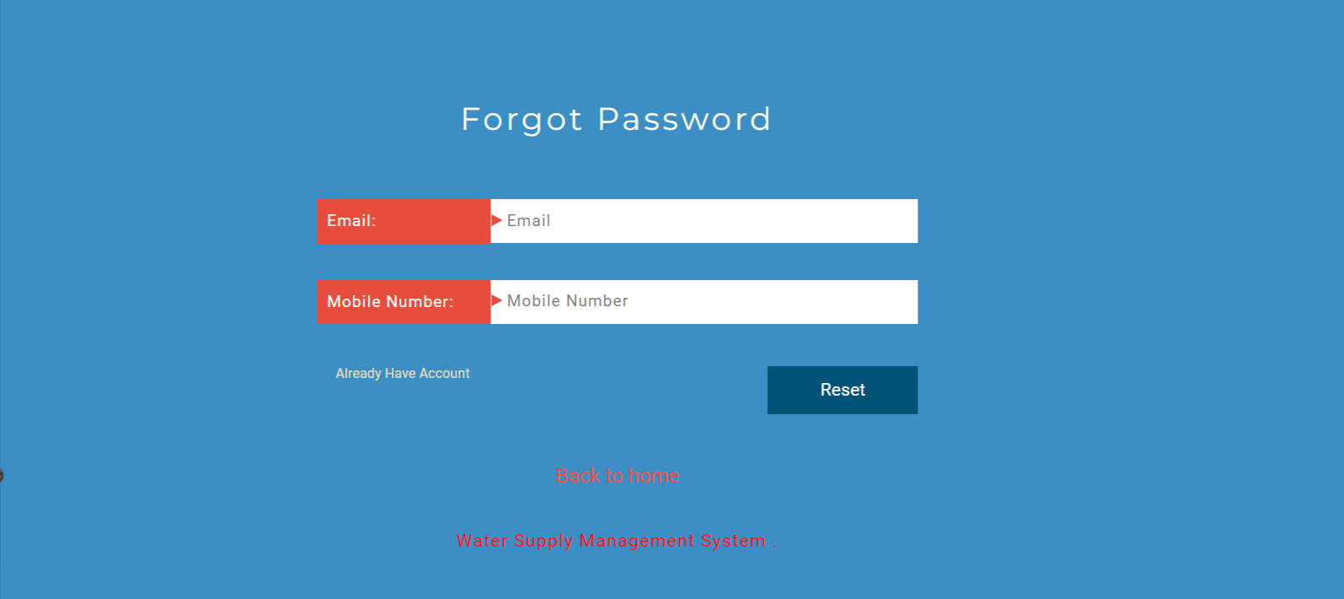

Reset Password

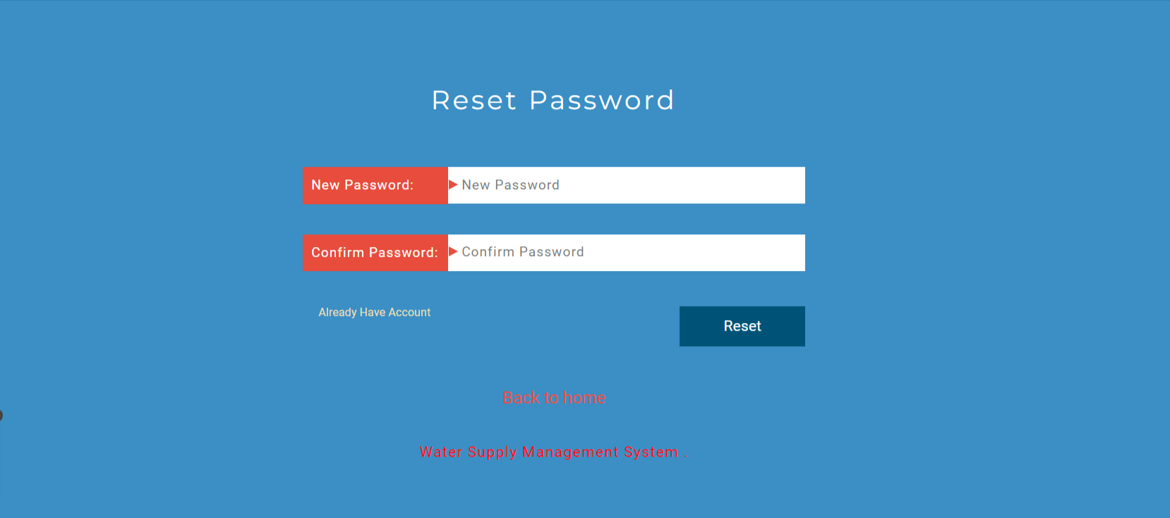

Dashboard

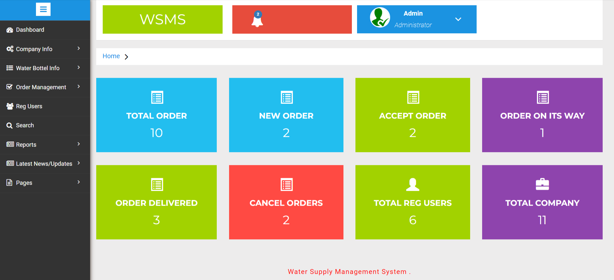

Profile
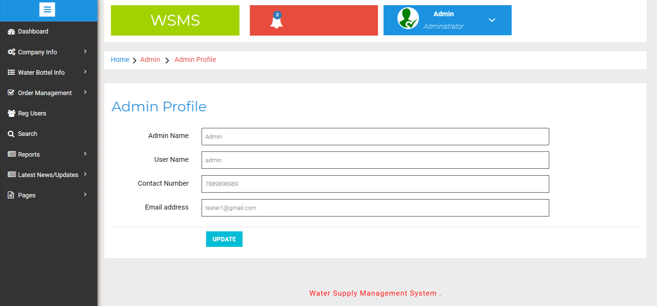

Change Password

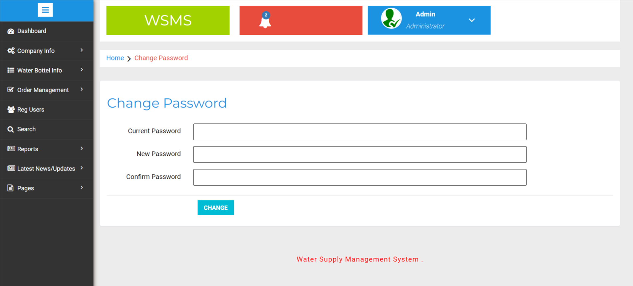

Add Company

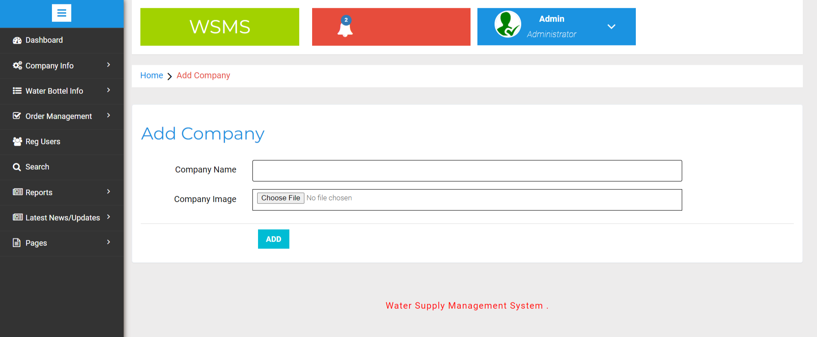

Manage Company

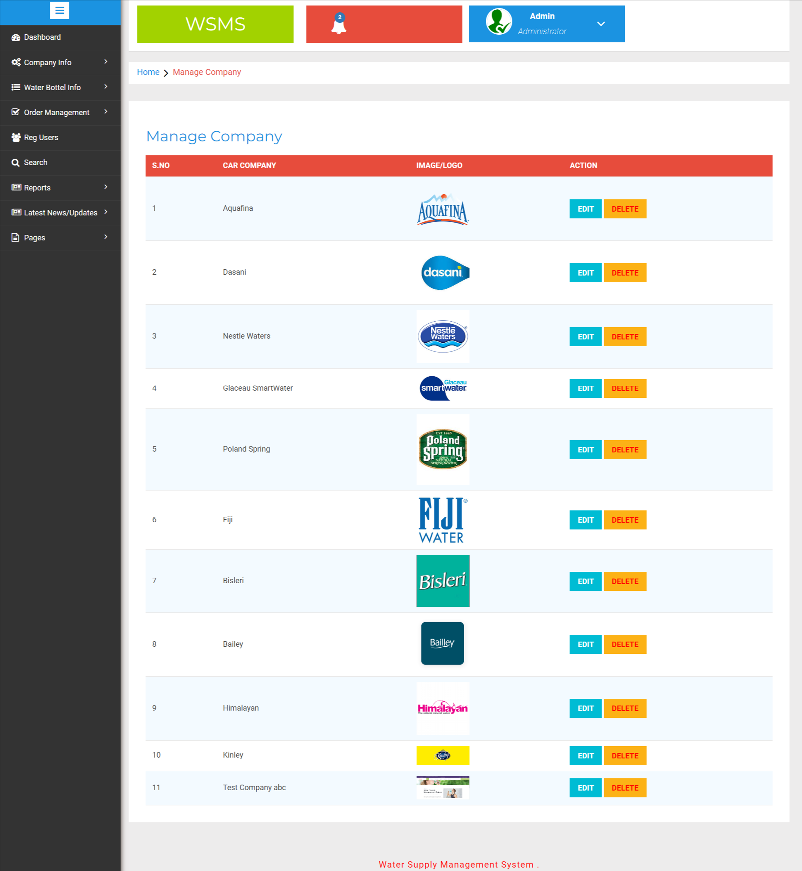

Update Company

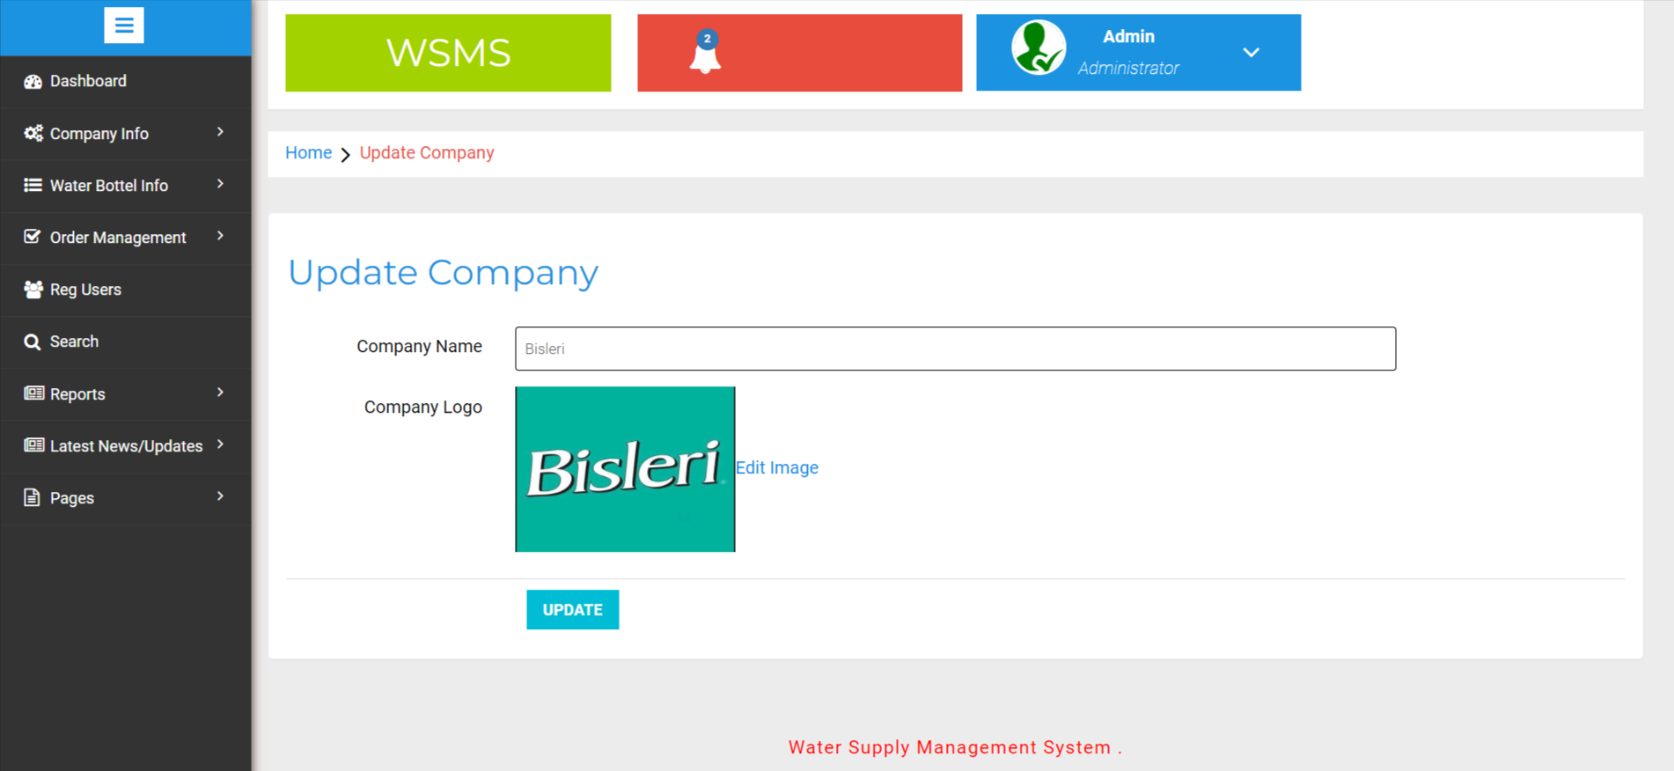

Update Company Logo

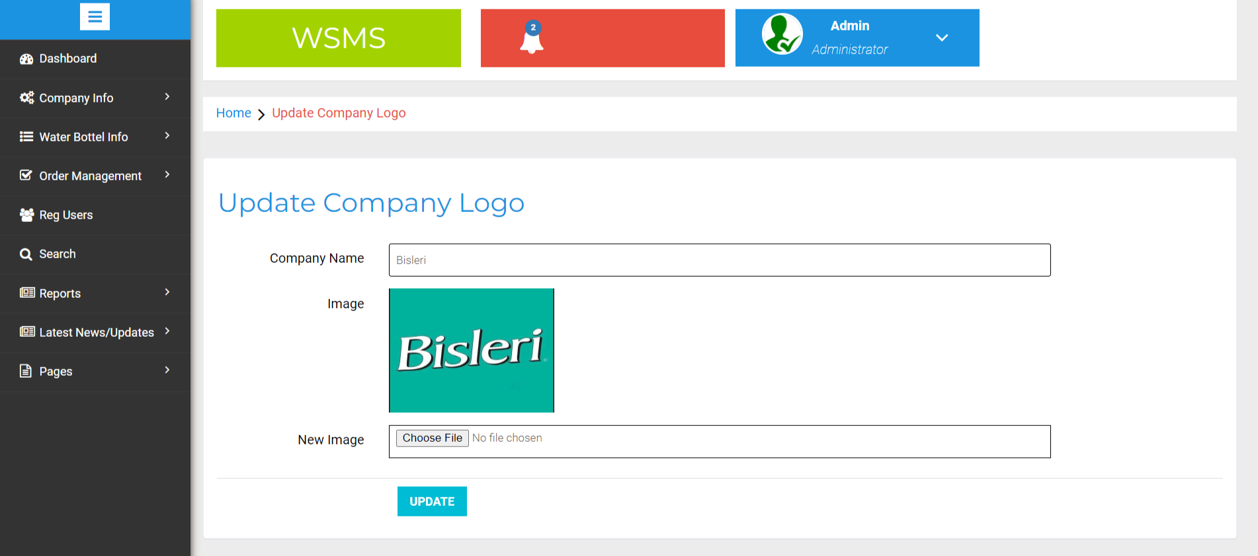

Add Water Bottle

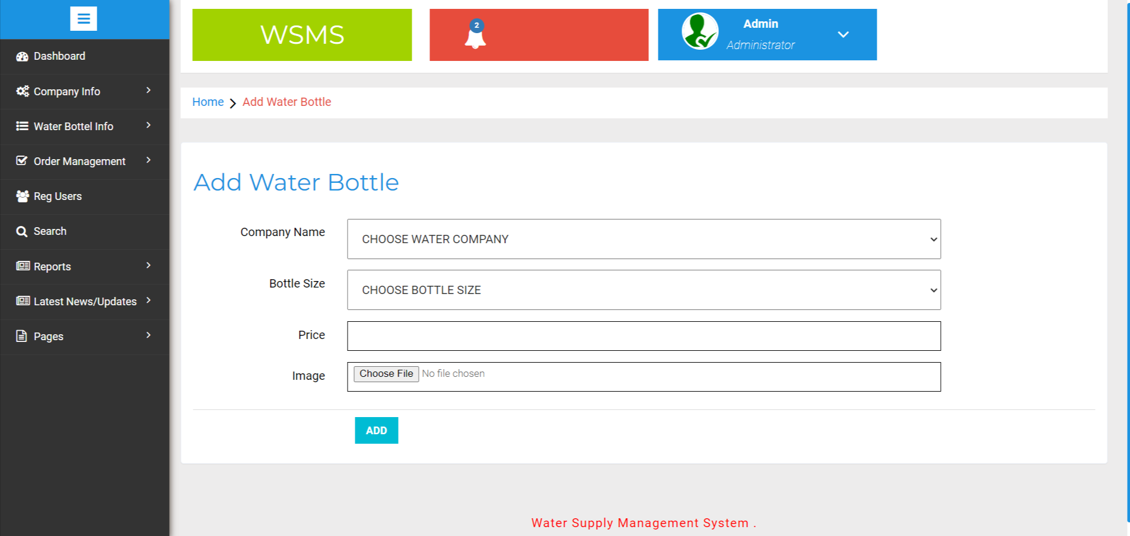

Manage Water Bottle

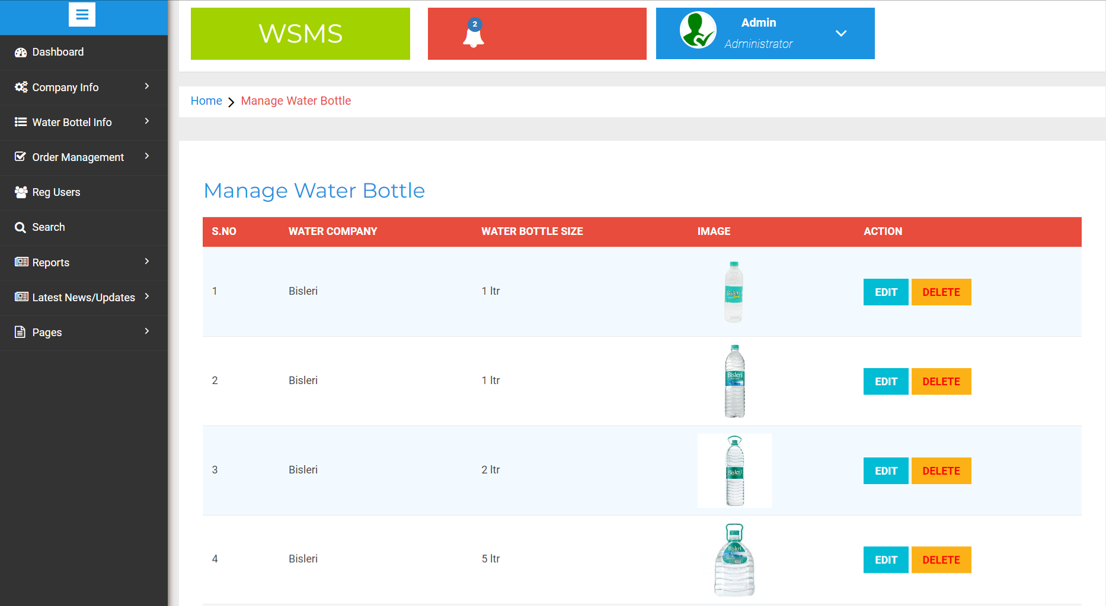

Update Water Bottle

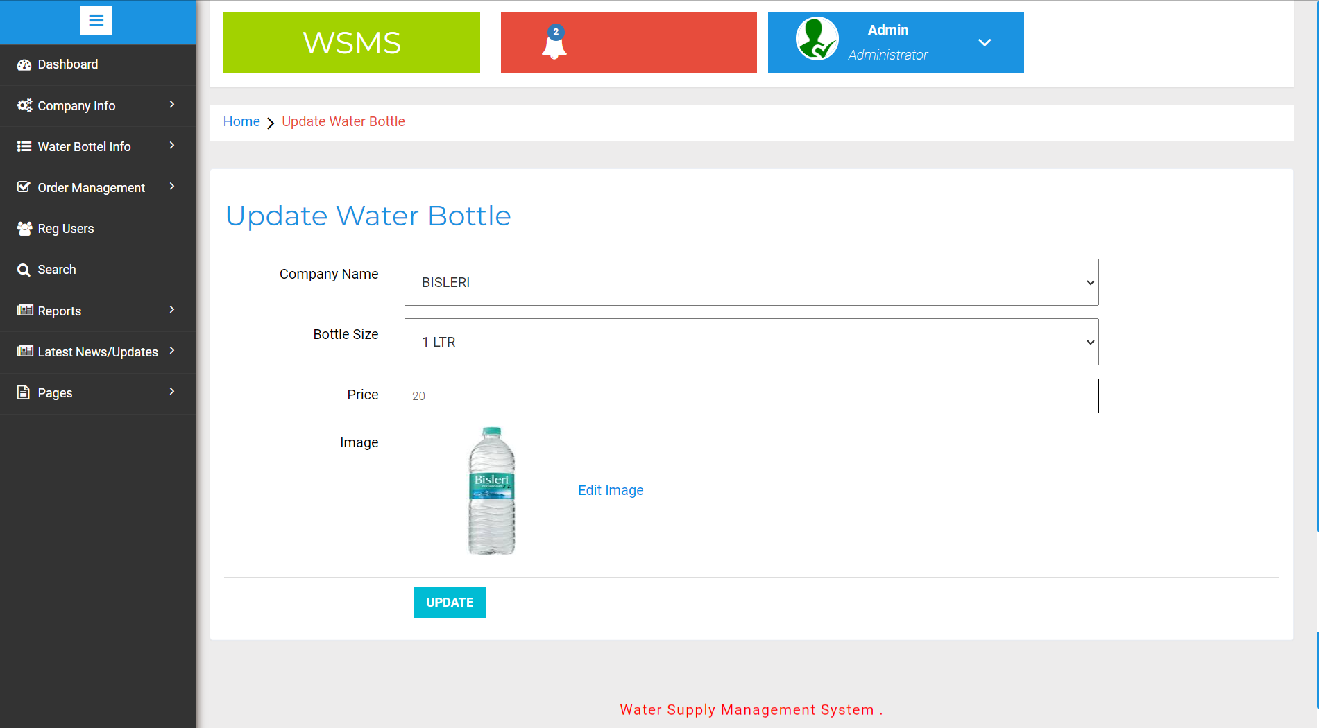

Update Image

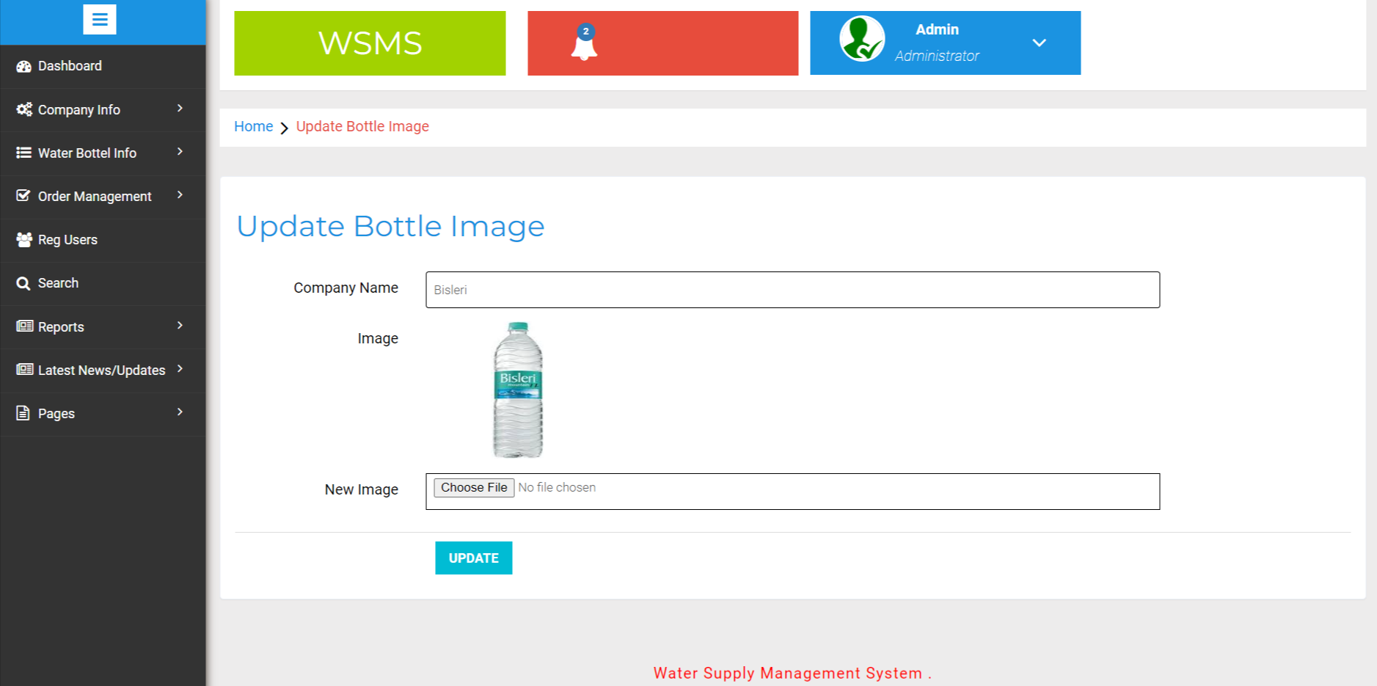

New Order

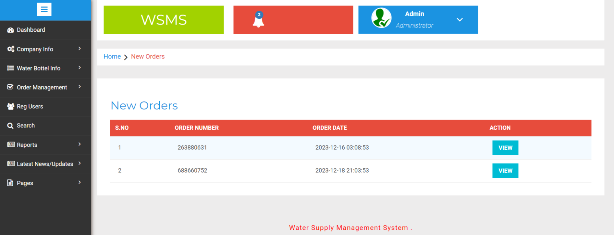

View New Order Details

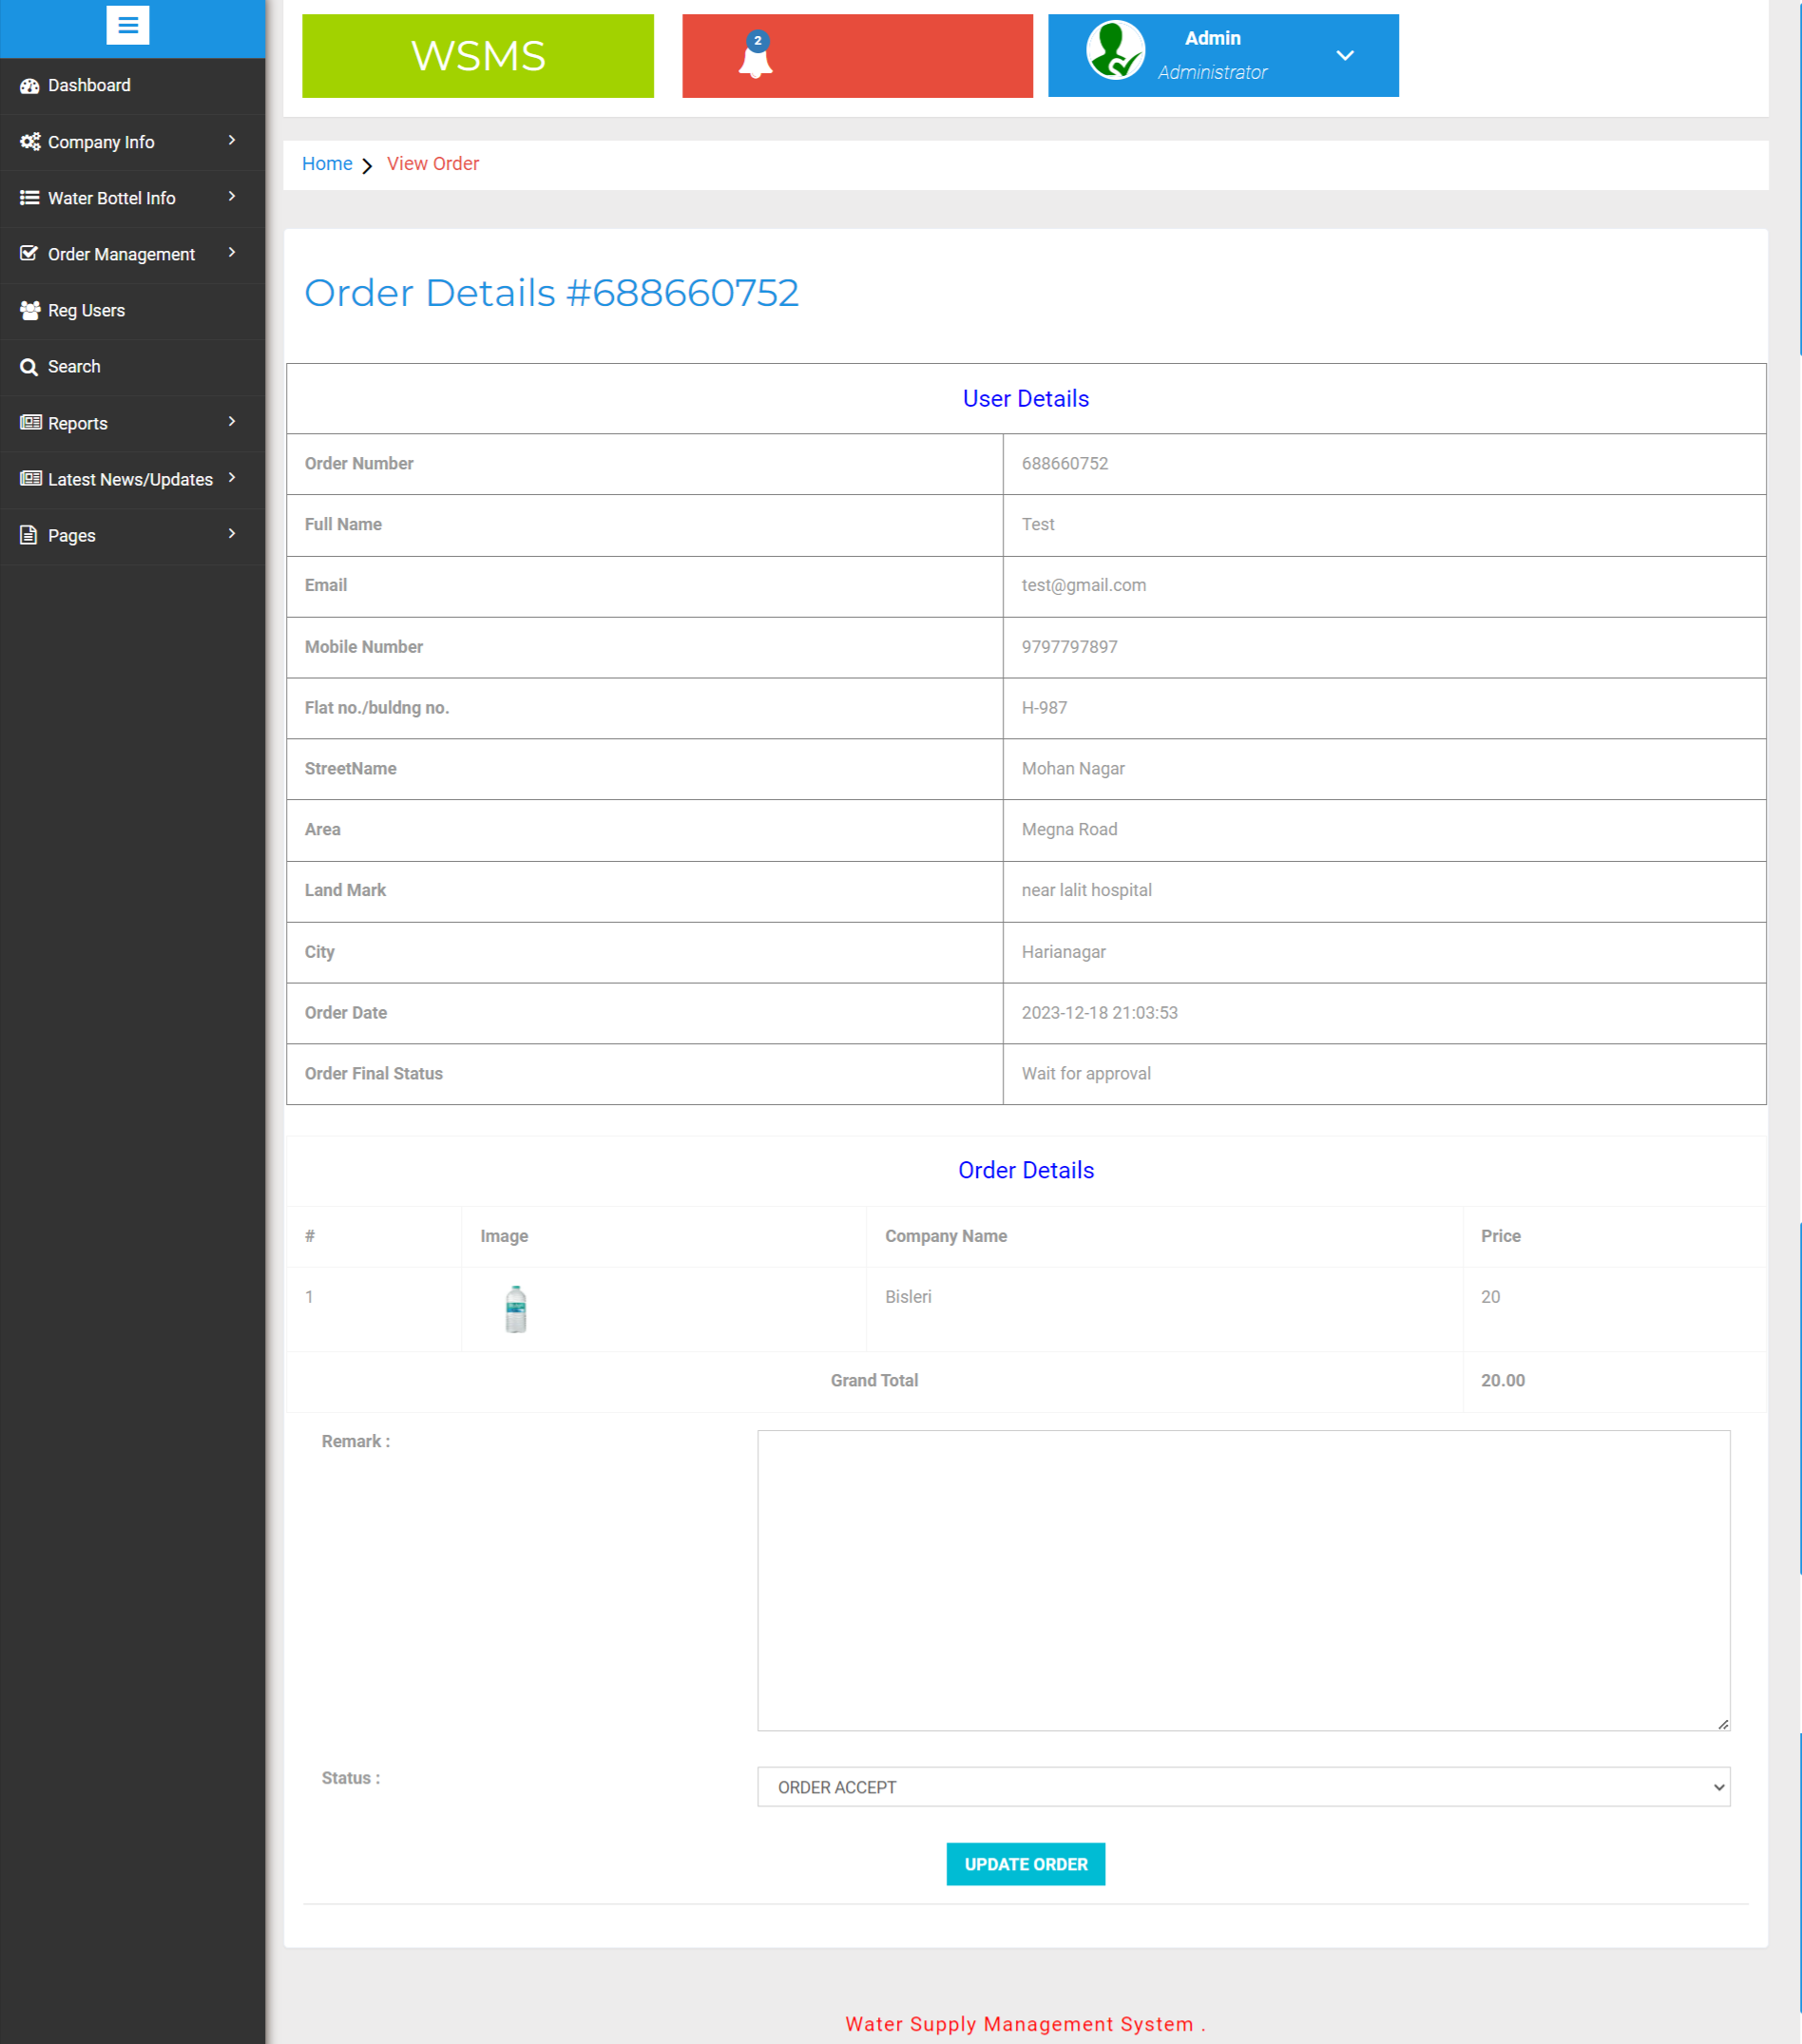

Accepted Orders

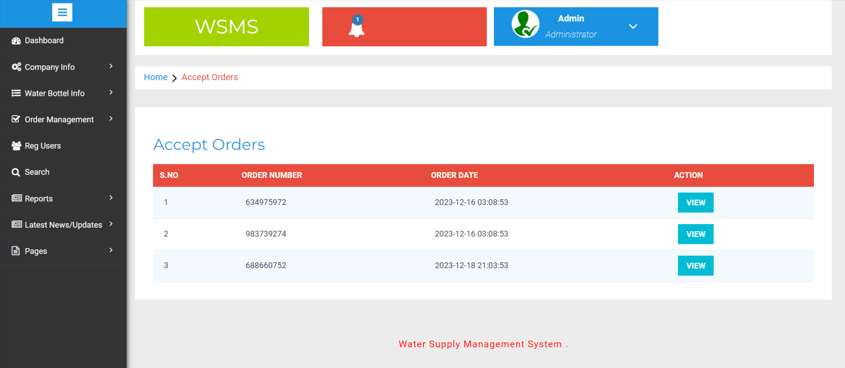

View Accepted Orders

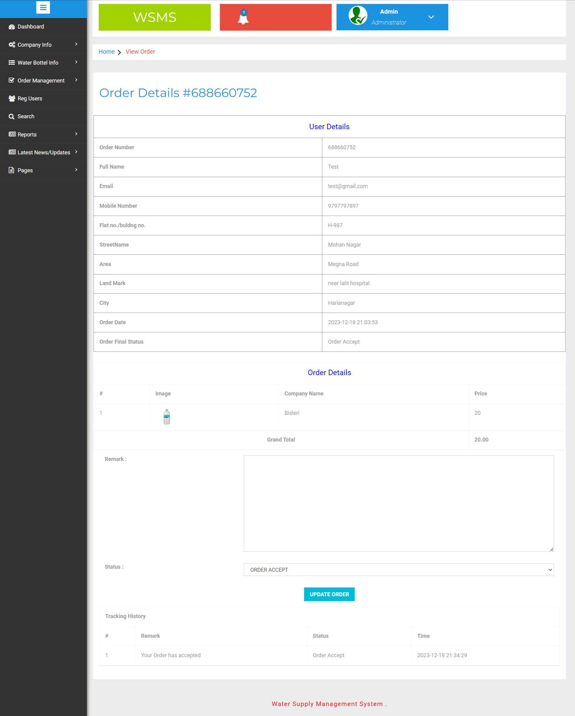

Delivered Order
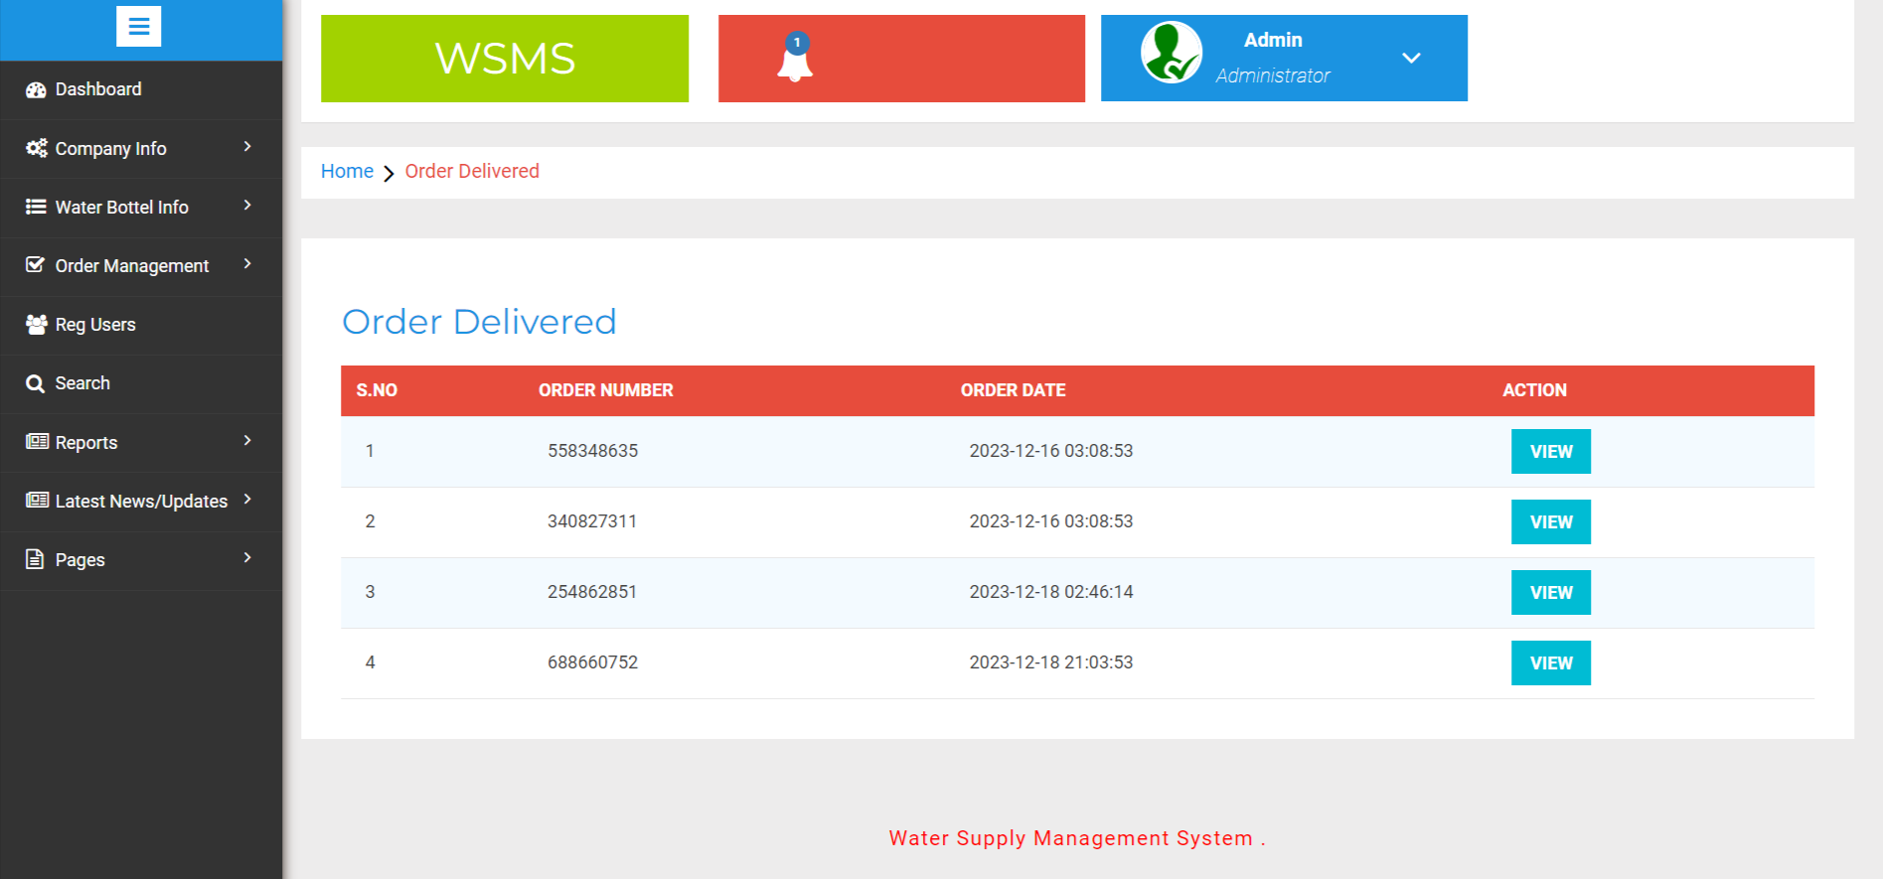

View Delivered Order Details
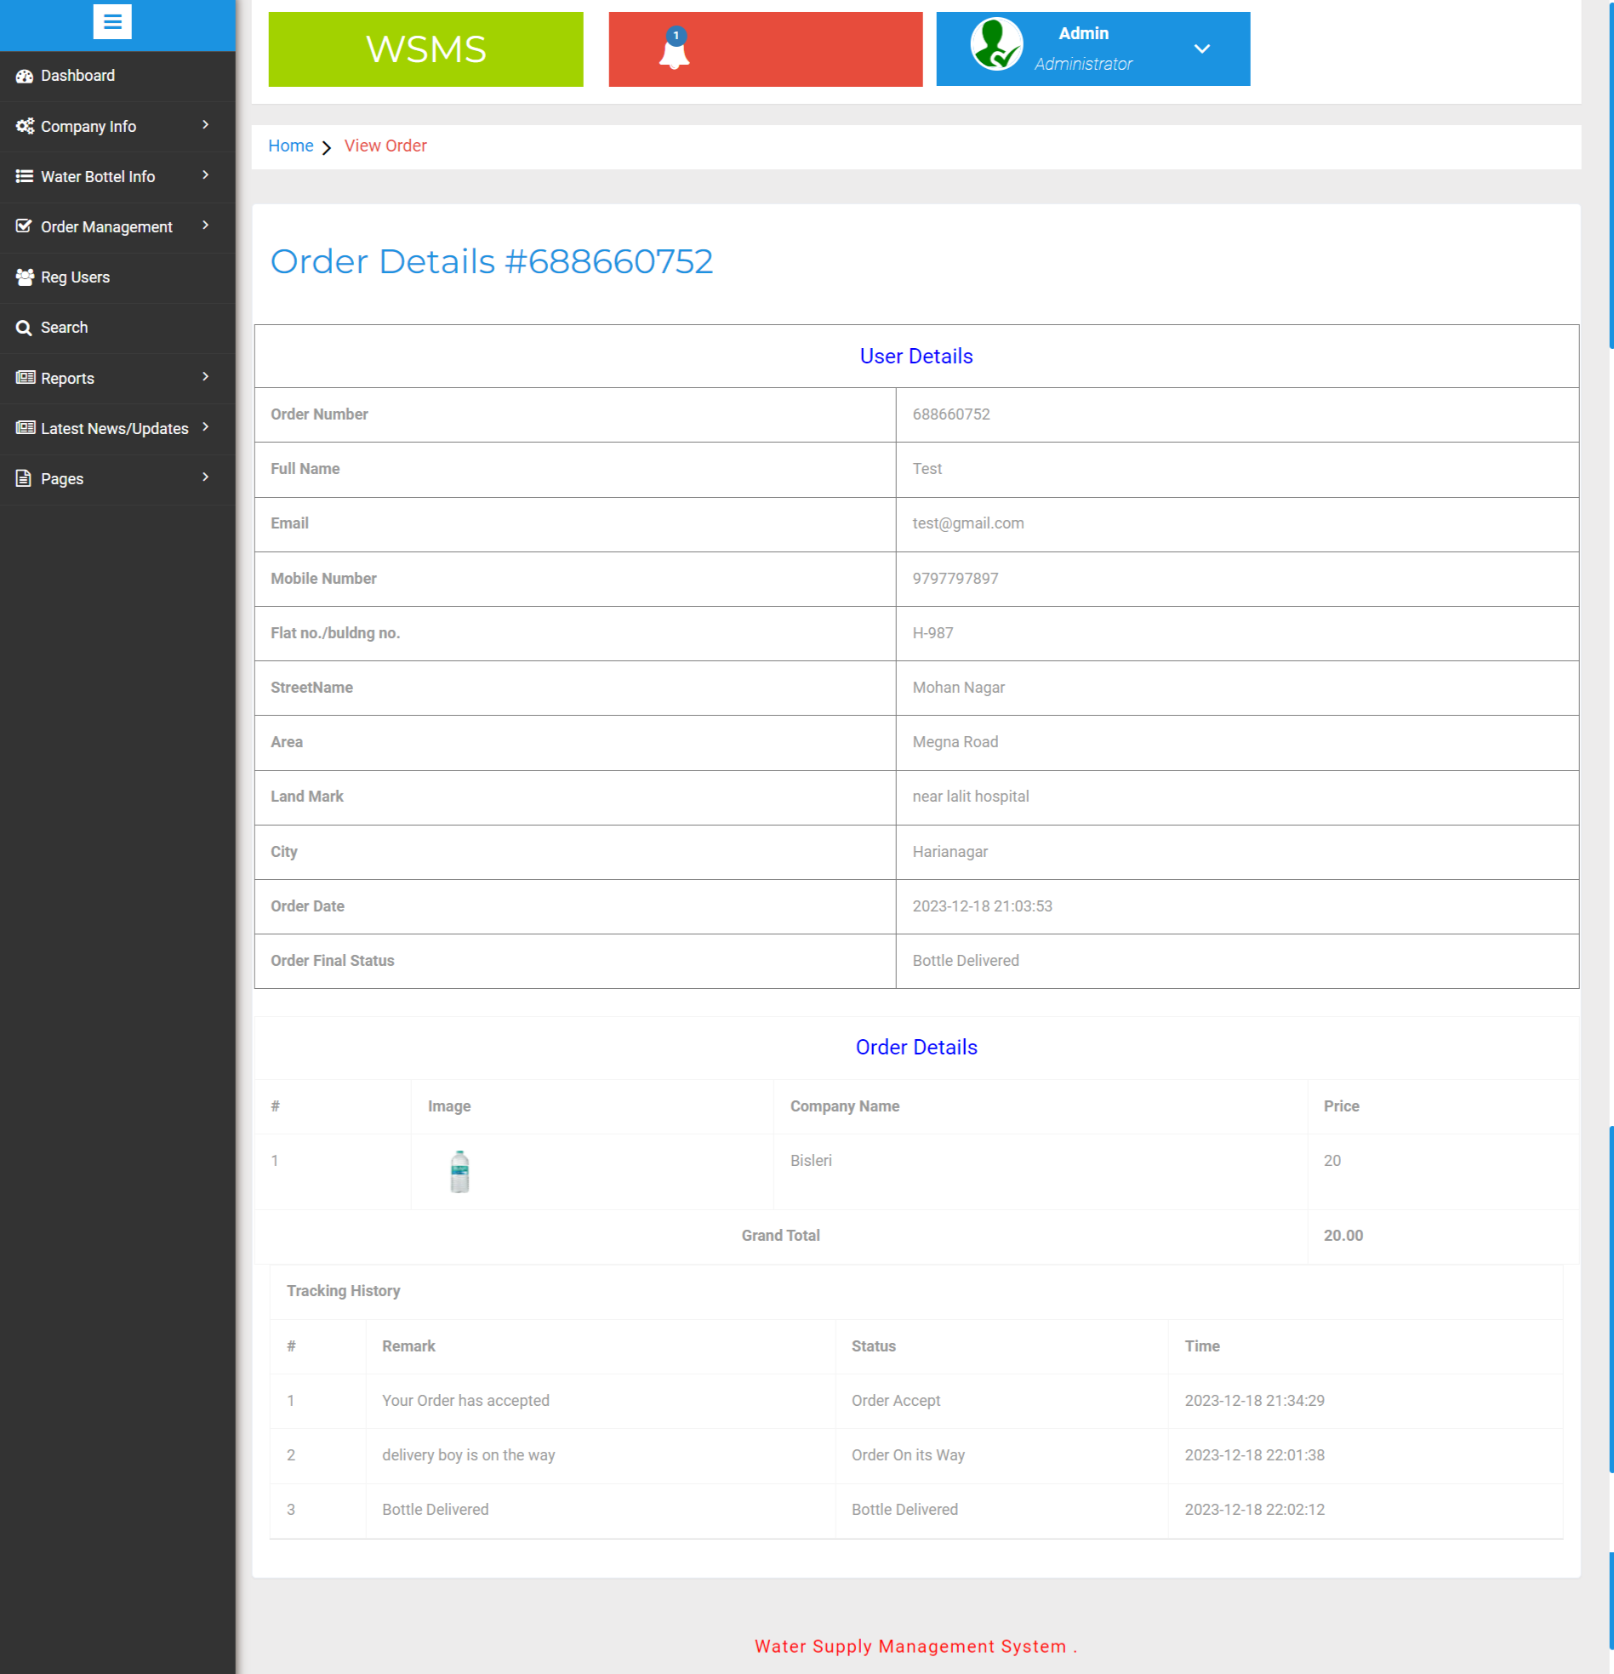

Registered Users

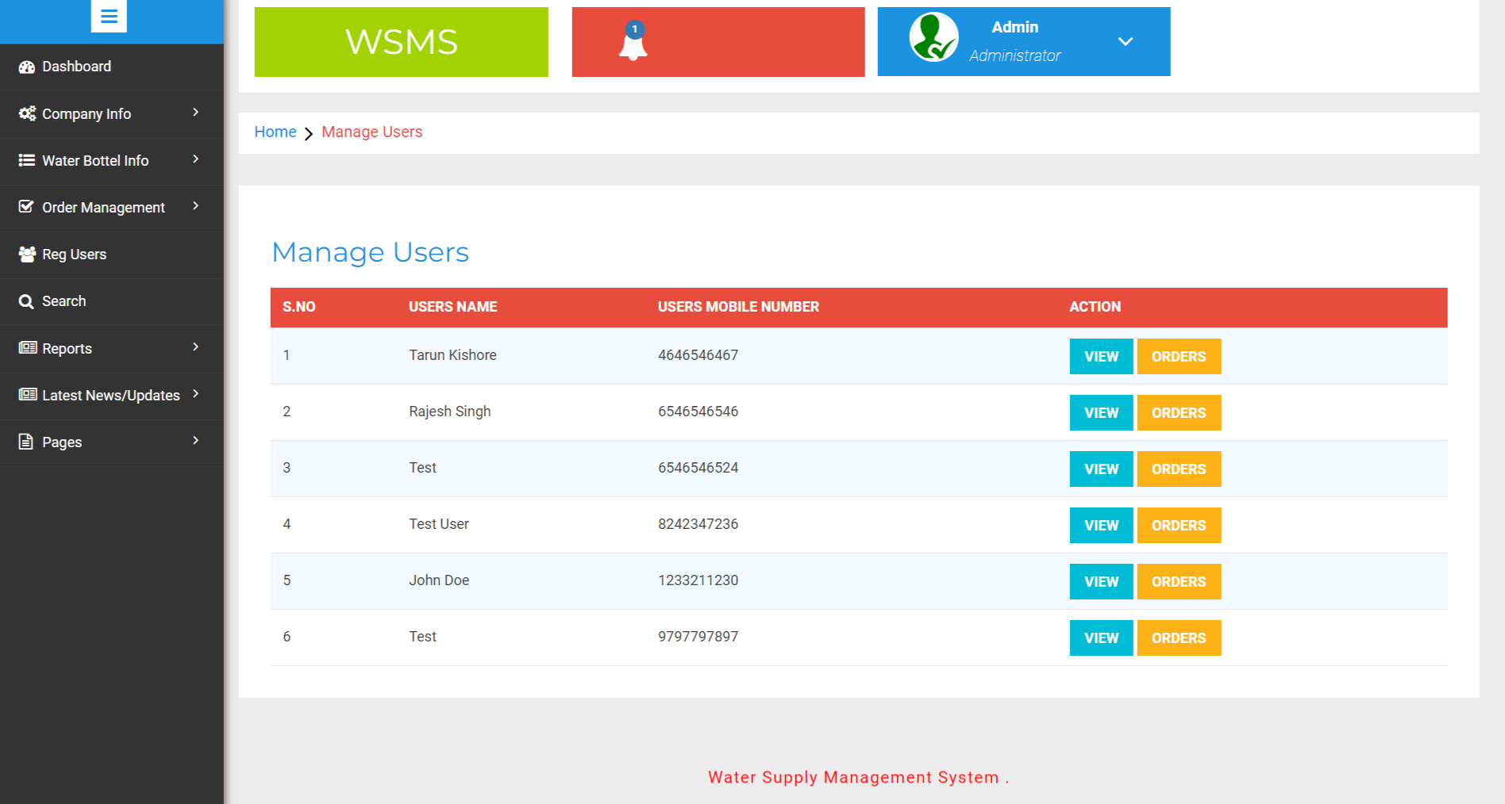

View Registered User’s Orders Details

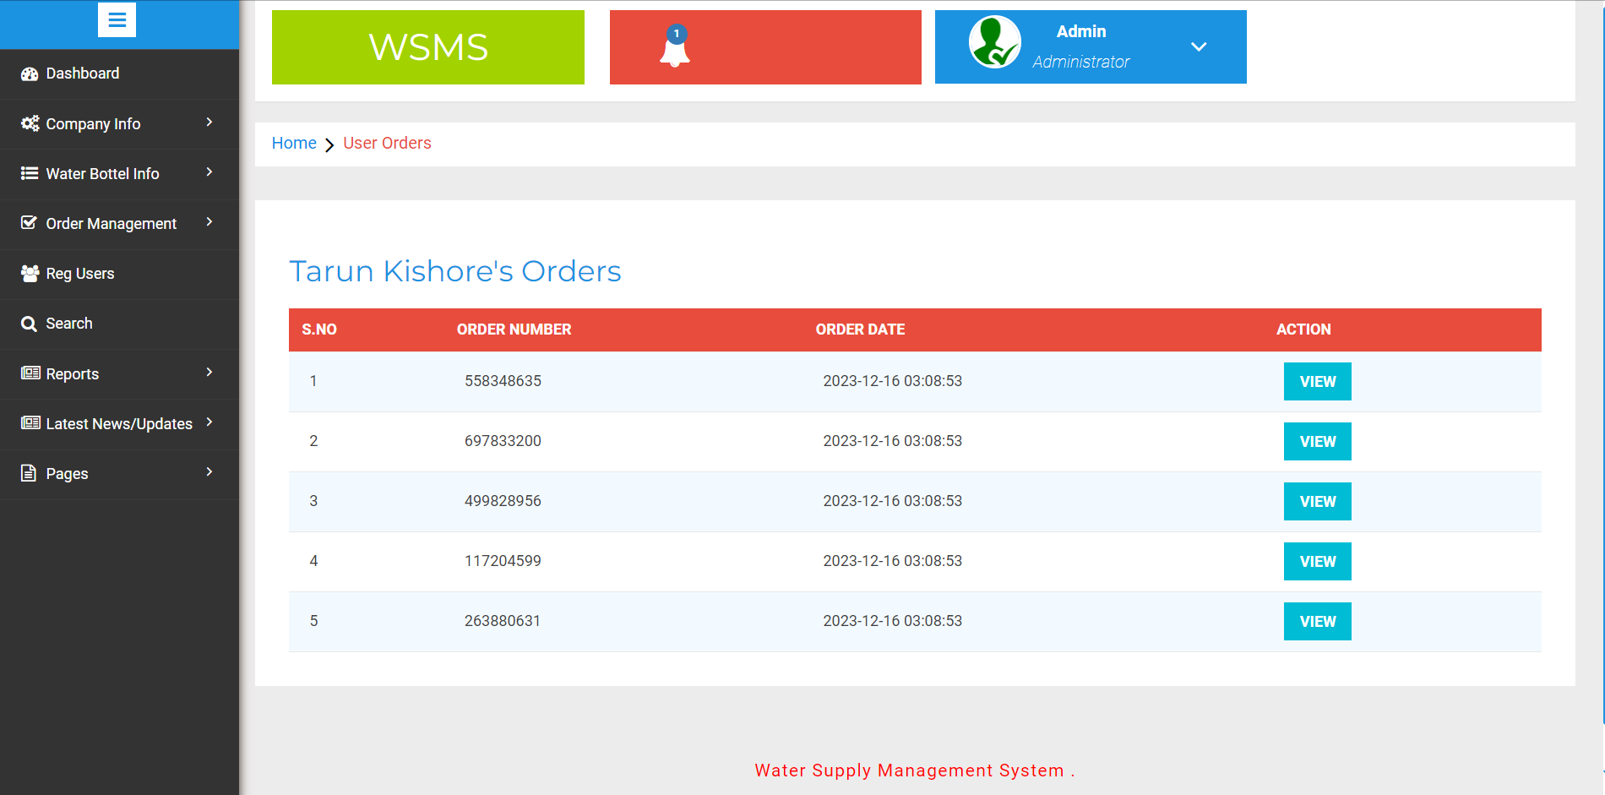

Search Order

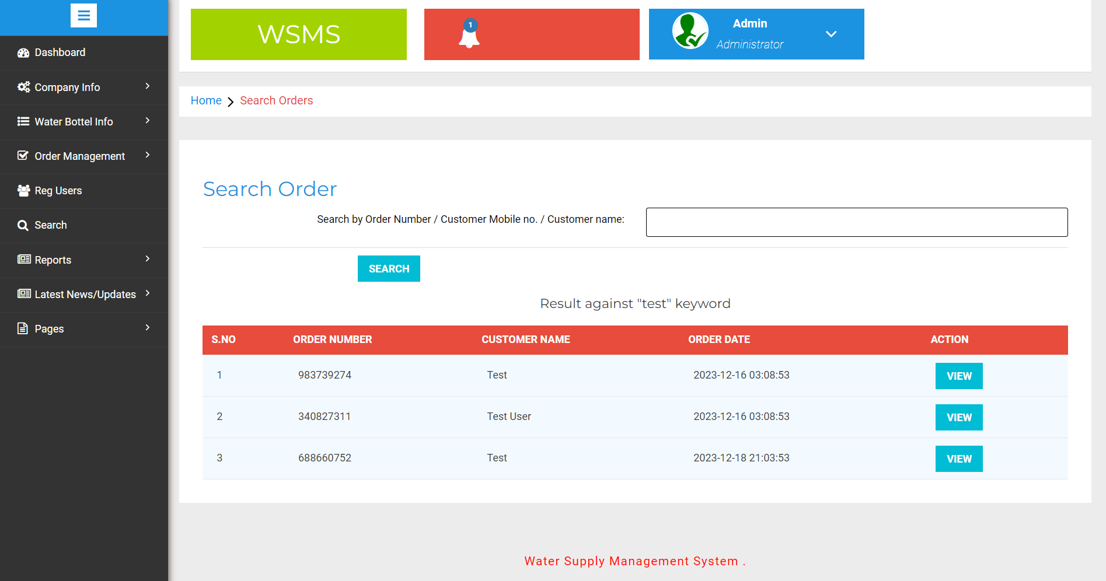

Between Dates Reports

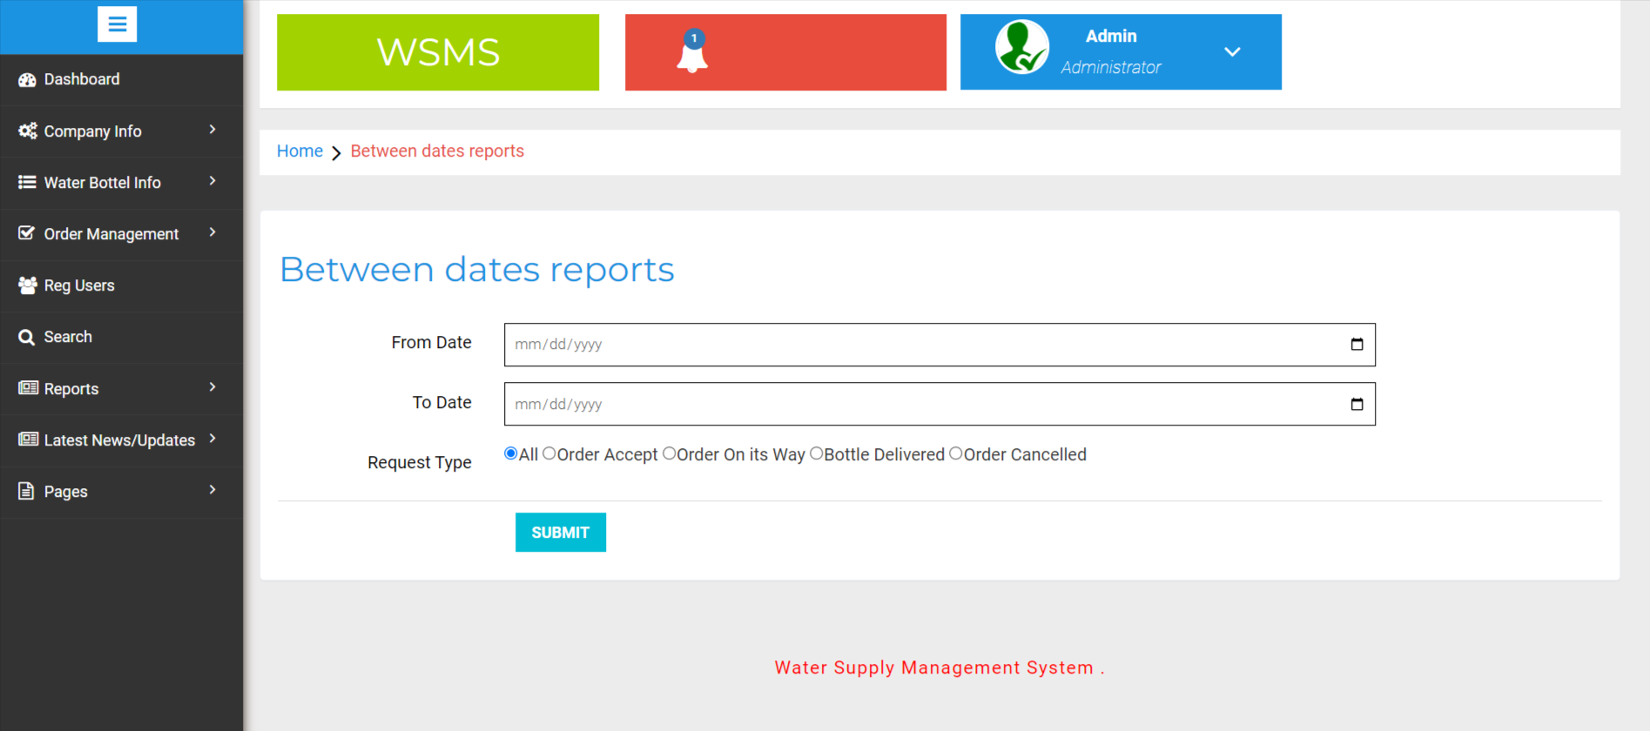

Details of Between Date Reports

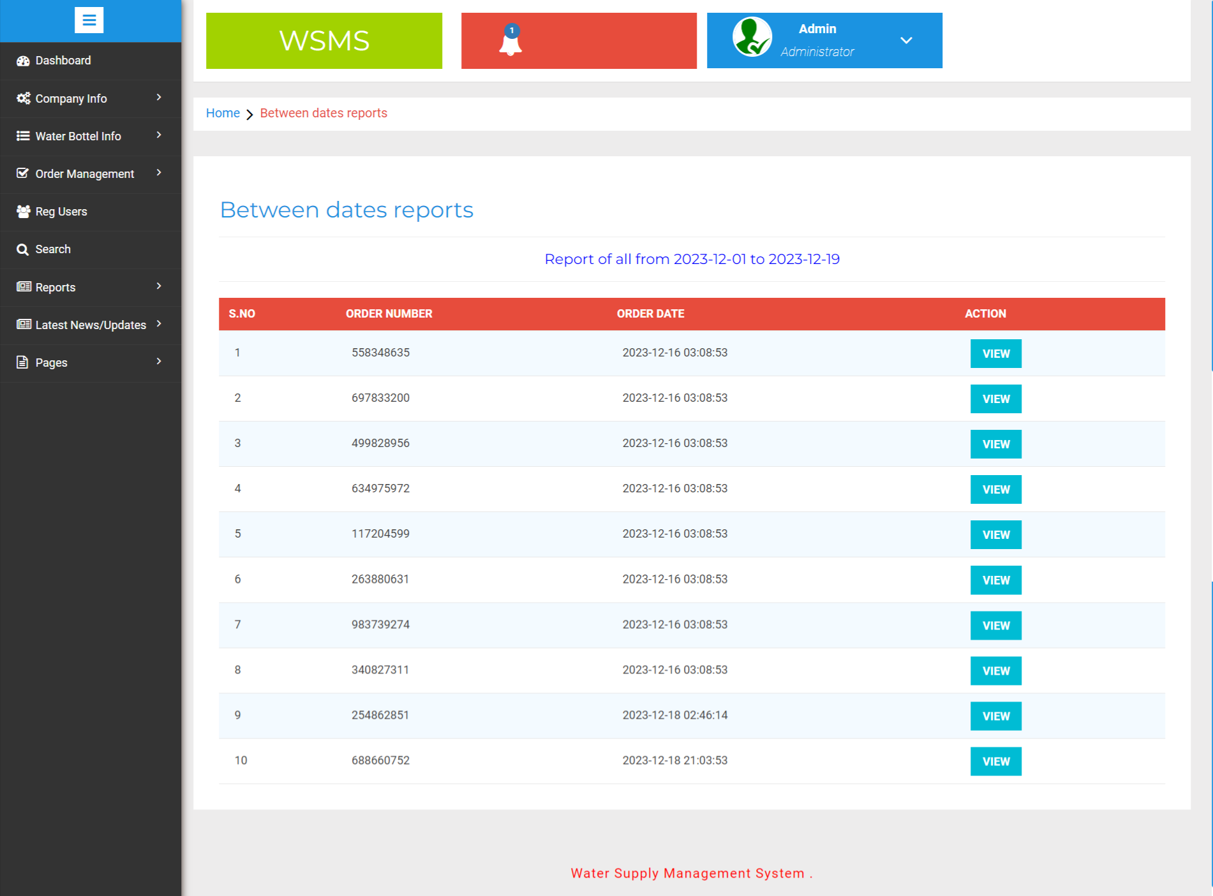

Order Count Report

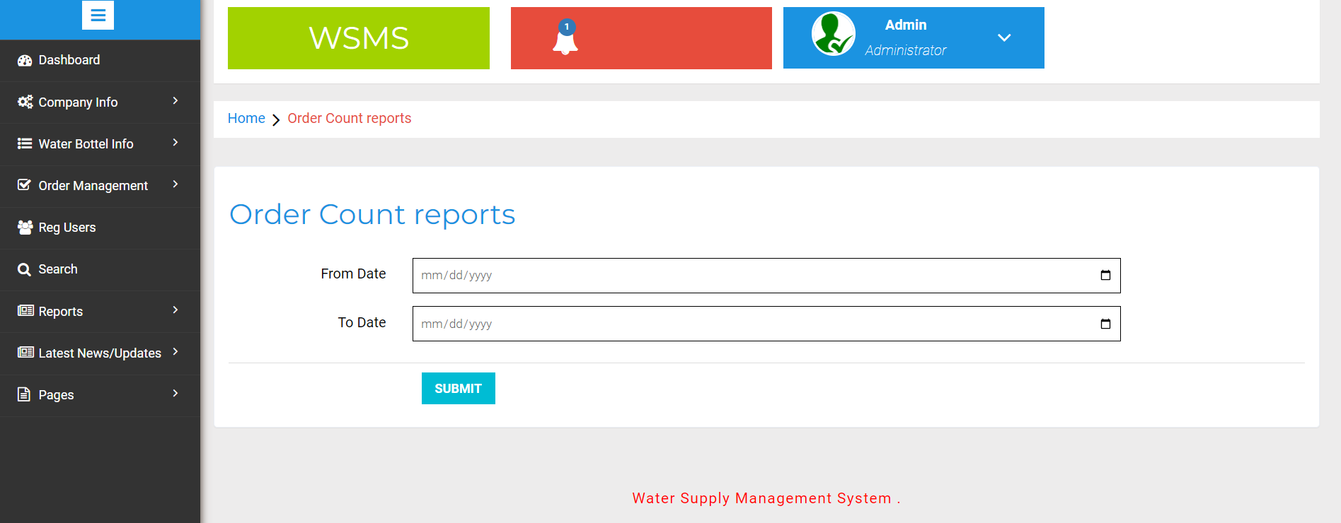

View Details of Order Count Report

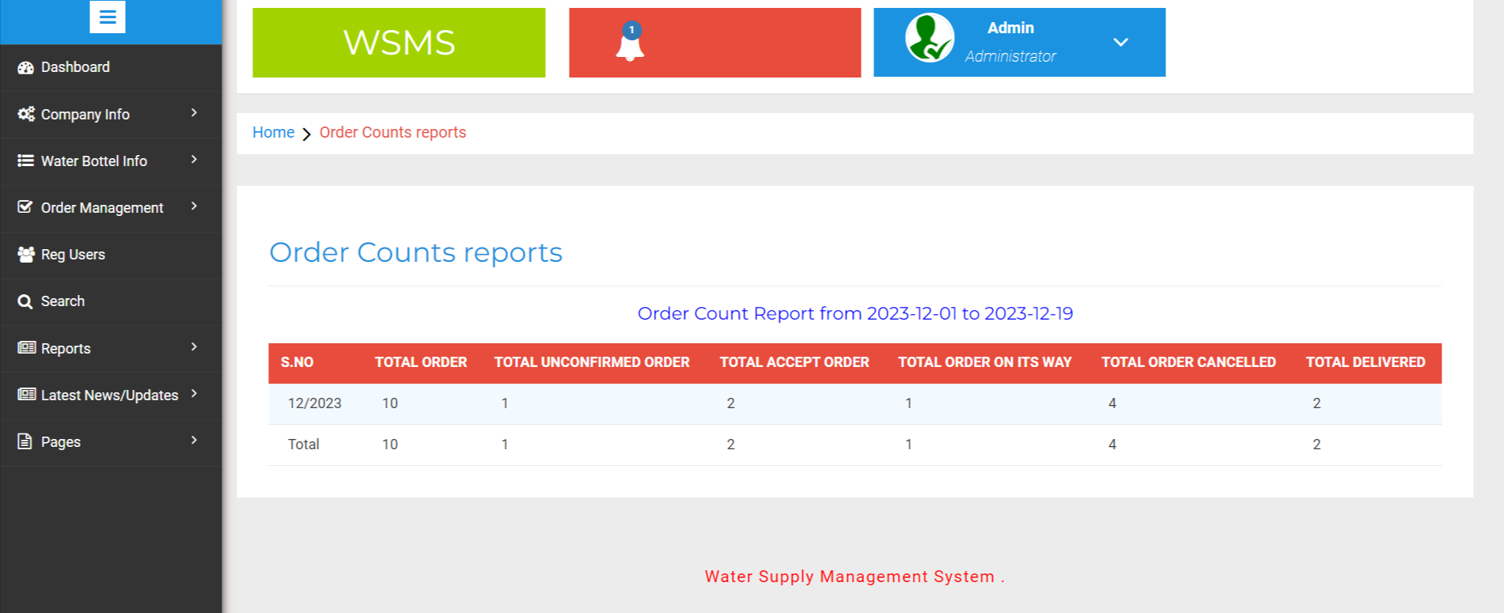

Month wise Sale Report

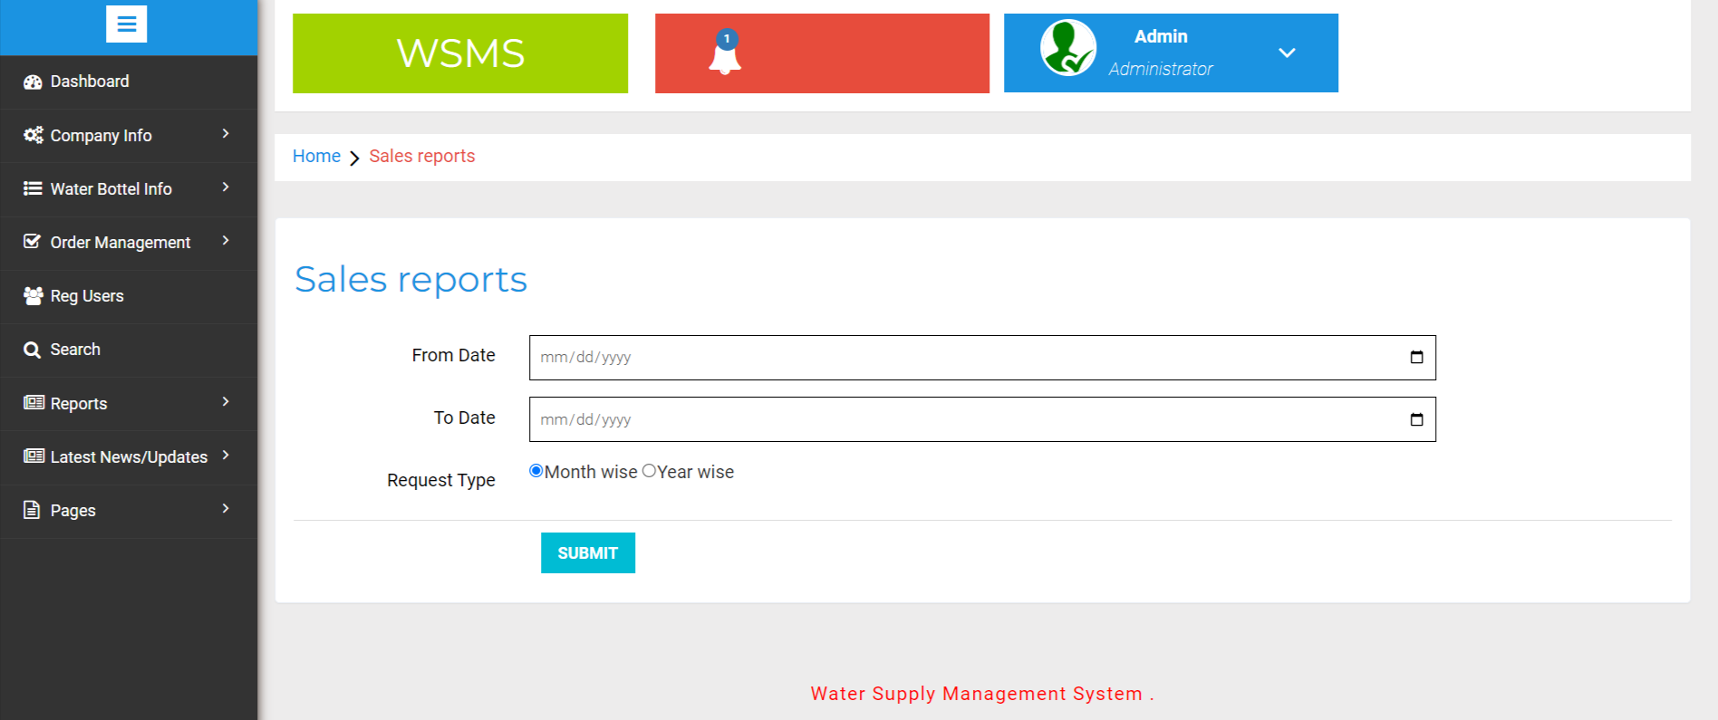

Details Month wise Sale Report

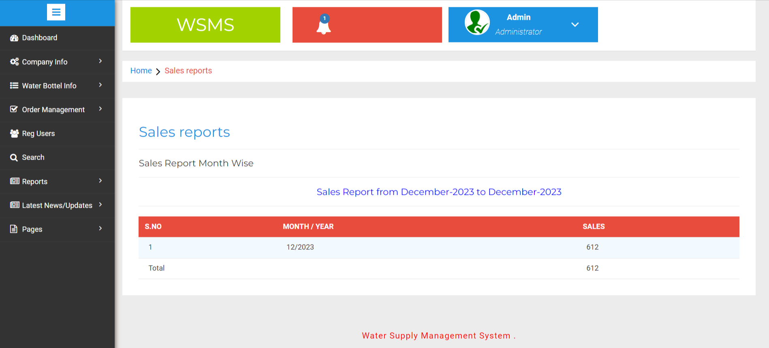

Add News

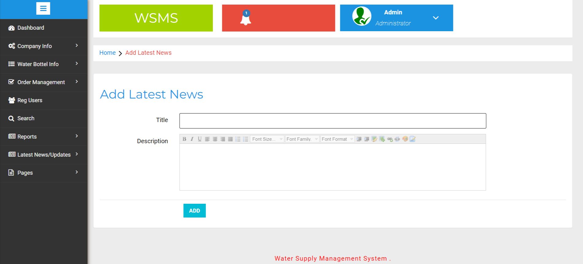

Manage News

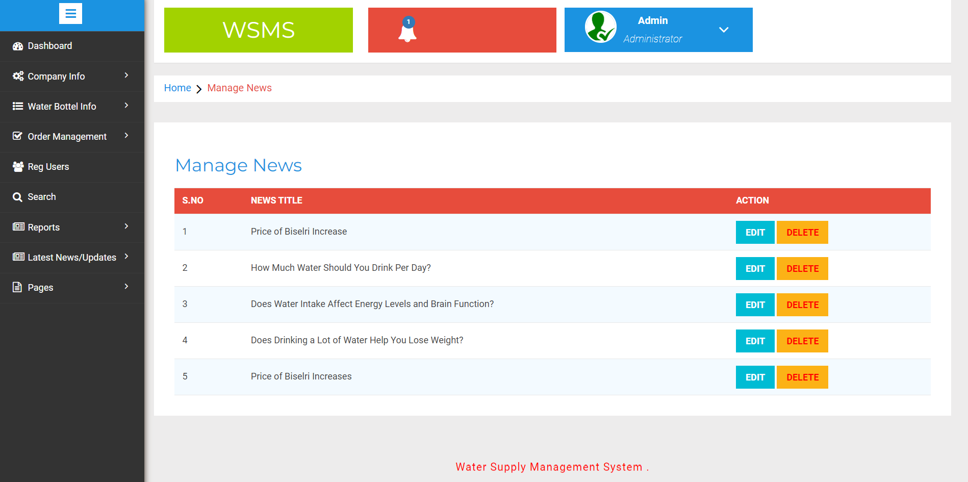

Update News

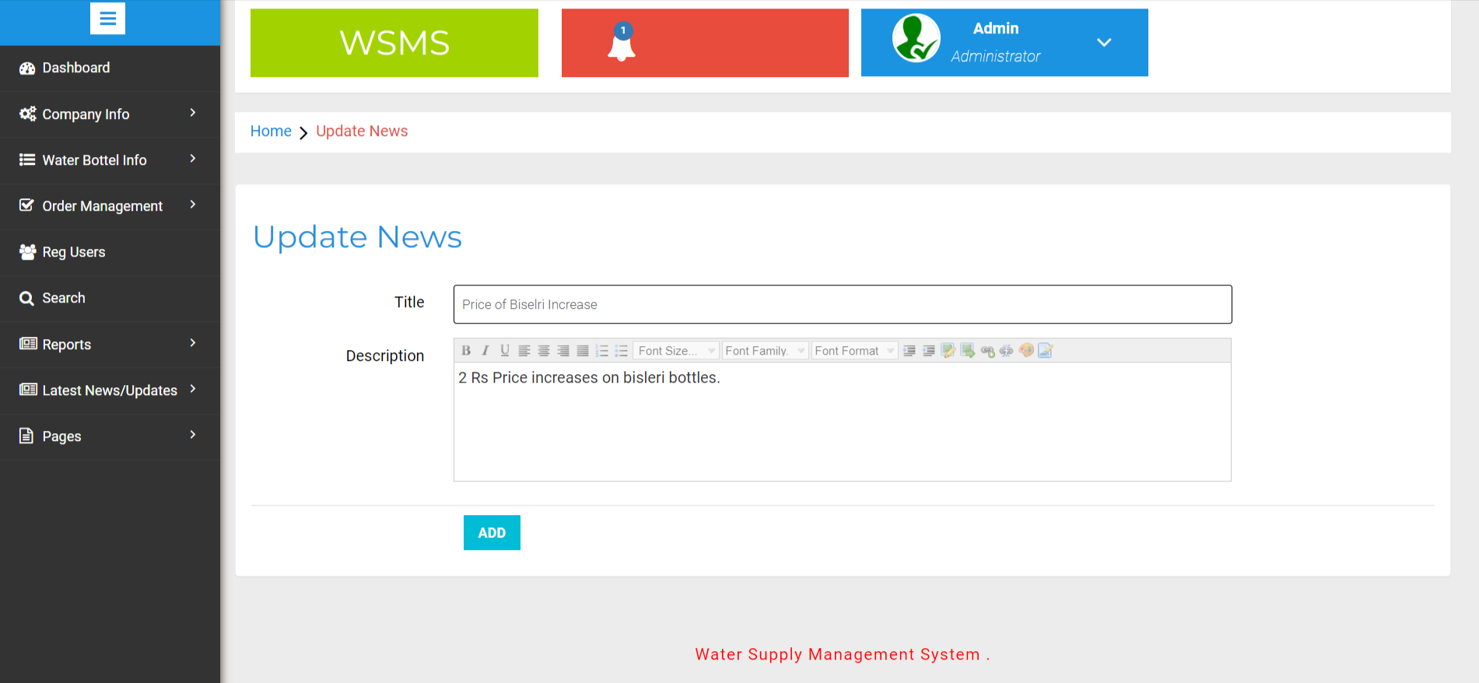

About Us

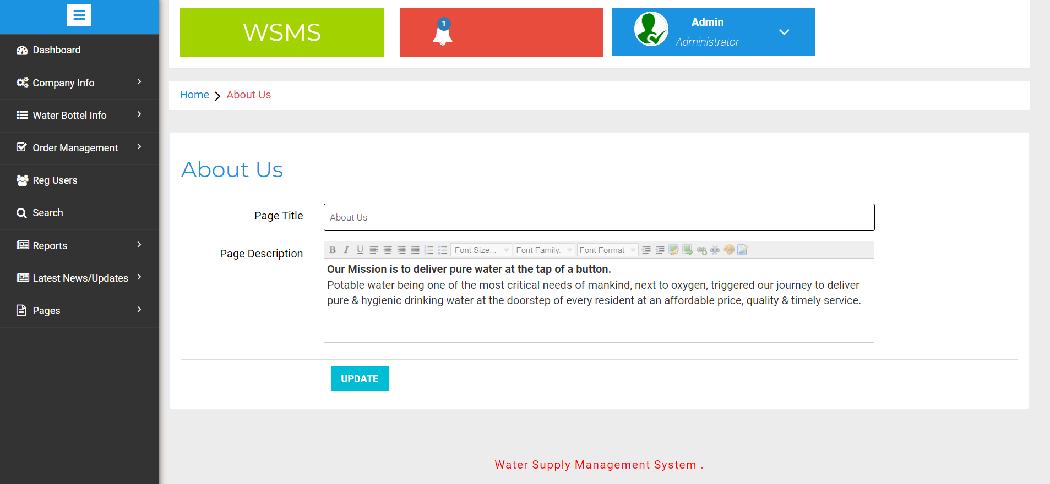

Contact Us

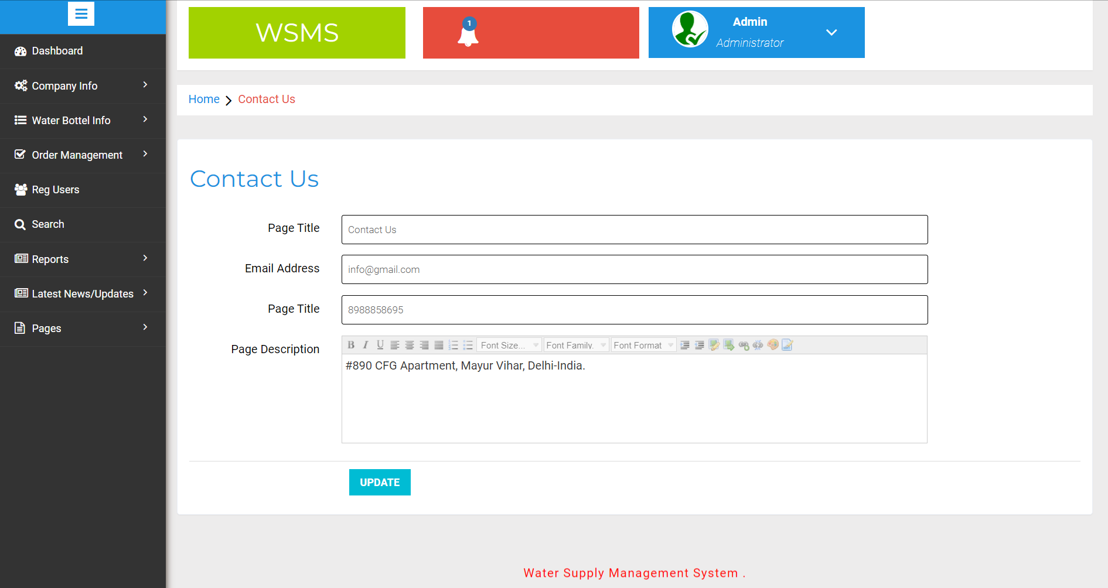

System Testing and Implementation

INTRODUCTION
Software testing is a critical element of software quality assurance and represents the ultimate review of specification, design and coding. In fact, testing is the one step in the software engineering process that could be viewed as destructive rather than constructive.
A strategy for software testing integrates software test case design methods into a well-planned series of steps that result in the successful construction of software. Testing is the set of activities that can be planned in advance and conducted systematically. The underlying motivation of program testing is to affirm software quality with methods that can economically and effectively apply to both strategic to both large and small-scale systems.

STRATEGIC APPROACH TO SOFTWARE TESTING
The software engineering process can be viewed as a spiral. Initially system engineering defines the role of software and leads to software requirement analysis where the information domain, functions, behavior, performance, constraints and validation criteria for software are established. Moving inward along the spiral, we come to design and finally to coding. To develop computer software we spiral in along streamlines that decrease the level of abstraction on each turn.

A strategy for software testing may also be viewed in the context of the spiral. Unit testing begins at the vertex of the spiral and concentrates on each unit of the software as implemented in source code. Testing progress by moving outward along the spiral to integration testing, where the focus is on the design and the construction of the software architecture. Talking another turn on outward on the spiral we encounter validation testing where requirements established as part of software requirements analysis are validated against the software that has been constructed. Finally we arrive at system testing, where the software and other system elements are tested as a whole.

UNIT TESTING

MODULE TESTING

SUB-SYSTEM TESING

SYSTEM TESTING

ACCEPTANCE TESTING
Component Testing
Integration Testing
User Testing

Unit Testing
Unit testing focuses verification effort on the smallest unit of software design, the module. The unit testing we have is white box oriented and some modules the steps are conducted in parallel.

1. WHITE BOX TESTING
This type of testing ensures that
- All independent paths have been exercised at least once
- All logical decisions have been exercised on their true and false sides
- All loops are executed at their boundaries and within their operational bounds
- All internal data structures have been exercised to assure their validity.

To follow the concept of white box testing we have tested each form .we have created independently to verify that Data flow is correct, All conditions are exercised to check their validity, All loops are executed on their boundaries.

2. BASIC PATH TESTING
Established technique of flow graph with Cyclomatic complexity was used to derive test cases for all the functions. The main steps in deriving test cases were:
Use the design of the code and draw correspondent flow graph.
Determine the Cyclomatic complexity of resultant flow graph, using formula:
V(G)=E-N+2 or
V(G)=P+1 or
V(G)=Number Of Regions
Where V(G) is Cyclomatic complexity,
E is the number of edges,
N is the number of flow graph nodes,
P is the number of predicate nodes.
Determine the basis of set of linearly independent paths.

3. CONDITIONAL TESTING
In this part of the testing each of the conditions were tested to both true and false aspects. And all the resulting paths were tested. So that each path that may be generate on particular condition is traced to uncover any possible errors.
4. DATA FLOW TESTING
This type of testing selects the path of the program according to the location of definition and use of variables. This kind of testing was used only when some local variable were declared. The definition-use chain method was used in this type of testing. These were particularly useful in nested statements.
5. LOOP TESTING
In this type of testing all the loops are tested to all the limits possible. The following exercise was adopted for all loops:
- All the loops were tested at their limits, just above them and just below them.
- All the loops were skipped at least once.
- For nested loops test the inner most loop first and then work outwards.
- For concatenated loops the values of dependent loops were set with the help of connected loop.
- Unstructured loops were resolved into nested loops or concatenated loops and tested as above.

Each unit has been separately tested by the development team itself and all the input have been validated.

CONCLUSION

It has been a great pleasure for me to work on this exciting and challenging project. This project proved good for me as it provided practical knowledge of not only programming in PHP and MySQL web based application. It also provides knowledge about the latest technology used in developing web enabled application and client server technology that will be great demand in future. This will provide better opportunities and guidance in future in developing projects independently.
BENEFITS:
The project is identified by the merits of the system offered to the user. The merits of this project are as follows: -
- It’s a web-enabled project.
- This project offers user to enter the data through simple and interactive forms. This is very helpful for the client to enter the desired information through so much simplicity.
- The user is mainly more concerned about the validity of the data, whatever he is entering. There are checks on every stages of any new creation, data entry or updation so that the user cannot enter the invalid data, which can create problems at later date.
- Sometimes the user finds in the later stages of using project that he needs to update some of the information that he entered earlier. There are options for him by which he can update the records. Moreover there is restriction for his that he cannot change the primary data field. This keeps the validity of the data to longer extent.
- User is provided the option of monitoring the records he entered earlier. He can see the desired records with the variety of options provided by him.
- From every part of the project the user is provided with the links through framing so that he can go from one option of the project to other as per the requirement. This is bound to be simple and very friendly as per the user is concerned. That is, we can say that the project is user friendly which is one of the primary concerns of any good project.
- Data storage and retrieval will become faster and easier to maintain because data is stored in a systematic manner and in a single database.
- Decision making process would be greatly enhanced because of faster processing of information since data collection from information available on computer takes much less time then manual system.
- Allocating of sample results becomes much faster because at a time the user can see the records of last years.
- Easier and faster data transfer through latest technology associated with the computer and communication.
- Through these features it will increase the efficiency, accuracy and transparency,

LIMITATIONS:
- The size of the database increases day-by-day, increasing the load on the database back up and data maintenance activity.
- Training for simple computer operations is necessary for the users working on the system.

BIBLIOGRAPHY

For PHP
- https://www.w3schools.com/php/default.asp
- https://www.sitepoint.com/php/
- https://www.php.net/

For MySQL

- https://www.mysql.com/
- http://www.mysqltutorial.org

For XAMPP
- https://www.apachefriends.org/download.html

