Mid-Term Test Questions:

Code will be turned into Dropbox during the test. Because of the short time frame, the code will not have to be fully commented, but you must turn in code that is readable, and indented properly, and you must provide your name and your section number in the header comments. You can receive up to 5 points per question extra credit if the turned in code meets coding standards including class and method header comments with Javadoc tags. Partial credit will be given for partially correct solutions.

**Question 1: 25 points**

Create a GUI using JavaFX that looks like this picture called Problem1.java.

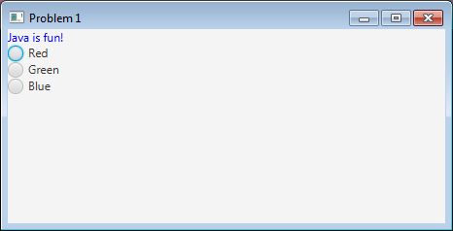

**Initial Appearance of Problem1.java**

**Hints: Use Text instead of Label for Java is fun!. Radio buttons should be part of a ToggleGroup for full credit.**

Turn in Problem1.java

**Question 2: 25 points**

Copy Problem1 into a class called Problem2

Construct three event handlers , one for each radio button. When red is clicked, the color of “Java is fun!” should change to red. Green turns it green and blue turns it blue.

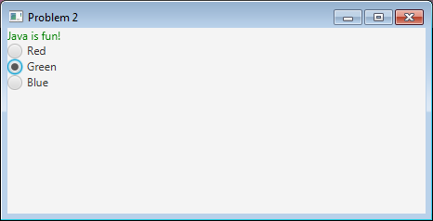

Turn in Problem2.java.

**Question 3: 25 points**

Attached to this dropbox are the files:

* WritePets.java
* Pet.java
* pets.dat

Write the file ReadPets.java that opens pets.dat and reads the individual pets and prints them to the console. You may not change Pet.java or WritePets.java or generate new pets.dat.

Turn in ReadPets.java