Lab 2 AES Side Channel Attack

Group Members:
Jerry Wu
DeeJay Morvay
Catherine Bernaciak

Part 1 – Milestone April 12, 2023
For this part, we are to implement an AES encryption engine onto our DE0-CV board using an open-source implementation. We were unable to get an account on OpenCores so we used the public Github implementation of Michael Ehab, [AES-Verilog]. The [AES-Verilog] implementation has a file with it’s own internal test vectors (AES.v). We modified this by adding the above NIST AESVS test vectors. If the ciphertext is as expected, then LEDR0 lights up. We were able to get it to run on the board and verified the following test vectors from the NIST AESVS document, Appendix B, did pass.

Test Vector Set #1
Here, the KEY is set to zero and the plaintext takes seven different values. In all cases, the output of [AES-Verilog] matched the NIST CIPHERTEXT output.

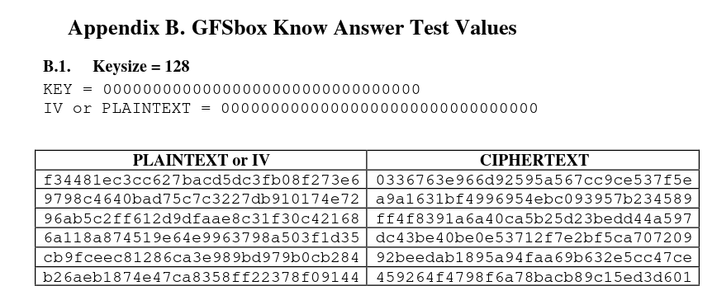
Test Vector Set #2
Here, the PLAINTEXT is set to zero and the key takes eight different values. In all cases, the output of [AES-Verilog] matched the NIST CIPHERTEXT output .

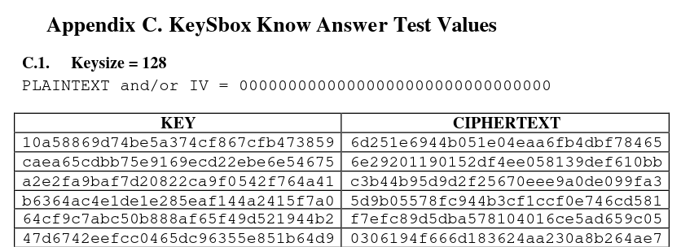

Power Analysis
From the ‘PowerPlay Power Analyzer’ output, the ‘Total Thermal Power Dissipation’ is 196.95mW.
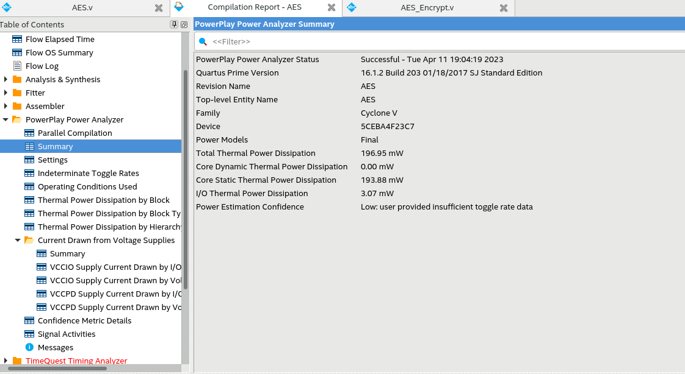
Flow Summary
Other metrics like Logic Utilization, are shown below
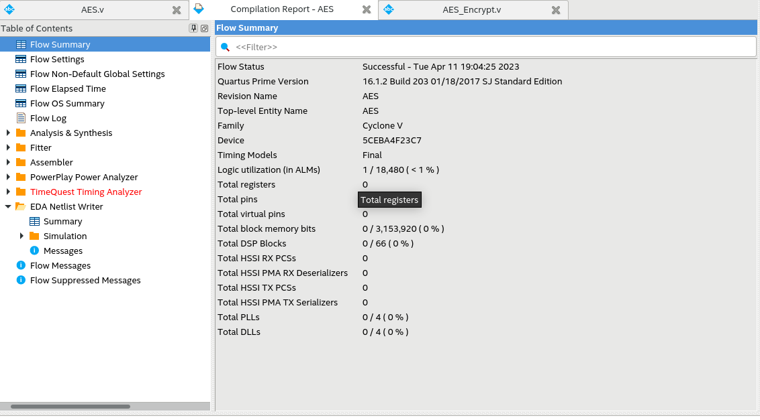

[AES-Verilog] https://github.com/michaelehab/AES-Verilog
[AESVS] https://csrc.nist.gov/CSRC/media/Projects/Cryptographic-Algorithm-Validation-Program/documents/aes/AESAVS.pdf

