**BROSS Google Earth Engine User Manual**

*Written by Claire Beveridge of University of Washington SASWE Research Group.*

*Originally published on 27 April 2020**, Last modified 1 June 2020*

1. **Introduction**

BROSS (“Bangladesh Remote Sensing of Suspended Sediments”) is an application co-developed by the Bangladesh Water Development Board (BWDB) and University of Washington SASWE Research Group. BROSS provides spatially and temporally distributed suspended sediment concentration (SSC) predictions for the Brahmaputra-Jamuna, Ganges-Padma, Padma, and Lower Meghna rivers of Bangladesh (Figure 1). BROSS uses satellite remote sensing imagery in the visible (red, green, blue) and near-infrared (NIR) spectra as inputs to models calibrated for Bangladesh rivers. BROSS is primarily intended to support BWDB in sustainably managing water resources and protecting human livelihoods throughout Bangladesh.

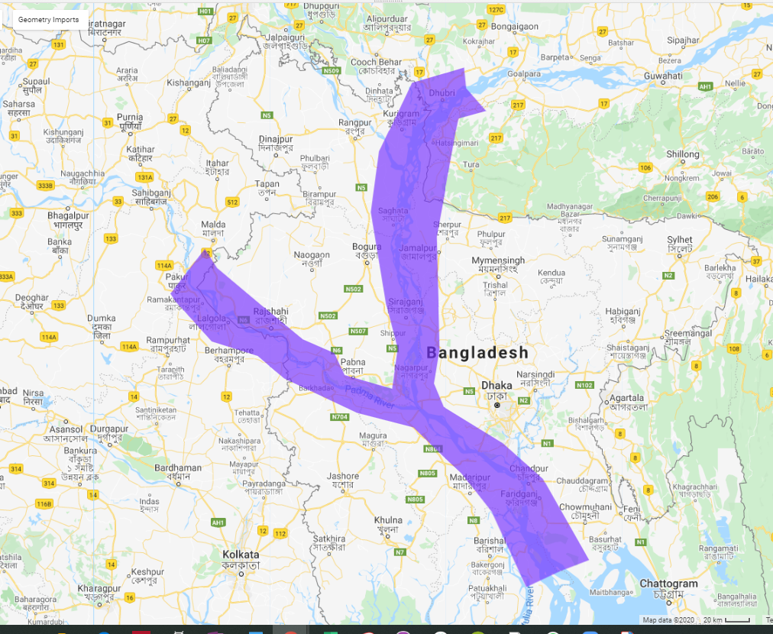

***Figure 1: BROSS (Google Earth Engine tool) domain***

BROSS has two operational platforms. One platform is Google Earth Engine (GEE). The second is called a ‘local server’ platform which operates using both a local desktop server and Google cloud. This manual provides user instructions for operating BROSS on the GEE platform. The link to this tool is [https://cbev.users.earthengine.app/view/bross-gee/](http://depts.washington.edu/saswe/bross/). This is a living document stored at <https://github.com/cbev/bross/blob/master/manual_user_GEE.pdf>.

The BROSS local server tool is found at <http://depts.washington.edu/saswe/bross/> and its manual is found at <https://github.com/cbev/bross/blob/master/manual_user_SASWE.pdf>.

Detailed technical background on the remote sensing and modeling techniques is found in the technical manual. We recommend that users who will be using SSC data from BROSS review the manual to understand the limitations and uncertainties of the data. The technical manual is a living document stored at <https://github.com/cbev/bross/blob/master/manual_technical.pdf>.

In this manual:

* Section 2 describes the BROSS GEE tool and how it compares to the BROSS local server tool
* Section 3 provides the mandatory and optional steps for operating the BROSS GEE system.
* Section 4 provides troubleshooting questions
* Section 5 provides frequently asked questions (FAQs)
* Section 6 provides the disclaimer

1. **Description of BROSS**

The BROSS GEE system operates using Landsat (5, 7, 8), Sentinel-2, and MODIS satellite data (Table 1). This system provides two data output options: (1) SSC estimated from satellite data using a regression model; and (2) satellite reflectance (SR) data in the visible (red, green, and blue) and near-infrared (NIR) wavelengths. Each of these outputs are provided in two forms: (1) a time series (of SSC predictions or SR data) averaged within a user-specified region of interest (ROI), over a user-specified date range; and (2) mapped over the BROSS domain (Figure 1) for each date of the time series. The maps are produced at the same spatial resolution as the satellite data (Table 1). Figure 2 shows and example of the two forms of outputs for the SSC option. The SSC and SR time series can be downloaded as .csv or image files.

***Table 1: Satellites used in BROSS******GEE tool***

|  |  |  |  |
| --- | --- | --- | --- |
| **Satellite** | **Spatial Resolution** | **Temporal Resolution** | **Date Range** |
| Landsat 5 (TM) | 30 m | 16 days | 1/1/1984-5/5/2012 |
| Landsat 7 (ETM+) | 30 m | 16 days | 4/15/1999- Present |
| Landsat 8 (OLI) | 30 m | 16 days | 2/11/2013- Present |
| Sentinel-2 | 10 m | 5 days | 2017- Present |
| MODIS | 500 m | 1 day | 2000- Present |

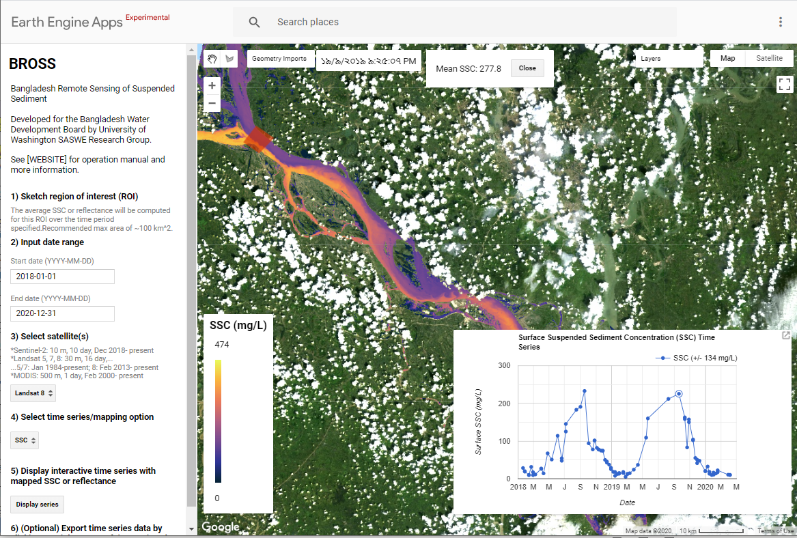

***Figure 2: Example output of BROSS in GEE****- A map of SSC along the Padma river and a time series of the SSC averaged for region of interest (red box, upper left of satellite image)*

BROSS computes/maps SSC and SR only for pixels that are classified as water and cloud-free. Therefore, there may be limited pixels in regions with river widths narrower than satellite resolution, such as along the braided Jamuna river when flows are low. This is a notable issue with the MODIS satellite data, due to its relatively large spatial resolution (500m). Cloud cover is a prominent issue during the monsoon season (June to September). It is possible that there are no cloud-free pixels for a given date and that the entire image will be excluded from BROSS results. Not all pixels impacted by land surface, clouds, and fog are masked perfectly, therefore users should be especially cautious when interpreting data in river pixels that are shallow depth and/or near land, and during foggy/cloudy days. Limitations are further discussed in the technical manual.

Accompanying the GEE tool is a computational notebook that uses the satellite reflectance data downloaded from GEE to generate a time series of SSC predicted from an artificial neural network (ANN) model (see more information in step v of Section 3). Table 2 summarizes the difference between the regression and ANN model performance, and further details are provided in the technical manual.

***Table 2: Statistical Tests for Model Performance of SSC Predictions (ANN vs Regression).*** *Stronger results for each satellite group and indicator is in* ***bold.***



The BROSS local server system directly predicts and maps SSC from both regression and ANN models. Table 3 compares the key features of the two BROSS tools.

***Table 3: Comparison of BROSS GEE and BROSS SASWE systems***

| **Feature** | **Local server** | **Google Earth Engine** |
| --- | --- | --- |
| Mapped SSC from regression | X | X |
| Mapped SSC from ANN | X |  |
| SSC time series from regression | X | X |
| SSC time series from ANN | X | Use separate computational notebook |
| SSC time series for user-defined region of interest |  | X |
| SSC time series auto-generated at in situ monitoring stations | X |  |
| Satellite data availability | Landsat 8 | Landsat 5, 7, 8;  Sentinel-2; MODIS |
| Spatial resolution of maps | Regression: 100m, ANN: 200 m | Landsat: 30 m,  Sentinel-2: 10 m,  MODIS: 500 m |
| Temporal availability | Time Series: Full extent of Landsat 8 data Map: Past 6 months | Full extent of satellite data |
| Able to export time series | X | X |
| Able to export map | X |  |
| Able to view values of individual pixels | X | X |
| Able to view and download satellite reflectance data |  | X |
| Data storage source | Local server | Google Cloud |
| Computing source | Google Cloud | Google Cloud |
| Computing language | Python | JavaScript |

1. **Operational steps**
2. **Start application.** In a web browser, navigate to the BROSS GEE website: <https://cbev.users.earthengine.app/view/bwdb-ssc-prototype>
3. **Set up filters.** Note that parts a-d can be completed in any order, but *all* must be completed for BROSS to work.
   1. **Sketch a region of interest (ROI) within the BROSS domain (Figures 1 and 3).** The average SSC or surface reflectance will be computed for this ROI over the time period specified (in step 2)**.**

* The ROI must be a closed polygon for BROSS to work. You will know that it is closed if it turns red (like in Figure 3)
* It is okay for the ROI to encompass land area as BROSS will exclude pixels classified as land.
* You can move, reshape, or redo the ROI (see Section 5, Frequently Asked Questions)

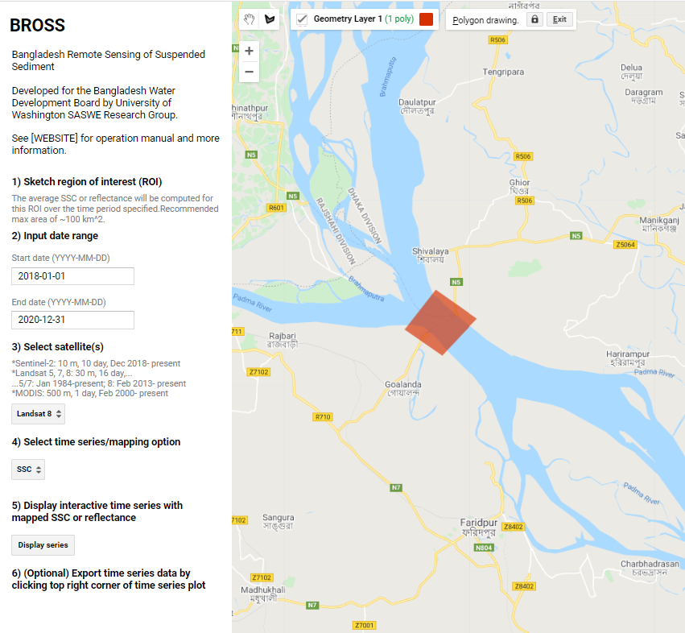

**Figure 3: Example region of interest (ROI)**

* 1. **Input the date range of interest.** The time series of SSC will be provided for this date range.
* There are default dates already in the boxes which can be modified.
* The input format is YYYY-MM-DD (e.g., 2019-03-26 for 26 March 2019).
  1. **Select satellite(s) from the dropdown menu.** The time series and mapped data will be generated using data from the satellite selected (Table 1)
* The satellites vary in their spatial resolution, temporal resolution, date range of availability, and performance, as shown in Tables 2 and 3.
  1. **Select time series/mapping option from the dropdown menu.** The time series and map will be displayed for either SSC or the surface reflectance (SR; (red/blue/green/NIR).
* SR (red/blue/green/NIR) is directly from the satellite.
* SSC is computed using SR and an equation developed from empirical regression.

1. **Click “Display interactive time series with mapped SSC or reflectance.”** This will apply the filters set up in step ii and begin calculating the time series for the SSC or SR.

* The box in the bottom right hand corner will say “Generating chart…” after you click this. The box will also display an alert if an error occurs.
* It may take a few seconds or up to several minutes for the processing to finish depending on the filters applied.

1. **Optional Steps in GEE:**
   1. **Display a data map (SSC or SR) for a specific date** by clicking a point on the time series

* For SR data option, the red reflectance data is automatically added to the map. To add blue, green, or NIR reflectance data, hover over the “Layers” panel in the upper right hand corner. Check the box for the layer (e.g., Blue) that you would like to add to the map and uncheck “Red.”
  1. **Display the value of a pixel (SSC or SR) by clicking on the pixel.**
* You may need to click the “Esc” key first to get the appropriate cursor, which is a cross
* This can only be done if step iv.a. has been done first
  1. **Export the time series plot data and/or image** by clicking on the small boxed arrow on the top right hand corner of the chart.
  2. **View the soil texture map**
  + Hover over the “Layers” panel in the upper right hand corner. Check the box for “Soil texture.” The “Soil Texture” legend is shown on the left hand side of the map.
  + To close the “Soil Texture” legend, click the “Close” button at the bottom.
  1. **Produce SSC time series for the ROI using ANN**
* Follow steps i-iii to generate a time series of surface reflectance (in step ii.d., must select “surface reflectance)
* On the time series chart on the bottom right hand corner of the screen, click on the small boxed arrow on the top right hand corner of the chart.
* A new tab will open in your browser showing the time series. On that tab, click on the “Download CSV” button at the top right hand corner.
* A file called “ee-chart.csv” will download. You will need this file in the next steps, so know where the file is located.
* If desired, you can download multiple files of satellite reflectance data and combine them into a single Excel file
* Navigate to the “Google Colab” notebook by clicking on the link that is below Step 5 in GEE application window, or by copying and pasting the following into your web browser: <https://colab.research.google.com/drive/1xR-YsvHcMfTR-HOhXeUWskIM3wQIqE2a>
* Follow the steps at the top of the notebook

1. **Troubleshooting**
2. **In GEE, the computation is taking too long or is timing out.** Try to decrease the size of the ROI (try ~100 km2 or smaller) and/or reduce the date range (try ~2 years)
3. **In GEE, the box in the lower right hand size says: “Error generating chart: Array: No number in ‘values’, must provide a type.**” Check that an ROI is sketched and that it is a closed polygon (i.e., filled with red on the inside). Check that the date range is valid (e.g., end date comes after the start date). Check that the date range entered is within the date range that the satellite you selected is available (date ranges are in Table 1 and listed under “c. Select satellite(s)” on the BROSS interface). Check that a satellite is selected from the dropdown menu. Check that a time series/mapping option is selected from the dropdown menu.
4. **In GEE, I cannot sketch an ROI.** Go to the upper left hand corner of the screen and hover over “Geometry layer 1.” It will then turn to a dropdown box with a heading of “Geometry Imports.” Click on/toggle “Geometry layer 1” and ensure that it’s bolded. Then, you should be able to sketch the ROI directly on the map.
5. **In GEE, the time series of SSC or SR has two values and maps for the same date.** Often, there will duplicate images from a satellite for the same date a location. BROSS includes both so that they user has a sense of the range of uncertainty for the given date.
6. **In GEE, the map only covers a portion of the BROSS domain.** The BROSS domain is large enough such that it contains multiple satellite images. Google Earth Engine automatically excludes images that are excessively impacted by cloud cover or other issues (e.g., equipment failure).
7. **In GEE, data is available for a specific date for one ROI, but not for another.** At least 30% of the pixels in the user-specified ROI must pass both the “water” and “cloud-free” tests for a data point to be computed for the time series. So, if less than 30% of the pixels are “water” and “cloud-free” in and ROI, all images will be excluded from the time series for that time series.
8. **In GEE, why do there appear to be “stripes” in the images?** Unfortunately, this is a known issue with Landsat data. Please see the following link for more information: <https://www.usgs.gov/land-resources/nli/landsat/detector-striping?qt-science_support_page_related_con=0#qt-science_support_page_related_con>

*Do you have a troubleshooting question that is not shown? Please submit it at:* [*https://forms.gle/z7WSYt4b94rZFwh78*](https://forms.gle/z7WSYt4b94rZFwh78)

1. **Frequently Asked Questions (FAQ)**
2. **In GEE, how do I modify or redo the ROI after I have sketched it?**

* To modify the ROI, you will need to first click on it. Then, you can move it by clicking, holding, and dragging it. You can reshape it by selecting vertices and moving them.
* To redo the ROI, click on it and hit “Delete” on your keyboard. Go to the upper left hand corner of the screen and hover over “Geometry layer 1.” It will then turn to a dropdown box with a heading of “Geometry Imports.” Click on/toggle “Geometry layer 1” and ensure that it’s **bolded.** Then, you should be able to sketch a new ROI directly on the map.

1. **In GEE, how do I expand the range of SSC in the legend?** The legend automatically adjusts based on the range of SSC in the ROI for a given data (it’s ~2x higher than the max SSC of the ROI for each date). To change the range, move the ROI to an area with higher or lower SSC.
2. **In GEE, for the satellite reflectance data option, what it the “Satellite ID” in the legend and .csv output?** This is a number that represents which satellite the data comes from. It is a necessary input for the ANN notebook (Step iv.e). It does not plot on the time series in GEE, however we are unable to remove it from the legend- so please ignore it.
3. **How do I cite this tool?** See the information at the following link: <http://depts.washington.edu/saswe/bross/cite.html>

*Do you have a question that is not shown? Please submit it at:* [*https://forms.gle/z7WSYt4b94rZFwh78*](https://forms.gle/z7WSYt4b94rZFwh78)

1. **Disclaimer**

BROSS is a research grade platform that is continuously under development. Users should use the outputs at their own risk. Developers of the system do not accept any responsibility for erroneous data or outputs that may trigger improper decision making.