**BROSS User Manual- SASWE Application**

*Written by Claire Beveridge with assistance from Shahryar Ahmad of University of Washington SASWE Research Group.*

*Originally published on 27 April 2020*

1. **Introduction**

BROSS (“Bangladesh Remote Sensing of Suspended Sediments”) is a tool developed for the Bangladesh Water Development Board (BWDB) by the University of Washington SASWE Research Group. BROSS provides spatially and temporally distributed suspended sediment concentration (SSC) predictions for the Brahmaputra-Jamuna, Ganges-Padma, and Padma rivers of Bangladesh (Figure 1). BROSS uses satellite remote sensing imagery in the visible (red, green, blue) and near-infrared (NIR) spectra as inputs to models calibrated to Bangladesh rivers. It is intended that BROSS will help BWDB with river sediment monitoring and management.

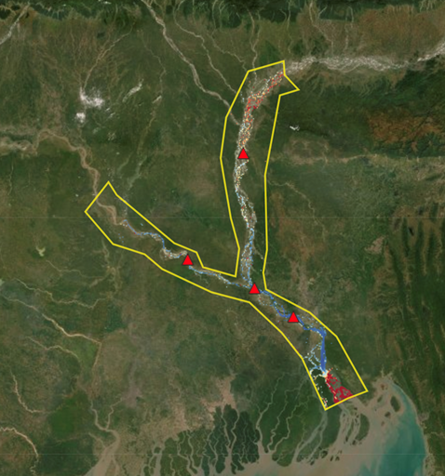

***Figure 1: BROSS (SASWE tool) domain***

This manual provides user instructions for operating BROSS on the SASWE system (<http://depts.washington.edu/saswe/bross/>). This is a living document stored at <https://github.com/cbev/bross/blob/master/manual_user_SASWE.docx>. Detailed technical background on the remote sensing and modeling techniques is found in the technical manual. We recommend that users who will be using SSC data from BROSS review the manual to understand the limitations and uncertainties of the data. The technical manual is a living document stored at <https://github.com/cbev/bross/blob/master/manual_technical.docx>.

The BROSS SASWE system operates using Landsat 8 satellite data. The system provides two data output options: (1) SSC estimated from satellite data using a regression model; and (2) SSC estimated from satellite data using an artificial neural network (ANN) model. Table 1 summarizes the difference between the regression and ANN model performance, and further details are provided in the technical manual. Each of the outputs are provided in two forms: (1) a time series of SSC estimates at four in situ monitoring stations (Bahadurabad, Hardinge Bridge, Baruria, and Mawa) since 2013 (when Landsat 8 was first operational); and (2) SSC mapped over the BROSS domain (Figure 1) for the past 6 months. Figure 2 shows an example of these two forms of outputs. Both the SSC time series and map data can be downloaded by the user.

***Table 1: Statistical Tests for Model Performance of SSC Predictions for Landsat 8 (ANN vs Regression).*** *Stronger results for each satellite group and indicator is in* ***bold.***



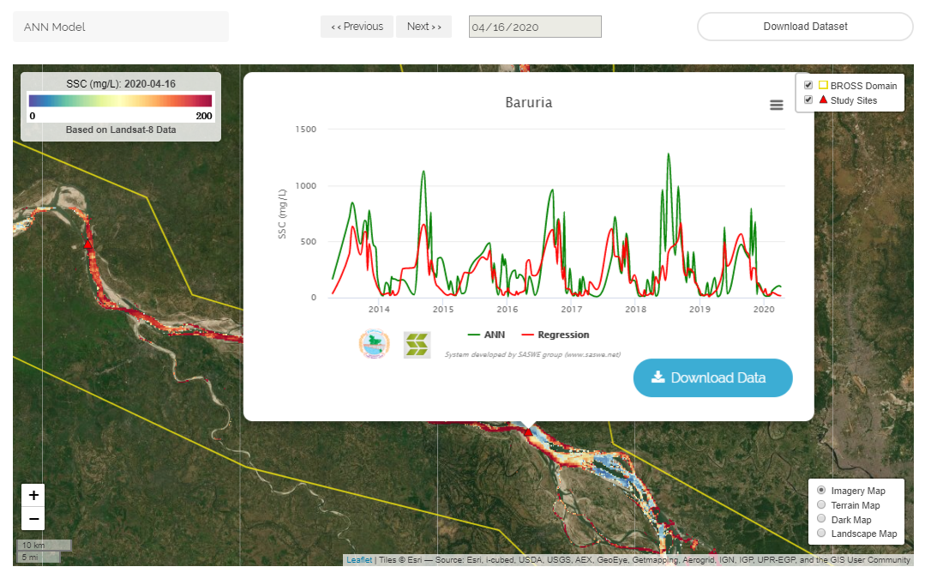

***Figure 2: Example outputs of BROSS SASWE system****. A map of SSC from ANN model along the Padma river and a long-term time series of SSC predicted from satellite data using ANN and regression models at Baruria.*

In addition to the BROSS SASWE tool, there is a BROSS system implemented in Google Earth Engine (GEE) which provides the raw satellite reflectance data and SSC predictions from regression. The BROSS GEE tool has an accompanying computational notebook to generate SSC time series from ANN. Table 2 summarizes the difference capabilities of the two BROSS tools. The BROSS GEE tool is found at <https://cbev.users.earthengine.app/view/bwdb-ssc-prototype> and its living manual is found at <https://github.com/cbev/bross/blob/master/manual_user_GEE.docx>.

***Table 2: Comparison of BROSS GEE and BROSS SASWE systems***



In this manual:

* Section 2 provides the mandatory and optional steps for operating the BROSS SASWE system.
* Section 3 provides troubleshooting questions
* Section 4 provides frequently asked questions (FAQs)

1. **Operational steps**
2. **Start application.** In a web browser, navigate to the BROSS SASWE system website: <http://depts.washington.edu/saswe/bross/>
3. By default, the initial SSC map that will appear is developed from the most recent Landsat 8 data using the regression model
4. **Optional Steps**. Note that these steps can be conducted in any order
5. View the full (Landsat 8) time series of SSC predicted using the regression and ANN models at that site by clicking on a “Study site” symbol (red triangle) on the map

* To obtain the data as comma separated values, click on “Download data” at the bottom right corner of the time series box. You can copy and paste the displayed values into an Excel sheet or text editor.

1. View SSC map from a different model (Regression or ANN) by clicking on the “Regression Model” or “ANN Model” dropdown menu at the top left corner of the application window. Then, select the desired model.
   * Note that it may take several seconds for the new map to load. Be patient during this time and minimize interaction with the application.
   * Table 1 (Section 1) and technical manual (link in Section 1) provide the difference in performance between the regression and ANN models for Landsat 8.
2. Get the SSC value of a single pixel on the SSC map by clicking on the pixel. A callout box with the SSC value will pop-up.
3. Export the SSC map as a .tif file by clicking on the “Download Dataset” button on the top right hand corner of the application window.
4. View data from a different date over the past 6 months by clicking the “<<Previous” or “Next >>” button at the top center of the application screen.
   * Only 1st and 16th date of each month is available in the application. This is because Landsat 8 collects data every 16 days. Since there are multiple satellite images collected across the domain, we grouped the data by the 1st and 16th date for convenience. The data was not necessarily collected on the 1st or 16th of the month. The actual dates that data were collected are shown in the time series for each study site.
   * Only data over the past 6 months can be mapped.
   * Note that it may take several seconds for the new map to load. Be patient during this time and minimize interaction with the application.
5. **Troubleshooting**
6. **The computation is taking too long or is timing out.** This is a known challenge in working with a large study domain, high resolution, and extensive computations. Please be patient when operating the system. After making one change, wait for the map to finish loading before going to the next change (a change, for example, would be changing the data or model, or zooming in/out of the map). If the system is persistently crashing and/or persistently taking several minutes for a single change to occur, please submit the issue at [*https://forms.gle/z7WSYt4b94rZFwh78*](https://forms.gle/z7WSYt4b94rZFwh78)*.*
7. **Why do there appear to be “stripes” in some of the images?** Unfortunately, this is a known issue with Landsat data. Please see the following link for more information: <https://www.usgs.gov/land-resources/nli/landsat/detector-striping?qt-science_support_page_related_con=0#qt-science_support_page_related_con>

*Do you have a troubleshooting question that is not shown? Please submit it at:* [*https://forms.gle/z7WSYt4b94rZFwh78*](https://forms.gle/z7WSYt4b94rZFwh78)

1. **Frequently Asked Questions (FAQ)**
2. **Can additional study sites be added?** Additional study sites may be added at the request of BWDB staff. We recommend adding study sites that need to be frequently monitored. However, please be aware that increasing the number of study sites will increase the map loading time. Please submit site name, location (latitude, longitude, and coordinate system), and justification for the request at: [*https://forms.gle/z7WSYt4b94rZFwh78*](https://forms.gle/z7WSYt4b94rZFwh78)
3. **What is the uncertainty of the SSC predictions?** See the root mean square error (RMSE) in Table 1 for the respective regression or ANN model. The range of error is plus or minus the RMSE.
4. **How do I cite this tool?** Click the “How to Cite” button at the top right of the application window for more information.

*Do you have a question that is not shown? Please submit it at:* [*https://forms.gle/z7WSYt4b94rZFwh78*](https://forms.gle/z7WSYt4b94rZFwh78)