**Subject: Update on satellite-based monitoring of suspended sediment in Bangladesh rivers**

Date: 27 April 2020

To: AM Aminul Haque, Director General, Bangladesh Water Development Board (BWDB)

From: Claire Beveridge, PhD Candidate, SASWE Research Group, University of Washington (UW)

Dear Sir AM Aminul Haque,

I am writing to inform you that “BROSS” (Bangladesh Remote Sensing of Suspended Sediments) is ready for BWDB’s trial use. **I am also kindly asking that the latest BROSS deliverables (listed below) be provided to staff to review and test.** I would greatly appreciate any feedback on BROSS that BWDB has to offer.

As we discussed in our meeting at the BWDB headquarters on 5 January 2020, SASWE has been using two approaches for predicting river suspended sediment concentrations (SSC) from satellite data: regression and artificial neural networks (ANN). **Both regression and ANN give meaningful insights on SSC in Bangladesh rivers, however ANN has stronger performance overall** (for more information, see Table 4 in Technical Manual, link below). Regression is a simple, widespread approach that is easier to implement. ANN is more complicated and limited in applications, but is well-suited for complex, non-linear systems such as the rivers of Bangladesh.

**SASWE has developed two BROSS tools for satellite-based monitoring of SSC: (1) using a cloud-based computing system, Google Earth Engine; and (2) using the SASWE server.** The systems differ in their capabilities of using regression and ANN to predict SSC. They also differ in factors such as spatial resolution and available satellite data. Please see the table and figures on next pages for more details. Our goal is to develop a single BROSS application in Google Earth Engine that combines the strengths of both existing tools. However, we encountered challenges to implementing ANN using Google Earth Engine which require further investigation. Until we resolve the challenges, we are making two tools available so BWDB may begin to leverage the benefits of remote SSC monitoring.

The latest deliverables can be found at the following links.

* SASWE application: <http://depts.washington.edu/saswe/bross/>
  + SASWE application user manual (click “Download” button at the link): <https://github.com/cbev/bross/blob/master/manual_user_SASWE.docx>
* GEE application: <https://cbev.users.earthengine.app/view/bross-gee>
  + GEE application user manual (click “Download” button at the link): <https://github.com/cbev/bross/blob/master/manual_user_GEE.docx>
* Technical manual (click “Download” button at the link): <https://github.com/cbev/bross/blob/master/manual_technical.docx>

Thank you for your time and assistance. I would be happy to conduct a virtual meeting with BWDB staff on these deliverables, if desired. If you or any BWDB staff have any questions or concerns, please feel free to contact me (Claire) at [cbev@uw.edu](mailto:cbev@uw.edu) or Professor Faisal Hossain at [fhossain@uw.edu](mailto:fhossain@uw.edu). I look forward to receiving feedback on BROSS and continuing to work on it so that it meets BWDB’s needs.

**Table 1: Comparison of BROSS tools- GEE and SASWE monitoring systems**

|  |  |  |
| --- | --- | --- |
| **Feature** | Google Earth Engine | SASWE server |
| Mapped SSC from regression | X | X |
| Mapped SSC from ANN |  | X |
| SSC time series from regression | X | X |
| SSC time series from ANN | Use separate computational notebook | X |
| SSC time series for user-defined region of interest | X |  |
| SSC time series auto-generated at in situ monitoring stations |  | X |
| Satellite data availability | Landsat 5, 7, 8;  Sentinel-2; MODIS | Landsat 8 |
| Spatial resolution | Landsat: 30m, Sentinel-2: 10m, MODIS: 500m | 200m |
| Temporal availability | Full extent of satellite data | Past 6 months |
| Able to export time series | X | X |
| Able to export map |  | X |
| Able to view values of individual pixels | X | X |
| Able to view and download satellite reflectance data | X |  |
| Data storage source | Google Cloud | SASWE server |
| Computing source | Google Cloud | Google Cloud |
| Computing language | Javascript | Python |

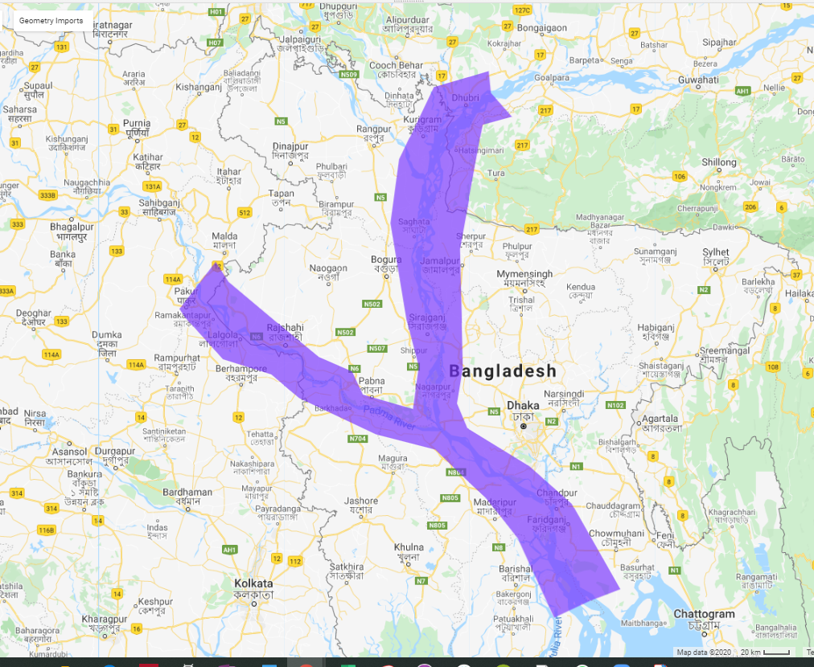

**Figure 1: BROSS (GEE tool) domain**

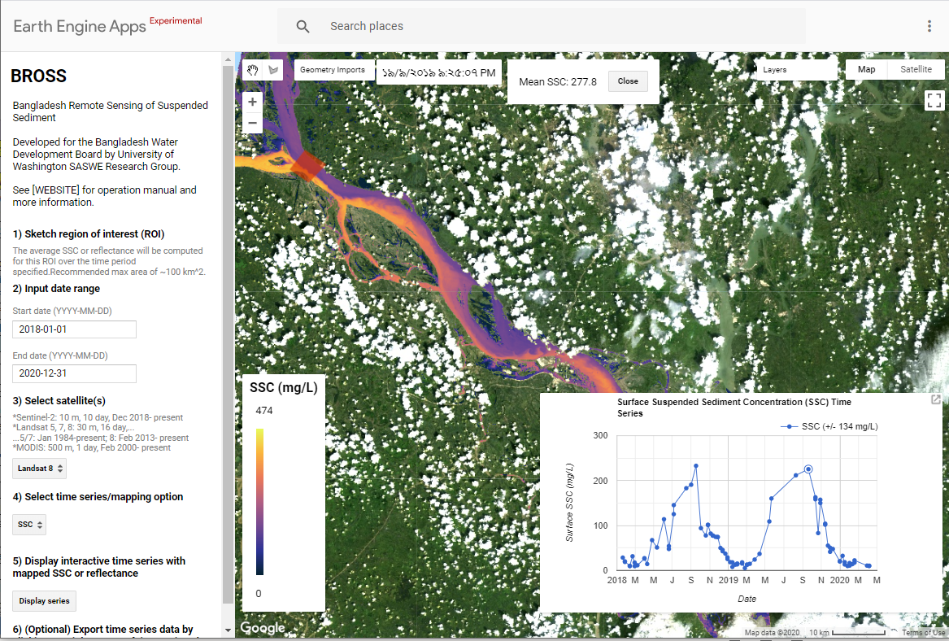

**Figure 2: Example output of BROSS in GEE**- A map of SSC along the Padma river and a time series of the SSC averaged for region of interest (red box, upper left of satellite image)

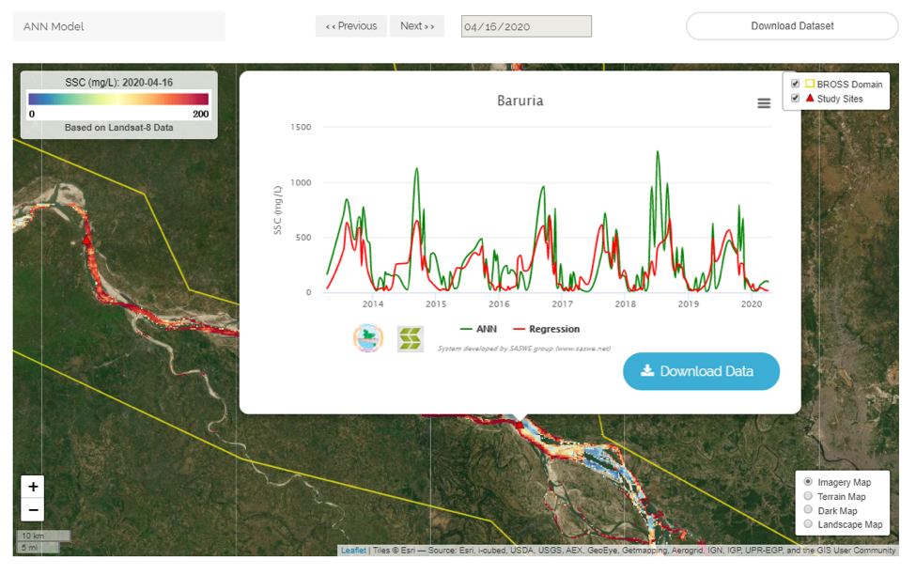

**Figure 3: Example outputs of BROSS SASWE system**. A map of SSC from ANN model along the Padma river and a long-term time series of SSC predicted from satellite data using ANN and regression models at Baruria.