# Time references

The following diagram demonstrates a timeline example for a single resource and successful containment. This one is correct because it is a single resource.

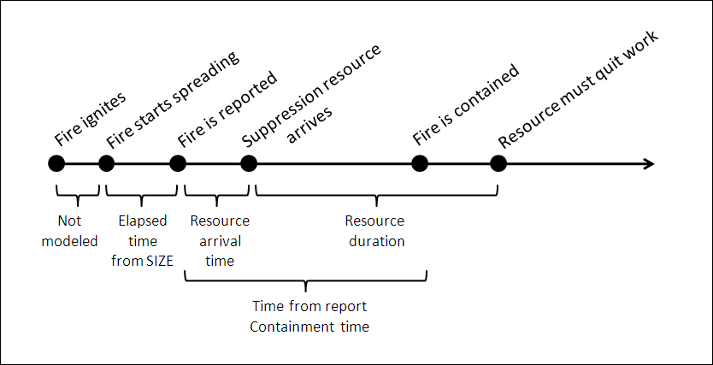

The next diagram provides a timeline example for multiple resources (two in this case) and unsuccessful containment because resource need exceeded specified duration. So in this case, Resource 1 will arrive earlier than Resource 2, but, if I understand correctly from your notes….

* + Resource 1 was unable to stop the fire alone.
  + Therefore, no one starts working until Resource 2 arrives.
  + What happens when Resource 2 has to stop work before Resource 1 – does all suppression work stop at that time?

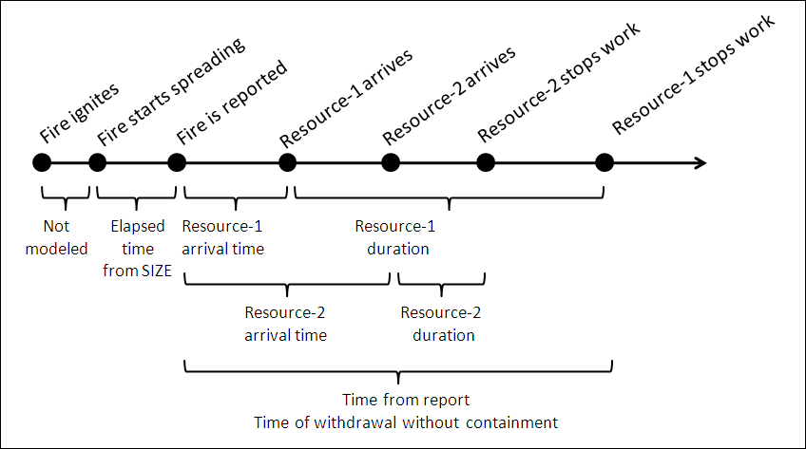

This is the main contain simulation loop:

* SET initial attack time to arrival of first force
* SET rerun to TRUE
* WHILE rerun
  + WHILE forces not overrun AND fire not contained AND spread distance limit not exceeded AND maximum step limit not exceeded
    - Simulate next time step
    - IF forces are overrun
      * SET status to OVERRUN
      * IF no retry is allowed
        + SET rerun to FALSE
      * ELSE IF more forces are arriving
        + SET initial attack time as the next force arrival time
      * ELSE IF no more forces are arriving
      * SET status to EXHAUSTED
        + SET rerun to FALSE
      * LOOP
    - ELSE (fire is contained, spread distance exceeded, etc)
  + END WHILE
* END WHILE

It may be helpful to add “Initial Attack” to the diagrams.

To answer your question:

* Initial attack is delayed until Resource 2 arrives
* Both resources work until Resource 2 duration expires
* At some point thereafter Resource 1 works alone until it is overrun or contains the fire. Containment might still be possible depending upon the tactic, attack distance, and amount of control line remaining to be built to achieve containment. For example, if Resource 2 quits with just 1 chain of line left to build, Resource 1 could possibly manage containment.

Collin