**BehavePlus6, Build 614, Detailed Release and Status Notes**

**Collin Bevins, April 8, 2015**

BehavePlus6 Build 614 contains significant changes from the previous Build in two major areas. First, it includes the Scott & Reinhardt (2005) crown fire model computations and variables as requested by Issue #064FAH. Because BP6 now deals with multiple fire types (surface fire, Rothermel crown fire, active and passive/torching crown fire) and multiple fuel layers and types (surface, canopy/crown, p-g, aspen, and chaparral), there is a need to disambiguate many of the variable labels still in use from Version 5 where surface fire predominated. It is no longer adequate to have unattributed labels such as “Flame Length” or “Fine Fuel Load”.

**Scott & Reinhardt Crown Fire Model Considerations**

Build 614 yields results identical with Nexus for the following variables

* Surface Fire ROS (Rsurface)
* Crown Fire ROS (Ractive)
* Surface Fireline Intensity (I)
* Critical Surface Fireline Intensity (I’initiation)
* Critical Surface Fire ROS (R’initiation)
* Critical Crown Fire ROS (R’active)
* Quantitative Crown Fire Classification (Surface, Passive, Active)

However, the calculation of O’active (and therefore R’sa ) differs significantly. Within the O’active Equation 20, the term:

( ϵ x Qig ) / (IR x CBD)

evaluates to 2316 within Nexus, but 2601 within BehavePlus6. Since CBD is a simple user input (and essentially is a constant in the content of this equation), it can probably be ruled out as the source of the difference. Also, the fact that all the crown fire variables bulleted above are in agreement between Nexus and BP6 indicates that both programs are using the same value for IR. I have confirmed that BehavePlus6 is using the weighted cumulative ( ϵ x Qig ) as indicated by Rothermel (1972) Eq 77 on page 32. Since I do not have access to the computational code used by Nexus (it appears to use a dll from some other source, perhaps FlamMap), I am unsure how it obtains ( ϵ x Qig ). The net result is that Nexus produces an O’active of 34.8 mph when BP6 yields 37.7 mph for the test case. The resulting R’sa is 19.42 ch/h by Nexus and 21.56 ch/h by BP6. Close, but…

**Crown Module Dialog**

The Crown Module configuration dialog for Build 614 has 1 tab for “Input Options”, and spreads output variables across 5 tabs:

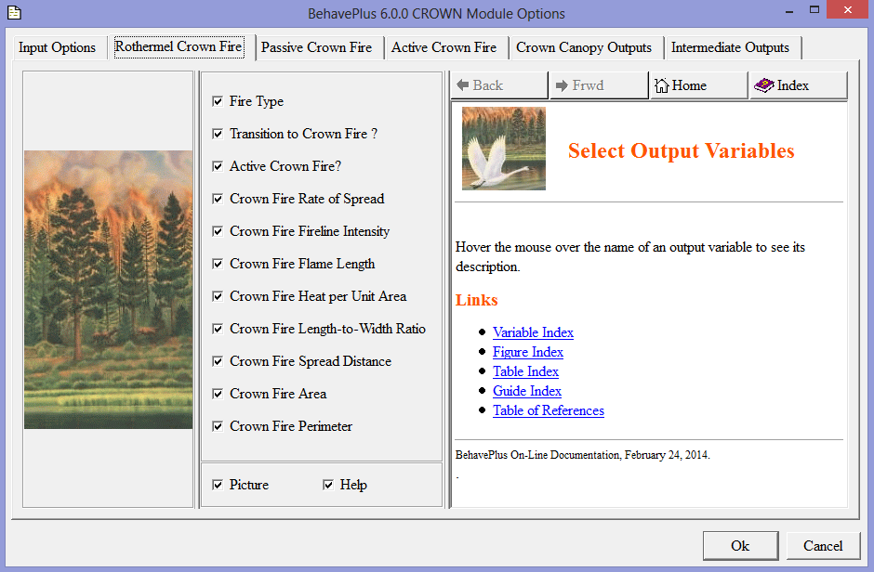

Scott & Reinhardt calculations are invoked only if one or more of the Active Crown Fire or Passive Crown Fire variables are selected for output. There is no need for a “Use S&R” check box or for a Run Option indicating that S&R is selected, since S&R does not change any of the Rothermel crown fire variables.

**Variable Labels**

Version 6 now contains multiple fire types (surface fire, Rothermel crown, active crown, passive crown) each with its own set of attributes (ros, intensity, flame length, spread distance, area, perimeter). The number of fuel types has also expanded (surface, crown, aspen, p-g, chaparral) each with its own set of attributes (load, bulk density, moisture content). Also consider the naming issues surrounding all the *…from Ignition Point* *and …from Fire Front* variables).

In summary, the variable labeling scheme used in Version 5 is no longer adequate to disambiguate between the common attributes of the various fire and fuel types. For example, Version 5 uses the label “Flame Length” for surface fire flame length, and “Crown Flame Length” for the Rothermel crown fire flame length.

I propose a two tier naming convention wherein each variable has a ‘genus’ label (“Surface Fire”, “Rothermel Crown”, “Passive Crown”, “Active Crown”, etc.) and a ‘species’ or attribute label (“Spread Rate”, “Flame Length”, etc.). The genus-species combination makes up the label that appears on input forms, output checkboxes, and simple table outputs. In tabular output the genus is used as the first column header and the species/attribute is used as the second column header.

To initiate and illustrate this approach, I have relabeled many of the Version 5 variables in Build 614. I have also created a spreadsheet listing all the Version 5 and Version 6 variables and their attributes. This simplifies the task of identifying variables introduced in Version 6 (highlighted in green) and variables from Version 5 that now have updated label and/or column headers (highlighted in yellow) in V6.

Implementing a new label scheme will be challenging, as it necessitates updating many of the help files and published documentation. But there may be little other recourse to aid users in differentiating amongst all the variables now in BehavePlus.

**Additional Help Files Needed**

Build 614 installs stub help files for the new S&R variables (the files currently just contain their title line). These files are:

* vCrownFireActiveCritOpenWindSpeed.html
* vCrownFireActiveCritSurfSpreadRate.html
* vCrownFireActiveArea.html
* vCrownFireActiveFireLineInt.html
* vCrownFireActiveFirePerimeter.html
* vCrownFireActiveFireWidth.html
* vCrownFireActiveFlameLeng.html
* vCrownFireActiveHeatPerUnitArea.html
* vCrownFireActiveSpreadDist.html
* vCrownFireActiveSpreadRate.html
* vCrownFireCanopyFractionBurned.html
* vCrownFirePassiveArea.html
* vCrownFirePassiveFireLineInt.html
* vCrownFirePassiveFirePerimeter.html
* vCrownFirePassiveFireWidth.html
* vCrownFirePassiveFlameLeng.html
* vCrownFirePassiveHeatPerUnitArea.html
* vCrownFirePassiveSpreadDist.html
* vCrownFirePassiveSpreadRate.html

**Optional Desktop Icon on Installation**

The Build 614 installer package bp6_614.msi now includes a checkbox on the “Destination Folder” dialog that says “Check here to create a desktop shortcut for BehavePlus6”. If checked, then a BehavePlus6 icon is placed on the desktop and a BehavePlus6 entry appears on the TaskBar Desktop menu. Regardless of whether or not this is checked, a BehavePlus6 entry is always installed on the Start Menu (or Start page for Win 8).