Back end result

Eureka Server

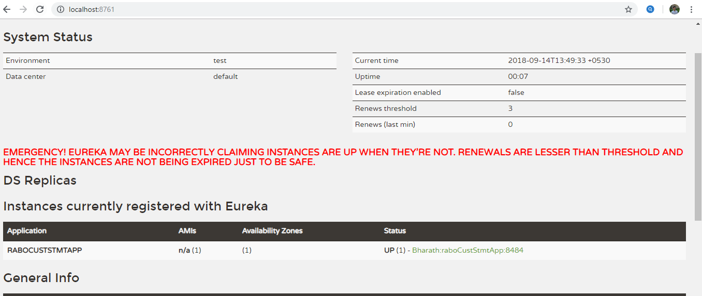

Service to validate and create the customer file

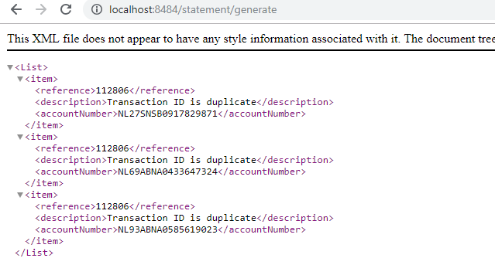

Output files



CSV file



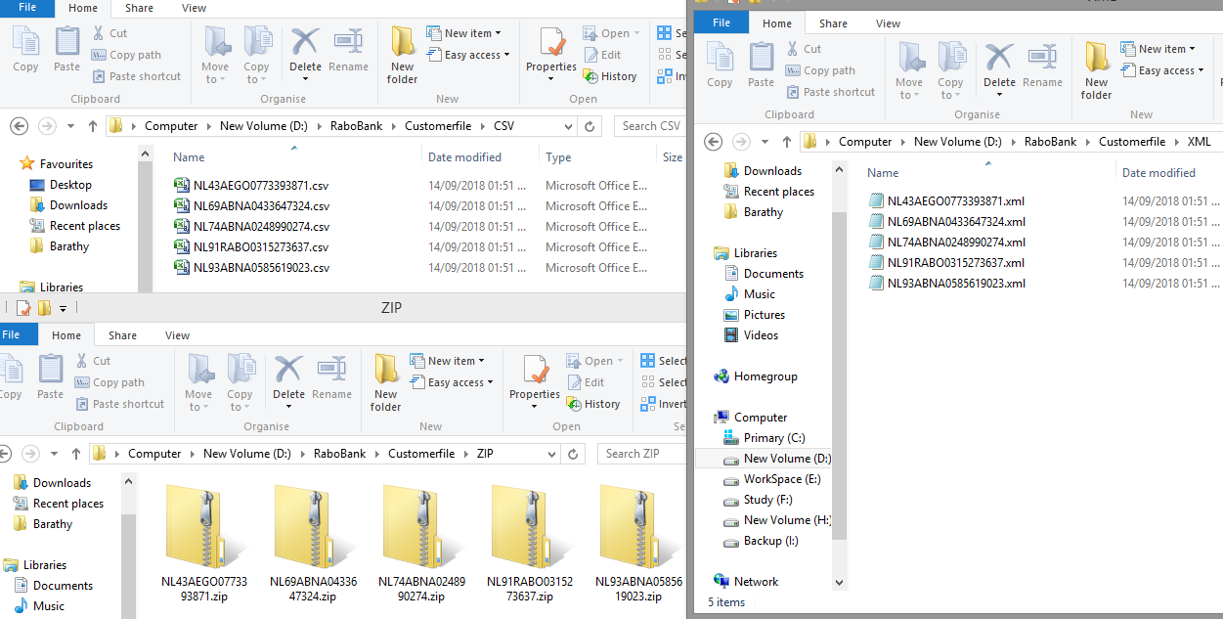

And also you can find failed report in

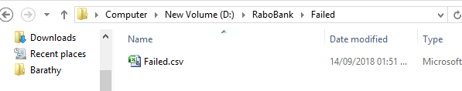

Service to download the customer files

localhost:8484/statement/getFile/NL74ABNA0248990274?fileType=CSV

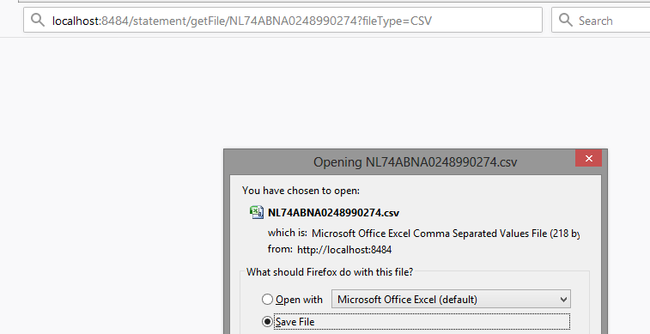

localhost:8484/statement/getFile/NL74ABNA0248990274?fileType=XML

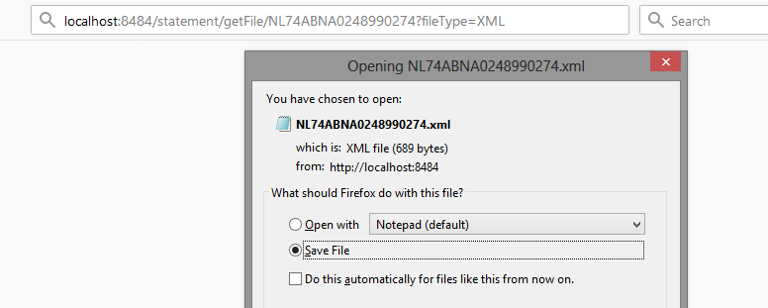

localhost:8484/statement/getFile/NL74ABNA0248990274

