**Q 49. Connect to sql and write a query to find all patients who have a gender of 'Male' ( Attach screenshots for this question)**

**Connecting to postgresql through jupyter notebook:**

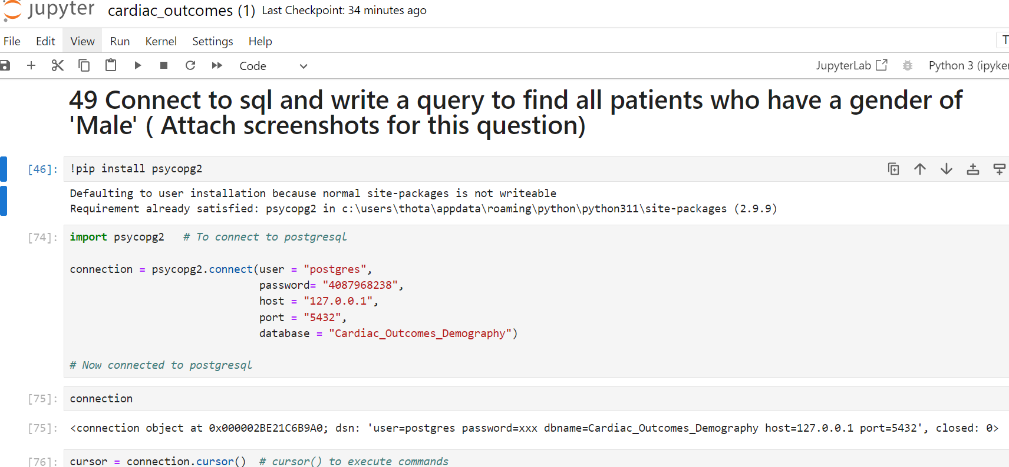

**Executed to view all rows :**

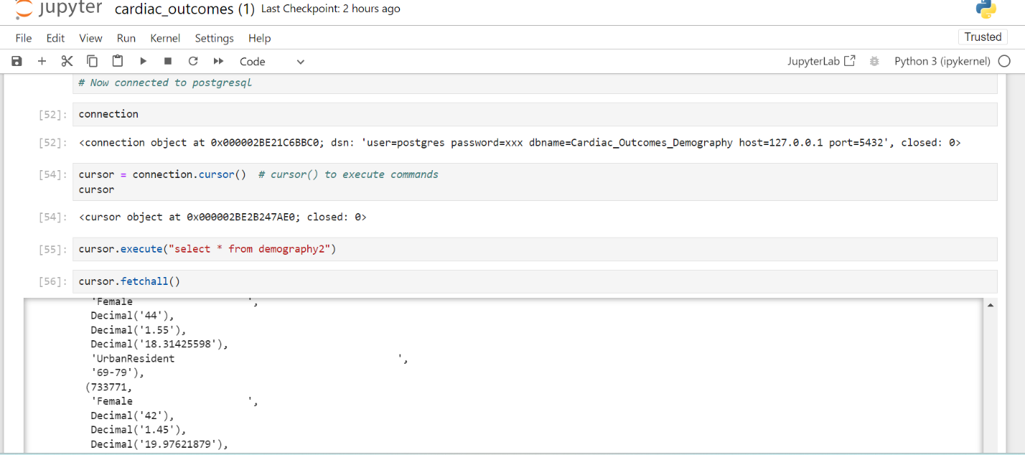

**Executed to view where gender = Male:**

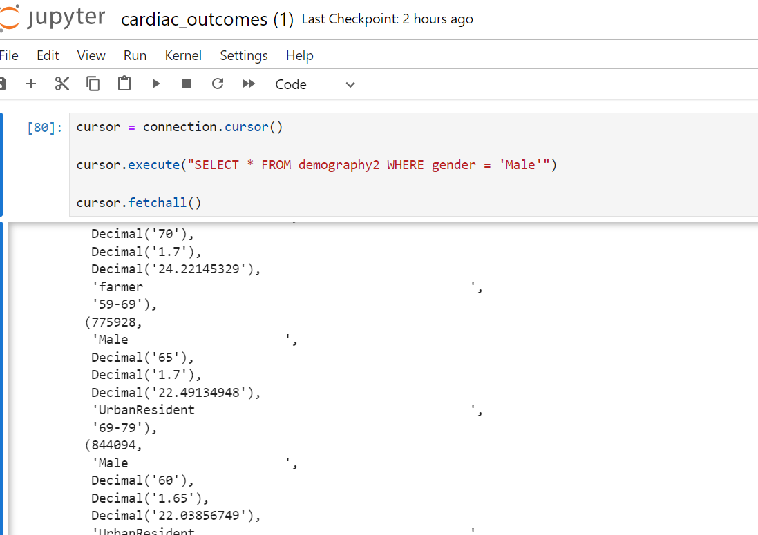

**Result – All Male patients retrieved successfully .**

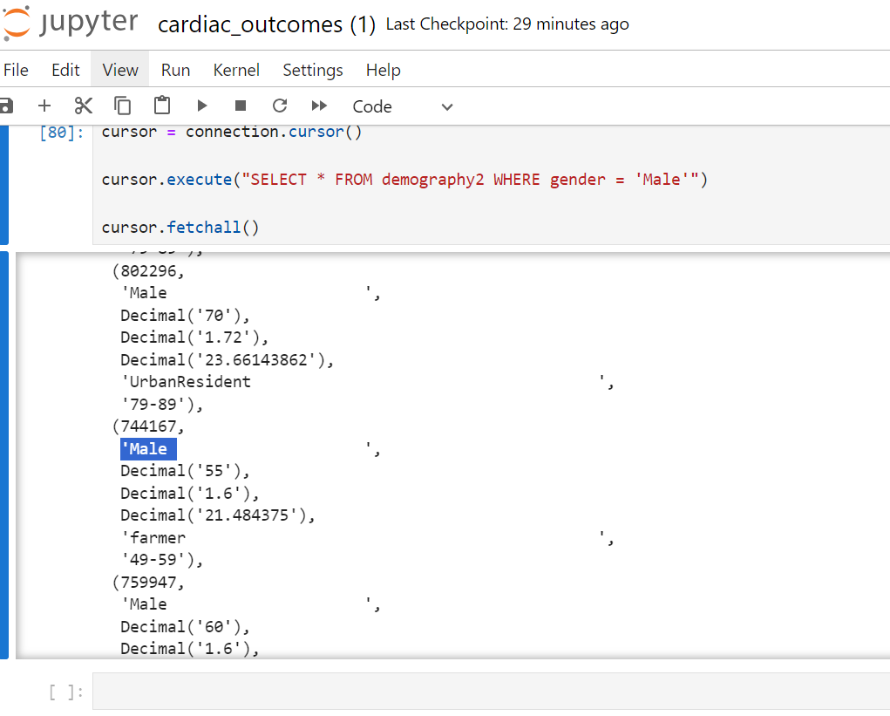

**Postgresql database:**

**Data Imported to PgAdmin**

