

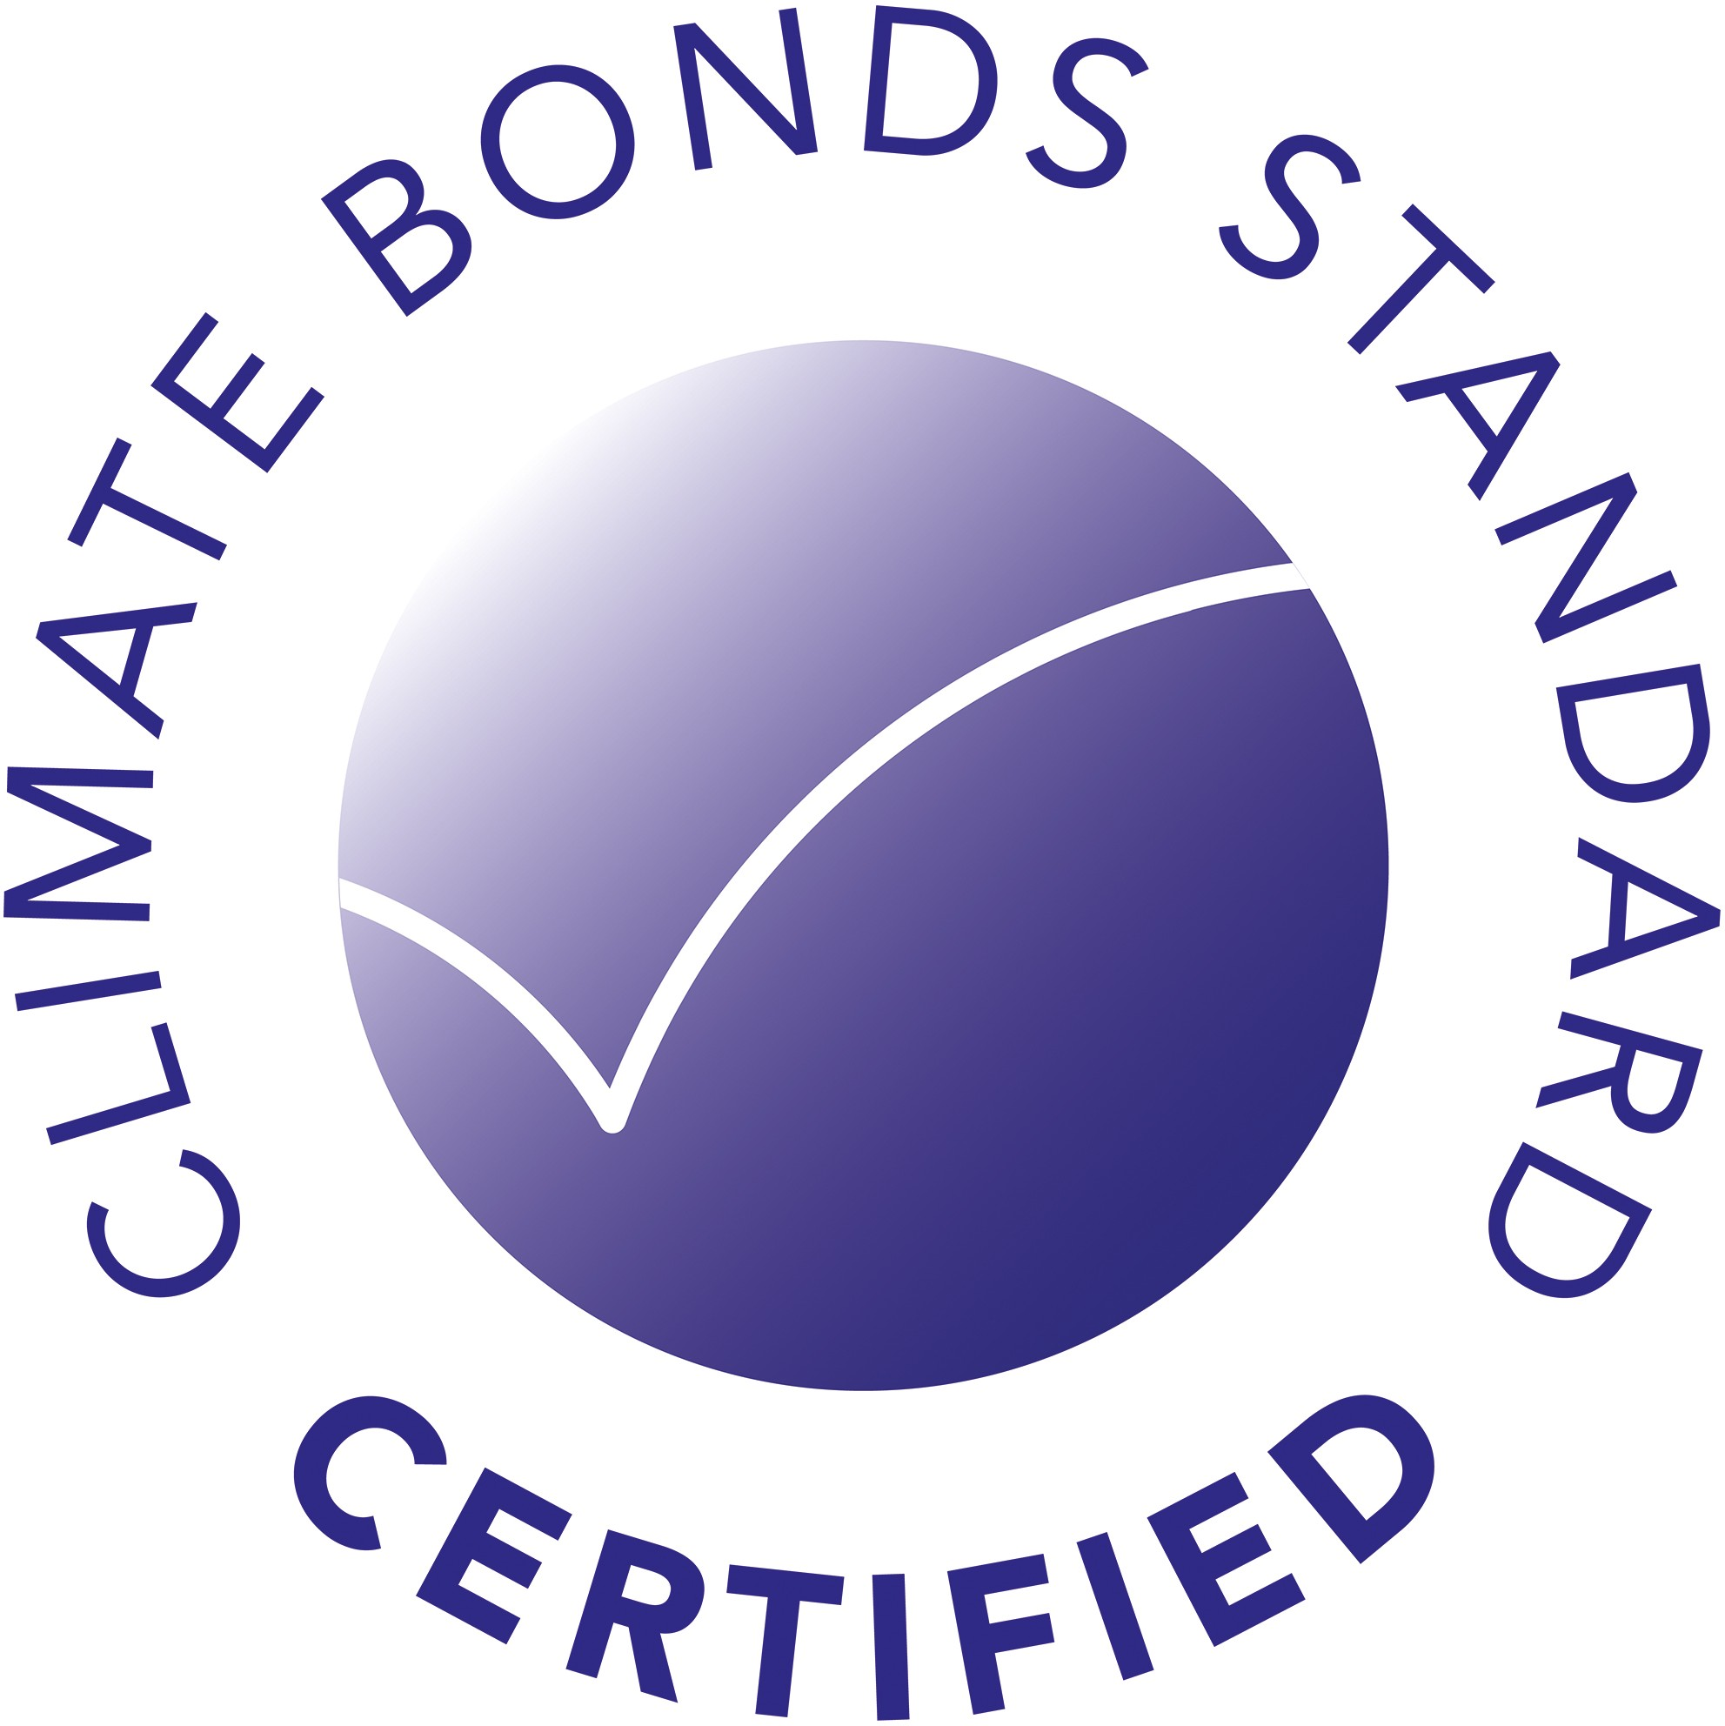Certification

This is to certify that the

# Green {{instrument_type}}

Issued by

# {{issuing_entity_legal_name}}

Has met the criteria for certification by the Climate Bonds Standard Board on behalf of the Climate Bonds Initiative

*{{approval_date}}*

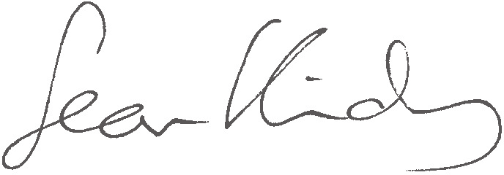

**Sean Kidney**

*CEO, Climate Bonds Initiative*