

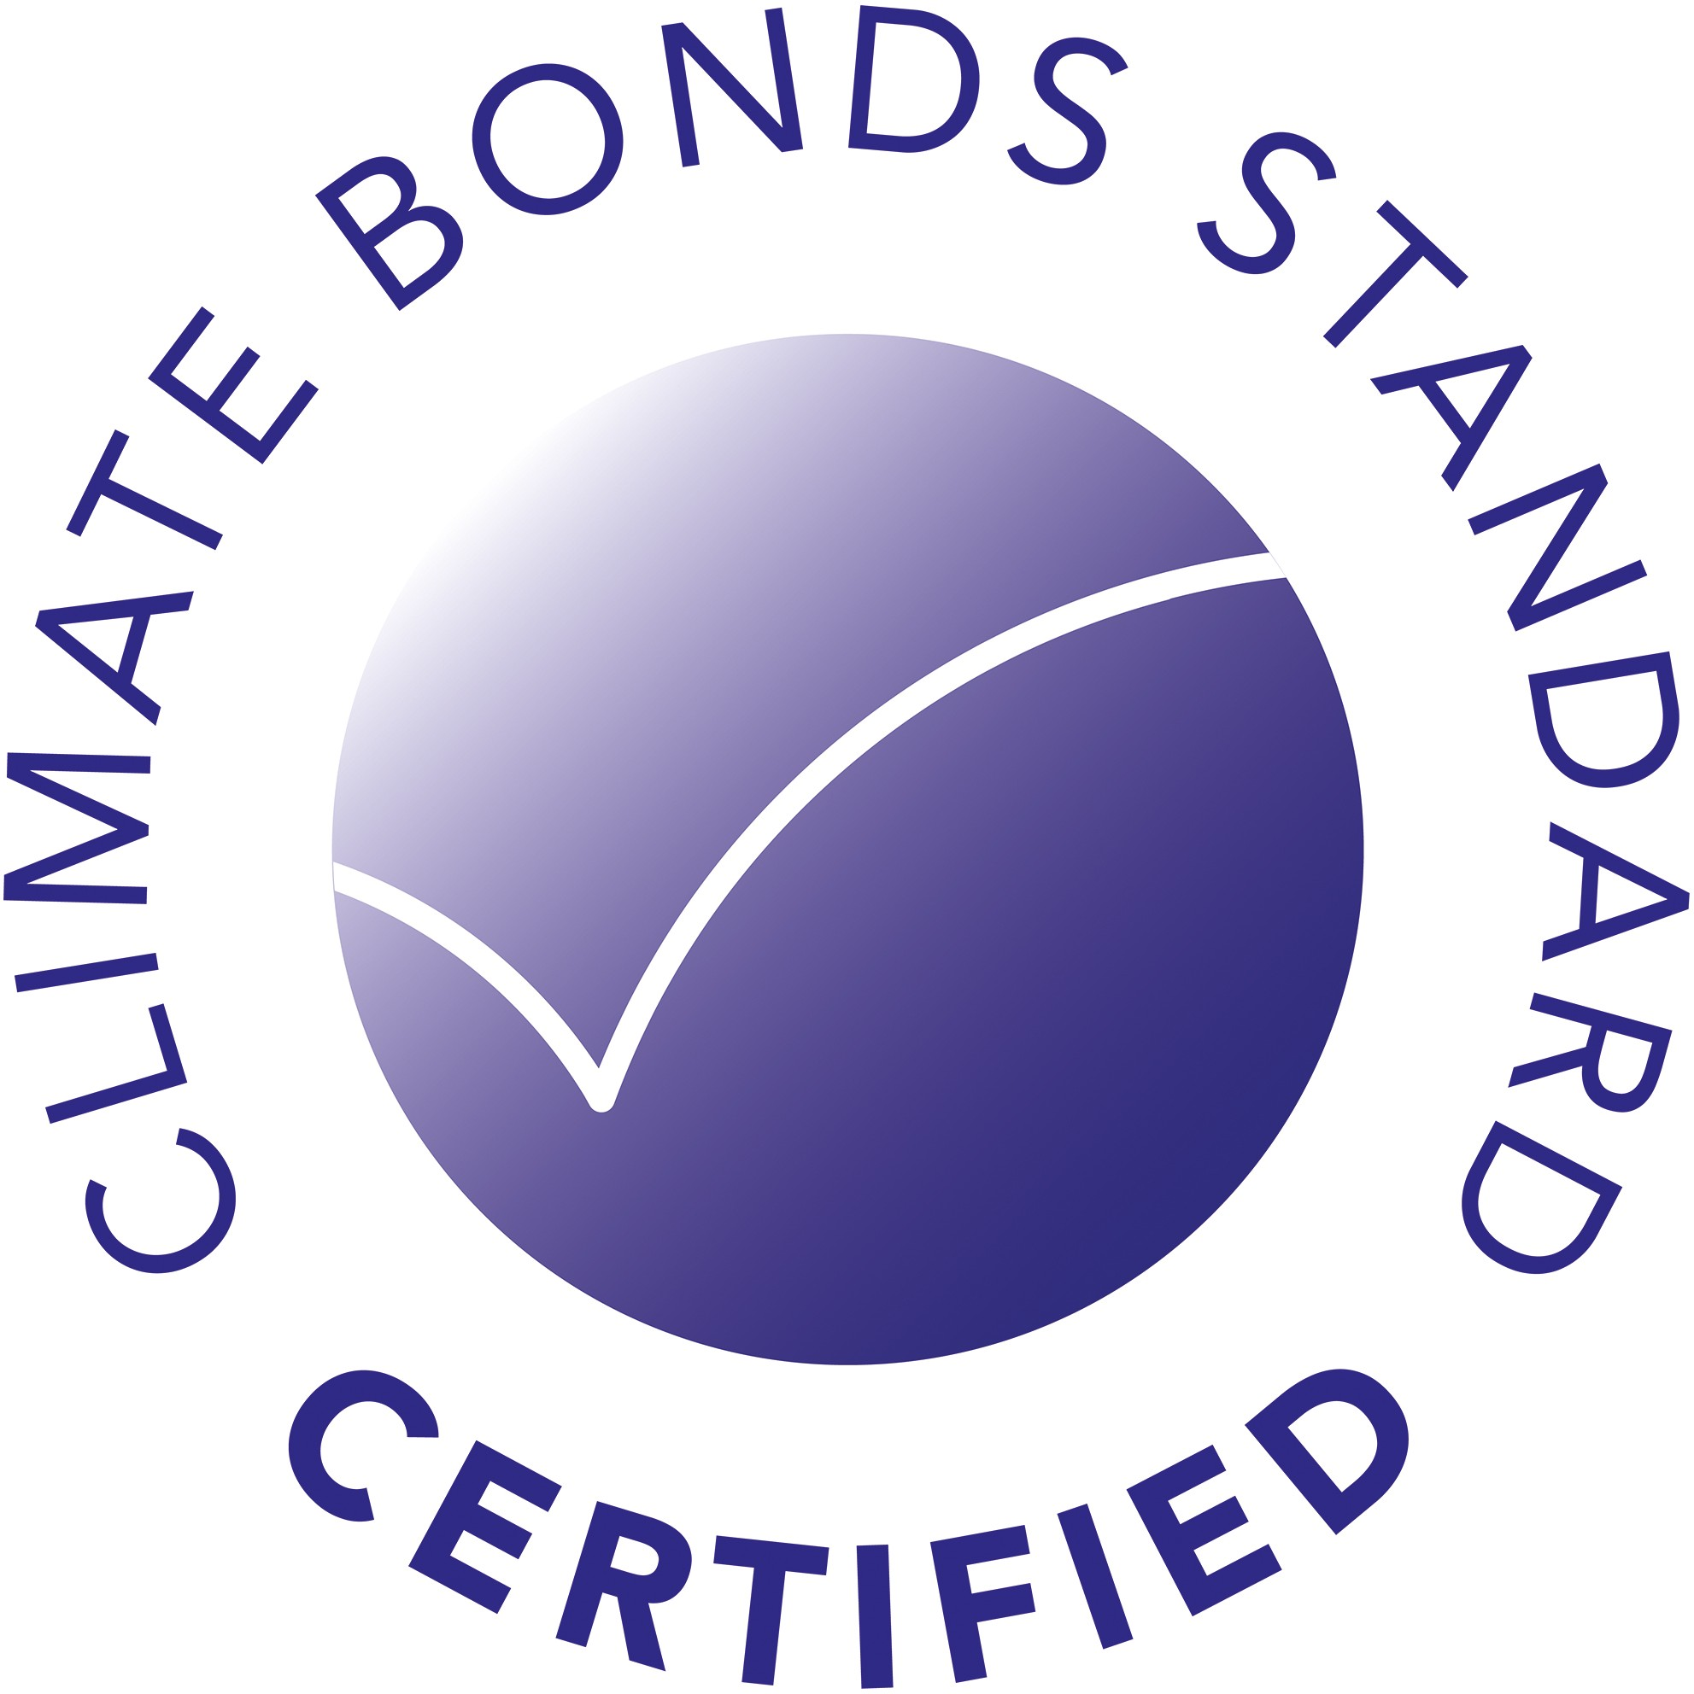Certification

This is to certify that the

# Green Bond

Issued by

*Guruvana*

Has met the criteria for certification by the Climate Bonds Standard Board on behalf of the Climate Bonds Initiative

*07-12-2021*

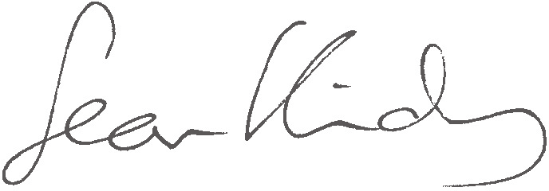

**Sean Kidney**

*CEO, Climate Bonds Initiative*