Capstone Project

Starting with hospital systems we looked at visits. Some hospital systems (Tenet Healthcare) had incomplete reporting for ER length of stay during certain periods. These observations were excluded to maintain data quality.
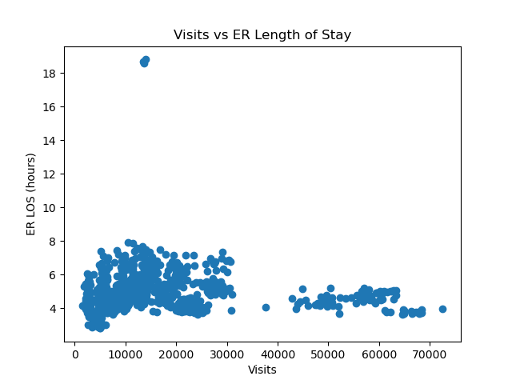
While ER visit volume varies significantly across hospital systems, there is no clear relationship between volume and ER length of stay. In fact, some higher-volume systems exhibit more stable and lower wait times compared to smaller systems.”
UMass Memorial Health Care was experiencing significant financial and operational strain in 2019, driven by a high proportion of complex, Medicaid-covered patients. While this does not directly explain the short-term spike observed in our data, it provides important context suggesting that the system was under sustained pressure, making it more susceptible to temporary bottlenecks in patient flow.

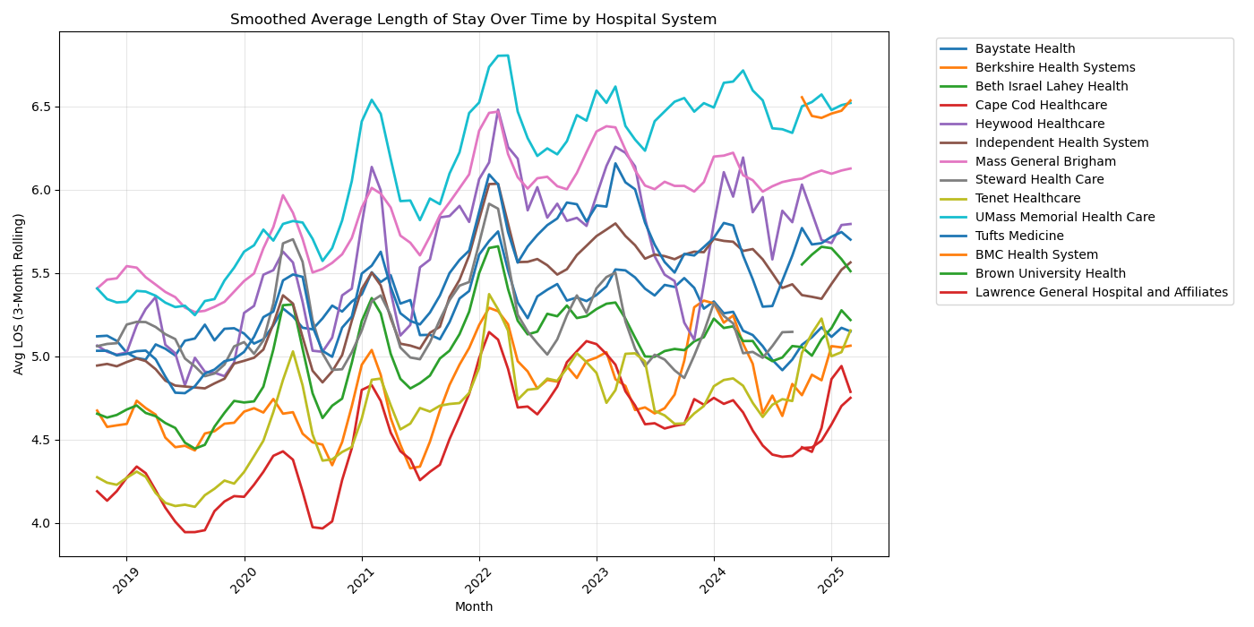
In addition to differences across hospital systems, we observe consistent peaks and dips in ER length of stay across all systems. These synchronized patterns suggest that there are broader, system-wide factors influencing ER performance, such as seasonal demand or external pressures.”
We also see a gradual upward trend over time, indicating that ER length of stay has been increasing across nearly all systems.
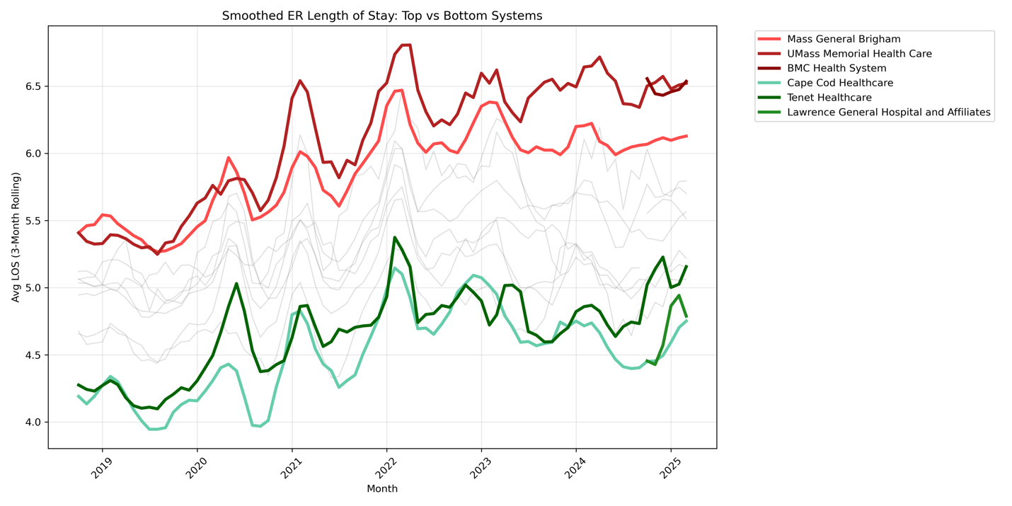
To better understand these persistent differences, we isolate the highest and lowest performing systems
“If all systems are experiencing the same external pressures, but still perform differently, the question becomes: what internal factors explain these differences?
“One key factor is the type and complexity of patients being treated.”
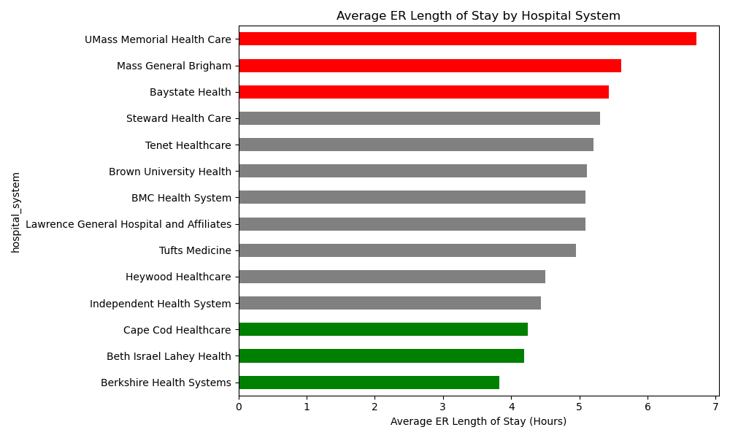
This chart shows the average ER length of stay by hospital system. We see a wide range of performance, with some systems averaging under 4 hours, while others exceed 6 hours. Importantly, this variation persists even after accounting for differences in patient volume, suggesting that system-level factors play a critical role in determining ER wait times.”

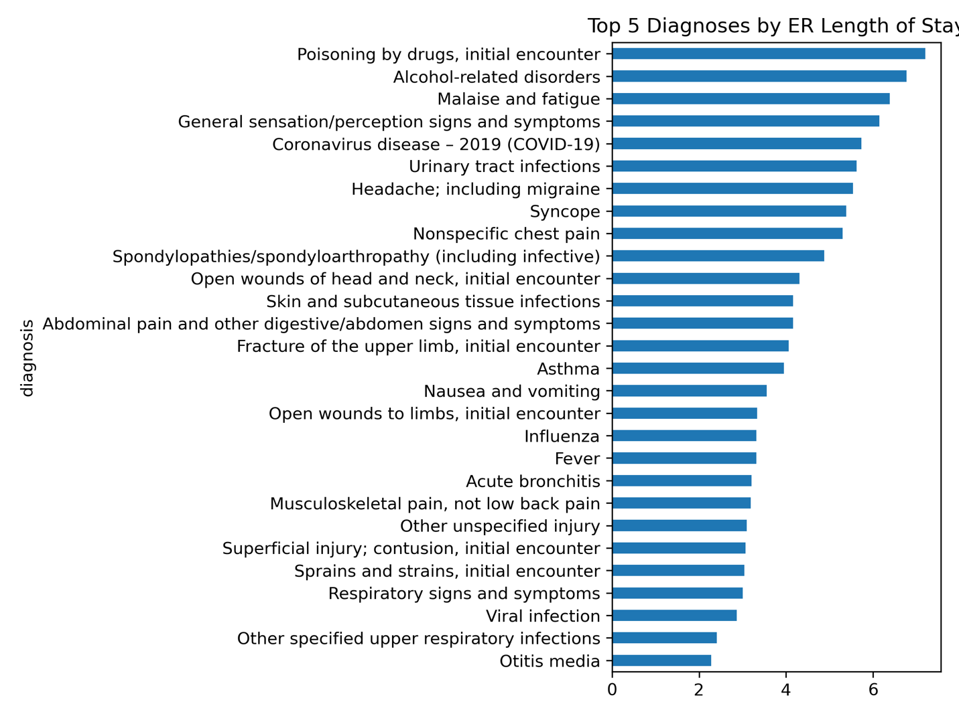

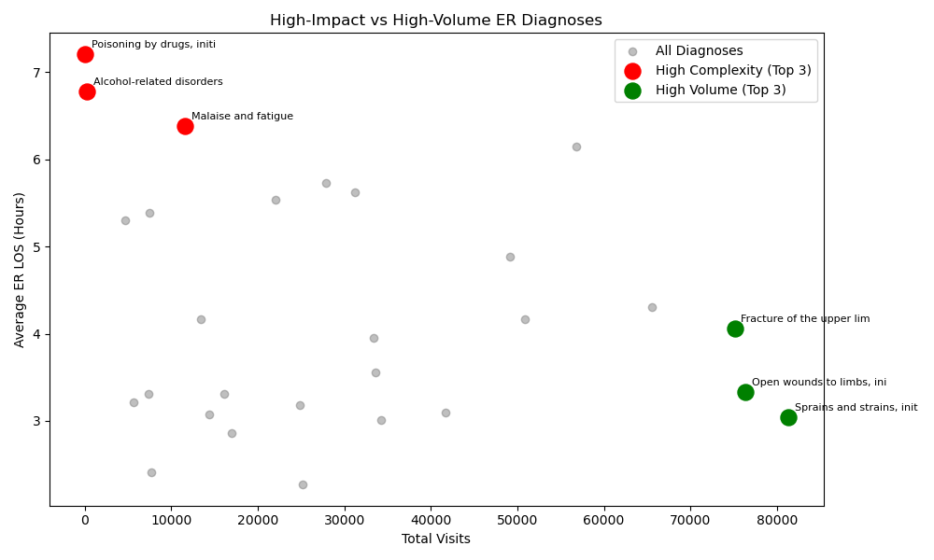
The diagnoses associated with the longest ER stays are not the most common, but rather those that require extended evaluation and monitoring. These cases often involve uncertainty or higher clinical complexity, which increases the time required per patient. In contrast, the most frequent cases are typically straightforward injuries that can be treated and discharged quickly
This also helps explain why some hospital systems experience longer wait times — systems serving more complex patient populations may face greater operational strain

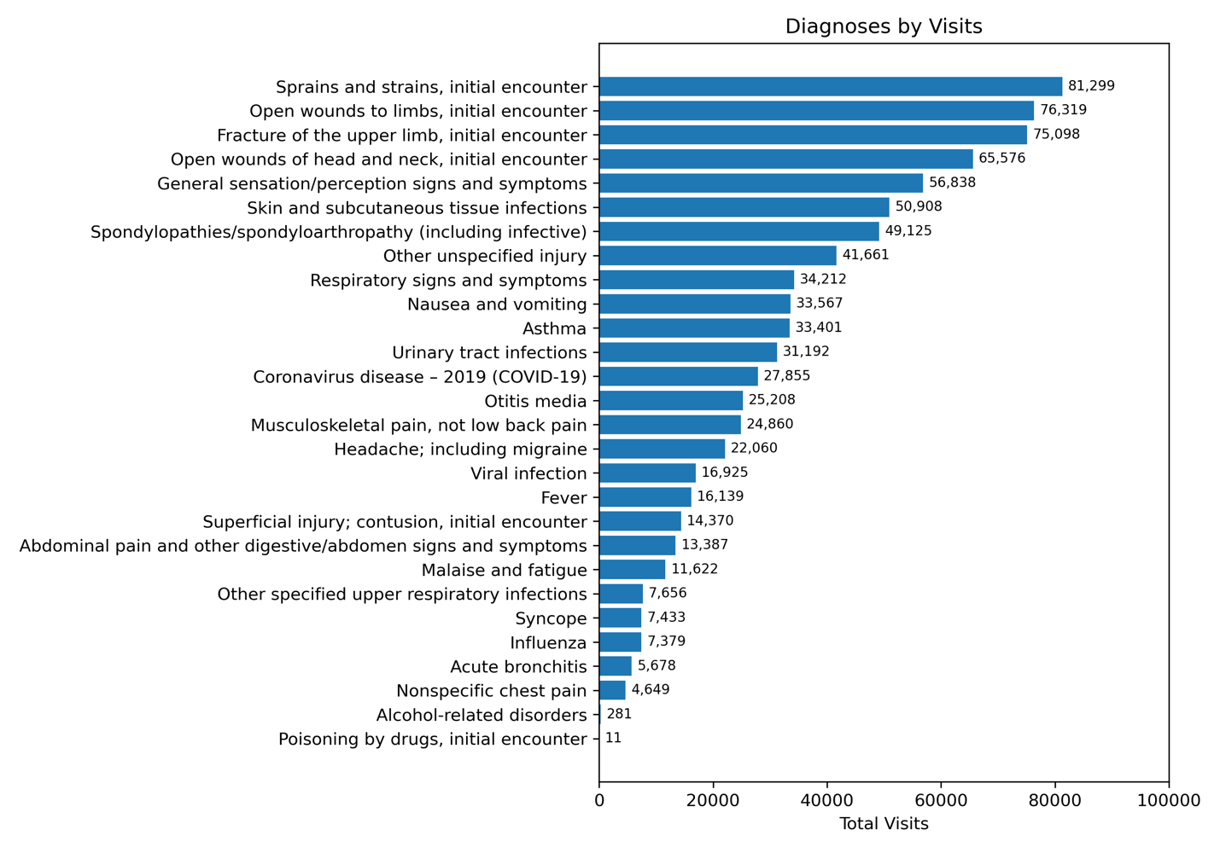
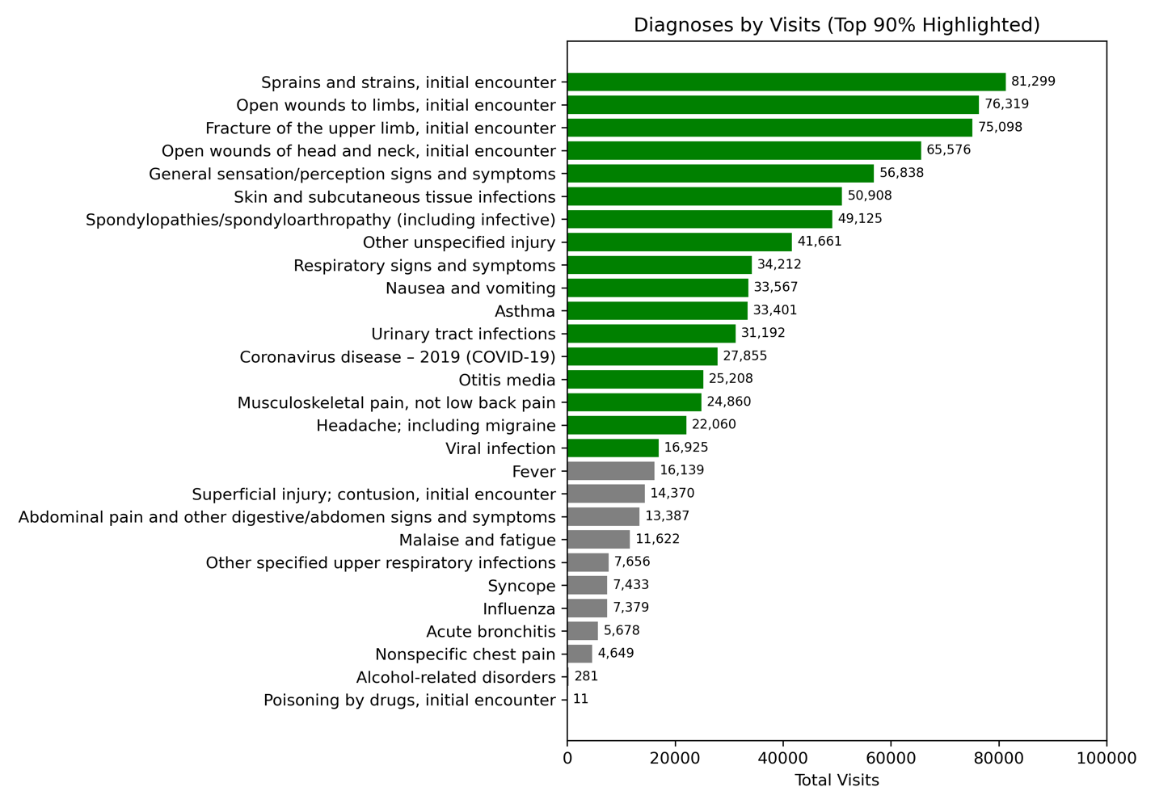
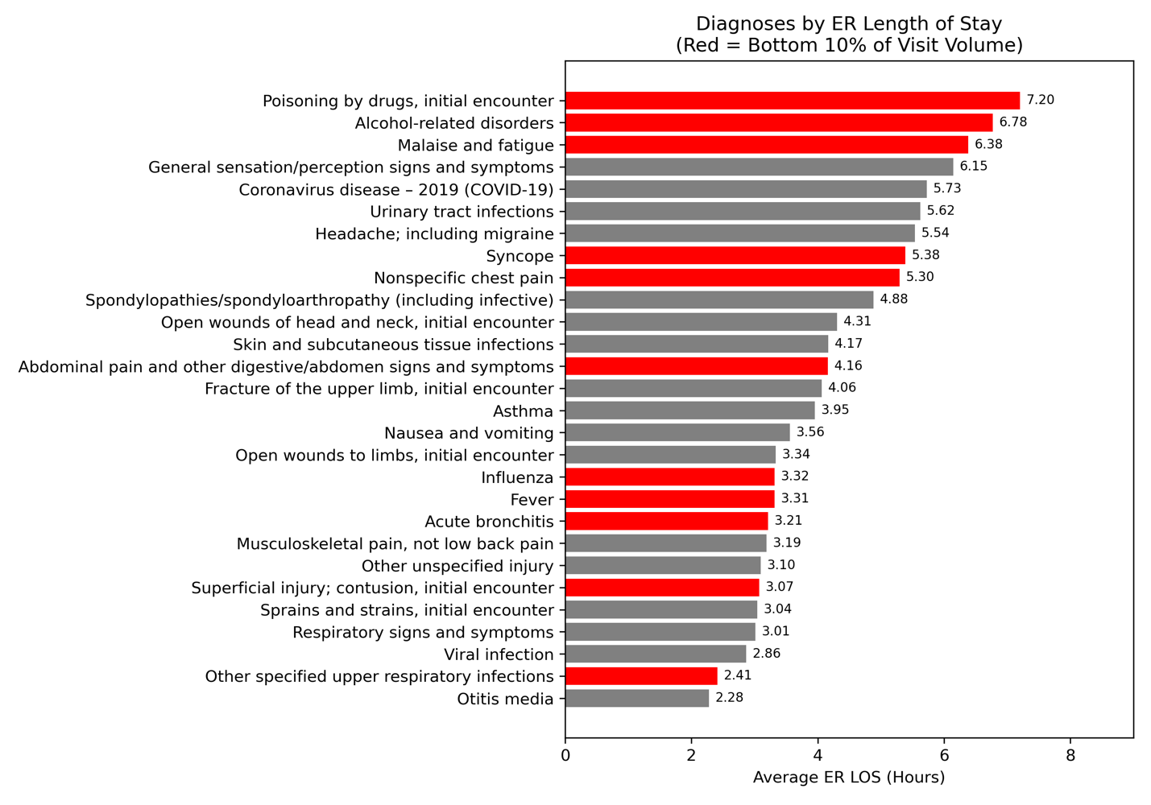
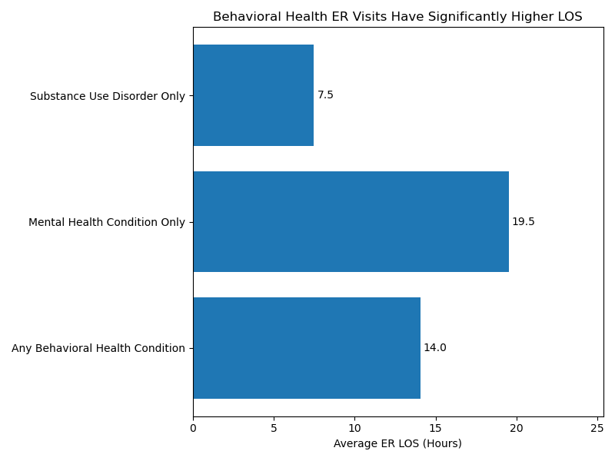
Behavioral health cases represent some of the most time-intensive ER visits, reinforcing that complexity — not volume — is the primary driver of ER congestion

