Caleb Javier
Adrianna Holden-Gouveia
Linux Administration
5 October 2025

Documentation: Awk
The following documentation will demonstrate the use of the awk command, a power tool used for data manipulation and parsing/viewing text.

Using a provided file, the following problems and commands will demonstrate how to use awk in different scenarios to procure different information and manipulate the contents of a file.

- Print all the First Names.
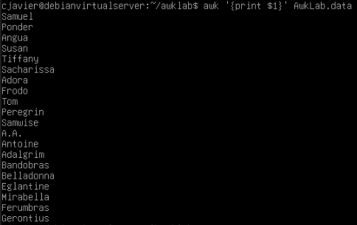
Command used: awk ‘{print $1}’ AwkLab.data
Explanation: Awk, using the space character as its default delimiter, will assign a number to each instance of a string outside of those spaces. The very first string of text before a space in this case is the first name of the characters, and so it is delineated by awk as “$1”. Using the print command for awk, we can print the first section of each line, which includes all first names.

- Print phone numbers for Tom and Frodo after their names
Command used: awk -F: ‘/Tom/ || /Frodo/ {print $1 “ ” $2}’ AwkLab.data
Explanation: To print more efficient information more cleanly, the delimiter will be changed using the -F option, which changes the delimiter to a character that follows it. As this better suits the format of the lines in the file, our first two sections are now the name of the character and their phone number. Now, using regular expressions and logic to match specific patterns, the search focuses on lines that contain either Tom or Frodo (double pipe), and prints for them the first two sections, separated by a literal (in double quotes) space.

- Print Peregrin’s full name and phone number area code only.
Command used: awk ‘/Peregrin/ {print $1 “ “ $2}’ AwkLab.data
Explanation: By using the default space character as the delimiter, the format of the line will provide only the area code of the phone number, as that is split by space as well. This makes the items one and two of the line the first name and the last name with an area code, respectively.

- Print all phone numbers (full number) in the 123 area code along with the names
Command used: awk -F: ‘/123/ {print $2 “ “ $1}’ AwkLab.data
Explanation: Switching the delimiter to the colon respects the format’s design for the phone number. Now, the second item in the line is a complete phone number, so the pattern to search lines can be “123”, which only appears in the area code. The names are printed directly after along with them.

- Print all Last names beginning with either a T or D (careful of middle names!)
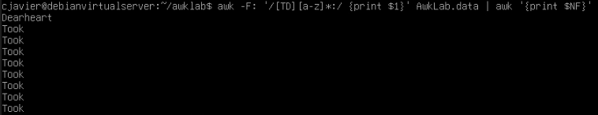
Command used: awk -F: ‘/[TD][a-z]*:/ {print $1}’ AwkLab.data | awk ‘{print $NF}’
Explanation: When using the colon as the delimiter character, we can better manipulate the full name here. We’ll first extract all lines that contain the specified last names by using a regex pattern that matches either T or D followed by any number (asterisk) of lowercase characters, which indicates a name. Then, searching for a colon at the end of x lowercase letters identifies the target pattern as a last name, as that is what follows the end of the full name. After printing, this result can be piped into a new awk command that prints the section that is equivalent to the total number of sections, which is denoted by “NF”. This will ensure that middle names are not included in the result.

- Print all first names containing four or less characters.
Command used: awk ‘length($1) <=4 {print $1}’ AwkLab.data
Explanation: The “length” command allows for quantity of characters to be determined for a section in a line. In this case, the length of the pattern to match must be equal to 4 or less characters. That section is then printed to achieve the result.

- Print the first names and area codes of all those in the 916 area code.
Command used: awk ‘/916/ {print $1 “ “ $2}’ AwkLab.data | awk ‘{print $1 “ “ $3}’
Explanation: This command will create a result where the pattern matched is 916, which indicates the area code. That result, which contains the full name and full phone number, is further parsed by being piped into another command that is able to use the space delimiter to print the first name and area code only.

- Print Sacharissa’s campaign contributions following her name. Each value should be printed with a leading dollar sign; e.g., $250 $100 $175.
Command used: awk -F: ‘{print $1, “$” $3, “$” $4, “$” $5}’ AwkLab.data
Explanation: Again taking advantage of the colon delimiter, we can simply pick out the sections where the donations and name are denoted. Inserting quoted dollar signs will allow for the literal dollar sign to preface each number.

- Print last names followed by a comma and the phone number. Be careful of the last names’s format.
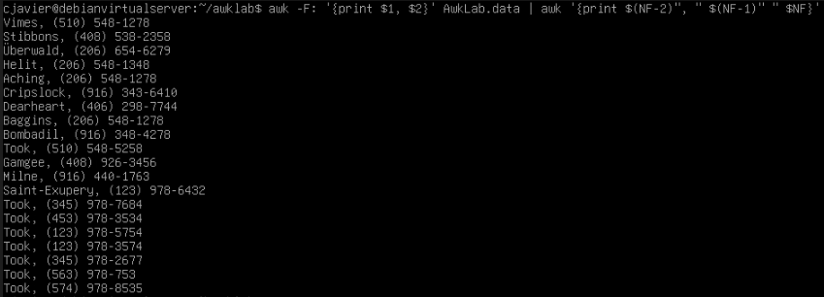
Command used: awk -F: ‘{print $1, $2}’ AwkLab.data | awk ‘{print $(NF-2)”, “ $(NF-1)” “ $NF)’
Explanation: Using the colon as the delimiter, we can obtain the full name and the phone number to be further manipulated like above. Piping it into a second command, we can use formulas to subtract from the NF variable to account for name differences and the extra spaces created by the initial colon delimiter. Adding the literal comma and spaces continues to clean it up, which provides a neat result.

- Print the first and last names of those who contributed more than $110 in the last month. Make sure to include their last month contribution amount after the name
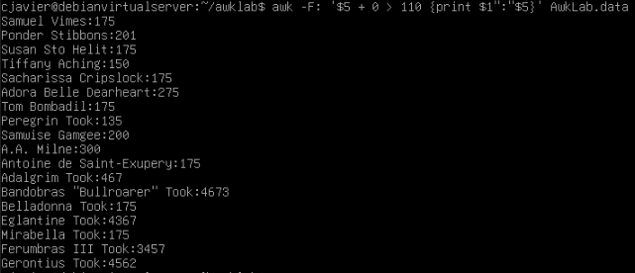
Command used: awk -F: ‘$5 + 0 > 110 {print $1”:”$5}’ AwkLab.data
Explanation: In this case, there is another condition being used as a pattern. However, doing it normally seemed to read it as text, which made the condition essentially true for every line. In order to convert the fifth section to a literal number, it is placed into an expression. This allows the two numbers to be accurately compared, and thus prints every name according to the criteria followed by that donation amount.

- Print the last names, phone numbers, and first month contribution of those who contributed less than $150 in the first month.
Command used: awk -F: ‘$3 + 0 < 150 {print $1, $2, $3}’ AwkLab.data | awk ‘{print $(NF-3), $(NF-2), $(NF -1), $NF}’
Explanation: Similar to above, there is a condition that parses the file for a specific value, but it must first be converted to an integer by adding zero. Then, the sections are printed in a way that is easier to manipulate for the piped command, which selects from each section, so as to account for the last name being present. Now, we are able to print only the last name followed by the full phone number and first contribution.

- Print the first names and contribution of those who contributed between $10 and $200 in the first month.
Command used: awk -F: ‘($3 + 0) > 10 && ($3 + 0) < 200 {print $1, $3}’ AwkLab.data | awk ‘{print $1, $3}’
Explanation: Much like above, the pattern recognition operates with a conditional argument, except this time the “and” logic operator is added to further specify the condition. The result is simplified as the first name is the first section that is able to be printed, and the number will always be the last.

- Print the first name, last names and total contributions of those who contributed less than $700 over the three-month period.
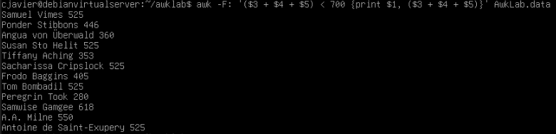
Command used: awk -F: ‘($3 + $4 + $5) < 700 {print $1,($3 + $4 + $5)}’ AwkLab.data
Explanation: To obtain the total for use in a condition, we can add them together to convert to integers by creating an expression. This is then printed alongside the full name, which is made able to be selected by using the colon as the field operator.

- Print the first names and first letter of the last name, and average contribution of those who had an average contribution of more then $300
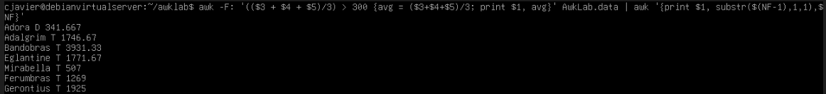
Command used: awk -F: ‘(($3 + $4 + $5)/3) > 300 {avg = ($3+$4+$5)/3; print $1, avg}’ AwkLab.data | awk ‘{print $1, substr($(NF-1),1,1),$NF}’
Explanation: This command sets a variable to be used to reduce the number of times this expression must be typed. By setting the variable “avg” as the expression of mean, it can also be printed alongside the desired section. The condition uses the same expression and compares it to the desired limit of 300 to test for the correct pattern. This command is then piped into another that will use the substr function to return a substring of the last name that begins at the first character and is one character long, which is how the first letter of the last name is obtained. The first name and this substring are then printed followed by the average value.
- Print the last name and area code of those not in the 916 area code.
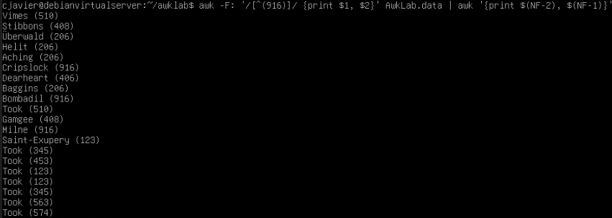
Command used: awk -F: ‘/[^(916)]/ {print $1, $2}’ AwkLab.data | awk ‘{print $(NF-2), $(NF-1)}’
Explanation: Here we can use a regular expression operator (^) to negate what is contained in the brackets for a pattern to search. With that, the specified area code will not appear in the results. Now, the first two sections are printed to better manipulate the results, where the NF variable is again used to mind the structure of the last name, given that there are always two sections of the phone number when separated by a space.

- Print each record preceded by the number of the record.
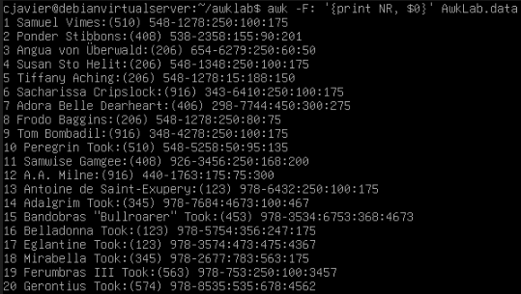
Command used: awk -F: ‘{print NR, $0}’ AwkLab.data
Explanation: The built-in Number of Records variable (NR) can be called to print the number of each line. In this command, it will precede the first section of the line (denoted by $0), which will place it before it so as to number each line. The colon will still have to be the delimiter to successfully complete this.

- Print the name and total contribution of each person.
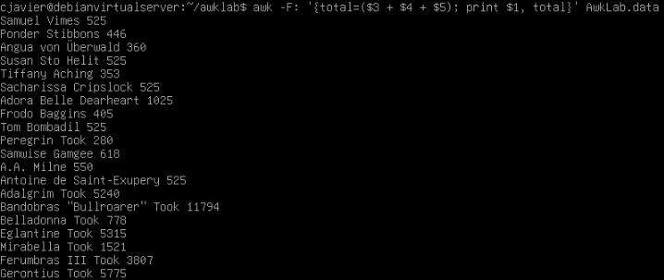
Command used: awk -F: ‘{total = ($3 + $4 + $5); print $1, total}’ AwkLab.data
Explanation: Here, another variable is created which is equal to the expression of the sum of all donation values. After that, we can simply print the name (colon separator) and the “total” variable.

- Add $10 to Tiffany Aching’s first contribution and print her full name and first contribution.
Command used: awk -F: ‘/Tiff/ {print $1, ($3 + 10)}’ AwkLab.data
Explanation: By first searching for the simple pattern “Tiff”, we can locate the line where Tiffany’s name is. This line’s first section is printed, and the third section is placed into an expression to convert it to an integer and add a value to it, which also prints the desired result.

- Change Samwise Gamgee’s name to Sean Astin
Command used: awk -F: ‘/Samwise/ {gsub(“Samwise Gamgee”, “Sean Astin”); print}’ AwkLab.data
Explanation: After setting the delimiter and searching for Samwise’s line, we can use the gsub function to replace the instance where “Samwise Gamgee” appears with whatever text is in the second argument. After that, the same line is printed to reveal the substituted string.

- Write an awk script to do the following (MUST be an awk script not just a bash script or commands on the commandline) (a) Prints first name of the all the Tooks followed by their total campaign contributions . (b) Print the full names and contributions of anyone who contributed between $10 and $200 in the last contribution (c) Prints the full names and average contribution of those who contributed less than $300 on average
- Creating an awk script:
  - First, create a file using the touch command and provide it with a .awk extension for recognition. This can be edited by using the vim text editor.
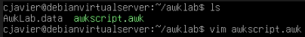
  - The first line will startwith the shebang line, which determines the type of script that will be run. To begin the script, we will include the BEGIN function, which prefaces the script with our delimiter character, which will remain the colon.
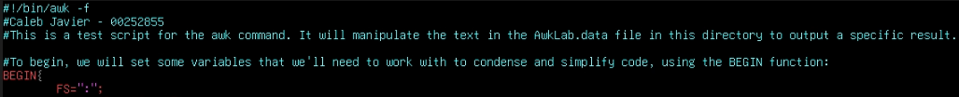
  - We will then create the first part of the script, which will:
    - Create a variable and call it later in the function.
    - Split the first section (containing the name), create a labeled array, and use a literal space character as the new delimiter to call a section from that array.
    - Use the “next” function, which will prevent these commands from being applied to other lines in the printed results.
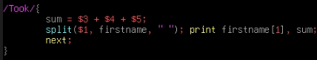
  - Part A of the script will appear like this and below is the tested code:
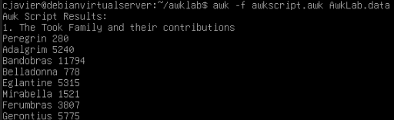
  - At this point, there are two issues: The order of the script will not be changed, and the necessary expressions (such as sum and average of contribution) are required in more places than one. To resolve this, each line printed for each section will be prefaced by the letter of the problem that it is printing for, and the expression functions will be created at the beginning of the script.
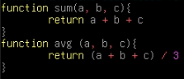
  - With these things accounted for, the script is now complete and is tested to achieve the following results.
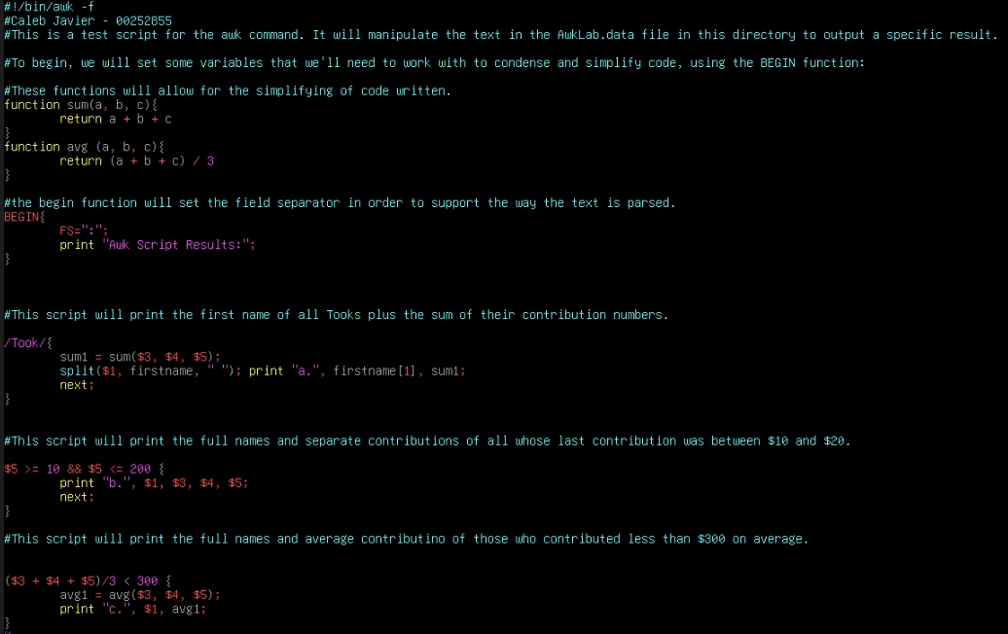
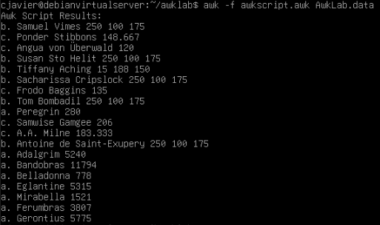
  - The latter two blocks are as follows:
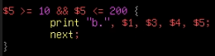
This will create a multi-part condition based on the fifth section of the line, which contains the third donation. Lines adhering to this will condition will all be printed along with their individual contributions.
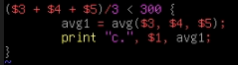
Using the previously designed average function, there is also a condition that will then test the average value and print lines that match. The variable that invokes that function is also called to be printed after the name section.

Works Cited
- xelco52 5, et al. “Casting to Int in Awk.” Stack Overflow, https://stackoverflow.com/#organization, 10 May 2016, stackoverflow.com/questions/5808971/casting-to-int-in-awk.
- String Functions (the GNU AWK User’s Guide), www.gnu.org/software/gawk/manual/html_node/String-Functions.html. Accessed 6 Dec. 2025.
- Iamdillion. “Negated Character Class in Regular Expressions.” Simple Regex, simpleregex.dev/negated-character-class/. Accessed 6 Dec. 2025.
- Palandri, Marta. “The AWK Command in Linux: Understanding Syntax, Options and Common Examples.” Hostinger Tutorials, 23 Apr. 2025, www.hostinger.com/tutorials/awk-command?utm_campaign=Generic-Tutorials-DSA-t5%7CNT%3ASE%7CLO%3AUSA&utm_medium=ppc&gad_source=1&gad_campaignid=15858927967&gbraid=0AAAAADMy-hbmvmajcjUgDuf0tQwzsbojm&gclid=Cj0KCQiAosrJBhD0ARIsAHebCNqO9gfBZn9_mKihrLQ2e0zRK9xn6uigI50HiY27ep7srGqZo4SWTJcaAq4REALw_wcB.
- Ellingwood, Justin, and Brian Hogan. “How to Use the Awk Language to Manipulate Text in Linux.” DigitalOcean, DigitalOcean, 26 May 2020, www.digitalocean.com/community/tutorials/how-to-use-the-awk-language-to-manipulate-text-in-linux.
- Kenlon, Seth. “A Guide to Intermediate Awk Scripting.” Opensource.Com, opensource.com/article/19/11/intermediate-awk-scripting. Accessed 6 Dec. 2025.

