Caleb Javier
Adrianna Holden-Gouveia
Linux Administration
19 October 2025

Documentation: Networking
This documentation will explore setting up network management capabilities and how to read and understand networking tools found or installed on Linux systems.

- Network Setup
  - On a CentOS Server
CentOS Stream 10 already has net-tools installed, which will be used to view details of the current network. If it is not installed, the user can perform sudo dnf install net-tools to ensure that its package is available and ready to be used. 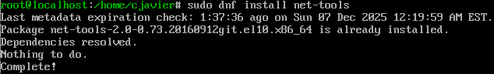
ip a and ip route:
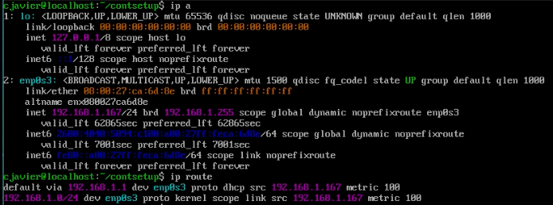
Displayed are the network adapters installed for the machine, as well as the IP addresses provided via DHCP and the broadcast address for that subnet. The inet6 addresses are IPv6 addresses.
The routing table that follows shows the router IP (default gateway) and local IP address used to communicate within the network.
  - On a Debian server
The process is the exact same, as the same net tools program is being used. sudo apt install net-tools will install the package if it is not already (it is on this version).
ip a and ip route:
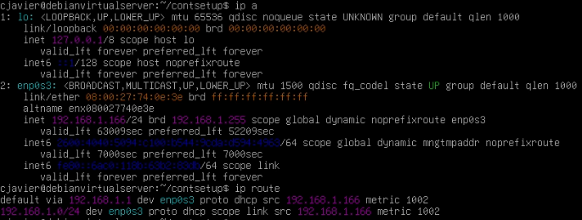
Both networks are functional and provided IP addresses by the router.

- Network Interfaces
  - On a CentOS Server
For CentOS Stream 10, the nmcli command is used to do many things like view active connections and configure network interfaces. The command
nmcli connection show
will display to the user details about the currently used connection method.
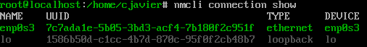
nmcli on its own will show IP details and more connection information about the interfaces on the machine.
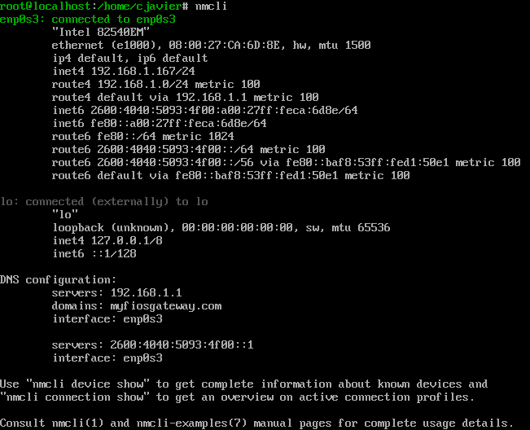
Additionally, nmcli can be used to modify these connections.
nmcli c m enp0s3 ipv4.method manual will be used to begin setting the desired IP address, gateway, subnet mask, and DNS server if desired.
The connection will need to be brought down and back up to reflect these changes:
nmcli connection down enp0s3; nmcli connection up enp0s3
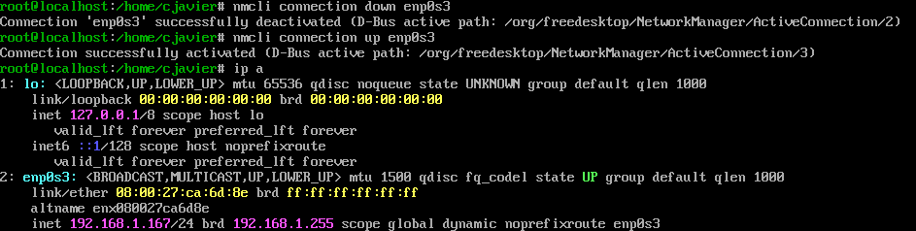
(This has been set to DHCP/automatic).

  - On a Debian Server
Network interfaces are configured in the interfaces file, which resides in /etc/network/interfaces, where the hotpluggability and method of IP assignment (currently set to DHCP here) can be edited in detail. Entire interfaces can also be added in addition to configuring current ones.
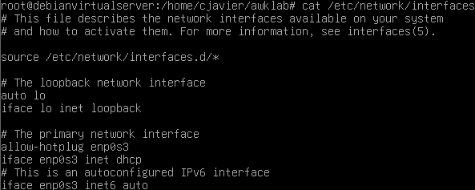
When writing changes, they can be reflected without rebooting by using the commands
ifdown enp0s3
ifup enp0s3
and then can be checked again by using
ip a

Here, we can test the successful connection to the network by pinging Google’s DNS server (8.8.8.8) and a local machine (my host computer, 192.168.1.209):
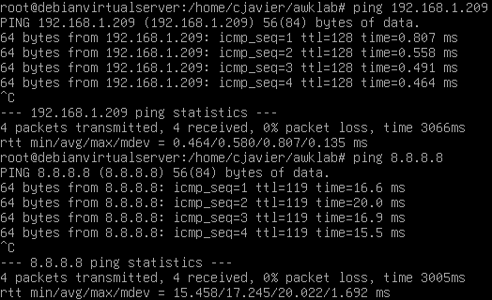
Note - using the bridged adapter connection method, the server was originally unable to communicate incoming pings to the host computer until it was allowed via Windows Defender rules.

The networks on these two servers both are able to connect to the network that the host machine is on because they are connected via the Bridged Adapter setting, which will provide them each their own IP address on the network and subnet that the host machine is on. As such, both servers have temporarily but by default been set to automatically receive their IP addresses and network information. Also by default, both use NetworkManager to control and configure the network settings and interfaces, and also store profiles and configuration files in /etc/NetworkManager/ (see screenshot). NetworkManager is essential to parsing and observing network information for either server.

- Document analysis - Network Setup and Research

When deciding what to include in a network report for a server, efficiency must be the prime factor to consider. This can be best achieved by focusing on two aspects of efficiency: conciseness and relevance. The network report must include information about the network that can both prove that a connection is established, running, and healthy, and it must be presented to the user in a way that is presentable and easy to read. With that being said, there is still a lot of information that must be reported to the user in order to ensure that they can understand all crucial parts of the network and established connection are running smoothly.
The report dump will be structured in a way that contains two main sections: network information and connection testing. To present the most efficient information to the user, they will first get simple, quick-to-read bits of information, such as hostname and their IP addresses for their interface. This information will be able to tell a user details about their system they can use in real time to look for anomalies or errors that would otherwise signify potential equipment failures or attacks. This will also include routing details and listing listening ports, which is crucial for troubleshooting or observing activity (Devopscube).
The second part will focus on the testing of connectivity to ensure that there is active communication between the machine and the Internet. It will begin with a ping command, which provides the user with packet activity to determine whether a connection is actually established with another host. It will also involve nslookup to query a provided external server, as well as a traceroute command to view the path a packet takes to get to the destination host (Adoga). The user makes use of these data by being able to further examine where exactly errors occur in order to pinpoint potential issues. The address resolution protocol is also important to the log, as it provides the user insight as to whether IP addresses are properly being resolved to domains, which rules out many options for troubleshooting.
When this is finally dumped into a text file, the user can recall the dates recorded to search for timestamps and particular events, which make documentation accessible for any user attempting to diagnose network problems.

Works Cited:
1. Amoany, Evans. “7 Linux Networking Commands That Every Sysadmin Should Know.” Red Hat - We Make Open Source Technologies for the Enterprise, 2 June 2021, www.redhat.com/en/blog/7-great-network-commands.
2. Devopscube. “17 Best Linux Networking and Troubleshooting Commands.” DevOpsCube, DevOpsCube – Easy DevOps, SRE Guides & Reviews, 13 Oct. 2025, devopscube.com/list-linux-networking-troubleshooting-and-commands-beginners/.
3. Haruna Adoga. YouTube, YouTube, www.youtube.com/watch?v=NcpWU9tFpI8. Accessed 7 Dec. 2025.

Script 1 - Network Dump
This script can be run using the command ./network_report.sh. The permissions must be changed to allow it to be run by a standard user.
A successful test on both servers (I did not perform the user input piece as it would block the view of the crucial information):
