Caleb Javier
Adrianna Holden-Gouveia
Linux Administration
28 September 2025

Documentation: The Sed Command
This documentation will go over the sed command, a tool used to modify or replace instances of text without having to open its file, and display it to the user, somewhat like grep.

The following commands from the provided file will demonstrate the editing capabilities and options available for sed.

- Change the name Jo to Josephine
Command used: sed -n ‘s/Jo /Josephine /p’ SedLab
Explanation: Start by using the -n option, which suppresses printing and allows the lines edited to be printed if desired. In the main argument, by using “s”, or “substitute”, initiate a text replacement command. Each argument is separated by a delimiter, which will be recognized by the command no matter what character it is. The search pattern will be “Jo “ followed by a space, as “Jo” appears in other places in the file and would likely insert it where it is not wanted. Separated by slashes, the replacement string will be “Josephine “, also accounting for the space. Finalize the command with p before closing quotes, which commands the system to print if there was a successful substitution. The result is one name changed from Jo to Josephine.

- Delete the last 5 lines.
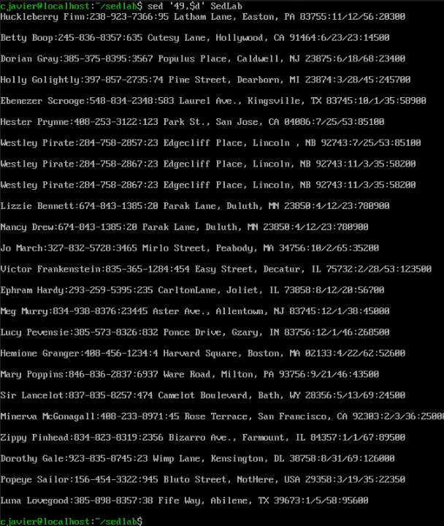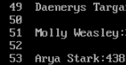
Command used: sed ‘49,$d’ SedLab
cat -n SedLab
Explanation: Using the cat command and option -n, which denotes the numbering of all lines, we find that there are a total of 53 lines. For the sed command, the “d” operator will delete specified lines. For the argument, it will be the 49th (the difference of the total and 5), and the last (which is indicated by the dollar symbol), separated by a comma to indicate a range of lines to be deleted.

- Print lines 3-15.
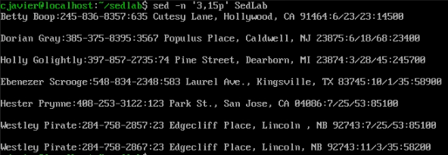
Command used: sed -n ‘3,15p’ SedLab
Explanation: The -n option here, instead of numbering, is just noting to the command to only print specified, successfully modified lines. Similarly to above, there is another range of lines determined, but a different operation, “p”, which will determine what’s printed for the user.

- Delete lines for people who live in California
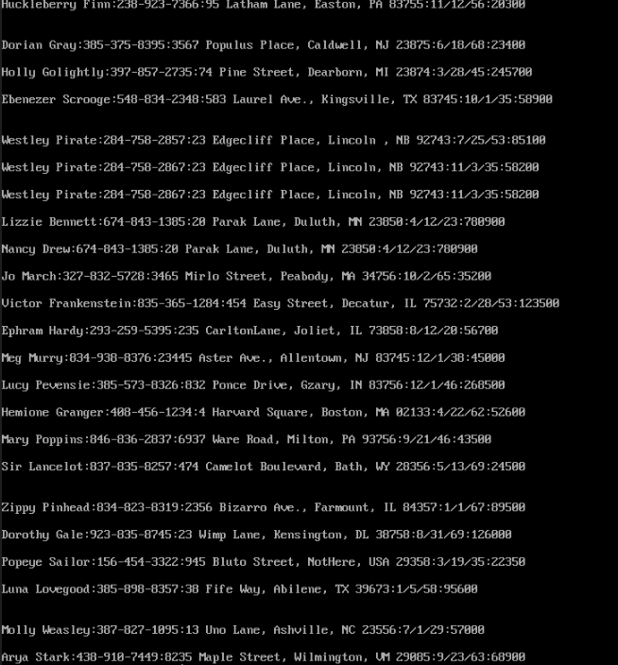
Command used: sed ‘/CA/d’ SedLab
Explanation: Providing an argument and a deletion operation, delimiters (the slashes) will be utilized to ensure that the only instances of CA are those in that format, as the state is formatted in the actual document. Any line containing CA has been removed in this preview.

- Print all lines where the birthdays are in the first week of the month. Be careful of the dates for birthdays, the format is MM/DD/YY
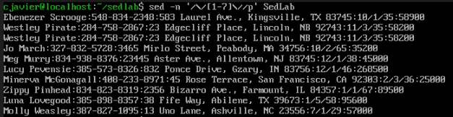
Command used: sed -n ‘/\/[1-7]\//p’ SedLab
Explanation: To achieve this, sed will need to scan for lines where the second section of the birthdate falls between digits 1 and 7 (01-07, DD format). Because the slash is used and therefore the same as the typical delimiter, it must be identified using a backslash right before, which will discern it from a delimiter and a character (a character slash in an argument looks like this: \/).
- Append three asterisks (*) to the end of lines starting with Sir
Command used: sed ‘^Sir/a\***’ SedLab
Explanation: At the end of each line is a “newline” character, which can be substituted in order to technically append text to the very end of a line. To find lines starting with sir, use the caret symbol, which indicates that the target pattern will begin at the start of a line. Using “a” (append), the target to be appended is now the designated pattern. Lastly, provide “***” as the final argument.

- Replace the line containing ”Westley Pirate” with the phrase ”As you wish.” Make sure you replace the whole line not just the name
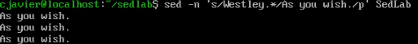
Command used: sed -n ‘s/Westley.*/As you wish./p’ SedLab
Explanation: After searching for a pattern, instead of just substituting that pattern, the entire line can be substituted with a wildcard operator for the entire line (.*). With that, the substitution is the next argument and the results are printed through -n.

- Change Minerva McGonagall’s birthday to 10/04/1935. Assume you don’t know Minerva’s original birthday. Use a regular expression to search for it.

Command used: sed -E ‘s/Minerva SedLab
Explanation:

- Delete all blank lines.
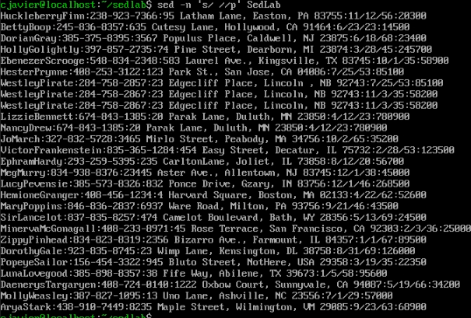
Command used: sed -n ‘s/ //p’ SedLab
Explanation: As mentioned before, all line breaks contain a newline character. The newline character creates empty space Although the user does not see it, it can still be manipulated by sed. By substituting the space after the newline (which can be denoted using a space character) with nothing (no character) all the whitespace in the file can be deleted.

- Write a sed script that will (actual sed script, NOT just the commands on the command line) (a) Insert above the first line the title - Great Literary Characters -. (b) Print the contents of the file, but instead of the phone number starting with an area code, have it start with a +1, then include the area code and number. For example, (603)123-1234 would turn into +1 (603)123-1234 (c) Append at the end of the file ”Happily Ever after. The End”
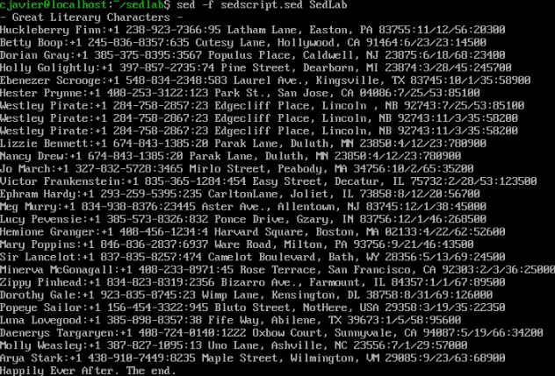
Script file:
#Caleb Javier - 00252855
#Linux Administration - Fall 2025
/^$/d
#Removes whitespace for visiblity in terminal.
1i\
- Great Literary Characters -
#Inserts the above text above the first line in the file.
s/\([0-9][0-9][0-9]\)/+1 (\1)/
#Adds a "+1" to the area code of all phone numbers.
$a\
Happily Ever After. The end.
#Appends the above text to the end of the file.

Explanation: The first command was used to compress the formatting of the file so that all edits could be visible in the frame. The command deletes (d) all lines that start and end with nothing between them, like in question 9, except that would not work, so a new command was tried (DigitalOcean, Empty Lines). The next inserts a line before line 1 (1i), and the required text is prefaced by a newline in order to ensure it properly prints beforehand. The next command uses substitute (s) to replace a captured set of digits using the regex backreference function (\(, \)). By capturing the first pattern of three digits, and substituting that with itself, surrounded by parentheses, preceded by a +1, there is a very nicely formatted new phone number area code. Finally, the last text requirement is appended ($a) after the last line in the file.

Works Cited
Courter, A. (n.d.). Sed - Replace text using your CLI. YouTube. https://www.youtube.com/watch?v=ZLzVG98i-64
user2669155user2669155 8711 gold badge22 silver badges99 bronze badges. (2014, March 5). SED: C Command, change only the first line, text deleted. Stack Overflow. https://stackoverflow.com/questions/22201056/sed-c-command-change-only-the-first-line-text-deleted
Walia, A. S. (2025, January 9). Mastering SED Command in linux: A comprehensive guide. DigitalOcean. https://www.digitalocean.com/community/tutorials/linux-sed-command

