Caleb Javier

Professor Holden-Gouveia

CIS-245

12 September 2024

Assignment 1: Server Setup/Documentation

Begin installing servers. This documentation walks through the installation process of two different Linux distributions onto a Windows device via virtual machine. The software used to install the virtual machine will be VirtualBox. Begin by downloading it [here](https://www.virtualbox.org/wiki/Downloads) and clicking the “Windows hosts” button under VirtualBox Platform Packages. It appears as such:

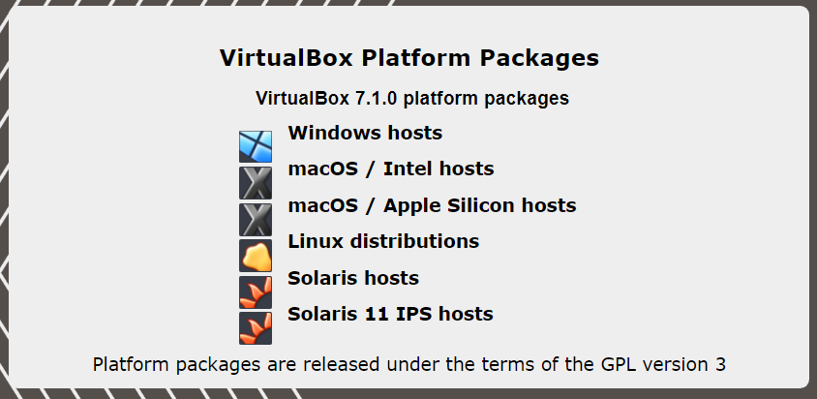

Execute the installer and go through the setup wizard to install the VirtualBox program. Below are two initial sections: see section one for installing CentOS or section two for Ubuntu.

Section 1: Installing CentOS for Windows

To install CentOS on your VirtualBox, begin with downloading the latest version on the official CentOS website [here](https://www.centos.org/download/). Download the .iso from the “x86_64” hyperlink, as that is most practical for the systems being used. This appears as such: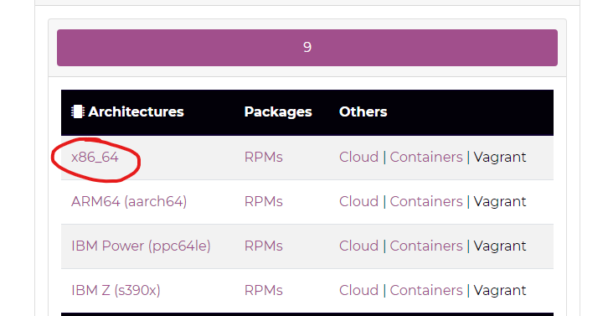

After this is complete, begin creating a new virtual machine. Execute VirtualBox and click “New”.

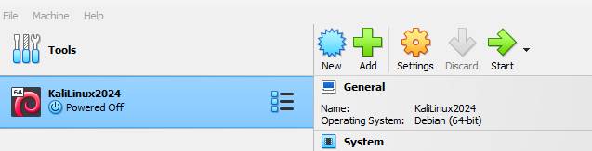

In the Create Virtual Machine wizard, provide the virtual machine with a name (in this case, “CentOS”). When selecting the **ISO Image**, locate the newly downloaded CentOS ISO by clicking  and open it there.From there, all settings should be detected and auto-set.

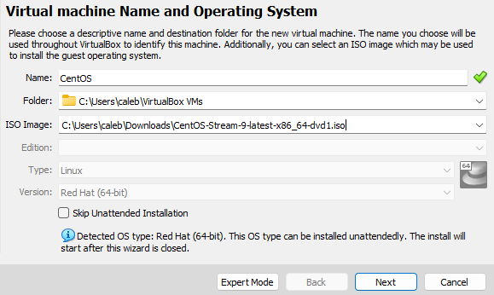

Click  and change the username and password.

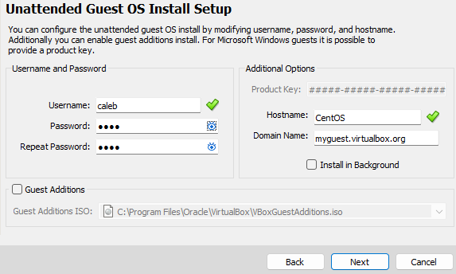

Click “Next” again. Begin to allocate memory to the machine based on how much memory is installed in your system. Repeat this process for the desired number of cores used.

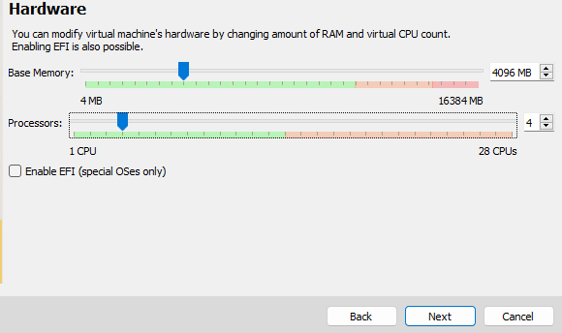

Click Next to proceed again.

Now create a virtual hard disk by allocating the virtual disk size. This can also be adjusted as needed.

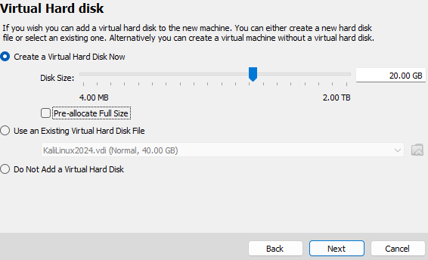

Click Next one last time, where you will review a summary of the configuration and press  to complete.

Now begin the installation. With the machine selected, start an instance by clicking the Start icon in the ribbon.



When the machine boots, mount the ISO file and this screen will be presented. Highlight the “Install” option using the arrow keys and press enter. The installer will begin and the language must now be selected.

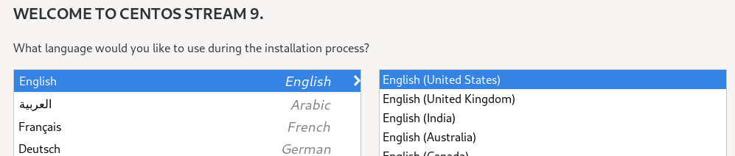

After ensuring that the keyboard layout and time settings reflect the host system, configure the installation destination.

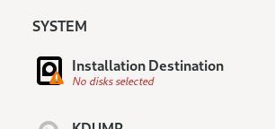

This will be the virtual disk that was allocated in the above steps.

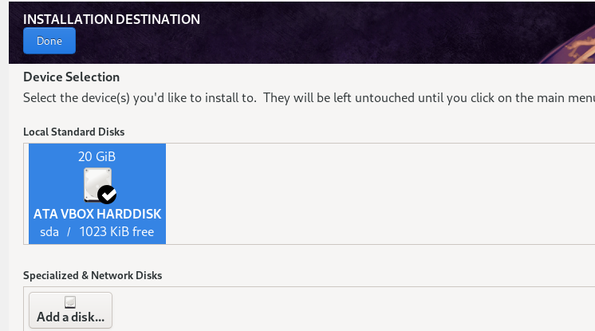Select it and then press  to continue.

Next, configure the software selection—the server with GUI must not be used. 

Select “Server” and then “Done”.

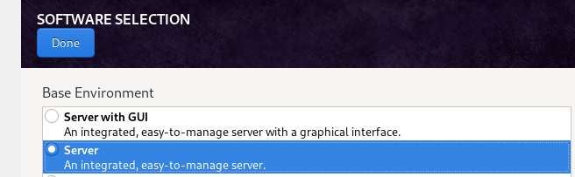

Finally, before installing, create a user and enable the root account.

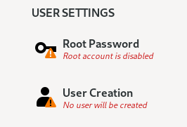

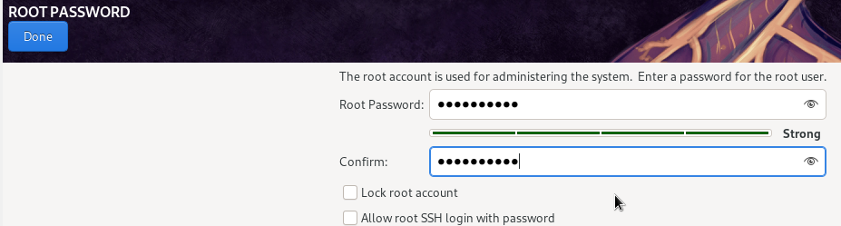

The root account can be unlocked and SSH login can be disabled. Click done and create a user.

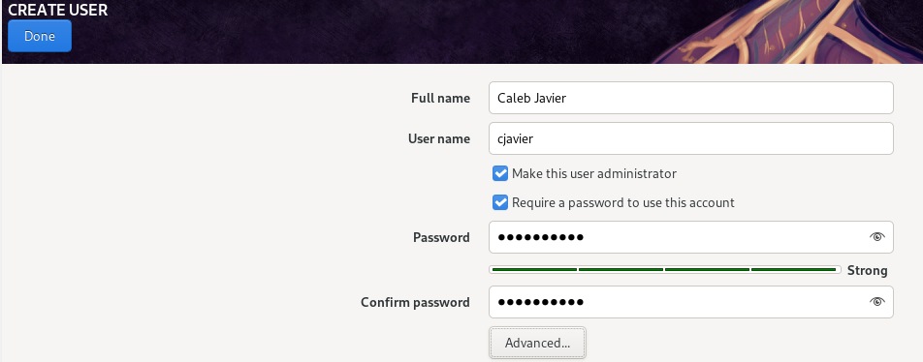

This user can be made admin, and a password should be required for additional security. Clicking done, return to the initial menu and click . When completed, perform a reboot with the button on the bottom right again.

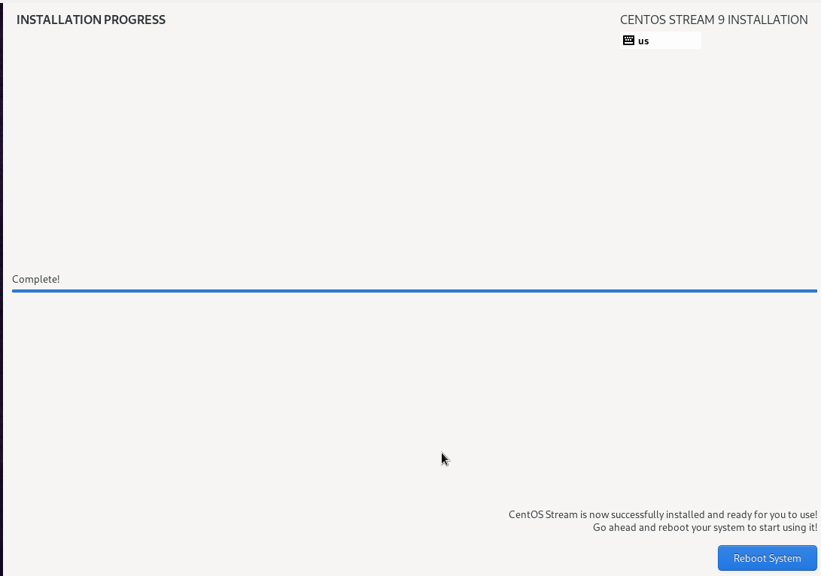

Upon startup, the user is prompted to log in. After doing so, the localhost will be signed in and ready to begin working with the server.

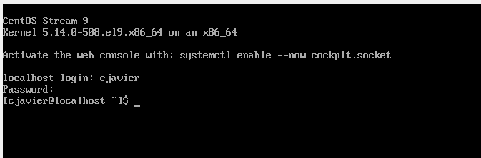

Section 2: Installing Ubuntu for Windows

Begin by heading to the Ubuntu official downloads page (here) and clicking .

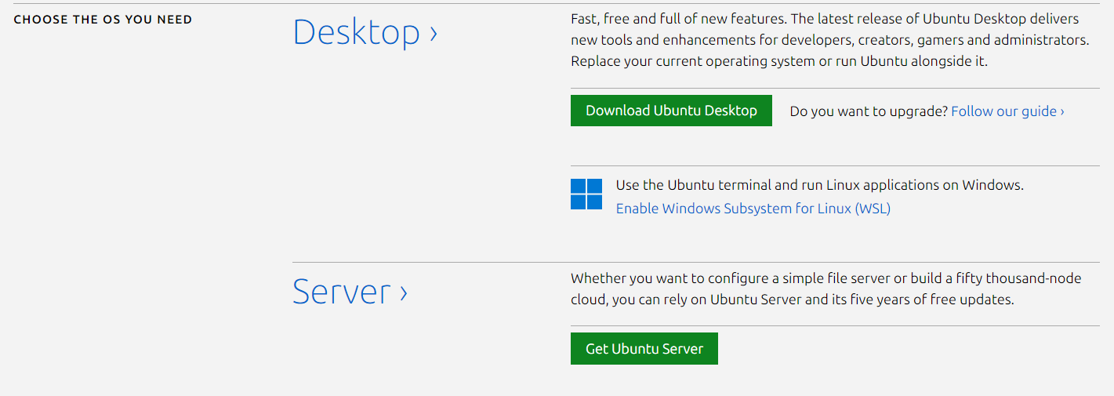

Simply download the latest stable version available.

Once complete, execute the VirtualBox application and create a new virtual machine by clicking “New” in the ribbon.



Simply name the machine and provide it with the newly downloaded ISO image, navigating to it by using the “Other…” button if necessary. The ISO will be detected and the settings will be set.

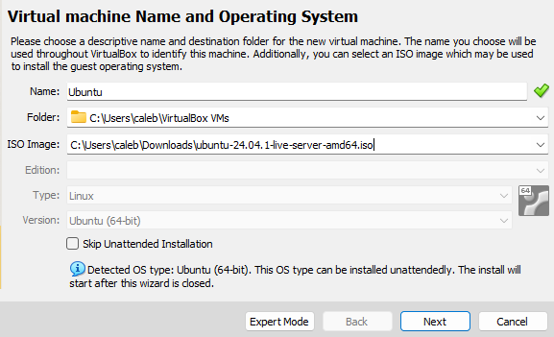

Clicking “Next”, provide a username and password for the unattended guest OS install.

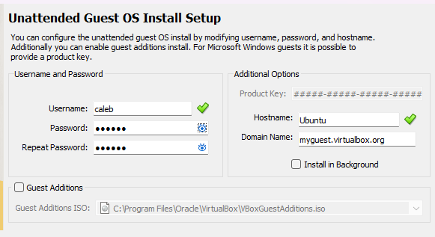

Proceed by clicking “Next” again, where in this step the host machine’s resources must be allocated for the virtual machine. Adjust the sliders as necessary and continue.

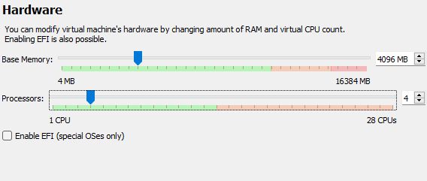

Next, the virtual hard disk’s size will be determined. Repeat the previous step and continue again.

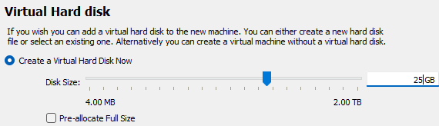

Now review the summary of the virtual machine’s configured information and click “Finish”.

The machine will now boot. There is a small window of time to use the arrow keys to select a boot option, but the highlighted option will automatically be selected after that time. Ensure that “Try or Install Ubuntu Server” is selected and proceed.

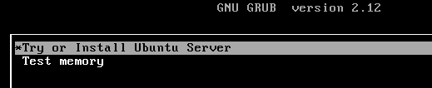

Continue to use the arrow and enter keys to navigate the system. Select a language and continue.

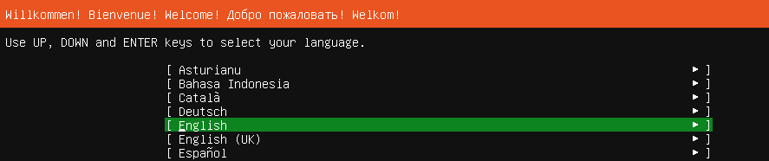

Based on the language, the keyboard layout should be automatically set. Press enter with  selected.

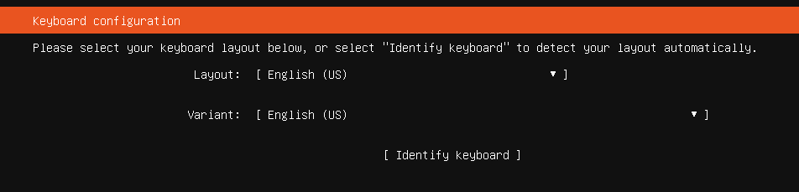

The software installation will now be selected. Ensure that the initial “Ubuntu Server” is selected and again select “done”.

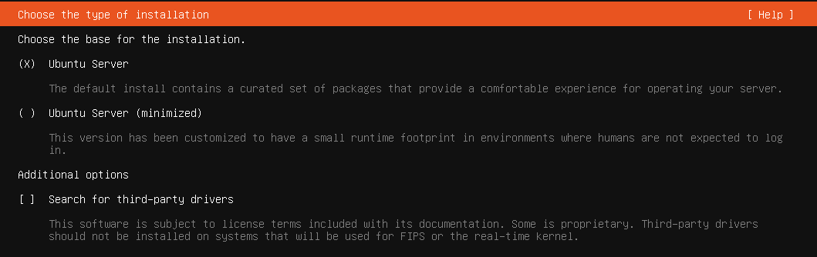

Proceed with the default network configurations.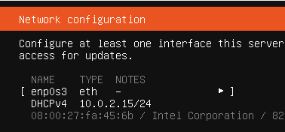

A proxy address is not necessary and can be skipped. Do the same for the default mirror address.

Select “Use an entire disk” for the allocated space provided from the machine setup. It may be encrypted if desired. Navigate to the Done selection and continue.

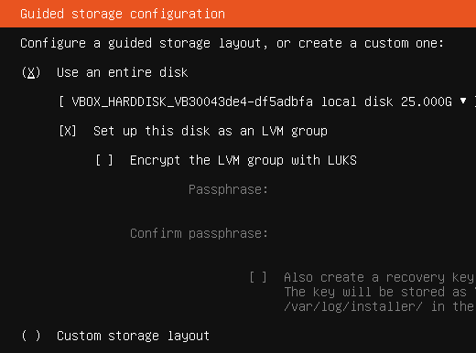

Again the machine displays a summary of configuration with a confirmation message, which may be ignored at this point. Select continue.

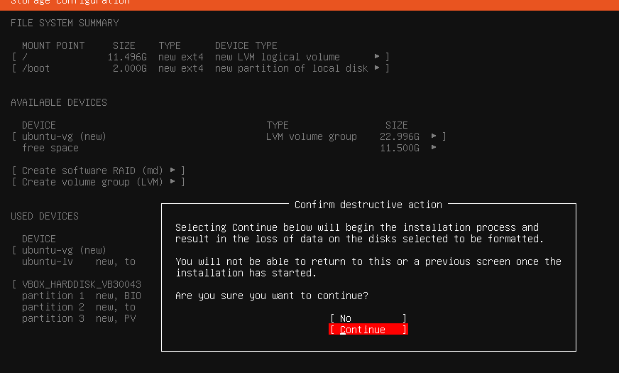

It is now time to configure the user information, password, and server name.

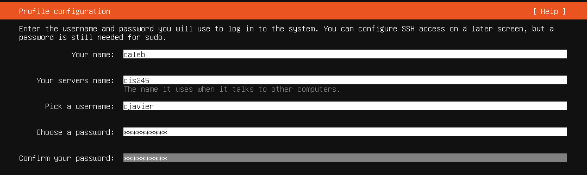

Provide all of these and continue.

The user will be prompted to upgrade to Ubuntu Pro—this can be ignored.

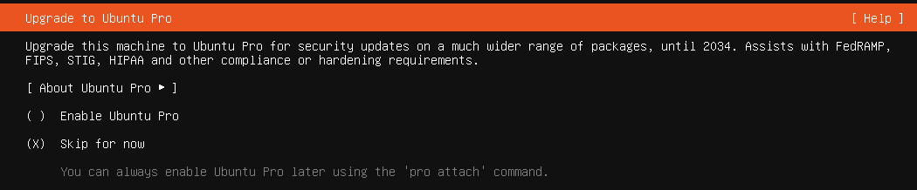

For the next step, the installation of OpenSSH server is not required but for this setup it will be selected. Proceed with “Done”.

The user can elect to install additional server snaps, but this will also be skipped.

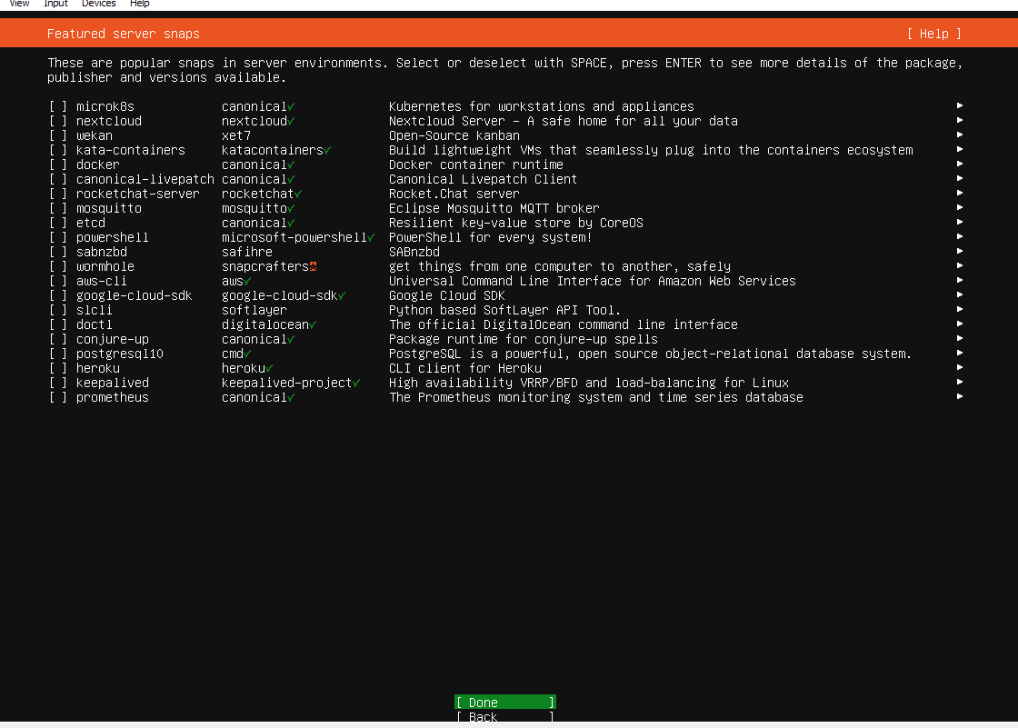

The server will now be installed.

Once finished, navigate to the  option which will perform a system reboot. The system will boot and the user can press enter to begin the login.

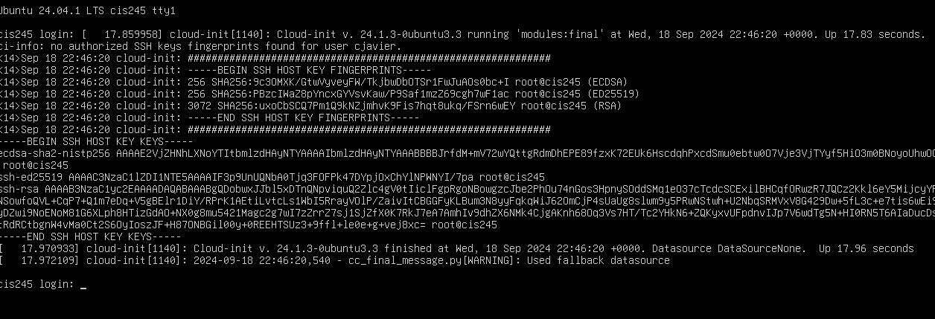

After providing the credentials, the user is now logged in to the server and the terminal should look like this:

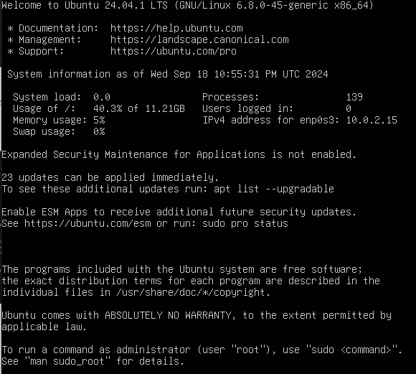

The installation is now complete.

Section 3: Performing File Sharing Using SCP

In order to exchange files between servers, a special command must be used. The “secure copy” or SCP command is used to send files from one host to another using their respective IP addresses. These can be found by using the **ifconfig** command, and if the command isn’t available it can be installed usually with a command provided by the system. For Ubuntu, it looks like this : 

This is the initial SCP command: 

Where the command begins with **scp**, then the name of the file desired for transfer, then the host user name of the destination server, followed immediately by “@” and the IP address found using **ifconfig**. The last portion is a colon followed by the actual destination path of the file, in this case a directory named “2”. This should be the full file path.

Once the command is run, this response may appear if performing for the first time:

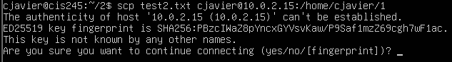

Enter “yes” and the destination server’s password when prompted.



The transfer should occur after this, but I believe there is no status update because of the fact that both servers have the same username and same IP, so the file may be being transferred locally.