Caleb Javier

Professor Holden-Gouveia

CIS-245

15 September 2024

Grep

**Practicing grep: Command Examples and Descriptions**

1. **Print all lines containing the string “Lane”.**

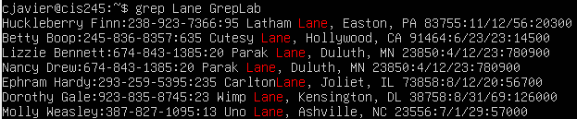

This command searches the file for every line that contains the string “Lane”. It is case-sensitive.

1. **Print all lines where the person’s first name starts with “H”.**

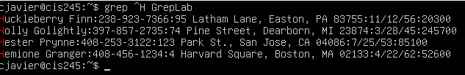

Because all lines start with names, the ^ can be used to find every line that starts with “H”; every name that begins with H.

1. **Print all lines ending in three zeros (“000”).**

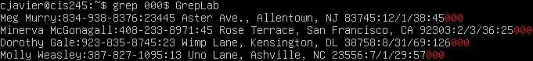

Opposite of the previous section, the end of line operator allows for a search of terminating strings in a line.

1. **Print all lines that don’t contain “408”.**



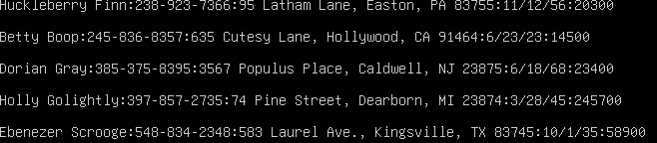

By using the invert match option, all lines that contain the string “408” are excluded from the results. The names of these lines (Hester Prynne, Hermione Granger, Minerva McGonagall, and Daenerys Targaryen) were not included in this command’s output.

1. **Print all lines where birthdays are in the year 1935 (date format MM/DD/YY).**

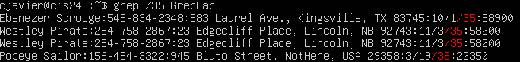

With the way the date is formatted, simply adding a slash before the number 35 will print all lines containing those born in 1935.

1. **Print all lines where a phone number’s area code starts with 8.**

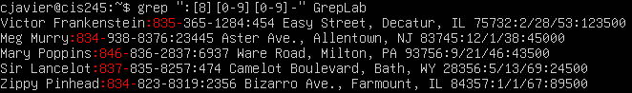

By using regular expressions, the command can find all lines where 8 precedes the phone number. Due to the phone number’s format, a dash was added to help remove undesired results.

1. **Print all lines containing an uppercase letter followed by four lowercase letters, a space, and one uppercase letter.**

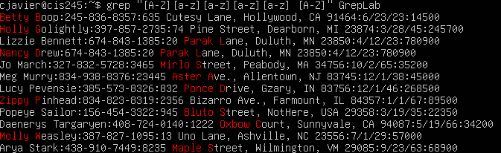

Again, implementing regular expressions to provide ranges of case sensitive characters in a specific order lets one find these results.

1. **Print lines where the address begins with a two or three-digit number.**

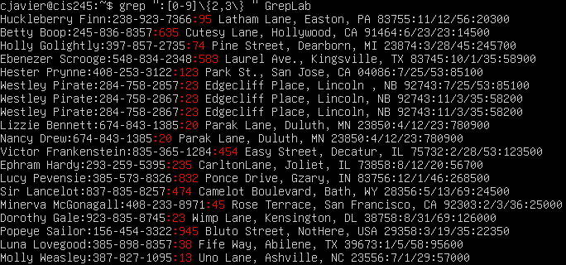

Occurrence operators can be used to repeat desired patterns. The number in the backslash/curly brackets represents the number of times that pattern is repeated. The backslash is necessary as grep will not properly run the command without differentiating it from literal character operators. By adding a comma in the repeating operator, a search range is created. The range in this case is 2-3. The space included at the end of the command allows for only the address number to be highlighted as it is the only time two or three numbers are followed by a space.

1. **Print lines where the person lives in Massachusetts or Illinois.**

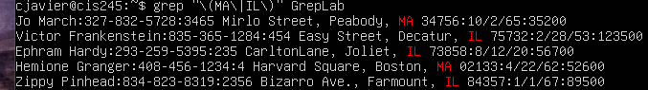

The pipe character acts as an or operator. Again, backslash characters are necessary in order for grep to function properly.

1. **Print lines containing the addresses that aren’t on a street.**

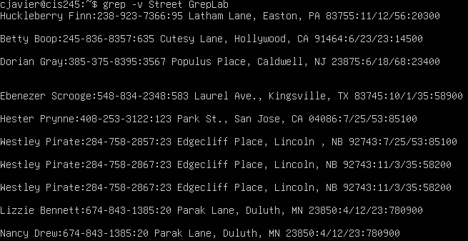

By again using the invert match grep option (I am assuming this is referring to the street type), all results that do not contain “Street” are pulled.

Works Cited

1. “GREP Command in Unix/Linux.” *GeeksforGeeks*, GeeksforGeeks, 12 July 2024, www.geeksforgeeks.org/grep-command-in-unixlinux/.
2. Linuxcommand.org And Original Man Page Author. “Grep Manual Page.” *Grep Man Page*, linuxcommand.org/lc3_man_pages/grep1.html. Accessed 9 Oct. 2024.
3. *Regex Basics | Ubuntu*, ubuntu.com/blog/regex-basics. Accessed 9 Oct. 2024.