Caleb Javier

Professor Holden-Gouveia

CIS-245

22 September 2024

Week 3: Sed

1. **Change the name “Jo” to Josephine”.**



Jo’s name can be searched for using spaces in the command. The name is then replaced with what follows.

1. **Delete the last five lines.**



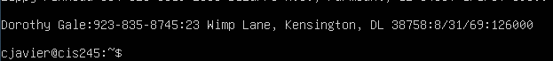

In order to delete the last five lines, grep was used to find exactly where the fifth line up from the bottom (Popeye) is. The “d” (deletion) operation is used along with the “$” character which signifies the last line. The comma separation provides a range, so lines 45-50 are deleted.

1. **Print lines 3-15.**

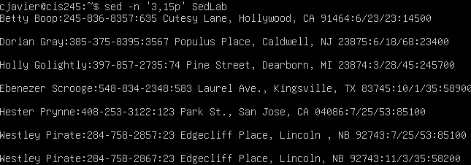

Again a range is provided followed by “p”. The “-n” disposes of duplicate/unnecessary lines.

1. **Delete lines for people who live in California.**

****Lines containing the pattern searched within the delimiters are deleted. There are no residents of CA in the results.

1. **Print all lines where the birthdays are in the first week of the month.**

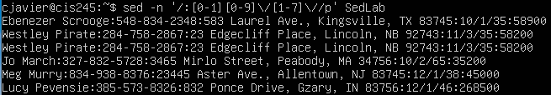

Beginning the regular expression query with the first portion of the date followed by a digit one through seven, all birthdays that reside within the first week of the month can be found. Again, the slashes in the date format must be separated as literal characters with backslashes.

1. **Append three asterisks to the end of lines starting with Sir.**
2. **Replace the line containing “Westley Pirate” with the phrase “As you wish.”**



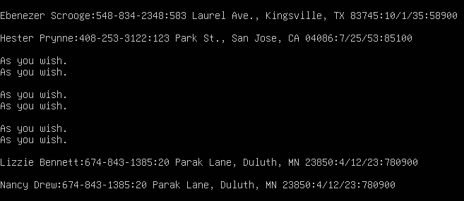

By using “.*”, the pattern is enhanced to substitute the rest of the line after the first name with the provided text. I forgot -n here.

1. **Change Minerva McGonagall’s birthday to 10/04/1935 (searching for it using Regular Expressions).**



By finding the line with the name using grep and piping it into a regex query, the birthday alone can be replaced. The number of digits in the initial birthdate was unknown, so this was edited until a match was made.

1. **Delete all blank lines.**

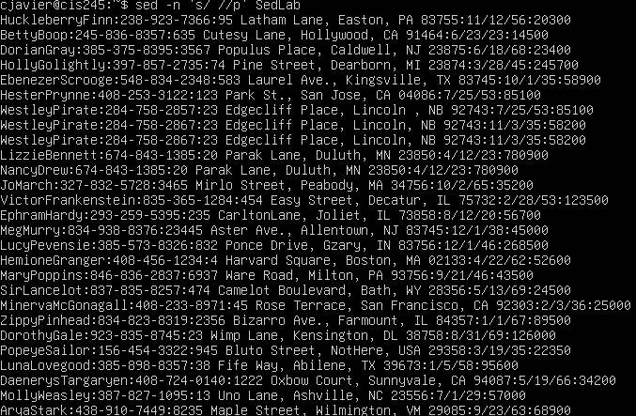

To remove whitespaces in between lines containing text, the space character can be substituted with nothing. This deletes all excess whitespace. With nothing to put in its place, this also works for the lines with text. If a space is added as a substitute, this restores the first space in every text line.

1. **Write a sed script that will** 
   1. **Insert above the first line in the title “Great Literary Characters”.**
   2. **Print the contents of the file with all phone numbers prepended with +1.**
   3. **Append the phrase “Happily ever after” to the file.**

After writing the script, it was copied into the server and then run on the file SedLab using the file option.



The results appear as such:

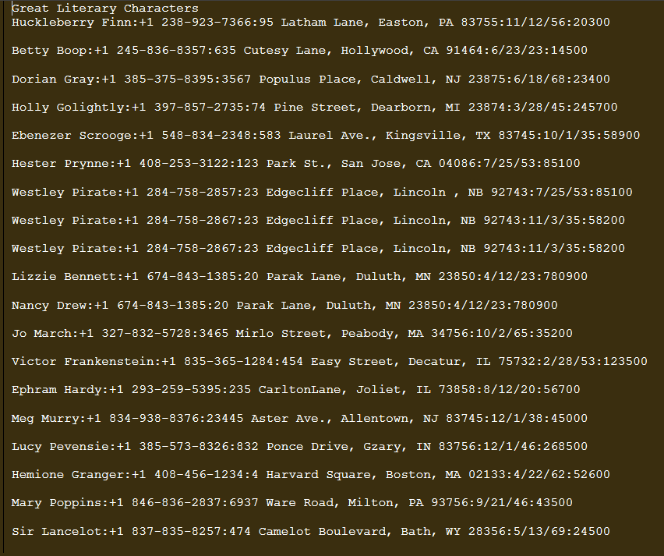

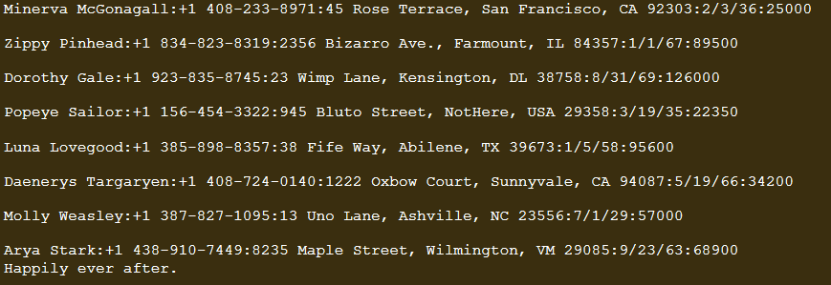

Works Cited:

1. JohnJohn 3, et al. “How Exactly Do I Create a SED Script and Use It to Edit a File?” *Unix & Linux Stack Exchange*, 1 Feb. 1959, unix.stackexchange.com/questions/95939/how-exactly-do-i-create-a-sed-script-and-use-it-to-edit-a-file.
2. “SED Command in Linux/Unix with Examples.” *GeeksforGeeks*, GeeksforGeeks, 23 Sept. 2024, www.geeksforgeeks.org/sed-command-in-linux-unix-with-examples/.
3. “Sed, a Stream Editor.” *Sed, a Stream Editor*, www.gnu.org/software/sed/manual/sed.html#sed-commands-list. Accessed 10 Oct. 2024.