Caleb Javier

Professor Holden-Gouveia

CIS-245

06 October 2024

Week 5: Continue Setup - Installs, Updates, and Documentation

This documentation will explore the installation process for repositories and programs for both Ubuntu and CentOS servers.

1. Checking and adding repositories and installing programs
   1. For Ubuntu: In order to first check what is already installed, begin by using the grep command to display the contents of the sources.list.d file. The excess lines (comments in this case) can be removed using regular expressions, like so:

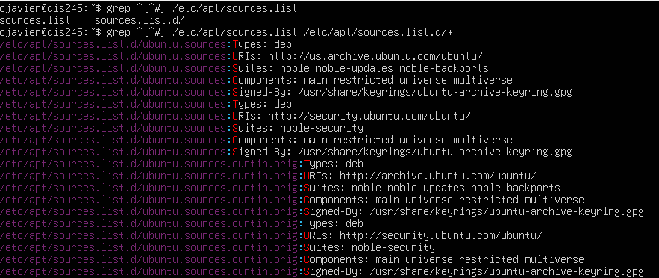

Provided is now a simple list of the two resources installed on this machine.

* 1. For CentOS: Begin by sudo using the “dnf” command, a package manager that is used to install, update, or remove programs. The command to display the list of currently installed repositories is as follows:

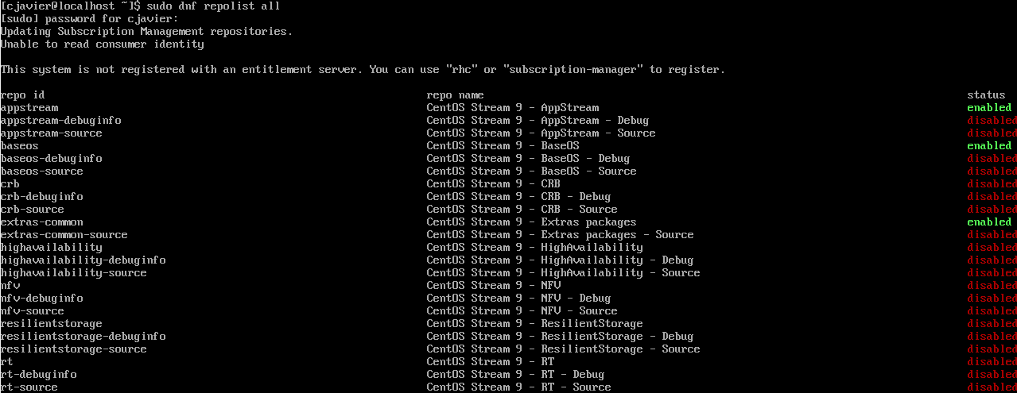

1. Installing Tmux, emacs, and Fail2Ban

The user will now attempt to install three different programs.

1. For Ubuntu: the APT tool is used to install packages. Begin by first running “sudo apt-get update” to ensure that the system is up to date, and then testing installing using apt-get and removing using apt-get remove. “conky” will be used as an example.

Here is the update command followed by the process:

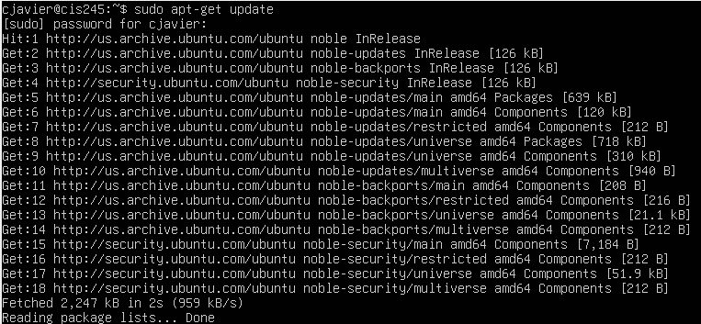

Installation: sudo apt-get install conky-cli (there are multiple iterations of this, this version is cli)

Notice: The user will be prompted to continue with a (Y/n) choice. Type Y and press enter to continue.

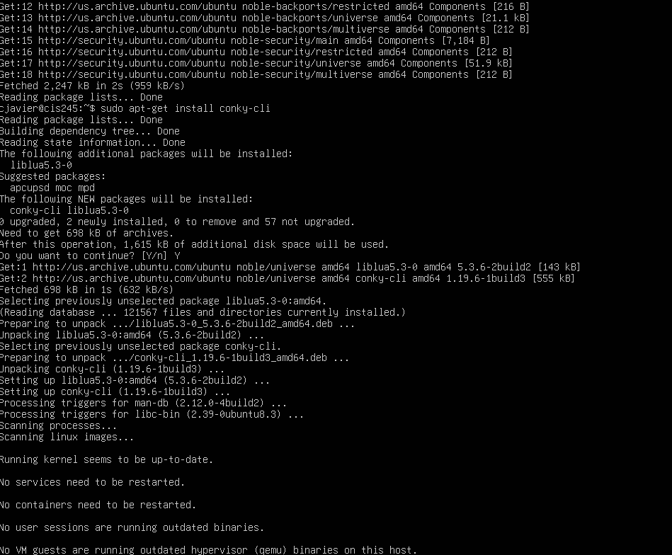

Removal:

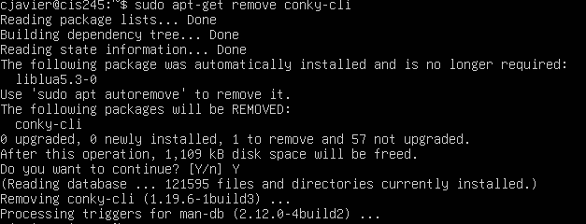

For CentOS: The dnf command is now used instead of yum. To perform an update, the user can enter “sudo dnf update”, where they will also be prompted to confirm like so:

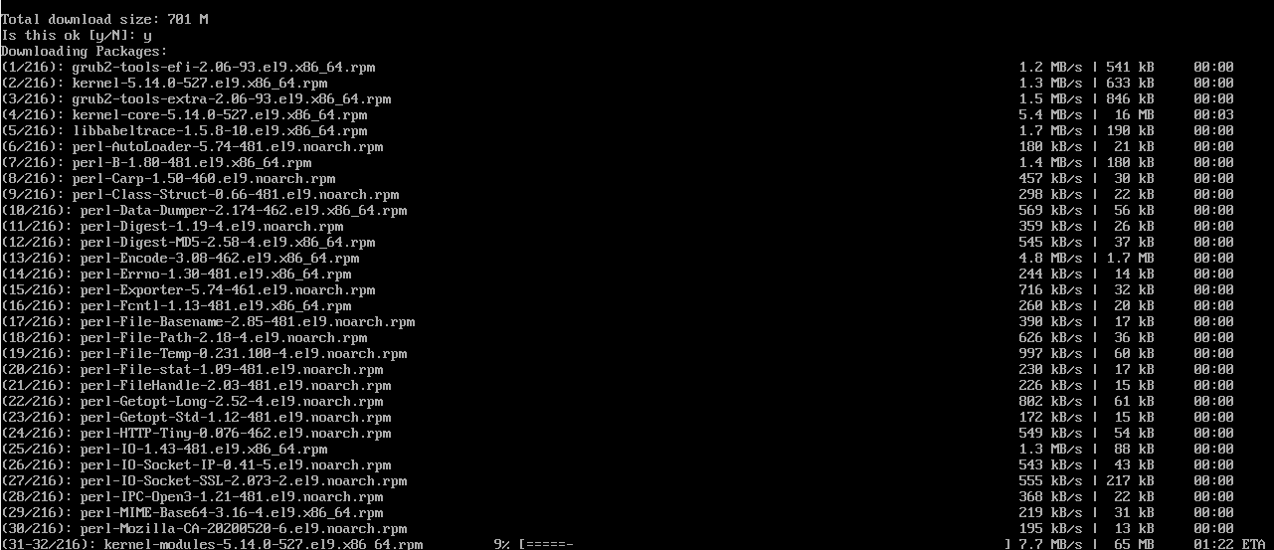

Enter y and press return to continue. This process is seemingly a bit lengthier.

To install tmux for this example, use “sudo dnf install tmux”

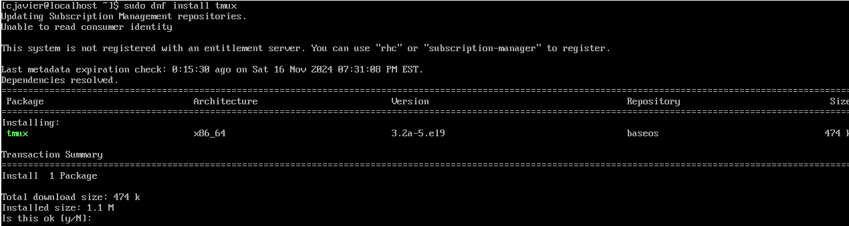

A prompt will appear again. Confirm and continue. Here is the complete installation.

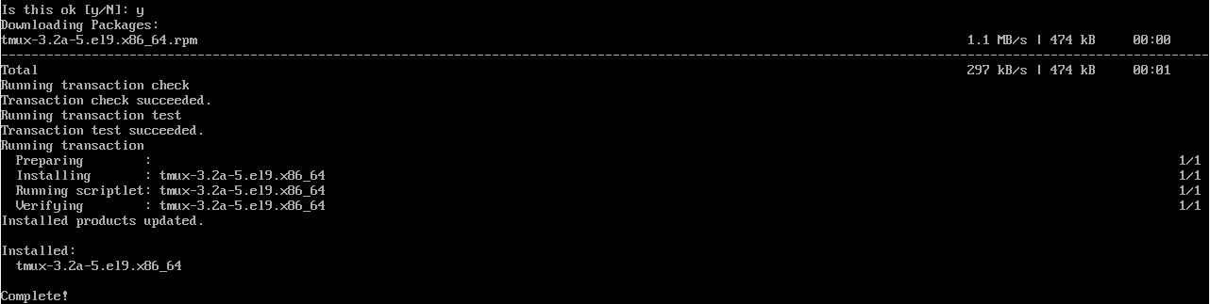

To remove it, “sudo dnf remove tmux”.

Repeat this process for both machines with tmux, emacs, and fail2ban.

I encountered an error with CentOS trying to install Fail2Ban, I could not find it.

1. Installing cosway and lolcat

Repeating the process with cosway and lolcat:

For Ubuntu, the cosway package could not be found. Lolcat was installed without an issue.

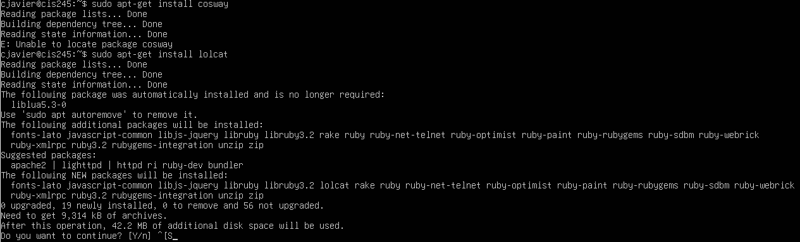

For CentOS, the case is quite different. The machine must be registered to an organization which requires a login. I created a login and attempted to register the VM, but received this message:

