Caleb Javier

Professor Holden-Gouveia

CIS-245

13 October 2024

Assignment 6: Networking

The following documentation will delve into the setting up of a network and obtaining all network information in the Linux server. The first example will be for Ubuntu followed by the second for CentOS.

1. Setting up a network in Ubuntu

To begin, use the **ip a** command in order to see basic information on all network interfaces on the current system.

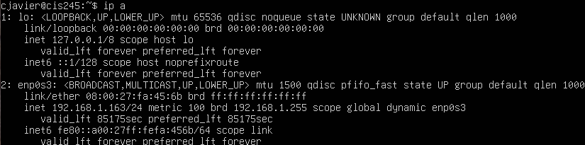

To view the stats on transmitted packets (typically included in the now outdated “ifconfig” command), use the command **ip -s link show [interface]**. In this example, the interface used is the network, counter to the loopback.

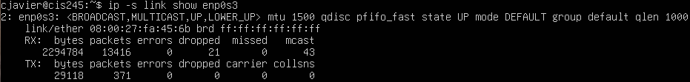

To check information on the routing table, the ip command is used again as **ip route show**.

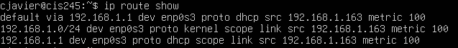

In order to view the current DNS configuration, the user can **cat** resolv.conf which is found in the /etc directory. These comments are warnings and advisories.

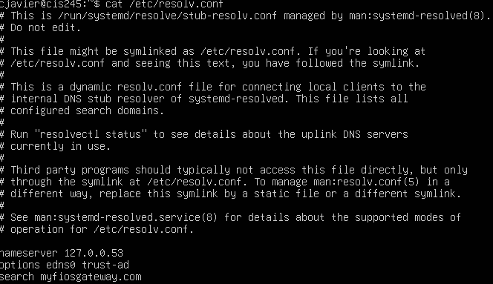

Finally, to check all open ports, begin by installing netstat (if it is not already on the system) by using **sudo apt install net-tools**. Then, use **sudo netstat -ntlp**  to view all ports actively listening for traffic.

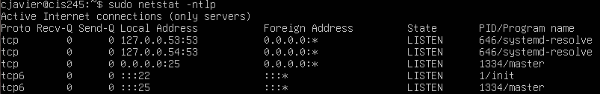

1. Setting up Network in CentOS

The process is very similar to that of Ubuntu’s. Begin by viewing the system’s network interfaces by using ip a.

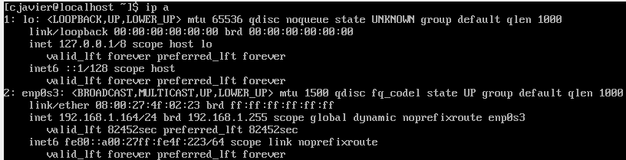

Then, for additional stats, ip -s link show [interface]. If you do not know which one to select, the tab key will provide suggestions available.

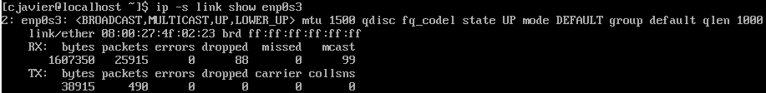

To check routing table info, again ip route show.



In order to view or edit the DNS configuration, access the file named resolv.conf. 

And to view open ports, the command is also the same with netsat. Install it if it is unable to be used.

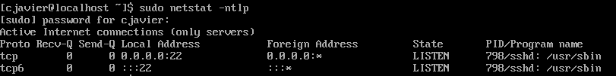

1. Creating a Script to Review Important Network Information

To first create the script, an aptly-named file will be created by using the touch command.



Then, the file will be populated with commands to dump the ip and network information. The script can be copied and pasted into the document and will be as follows:

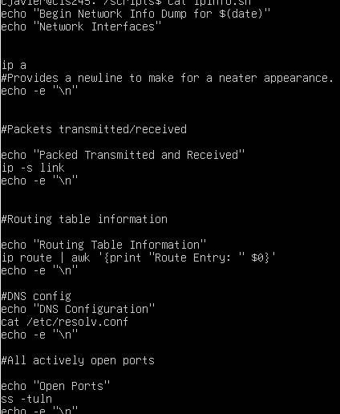

The permissions must be edited by running this command:



Note the period which pertains to the directory. The script can now be run with “./ipinfo.sh”

It can then be appended to a new file in order to log it; for which a directory can also be created.

3. Contents of Script

Using all that has been learned about how to gather various network information, the script contains a command for each form of the previously mentioned methods. There is a heavy reliance on the “echo” command to make this script functional, as that is how the presentation of the script output is made to be much more neat, as well as how it can be cast to a file in order to log current statistics. Because of the extensive length of the output of some commands, the files can be parsed using the grep, awk, and sed commands to reduce unnecessary information. For example, with the DNS configuration command, with each use follows a large string of comments and newline characters. To remove them, grep is used to begin the output of the command exactly where it should begin. The same is true for viewing all open ports, as the command provided allows the user to look at all ports currently connected. Using grep again, this is filtered to only display the ports that currently contain “LISTEN” in their line.

Works Cited

JonasJonas 8, et al. “How Can I See What Ports Are Open on My Machine?” *Ask Ubuntu*, 1 Dec. 1955, askubuntu.com/questions/9368/how-can-i-see-what-ports-are-open-on-my-machine.

zozozozo 85333 gold badges1313 silver badges2222 bronze badges, et al. “Check Port Status on Centos.” *Server Fault*, 1 Apr. 1956, serverfault.com/questions/239145/check-port-status-on-centos.

McKenzie, Cameron. “How to Create and Run a Shell Script in Linux and Ubuntu.” *TheServerSide*, TheServerSide.com, 14 Jan. 2022, www.theserverside.com/blog/Coffee-Talk-Java-News-Stories-and-Opinions/run-Unix-shell-script-Linux-Ubuntu-command-chmod-777-permission-steps.

“The ‘echo’ Command In Linux.” *YouTube*, RobertElderSoftware, www.youtube.com/watch?v=7DdEFSrvYv0. Accessed 5 Dec. 2024.