# Sample Data



# Visualizations in the Web Browser

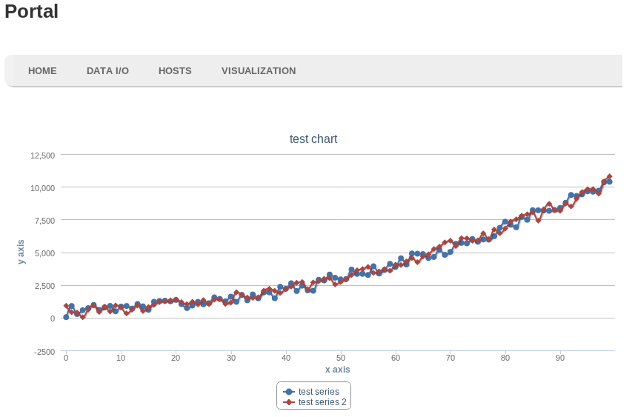

## The server side-code used to generate the sample graph:

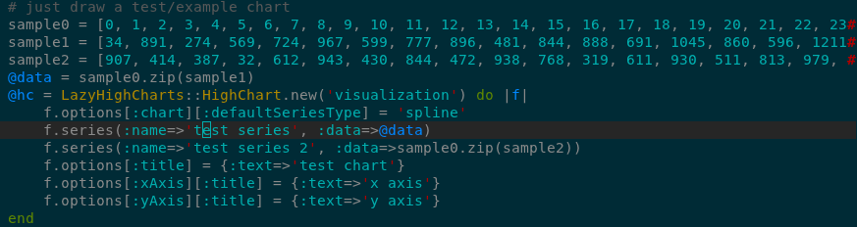

# Long Term Goals

While the simplest use of EcoData is a simple process involving the importing and storage of data followed by manipulations and visualizations, each stage of the process can and will be elaborated upon.

* Import data
  + Support other data types
* Manipulate Data
  + Filtering
  + Joins between tables of data
* Visualize data
  + Add more types of visualizations

Other objectives include:

* Authentication and security for data
* Availability of data between servers
* Cross-server data availability
  + Fast transfers of data between remote servers

# Beyond EcoData

EcoData is the first piece in a larger data management and analysis system. It provides the tools necessary to convert and store data in a structured format and to produce basic visualizations of that data.

Eventually, it will be used as one piece in a more complex data analysis pipeline, allowing for more sophisticated data manipulations and visualizations.

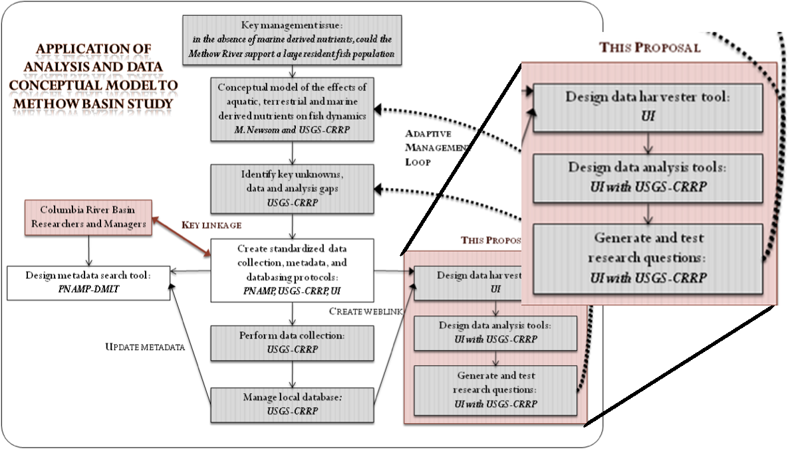

# Completed Tasks

## Import Data

Currently, EcoData supports data that is formatted in well-structured Comma-Separated Values (CSV) format.

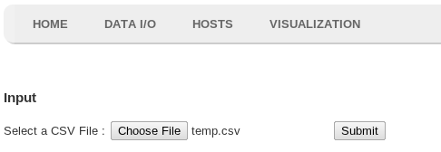

A CSV data file is uploaded via the web interface (pictured above) and stored in the database.

## Manipulate Data

Currently all data must be manipulated before being imported into EcoData. This limitation will be overcome as the database backend is finalized.

## Visualize Data

A visualization framework has been put in place and is nearly ready to accept user data. Once the database structure is finalized, data will be graphed as seen in “Visualizations in the Web Browser.”

# EcoData

# Mike Solomon and Colby Blair

# Sponsored by Alex Fremier, College of Natural Resources

# University of Idaho

# Future Visualizations

Upcoming visualizations include scatter plots:

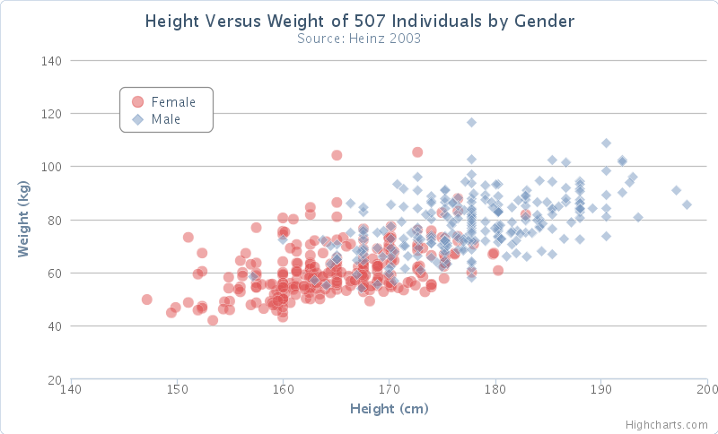

And bar charts: