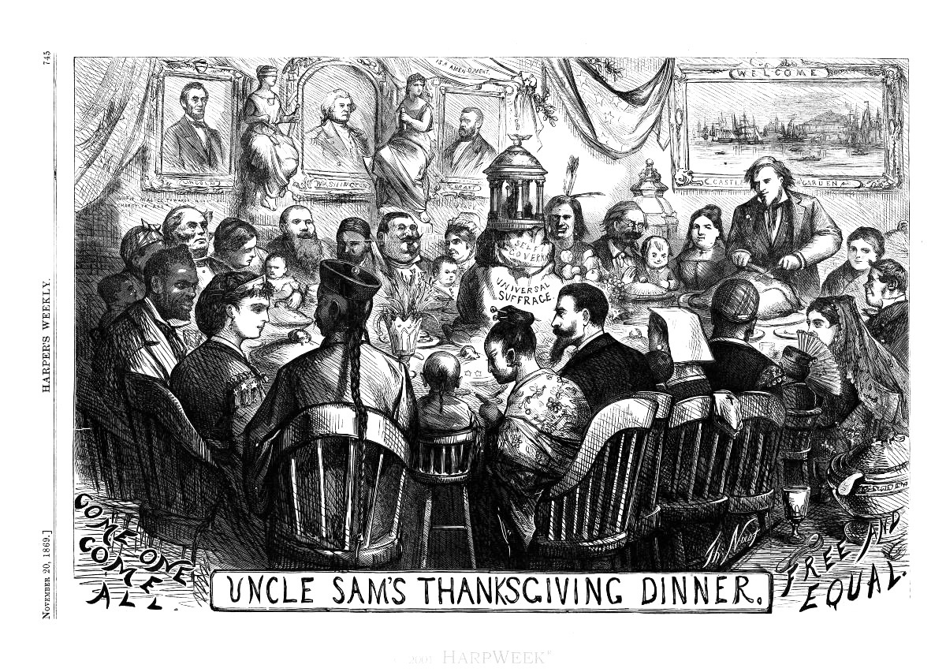

Thomas Nast, “Uncle Sam’s Thanksgiving Dinner,” Harper’s Weekly, November 20, 1869, pg. 745. <http://www.harpweek.com/09Cartoon/BrowseByDateCartoon.asp?Month=November&Date=22>. From Harper’s Weekly

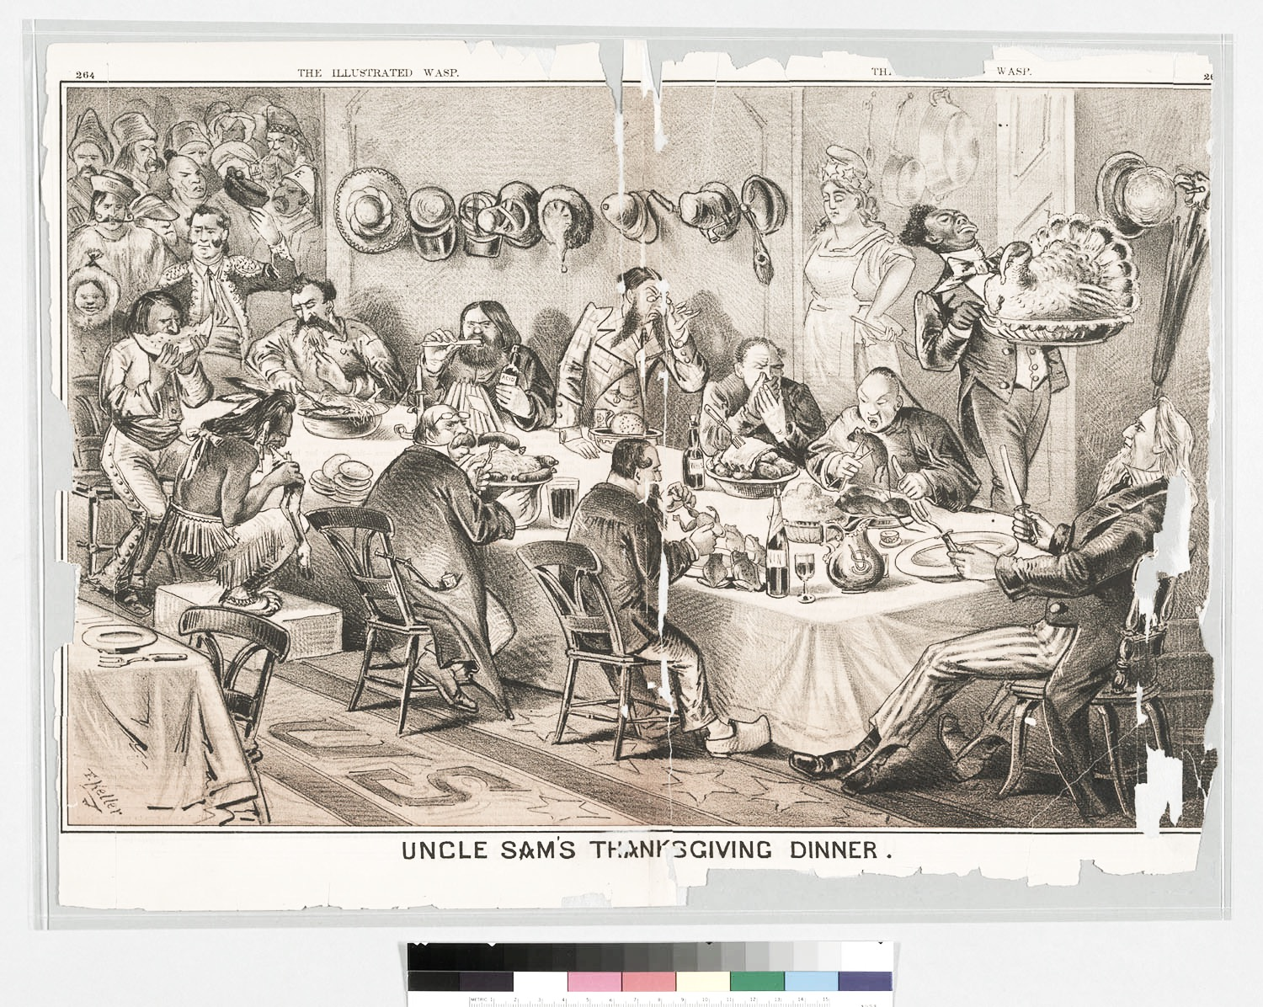

George Frederick Keller, “Uncle Sam’s Thanksgiving Dinner,” *The Illustrated Wasp*, Vol. 2, No. 69, 1877. <http://www.oac.cdlib.org/ark:/13030/hb709nb1k7/?order=1>. From “Chinese in California” collection, Bancroft Library.