**Week 4 Primary Source Packet**

**HIST 1200/1201: History and Trump, Fall 2017**

**U.S. Congress, 1790 Naturalization Act**

****

**Territorial boundaries of Mexico, 1835-1836 vs. 1848-1853**

Source: Wikimedia Commons contributors, "Atlas of Mexico," *Wikimedia Commons, the free media repository,* <https://commons.wikimedia.org/w/index.php?title=Atlas_of_Mexico&oldid=239325862> (accessed

September 20, 2017).

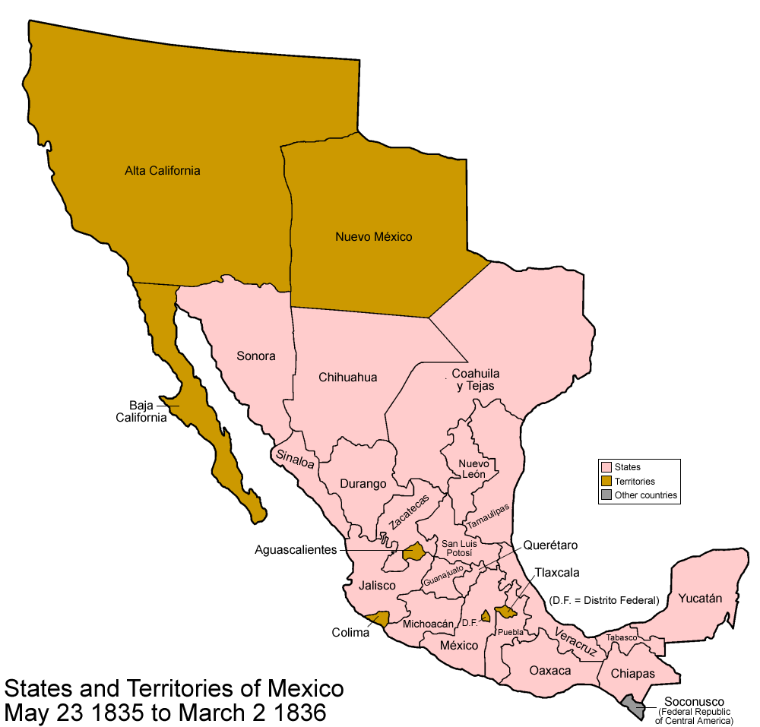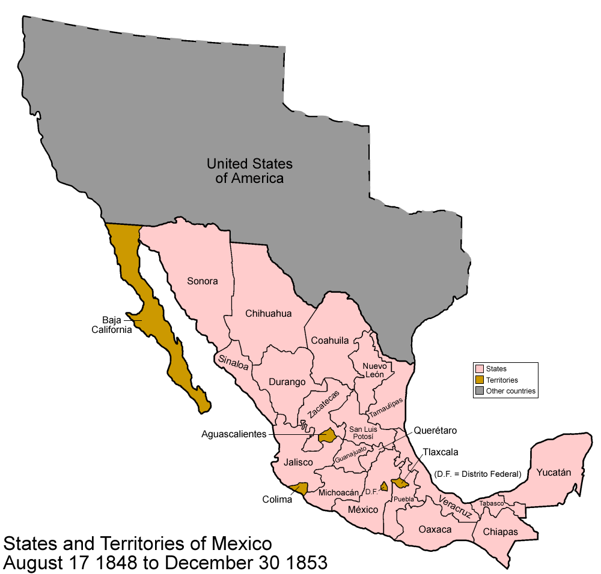

**Treaty of Guadalupe Hidalgo, 1848 (selections)**

**TREATY OF PEACE, FRIENDSHIP, LIMITS, AND SETTLEMENT BETWEEN THE UNITED STATES OF AMERICA AND THE UNITED MEXICAN STATES CONCLUDED AT GUADALUPE HIDALGO, FEBRUARY 2, 1848; RATIFICATION ADVISED BY SENATE, WITH AMENDMENTS, MARCH 10, 1848; RATIFIED BY PRESIDENT, MARCH 16, 1848; RATIFICATIONS EXCHANGED AT QUERETARO, MAY 30, 1848; PROCLAIMED, JULY 4, 1848.**

**………**

**ARTICLE VIII**

Mexicans now established in territories previously belonging to Mexico, and which remain for the future within the limits of the United States, as defined by the present treaty, shall be free to continue where they now reside, or to remove at any time to the Mexican Republic, retaining the property which they possess in the said territories, or disposing thereof, and removing the proceeds wherever they please, without their being subjected, on this account, to any contribution, tax, or charge whatever.

Those who shall prefer to remain in the said territories may either retain the title and rights of Mexican citizens, or acquire those of citizens of the United States. But they shall be under the obligation to make their election within one year from the date of the exchange of ratifications of this treaty; and those who shall remain in the said territories after the expiration of that year, without having declared their intention to retain the character of Mexicans, shall be considered to have elected to become citizens of the United States.

In the said territories, property of every kind, now belonging to Mexicans not established there, shall be inviolably respected. The present owners, the heirs of these, and all Mexicans who may hereafter acquire said property by contract, shall enjoy with respect to it guarantees equally ample as if the same belonged to citizens of the United States.

**ARTICLE IX**

The Mexicans who, in the territories aforesaid, shall not preserve the character of citizens of the Mexican Republic, conformably with what is stipulated in the preceding article, shall be incorporated into the Union of the United States. and be admitted at the proper time (to be judged of by the Congress of the United States) to the enjoyment of all the rights of citizens of the United States, according to the principles of the Constitution; and in the mean time, shall be maintained and protected in the free enjoyment of their liberty and property, and secured in the free exercise of their religion without; restriction.

………

**Selection of Immigration**

Prescott F. Hall

*The Annals of the American Academy of Political and Social Science*

Vol. 24, The Government in Its Relation to Industry (Jul., 1904), pp. 169-184

[excerpts – page 177-178]

/var/folders/vv/k5f6zmrs5nvgpxvf0p_smps40000gn/T/com.apple.Preview/com.apple.Preview.PasteboardItems/Unsaved Preview Document (dragged).pdf

/var/folders/vv/k5f6zmrs5nvgpxvf0p_smps40000gn/T/com.apple.Preview/com.apple.Preview.PasteboardItems/Unsaved Preview Document (dragged) 1.pdf

**Speech by Ellison DuRant Smith, April 9, 1924, Congressional Record, 68th Congress, 1st Session (Washington DC: Government Printing Office, 1924), vol. 65, 5961–5962.**

[excerpts]

It seems to me the point as to this measure—and I have been so impressed for several years—is that the time has arrived when we should shut the door. We have been called the melting pot of the world. We had an experience just a few years ago, during the great World War, when it looked as though we had allowed influences to enter our borders that were about to melt the pot in place of us being the melting pot. I think that we have sufficient stock in America now for us to shut the door, Americanize what we have, and save the resources of America for the natural increase of our population. We all know that one of the most prolific causes of war is the desire for increased land ownership for the overflow of a congested population. We are increasing at such a rate that in the natural course of things in a comparatively few years the landed resources, the natural resources of the country, shall be taken up by the natural increase of our population. It seems to me the part of wisdom now that we have throughout the length and breadth of continental America a population which is beginning to encroach upon the reserve and virgin resources of the country to keep it in trust for the multiplying population of the country…

…I think we now have sufficient population in our country for us to shut the door and to breed up a pure, unadulterated American citizenship. I recognize that there is a dangerous lack of distinction between people of a certain nationality and the breed of the dog. Who is an American? Is he an immigrant from Italy? Is he an immigrant from Germany? If you were to go abroad and some one were to meet you and say, “I met a typical American,” what would flash into your mind as a typical American, the typical representative of that new Nation? Would it be the son of an Italian immigrant, the son of a German immigrant, the son of any of the breeds from the Orient, the son of the denizens of Africa? We must not get our ethnological distinctions mixed up with out anthropological distinctions. It is the breed of the dog in which I am interested. I would like for the Members of the Senate to read that book just recently published by Madison Grant, The Passing of a Great Race. Thank God we have in America perhaps the largest percentage of any country in the world of the pure, unadulterated Anglo-Saxon stock; certainly the greatest of any nation in the Nordic breed. It is for the preservation of that splendid stock that has characterized us that I would make this not an asylum for the oppressed of all countries, but a country to assimilate and perfect that splendid type of manhood that has made America the foremost Nation in her progress and in her power, and yet the youngest of all the nations. I myself believe that the preservation of her institutions depends upon us now taking counsel with our condition and our experience during the last World War.

# Immigration Act of 1924

From Wikipedia, the free encyclopedia

The **Immigration Act of 1924**, or **Johnson–Reed Act**, including the **National Origins Act**, and **Asian Exclusion Act** ([Pub.L. 68–139](http://legislink.org/us/pl-68-139), 43 [Stat.](https://en.wikipedia.org/wiki/United_States_Statutes_at_Large) [153](http://legislink.org/us/stat-43-153), enacted May 26, 1924), was a [United States federal law](https://en.wikipedia.org/wiki/United_States_federal_law) that limited the annual number of [immigrants](https://en.wikipedia.org/wiki/Immigration_to_the_United_States) who could be admitted from any country to 2% of the number of people from that country who were already living in the [United States](https://en.wikipedia.org/wiki/United_States) as of the [1890 census](https://en.wikipedia.org/wiki/United_States_Census,_1890), down from the 3% cap set by the [Emergency Quota Act](https://en.wikipedia.org/wiki/Emergency_Quota_Act) of 1921, which used the [Census of 1910](https://en.wikipedia.org/wiki/United_States_Census,_1910). The law was primarily aimed at further restricting immigration of [Southern Europeans](https://en.wikipedia.org/wiki/Southern_Europe) and [Eastern Europeans](https://en.wikipedia.org/wiki/Eastern_Europe), especially [Italians](https://en.wikipedia.org/wiki/Italian_people) and Eastern European [Jews](https://en.wikipedia.org/wiki/Jews).[[1]](https://en.wikipedia.org/wiki/Immigration_Act_of_1924#cite_note-1)[[2]](https://en.wikipedia.org/wiki/Immigration_Act_of_1924#cite_note-LEP-2)[[3]](https://en.wikipedia.org/wiki/Immigration_Act_of_1924#cite_note-washpost-3) In addition, it severely restricted the immigration of [Africans](https://en.wikipedia.org/wiki/African_Americans) and outright banned the immigration of [Arabs](https://en.wikipedia.org/wiki/Arab_Americans) and [Asians](https://en.wikipedia.org/wiki/Asian_Americans).

According to the U.S. Department of State [Office of the Historian](https://en.wikipedia.org/wiki/Office_of_the_Historian) the purpose of the act was "to preserve the ideal of American homogeneity".[[4]](https://en.wikipedia.org/wiki/Immigration_Act_of_1924#cite_note-4) But though the Act aimed at preserving American racial homogeneity, it set no limits on immigration from other countries of the [Americas](https://en.wikipedia.org/wiki/Americas).[[5]](https://en.wikipedia.org/wiki/Immigration_Act_of_1924#cite_note-5) Congressional opposition was minimal. According to Columbia University historian [Mae Ngai](https://en.wikipedia.org/wiki/Mae_Ngai), the 1924 Act put an end to a period where the United States essentially had [open borders](https://en.wikipedia.org/wiki/Open_border).[[6]](https://en.wikipedia.org/wiki/Immigration_Act_of_1924#cite_note-6)

**Source: Wikipedia contributors, "Immigration Act of 1924," *Wikipedia, The Free Encyclopedia*, https://en.wikipedia.org/w/index.php?title=Immigration\_Act\_of\_1924&oldid=800660337 (accessed September 20, 2017). NYTimes_1931.pdf**